Week7_React_HandsOn
HandsOn 1:
src/components/IndianPlayers.js
import React from 'react';
const IndianPlayers = () => {
const T20players = ['Virat', 'Rohit', 'Gill', 'Pant', 'Surya'];
const RanjiTrophyPlayers = ['Pujara', 'Rahane', 'Shaw', 'Sundar', 'Kuldeep'];
const mergedPlayers = [...T20players, ...RanjiTrophyPlayers];
const [p1, p2, p3, p4, p5, p6, p7, p8, p9, p10] = mergedPlayers;
const oddTeam = [p1, p3, p5, p7, p9];
const evenTeam = [p2, p4, p6, p8, p10];
return (
<div>
<h2>Merged Players</h2>
<p>{mergedPlayers.join(', ')}</p>
<h3>Odd Team Players</h3>
<ul>
{oddTeam.map((player, index) => (
<li key={index}>{player}</li>
))}
</ul>
<h3>Even Team Players</h3>
<ul>
{evenTeam.map((player, index) => (
<li key={index}>{player}</li>
))}
</ul>
</div>
);
};
export default IndianPlayers;
src/components/ListofPlayers.js
import React from 'react';
const ListofPlayers = () => {
const players = [
{ name: "Virat", score: 85 },
{ name: "Rohit", score: 60 },
{ name: "Dhoni", score: 95 },
{ name: "KL Rahul", score: 30 },
{ name: "Jadeja", score: 78 },
{ name: "Bumrah", score: 55 },
{ name: "Shami", score: 68 },
{ name: "Gill", score: 88 },
{ name: "Pant", score: 72 },
{ name: "Suryakumar", score: 45 },
{ name: "Ashwin", score: 91 },
];
const filteredPlayers = players.filter(player => player.score < 70);
return (
<div>
<h2>All Players</h2>
<ul>
{players.map((player, index) => (
<li key={index}>{player.name} - {player.score}</li>
))}
</ul>
<h2>Players with Score Below 70</h2>
<ul>
{filteredPlayers.map((player, index) => (
<li key={index}>{player.name} - {player.score}</li>
))}
</ul>
</div>
);
};
export default ListofPlayers;
App.js
import React from 'react';
import ListofPlayers from './components/ListofPlayers';
import IndianPlayers from './components/IndianPlayers';
function App() {
const flag = false; // change to false to test

return (
<div className="App">
<h1>🏏 Welcome to Cricket App</h1>
{flag ? <ListofPlayers /> : <IndianPlayers />}
</div>
);
}
export default App;
OUTPUT :
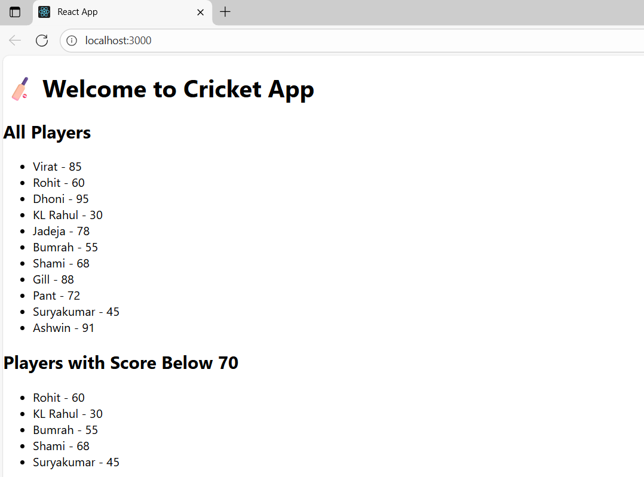
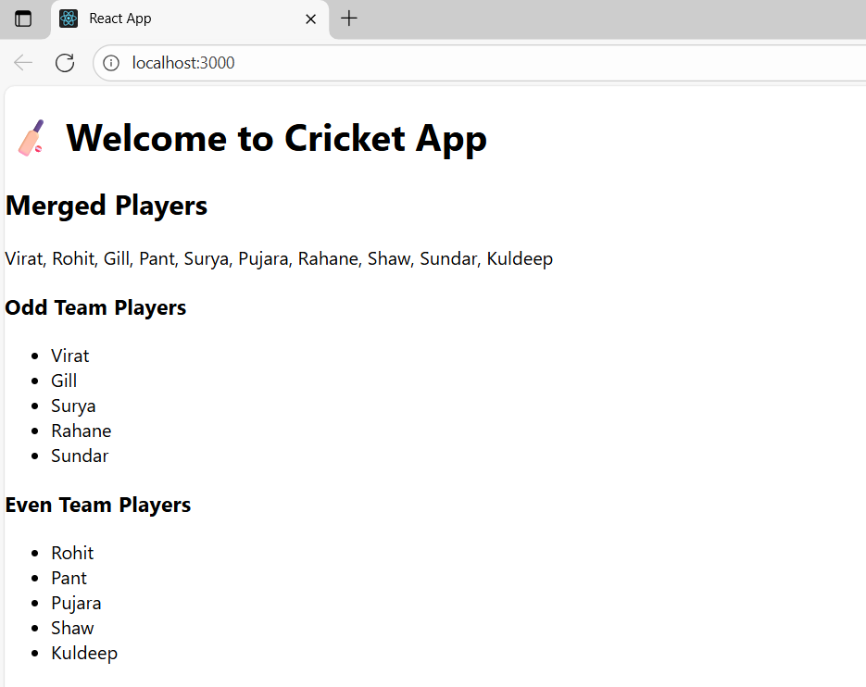
HandsOn 2:
App.js
import React from 'react';
function App() {
// Create an object for one office
const office = {
name: 'ABC Towers',
rent: 55000,
address: 'Chennai, Tamil Nadu',
image: 'off.jpg'
};
// List of office objects
const officeList = [
{
name: 'XYZ Corporate',
rent: 65000,
address: 'Bangalore, Karnataka'
},
{
name: 'Tech Park',
rent: 40000,
address: 'Hyderabad, Telangana'
},
{
name: 'Green Work Hub',
rent: 75000,
address: 'Mumbai, Maharashtra'
}
];
// Function to get rent style dynamically
const getRentStyle = (rent) => {
return {
color: rent < 60000 ? 'red' : 'green',
fontWeight: 'bold'
};
};
return (
<div className="App" style={{ padding: '20px', fontFamily: 'Arial' }}>
{/* Heading using JSX */}
<h1>🏢 Office Space Rental App</h1>
{/* Image using JSX attribute */}
<img src={office.image} alt="Office" style={{ width: '300px', borderRadius: '8px' }} />
{/* Single Office Details */}
<h2>{office.name}</h2>
<p><strong>Address:</strong> {office.address}</p>
<p><strong>Rent:</strong> <span style={getRentStyle(office.rent)}>₹{office.rent}</span></p>

<hr />

{/* List of Offices */}
<h2>Available Offices</h2>
{officeList.map((item, index) => (
<div key={index} style={{ marginBottom: '15px' }}>
<p><strong>Name:</strong> {item.name}</p>
<p><strong>Address:</strong> {item.address}</p>
<p><strong>Rent:</strong> <span style={getRentStyle(item.rent)}>₹{item.rent}</span></p>
</div>
))}
</div>
);
}
export default App;
OUTPUT :
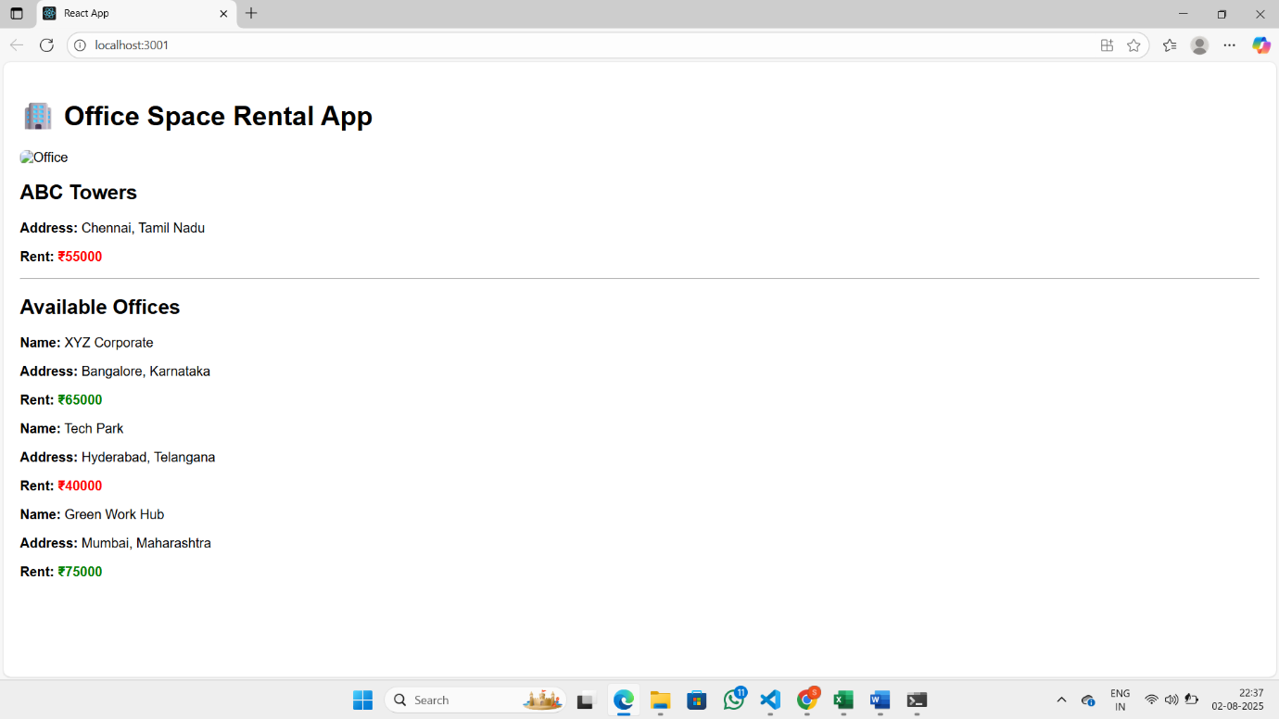

HandsOn 3 :
App.js
import React, { Component } from 'react';
import CurrencyConvertor from './components/CurrencyConvertor';
class App extends Component {
constructor(props) {
super(props);
this.state = {
counter: 0
};
}
// Method to increment counter
increment = () => {
this.setState({ counter: this.state.counter + 1 });
};
// Say hello method
sayHello = () => {
console.log("Hello! React is awesome!");
};
// Combined method
handleIncrease = () => {
this.increment();
this.sayHello();
};
// Decrement method
handleDecrease = () => {
this.setState({ counter: this.state.counter - 1 });
};
// Function with argument
sayWelcome = (message) => {
alert(message);
};
// Synthetic event handler
handleSyntheticEvent = (event) => {
alert("I was clicked!");
console.log(event); // SyntheticEvent object
};
render() {
return (
<div style={{ padding: '20px' }}>
<h1>React Event Examples</h1>
<h2>Counter: {this.state.counter}</h2>
<button onClick={this.handleIncrease}>Increment</button>
<button onClick={this.handleDecrease}>Decrement</button>
<hr />
<button onClick={() => this.sayWelcome("Welcome to React!")}>
Say Welcome
</button>
<hr />
<button onClick={this.handleSyntheticEvent}>OnPress (Synthetic Event)</button>
<hr />
<CurrencyConvertor />
</div>
);
}
}
export default App;
components/CurrencyConverter.js
import React, { Component } from 'react';
class CurrencyConvertor extends Component {
constructor(props) {
super(props);
this.state = {
rupees: '',
euros: ''
};
}
// Handle input change
handleChange = (event) => {
this.setState({ rupees: event.target.value });
};
// Convert Rupees to Euros
handleSubmit = () => {
const euroRate = 0.011; // 1 Rupee ≈ 0.011 Euro
const euros = this.state.rupees * euroRate;
this.setState({ euros: euros.toFixed(2) });
};
render() {
return (
<div>
<h2>Currency Convertor (INR to EUR)</h2>
<input
type="number"
value={this.state.rupees}
onChange={this.handleChange}
placeholder="Enter Rupees"
/>
<button onClick={this.handleSubmit}>Convert</button>
<p><strong>Euros:</strong> {this.state.euros}</p>
</div>
);
}
}
export default CurrencyConvertor;
OUTPUT :
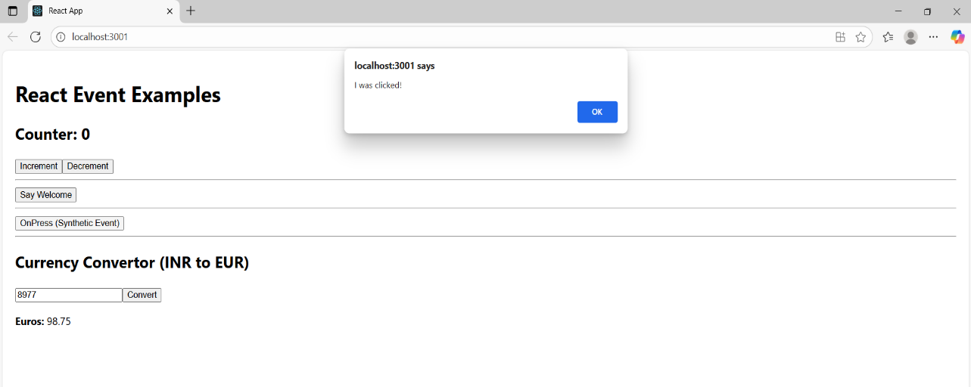
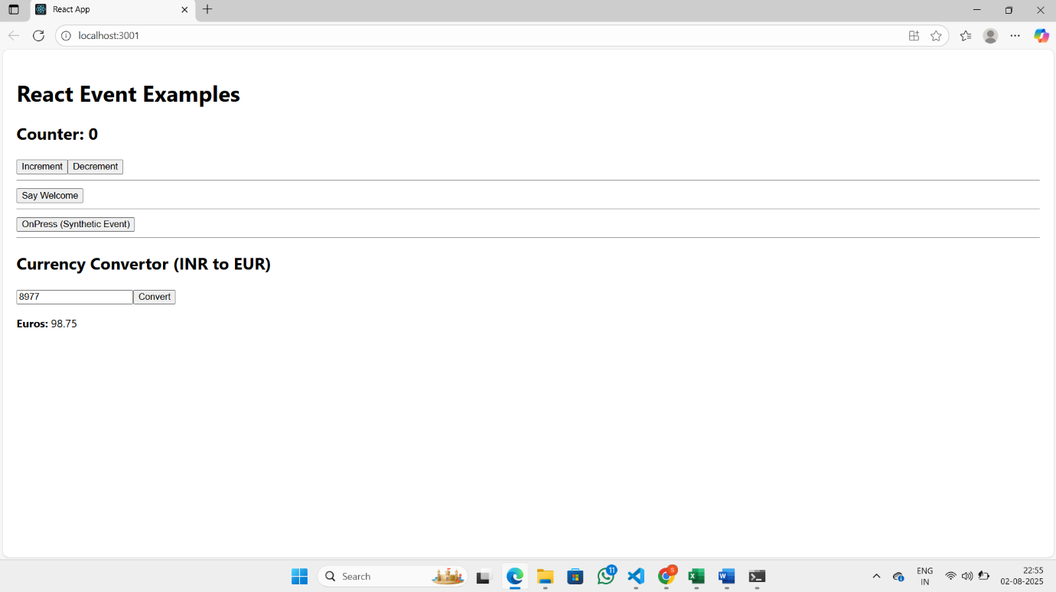
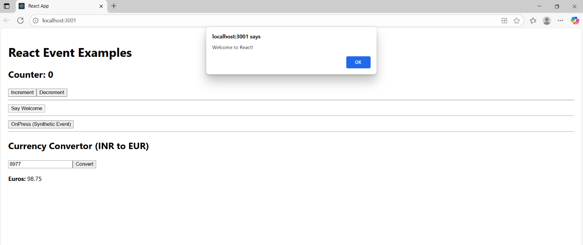
HandsOn4 :
App.js
// src/App.js
import React, { Component } from 'react';
import './App.css';
class App extends Component {
constructor(props) {
super(props);
this.state = {
isLoggedIn: false, // Initial state: user is a guest
};
}
handleLogin = () => {
this.setState({ isLoggedIn: true });
};
handleLogout = () => {
this.setState({ isLoggedIn: false });
};
render() {
// Element variable for rendering pages
let page;
let button;
if (this.state.isLoggedIn) {
page = (
<div>
<h2>Welcome, User!</h2>
<p>You can now book your flight tickets.</p>
<button onClick={this.handleLogout}>Logout</button>
</div>
);
} else {
page = (
<div>
<h2>Welcome, Guest!</h2>
<p>You can browse flights, but login to book tickets.</p>
<button onClick={this.handleLogin}>Login</button>
</div>
);
}
return (
<div className="App" style={{ padding: '20px', fontFamily: 'Arial' }}>
<h1>✈️ Ticket Booking App</h1>
{page}
<hr />
<FlightDetails />
</div>
);
}
}
const FlightDetails = () => {
// Static flight data for display
const flights = [
{ id: 1, airline: 'IndiGo', from: 'Chennai', to: 'Delhi' },
{ id: 2, airline: 'Air India', from: 'Mumbai', to: 'Bangalore' },
{ id: 3, airline: 'SpiceJet', from: 'Kolkata', to: 'Hyderabad' },
];
return (
<div>
<h2>Available Flights</h2>
<ul>
{flights.map((flight) => (
<li key={flight.id}>
{flight.airline}: {flight.from} ➡ {flight.to}
</li>
))}
</ul>
</div>
);
};
export default App;
OUTPUT :
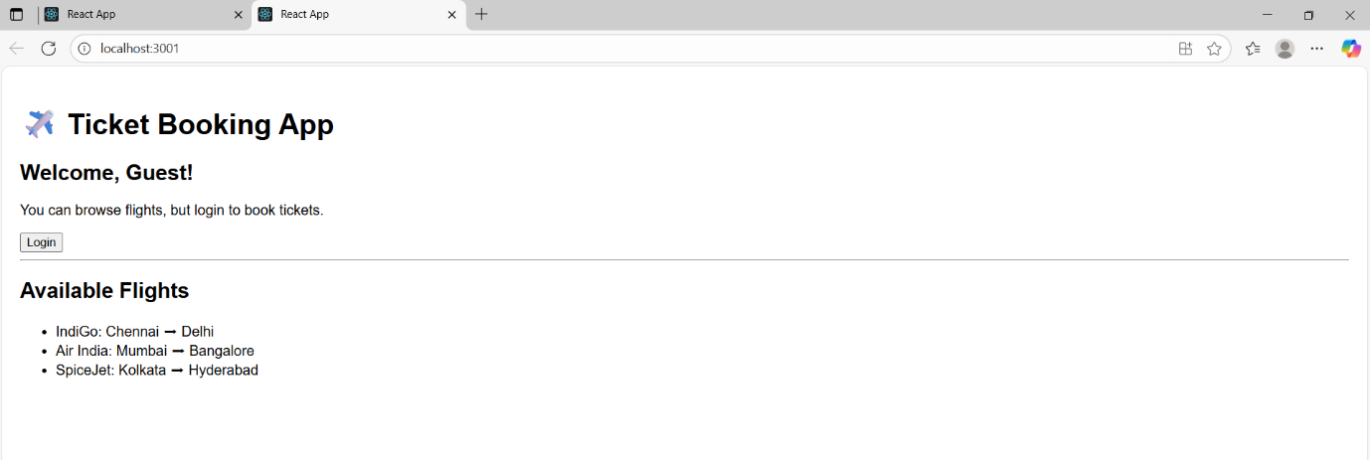
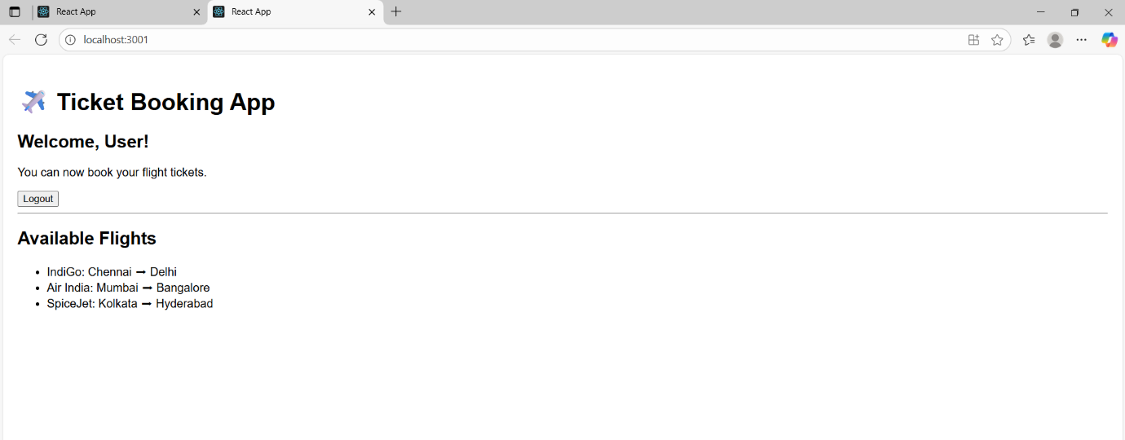

HandsOn 5 :
BlogDetails.js
import React from 'react';
const BlogDetails = ({ blogs }) => {
return (
<div>
<h2>📝 Blog Articles</h2>
{blogs.length > 0 ? (
blogs.map(blog => (
<div key={blog.id}>
<h4>{blog.title}</h4>
<p>{blog.content}</p>
<hr />
</div>
))
) : (
<p>No blogs available</p>
)}
</div>
);
};
export default BlogDetails;
BookDetails.js
import React from 'react';
const BookDetails = ({ books }) => {
return (
<div>
<h2>📚 Book List</h2>
<ul>
{books.map(book => (
<li key={book.id}>
<b>{book.title}</b> by {book.author}
</li>
))}
</ul>
</div>
);
};
export default BookDetails;
CourseDetails.js
import React from 'react';
const CourseDetails = ({ courses }) => {
return (
<div>
<h2>📖 Courses</h2>
{courses.length ? (
<ul>
{courses.map(course => (
<li key={course.id}>{course.name} - {course.duration} weeks</li>
))}
</ul>
) : null}
</div>
);
};
export default CourseDetails;
App.js
import React, { useState } from 'react';
import './App.css';
import BookDetails from './BookDetails';
import BlogDetails from './BlogDetails';
import CourseDetails from './CourseDetails';
function App() {
const [view, setView] = useState("books");
const books = [
{ id: 1, title: "React in Action", author: "Mark T." },
{ id: 2, title: "Learning ES6", author: "Alex R." }
];
const blogs = [
{ id: 1, title: "Why React is Awesome", content: "React lets you build UI declaratively..." },
{ id: 2, title: "Understanding useState", content: "useState lets you add state to components..." }
];
const courses = [
{ id: 1, name: "React Bootcamp", duration: 4 },
{ id: 2, name: "Advanced JavaScript", duration: 6 }
];
// JSX stored in a variable
let content;
if (view === "books") {
content = <BookDetails books={books} />;
} else if (view === "blogs") {
content = <BlogDetails blogs={blogs} />;
} else {
content = <CourseDetails courses={courses} />;
}
return (
<div className="App" style={{ padding: "20px" }}>
<h1>📘 Blogger App</h1>

{/* Conditional Buttons */}
<div>
<button onClick={() => setView("books")}>Show Books</button>
<button onClick={() => setView("blogs")}>Show Blogs</button>
<button onClick={() => setView("courses")}>Show Courses</button>
</div>
<hr />

{/* Rendered using if/else (content variable) */}
{content}
{/* Ternary conditional rendering */}
{view === "books" ? <p>📘 You're viewing books</p> : null}
{/* Logical AND rendering */}
{view === "blogs" && <p>📝 You're viewing blogs</p>}
</div>
);
}
export default App;
OUTPUT :
