***Day-2 React Answers:***

***CW:***

**1.Pass Or Fail:**  
App.js:

import PassMessage from './PassMessage'

import FailMessage from './FailMessage'

function App(props)

{

  const isPass = props.isPass;

  if(isPass)

  {

    return <PassMessage/>

  }

  return<FailMessage/>

};

export default App;

FailMessage.js:

import React from "react"

import App from "./App"

function FailMessage()

{

    return(

        <div>

            <h1 style={

                {

                    textAlign: 'center',

                    color: 'red'

                }

            }>You failed the test! Better Luck Next Time</h1>

        </div>

    )

}

export default FailMessage

PassMessage.js:

import React from "react"

import App from "./App"

function PassMessage()

{

    return(

        <div>

            <h1 style={

                {

                    textAlign: 'center',

                    color: 'green'

                }

            }>Congratulations!!! You passed the test.</h1>

        </div>

    )

}

export default PassMessage

index.js:

import React from 'react';

import ReactDOM from 'react-dom';

import App from './App';

ReactDOM.render(<App isPass={false}/>,

    document.getElementById('root'));

OUTPUT:

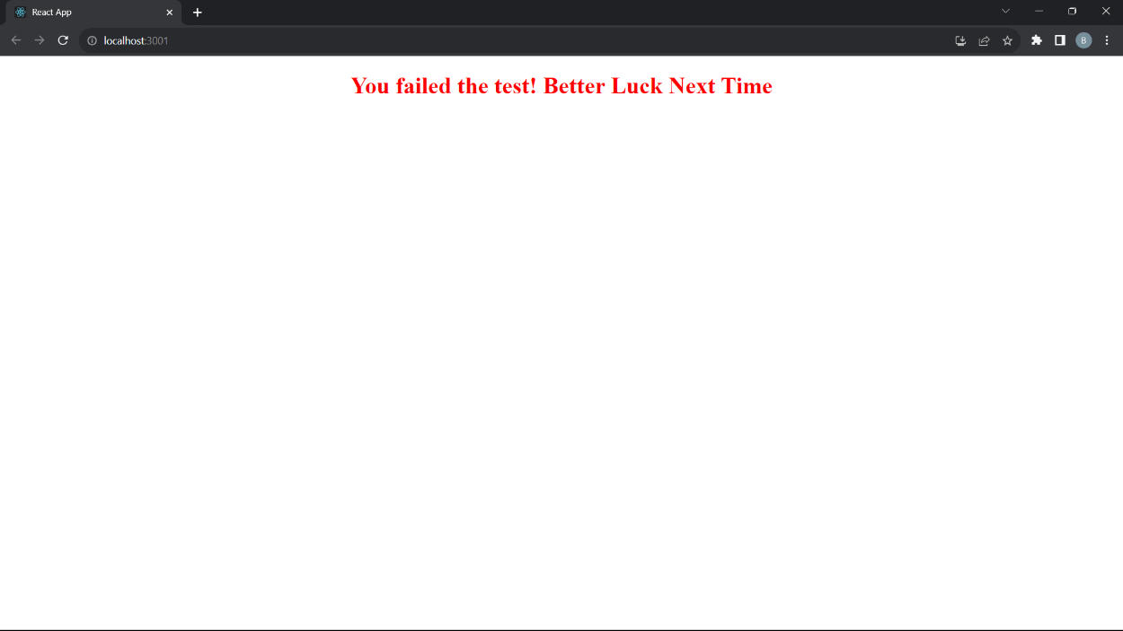

---------------------------------------------------------------------------------  
**2. Forms:**

App.js:

import React from 'react';

import logo from './logo.svg';

import './App.css';

function App() {

  return (

    <div>

      <form>

        <label htmlFor="name"><h4>NAME:</h4></label>

        <input type='text' id='name' placeholder='Enter your name' />

        <label htmlFor="password"><h4>PASSWORD:</h4></label>

        <input type='password' id='password' placeholder='Enter your password' />

        <label htmlFor="age"><h4>AGE:</h4></label>

        <input type='date' id='age' />

        <label><h4>SELECT YOUR GENDER:</h4></label>

        <input type='radio' name='gender' value='Male' /> Male

        <input type='radio' name='gender' value='Female' /> Female

        <br/>

        <button type='submit' id='but'>Submit</button>

      </form>

    </div>

  );

}

export default App;

App.css:

.App {

  text-align: center;

}

.App-logo {

  height: 40vmin;

  pointer-events: none;

}

@media (prefers-reduced-motion: no-preference) {

  .App-logo {

    animation: App-logo-spin infinite 20s linear;

  }

}

.App-header {

  background-color: #282c34;

  min-height: 100vh;

  display: flex;

  flex-direction: column;

  align-items: center;

  justify-content: center;

  font-size: calc(10px + 2vmin);

  color: white;

}

.App-link {

  color: #61dafb;

}

@keyframes App-logo-spin {

  from {

    transform: rotate(0deg);

  }

  to {

    transform: rotate(360deg);

  }

}

/* App.css */

/* Define your styles here */

body {

  margin: 0;

  font-family: -apple-system, BlinkMacSystemFont, 'Segoe UI', 'Roboto', 'Oxygen',

    'Ubuntu', 'Cantarell', 'Fira Sans', 'Droid Sans', 'Helvetica Neue',

    sans-serif;

  -webkit-font-smoothing: antialiased;

  -moz-osx-font-smoothing: grayscale;

  background-color: rgb(171, 255, 3);

  text-align: center; /* Center content horizontally */

  display: flex;

  flex-direction: column;

  justify-content: center;

  height: 100vh; /* Center content vertically */

  color:inherit;

  display: flex;

}

#but {

  background-color: rgb(5, 13, 255);

  color: white;

  padding: 10px 20px;

  border: none;

  cursor:grab;

  margin-top: 10px;

  font-style: normal;

}

.logincontainer {

  background-color: rgb(229, 233, 236);

  width: max-content;

  height: auto;

  display: flex;

  flex-direction: column;

  align-items: center; /* Center horizontally */

  justify-content: center; /* Center vertically */

  color: black;

  margin: 0 auto; /* Horizontally center within its parent container */

}

OUTPUT:

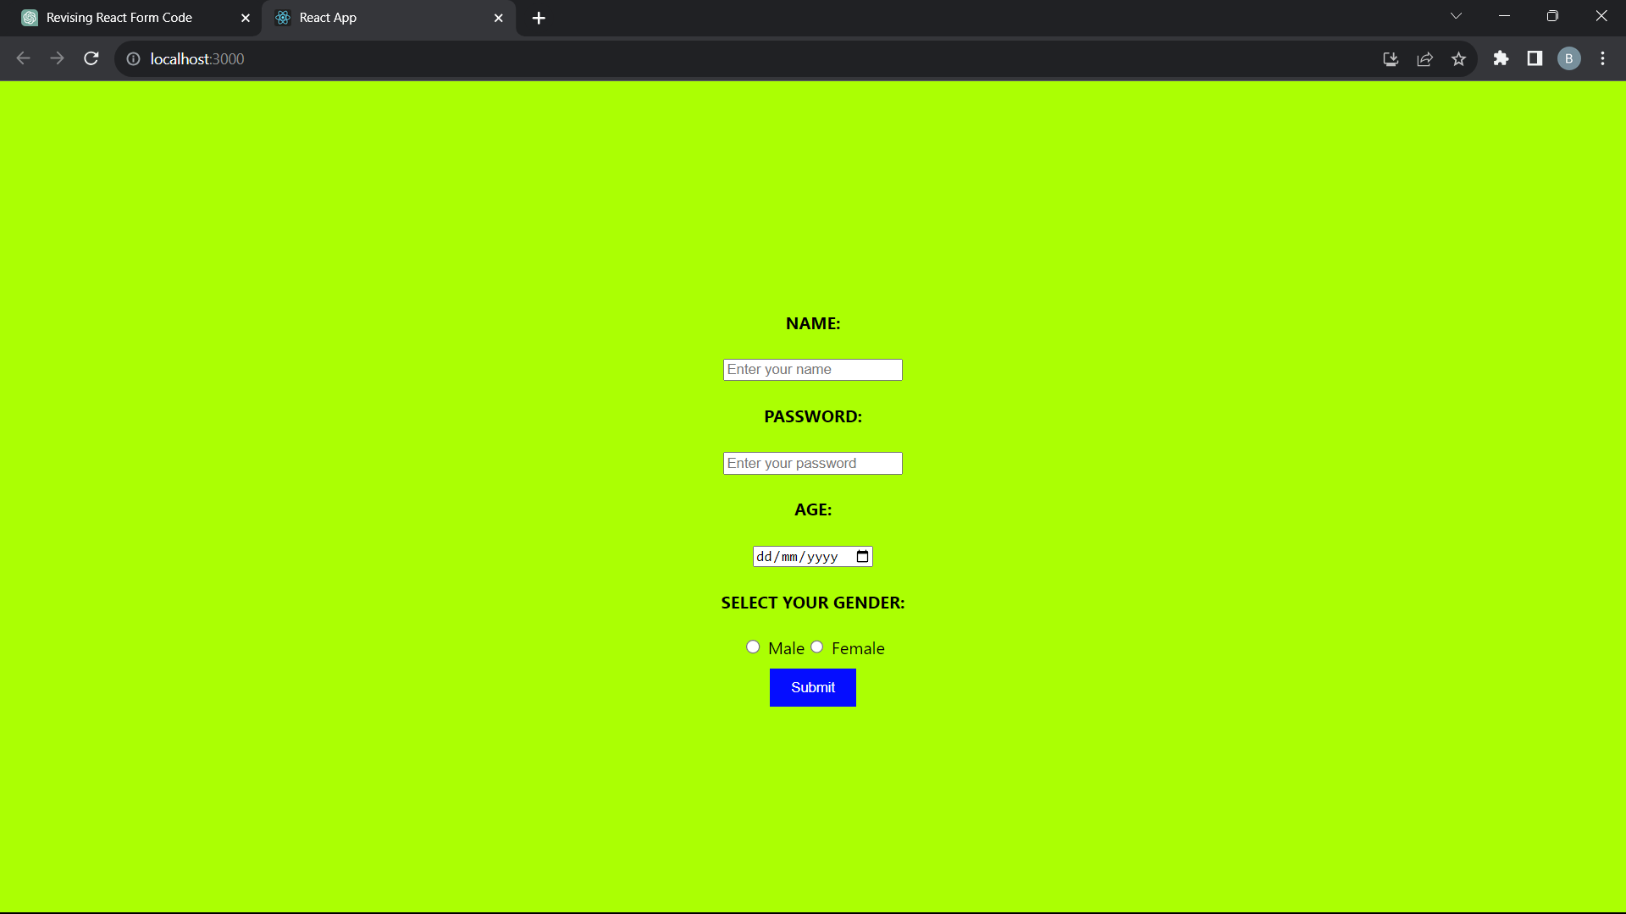

---------------------------------------------------------------------------------

**PRATICE**

**3**.**Hello World:**

App.js:

import React from "react";

import './App'

function App()

{

  return(

    <h1>Hello World</h1>

  )

}

export default App

OUTPUT:



