***Day-3 React Answers:***

**3.Tagging two .js simply using class:**

**Cw:**

App.js:

**import React from 'react';**

**import PassMessage from './PassMessage'**;

import FailMessage from './FailMessage';

class App extends React.Component {

  render (){

    return(

      <div>

        <PassMessage />

        <FailMessage />

      </div>

    )

  }

}

export default App;

PassMessage.js:

import React from "react"

class PassMessage extends React.Component{

    render(){

        return <h1>You have passed the test!!</h1>

    }

}

export default PassMessage

FailMessage.js:

import React from "react"

class FailMessage extends React.Component{

    render(){

        return <h1>You have failed the test!!</h1>

    }

}

export default FailMessage

OUTPUT:

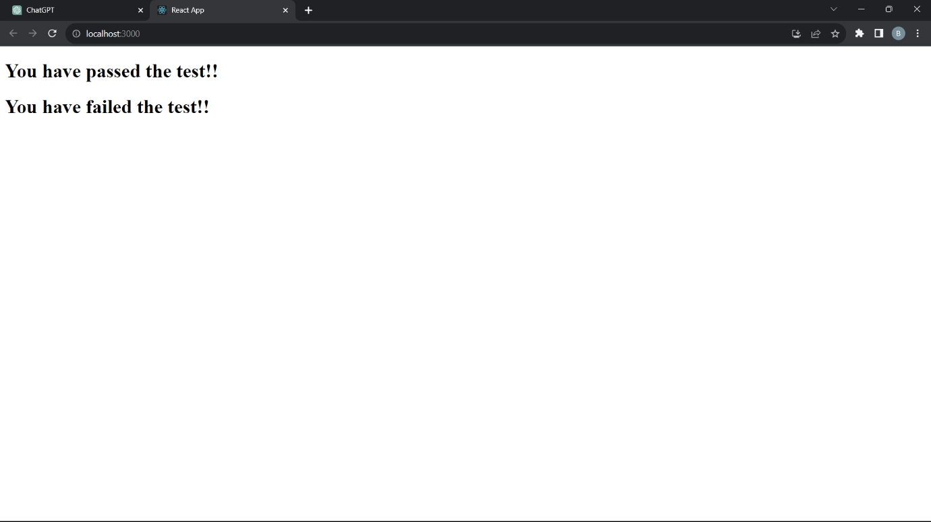

---------------------------------------------------------------------------------

**Forms Project with onClick:**

**POD:**

App.js:

import React from 'react';

import PassMessage from './PassMessage';

import FailMessage from './FailMessage';

class App extends React.Component {

  render (){

    return(

      <div>

        <PassMessage/>

      </div>

    )

  }

}

export default App;

PassMessage.js:

import React from 'react';

import './App.css';

class PassMessage extends React.Component {

  constructor() {

    super();

    this.state = {

      message: (

        <div>

          <form>

            <label htmlFor="name"><h4>NAME:</h4></label>

            <input type='text' id='name' placeholder='Enter your name' />

            <label htmlFor="password"><h4>PASSWORD:</h4></label>

            <input type='password' id='password' placeholder='Enter your password' />

            <label htmlFor="age"><h4>AGE:</h4></label>

            <input type='date' id='age' />

            <label><h4>SELECT YOUR GENDER:</h4></label>

            <input type='radio' name='gender' value='Male' /> Male

            <input type='radio' name='gender' value='Female' /> Female

            <br/>

          </form>

        </div>

      ),

    };

  }

  changeMessage() {

    this.setState({

      message: <img src='https://cdn.pixabay.com/photo/2016/03/31/14/37/check-mark-1292787_1280.png' width={100} height={100}/>,

    });

  }

  render() {

    return (

      <div>

        <div>

          {this.state.message}

        </div>

        <button type='submit' id='but' onClick={() => this.changeMessage()}>Submit</button>

      </div>

    );

  }

}

export default PassMessage;

ap

App.css:

.App {

  text-align: center;

}

.App-logo {

  height: 40vmin;

  pointer-events: none;

}

@media (prefers-reduced-motion: no-preference) {

  .App-logo {

    animation: App-logo-spin infinite 20s linear;

  }

}

.App-header {

  background-color: #282c34;

  min-height: 100vh;

  display: flex;

  flex-direction: column;

  align-items: center;

  justify-content: center;

  font-size: calc(10px + 2vmin);

  color: white;

}

.App-link {

  color: #61dafb;

}

@keyframes App-logo-spin {

  from {

    transform: rotate(0deg);

  }

  to {

    transform: rotate(360deg);

  }

}

/* App.css */

/* Define your styles here */

body {

  margin: 0;

  font-family: -apple-system, BlinkMacSystemFont, 'Segoe UI', 'Roboto', 'Oxygen',

    'Ubuntu', 'Cantarell', 'Fira Sans', 'Droid Sans', 'Helvetica Neue',

    sans-serif;

  -webkit-font-smoothing: antialiased;

  -moz-osx-font-smoothing: grayscale;

  background-color: white;

  text-align: center; /* Center content horizontally */

  display: flex;

  flex-direction: column;

  justify-content: center;

  height: 100vh; /* Center content vertically */

  color:inherit;

  display: flex;

}

#but {

  background-color: rgb(5, 13, 255);

  color: white;

  padding: 10px 20px;

  border: none;

  cursor:grab;

  margin-top: 10px;

  font-style: normal;

}

.logincontainer {

  background-color: rgb(229, 233, 236);

  width: max-content;

  height: auto;

  display: flex;

  flex-direction: column;

  align-items: center; /* Center horizontally */

  justify-content: center; /* Center vertically */

  color: black;

  margin: 0 auto; /* Horizontally center within its parent container */

}

OUTPUT:

