Pubmed Search Results of NONMEM

Sungpil Han

2017-04-27

# Introduction and Methods

The number of publications containing NONMEM was retrieved from the Pubmed search at 2017-04-27 14:30 KST through [Medline (PubMed) trend website](http://dan.corlan.net/medline-trend.html) and the fetched data was processed by R 3.4.0 (R Core Team 2017) and ggplot2 (Wickham and Chang 2016).

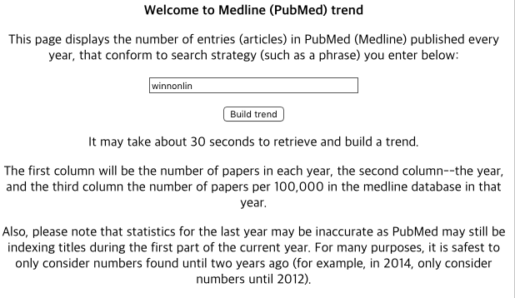

Medline trend

# Results

Results from a PubMed search for the term, NONMEM and WinNonLin were plotted against the year the publication appeared.

library(knitr)  
library(ggplot2)  
library(dplyr)  
library(tibble)  
library(tidyr)

Pubmed <- list()  
  
# Read Medline Trend data  
Pubmed$winnonlin <- readLines("http://dan.corlan.net/cgi-bin/medline-trend?Q=winnonlin")  
Pubmed$nonmem <- readLines("http://dan.corlan.net/cgi-bin/medline-trend?Q=nonmem")  
  
# Data Prep  
PubmedPrep <- function(x) data.frame(raw = Pubmed[[x]]) %>%  
 filter(!grepl("Medline|Number|PRE", raw)) %>%  
 mutate(raw = trimws(raw)) %>%  
 separate(col = "raw", into = c("number", "year", "freq"), sep = "[^[:alnum:]|^.]+") %>%  
 mutate_all(as.numeric) %>%  
 mutate(term = x)  
  
Dataset <- bind_rows(lapply(names(Pubmed), PubmedPrep)) %>%  
 arrange(year) %>%   
 filter(year >= 1980) # First appearance is in 1980.  
  
RawData <- Dataset %>%   
 select(-freq) %>%   
 arrange(year) %>%   
 spread("term", value = "number")

## Bar Plots

ggdata <- Dataset %>%   
 filter(term == "nonmem")  
  
gg1 <- ggplot(data=ggdata, aes(x=year, y=number)) +  
 geom_bar(stat="identity") +   
 guides(fill=FALSE) +  
 xlab("Year") + ylab("Number of Articles") +  
 ggtitle("Number of Articles Using NONMEM")+  
 scale_y_continuous(limits = c(0, 200))  
gg1

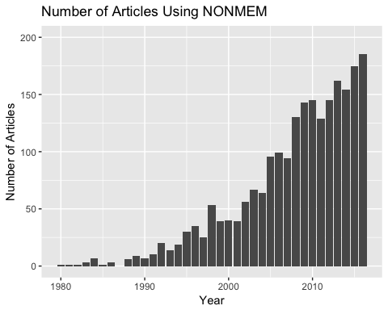

Publications utilizing NONMEM or WinNonLin

ggdata <- Dataset %>%   
 filter(term == "winnonlin")# %>%   
 #filter(number != 0)  
   
gg2 <- ggplot(data=ggdata, aes(x=year, y=number)) +  
 geom_bar(stat="identity") +   
 guides(fill=FALSE) +  
 xlab("Year") + ylab("Number of Articles") +  
 ggtitle("Number of Articles Using WinNonLin")+  
 scale_y_continuous(limits = c(0, 200))  
gg2

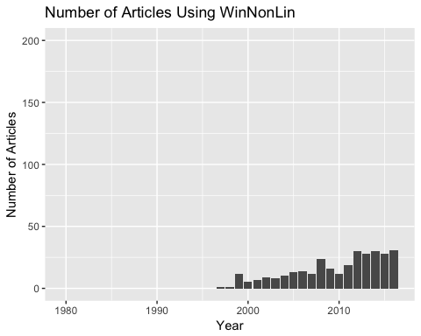

Publications utilizing NONMEM or WinNonLin

ggplot(Dataset, aes(x=year, y=number, fill=term)) +  
 geom_bar(stat="identity", position=position_dodge()) +  
 ggtitle("Number of Articles Using NONMEM or WinNonLin") +  
 xlab("Year") + ylab("Number of Articles") +  
 scale_y_continuous(limits = c(0, 200))

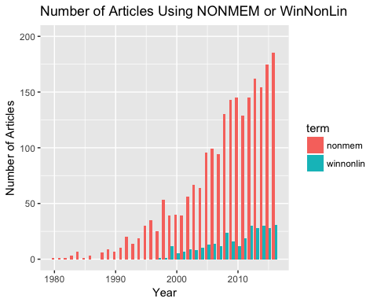

## Line Plots

ggplot(Dataset, aes(x=year, y=number, colour=term, group=term)) +  
 geom_line() +   
 xlab("Year") + ylab("Articles") +  
 ggtitle("Number of Articles Using NONMEM or WinNonLin") +  
 xlab("Year") + ylab("Number of Articles")

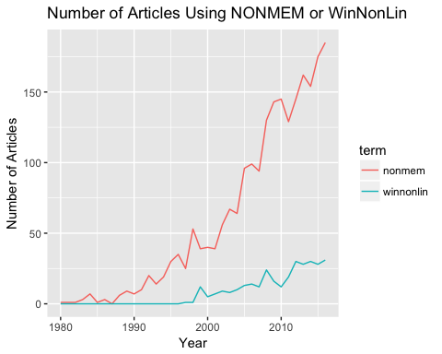

ggplot(Dataset, aes(x=year, y=freq, colour=term, group=term)) +  
 geom_line() +   
 xlab("Year") + ylab("Articles per 100,000 in each year)") +  
 ggtitle("Normalized Number of Articles Using NONMEM or WinNonLin")

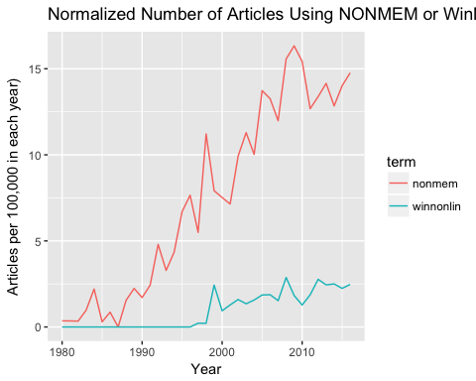

## Raw data

Results from a PubMed search for the term, NONMEM were listed.

knitr::kable(RawData, caption = "Raw data of the number of publications utilizing NONMEM.")

Raw data of the number of publications utilizing NONMEM.

|  |  |  |
| --- | --- | --- |
| year | nonmem | winnonlin |
| 1980 | 1 | 0 |
| 1981 | 1 | 0 |
| 1982 | 1 | 0 |
| 1983 | 3 | 0 |
| 1984 | 7 | 0 |
| 1985 | 1 | 0 |
| 1986 | 3 | 0 |
| 1987 | 0 | 0 |
| 1988 | 6 | 0 |
| 1989 | 9 | 0 |
| 1990 | 7 | 0 |
| 1991 | 10 | 0 |
| 1992 | 20 | 0 |
| 1993 | 14 | 0 |
| 1994 | 19 | 0 |
| 1995 | 30 | 0 |
| 1996 | 35 | 0 |
| 1997 | 25 | 1 |
| 1998 | 53 | 1 |
| 1999 | 39 | 12 |
| 2000 | 40 | 5 |
| 2001 | 39 | 7 |
| 2002 | 56 | 9 |
| 2003 | 67 | 8 |
| 2004 | 64 | 10 |
| 2005 | 96 | 13 |
| 2006 | 99 | 14 |
| 2007 | 94 | 12 |
| 2008 | 130 | 24 |
| 2009 | 143 | 16 |
| 2010 | 145 | 12 |
| 2011 | 129 | 19 |
| 2012 | 145 | 30 |
| 2013 | 162 | 28 |
| 2014 | 154 | 30 |
| 2015 | 175 | 28 |
| 2016 | 185 | 31 |

# Conclusion

The total number of articles using NONMEM is 2207 and the total number of articles using WinNonLin is 310.

The number of publications utilizing NONMEM or WinNonLin tends to increase. The percentage of the number of papers per 100,000 in the medline database in each year also increases but articles using NONMEM seem to increase faster.

# References

R Core Team. 2017. *R: A Language and Environment for Statistical Computing*. Vienna, Austria: R Foundation for Statistical Computing. <https://www.R-project.org/>.

Wickham, Hadley, and Winston Chang. 2016. *Ggplot2: Create Elegant Data Visualisations Using the Grammar of Graphics*. <https://CRAN.R-project.org/package=ggplot2>.