**WEEK - 6**

**ReactJS**

**Additional**

**6.**

**Trainer.js**

class Trainer {

constructor(trainerId, name, email, phone, technology, skills) {

this.trainerId = trainerId;

this.name = name;

this.email = email;

this.phone = phone;

this.technology = technology;

this.skills = skills;

}

}

export default Trainer;

**TrainersMock.js**

import Trainer from "./Trainer";

const trainersMock = [

new Trainer(

"t-syed8",

"Syed Khaleelullah",

"khaleelullah@cognizant.com",

"97676516962",

".NET",

["C#", "SQL Server", "React", ".NET Core"]

),

new Trainer(

"t-jojo",

"Jojo Jose",

"jojo@cognizant.com",

"9897199231",

"Java",

["Java", "JSP", "Angular", "Spring"]

),

new Trainer(

"t-elisa",

"Elisa Jones",

"elisa@cognizant.com",

"9871212235",

"Python",

["Python", "Django", "Angular"]

)

];

export default trainersMock;

**TrainerList.js**

import React from "react";

import { Link } from "react-router-dom";

function TrainersList({ trainers }) {

return (

<div>

<h2>Trainers List</h2>

<ul>

{trainers.map((trainer) => (

<li key={trainer.trainerId}>

<Link to={`/trainers/${trainer.trainerId}`}>{trainer.name}</Link>

</li>

))}

</ul>

</div>

);

}

export default TrainersList;

**TrainerDetails.js**

import React from "react";

import { useParams } from "react-router-dom";

import trainersMock from "./TrainersMock";

function TrainerDetail() {

const { id } = useParams();

const trainer = trainersMock.find((t) => t.trainerId === id);

if (!trainer) return <p>Trainer not found!</p>;

return (

<div>

<h2>Trainers Details</h2>

<p>

<strong>{trainer.name}</strong> ({trainer.technology})

</p>

<p>{trainer.email}</p>

<p>{trainer.phone}</p>

<ul>

{trainer.skills.map((skill, index) => (

<li key={index}>{skill}</li>

))}

</ul>

</div>

);

}

export default TrainerDetail;

**Home.js**

import React from "react";

function Home() {

return (

<div>

<h2>Welcome to My Academy trainers page</h2>

</div>

);

}

export default Home;

**App.js**

import React from "react";

import { BrowserRouter, Routes, Route, Link } from "react-router-dom";

import Home from "./Home";

import TrainersList from "./TrainerList";

import TrainerDetail from "./TrainerDetail";

import trainersMock from "./TrainersMock";

function App() {

return (

<BrowserRouter>

<div>

<h1>My Academy Trainers App</h1>

<nav>

<Link to="/">Home</Link> | <Link to="/trainers">Show Trainers</Link>

</nav>

<Routes>

<Route path="/" element={<Home />} />

<Route

path="/trainers"

element={<TrainersList trainers={trainersMock} />}

/>

<Route path="/trainers/:id" element={<TrainerDetail />} />

</Routes>

</div>

</BrowserRouter>

);

}

export default App;

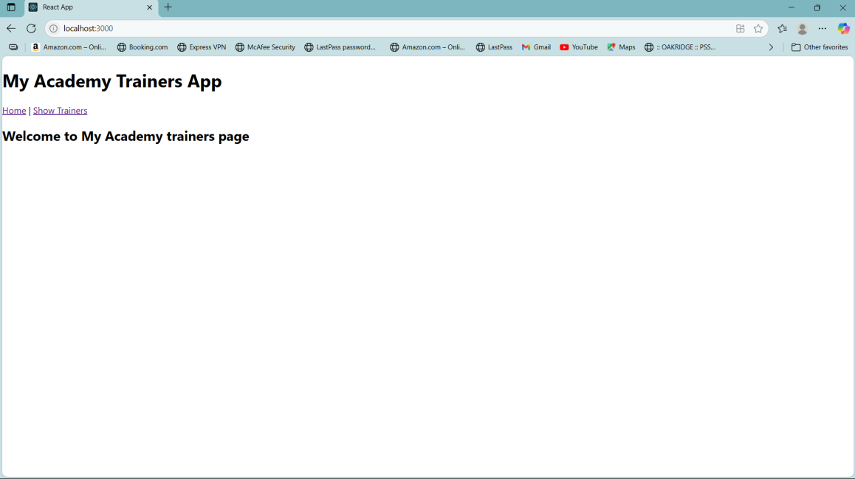

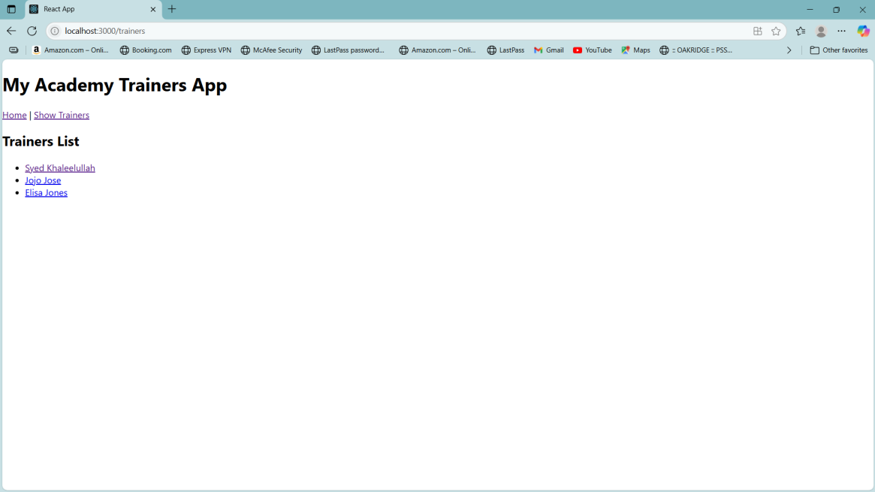

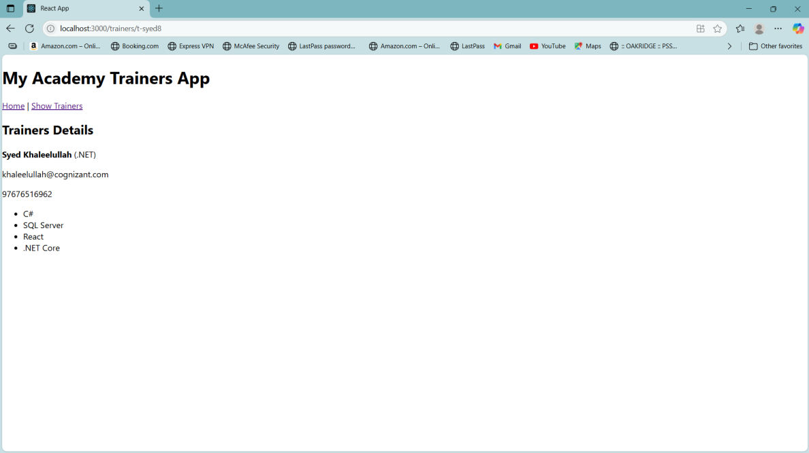

**7.**

**Cart.js**

class Cart {

constructor(itemname, price) {

this.itemname = itemname;

this.price = price;

}

}

export default Cart;

**OnlineShopping.js**

import React, { Component } from 'react';

import Cart from './Cart';

import './App.css';

class OnlineShopping extends Component {

constructor() {

super();

this.cartItems = [

new Cart('Laptop', 80000),

new Cart('TV', 120000),

new Cart('Washing Machine', 50000),

new Cart('Mobile', 30000),

new Cart('Fridge', 70000)

];

}

render() {

return (

<div style={{ textAlign: 'center', marginTop: '30px' }}>

<h1 style={{ color: 'green' }}>Items Ordered :</h1>

<table

style={{

margin: '0 auto',

border: '1px solid grey',

borderCollapse: 'collapse',

fontFamily: 'Arial',

color: 'green'

}}

>

<thead>

<tr>

<th style={{ border: '1px solid grey', padding: '10px' }}>Name</th>

<th style={{ border: '1px solid grey', padding: '10px' }}>Price</th>

</tr>

</thead>

<tbody>

{this.cartItems.map((item, index) => (

<tr key={index}>

<td style={{ border: '1px solid grey', padding: '10px' }}>{item.itemname}</td>

<td style={{ border: '1px solid grey', padding: '10px' }}>{item.price}</td>

</tr>

))}

</tbody>

</table>

</div>

);

}

}

export default OnlineShopping;

**index.js**

import React from 'react';

import ReactDOM from 'react-dom/client';

import './index.css';

import OnlineShopping from './OnlineShopping';

const root = ReactDOM.createRoot(document.getElementById('root'));

root.render(

<React.StrictMode>

<OnlineShopping />

</React.StrictMode>

);

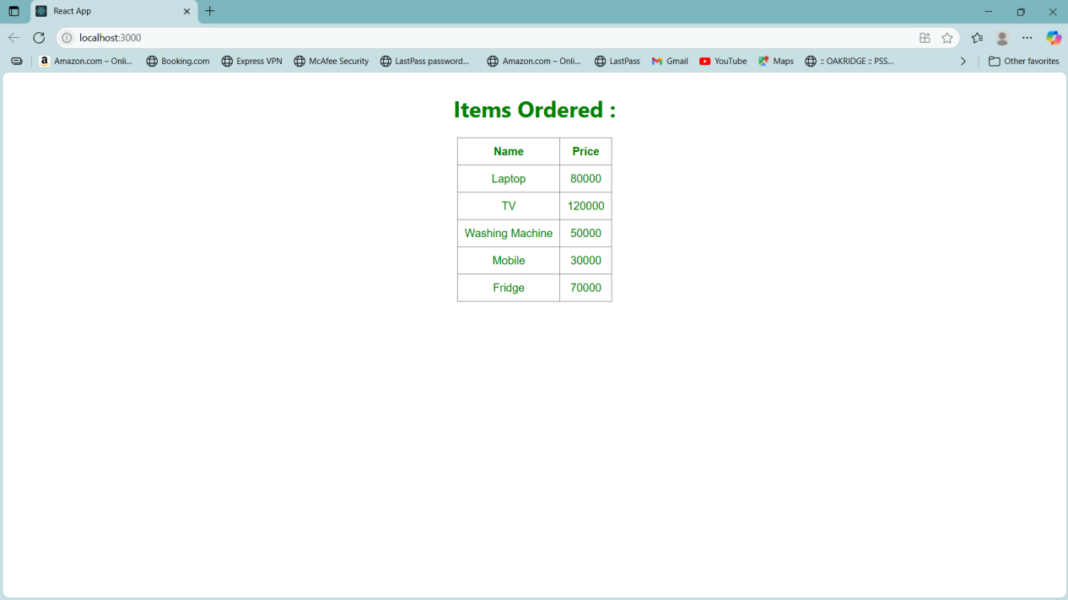

**8.**

**CountPeople.js**

import React, { Component } from 'react';

class CountPeople extends Component {

constructor(props) {

super(props);

this.state = {

entryCount: 0,

exitCount: 0,

};

}

updateEntry = () => {

this.setState(prevState => ({

entryCount: prevState.entryCount + 1

}));

};

updateExit = () => {

this.setState(prevState => ({

exitCount: prevState.exitCount + 1

}));

};

render() {

const buttonStyle = {

backgroundColor: 'green',

color: 'white',

border: '1px solid black',

borderRadius: '5px',

padding: '5px 10px',

marginRight: '10px',

cursor: 'pointer'

};

return (

<div style={{ display: 'flex', justifyContent: 'center', marginTop: '50px' }}>

<div style={{ marginRight: '100px' }}>

<button style={buttonStyle} onClick={this.updateEntry}>Login</button>

<span style={{ fontWeight: 'bold' }}>{this.state.entryCount} People Entered!!!</span>

</div>

<div>

<button style={buttonStyle} onClick={this.updateExit}>Exit</button>

<span style={{ fontWeight: 'bold' }}>{this.state.exitCount} People Left!!!</span>

</div>

</div>

);

}

}

export default CountPeople;

**index.js**

import React from 'react';

import ReactDOM from 'react-dom/client';

import './index.css';

import CountPeople from './CountPeople';

const root = ReactDOM.createRoot(document.getElementById('root'));

root.render(

<React.StrictMode>

<CountPeople />

</React.StrictMode>

);

