**WEEK - 6**

**Microservices with API gateway**

**Mandatory**



**App.js**

import React from 'react';

function App() {

return (

<div>

<h1>Welcome to the first session of React</h1>

</div>

);

}

export default App;

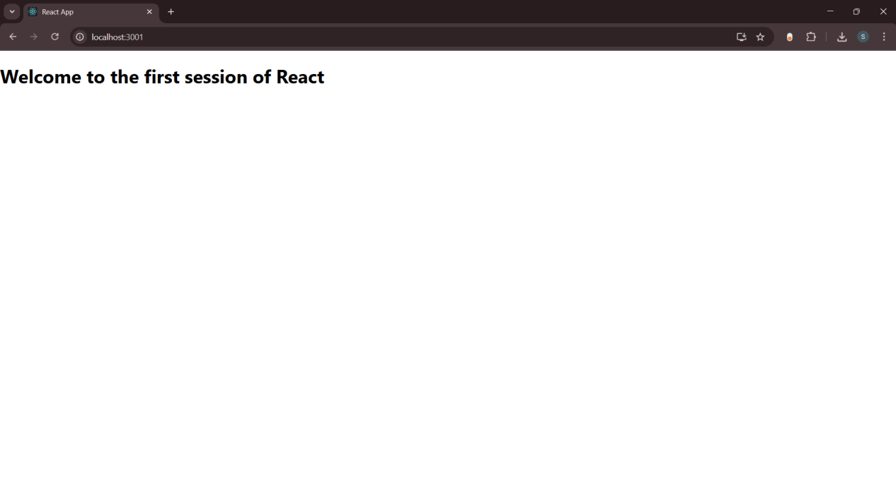



**Home.js**

import React from 'react';

function Home() {

return (

<div>

<h2>Welcome to the Home page of Student Management Portal</h2>

</div>

);

}

export default Home;

**About.js**

import React from 'react';

function About() {

return (

<div>

<h2>Welcome to the About page of the Student Management Portal</h2>

</div>

);

}

export default About;

**Contact.js**

import React from 'react';

function Contact() {

return (

<div>

<h2>Welcome to the Contact page of the Student Management Portal</h2>

</div>

);

}

export default Contact;

**App.js**

import React from 'react';

import Home from './Components/Home';

import About from './Components/About';

import Contact from './Components/Contact';

function App() {

return (

<div>

<Home />

<About />

<Contact />

</div>

);

}

export default App;

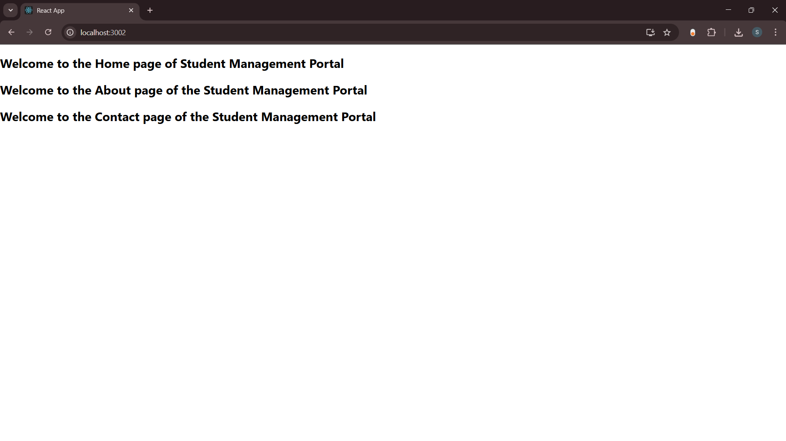



**CalculatorScore.js**

import React from 'react';

import '../Stylesheets/mystyle.css';

function CalculateScore() {

const name = "Alice";

const school = "Green Valley High School";

const total = 450;

const goal = 500;

const average = ((total / goal) * 100).toFixed(2);

return (

<div className="score-container">

<h2>Student Score Calculator</h2>

<p><strong>Name:</strong> {name}</p>

<p><strong>School:</strong> {school}</p>

<p><strong>Total Marks:</strong> {total}</p>

<p><strong>Goal Marks:</strong> {goal}</p>

<p><strong>Average Score:</strong> {average}%</p>

</div>

);

}

export default CalculateScore;

**mystyle.css**

.score-container {

text-align: center;

margin-top: 50px;

font-family: Arial, sans-serif;

background-color: #f0f8ff;

padding: 30px;

border-radius: 10px;

width: 60%;

margin-left: auto;

margin-right: auto;

box-shadow: 0 0 10px rgba(0,0,0,0.2);

}

.score-container h2 {

color: #1e90ff;

}

**App.js**

import React from 'react';

import './App.css';

import CalculateScore from './Components/CalculateScore';

function App() {

return (

<div className="App">

<CalculateScore />

</div>

);

}

export default App;

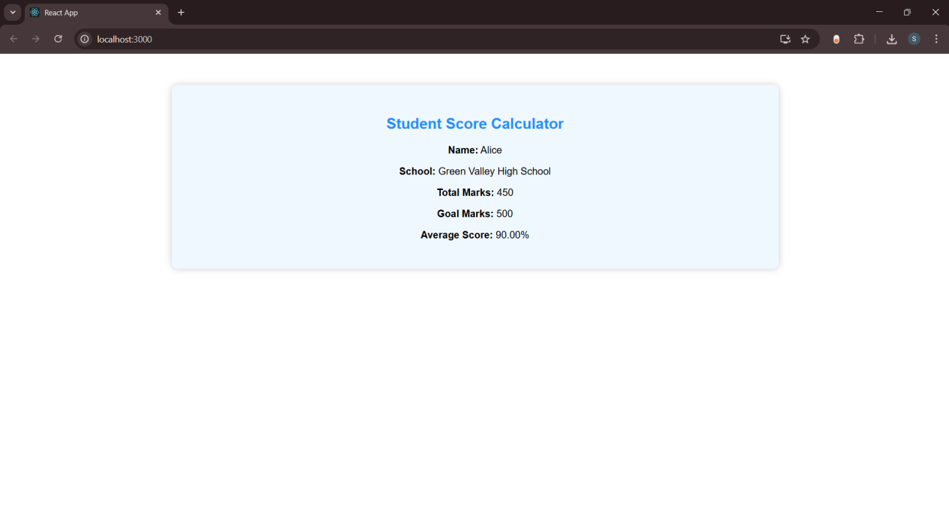



**Post.js**

class Post {

constructor(userId, id, title, body) {

this.userId = userId;

this.id = id;

this.title = title;

this.body = body;

}

}

export default Post;

**Posts.js**

import React, { Component } from 'react';

import Post from './Post';

class Posts extends Component {

constructor(props) {

super(props);

this.state = {

posts: [],

};

}

loadPosts() {

fetch('https://jsonplaceholder.typicode.com/posts')

.then((response) => {

if (!response.ok) throw new Error("Failed to fetch posts.");

return response.json();

})

.then((data) => {

const postList = data.map(

(item) => new Post(item.userId, item.id, item.title, item.body)

);

this.setState({ posts: postList });

})

.catch((error) => {

alert("Error fetching posts: " + error.message);

});

}

componentDidMount() {

this.loadPosts();

}

componentDidCatch(error, info) {

alert("An error occurred: " + error.message);

}

render() {

return (

<div style={{ padding: '20px' }}>

<h2>Blog Posts</h2>

{this.state.posts.map((post) => (

<div key={post.id} style={{ marginBottom: '20px' }}>

<h3>{post.title}</h3>

<p>{post.body}</p>

</div>

))}

</div>

);

}

}

export default Posts;

**App.js**

import React from 'react';

import './App.css';

import Posts from './Posts';

function App() {

return (

<div className="App">

<Posts />

</div>

);

}

export default App;

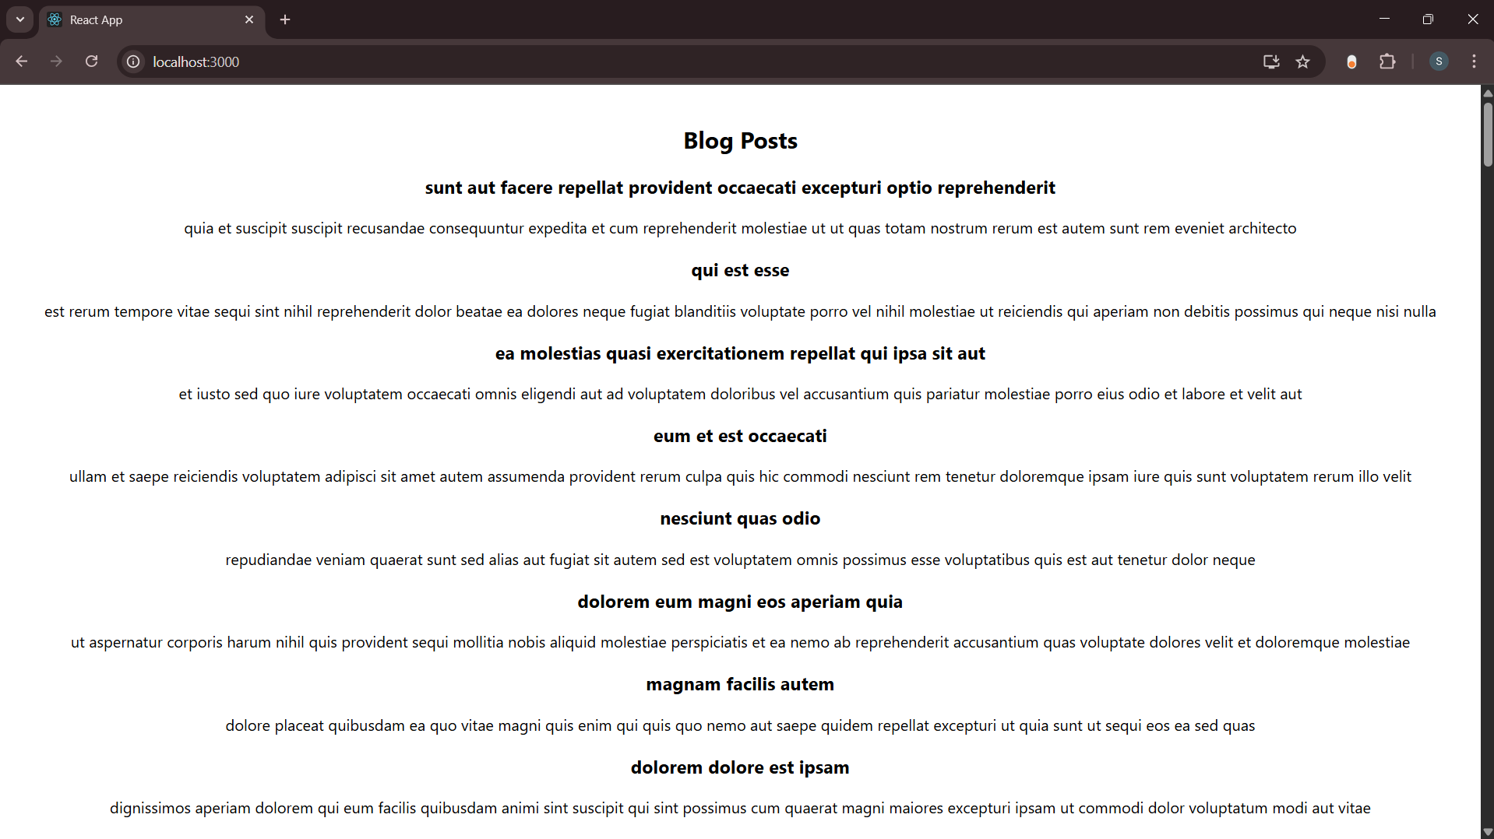



**CohortDetails.js**

import styles from './CohortDetails.module.css';

function CohortDetails(props) {

return (

<div className={styles.box}>

<h3 style={{ color: props.cohort.currentStatus === 'ongoing' ? 'green' : 'blue' }}>

{props.cohort.cohortCode} -

<span>{props.cohort.technology}</span>

</h3>

<dl>

<dt>Started On</dt>

<dd>{props.cohort.startDate}</dd>

<dt>Current Status</dt>

<dd>{props.cohort.currentStatus}</dd>

<dt>Coach</dt>

<dd>{props.cohort.coachName}</dd>

<dt>Trainer</dt>

<dd>{props.cohort.trainerName}</dd>

</dl>

</div>

);

}

export default CohortDetails;

**CohortDetails.module.css**

.box {

width: 300px;

display: inline-block;

margin: 10px;

padding: 10px 20px;

border: 1px solid black;

border-radius: 10px;

}

dt {

font-weight: 500;

}

