**WEEK - 7**

**ReactJS**

**Additional**

**14.**

**App.js**

import logo from './logo.svg';

import './App.css';

import { EmployeesData } from './Employee';

import EmployeesList from './EmployeesList';

import { useState } from 'react';

function App() {

const Employees = EmployeesData;

const [theme, setTheme] = useState('light');

return (

<>

<div>

<label>SELECT A THEME </label>

<select onChange={(e) => setTheme(e.target.value)}>

<option value='light'>Light</option>

<option value='dark'>Dark</option>

</select>

</div>

<EmployeesList theme={theme} employees={Employees} />

</>

);

}

export default App;

**EmployeesList.js**

import EmployeeCard from './EmployeeCard';

function EmployeesList(props) {

return (

<div>

<h1>Employees List</h1>

{

props.employees.map(employee =>

<EmployeeCard theme={props.theme} employee={employee} key={employee.id} />

)}

</div>

);

}

export default EmployeesList;

**EmployeeCard.js**

import Styles from './EmployeeCard.module.css';

function EmployeeCard(props) {

return (

<div className={Styles.Card}>

<h3>{props.employee.name}</h3>

<p>{props.employee.email}</p>

<p>{props.employee.phone}</p>

<p>

<a href="#" className={props.theme}>Edit</a>

<a href="#" className={props.theme}>Delete</a>

</p>

</div>

);

}

export default EmployeeCard;

**ThemeContext.js**

import React from 'react';

const ThemeContext = React.createContext('light');

export default ThemeContext;

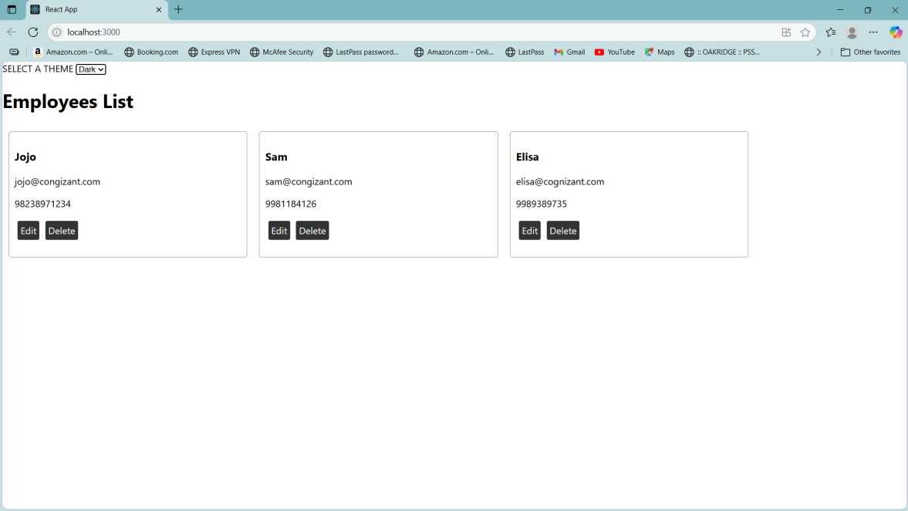

**15.**

**App.js**

import './App.css';

import ComplaintRegister from './ComplaintRegister';

function App() {

return (

<div className="App">

<ComplaintRegister />

</div>

);

}

export default App;

**ComplaintRegister.js**

import { useState } from 'react';

function ComplaintRegister() {

const [name, setName] = useState('');

const [complaint, setComplaint] = useState('');

const handleSubmit = (e) => {

e.preventDefault();

const referenceNumber = Math.floor(Math.random() * 100) + 1;

alert(`Thanks ${name}\nYour Complaint was Submitted.\nTransaction ID is: ${referenceNumber}`);

};

return (

<div>

<h1 style={{ color: 'red' }}>Register your complaints here!!!</h1>

<form onSubmit={handleSubmit}>

<table align="center">

<tbody>

<tr>

<td>Name:</td>

<td>

<input

type="text"

value={name}

onChange={(e) => setName(e.target.value)}

required

/>

</td>

</tr>

<tr>

<td>Complaint:</td>

<td>

<textarea

value={complaint}

onChange={(e) => setComplaint(e.target.value)}

required

/>

</td>

</tr>

<tr>

<td colSpan="2" align="center">

<button type="submit">Submit</button>

</td>

</tr>

</tbody>

</table>

</form>

</div>

);

}

export default ComplaintRegister;

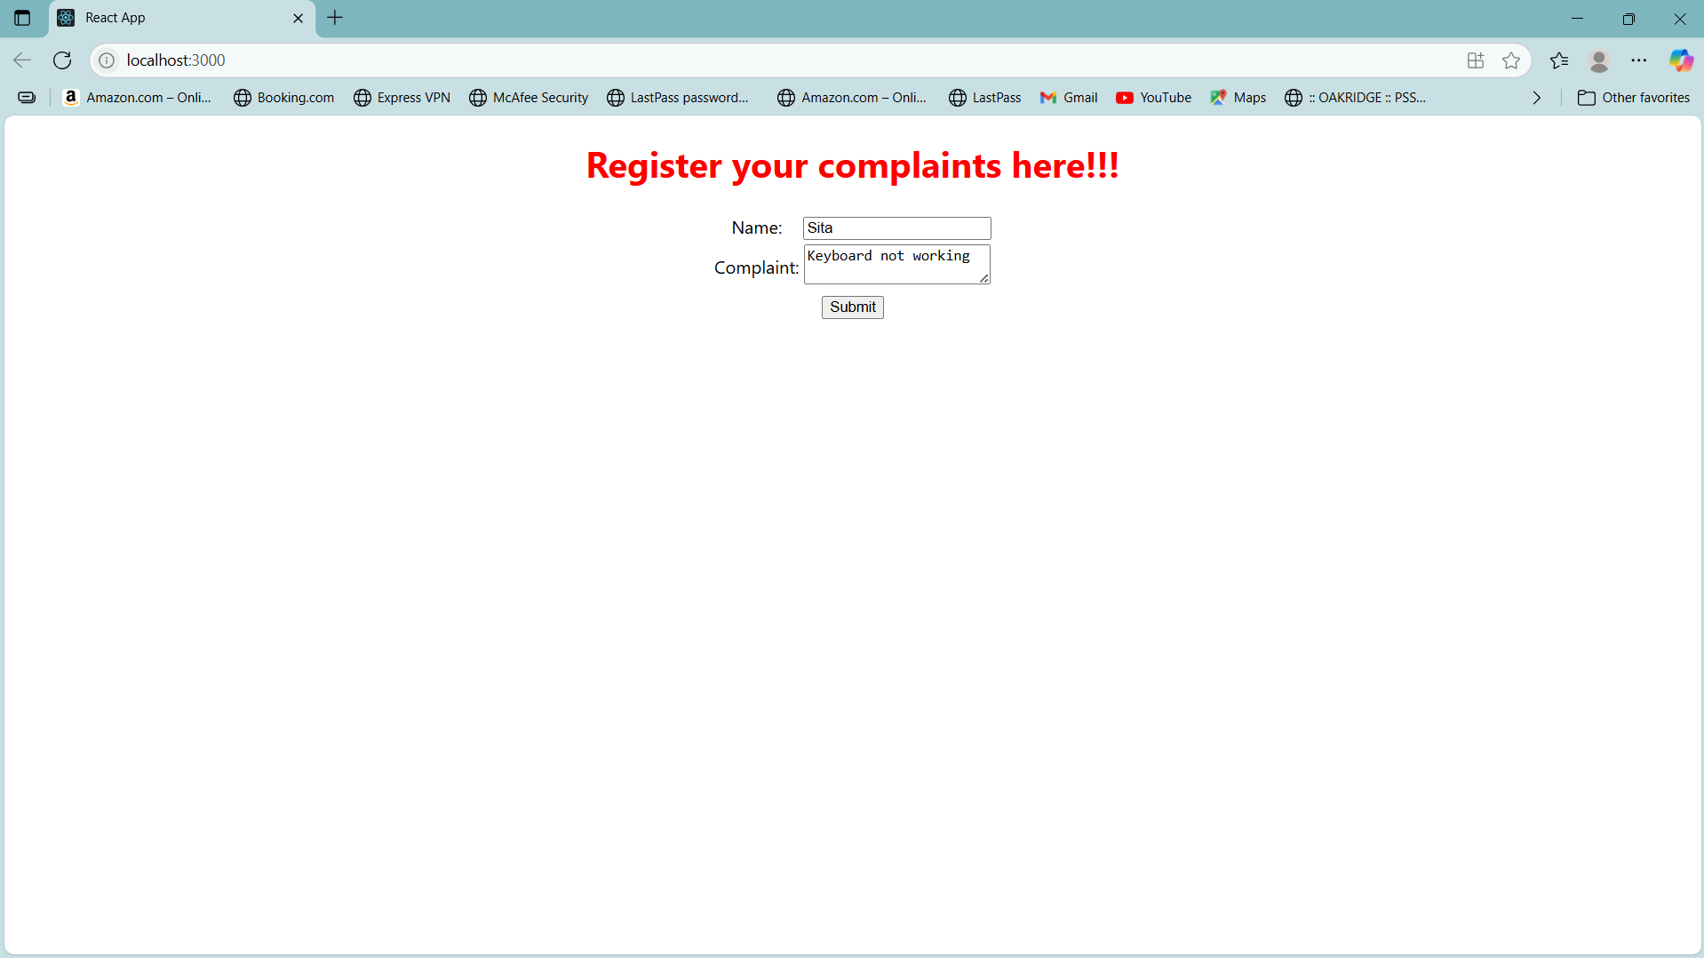

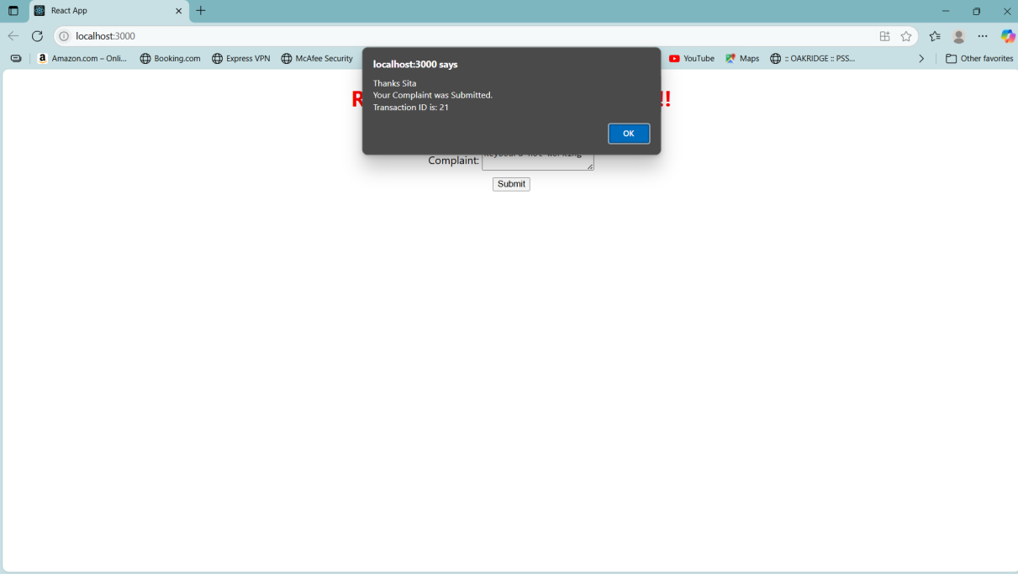

**16.**

**register.js**

import React, { useState } from "react";

function Register() {

const [name, setName] = useState("");

const [email, setEmail] = useState("");

const [password, setPassword] = useState("");

const handleSubmit = (event) => {

event.preventDefault();

if (name.length < 5) {

alert("Full Name must be 5 characters long!");

return;

}

if (!email.includes("@") || !email.includes(".")) {

alert("Email is not valid!");

return;

}

if (password.length < 8) {

alert("Password must be 8 characters long!");

return;

}

alert("Registration Successful!");

};

return (

<div style={{ textAlign: "center", marginTop: "50px" }}>

<h1 style={{ color: "red" }}>Register Here!!!</h1>

<form onSubmit={handleSubmit}>

<div>

<label>Name: </label>

<input

type="text"

value={name}

onChange={(e) => setName(e.target.value)}

/>

</div>

<br />

<div>

<label>Email: </label>

<input

type="text"

value={email}

onChange={(e) => setEmail(e.target.value)}

/>

</div>

<br />

<div>

<label>Password: </label>

<input

type="password"

value={password}

onChange={(e) => setPassword(e.target.value)}

/>

</div>

<br />

<button type="submit">Submit</button>

</form>

</div>

);

}

export default Register;

**App.js**

import React from "react";

import Register from "./register";

function App() {

return (

<div>

<Register />

</div>

);

}

export default App;

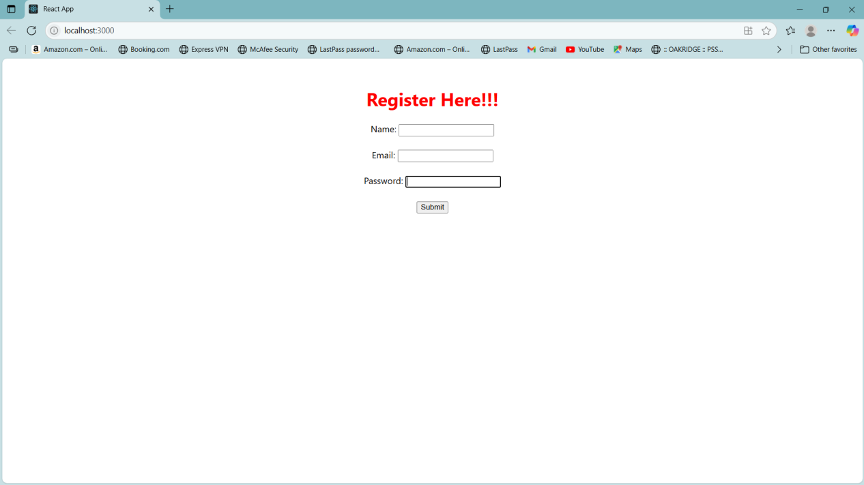

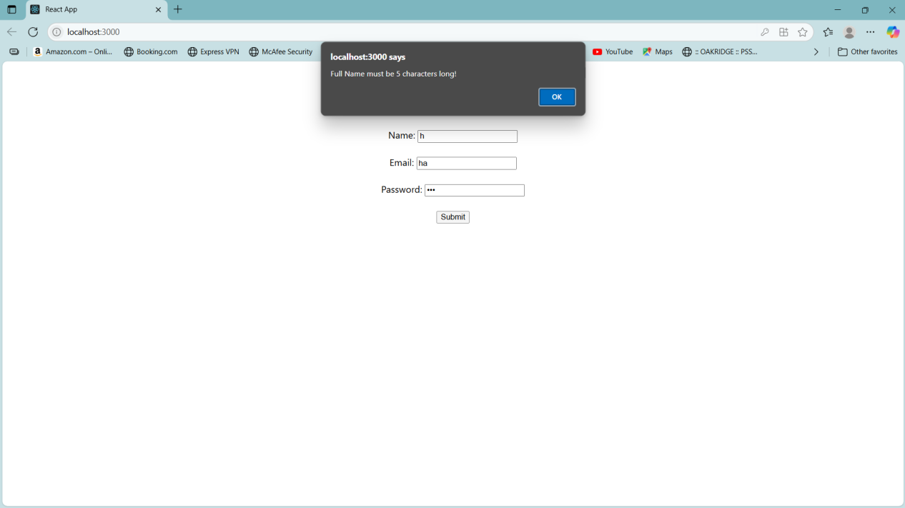

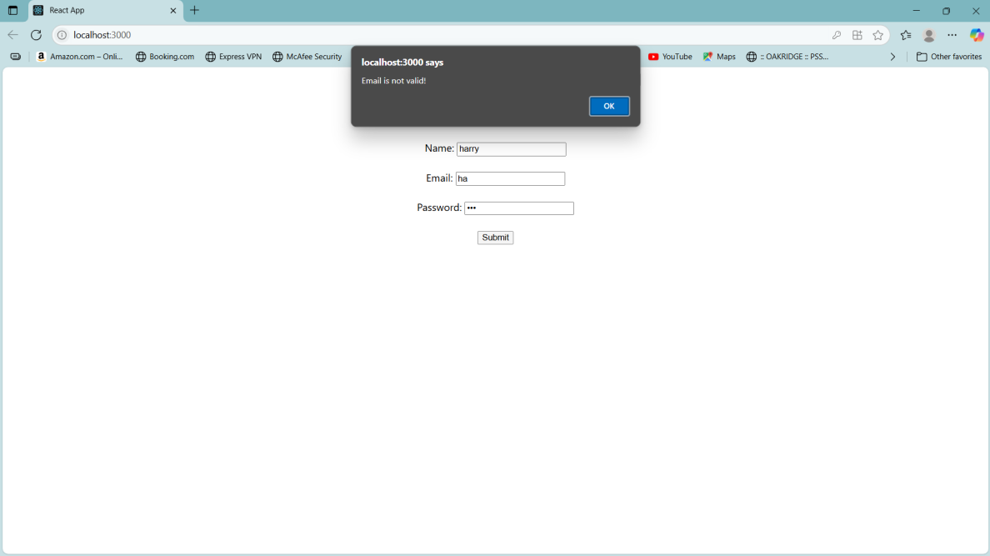

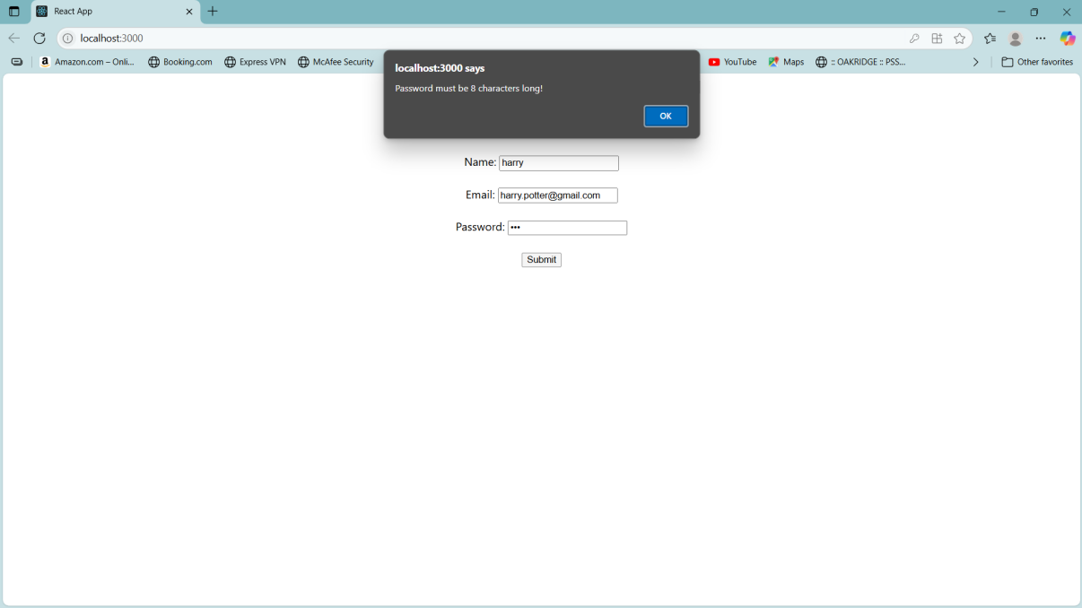

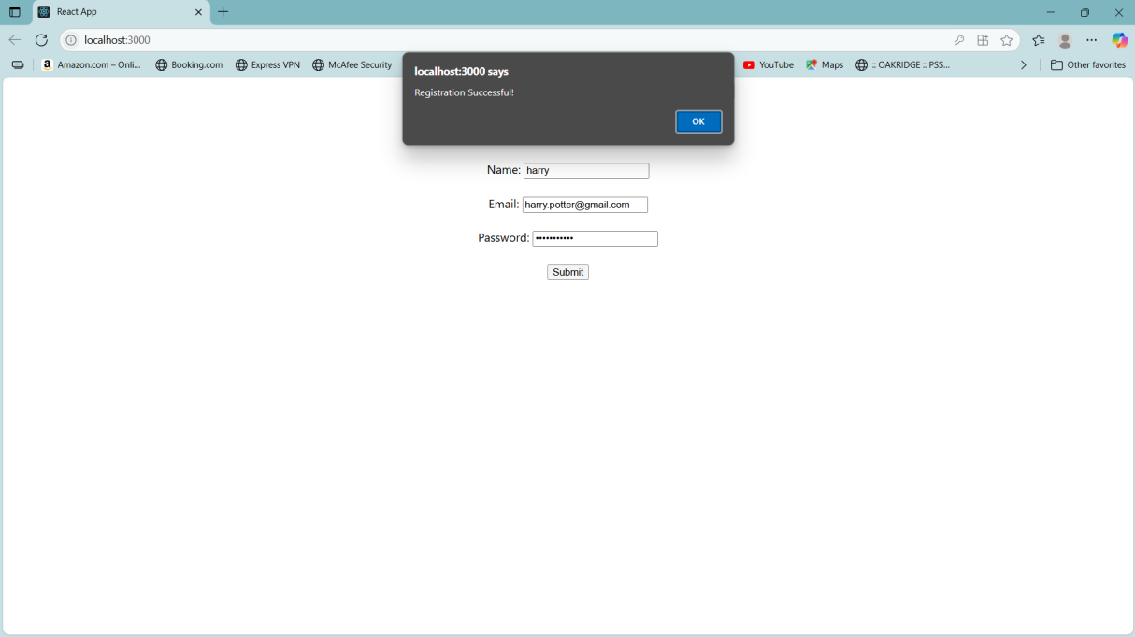

**17.**

**GetUsers.js**

import React, { Component } from "react";

class Getuser extends Component {

constructor(props) {

super(props);

this.state = {

title: "",

firstName: "",

image: ""

};

}

async componentDidMount() {

try {

const response = await fetch("https://api.randomuser.me/");

const data = await response.json();

const user = data.results[0];

this.setState({

title: user.name.title,

firstName: user.name.first + " " + user.name.last,

image: user.picture.medium

});

} catch (error) {

console.error("Error fetching data:", error);

}

}

render() {

return (

<div style={{ textAlign: "center", marginTop: "50px" }}>

<h2>

{this.state.title} {this.state.firstName}

</h2>

<img src={this.state.image} alt="User" />

</div>

);

}

}

export default Getuser;

**App.js**

import React from "react";

import Getuser from "./Getuser";

function App() {

return (

<div>

<Getuser />

</div>

);

}

export default App;

