**WEEK - 7**

**ReactJS**

**Mandatory**



**ListofPlayers.js**

import React from 'react';

const ListofPlayers = () => {

const players = [

{ name: 'Virat Kohli', score: 95 },

{ name: 'Rohit Sharma', score: 85 },

{ name: 'KL Rahul', score: 45 },

{ name: 'Shubman Gill', score: 67 },

{ name: 'Hardik Pandya', score: 88 },

{ name: 'Ravindra Jadeja', score: 72 },

{ name: 'Jasprit Bumrah', score: 50 },

{ name: 'Mohammed Shami', score: 78 },

{ name: 'Kuldeep Yadav', score: 69 },

{ name: 'Rishabh Pant', score: 91 },

{ name: 'Surya Kumar Yadav', score: 39 }

];

const lowScoringPlayers = players.filter(player => player.score < 70);

return (

<div>

<h2>All Players</h2>

<ul>

{players.map((player, index) => (

<li key={index}>{player.name} - {player.score}</li>

))}

</ul>

<h3>Players with score below 70</h3>

<ul>

{lowScoringPlayers.map((player, index) => (

<li key={index}>{player.name} - {player.score}</li>

))}

</ul>

</div>

);

};

export default ListofPlayers;

**IndianPlayers.js**

import React from 'react';

const IndianPlayers = () => {

const allPlayers = ['Virat', 'Rohit', 'KL', 'Gill', 'Hardik', 'Pant', 'Bumrah', 'Shami'];

const oddPlayers = allPlayers.filter((_, index) => index % 2 === 0);

const evenPlayers = allPlayers.filter((_, index) => index % 2 !== 0);

const T20players = ['Virat', 'Rohit', 'Pant'];

const RanjiPlayers = ['Pujara', 'Rahane', 'Jadeja'];

const allMergedPlayers = [...T20players, ...RanjiPlayers];

return (

<div>

<h2>Odd Team Players</h2>

<ul>

{oddPlayers.map((player, index) => (

<li key={index}>{player}</li>

))}

</ul>

<h2>Even Team Players</h2>

<ul>

{evenPlayers.map((player, index) => (

<li key={index}>{player}</li>

))}

</ul>

<h2>Merged T20 & Ranji Trophy Players</h2>

<ul>

{allMergedPlayers.map((player, index) => (

<li key={index}>{player}</li>

))}

</ul>

</div>

);

};

export default IndianPlayers;

**App.js**

// src/App.js

import React from 'react';

import ListofPlayers from './components/ListofPlayers';

import IndianPlayers from './components/IndianPlayers';

function App() {

const flag = true; // Change to false to see IndianPlayers

return (

<div className="App">

<h1>🏏 Cricket App</h1>

{flag ? <ListofPlayers /> : <IndianPlayers />}

</div>

);

}

export default App;

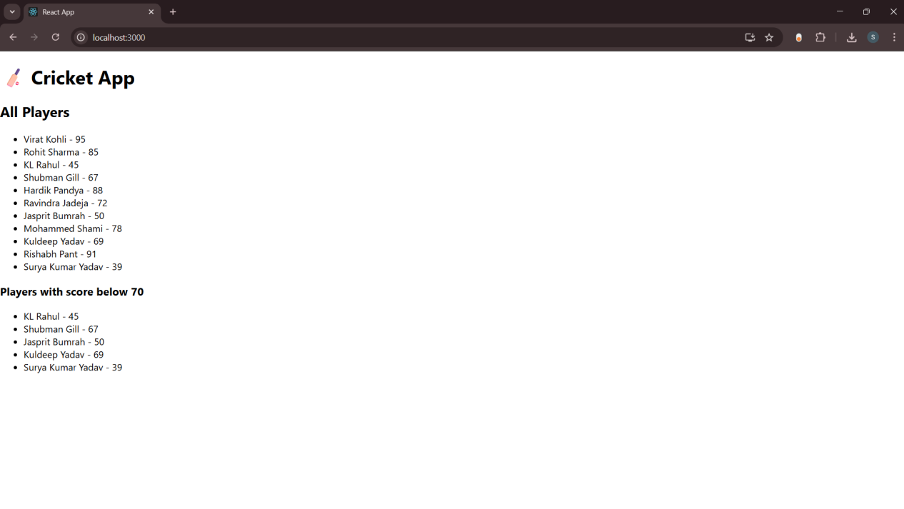



**App.css**

.App {

text-align: center;

padding: 2rem;

font-family: Arial, sans-serif;

}

.office-card {

border: 1px solid #ddd;

border-radius: 10px;

margin: 20px auto;

padding: 20px;

width: 350px;

box-shadow: 0 0 10px rgba(0,0,0,0.1);

}

.office-card img {

width: 100%;

border-radius: 8px;

margin-bottom: 10px;

}

**App.js**

import React from 'react';

import './App.css';

const officeSpaces = [

{

id: 1,

name: "Prestige Tech Park",

rent: 75000,

address: "Whitefield, Bangalore",

image: "https://encrypted-tbn0.gstatic.com/images?q=tbn:ANd9GcQK7OUxYrkZEKM5_WACQBJx1y_uatPgEQJE8A&s"

},

{

id: 2,

name: "WeWork Tower",

rent: 58000,

address: "Koramangala, Bangalore",

image: "https://resources.owllabs.com/hs-fs/hubfs/annie-spratt-FSFfEQkd1sc-unsplash-jpg.jpeg?width=880&name=annie-spratt-FSFfEQkd1sc-unsplash-jpg.jpeg"

},

{

id: 3,

name: "Mindspace",

rent: 95000,

address: "HiTech City, Hyderabad",

image: "https://www.shutterstock.com/shutterstock/videos/3409275957/thumb/1.jpg?ip=x480"

}

];

function App() {

return (

<div className="App">

<h1>🏢 Office Space Rental App</h1>

{officeSpaces.map((office) => (

<div key={office.id} className="office-card">

<img src={office.image} alt={office.name} />

<h2>{office.name}</h2>

<p>Address: {office.address}</p>

<p

style={{

color: office.rent < 60000 ? 'red' : 'green',

fontWeight: 'bold'

}}

>

Rent: ₹{office.rent}

</p>

</div>

))}

</div>

);

}

export default App;

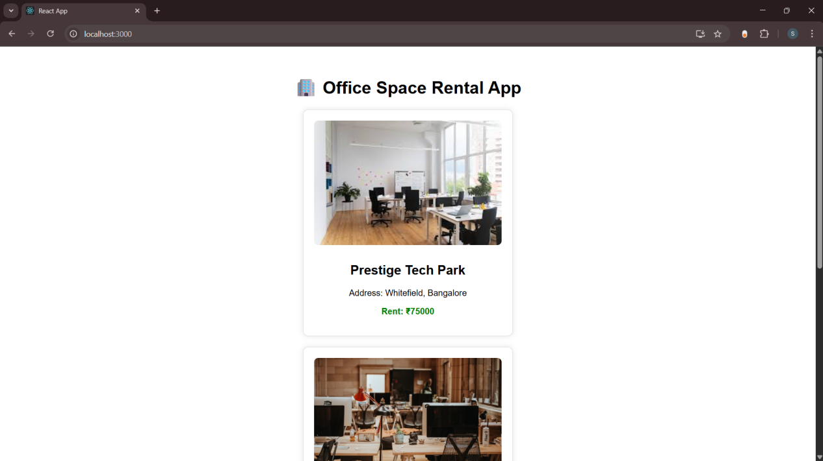

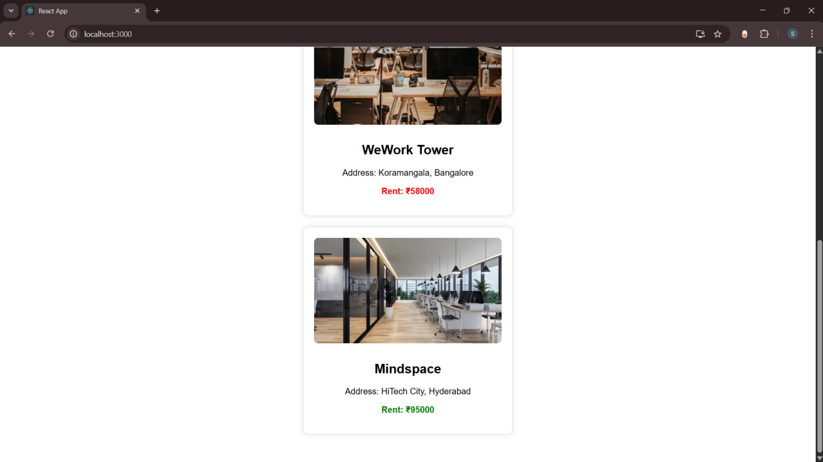



**App.css**

.App {

text-align: center;

padding: 2rem;

}

button {

margin: 10px;

padding: 8px 15px;

font-size: 16px;

}

input {

padding: 8px;

font-size: 16px;

margin-right: 10px;

}

**App.js**

import React, { useState } from 'react';

import './App.css';

import CurrencyConverter from './CurrencyConverter';

function App() {

const [counter, setCounter] = useState(0);

const incrementValue = () => {

setCounter(counter + 1);

};

const sayHello = () => {

console.log("Hello! This is a static message.");

};

const handleIncrementClick = () => {

incrementValue();

sayHello();

};

const decrementValue = () => {

setCounter(counter - 1);

};

const sayWelcome = (message) => {

alert(message);

};

const handleSyntheticEvent = (event) => {

alert("I was clicked");

console.log("Synthetic event object:", event);

};

return (

<div className="App">

<h1>🧪 Event Examples App</h1>

<h2>Counter: {counter}</h2>

<button onClick={handleIncrementClick}>Increment</button>

<button onClick={decrementValue}>Decrement</button>

<hr />

<button onClick={() => sayWelcome("Welcome to Event Examples!")}>

Say Welcome

</button>

<hr />

<button onClick={handleSyntheticEvent}>Click Me (Synthetic Event)</button>

<hr />

<CurrencyConverter />

</div>

);

}

export default App;

**CurrencyConverter.js**

import React, { useState } from 'react';

function CurrencyConverter() {

const [rupees, setRupees] = useState('');

const [euro, setEuro] = useState('');

const handleSubmit = () => {

if (!isNaN(rupees) && rupees !== '') {

const conversionRate = 0.011; // Approximate rate (1 INR = 0.011 EUR)

setEuro((rupees * conversionRate).toFixed(2));

} else {

alert("Please enter a valid number!");

}

};

return (

<div>

<h2>💱 Currency Converter (INR ➡ EUR)</h2>

<input

type="text"

placeholder="Enter amount in INR"

value={rupees}

onChange={(e) => setRupees(e.target.value)}

/>

<button onClick={handleSubmit}>Convert</button>

{euro && (

<p>

<strong>Converted:</strong> €{euro}

</p>

)}

</div>

);

}

export default CurrencyConverter;

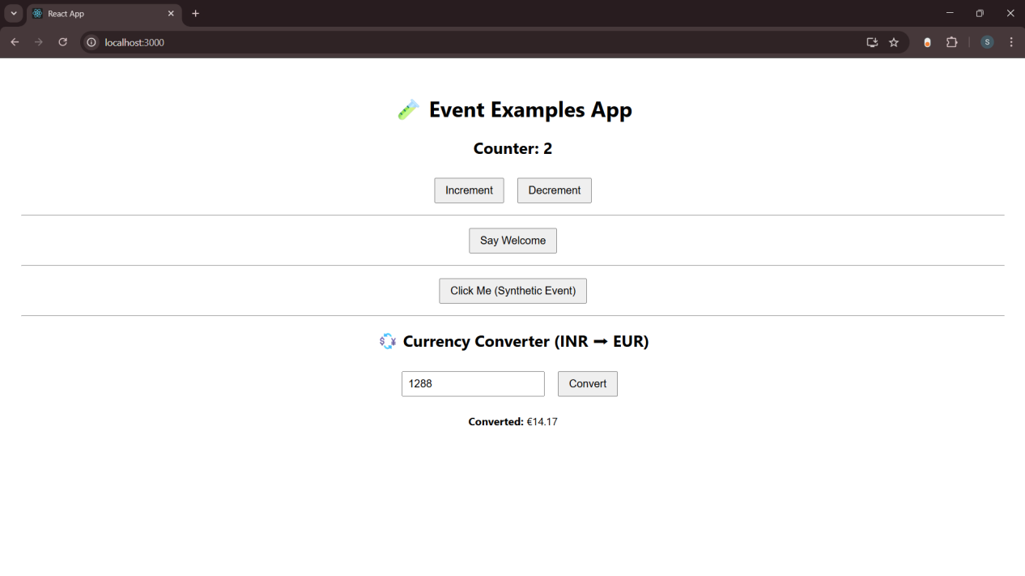

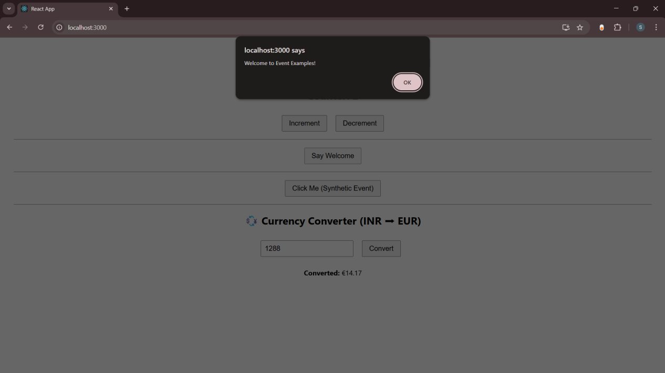

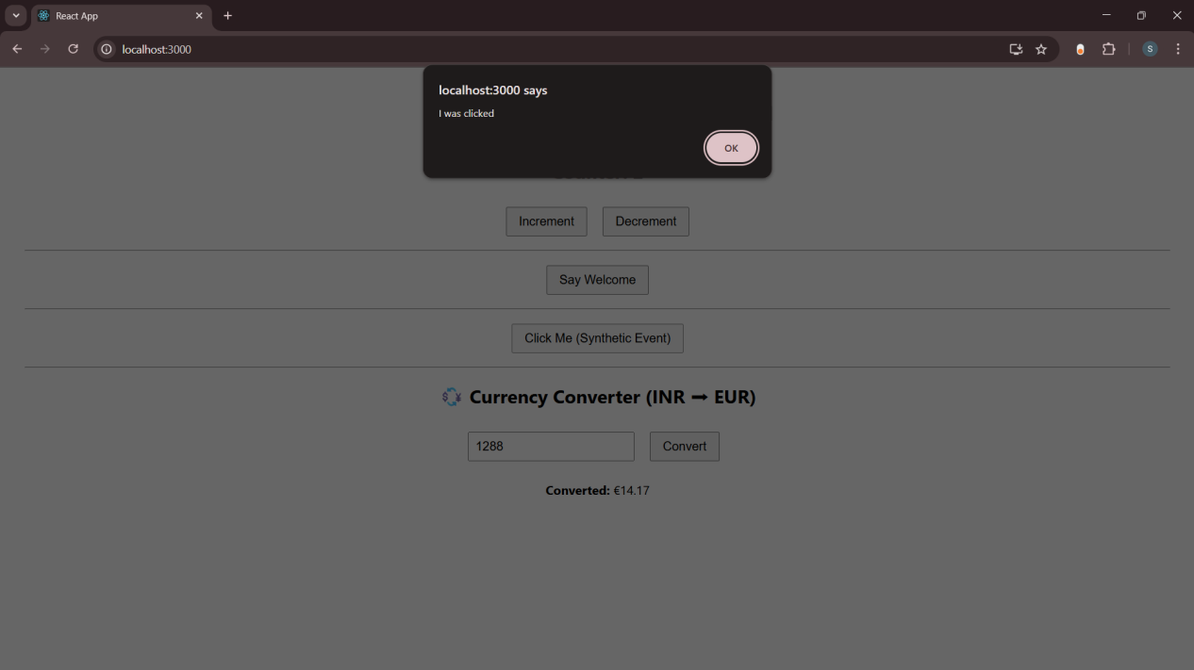



**FlightList.js**

import React from 'react';

const FlightList = () => {

const flights = [

{ id: 1, from: 'Delhi', to: 'Mumbai', time: '10:00 AM' },

{ id: 2, from: 'Bangalore', to: 'Chennai', time: '12:00 PM' },

];

return (

<div>

<h2>Flight Details</h2>

<ul>

{flights.map(flight => (

<li key={flight.id}>

{flight.from} ➡️ {flight.to} at {flight.time}

</li>

))}

</ul>

</div>

);

};

export default FlightList;

**GuestPage.js**

import React from 'react';

import FlightList from './FlightList';

const GuestPage = () => (

<div>

<h1>Welcome, Guest!</h1>

<FlightList />

<p>Please login to book flights.</p>

</div>

);

export default GuestPage;

**UserPage.js**

import React from 'react';

import FlightList from './FlightList';

const UserPage = () => (

<div>

<h1>Welcome, User!</h1>

<FlightList />

<button>Book Tickets</button>

</div>

);

export default UserPage;

**Login.js**

import React from 'react';

const Login = ({ onLogin }) => (

<div>

<h2>Login Page</h2>

<button onClick={onLogin}>Login</button>

</div>

);

export default Login;

**Navbar.js**

import React from 'react';

const Navbar = ({ isLoggedIn, onLogin, onLogout }) => (

<nav>

<h2>Ticket Booking App</h2>

{isLoggedIn ? (

<button onClick={onLogout}>Logout</button>

) : (

<button onClick={onLogin}>Login</button>

)}

</nav>

);

export default Navbar;

**App.js**

import React, { useState } from 'react';

import GuestPage from './components/GuestPage';

import UserPage from './components/UserPage';

import Login from './components/Login';

import Navbar from './components/Navbar';

function App() {

const [isLoggedIn, setIsLoggedIn] = useState(false);

const [showLogin, setShowLogin] = useState(false);

const handleLogin = () => {

setIsLoggedIn(true);

setShowLogin(false);

};

const handleLogout = () => {

setIsLoggedIn(false);

};

return (

<div>

<Navbar isLoggedIn={isLoggedIn} onLogin={() => setShowLogin(true)} onLogout={handleLogout} />

{showLogin ? (

<Login onLogin={handleLogin} />

) : isLoggedIn ? (

<UserPage />

) : (

<GuestPage />

)}

</div>

);

}

export default App;

**index.js**

import React from 'react';

import ReactDOM from 'react-dom/client';

import App from './App';

const root = ReactDOM.createRoot(document.getElementById('root'));

root.render(

<React.StrictMode>

<App />

</React.StrictMode>

);

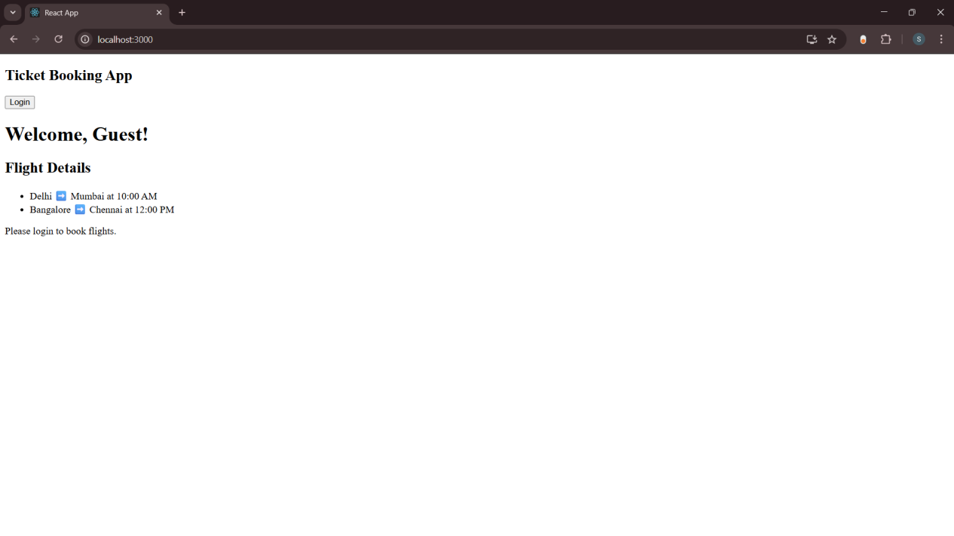



**BookDetails.js**

import React from 'react';

const BookDetails = () => (

<div>

<h2>📘 Book Details</h2>

<p>Author: J.K. Rowling</p>

<p>Title: Harry Potter</p>

</div>

);

export default BookDetails;

**BlogDetails.js**

import React from 'react';

const BlogDetails = () => (

<div>

<h2>✍️ Blog Details</h2>

<p>Author: Alice</p>

<p>Title: Understanding React Hooks</p>

</div>

);

export default BlogDetails;

**CourseDetails.js**

import React from 'react';

const CourseDetails = () => (

<div>

<h2>📚 Course Details</h2>

<p>Course: React for Beginners</p>

<p>Duration: 4 weeks</p>

</div>

);

export default CourseDetails;

**App.js**

import React, { useState } from 'react';

import BookDetails from './components/BookDetails';

import BlogDetails from './components/BlogDetails';

import CourseDetails from './components/CourseDetails';

function App() {

const [selected, setSelected] = useState('book');

const [showCourse, setShowCourse] = useState(true);

return (

<div style={{ padding: '20px' }}>

<h1> Blogger App</h1>

<div>

<button onClick={() => setSelected('book')}>Show Book</button>

<button onClick={() => setSelected('blog')}>Show Blog</button>

<button onClick={() => setSelected('course')}>Show Course</button>

<button onClick={() => setShowCourse(!showCourse)}>

Toggle Course (Ternary)

</button>

</div>

<hr />

{/* ✅ 1. Using If-Else (simulated via function) */}

{renderContentIfElse(selected)}

<hr />

{/* ✅ 2. Using Ternary Operator */}

{showCourse ? <CourseDetails /> : <p>📕 Course is hidden</p>}

<hr />

{/* ✅ 3. Using Logical AND (&&) */}

{selected === 'book' && (

<p>✅ You have selected the Book section (via && operator).</p>

)}

{/* ✅ 4. Using Switch Statement */}

<div>

<h3>🔄 Rendering using Switch:</h3>

{renderContentSwitch(selected)}

</div>

</div>

);

}

// Function for If-Else style

function renderContentIfElse(selected) {

if (selected === 'book') {

return <BookDetails />;

} else if (selected === 'blog') {

return <BlogDetails />;

} else if (selected === 'course') {

return <CourseDetails />;

} else {

return <p>No valid content selected.</p>;

}

}

// Function for Switch-case style

function renderContentSwitch(selected) {

switch (selected) {

case 'book':

return <BookDetails />;

case 'blog':

return <BlogDetails />;

case 'course':

return <CourseDetails />;

default:

return <p>🔍 Please select a valid option.</p>;

}

}

export default App;

