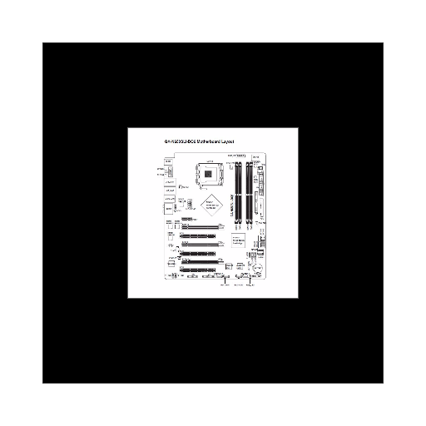**Motherboard**

A motherboard (sometimes alternatively known as the mainboard, system board, baseboard, planar board or logic board,[1] or colloquially, a mobo) is the main printed circuit board (PCB) found in general purpose microcomputers and other expandable systems. It holds and allows communication between many of the crucial electronic components of a system, such as the central processing unit (CPU) and memory, and provides connectors for other peripherals. Unlike a backplane, a motherboard usually contains significant sub-systems such as the central processor, the chipset's input/output and memory controllers, interface connectors, and other components integrated for general purpose use.

Motherboard specifically refers to a PCB with expansion capability and as the name suggests, this board is often referred to as the "mother" of all components attached to it, which often include peripherals, interface cards, and daughtercards: sound cards, video cards, network cards, hard drives, or other forms of persistent storage; TV tuner cards, cards providing extra USB or FireWire slots and a variety of other custom components.

**Battleship**

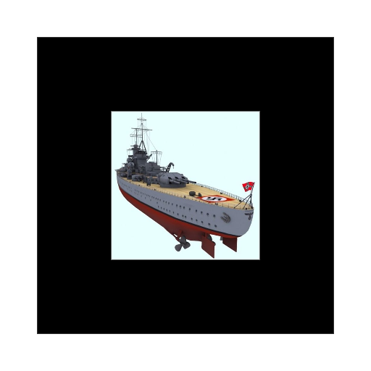A battleship is a large armored warship with a main battery consisting of large caliber guns. During the late 19th and early 20th centuries the battleship was the most powerful type of warship, and a fleet of battleships was considered vital for any nation that desired to maintain command of the sea. The word battleship was coined around 1794 and is a contraction of the phrase line-of-battle ship, the dominant wooden warship during the Age of Sail.[1] The term came into formal use in the late 1880s to describe a type of ironclad warship,[2] now referred to by historians as pre-dreadnought battleships.

In 1906, the commissioning of HMS Dreadnought heralded a revolution in battleship design. Subsequent battleship designs, influenced by HMS Dreadnought, were referred to as "dreadnoughts". Battleships were a symbol of naval dominance and national might, and for decades the battleship was a major factor in both diplomacy and military strategy.[3] A global arms race in battleship construction began in Europe in the 1890s and culminated at the decisive Battle of Tsushima in 1905;[4][5][6] the outcome of which significantly influenced the design of HMS Dreadnought.[7][8] The launch of Dreadnought in 1906 commenced a new naval arms race.

**Airplane**

An airplane or aeroplane (informally plane) is a powered, fixed-wing aircraft that is propelled forward by thrust from a jet engine or propeller. Airplanes come in a variety of sizes, shapes, and wing configurations. The broad spectrum of uses for airplanes includes recreation, transportation of goods and people, military, and research. Commercial aviation is a massive industry involving the flying of tens of thousands of passengers daily on airliners. Most airplanes are flown by a pilot on board the aircraft, but some are designed to be remotely or computer-controlled. The Wright brothers invented and flew the first airplane in 1903, recognized as "the first sustained and controlled heavier-than-air powered flight".

They built on the works of George Cayley dating from 1799, when he set forth the concept of the modern airplane (and later built and flew models and successful passenger-carrying gliders).[2] Between 1867 and 1896, the German pioneer of human aviation Otto Lilienthal also studied heavier-than-air flight. Following its limited use in World War I, aircraft technology continued to develop. Airplanes had a presence in all the major battles of World War II. The first jet aircraft was the German Heinkel He 178 in 1939. The first jet airliner, the de Havilland Comet, was introduced in 1952. The Boeing 707, the first widely successful commercial jet, was in commercial service for more than 50 years, from 1958 to at least 2013.