**AngularJS**

**Case Study**

**Objective:**

**Creating SPA (Single Page Application) using Angular**

Details:

When you open the web page, it will initially display the following information, asking you to enter the details about the employee.

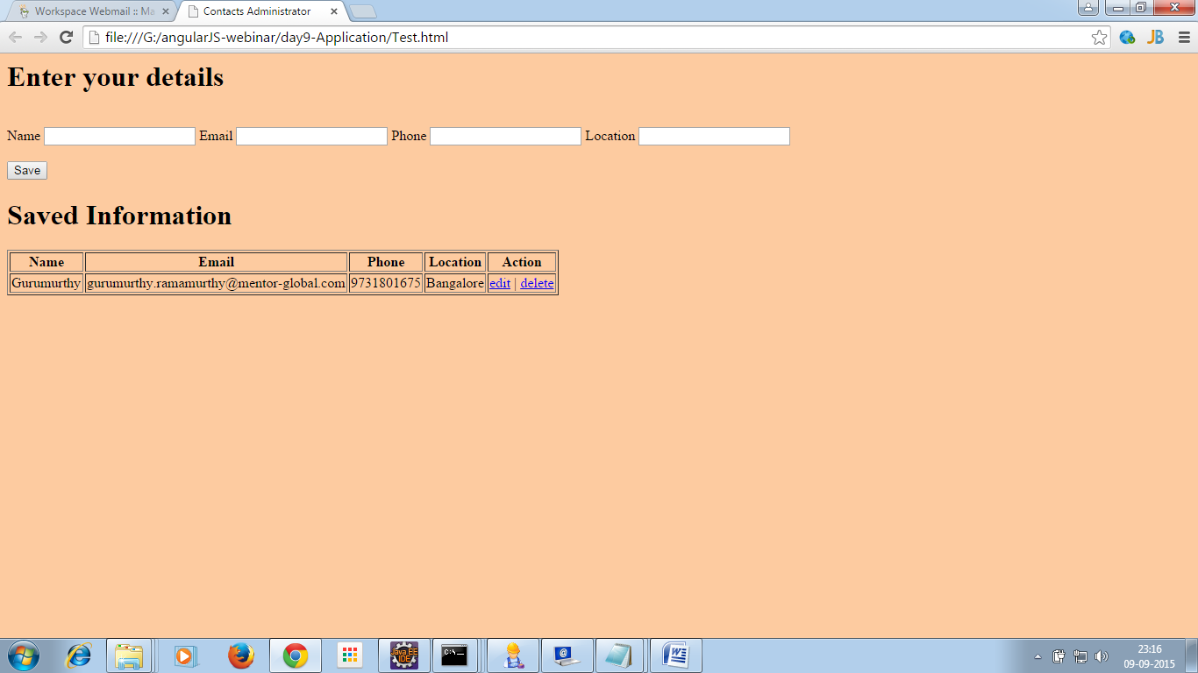

Using the links provided in the web page, you can insert, edit, delete, update the information (CRUD operations).

Everything needs to be done in the single page.