Balaji Robotic Rehab Hospital
Conversation flows and tool reference
Anu supports inbound enquiries and authorized outbound follow-up, explains rehabilitation services and collects consultation requests. This guide maps the current directional prompts, including native staff transfer.
Conversation flow
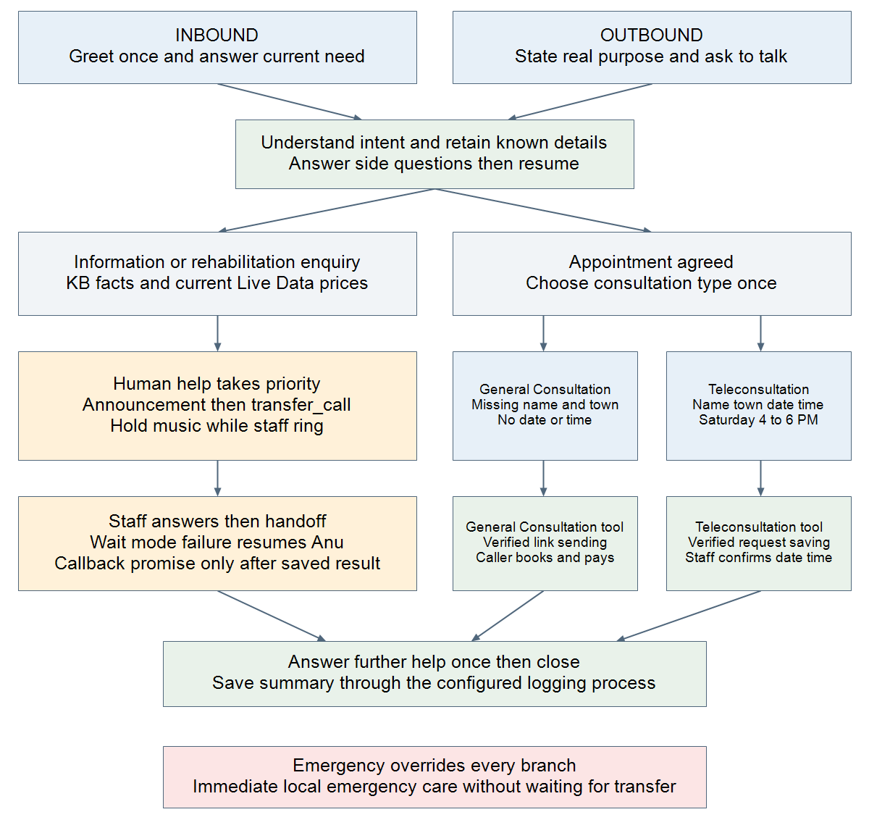
Both entry points share the same enquiry, consultation and human-help branches. Refusal or goodbye closes the call; busy callers can agree to an automated Anu callback.

Tools and their purposes
This inventory describes tools referenced by the repository prompts. A prompt mention does not prove that a webhook is assigned, credentials are valid or a live integration is connected. Built-in availability also depends on agent settings and runtime configuration.
Tool or capability | Purpose and conditions
General Consultation | Prompt-named external action. Uses missing patient name and town plus the known caller number. Sends the approved WhatsApp booking link. Claim sent only after verified delivery/action success; a link is not a confirmed appointment.
Teleconsultation | Prompt-named external action. Saves a request with patient name, town and preferred Saturday date/time between 4 and 6 PM. Staff confirms the appointment; tool success is not a booked slot.
transfer_call | Built-in transfer to this agent company approved destination. Explicit human-help request is consent. Play announcement before handoff. Wait mode restores Anu on busy/rejected/no answer; direct mode has a failure message and ends.
update_contact | Built-in caller-profile name update. Only a clearly stated caller-own name; never a patient or relative name. Replacement requires authorization and evidence. Confirm storage only on saved=true.
manage_follow_up | Built-in automated Anu callback/reminder on the current caller number. Requires agreement; absolute schedules need proposal confirmation. This does not arrange a human staff callback.
save_call_summary | Named in the prompts for one final call summary. Use an actually attached summary action or the configured runtime logging process. Do not invent a callable tool.
Staff callback action | Optional configured action after failed transfer. No exact tool name is mandated by current prompts. Requires caller consent and verified saved=true plus requestId before promising a callback; notification is separately verified.

Conversation rules and operating notes
Continuity and language. Speak natural Salem Tanglish in English letters unless English is requested. Keep known name, town, concern and consultation choice. Ask at most two missing intake fields per turn; answer interruptions and continue the next missing field without greeting again.
General Consultation. The current prompts state Monday, Wednesday and Friday from 2 to 6 PM and Rs 350 consultation fee, with verified Live Data overriding prices. Collect only missing patient name and town. The caller finishes booking and payment through the verified WhatsApp link.
Teleconsultation. Collect missing patient name, town, date and time. Saturday from 4 to 6 PM is the documented preference window. The hospital team confirms the fee and appointment. Do not describe the saved request as a confirmed booking.
Human assistance. Team/staff requests override intake. After failed transfer, explain the actual result, retain the conversation and offer further help. No staff callback is automatic unless an agreed configured action succeeds. Emergency care must never wait for transfer.
Connection status. Current prompt names are display labels; use the attached tool actual schema and identifier. The local documents cannot prove that General Consultation or Teleconsultation webhooks are assigned or operational in production.
Source conflict to resolve. SHARED_KB.md still describes an older no-WhatsApp-booking flow and proposed transfer_to_ward/save_appointment_request tools. The current inbound and outbound prompts instead specify the booking-link flow and transfer_call. This guide follows the current directional prompts and records the conflict rather than treating legacy tools as connected.
Price wording conflict. Fixed-facts text says never quote another General Consultation amount, while a later rule says verified Live Data overrides. Keep one unambiguous price authority when updating the prompts; current data must identify the correct service and currency.
Source files and scope
docs/prompts/balaji robatic/INBOUND_PROMPT.md
docs/prompts/balaji robatic/OUTBOUND_PROMPT.md
docs/prompts/balaji robatic/SHARED_KB.md and LIVE_PRICES.xlsx (price workbook present; no live sync or row values certified here)
Backend/src/voice/tools/call-transfer-tool.js and docs/CALL_TRANSFER_SETTINGS.md (native transfer behavior)
Prepared 16 October 2026 from the local repository. Production agent assignments and webhook execution history were not inspected. No credentials or private staff destinations are included.

