Shanmuga Hospital
Conversation flows and tool reference
Karthika handles Master Health Check-up enquiries, approved package information, appointment requests and patient support. Inbound calls follow the caller need; outbound calls first establish the authorized purpose and willingness to talk.
Conversation flow
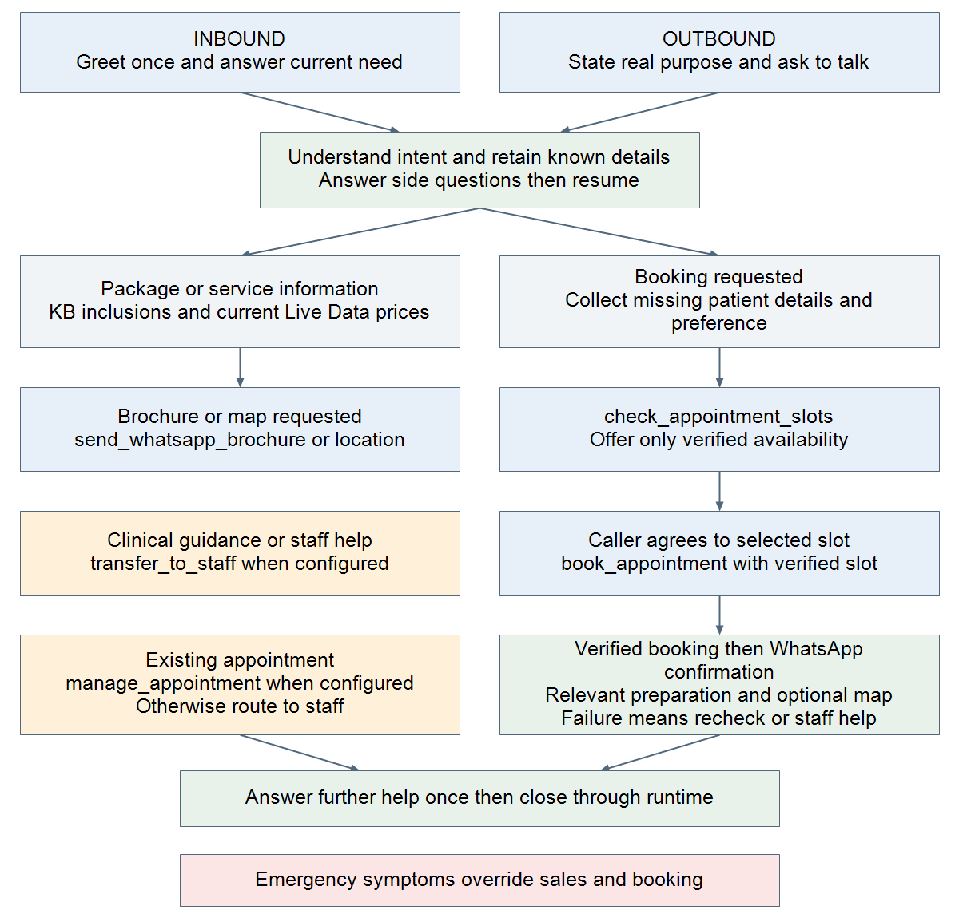
WhatsApp, staff help and existing appointment requests are intent branches, not compulsory steps. Busy callers can agree to an automated callback; refusal ends outbound outreach without pressure.

Tools and their purposes
This inventory describes tools referenced by the repository prompts. A prompt mention does not prove that a webhook is assigned, credentials are valid or a live integration is connected. Built-in availability also depends on agent settings and runtime configuration.
Tool or capability | Purpose and conditions
check_appointment_slots | External tool proposed in prompts. Read-only availability check for requested date/time. Clarify missing time or AM/PM and offer only returned slots. A check does not create a booking.
book_appointment | External tool proposed in prompts. Book only after verified availability, required patient details and clear caller agreement. Use exact returned slot ID/time; avoid duplicate booking on failure.
manage_appointment | External tool proposed in prompts. Cancel or reschedule an identified existing appointment after authorization. If unavailable, transfer to staff; callback cancellation is a separate action.
send_whatsapp_brochure | External tool proposed in prompts. Send approved package details when requested or agreed. Announce, execute and continue; claim delivery only after verified success.
send_whatsapp_location | External tool proposed in prompts. Send the approved hospital map/location when requested or agreed. Use configured recipient rules; do not invent a map URL.
send_whatsapp_booking_confirmation | External tool proposed in prompts. Send verified booking details after booking succeeds under the agreed flow. Do not send a fabricated appointment confirmation.
transfer_to_staff | External routing name in Shanmuga prompts. Staff help for clinical suitability, customization, insurance, refunds, complaints, doctor availability and unknown facts. Destination and implementation must be configured.
update_contact | Existing built-in caller-own name update with ownership, exact quote evidence and replacement consent. A patient or relative name must not overwrite the caller profile.
manage_follow_up | Existing built-in automated callback/reminder scheduling or cancellation on the caller number. Relative requests use backend time; absolute proposals need caller confirmation. Claim success only from verified flags.

Conversation rules and operating notes
Continuity and language. Use everyday spoken Tamil in Tamil script with familiar English terms; switch to English when clearly preferred. Ask one question at a time. Retain known details, answer the current question and avoid repeated introductions or intake.
Package discussion. Start with a short Silver, Gold and Platinum overview only when appropriate. Use the full KB catalogue for other packages. Explain inclusions from approved knowledge and prices/status from current Live Data. Do not quote pronunciation examples as current prices.
Clinical concerns. Match the actual concern to documented packages or departments without diagnosis or prescribing a screening package for symptoms. Unclear suitability, medical advice and undocumented services go to configured staff assistance. Emergencies take priority over packages, callbacks and transfers.
Booking sequence. Establish the actual patient, collect only missing required fields, check the preferred date/time, offer a verified slot and obtain booking agreement. Only verified book_appointment success allows confirmation. Then send the WhatsApp booking confirmation and appropriate preparation guidance.
WhatsApp sequence. Announce the requested action and execute without redundant permission. Continue the conversation without waiting for a read receipt. Queued, sent and failed are different outcomes; use only supported recipient and content policies.
Preparation and boundaries. KB guidance mentions 8 to 10 hours fasting and an 8 AM visit for relevant packages; these are not verified slots or universal instructions. Medication changes, individualized preparation and conflicting guidance require staff review.
Connection status. SHARED_KB.md explicitly calls the external tool names proposed for configuration. They are not evidence of production connections. Verify all seven external actions in Agent Tools, including credentials, endpoints, recipient policies and booking schemas. Built-in update_contact and manage_follow_up also obey runtime authorization.
Summary and ending. Use configured runtime call ending and logging. The Shanmuga directional prompts do not specify a separate save_call_summary tool. Do not add one to the connected-tool inventory without inspecting the actual agent settings.
Source files and scope
docs/prompts/shannmuga hospital/INBOUND_PROMPT.md
docs/prompts/shannmuga hospital/OUTBOUND_PROMPT.md
docs/prompts/shannmuga hospital/SHARED_KB.md especially Operational tool roles
docs/prompts/shannmuga hospital/LIVE_PRICES.xlsx (present; workbook contents are not certified live prices)
Prepared 16 October 2026 from the local repository. Production agent assignments and webhook execution history were not inspected. No credentials or private staff destinations are included.

