Abstract
This study develops an interactive two-page dashboard to explore the prevalence of raised blood pressure, obesity, and diabetes across 23 Middle East and North Africa (MENA) countries from 1975 to 2016. The first page provides a global regional overview, while the second presents a MENA-focused deep dive structured around seven analysis questions within a tabbed interface. The analysis uses data from the NCD Risk Factor Collaboration, supplemented by World Bank GDP per capita, population, and income classification data, and follows the CRISP-DM analytical framework with dashboard design grounded in established visualization theory including Shneiderman’s visual information-seeking mantra, Munzner’s What-Why-How framework, and Cleveland and McGill’s channel-effectiveness hierarchy.
The central finding is that income shapes the NCD burden in opposite directions depending on the indicator: higher-income Gulf states show elevated diabetes and obesity but declining blood pressure, while lower-income MENA states show the inverse pattern. This divergence accelerated from the 1990s onwards and culminated in 2010 when obesity overtook blood pressure as the second most prevalent NCD in the region. At the country level, Kuwait carries the worst combined metabolic profile since at least 1980, while Yemen records the highest blood pressure prevalence. Population size has no influence on NCD prevalence across any indicator.
These findings demonstrate that effective NCD policy in MENA cannot treat the region as a single entity, the burden is income-stratified, indicator-specific, and requires differentiated responses targeting dietary and lifestyle change in wealthier Gulf states and healthcare access and screening coverage in lower-income states.
Introduction
Non-communicable diseases (NCDs) - principally raised blood pressure, obesity, and diabetes represent one of the defining public health challenges of the twenty-first century, accounting for approximately three-quarters of all deaths worldwide (WHO, n.d.). Understanding how these conditions are distributed across countries and how they have changed over time is essential for the design of effective policy responses, yet the scale of the available data - spanning 200 countries, two sexes, and four decades - renders direct country-level comparison impractical without structured visual exploration.
This study develops an interactive dashboard to explore global NCD prevalence using the NCD Risk Factor Collaboration (NCD-RisC) dataset, supplemented by World Bank GDP and regional classification data. Following Shneiderman’s (1996) visual information-seeking mantra of "overview first, zoom and filter, then details on demand," the analysis begins at the global regional level rather than the country level. Aggregating 200 countries into seven World Bank regions reduces visual clutter and allows the most meaningful patterns which region carries the highest burden, and for which indicators, to emerge before any country-level detail is examined.
This regional overview immediately identifies the Middle East and North Africa (MENA) as the focus for deeper investigation: MENA ranks first globally for diabetes prevalence and second for obesity, while ranking only fourth for blood pressure which is a pattern that is specifically metabolic rather than uniform across all three indicators, and that has held consistently since at least 1985. MENA is also an analytically distinctive region: its 23 countries span a 16-fold income gap, from lower-income states such as Afghanistan, Yemen, and Pakistan (median GDP per capita below $5,000 in 2014, computed from ncd_merged.csv, 2014) to wealthy Gulf states such as Kuwait, Qatar, and the UAE (median GDP per capita above $59,000 computed from ncd_merged.csv, 2014) . This income heterogeneity makes MENA an unusually rich setting for examining whether NCD prevalence tracks national wealth and, if so, in which direction.
The dashboard addresses seven analysis questions, covering the relationship between income and NCD prevalence, gender differences over time, the interconnection between the three indicators, the independence of prevalence from population size, sub-regional variation, the timing of MENA’s rising burden, and country-level combined profiles. The remainder of this report documents the data preparation process, presents the analytical findings for each question, and discusses the methodological choices and limitations that underpin the analysis.
1.Business Understanding
Following the CRISP-DM framework (Wirth and Hipp, 2000), the business understanding phase established the analytical objectives, scope, and intended audience of the dashboard. Three indicators raised blood pressure, obesity, and diabetes were selected because they represent the World Health Organization’s primary metabolic risk factors and are biologically interconnected. Together, these conditions contribute substantially to the global burden of non-communicable diseases and preventable mortality.
An initial regional overview, following Shneiderman’s (1996) overview-first principle, was conducted to identify the most appropriate analytical focus. As Figure 1, Table 1, and Figure 2 show, MENA ranks first globally for diabetes and second for obesity in 2014, while ranking only fourth for blood pressure , a divergence confirmed to have held consistently since at least 1985, suggesting a structural metabolic pattern rather than a single-year anomaly. This divergence suggested a distinct metabolic disease profile and justified the selection of MENA as the primary region of interest.
The analytical scope was subsequently defined through seven research questions developed iteratively during the design process. The initial framework consisted of four questions examining relationships between GDP and NCD prevalence, gender differences, interconnections among indicators, and population effects. As the design process progressed, three additional questions were introduced to investigate sub-regional variation, the timing of epidemiological change, and country-level combined risk profiles. These additions reflected the need to capture important within-region differences that would otherwise be obscured by aggregate MENA-level comparisons. 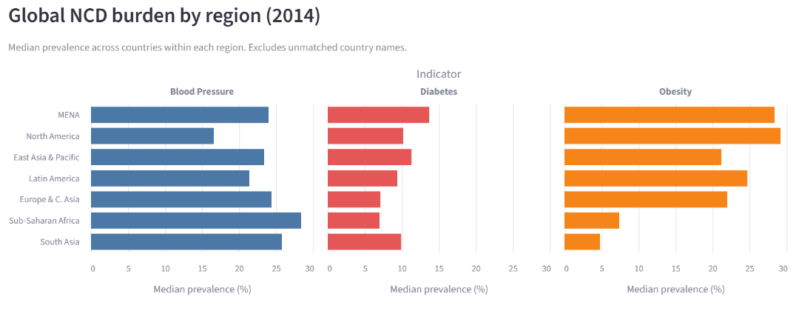
Figure 1: Median NCD prevalence by World Bank region, 2014. MENA ranks first for diabetes, second for obesity, and fourth for blood pressure, a pattern that is specifically metabolic rather than uniform across all three indicators
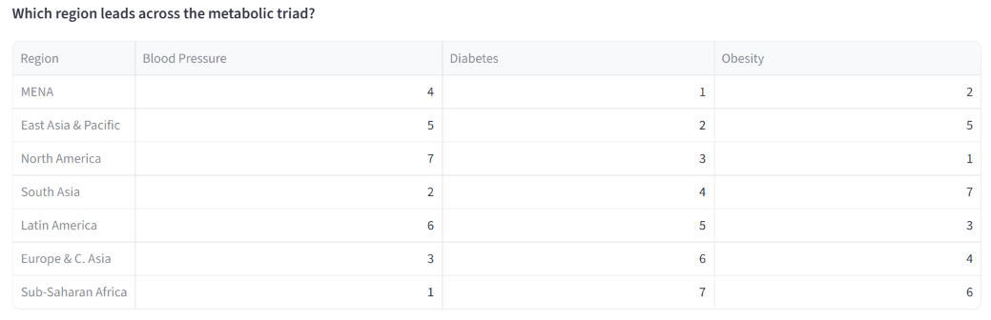
Table 1: Regional ranking by NCD indicator, 2014 (rank 1 = highest prevalence). MENA leads for diabetes and obesity but ranks only fourth for blood pressure, confirming the metabolic specificity of its NCD burden
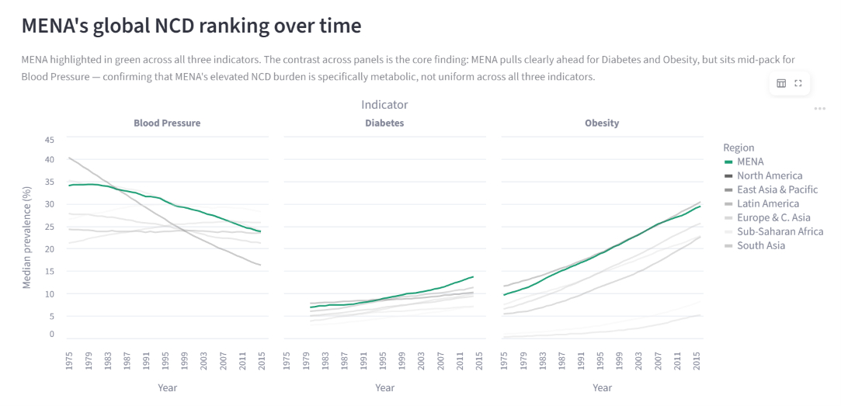
Figure 2: MENA's global NCD ranking over time, 1975-2016. MENA (highlighted in green) pulls clearly ahead of all other regions for diabetes and obesity from the mid-1980s onwards, while remaining mid-ranked for blood pressure throughout - confirming that the metabolic specificity identified in Figure 1 is not a single-year snapshot but a structural pattern persisting across four decades.
The target audience comprises health ministry policymakers across the 23 MENA countries. As no unified regional health authority exists, each country is responsible for its own public health planning and intervention strategies. This context informed the decision to aggregate data using a country-equal approach rather than population weighting, ensuring that smaller countries retained equal analytical visibility. Consequently, the dashboard was designed to support both regional benchmarking and individual country positioning, enabling policymakers to compare national performance against regional trends while identifying country-specific patterns and priorities.

The target audience for this dashboard is health ministries and policymakers. However, each MENA country has its own policymakers MENA has no single unified health authority. Each country’s ministry makes independent decisions with its own budget.
The dashboard is therefore, designed to let each country’s policymakers see both their own country’s position and how it compares to regional peers.
2. Data Understanding
Following the CRISP-DM framework (Wirth and Hipp, 2000) and Munzner’s (2014) data abstraction framework, the data understanding phase examined what data were available, how they were structured, and whether they were suitable for answering the seven analysis questions. Five tabular datasets were used. The primary dataset was the NCD Risk Factor Collaboration (NCD-RisC) prevalence data covering raised blood pressure, obesity, and diabetes. This was supplemented with World Bank GDP per capita, population, regional classification, and historical income-group datasets to provide economic, demographic, and geographic context.
The datasets contain a mixture of categorical, quantitative, ordinal, and temporal attributes. Country and Sex were treated as nominal categorical variables, Year as a temporal variable, and prevalence as a quantitative variable suitable for aggregation and numerical comparison. Historical income classification (Low, Lower-middle, Upper-middle, and High income) was treated as an ordinal variable because the categories possess a meaningful ranking. These classifications informed both the visual encoding strategy and the selection of appropriate chart types throughout the dashboard.
Prevalence rates rather than absolute case counts were adopted as the primary analytical measure. This decision ensured that comparisons reflected disease burden relative to population size rather than national population volume. For example, a highly populated country such as Pakistan would dominate analyses based on raw counts regardless of its underlying prevalence rate. The validity of this design choice was later examined explicitly through AQ4, which compares prevalence and population relationships across the region.
Inspection of the datasets revealed several structural constraints. The three NCD indicators cover slightly different time periods: raised blood pressure is available from 1975–2015, obesity from 1975–2016, and diabetes from 1980–2014. In addition, Palestine contains population data only from 1990 onwards, reflecting its later inclusion within World Bank statistical reporting. Historical income-group classifications are unavailable before 1987 because the World Bank’s income classification system does not extend further back. This absence represents a genuine limitation of the source data rather than missing observations. Consequently, analyses involving income-group comparisons were restricted to the period 1987–2016, whereas analyses using GDP per capita remained unaffected because GDP data were available throughout the study period.
No substantial issues were identified regarding country coverage for the 23 MENA countries after harmonisation of country names and codes across datasets. However, the differing temporal coverage of the three indicators required careful filtering during dashboard development to ensure that comparisons were made only across valid overlapping periods where appropriate.
3. Data Preparation
Following the CRISP-DM framework (Wirth and Hipp, 2000), data preparation comprised five principal activities: data selection, cleaning, construction, integration, and formatting. These steps transformed five independent source datasets into a single analytical dataset suitable for interactive visualisation and comparative analysis.
3.1 Data Selection
Only records relating to the 23 MENA countries were retained from the original datasets. The overall study period was defined as 1975-2016 to maximise temporal coverage and align with the NCD-RisC data. However, individual indicators have narrower temporal ranges, as discussed in Section 2, and dashboard filters were designed to respect these constraints.
3.2 Data Cleaning
Several data-quality checks were performed prior to integration. A country-name mismatch was identified during validation of country counts: Iran appeared as “Iran” in one dataset rather than the expected “Iran (Islamic Republic of)”. This discrepancy was detected when only 22 of the expected 23 countries were returned following filtering and was subsequently corrected. The World Bank missing-value marker (“..”) was converted to a standard null value to ensure compatibility with analytical and visualisation tools.
Historical income classifications for 1975-1986 were retained as missing values rather than imputed because the World Bank’s income-group classification system does not extend before 1987. As these values represent a structural absence rather than missing observations, imputation would have introduced artificial information into the dataset. Finally, all three NCD-RisC indicators were confirmed to be age-standardised through inspection of the NCD-RisC methodological documentation (NCD-RisC, 2017), eliminating the need for additional demographic standardisation.
3.3 Feature Construction
Three derived attributes were created to support the analysis questions and dashboard interactions.
- Prevalence_pct converted prevalence values from proportions (0 - 1) to percentages (0 - 100) to improve interpretability.
- Absolute_count was calculated as prevalence multiplied by population, providing demographic context for AQ4 and enabling comparison between prevalence-based and population-based perspectives.
- Sub_Region grouped countries into four analytical categories: Gulf, North Africa, Levant, and Lower-Income MENA. This derived variable enabled investigation of intra-regional variation and supported AQ5.
3.4 Data Integration
The five datasets were merged using Country and Year as composite join keys. An alternative ISO-3 code-based merge strategy was initially evaluated but rejected after failing to resolve four key MENA country identifiers consistently across sources. Instead, a manually verified country-name translation dictionary was implemented. To ensure data integrity, the expected country count (23) was validated after each merge operation.
3.5 Data Formatting
Population and income datasets were originally provided in wide format, with separate columns representing individual years. These tables were transformed into long format using the pandas melt () function to facilitate temporal analysis and compatibility with Altair’s tidy-data requirements. The resulting integrated dataset, ncd_merged.csv, contained 5,428 observations spanning 23 countries, two sexes, three indicators, and up to 42 years of data.

3.6 Outlier Assessment
Potential outliers were examined using three complementary approaches: visual inspection through boxplots, percentile analysis, and a formal interquartile range (IQR) test. No observations fell outside the plausible prevalence range of 0 – 100%. The IQR analysis flagged 91 blood pressure observations; however, detailed inspection showed these values reflected genuine epidemiological variation rather than data-entry errors. Examples included blood-pressure prevalence among Maltese and Emirati men reaching 46.7% during 1975 -1977 and prevalence among Israeli women falling to 12.8% during 2012 - 2015. Consistent with best practice in observational health data analysis, all flagged observations were retained to preserve the integrity of the underlying population trends.
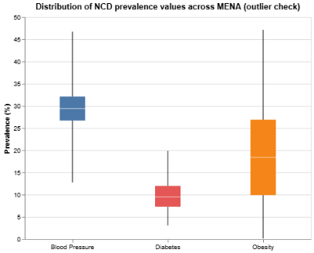
Figure 3: Boxplot to check outliers

4. Analysis Questions
Building on the Business Understanding phase, the following analysis questions were defined to structure the dashboard:
AQ1. Does NCD prevalence grow with GDP within MENA?
AQ2. How does NCD prevalence differ between men and women, and has this gap changed over time?
AQ3. What is the relationship between the three NCD indicators?
AQ4. Does NCD prevalence track population size?
AQ5. Is MENA’s NCD burden evenly distributed, or concentrated in specific sub-regions?
AQ6. When did MENA’s NCD burden begin rising relative to other regions?
AQ7. Which MENA country carries the most severe combined NCD profile?

5.1 Dashboard Overview:
4.1 Dashboard Architecture and Design
The dashboard was implemented as a two-page Streamlit application using Altair, the Python interface to the Vega-Lite grammar of interactive graphics (Satyanarayan et al., 2017). The overall architecture follows Shneiderman’s (1996) visual information-seeking mantra of “overview first, zoom and filter, then details on demand”, providing users with a progressive analytical workflow that moves from global context to detailed country-level investigation.
Page 1 (Global Overview) establishes the broader epidemiological context. It contains KPI cards summarising headline statistics, a faceted regional comparison chart covering all seven World Bank regions, a regional ranking table, and a multi-line trend chart showing long-term prevalence patterns with MENA highlighted. Together, these views enable users to determine whether MENA differs from other world regions and whether its burden is consistent across all three indicators. This page addresses the business-understanding objective of justifying MENA as the primary analytical focus.
Page 2 (MENA Deep Dive) supports detailed exploration of the seven analysis questions. The page is organised into seven thematic tabs, each corresponding to a specific analytical objective. The sequence progresses from structural regional comparisons and economic drivers to temporal trends, indicator interrelationships, demographic effects, country rankings, and gender differences. This organisation mirrors the analytical narrative established in Section 4, allowing users to move systematically from broad regional patterns to detailed country-level insights.
Interactive controls were incorporated throughout to support exploratory analysis. Year sliders, indicator selectors, country filters, and hover tooltips allow users to investigate alternative perspectives while maintaining a consistent visual structure. These interactions support Shneiderman’s principles of zooming, filtering, and details on demand without requiring technical expertise from end users.
Chart selection followed Munzner’s (2014) What–Why–How framework and Cleveland and McGill’s (1984) hierarchy of graphical perception. Position-based encodings, including bar charts, line charts, and scatterplots, were prioritised for primary quantitative comparisons because position along a common scale provides the most accurate visual judgement. Colour was reserved primarily for categorical differentiation, such as sub-region identification, and as a secondary quantitative channel when additional variables required encoding beyond the available positional dimensions. Examples include the metabolic-triad scatterplot, where colour represents blood-pressure prevalence, and the gender-gap choropleth, where colour communicates the magnitude and direction of differences between male and female prevalence.
Accessibility considerations informed several design decisions. The diverging red - blue colour scheme used in the gender-gap choropleth remains interpretable for users with deuteranopia because it does not rely on red - green discrimination. All controls employ plain-language labels rather than technical variable names, and tooltips provide precise numerical values for every visual mark, ensuring that insights remain accessible regardless of colour perception or visual acuity (Few, 2013). A summary of visual encoding decisions for each chart is provided in Table 2.
Chart | Mark | Primary Channel | Secondary Channel | Interaction
Regional Comparison (P1) | Bar | Position(x)- Prevalence | Colour - Indicator | Tooltip
Global Trend Lines (P1) | Line | Position (x, y) - Year, Prevalence | Colour - Region; Opacity/Stroke Width - MENA Highlight | Tooltip
Sub-regional Bar Chart | Bar | Position (x) -Prevalence | Colour - Sub-region | Tooltip
Gapminder Scatter | Point | Position (x, y) -GDP, Prevalence | Colour - Sub-region; Size -Population | Year Slider; Tooltip
Country Trajectories | Line + Point | Position (x, y) - GDP, Prevalence | Colour - Country | Country Dropdowns; Indicator Dropdown
Diverging Trend Lines | Line | Position (x, y) -Year, Prevalence | Colour - Indicator | Tooltip
Metabolic Triad Scatter | Point | Position (x, y) -Obesity, Diabetes | Colour - Blood Pressure (Sequential Scale) | Year Slider; Tooltip
Correlation by Year | Line + Point | Position (x, y) -Year, Pearson r | Colour - Indicator Pair | Tooltip; Dashed Zero-Line
Population Scatter | Point | Position (x, y) -Population, Prevalence | Colour - Sub-region | Year Slider; Tooltip
Country Ranking Heatmap | Rectangle | Position (y) - Country Rank | Colour - Prevalence (Sequential Orange Red) | Year Dropdown; Colour Scale Dropdown
Gender Gap | Line + Area | Position (x, y) - Year, Prevalence | Colour - Sex; Area Opacity - Gap Magnitude | Indicator Dropdown
Gender Gap Choropleth | Geoshape | Colour - Gap (Diverging Red–Blue) | - | Indicator Dropdown; Year Dropdown; Tooltip
5. Findings and Interpretation
Table 2 : Table 2: Visual encoding decisions by chartacross four decades.
Primary channel follows Cleveland and McGill's (1984) hierarchy — position is used wherever precise quantitative comparison is required; colour is reserved for categorical distinction or as a secondary quantitative channel where a third variable must be encoded alongside two positional encodings.
Following Knaflic's (2015) data-storytelling framework, the findings are presented as a narrative progressing from what is happening, to why it is happening, who is most affected, and finally what policy responses may be appropriate. This structure aligns with the dashboard design and supports the communication of complex epidemiological patterns to policy audiences. Rather than treating each analysis question independently, the findings are synthesised to develop a coherent explanation of how NCD prevalence has evolved across the MENA region.

6. Findings
The analysis across seven questions reveals a consistent and coherent pattern: MENA’s elevated global NCD ranking is specifically metabolic in character, driven by a subset of countries and a particular historical period, rather than reflecting a uniform burden distributed evenly across the region or across all three indicators.
At the global level, MENA ranks first for diabetes and second for obesity among all seven World Bank regions, yet only fourth for blood pressure, a divergence that has held consistently since 1985. This finding is supported by clinical literature establishing that obesity and diabetes share a common metabolic pathway (WHO, n.d.; Shi et al., 2023), while blood pressure carries a distinct burden profile more closely linked to healthcare access and screening coverage in lower-income settings than to income-driven dietary change (Schutte et al., 2021). This distinction confirmed both cross-sectionally and longitudinally in the dashboard is the central finding of this study.
Within MENA, the NCD burden is not uniformly distributed. Sub-regional analysis shows that Gulf states (median GDP per capita $59,291 in 2014) carry the highest median prevalence for diabetes and obesity, while Lower-income MENA states (median GDP per capita $3,702) carry the highest blood pressure prevalence an inverse relationship confirmed by the Pearson correlation analysis, which found that the association between obesity and blood pressure reversed from strongly positive (r ≈ 0.85 in 1980) to strongly negative (r = -0.71 by 2014) as Gulf states’ incomes rose and their blood pressure fell. The divergence accelerated markedly from the early 1990s onwards, consistent with the period of rapid Gulf economic growth, and culminated in 2010 when obesity overtook blood pressure as the second most prevalent NCD in MENA by median prevalence.
At the country level, Kuwait carries the most severe combined metabolic profile in 2014 ranking first for both diabetes (19.6%) and obesity (39.6%), a position it has held since at least 1980. Lower-income MENA states (Yemen, Pakistan, Afghanistan) rank worst for blood pressure but lowest for obesity, illustrating that the question of which country carries the greatest NCD burden cannot be answered without specifying which indicator.
Population size does not explain NCD prevalence: scatter plots across all three indicators and all study years confirm no positive relationship between a country’s population and its prevalence rate, validating the methodological decision to use prevalence rates rather than absolute counts throughout this analysis. Finally, the gender analysis shows that while obesity has grown in both men and women across the region, women’s obesity prevalence has exceeded men’s throughout the entire 1975–2016 period , the only indicator where this holds universally across all 23 countries while diabetes has converged toward a male-leaning pattern and blood pressure has followed a more complex trajectory, with men pulling ahead only after 2001.
6.1 Policy Implications
The findings map directly onto existing international and regional frameworks, and in several cases reveal a gap between the scale of the burden and the adequacy of the policy response.
For Gulf states where this dashboard identifies Kuwait, Qatar, and Saudi Arabia as carrying the worst combined metabolic profiles , the most relevant frameworks are the WHO Global NCD Compact 2020–2030 (WHO, 2020a), which commits member states to saving 50 million lives by 2030, and the WHO EMRO Sugar Reduction Policy, which recommends a 50% or more reduction in national sugar intake to halt the rise in diabetes and obesity in the Eastern Mediterranean (WHO EMRO, n.d.). The finding that Gulf states are among the MENA countries under-investing in NCD research relative to their GDP suggests that political commitment at the compact level has not yet translated into proportionate domestic action in the countries that need it most.
The magnitude of this challenge is underscored by the fact that 6 out of 15 MENA countries still lack a national strategy for diabetes, and many have no national action plan against overweight and obesity responses that remain discordant with the scale of the problem (Hwalla, Jaafar and Sawaya, 2021). GCC countries, particularly Oman, Qatar, UAE and Kuwait, appear to be substantively under-investing in NCD-related research relative to their wealth (Hwalla, Jaafar and Sawaya, 2021), a finding that directly contradicts Kuwait’s position as the worst combined NCD profile in this dataset since at least 1980.
For Lower-income MENA states where this dashboard identifies the highest blood pressure burden only 10% of conflict-affected Eastern Mediterranean countries have a national diabetes action plan, compared with 67% of non-conflict countries (insert NIH citation). Yemen’s position as the highest blood pressure country in MENA (30.6%) yet one of the least likely to have a functioning NCD action plan illustrates precisely the gap the WHO EMRO Regional Framework for Action on Diabetes was designed to address.
For the region, the gender finding women’s obesity exceeds men’s in all 23 MENA countries maps directly onto the WHO Acceleration Plan to STOP Obesity (WHO EMRO, 2022), which identifies food environment reform and fiscal policy as the primary levers. This dashboard makes the geographic concentration of that gap visible to the policymakers who can act on it.

7. Conclusion
This study set out to examine how raised blood pressure, obesity, and diabetes have evolved across the MENA region between 1975 and 2016, and to identify which countries, sub-regions, and population groups carry the greatest burden across the metabolic triad. An interactive Streamlit dashboard was developed using the NCD-RisC dataset, supplemented by World Bank GDP and regional classification data, and structured around seven analysis questions covering income, gender, indicator inter-relationships, population size, sub-regional variation, timing, and country-level combined profiles.
The headline finding is that MENA’s elevated global NCD ranking is specifically metabolic, not uniform: the region leads globally for diabetes and ranks second for obesity, but only fourth for blood pressure a divergence that has held consistently since 1985 and that accelerated markedly from the 1990s onwards, coinciding with the period of rapid Gulf economic growth. Within MENA, rising national income is associated with rising diabetes and obesity but falling blood pressure which is the inverse of the pattern typically observed globally, and this relationship has shifted from a shared positive association in 1980 to a clearly divergent one by 2014. At the country level, Kuwait has carried the most severe combined metabolic profile since at least 1980, while Lower-income MENA states (Yemen, Afghanistan, Pakistan) carry a concentrated blood pressure burden alongside comparatively low obesity and diabetes prevalence.
Several limitations of this analysis should be acknowledged. First, the NCD-RisC data are modelled estimates derived from multilevel statistical models rather than direct survey measurements; countries with limited survey infrastructure plausibly including several Lower-income MENA states have estimates derived substantially from regional statistical pooling, meaning that cross-country comparisons between high- and low-survey-density countries should be interpreted with appropriate caution. Second, the sub-regional groupings and income tiers used throughout this dashboard are based on 2014 GDP per capita and applied retrospectively to all years, which may not accurately reflect each country’s economic status in earlier decades. Third, the MENA-wide aggregates reported here use country-equal medians rather than population-weighted averages; given the 150-fold population range across the region, this decision explicitly justified by the AQ4 analysis means that results represent the typical country experience rather than the typical person’s experience. Fourth, the income-prevalence patterns identified may be partly attributable to differences in underlying survey density and modelling uncertainty rather than to genuine epidemiological variation alone.
Future work could extend this analysis in three directions. First, incorporating cause-of-death data alongside prevalence data would allow the dashboard to move from risk-factor monitoring to outcome assessment, testing whether the sub-regional income-NCD relationship identified here translates into corresponding mortality differentials. Second, a population-weighted version of the MENA-wide aggregates would provide a complementary perspective to the country-equal median used here, and the degree of divergence between the two measures would itself be an informative finding. Third, extending the analysis beyond 2016 as updated NCD-RisC data become available would test whether the reversal in the obesity–blood pressure correlation identified in 1995 has continued to deepen or has begun to stabilise.

References
Cleveland, W.S. and McGill, R. (1984) ‘Graphical perception: theory, experimentation, and application to the development of graphical methods’, Journal of the American Statistical Association, 79(387), pp. 531–554. doi: 10.1080/01621459.1984.10478080.
Field, A. (2018) Discovering Statistics Using IBM SPSS Statistics. 5th edn. London: Sage.
Few, S. (2013) Information Dashboard Design: Displaying Data for At-a-Glance Monitoring. 2nd edn. Burlingame, CA: Analytics Press.
Holtz, Y. and Healy, C. (2018) From Data to Viz. Available at: https://www.data-to-viz.com (Accessed: [insert your access date]).
Maddison Project Database (2020) Maddison Project Database 2020. Available at: https://www.rug.nl/ggdc/historicaldevelopment/maddison/ (Accessed: [insert your access date]).
Munzner, T. (2014) Visualization Analysis and Design. Boca Raton, FL: CRC Press.
NCD Risk Factor Collaboration (NCD-RisC) (2016a) ‘Trends in adult body-mass index in 200 countries from 1975 to 2014: a pooled analysis of 1698 population-based measurement studies with 19·2 million participants’, The Lancet, 387(10026), pp. 1377–1396. doi: 10.1016/S0140-6736(16)30054-X.
NCD Risk Factor Collaboration (NCD-RisC) (2016b) ‘Worldwide trends in diabetes since 1980: a pooled analysis of 751 population-based studies with 4·4 million participants’, The Lancet, 387(10027), pp. 1513–1530. doi: 10.1016/S0140-6736(16)00618-8.
NCD Risk Factor Collaboration (NCD-RisC) (2017) ‘Worldwide trends in blood pressure from 1975 to 2015: a pooled analysis of 1479 population-based measurement studies with 19·1 million participants’, The Lancet, 389(10064), pp. 37–55. doi: 10.1016/S0140-6736(16)31919-5.
Satyanarayan, A., Moritz, D., Wongsuphasawat, K. and Heer, J. (2017) ‘Vega-Lite: a grammar of interactive graphics’, IEEE Transactions on Visualization and Computer Graphics, 23(1), pp. 341–350. doi: 10.1109/TVCG.2016.2599030.
Schutte, A.E., Srinivasapura Venkateshmurthy, N., Mohan, S. and Prabhakaran, D. (2021) ‘Hypertension in low- and middle-income countries’, Circulation Research, 128(7), pp. 808–826. doi: 10.1161/CIRCRESAHA.120.318729.
Shi, C., Xu, F., Yuan, H., Dong, X., Ren, L., Zhang, X. and Zhang, X. (2023) ‘The effect of the interaction between abnormal body mass index and hypertension on the risk of type 2 diabetes’, PLOS ONE. Available at: https://pmc.ncbi.nlm.nih.gov/articles/PMC9870675/ (Accessed: [insert your access date]).
Shneiderman, B. (1996) ‘The eyes have it: a task by data type taxonomy for information visualizations’, Proceedings of the IEEE Symposium on Visual Languages, pp. 336–343. doi: 10.1109/VL.1996.545307.
Tukey, J.W. (1977) Exploratory Data Analysis. Reading, MA: Addison-Wesley.
United Nations (2015) Transforming Our World: The 2030 Agenda for Sustainable Development. New York: United Nations. Available at: https://sdgs.un.org/2030agenda (Accessed: [insert your access date]).
World Bank (2025) World Bank Country and Lending Groups — Historical Classification by Income. Available at: https://datahelpdesk.worldbank.org/knowledgebase/articles/906519 (Accessed: [insert your access date]).
World Health Organization (n.d.) Diabetes. Available at: https://www.who.int/news-room/fact-sheets/detail/diabetes (Accessed: [insert your access date]).
World Health Organization (n.d.) Hypertension. Available at: https://www.who.int/news-room/fact-sheets/detail/hypertension (Accessed: [insert your access date]).
World Health Organization (2013) Global Action Plan for the Prevention and Control of Noncommunicable Diseases 2013–2020. Geneva: WHO. Available at: https://www.who.int/publications/i/item/9789241506236 (Accessed: [insert your access date]).
World Health Organization (2023) Global Status Report on Noncommunicable Diseases. Geneva: WHO. Available at: https://www.who.int/publications/i/item/9789240091887 (Accessed: [insert your access date]).
Wirth, R. and Hipp, J. (2000) ‘CRISP-DM: towards a standard process model for data mining’, Proceedings of the 4th International Conference on the Practical Application of Knowledge Discovery and Data Mining, pp. 29–39.
Appendix :
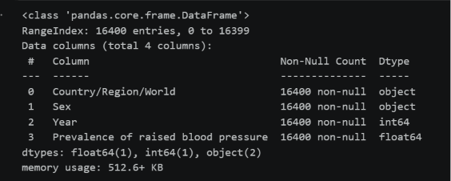
Appendix 1: Structure of the Raised Blood Pressure sheet

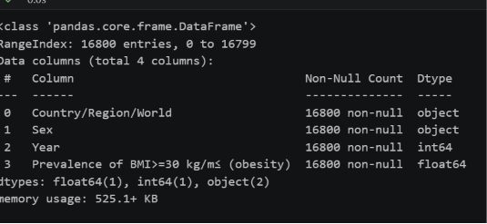
Appendix 2: Structure of the Body Mass Index (BMI) sheet

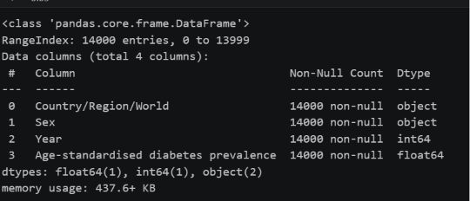
Appendix 3: Structure of the Diabetes sheet
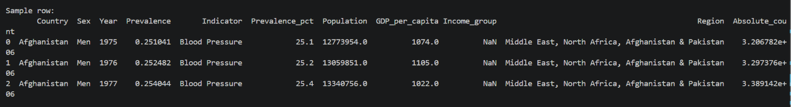
Appendix 4: Structure of merged csv file
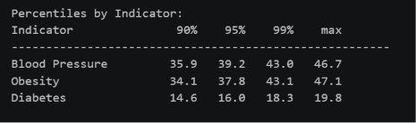
Appendix 5 : Boxplot to check outliers
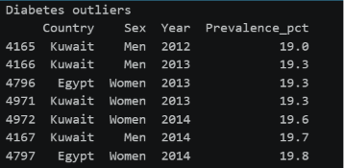
Appendix 6:

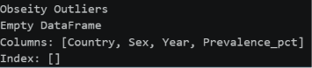
Appendix 7:
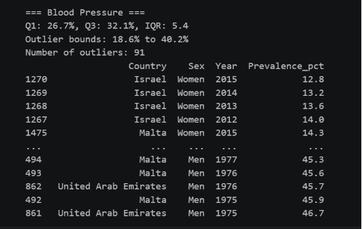
Appendix 8:

