Assessment 1 – Report on Data Visualisation
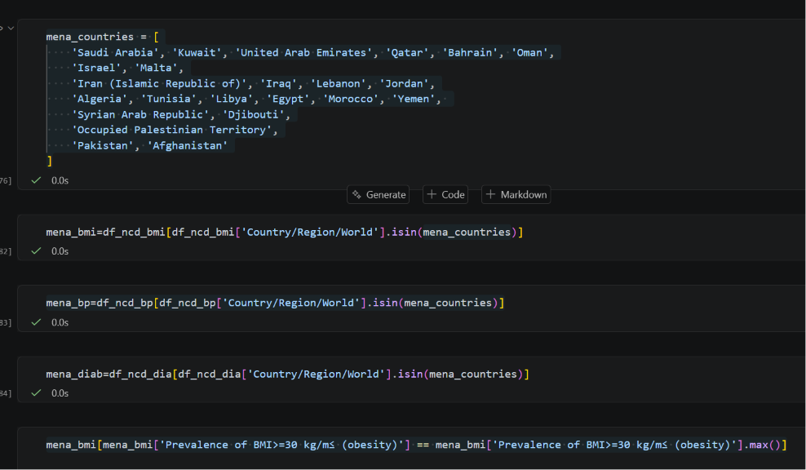
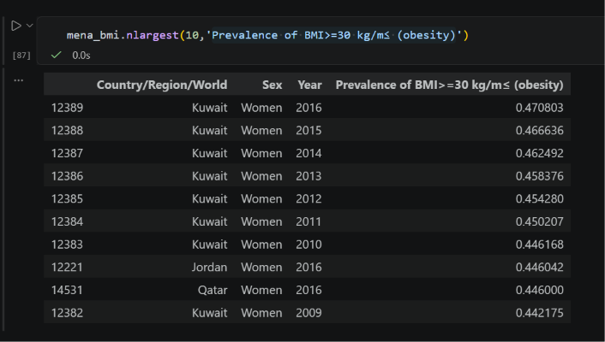

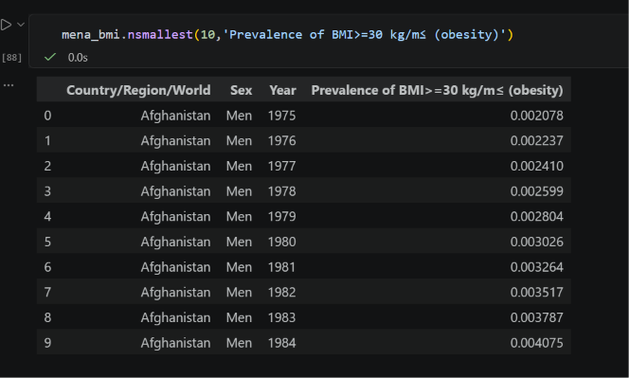
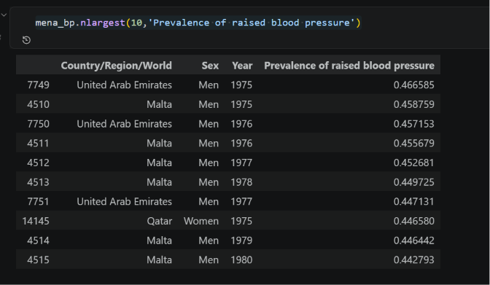
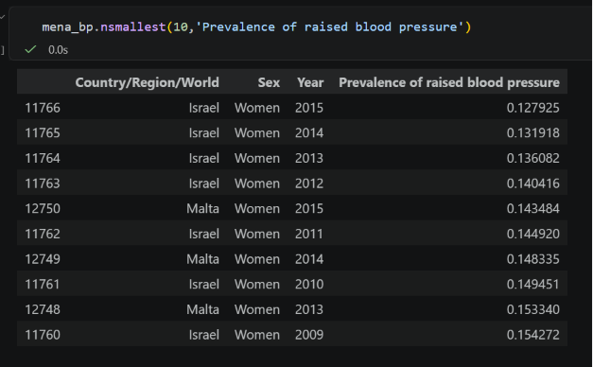
The World Bank population dataset (indicator SP.POP.TOTL) was filtered to the 23 MENA countries that comprise the study region. Country-name conventions differ between the World Bank and NCD-RisC sources — for example, Egypt is recorded as 'Egypt, Arab Rep.' in World Bank data and simply 'Egypt' in NCD-RisC — so two parallel country lists were maintained during this exploratory phase. In subsequent Data Preparation, ISO-3 country codes will be adopted as the canonical key for cross-source matching

