INCIDENT LIFE CYCLE AUTOMATION

Solution Architecture
Layered architecture aligned to the incident lifecycle
━━━━━━━━━━━━━━━━━━━━━━━━━━━━━━━━━━━━━━━━━━━━━━━━━━━━━━━━━━━━━━━━━━━━━━
STUDENT NAME  Shanmugapriya M | PROJECT  Incident Life Cycle Automation
DOCUMENT DATE  08 October 2026 | SCOPE  Incident lifecycle workflow & automation only

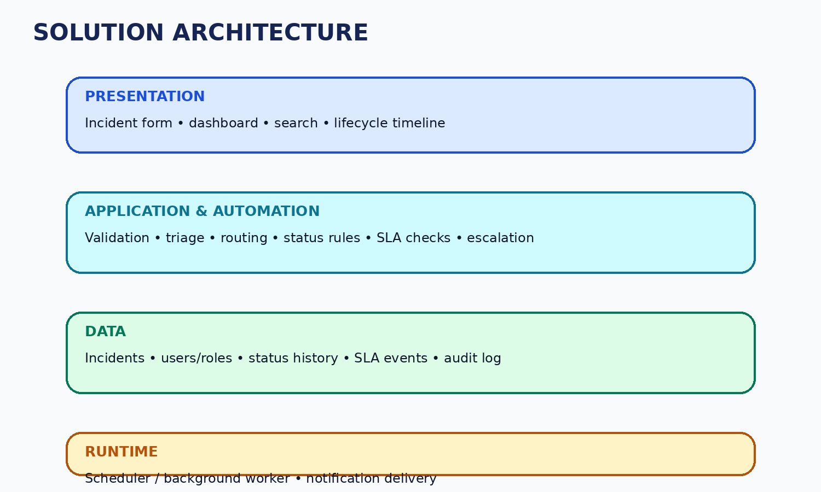
Layer | Responsibility | Project Components
Presentation | Collect input and show lifecycle state | Incident form, incident detail, dashboard, filters, timeline
Application & Automation | Apply lifecycle rules and trigger automated actions | Validation, triage, routing, status transitions, SLA checks, escalation
Data | Persist operational and audit information | Incidents, users/roles, status history, SLA events, audit log
Runtime | Run scheduled checks and message delivery | Scheduler/background worker, notification service

Architecture Principle
Keep user interaction, lifecycle logic, persistent data and scheduled automation separated so the project remains understandable and maintainable.

