INCIDENT LIFE CYCLE AUTOMATION

Data Flow Diagram & User Stories
Backlog-ready user stories aligned with the incident lifecycle
━━━━━━━━━━━━━━━━━━━━━━━━━━━━━━━━━━━━━━━━━━━━━━━━━━━━━━━━━━━━━━━━━━━━━━
STUDENT NAME  Shanmugapriya M | PROJECT  Incident Life Cycle Automation
DOCUMENT DATE  08 October 2026 | SCOPE  Incident lifecycle workflow & automation only

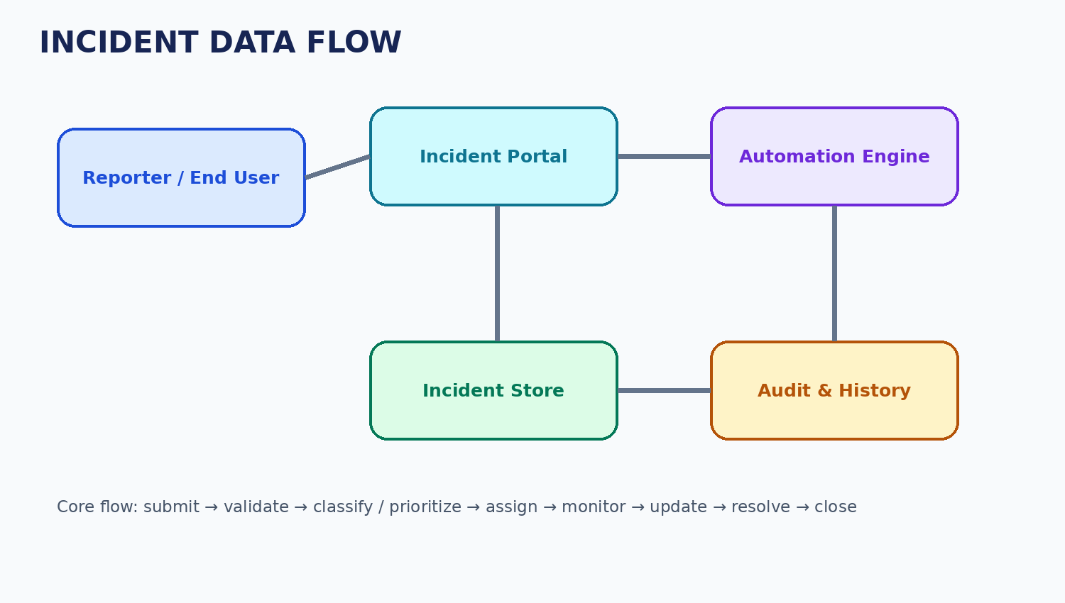

1. User Stories
User Type | Epic | Story | User Story | Acceptance Criteria | Priority
Reporter | Incident Intake | US-01 | Submit an incident with required details. | A unique ID is generated and the incident enters Logged/New. | High
Reporter | Status Tracking | US-02 | View current status and owner. | Current status, owner and last update are visible. | High
Support Engineer | Assignment | US-03 | See incidents assigned to me. | Assigned incidents are clearly listed with key details. | High
Support Engineer | Investigation | US-04 | Add work notes and lifecycle updates. | Authorized updates are timestamped in history. | High
Support Engineer | Resolution | US-05 | Record a resolution summary. | Resolution details are required before Resolved. | High
Incident Manager | Triage | US-06 | Review category, impact, urgency and priority. | Priority is visible and changes are recorded. | High
Incident Manager | Routing | US-07 | Assign or reassign an incident. | Ownership changes are immediately reflected and audited. | High
Incident Manager | SLA | US-08 | Monitor SLA risk and escalation. | At-risk/breached states are identifiable and escalation occurs. | High
Administrator | Rules | US-09 | Maintain routing and SLA rules. | Authorized rule changes affect future lifecycle processing. | Medium
Reviewer | Audit | US-10 | Review incident history. | Key who/what/when changes are visible. | Medium

