|  |  |
| --- | --- |
|  | **Cognizant Academy** **KASA IT Finishing School - Feedback Automation** **HTML TechnologiesKnock Out Challenge**  **Version 1.0** |
| |  |  |  |  | | --- | --- | --- | --- | |  | **Prepared By / Last Updated By** | **Reviewed By** | **Approved By** | | **Name** |  |  |  | | **Role** |  |  |  | | **Signature** |  |  |  | | **Date** |  |  |  | |
|  |

Table of Contents

1.0 Introduction 3

1.1 Purpose 3

1.2 Definitions & Acronyms 3

1.3 Project Overview 3

1.4 Scope 3

1.5 Target Audience 3

1.6 Hardware and Software Requirements 3

1.6.1 Hardware Requirements 3

1.6.2 Software Requirements 4

2.0 Functional Requirements 4

3.0 Design Specification 5

3.1 UI Design 5

3.2 General Design Constraints 5

4.0 Submission 6

4.1 Code submission instructions 6

5.0 Change Log 6

# Introduction

## Purpose of this document

KASA IT Finishing school often conducts Corporate and initial training programs for companies and colleges.  Employees get nominated for these trainings while the students register themselves. Feedback is provided by the participants once a training is over. The organization wants to automate the entire training process to make things simplier and more organized.  To begin with they plan to automate just the feedback received from the Colleges.

The requirement is to design a webpage, that displays a training feedback form with the required parameters where the participants can type their training feedback for the trainers. So create a Web page ”College Training Feedback Form”that has the following fields such as the participant name,college name, participant address, gender, email, mobile number, trainer’s name, course name, course completion date and trainer’s feedback rating and the Feedback should be displayed. The styles should be applied using CSS3 and the feedback should be displayed using Javascript.

1.2Definitions & Acronyms

|  |  |
| --- | --- |
| Definition / Acronym | Description |
| Nill |  |
|  |  |
|  |  |
|  |  |

## Project Overview

This project enables to implement the concepts of Web technologies such as HTML5, CSS3 and Javascript and helps to acquire the skills required by a Web designer. The HTML5, CSS3 and Javascript requirements are given precisely so that the associate can implement the various concepts learned in all these web technologies. The individual associate is expected to carry out the knock out challenge and complete it within 2 hours.

## Scope

The scope of KASA IT Finishing school – Feedback Automation is focused on the following:

1. Designing a Web page ”College Training Feedback Form” with the specified fields.
2. Applying the styles using CSS to the components.
3. Using JavaScript for displaying the feedback.

## Target Audience

Learner Level

## Hardware and Software Requirements

### Hardware Requirements

|  |  |  |
| --- | --- | --- |
| # | Item | Specification/Version |
|  |  |  |
|  |  |  |
|  |  |  |

### Software Requirements

|  |  |  |
| --- | --- | --- |
| # | Item | Specification/Version |
| 1. | HTML | 5 |
| 2. | CSS | 3 |
| 3. | Javascript |  |

Note: All the required hardware and software will be provided in the TekStac platform

# Functional Requirements

|  |  |  |
| --- | --- | --- |
| Req. # | Req. Name | Req. Description |
| 1 | Design a Web page  “College Training Feedback Form” with the specified fields. | |  |  |  | | --- | --- | --- | | **Label Name** | **Component  Name**  **(Specify it for the “name” attribute)** | **Description** | | Participant Name | participantName | To enter the name of the participant.  **It should be mandatory.** | | College Name | collegeName | To enter the college name of the participant.  **It should be mandatory.** | | Participant Address | participantAddress | To enter the address of the participant.  **Provide the correct tag and attribute to create a text area with  5 rows and 20 columns.**  **It should be mandatory.** | | Gender | gender | Select the gender.  **Provide the correct input type to make this component a radio button.**  **It should be mandatory.** | | Email ID | email | To enter the email of the participant.  Use type=”email” or type=”text. If you use type=”text”,use “pattern” attribute along with it.  **It should be mandatory.** | | Mobile Number | mobileNumber | To enter the mobile number.  Use type=”tel” or type=”text or type=”number”. If you use type=”text” or type=”number”, use “pattern” attribute to accept whether the 10 digit mobile no starts with either one of the following numbers:  7,8 or 9  **It should be mandatory.** | | Trainer’s Name | trainerName | To enter the trainer’s name.  **It should be mandatory.** | | Course Name | courseName | To enter the course name for which the feedback is being provided.  **It should be mandatory.** | | Course Completion date | dateofcompletion | To select the date of completion of the course.  Use type=”date” or type=”text. If you use type=”text”,use “pattern” attribute to accept the dateofcompletion in the following format :  mm/dd/yyyy  **It should be mandatory.** | | Trainer’s Feedback | trainerFeedback | An auto-complete feature should be available to the user for the following options.  **Excellent, Very Good, Good, Average, Below Average**  **(Use DataList with id attribute’s value as “feedback” to make use of auto-complete feature with options**  **Excellent, Very Good, Good, Average, Below Average).**  **It should be mandatory.** | | Submit Feedback | submit | The input type submit must be used. | | Clear | reset | Reset Button.  On clicking this button, all fields should be reset.  Provide the input type for this component. |    NOTE: The text highlighted in bold in the Description needs to be implemented in the code to complete the web page design. **Use the Label Name and the Component Name as given. The Component Name is mandatory. All the necessary attributes for the Components should be given.**  **All Tags, Elements and Attributes should conform to HTML5 Standards(All Tags, Elements and Attributes should be specified in Lowercase). All the fields are mandatory.** |
| 2 | Apply the mentioned styles using CSS to the components | 1.       Body color should be “#FFAACC”.  2.       The heading should be done using <h1> tag, the text color should be “#770080”, font should be “Courier New”, style should be “italics” and it should be aligned to center of the webpage.  3.       The result should be bold and color of the text should be #770080.  Note: Fill in the  style tag so that the given styles are applied to the components.  (Do not use Inline CSS) |
| 3 | Use JavaScript for displaying the feedback | Use JavaScript for doing the following calculation:  When the participant enters the valid values and clicks the “Submit Feedback” button, the feedback for the trainer has to be displayed based on the following assumptions :     |  |  | | --- | --- | | *Feedback* | *Feedback Rate* | | Excellent | 5 | | Very Good | 4 | | Good | 3 | | Average | 2 | | Below Average | 1 |     The result should be displayed as  “Feedback rating of *trainerName* is *feedbackRate* ”  in a div tag with  id  “result”.  Note: Use getElementsByName() or getElementById() function to retrieve the values. |
| 4 | form Tag with attribute onsubmit | **form** Tag is already given in the code template. Do not change the code template and do the coding as per the requirement and specification.  Make sure that the onsubmit attribute in the form tag is invoking the JavaScript function like "**return calculateFeedbackRating()**".  Also ensure that “return false;” statement is the last line of the JavaScript function **“calculateFeedbackRating()”.** |

# Design Specifications

## UI Design

Sample Webpage:

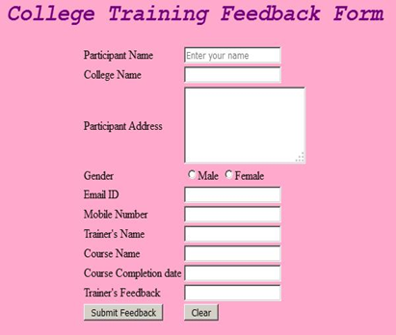

On providing the values the web page should look as follows :

Output Webpage: 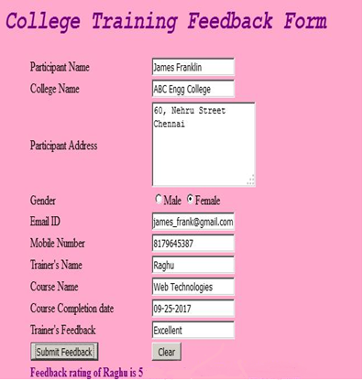

## General Design Constraints

**RULES/CONSTRAINTS: All validations for the field elements should be based on HTML 5**

# Submission

## Code submission instructions

Do not change the code skeleton given as your code will be auto evaluated.

You can validate your solution against sample test cases during the assessment duration.

Your last submitted solution will be considered for detailed evaluation.

Make sure to submit the solution before the specified time limit. Once the time is up, you will not be allowed to submit the solution.

Change Log

|  |  |  |  |  |
| --- | --- | --- | --- | --- |
|  | Changes Made | | | |
| V1.0.0 | Initial baseline created on <dd-Mon-yy> by <Name of Author> | | | |
| Vx.y.z | <Please refer to the configuration control tool / change item status form if the details of changes are maintained separately. If not, the template given below needs to be followed> | | | |
| **Section No.** | **Changed By** | **Effective Date** | **Changes Effected** |
|  |  |  |  |