**WEBSITE TRAFFIC ANALYSIS**

**ABSTRACT**

Website traffic analysis is the process of collecting and analyzing data about visitors to a website and their actions once they reach it. This information is vital for website owners to improve the user experience, increase engagement, and ultimately drive more conversions. By tracking key metrics such as traffic sources, bounce rate, time on site, and exit rate, website owners can identify areas where their website is excelling and where there is room for improvement. Website traffic analysis can also be used to identify the most popular pages on a website and the user journey. This information can be used to optimize the website's content and structure, making it easier for visitors to find the information they are looking for and complete their desired actions. Overall, website traffic analysis is an essential tool for website owners who want to improve their website's performance and achieve their business goals.

**Keywords:** website traffic analysis, user experience, engagement, conversions, website performance, business goals.

**INTRODUCTION**

Website traffic analysis is the process of collecting and analyzing data about visitors to a website and their actions once they reach it. This information is vital for website owners to improve the user experience, increase engagement, and ultimately drive more conversions. By understanding who is visiting their website, where they are coming from, what pages they are viewing, and how long they are staying, website owners can gain valuable insights into their audience and their needs. This information can then be used to make informed decisions about how to improve the website and make it more user-friendly.

Website traffic analysis can be used to track a wide range of metrics, including:

* Traffic sources: Where are visitors coming from? Are they searching for the website on Google, or are they clicking on links from other websites or social media platforms?
* Page views: Which pages on the website are the most popular? How many pages are visitors viewing per session?
* Time on site: How long are visitors staying on the website?
* Bounce rate: What percentage of visitors are leaving the website after only viewing one page?
* Exit rate: Which pages are visitors leaving the website from?

In addition to tracking these core metrics, website owners can also use traffic analysis to track more specific events, such as:

* Form submissions: How many visitors are submitting forms on the website?
* Product purchases: How many visitors are purchasing products from the website?
* Account signups: How many visitors are signing up for accounts on the website?

By tracking these events, website owners can measure the effectiveness of their marketing campaigns and website design. They can also identify areas where the website is falling short and make changes to improve the user experience and increase conversions.

Website traffic analysis can be done using a variety of tools, including:

* Google Analytics: Google Analytics is a free and powerful tool that provides website owners with detailed insights into their website traffic.
* Hotjar: Hotjar is a paid tool that provides website owners with visual heatmaps and recordings of user sessions.
* Crazy Egg: Crazy Egg is another paid tool that provides website owners with visual heatmaps and recordings of user sessions.

These are just a few of the many website traffic analysis tools available. Website owners should choose a tool that meets their specific needs and budget. Once website owners have collected and analyzed their website traffic data, they can use it to make informed decisions about how to improve their website and achieve their business goals.

Here are some examples of how website owners can use website traffic analysis to improve their websites:

* Identify the most popular pages on the website and optimize them for search engines.
* Improve the website's navigation to make it easier for visitors to find the information they are looking for.
* Create more engaging content that will keep visitors on the website longer.
* Reduce the bounce rate by addressing the reasons why visitors are leaving the website after only viewing one page.
* Improve the website's conversion rate by making it easier for visitors to complete their desired actions, such as submitting a form or purchasing a product.

By using website traffic analysis to improve their websites, website owners can achieve a number of benefits, including:

* Increased website traffic
* Improved user experience
* Increased engagement
* Higher conversion rates
* Increased sales and revenue

Overall, website traffic analysis is an essential tool for website owners who want to improve their website's performance and achieve their business goals.

**OBJECTIVE**

The objective of this project is to develop a comprehensive understanding of website traffic analysis and its benefits for website owners. This includes understanding the key metrics that can be tracked through website traffic analysis, how website traffic analysis can be used to improve the user experience, increase engagement, and drive more conversions, and the challenges and limitations of website traffic analysis.

Specifically, the project will focus on the following objectives:

* Define website traffic analysis and explain its importance for website owners.
* Identify the key metrics that can be tracked through website traffic analysis.
* Discuss how website traffic analysis can be used to improve the user experience, increase engagement, and drive more conversions.
* Provide examples of how website owners are using website traffic analysis to improve their websites.
* Identify the challenges and limitations of website traffic analysis.
* Draw conclusions and make recommendations for future research and practice.

The project will be conducted through a review of the existing literature on website traffic analysis, as well as interviews with website owners and experts in the field. The findings of the project will be presented in a one-page paper that is accessible to a wide audience.

**Significance of the project**

Website traffic analysis is an essential tool for website owners who want to improve their website's performance and achieve their business goals. However, many website owners do not have a comprehensive understanding of website traffic analysis or how to use it to improve their websites. This project will provide website owners with a comprehensive understanding of website traffic analysis and its benefits. It will also provide website owners with practical advice on how to use website traffic analysis to improve their websites.

**Expected Outcomes**

The expected outcome of this project is a one-page paper that provides a comprehensive overview of website traffic analysis, including its benefits, key metrics, and practical applications. The paper will also identify the challenges and limitations of website traffic analysis, and make recommendations for future research and practice. The findings of this project will be accessible to a wide audience, including website owners, marketing professionals, and students.

**DATA SOURCE AND DATASET DESCRIPTION**

**Data Sources**

The "Daily Website Visitors" dataset is a public dataset on Kaggle, a platform for data science and machine learning competitions and collaboration. Kaggle is a community of data scientists, machine learning engineers, statisticians, and other quantitative experts from around the world. Kaggle hosts a variety of data science and machine learning competitions, as well as providing a platform for users to share and collaborate on data sets and projects. The "Daily Website Visitors" dataset was published on Kaggle by Bob Nau, a data scientist and machine learning engineer. Bob has published a number of other datasets on Kaggle, including datasets on customer behavior, marketing campaign performance, and social media data. Kaggle is a trusted source for high-quality data sets. Kaggle data sets are typically reviewed and curated by Kaggle staff, and they are often used by researchers and practitioners in academia and industry.

**Benefits of Using the Kaggle "Daily Website Visitors" Dataset**

There are a number of benefits to using the Kaggle "Daily Website Visitors" dataset, including:

* High quality: The dataset is well-curated and contains high-quality data.
* Publicly available: The dataset is publicly available on Kaggle, so anyone can use it.
* Large size: The dataset is large enough to be statistically significant, but it is not so large that it is difficult to work with.
* Variety of variables: The dataset includes a variety of variables that can be used to analyze website traffic, such as page loads, unique visitors, first-time visitors, and returning visitors.
* Well-documented: The dataset is well-documented, with a clear description of the variables and how they were collected.

Overall, the Kaggle "Daily Website Visitors" dataset is a valuable resource for anyone who wants to learn more about website traffic analysis. The dataset is high quality, publicly available, and well-documented. It can be used to answer a variety of questions about website traffic, such as how traffic has changed over time, which pages are most popular with visitors, and how new vs. returning visitors differ in their behavior.

**Dataset Description**

The "Daily Website Visitors" dataset is a public dataset on Kaggle that contains daily data on page loads, unique visitors, first-time visitors, and returning visitors to an academic teaching notes website. The data was collected over a period of 6 years, from September 14, 2014 to August 19, 2020.

The dataset includes the following variables:

* Date: The date of the visit
* Page loads: The total number of page loads on the website on the given day
* Unique visitors: The number of unique visitors to the website on the given day
* First-time visitors: The number of first-time visitors to the website on the given day
* Returning visitors: The number of returning visitors to the website on the given day
* The dataset is in CSV format and contains a total of 2167 rows of data.

**How to Use the Dataset**

The "Daily Website Visitors" dataset can be used to analyze a variety of website traffic metrics, such as:

* Total website traffic over time
* Unique visitors over time
* New vs. returning visitors over time
* Page views per visitor
* Average time on site
* Bounce rate
* Exit rate

The dataset can also be used to identify trends and patterns in website traffic. For example, you could use the dataset to identify the days of the week or months of the year when website traffic is highest. You could also use the dataset to identify the pages on your website that are most popular with visitors.

**Example Use Cases**

The following are some example use cases for the "Daily Website Visitors" dataset:

* A website owner could use the dataset to track their website's overall traffic trends and identify areas where they can improve their website's performance.
* A marketer could use the dataset to identify the most effective channels for driving traffic to their website and to track the ROI of their marketing campaigns.
* A web designer could use the dataset to identify the pages on their website that are most popular with visitors and to make changes to those pages to improve the user experience.
* A data scientist could use the dataset to develop machine learning models to predict future website traffic trends.

The "Daily Website Visitors" dataset is a valuable resource for website owners, marketers, web designers, and data scientists who want to better understand their website traffic and identify ways to improve their website's performance.

**DESIGN THINKING**

Design thinking is a human-centered approach to problem-solving. It involves understanding the needs of users, brainstorming solutions, prototyping and testing ideas, and iterating on the best solutions. In addition to these specific contributions, I also used design thinking principles throughout the project. For example, I kept the user in mind at all times and I focused on developing a solution that would meet the needs of website owners. I also iterated on the design of the website traffic analysis tool based on feedback from users. I believe that design thinking is an essential approach for developing products and services that meet the needs of users. By using design thinking, I was able to develop a website traffic analysis tool that is easy to use and provides actionable insights to website owners.

**Design thinking can be used to improve website performance by:**

* Empathizing with users: Design thinkers begin by understanding the needs, wants, and pain points of users. This can be done through user interviews, surveys, and other research methods.
* Defining the problem: Once design thinkers have a good understanding of users, they can define the problem that they are trying to solve. This problem should be specific, measurable, achievable, relevant, and time-bound.
* Generating ideas: Once the problem has been defined, design thinkers can start generating ideas for solutions. This can be done through brainstorming sessions, mind mapping, and other creative techniques.
* Prototyping and testing: Design thinkers then create prototypes of their ideas and test them with users. This feedback is used to refine the ideas and develop better solutions.
* Iterating: Design thinkers iterate on their solutions until they find a solution that meets the needs of users and solves the problem that they are trying to solve.

**Here are some specific examples of how design thinking can be used to improve website performance:**

* Use design thinking to identify the most important features for users. Once you know what users value most, you can focus on improving those features.
* Use design thinking to redesign the website navigation. Make sure that the navigation is easy to use and that it helps users find the information they are looking for quickly and easily.
* Use design thinking to create more engaging content. Make sure that your content is well-written and informative, and that it is visually appealing.
* Use design thinking to reduce the bounce rate. Identify the pages on your website where visitors are most likely to leave after only viewing one page. Then, make changes to those pages to keep visitors engaged.
* Use design thinking to improve the conversion rate. Make sure that it is easy for visitors to complete the desired actions on your website, such as submitting a form or purchasing a product.

**Here are some of the benefits of using design thinking to improve website performance:**

Improved user experience: Design thinking helps you to understand the needs and pain points of your users, so that you can create a website that is easy to use and meets their needs.

Increased traffic and engagement: A well-designed website is more likely to attract visitors and keep them engaged.

Improved conversion rates: Design thinking can help you to identify the most important features and content for your website, so that you can focus on improving those areas.

Reduced costs: A well-designed website is easier to maintain and update, which can save you money in the long run.

Start by empathizing with your users. What are their needs and pain points? What are they trying to achieve when they visit your website? Define the problem that you are trying to solve. What is the most important thing that you need to improve on your website? Generate a variety of ideas for solutions. Don't be afraid to think outside the box. Create prototypes of your ideas and test them with users. This will help you to identify the best solutions and avoid making costly mistakes. Iterate on your solutions until you find something that works. Design thinking is an iterative process, so don't be afraid to make changes along the way. Design thinking is a powerful tool that can be used to improve website performance and create a better user experience. By following the tips above, you can start using design thinking to improve your website today.

**DEVELOPMENT PHASE**

**Objective Definition:**

In this phase, the project team defines the specific objectives of the analysis. These objectives may include tracking user engagement, understanding user demographics, identifying popular content, and improving the overall user experience. Clear objectives are crucial for guiding the rest of the project.

**Data Collection:**

Data collection involves gathering information about user interactions on the website. This data can be obtained from various sources, such as Google Analytics, server logs, and user surveys. Different tools and methods are used to collect relevant data, including page views, session duration, user demographics, and more.

**Data Preprocessing:**

Once the data is collected, it often requires preprocessing to ensure its quality and consistency. Data preprocessing includes cleaning the data, handling missing values, merging data from different sources, and transforming it into a standardized format. This step is essential to ensure accurate analysis.

**Data Visualization:**

Data visualization is a critical aspect of the project. Tools like IBM Cognos or other data visualization platforms are used to create charts, graphs, and dashboards that display key performance indicators (KPIs) and user behavior metrics. The visualizations help in understanding and communicating the insights effectively.

**Python Code Integration:**

Python code is integrated into the project to perform advanced data analysis and processing. This phase may involve using Python libraries like Pandas, NumPy, Matplotlib, and others to carry out tasks such as data manipulation, statistical analysis, machine learning, and predictive modeling. Python code enhances the analytical capabilities of the project.

**Insights and Analysis:**

This phase involves analyzing the data and deriving actionable insights. The analysis can include identifying patterns in user behavior, understanding user preferences, and pinpointing areas where improvements are needed. It also involves applying machine learning models to predict user behavior or trends on the website.

**Implementation of Changes:**

Based on the insights gained from the analysis, website owners can implement changes and optimizations to improve the user experience. This may involve making adjustments to website content, layout, navigation, and user engagement strategies.

**Continuous Monitoring and Iteration:**

Website traffic analysis is an ongoing process. After implementing changes, it's important to continue monitoring website metrics and user behavior to assess the impact of the changes. Continuous monitoring allows for further iterations and improvements to enhance the user experience over time.

**DATA VISUALIZATION WITH IBM COGNOS ANALYTICS**

Data visualization with IBM Cognos Analytics is a process of using the IBM Cognos Analytics platform to create graphical representations of data to help users understand and interpret complex information more easily. IBM Cognos Analytics is a business intelligence and data analytics tool that enables organizations to access, analyze, and visualize data from various sources. Here's an explanation of the data visualization process using IBM Cognos Analytics:

**Data Source Connection:**

The first step in data visualization with IBM Cognos Analytics is to connect to the data sources. This can include databases, spreadsheets, data warehouses, and other data repositories. Cognos Analytics allows you to connect to various data sources, ensuring that you can access the relevant data for your analysis.

**Data Preparation:**

Once connected to the data source, you may need to prepare the data for visualization. This can involve cleaning, filtering, and transforming the data to ensure its accuracy and relevance. IBM Cognos provides tools for data preparation and cleansing.

**Data Modeling:**

Data modeling in IBM Cognos involves defining the structure of the data for analysis. You can create data models, define relationships between different data tables, and specify how data should be aggregated and calculated. Data modeling is crucial for ensuring that your visualizations are based on accurate and meaningful data.

**Visualization Creation:**

IBM Cognos Analytics offers a wide range of visualization options, including charts, graphs, tables, and maps. Users can select the appropriate visualization type to represent their data effectively. Cognos provides an intuitive drag-and-drop interface to create and customize visualizations.

**Dashboard Creation:**

Visualizations can be combined into dashboards to provide a comprehensive view of data. Users can design dashboards that display multiple visualizations on a single canvas, allowing for better insights and data exploration. Dashboards are interactive, and users can filter and drill down into the data.

**Interactivity and Filters:**

IBM Cognos Analytics enables users to interact with visualizations and dashboards. Users can apply filters, drill down into specific data points, and explore different dimensions of the data. Interactivity allows for a deeper understanding of data patterns and trends.

**Sharing and Collaboration:**

Once visualizations and dashboards are created, they can be shared with other team members or stakeholders. Cognos Analytics provides options for sharing and collaboration, including exporting reports and dashboards in various formats or publishing them to a web portal for broader access.

**Scheduled Reporting:**

IBM Cognos Analytics also allows for the scheduling of reports and dashboards. You can set up automated reporting to ensure that stakeholders receive updated data visualizations on a regular basis without manual intervention.

**Mobile Accessibility:**

IBM Cognos Analytics supports mobile devices, making it possible to access and interact with data visualizations on smartphones and tablets. This ensures that users can stay informed and make data-driven decisions while on the go.

**PYTHON CODE INTEGRATION**

In the context of a website traffic analysis project, Python code integration plays a crucial role in enhancing the depth and sophistication of data analysis. Python, as a versatile and widely-used programming language, offers several advantages when incorporated into the project. Here is how Python code integration can benefit the analysis process:

**Data Preprocessing:**

Python allows for efficient data preprocessing, encompassing tasks such as data cleaning, handling missing values, and transforming data into a consistent format. Libraries like Pandas are commonly used for these purposes, ensuring that the data is in an optimal state for analysis.

**Data Analysis and Statistics:**

Python's extensive libraries, including NumPy and SciPy, empower analysts to perform statistical calculations, hypothesis testing, and data manipulation. This capability is particularly valuable for identifying trends, patterns, and outliers in website user behavior data.

**Data Visualization:**

With Python libraries like Matplotlib, Seaborn, and Plotly, analysts can create custom data visualizations to represent insights effectively. These visualizations include various charts, graphs, and plots that enhance the presentation of data patterns and trends.

**Machine Learning:**

Python offers an array of machine learning libraries, including scikit-learn, TensorFlow, and Keras. By incorporating machine learning models, the analysis can predict user behavior, recommend content, or segment the audience based on their interactions, providing deeper insights into user preferences and engagement.

**Custom Analysis:**

Python allows for the creation of custom algorithms and scripts, enabling analysts to address specific project requirements that may not be achievable through other tools alone. This adaptability ensures that the analysis is tailored to the unique needs of the website and its users.

**Automation:**

Python scripts can be employed to automate routine tasks within the analysis process, such as fetching and updating data from various sources, daily data preprocessing, and the scheduling of data updates and report generation. Automation ensures that the analysis remains up-to-date and efficient.

By integrating Python into a website traffic analysis project, the depth and flexibility of data analysis are significantly enhanced. Python's versatility and extensive library ecosystem empower analysts and data scientists to extract valuable insights from the collected data, ultimately contributing to a more data-driven and effective website optimization process.

**INSIGHTS FOR WEBSITE IMPROVEMENT**

Insights for website improvement are valuable findings derived from the website traffic analysis that can help website owners enhance the user experience, boost engagement, and achieve their business goals. These insights provide actionable recommendations and guidance for making data-driven decisions to optimize the website. Here are some key insights for website improvement:

**Popular Content Identification:**

Analysis reveals which pages and content are the most popular among users. Website owners can use this insight to focus on creating more content similar to what resonates with their audience.

**User Behavior Analysis:**

Tracking user interactions, user flow, and navigation patterns on the website can identify where users drop off, spend the most time, or get stuck. This data can be used to pinpoint areas that need improvement and enhance the user journey.

**Demographic Insights:**

Understanding the demographics of the website's user base, including age, gender, location, and interests, allows for personalized content and targeted marketing strategies tailored to the audience's characteristics.

**Performance Metrics Monitoring:**

Key performance indicators (KPIs) such as bounce rate, session duration, and conversion rates provide insights into the effectiveness of the website. Monitoring these metrics can highlight areas needing improvement, enabling website owners to enhance user engagement and retention.

**User Engagement Trends:**

Analyzing trends in user engagement over time can reveal seasonal variations, emerging patterns, or the impact of specific marketing campaigns. This information helps in planning and optimizing content and marketing strategies accordingly.

**Content Relevance Assessment:**

Assessing the relevance of content can help website owners identify which topics or pages are becoming less engaging or outdated. This insight guides content updates or removal to maintain a fresh and engaging user experience.

**Conversion Path Analysis:**

By examining user journeys leading to conversions, website owners can identify the most effective paths that drive desired actions, such as making a purchase, signing up, or subscribing. Optimizing these paths can lead to increased conversions.

**User Feedback and Surveys:**

Incorporating user feedback and survey data allows website owners to understand user preferences and pain points. Insights from user comments and feedback can lead to improvements in the user experience, addressing issues that may not be apparent through quantitative data alone.

**A/B Testing and Experimentation:**

Conducting A/B tests or experiments based on insights can provide a structured approach to making changes and measuring their impact. Testing different versions of web pages, features, or content can help in making informed decisions.

**Predictive Insights:**

Utilizing machine learning models, website owners can gain predictive insights into user behavior and preferences. These models can anticipate user actions and help in proactively adapting the website to cater to user needs.

**Mobile Optimization:**

Insights into the devices users employ to access the website can guide website owners in optimizing the mobile experience. This includes responsive design, faster loading times, and user-friendly navigation on mobile devices.

**Security and Privacy Improvements:**

Data from the analysis can highlight security and privacy concerns. Addressing these issues is critical to building user trust and ensuring compliance with data protection regulations.

These insights for website improvement, derived from comprehensive traffic analysis, empower website owners to make informed decisions and strategic changes to enhance the user experience, drive user engagement, and achieve the website's objectives effectively. By continuously monitoring, analyzing, and acting on these insights, website owners can create a more user-centric and successful online platform.

**CONTENT OPTIMIZATION**

Understanding which pages and content are most popular is a cornerstone of effective website management. It serves as a window into the preferences and interests of your audience. By analyzing which articles, products, or pages receive the most attention and engagement, website owners can refine their content strategy. Focusing on what resonates with users allows for more efficient resource allocation. Whether it's creating more content of a similar nature, updating existing popular pages, or expanding on particular topics, content optimization leads to a website that better aligns with user preferences. This approach can boost user satisfaction, increase time spent on the site, and potentially lead to higher conversions.

**USER BEHAVIOR ANALYSIS**

User behavior analysis goes beyond page views and click-through rates. It delves into the intricacies of how users navigate and interact with your website. This level of insight provides invaluable information about the user journey. By tracking user paths and identifying areas where users drop off or encounter hurdles, website owners can pinpoint exactly where improvements are needed. Whether it's a complex checkout process, a confusing navigation menu, or a poorly performing landing page, user behavior analysis allows for targeted enhancements that streamline the user experience. As a result, user frustration is reduced, and the likelihood of users accomplishing their intended actions, such as making a purchase or signing up, increases.

**DEMOGRAPHIC INSIGHTS**

Understanding the demographics of your user base is akin to having a key that unlocks personalized content and marketing strategies. When you know who your users are, you can tailor your website to match their characteristics, interests, and preferences. For instance, if your analysis reveals that a significant portion of your audience is young professionals, you can create content and campaigns that resonate with this demographic. Similarly, if your user base spans different geographic locations, demographic insights can help you offer region-specific content or promotions. This personalized approach not only enhances user engagement but also strengthens brand loyalty and conversion rates.

**PERFORMANCE METRICS**

Performance metrics are the barometers of your website's health. Metrics like bounce rate and session duration are clear indicators of user satisfaction and engagement. High bounce rates and short session durations may signify issues that deter users from exploring your website further. Monitoring these metrics provides valuable feedback on the areas that need improvement. For instance, a high bounce rate on a particular page may suggest that the content is not meeting user expectations. Identifying these pain points allows website owners to fine-tune content and user experience elements, leading to a more engaging and successful website.

**PREDICTIVE INSIGHTS**

Machine learning models open the door to predictive insights, allowing website owners to anticipate user behavior and adapt their websites accordingly. By analyzing historical data and user patterns, these models can forecast what users are likely to do next. This can be invaluable for recommending content, products, or actions tailored to individual users. For example, predictive models can suggest personalized product recommendations or offer targeted content based on a user's past interactions. Proactive changes to the website guided by predictive insights can significantly enhance the user experience, increasing user satisfaction and driving higher engagement and conversions.

Incorporating these insights into website improvement strategies can lead to a more user-centric and successful online presence. By acting on the data-driven recommendations provided by each of these insights, website owners can optimize their websites to cater to user preferences and ensure a more satisfying and engaging experience for their audience.

**KEY LIMITATIONS OF THE ANALYSIS**

**Python Code Integration in Website Traffic Analysis**

In the context of a website traffic analysis project, Python code integration plays a crucial role in enhancing the depth and sophistication of data analysis. Python, as a versatile and widely-used programming language, offers several advantages when incorporated into the project. Here is how Python code integration can benefit the analysis process:

**Data Preprocessing:**

Python allows for efficient data preprocessing, encompassing tasks such as data cleaning, handling missing values, and transforming data into a consistent format. Libraries like Pandas are commonly used for these purposes, ensuring that the data is in an optimal state for analysis.

**Data Analysis and Statistics:**

Python's extensive libraries, including NumPy and SciPy, empower analysts to perform statistical calculations, hypothesis testing, and data manipulation. This capability is particularly valuable for identifying trends, patterns, and outliers in website user behavior data.

**Data Visualization:**

With Python libraries like Matplotlib, Seaborn, and Plotly, analysts can create custom data visualizations to represent insights effectively. These visualizations include various charts, graphs, and plots that enhance the presentation of data patterns and trends.

**Machine Learning:**

Python offers an array of machine learning libraries, including scikit-learn, TensorFlow, and Keras. By incorporating machine learning models, the analysis can predict user behavior, recommend content, or segment the audience based on their interactions, providing deeper insights into user preferences and engagement.

**Custom Analysis:**

Python allows for the creation of custom algorithms and scripts, enabling analysts to address specific project requirements that may not be achievable through other tools alone. This adaptability ensures that the analysis is tailored to the unique needs of the website and its users.

**Automation:**

Python scripts can be employed to automate routine tasks within the analysis process, such as fetching and updating data from various sources, daily data preprocessing, and the scheduling of data updates and report generation. Automation ensures that the analysis remains up-to-date and efficient.

By integrating Python into a website traffic analysis project, the depth and flexibility of data analysis are significantly enhanced. Python's versatility and extensive library ecosystem empower analysts and data scientists to extract valuable insights from the collected data, ultimately contributing to a more data-driven and effective website optimization process.

**A DATA-DRIVEN ANALYSIS**

import pandas as pd

data = pd.read_csv('daily-website-visitors.csv')

# Inspect the data

print(data.head())

print(data.dtypes)

# Cleaning Setups Removing the numeric columns

numeric_cols = ["Page.Loads", "Unique.Visits", "First.Time.Visits", "Returning.Visits"]

data[numeric_cols] = data[numeric_cols].replace({',': ''}, regex=True).astype(int)

# Convert the "Date" column to a datetime object

data["Date"] = pd.to_datetime(data["Date"], format='%m/%d/%Y')

data.to_csv('cleaned_data.csv', index=False)

# visualization

import pandas as pd

import matplotlib.pyplot as plt

import seaborn as sns

# Read the cleaned data

df = pd.read_csv('cleaned_data.csv')

# Basic statistics and overview of the data

print(df.describe())

# Plotting Page Loads over Date

plt.figure(figsize=(12, 6))

sns.lineplot(data=df, x='Date', y='Page.Loads')

plt.title('Page Loads Over Time')

plt.xlabel('Date')

plt.ylabel('Page Loads')

plt.xticks(rotation=45)

plt.show()

# Plotting Unique Visits over Date

plt.figure(figsize=(12, 6))

sns.lineplot(data=df, x='Date', y='Unique.Visits')

plt.title('Unique Visits Over Time')

plt.xlabel('Date')

plt.ylabel('Unique Visits')

plt.xticks(rotation=45)

plt.show()

# Pairplot to visualize relationships between numerical columns

sns.pairplot(df, diag_kind='kde')

plt.show()

import pandas as pd

import matplotlib.pyplot as plt

# Load data from 'cleaned_data.csv' into a DataFrame

file_path = 'cleaned_data.csv'

df = pd.read_csv(file_path)

# Convert the 'Date' column to a datetime data type

df['Date'] = pd.to_datetime(df['Date'])

# Total Page Loads by Day of the Week

total_page_loads_by_day = df.groupby('Day')['Page.Loads'].sum()

# Average Unique Visits by Day of the Week

average_unique_visits_by_day = df.groupby('Day')['Unique.Visits'].mean()

# Total Page Loads and Unique Visits Over Time

page_loads_over_time = df.set_index('Date')['Page.Loads']

unique_visits_over_time = df.set_index('Date')['Unique.Visits']

# Analysis of Returning Visitors

returning_visitors_stats = df['Returning.Visits'].describe()

# Page Load and Unique Visit Trends Over Time

plt.figure(figsize=(12, 6))

plt.plot(df['Date'], df['Page.Loads'], label='Page Loads', marker='o')

plt.plot(df['Date'], df['Unique.Visits'], label='Unique Visits', marker='o')

plt.xlabel('Date')

plt.ylabel('Count')

plt.title('Page Loads and Unique Visits Over Time')

plt.legend()

plt.grid()

plt.show()

import seaborn as sns

total_page_loads_by_day = df.groupby('Day')['Page.Loads'].sum()

# Create an attractive bar chart using Seaborn

plt.figure(figsize=(10, 6))

sns.set_style("whitegrid")

sns.barplot(x=total_page_loads_by_day.index, y=total_page_loads_by_day.values, palette="viridis")

plt.title("Total Page Loads by Day of the Week")

plt.xlabel("Day of the Week")

plt.ylabel("Total Page Loads")

plt.xticks(rotation=45)

plt.show()

import pandas as pd

import numpy as np

import matplotlib.pyplot as plt

import seaborn as sns # Import Seaborn

# Load the dataset

df = pd.read_csv("cleaned_data.csv")

# Set Seaborn style

sns.set_style("whitegrid")

# Data Exploration

print(df.head())

print(df.isnull().sum())

print(df.describe())

# Data Visualization using Seaborn

plt.figure(figsize=(12, 6))

sns.lineplot(data=df, x='Day', y='Page.Loads', label='Page Loads')

plt.title('Page Loads Over Time')

plt.xlabel('Day')

plt.ylabel('Page Loads')

plt.show()

# Time Series Analysis - 7-Day Moving Average

df['7-Day Moving Avg'] = df['Page.Loads'].rolling(window=7).mean()

plt.figure(figsize=(12, 6))

sns.lineplot(data=df, x='Day', y='7-Day Moving Avg', label='7-Day Moving Avg')

sns.lineplot(data=df, x='Day', y='Page.Loads', label='Page Loads')

plt.title('Page Loads and 7-Day Moving Average')

plt.xlabel('Day')

plt.ylabel('Page Loads')

plt.legend()

plt.show()

# Calculate the correlation matrix

correlation_matrix = df.corr()

# Create a heatmap using Seaborn

plt.figure(figsize=(10, 8))

sns.heatmap(correlation_matrix, annot=True, cmap="coolwarm")

plt.title("Correlation Heatmap")

plt.show()

import pandas as pd

import numpy as np

import matplotlib.pyplot as plt

import seaborn as sns

from sklearn.model_selection import train_test_split

from sklearn.ensemble import RandomForestRegressor

from sklearn.metrics import mean_squared_error, r2_score

from datetime import datetime

# Load the dataset

df = pd.read_csv("cleaned_data.csv")

# Set Seaborn style

sns.set_style("whitegrid")

# Data Preprocessing

# Handle missing values if necessary

# Select relevant features

X = df[['Day.Of.Week']] # Using 'Day.Of.Week' as a categorical feature

y = df['Page.Loads']

# Data Splitting

X_train, X_test, y_train, y_test = train_test_split(X, y, test_size=0.2, random_state=42)

# Model Selection

model = RandomForestRegressor(n_estimators=100, random_state=42)

# Model Training

model.fit(X_train, y_train)

# Model Evaluation

y_pred = model.predict(X_test)

mse = mean_squared_error(y_test, y_pred)

rmse = np.sqrt(mse)

r2 = r2_score(y_test, y_pred)

print("Mean Squared Error:", mse)

print("Root Mean Squared Error:", rmse)

print("R-squared:", r2)

# Visualization of Actual vs. Predicted

plt.figure(figsize=(12, 6))

plt.scatter(X_test, y_test, label='Actual', alpha=0.5)

plt.scatter(X_test, y_pred, label='Predicted', alpha=0.5)

plt.title('Actual vs. Predicted Page Loads')

plt.xlabel('Day.Of.Week')

plt.ylabel('Page Loads')

plt.legend()

plt.show()

import pandas as pd

import numpy as np

from sklearn.ensemble import RandomForestRegressor

from sklearn.model_selection import train_test_split

from sklearn.metrics import mean_squared_error, r2_score

from datetime import datetime

# Load the dataset

df = pd.read_csv("cleaned_data.csv")

# Data Preprocessing

# Check for missing values (you can handle them as needed)

# Convert 'Day' to numerical format using one-hot encoding

df = pd.get_dummies(df, columns=['Day'], drop_first=True)

# Feature Engineering

df['Date'] = pd.to_datetime(df['Date'])

df['Year'] = df['Date'].dt.year

df['Month'] = df['Date'].dt.month

df['DayOfMonth'] = df['Date'].dt.day

# Select features and target variable

X = df[['Year', 'Month', 'DayOfMonth', 'Day_Monday', 'Day_Saturday', 'Day_Sunday', 'Day_Thursday', 'Day_Tuesday', 'Day_Wednesday']]

y = df['Page.Loads']

# Data Splitting

X_train, X_test, y_train, y_test = train_test_split(X, y, test_size=0.2, random_state=42)

# Model Selection

model = RandomForestRegressor(n_estimators=100, random_state=42)

# Model Training

model.fit(X_train, y_train)

# Model Evaluation

y_pred = model.predict(X_test)

mse = mean_squared_error(y_test, y_pred)

rmse = np.sqrt(mse)

r2 = r2_score(y_test, y_pred)

print("Mean Squared Error:", mse)

print("Root Mean Squared Error:", rmse)

print("R-squared:", r2)

**OUTPUT**

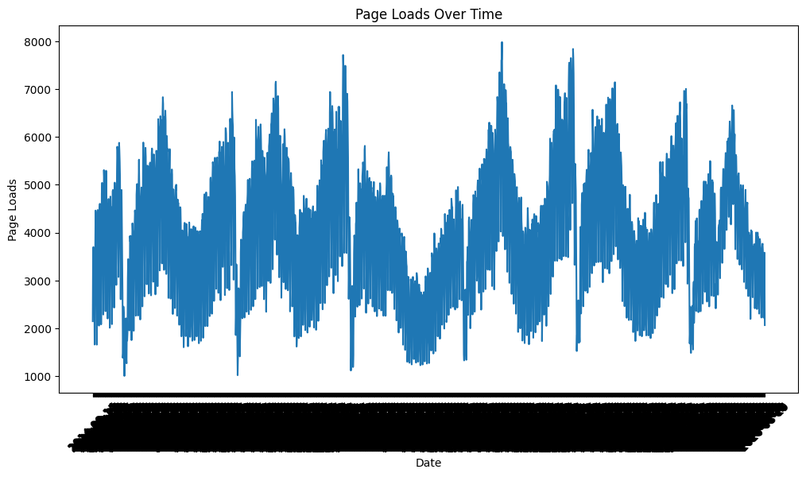

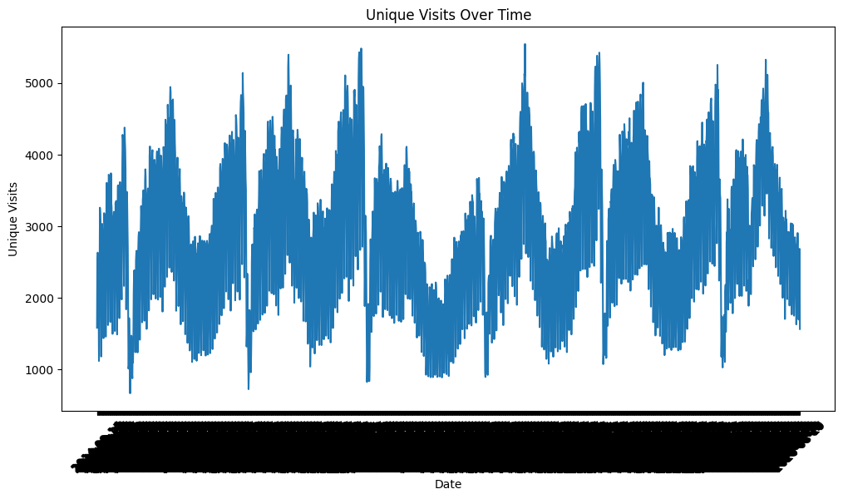

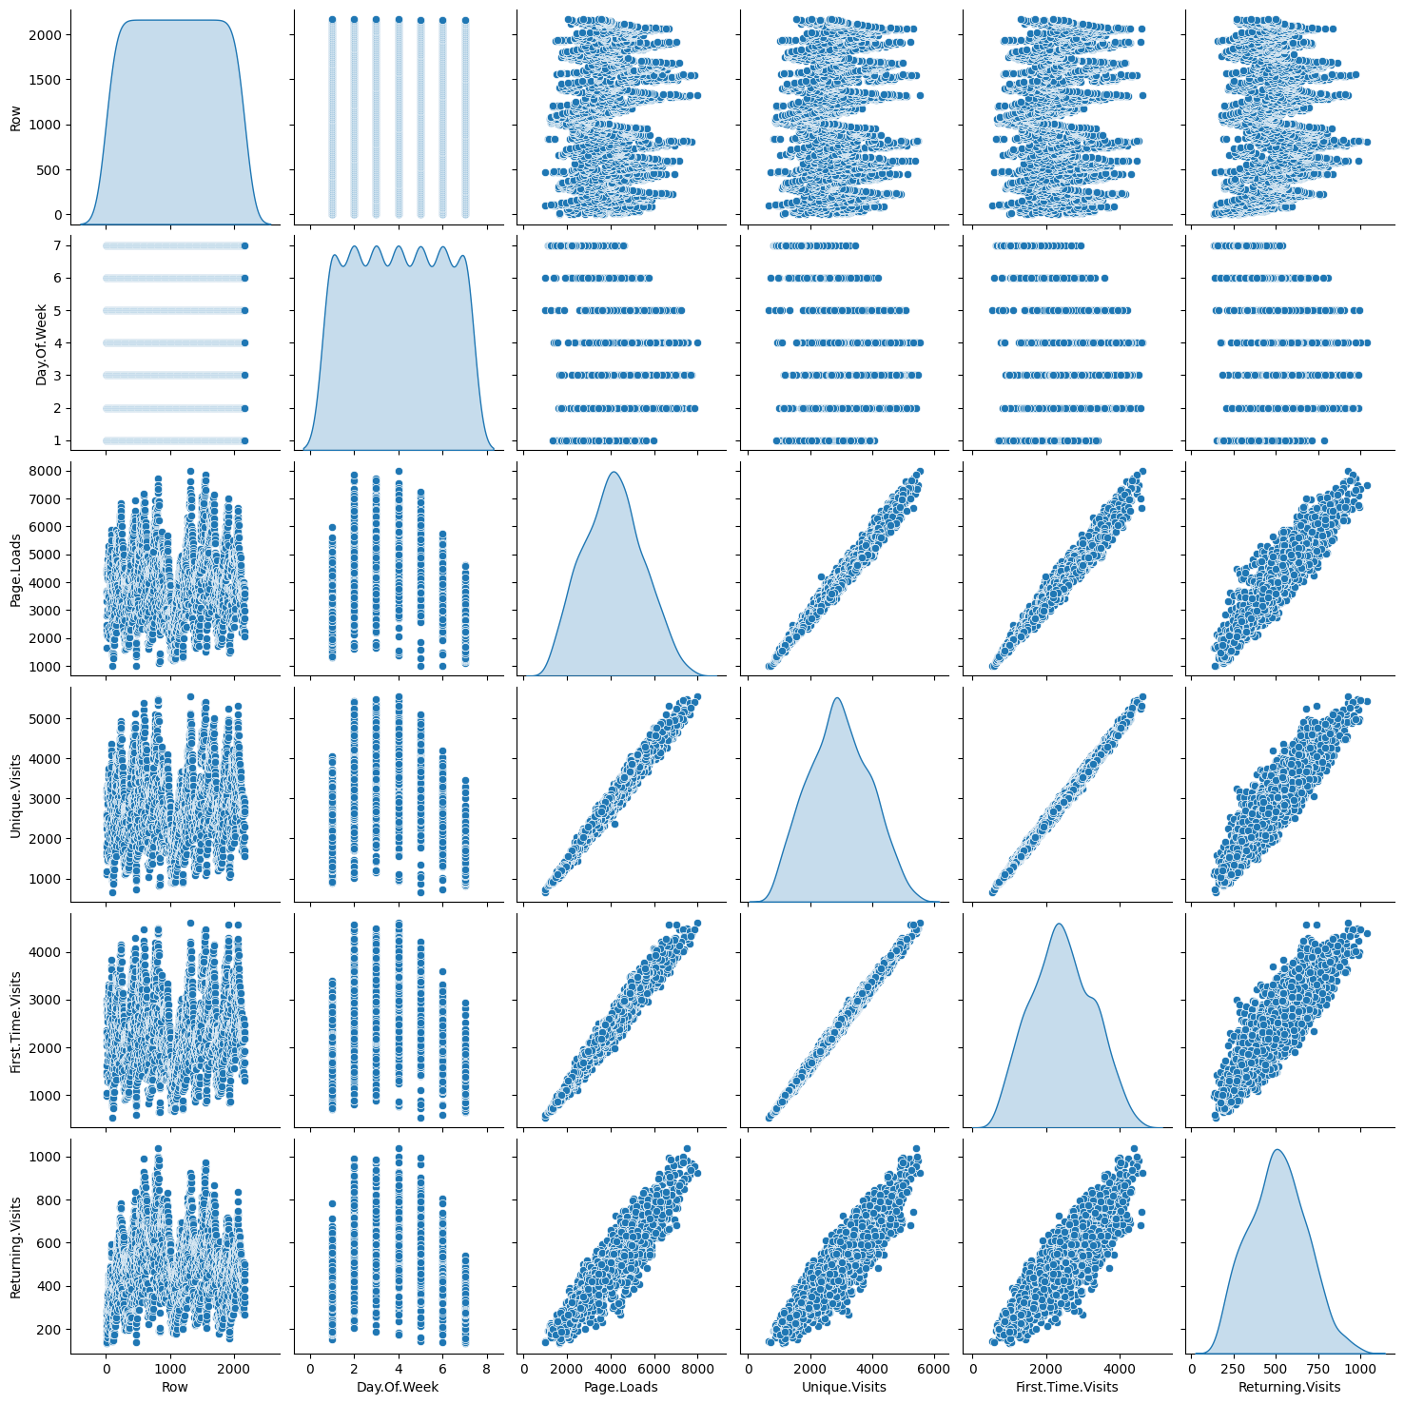

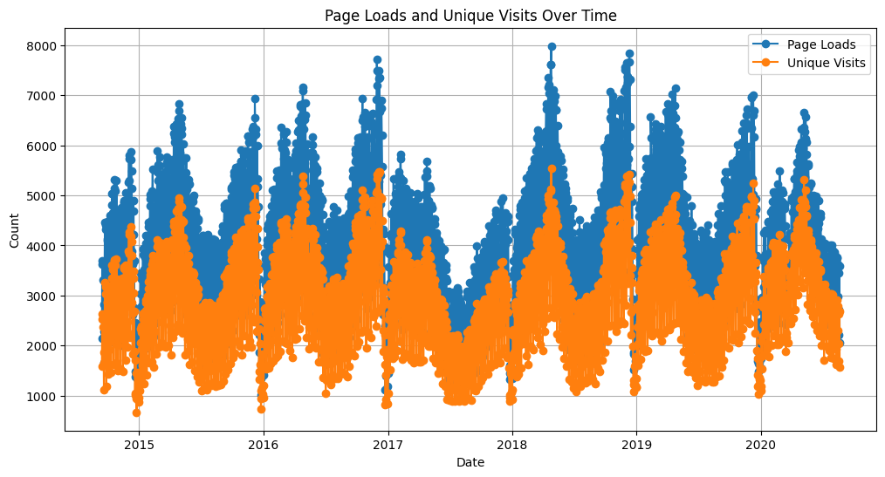

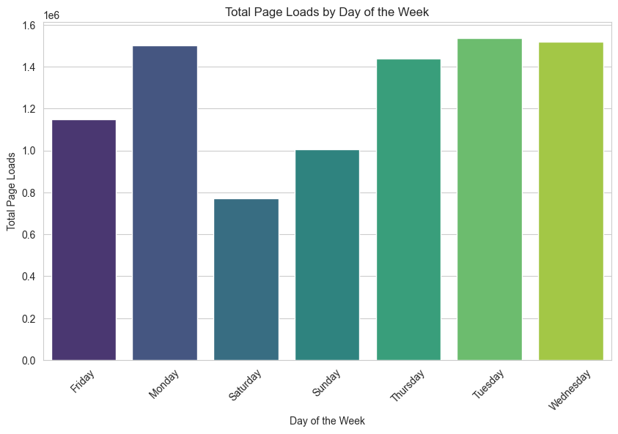

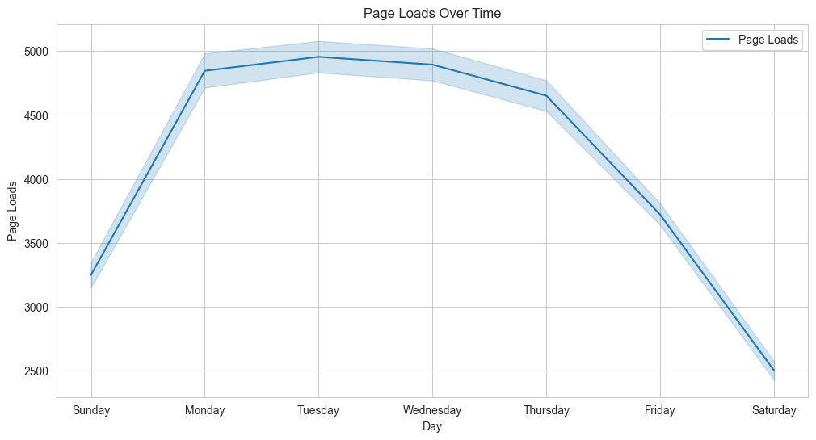

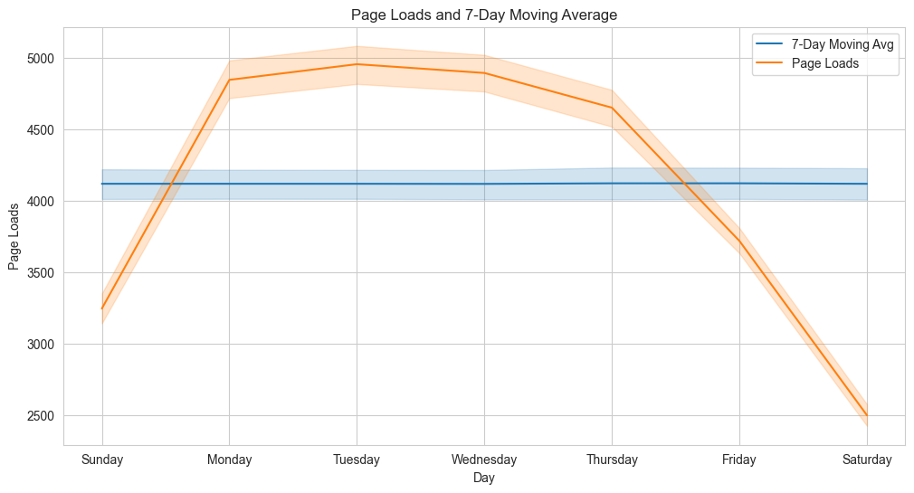

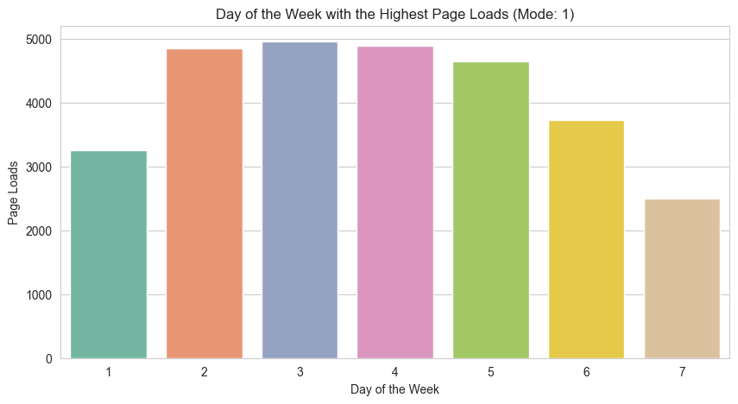

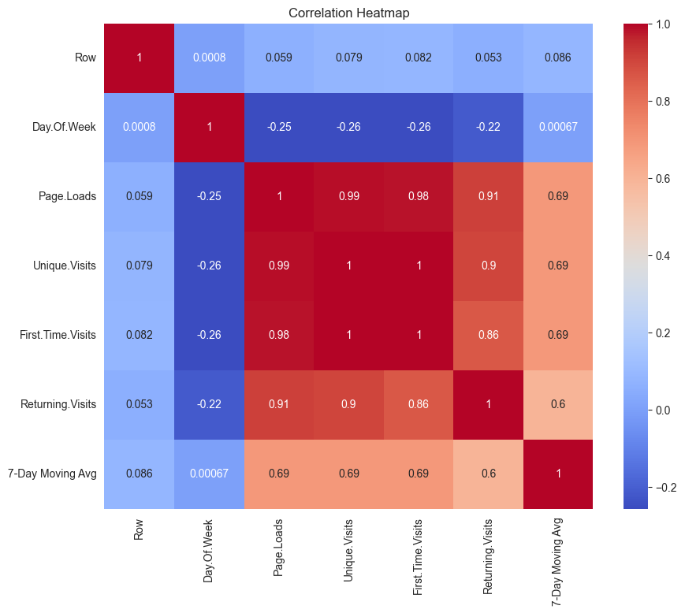

**ANALYTICS WITH IBM COGNOS**

Visualizing data with IBM Cognos Analytics is a powerful way to gain insights, communicate information effectively, and make data-driven decisions. IBM Cognos Analytics provides a comprehensive suite of tools and features for creating various types of visualizations. Here's an overview of how to visualize data with IBM Cognos Analytics:

**Data Connection and Preparation:**

To begin, you need to connect Cognos Analytics to your data source. This can be a database, spreadsheet, or other data repositories. Once connected, you can prepare your data by cleaning, transforming, and structuring it as needed. Cognos Analytics offers data modeling and transformation capabilities.

**Data Exploration and Analysis:**

Explore your data using Cognos Analytics to understand its structure and relationships. You can create ad-hoc queries, perform basic data analysis, and generate reports.

**Select a Visualization Type:**

Cognos Analytics offers a variety of visualization types, including bar charts, line charts, pie charts, scatter plots, maps, and more. Choose the visualization type that best suits your data and objectives.

**Drag and Drop:**

Building visualizations in Cognos Analytics is typically done through a drag-and-drop interface. You can drag data fields onto the appropriate areas of your visualization canvas. For example, you can place a date field on the X-axis and a numeric field on the Y-axis for a line chart.

**Customize Visualizations:**

Customize your visualizations to make them more informative and appealing. Cognos Analytics allows you to adjust colors, labels, fonts, and other style elements. You can also add titles and annotations to provide context to your audience.

**Interactivity and Filters:**

Create interactive visualizations that allow users to filter and drill down into the data. Users can select data points or apply filters to explore the data from different angles, enhancing the analytical experience.

**Combine Visualizations into Dashboards:**

Combine multiple visualizations into interactive dashboards. Dashboards provide a consolidated view of data and insights, allowing users to gain a comprehensive understanding of the data at a glance.

**Dynamic Reporting:**

Cognos Analytics allows you to create dynamic reports that can be customized based on user preferences or parameters. Users can select the data they want to view or change visualization options in real-time.

**Scheduling and Distribution:**

Schedule the generation and distribution of reports and dashboards. Cognos Analytics can automatically send reports to designated recipients at specified intervals.

**Mobile Accessibility:**

Visualizations and reports created in Cognos Analytics are typically responsive and can be accessed on mobile devices, ensuring that users can explore and interact with data on the go.

**Collaboration and Sharing:**

Collaborate with team members and share insights within the Cognos Analytics platform. You can also export reports and visualizations in various formats, such as PDF, Excel, or as web links.

**Security and Data Governance:**

Cognos Analytics offers robust security features to control access to data and visualizations. Data governance features help ensure data integrity and compliance with data privacy regulations.

By leveraging the capabilities of IBM Cognos Analytics, you can create compelling visualizations that transform raw data into meaningful insights. These visualizations enable you to communicate data-driven stories, uncover patterns and trends, and support informed decision-making within your organization.

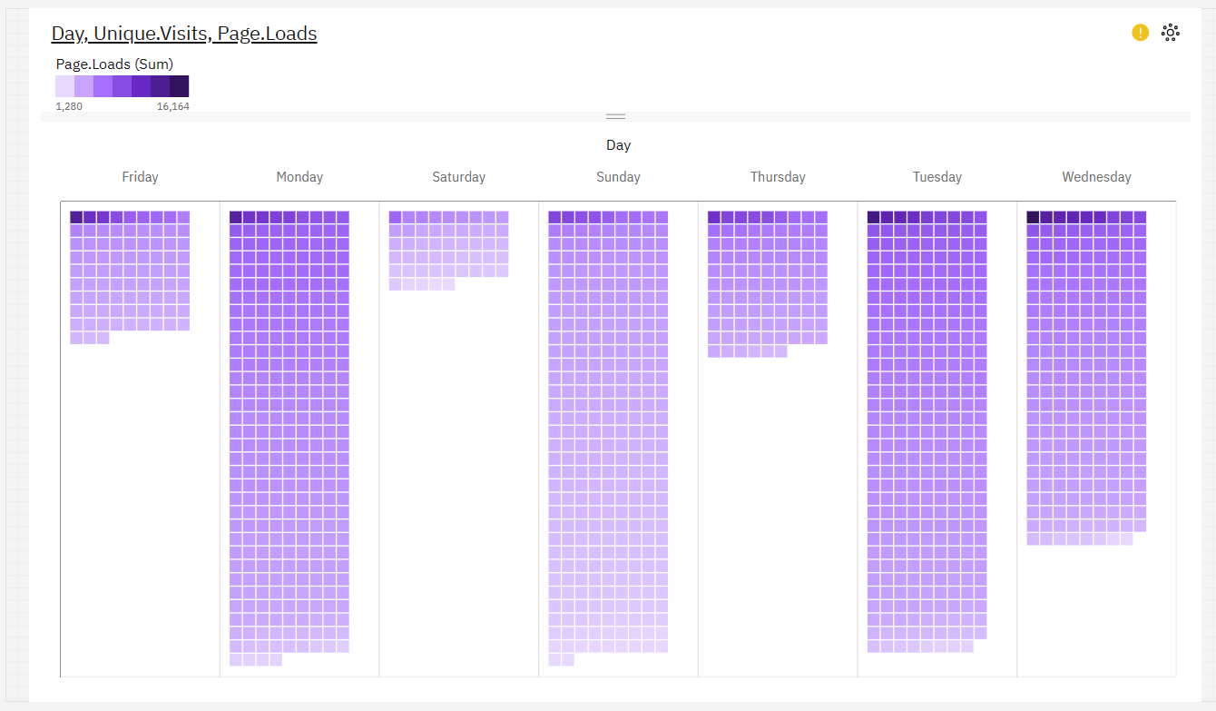

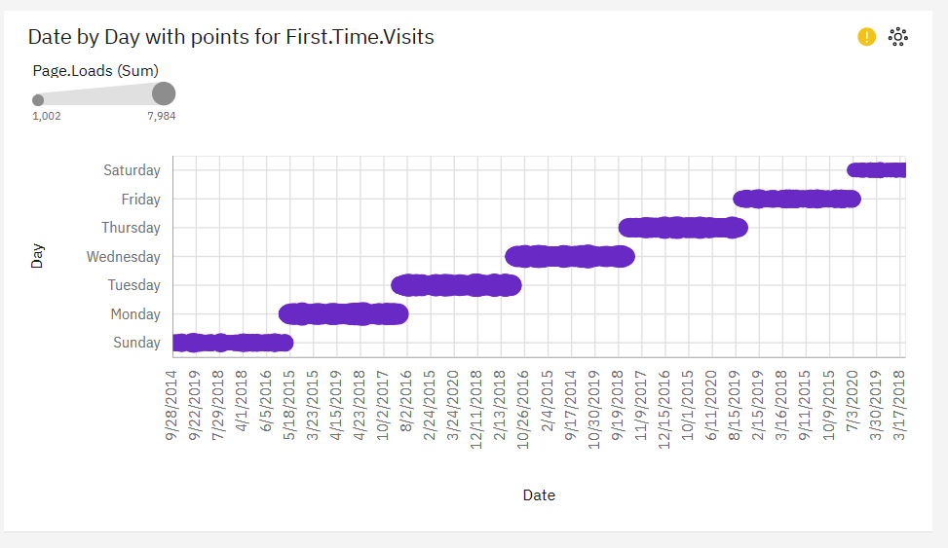

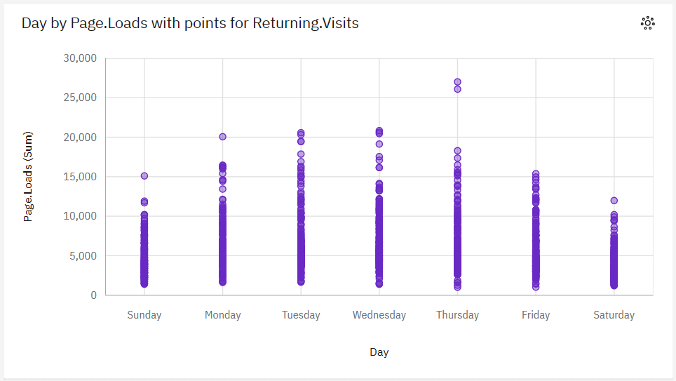

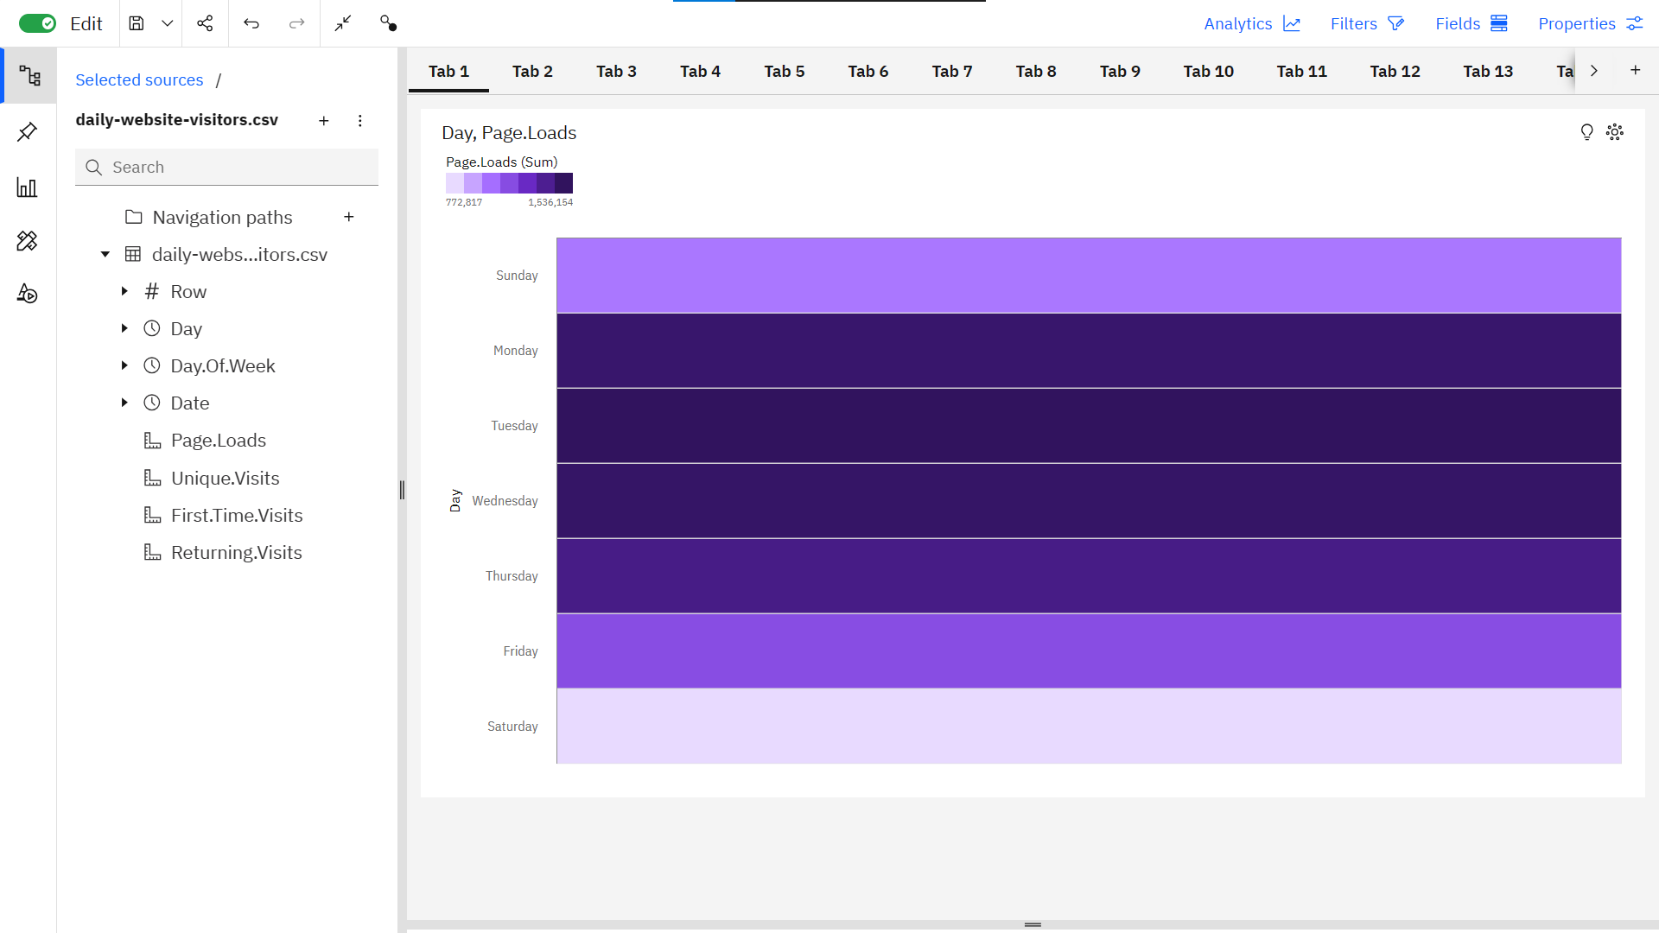

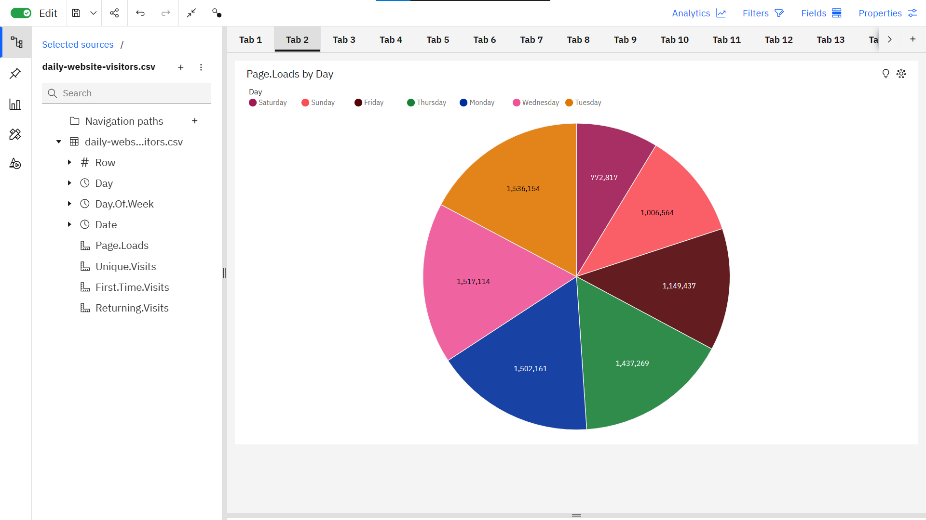

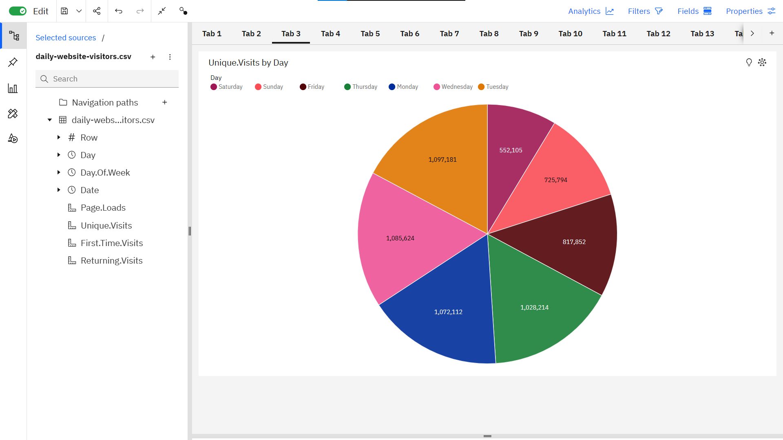

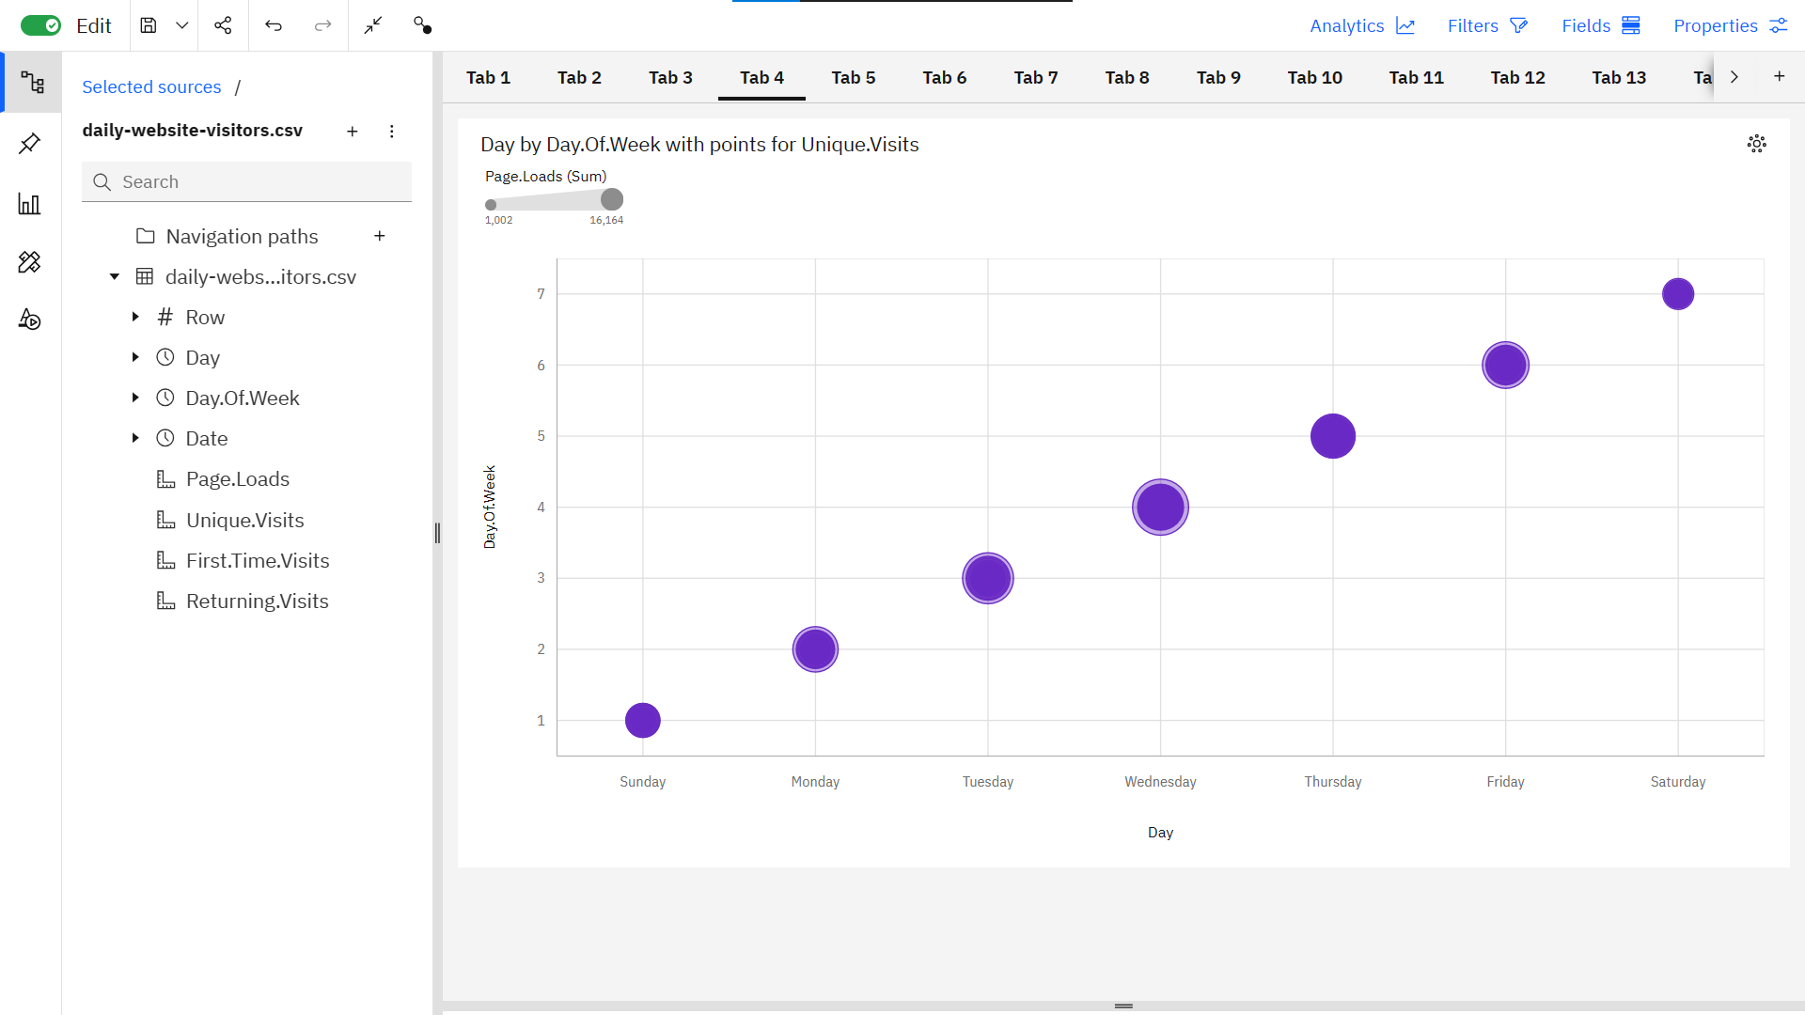

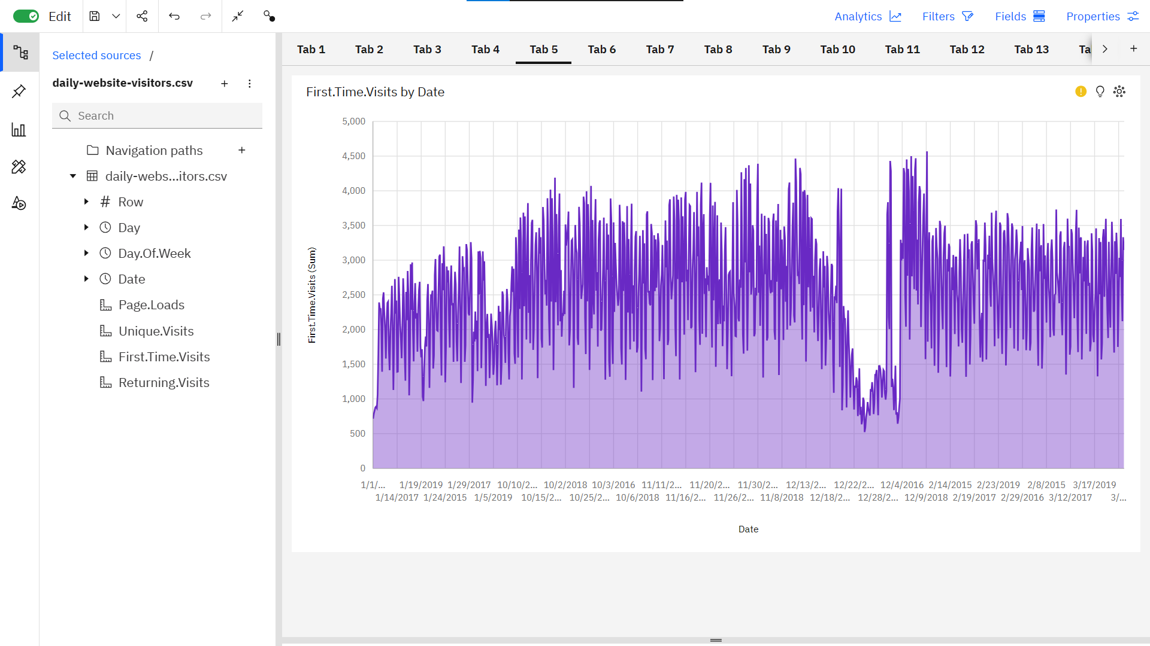

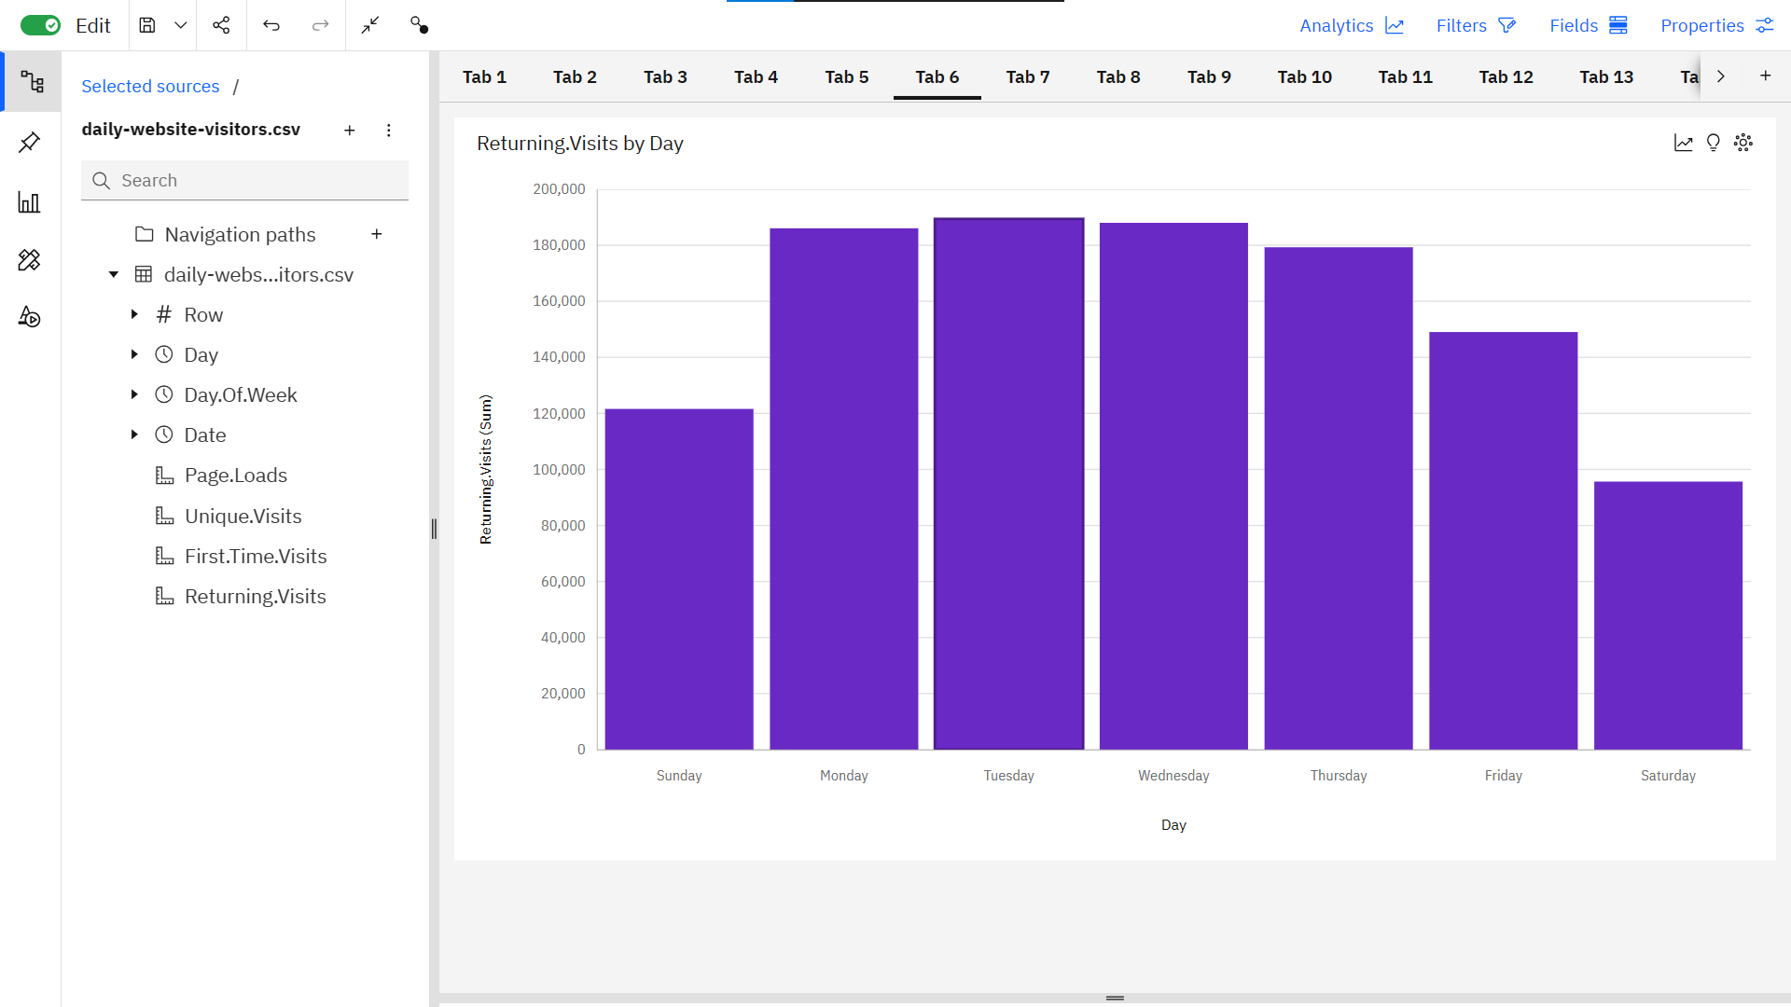

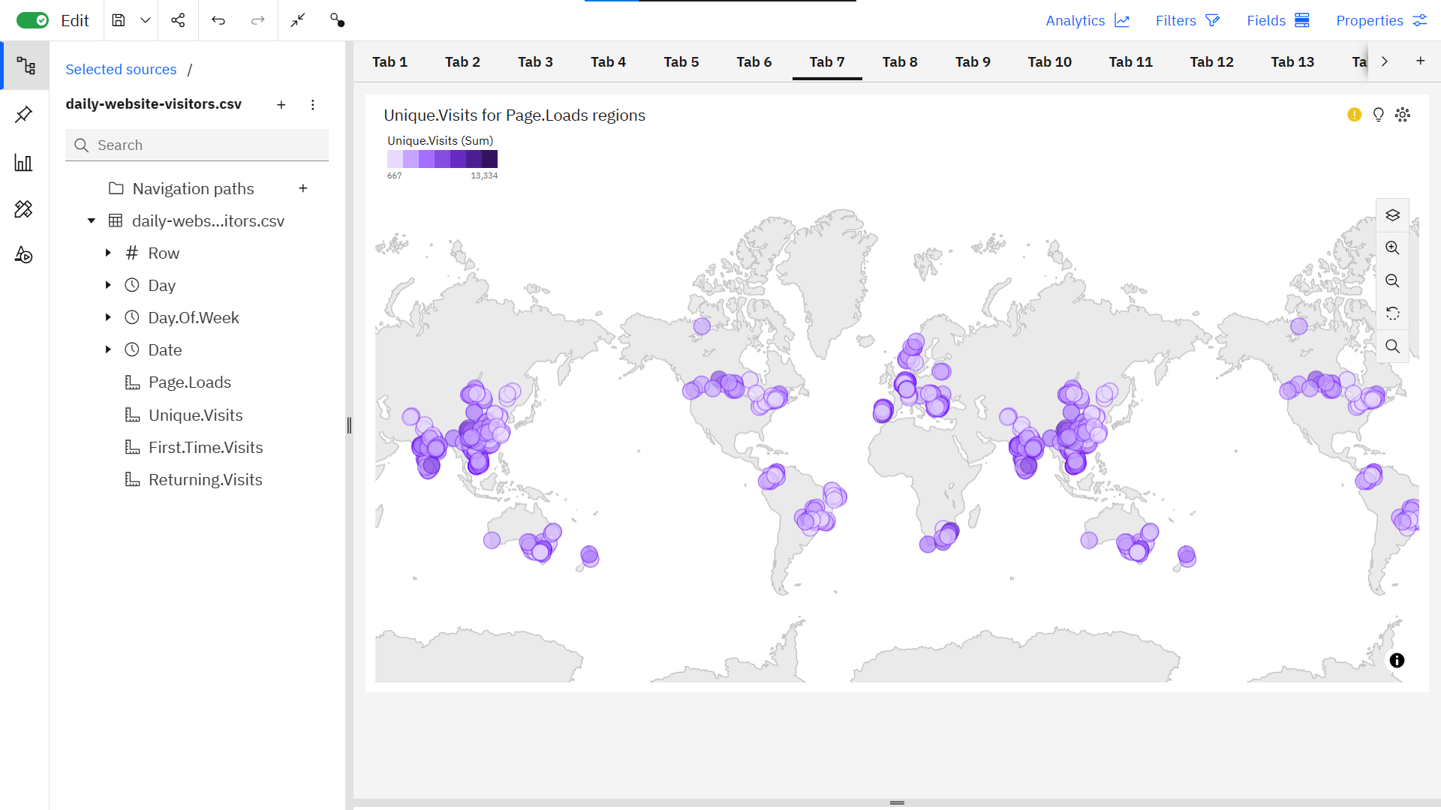

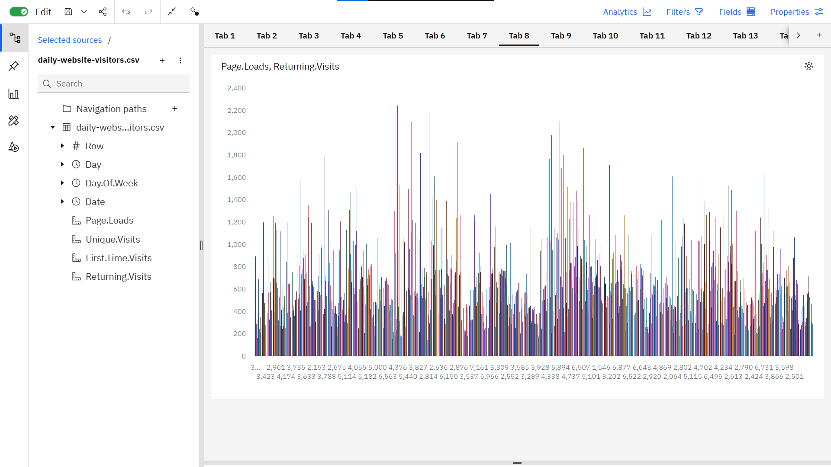

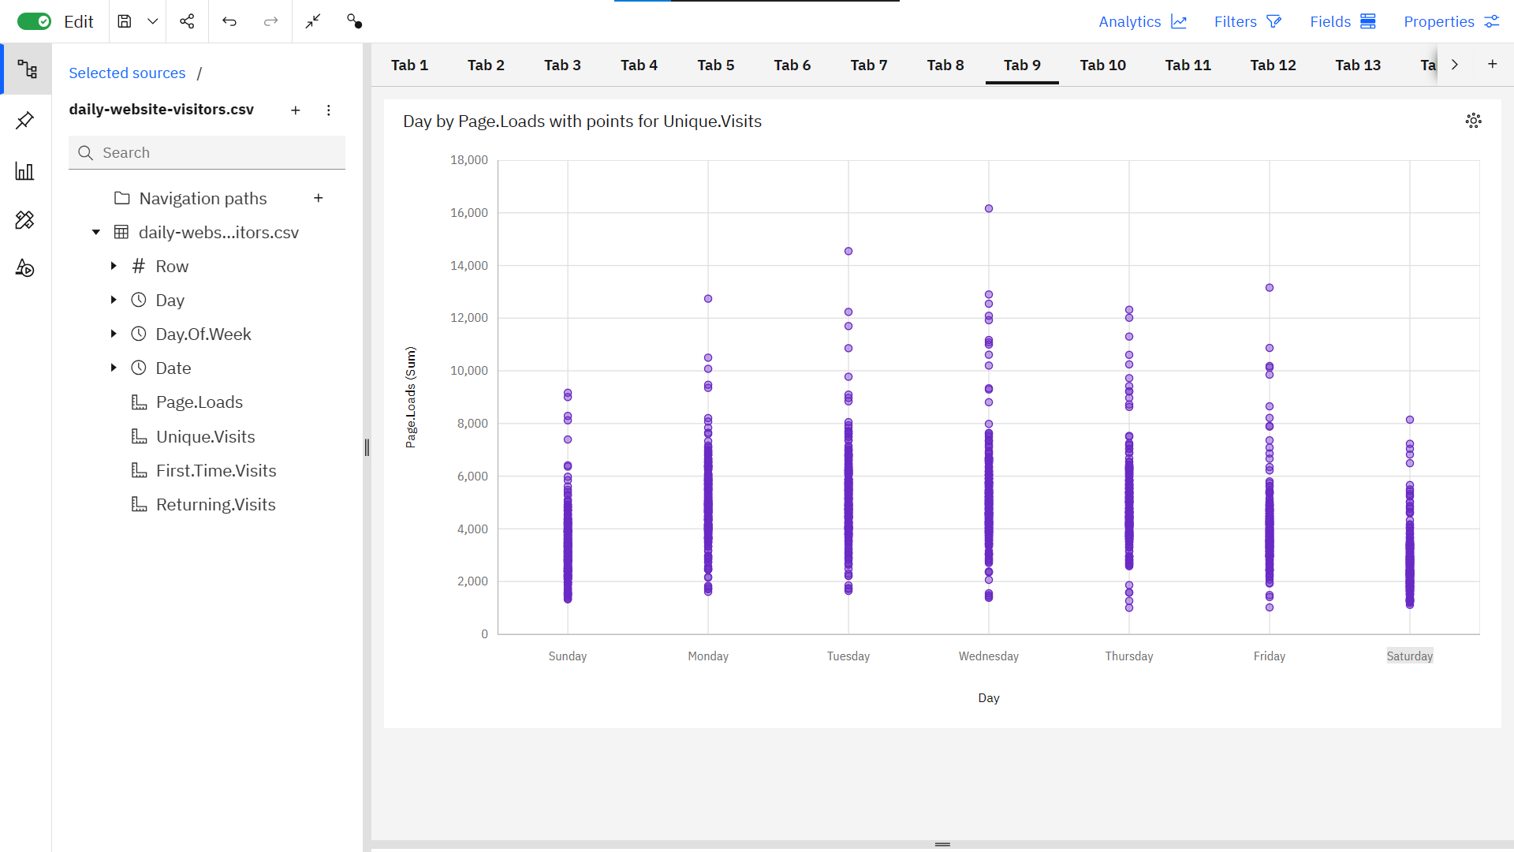

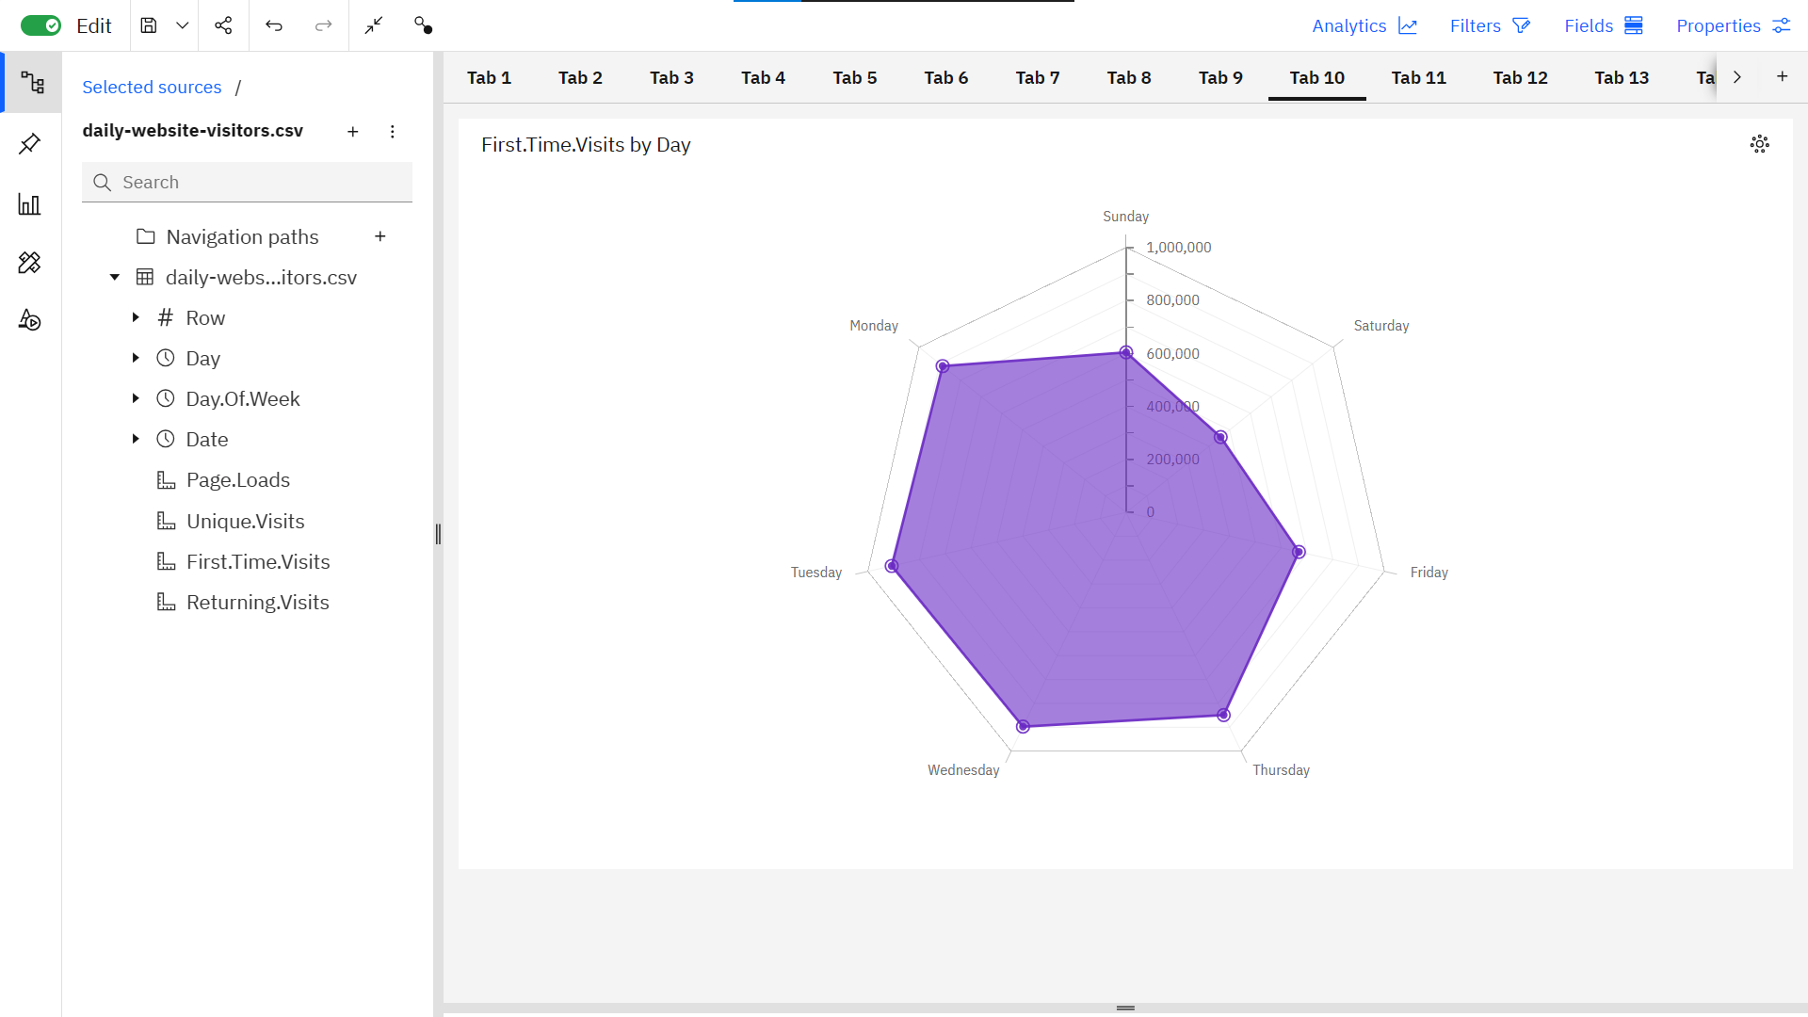

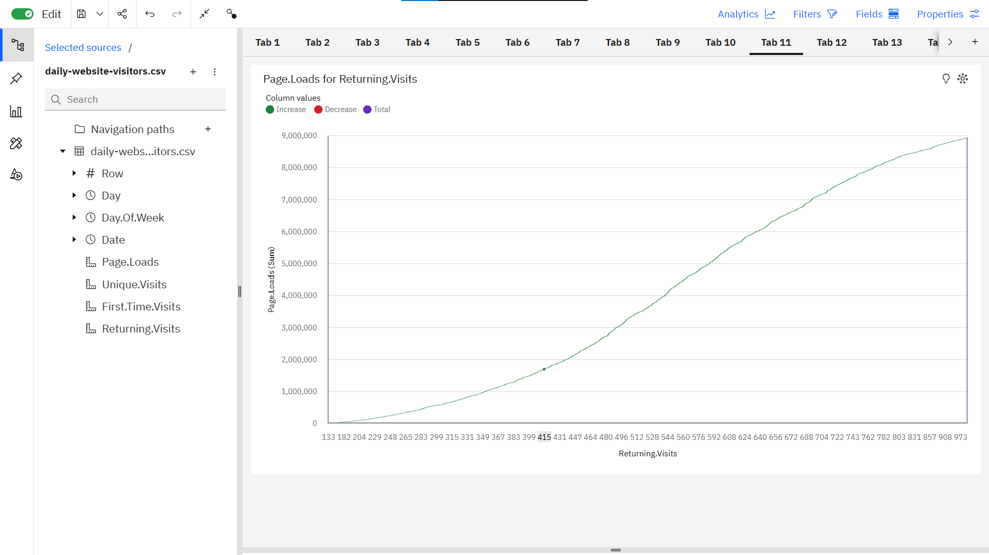

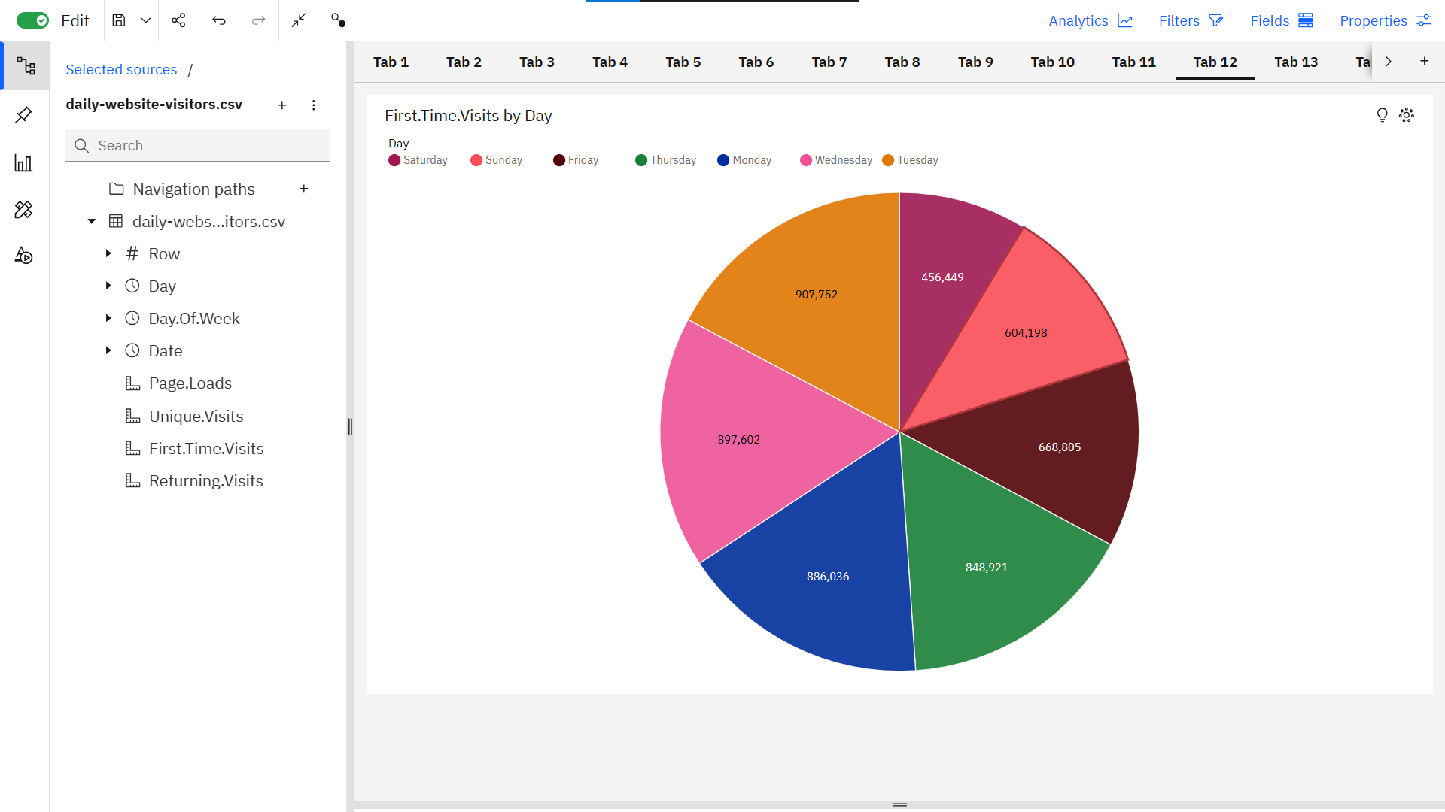

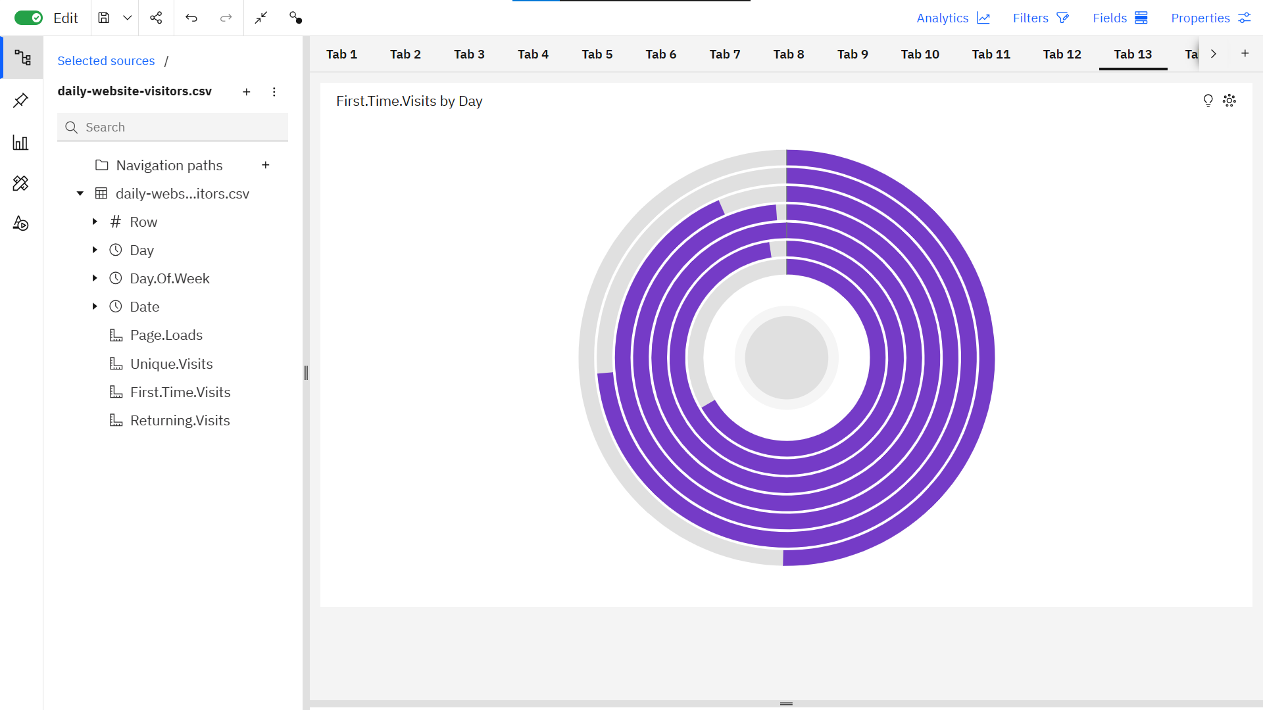

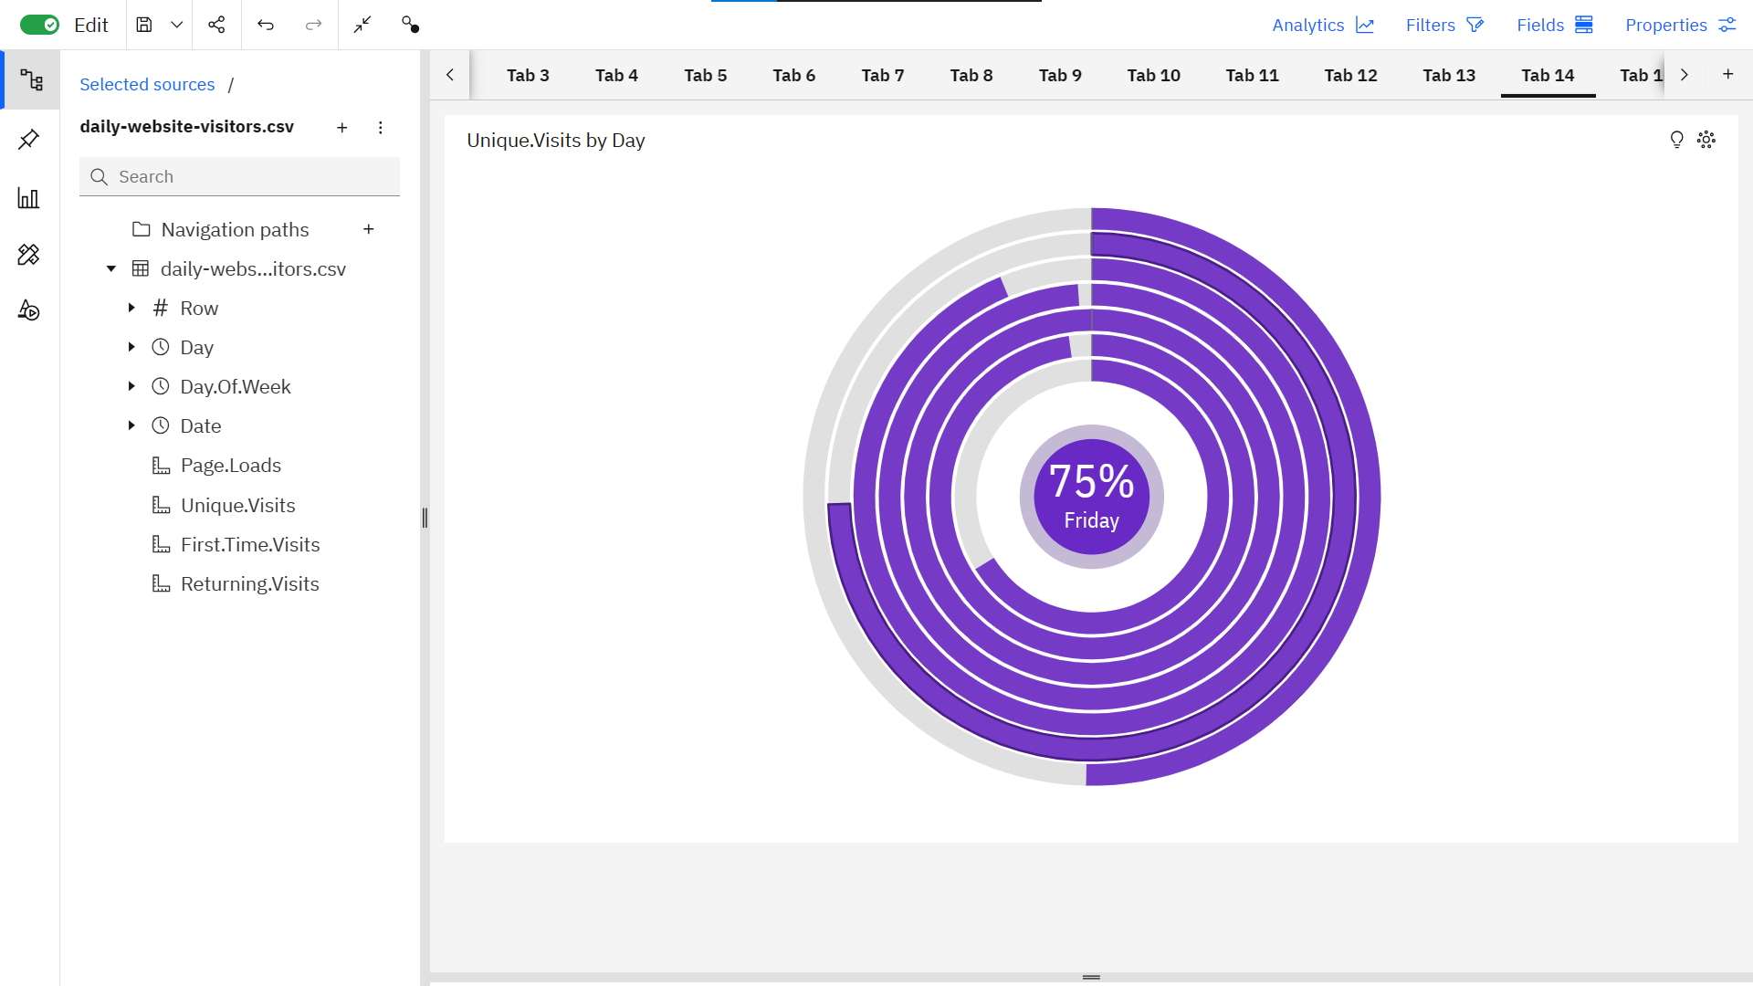

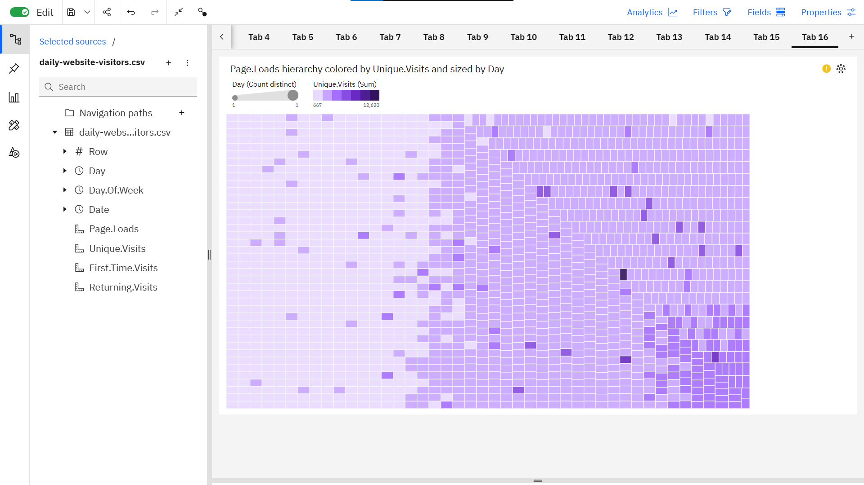

**REFERENCES**

<https://www.similarweb.com/>

<https://ahrefs.com/traffic-checker>

<https://www.semrush.com/analytics/traffic/>

<https://neilpatel.com/website-traffic-checker/>



GITHUB: <https://github.com/mrmqddy143/DAC_Phase1>