ECoG signal recording

1. Attach the ground electrode to the patient’s back. Use the white cable having the black plug at its end.
2. Run ASALAB with the license key plugged in. Click “Setup Recording”.
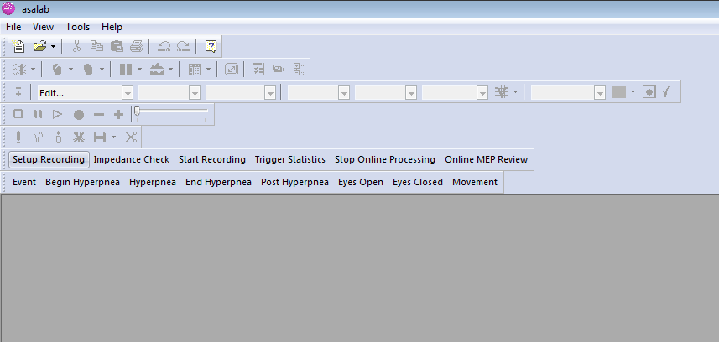

3. Select the montage “current_ECoG_CHU_spare11”.

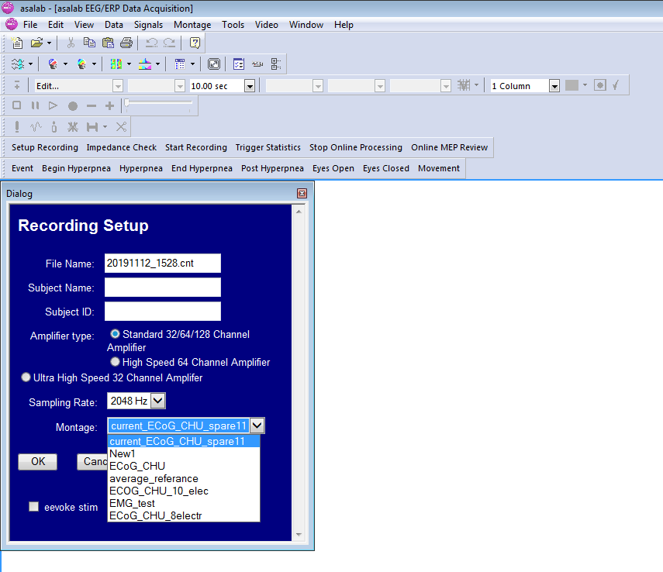
Note that the montage “current_ECoG_CHU_spare11” is defined as follows:

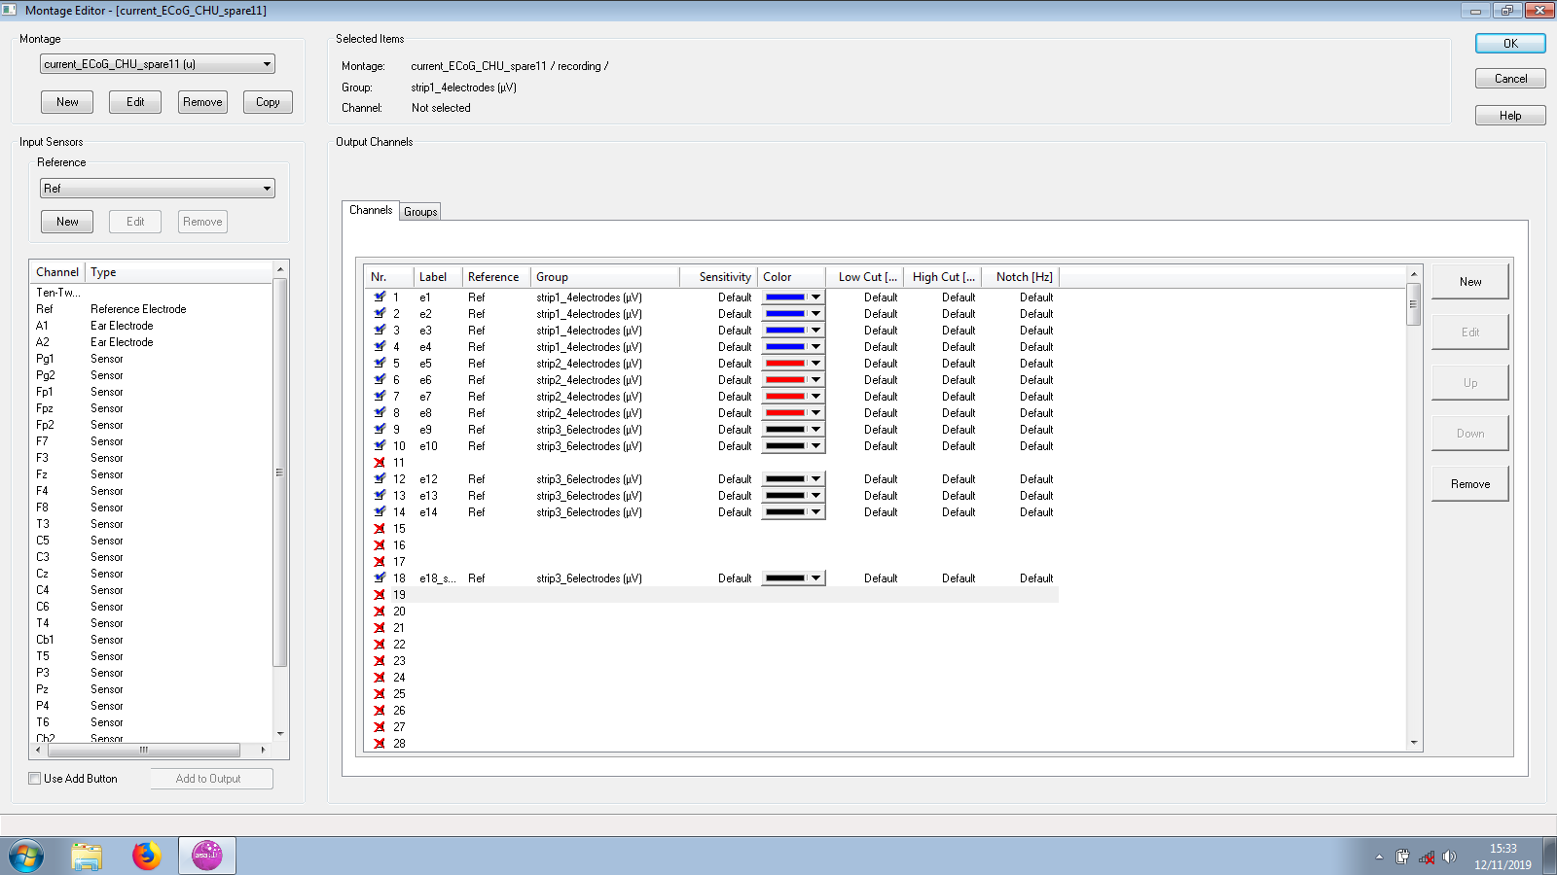
The first four channels represent electrodes 1-4 of the short strip. Then, the second short strip (electrodes 5-8). Finally, the 6 electrodes of the long strip.

Remember to connect the channel 18 in place of 11, due to the broken connector number 11.

4. Set the stimulation parameters to: 2Hz / 5mA

5. Start recording. Remember to mark events representing onsets of stimulation. Make hand notes describing the stimulation procedure.

6. Use the interface of the neuronavigation system to take screenshots showing the placement of electrodes.

7. Remind Fabien to take a photo of electrodes and labels.

