Postsurgical ECoG Data Processing

1. Copy the ‘events.csv’ file from the following location on NEF to your computer:

sftp://nef-devel/data/athena/user/monno/connectc/patient01/ecog/events.csv

Note that we used the Patient 1 in the example above.

2. Open the ‘events.csv’ file on your computer for editing:

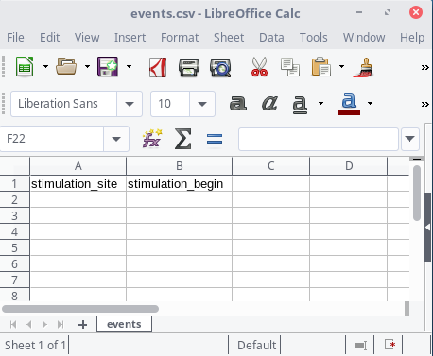

3. Open the ECoG recording using ASALAB and note the start times of all the stimulations in the ‘events.csv’ file as follows:

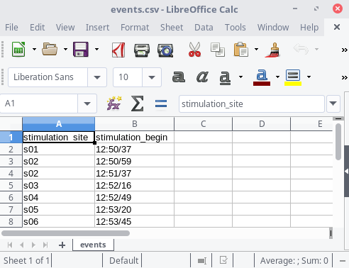
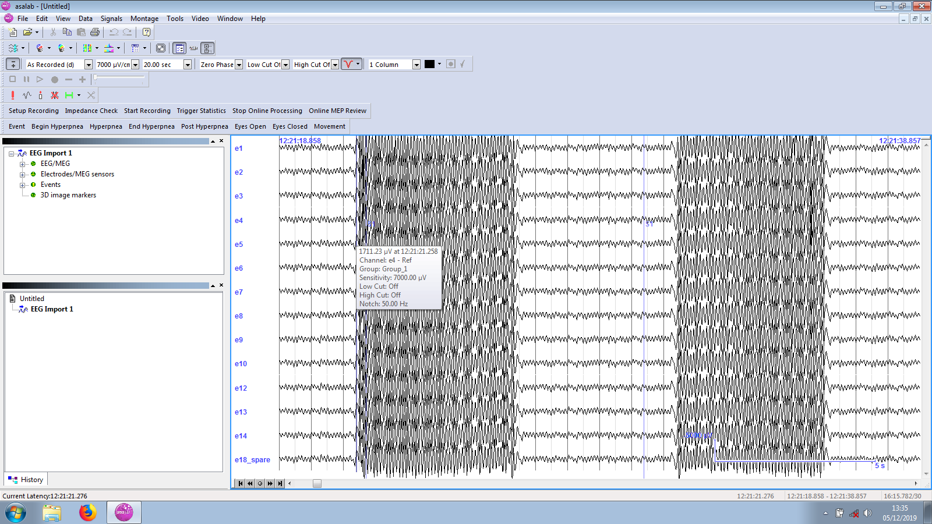

Remember to use the HH:MM/SS time format, for example: 14:26/31

The times don’t need to reflect the exact moments of stimulation artifacts. The script will tune them afterwards. Please just provide the estimates of stimulation onsets and the labels of the stimulations, for example:

s01 12:21/21
s01 12:21/31
s02 12:51/50
...

4. Export the ECoG recording to the BrainVision format.

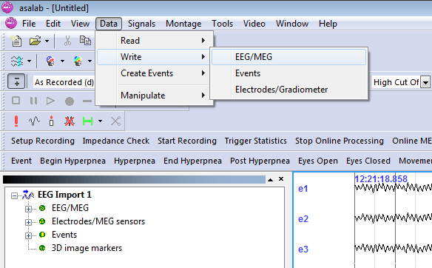
(a)

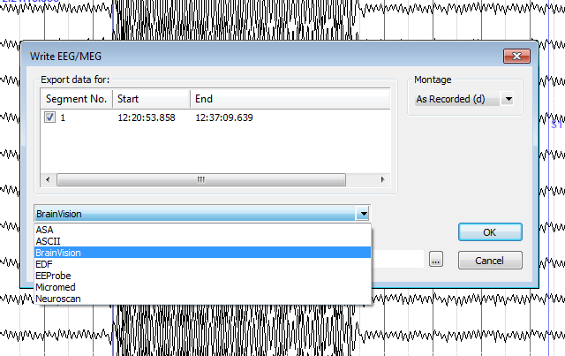
(b)

4. Copy the three BrainVision files to the following location on NEF:

sftp://nef-devel/data/athena/user/monno/connectc/patient01/ecog/

The file names can be for example:
20190909_1148.eeg
20190909_1148.vhdr
20190909_1148.vmrk

5. Copy the filled in ‘events.csv’ file to the following location on NEF:

sftp://nef-devel/data/athena/user/monno/connectc/patient01/ecog/

6. Login to NEF:

ssh nef-devel

7. Go to our patient’s directory:

cd /data/athena/user/monno/connectc/patient01

8. Run the ECoG processing script:

./run_ecog.sh

Running time is a few minutes.

