Postsurgical MRI data processing

1. Set up ROIs representing the stimulation sites and electrode locations using MI-Brain:

Note that we will use the Patient 1 as an example.

(a) Use the screenshots from the neuronavigation system to localize extremities of the ECoG strips.

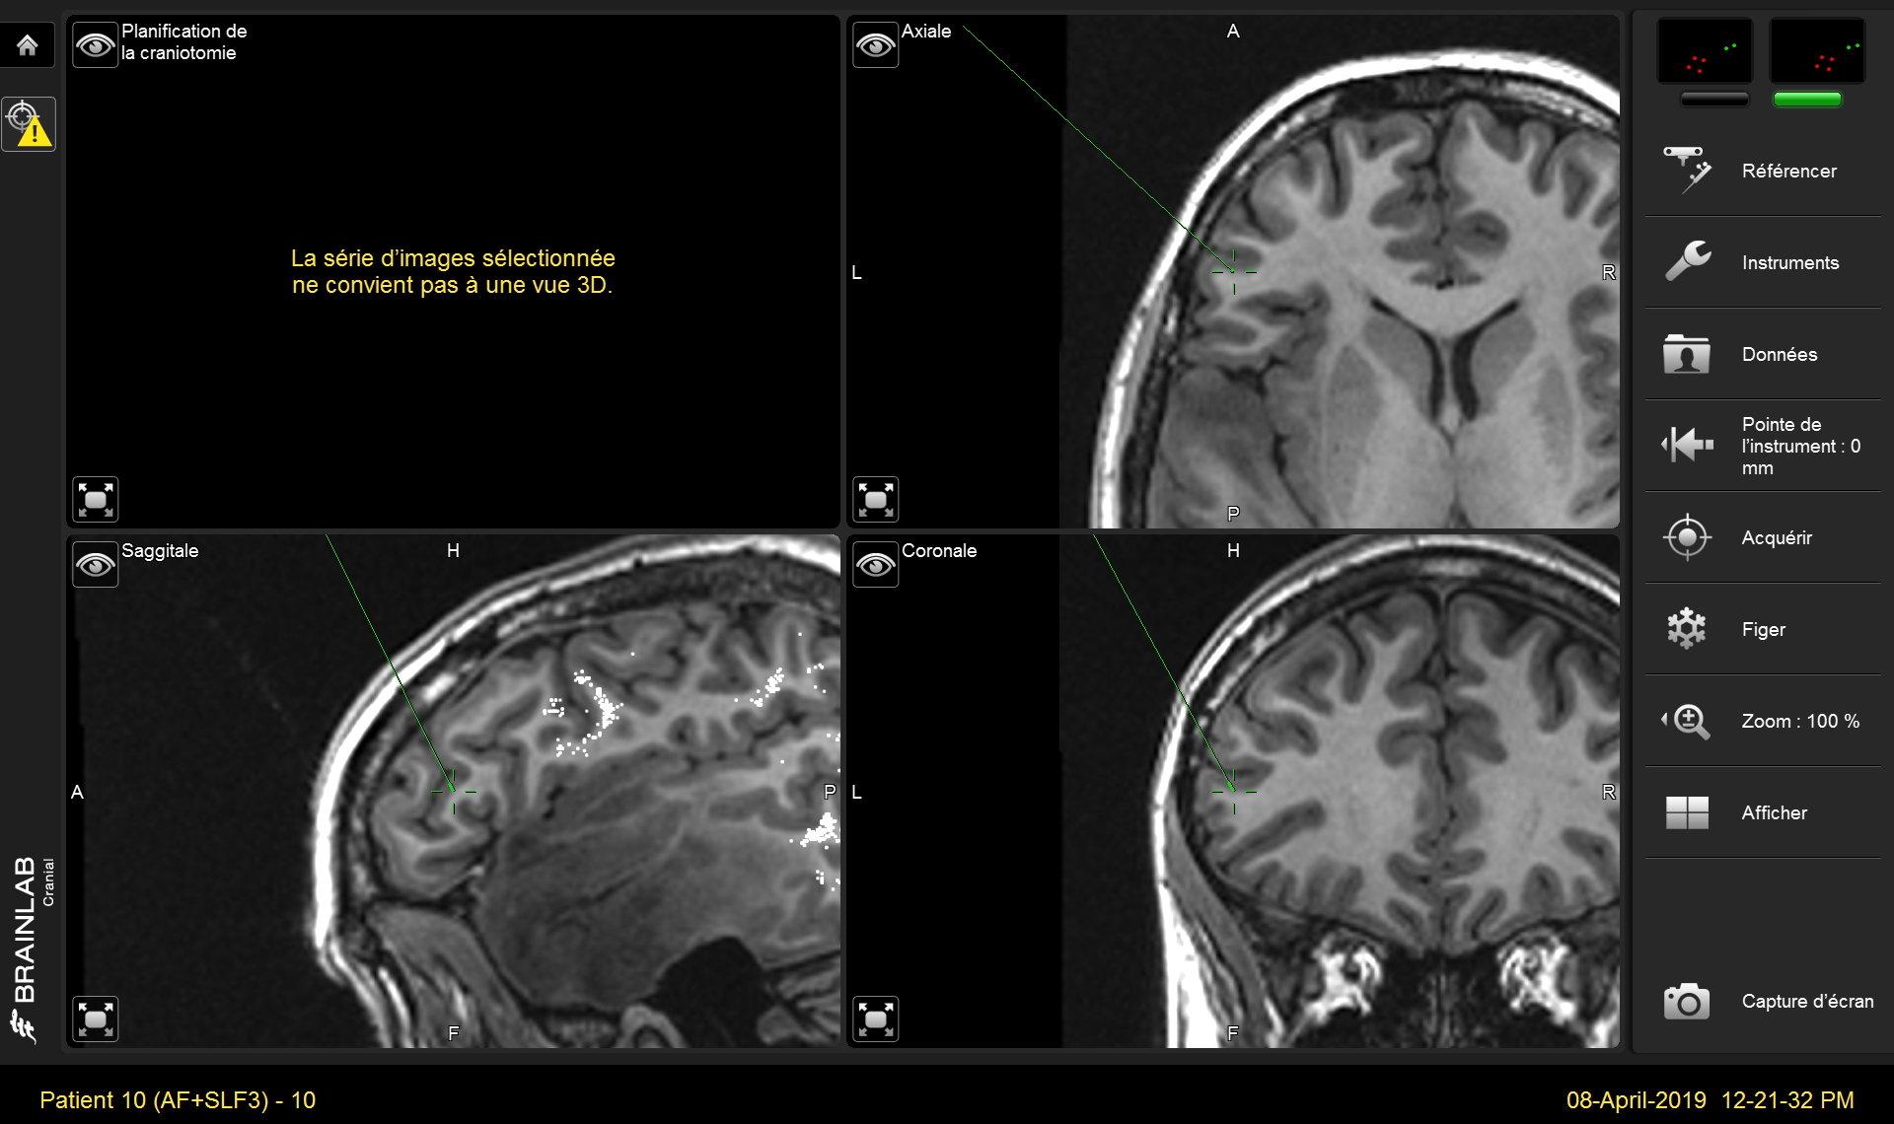
(b) Copy the T1-weighted image with overlaid tracts from NEF to your computer and open it with MI-Brain:

sftp://nef-devel/data/athena/user/monno/connectc/patient01/bids/sub-patient01/ses-presurgical/tracts/t1_with_tracts.nii.gz

(c) Use spherical ROIs to define the stimulation sites and electrode locations. Give them names s01, s02, s03, etc. (for the stimulation sites) and e01, e02, e03, etc. (for the electrode locations).

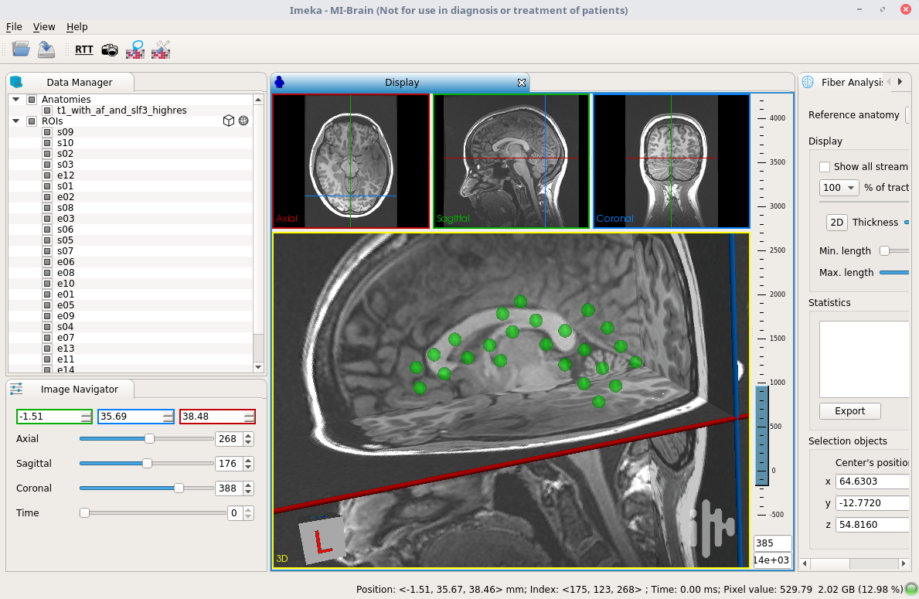
(d) Save your work as a project (File → Save Project…) and copy the .mitk file to the following directory on NEF:

sftp://nef-devel/data/athena/user/monno/connectc/patient01/bids/sub-patient01/ses-presurgical/electrodes/

For instance, you can name it:

sftp://nef-devel/data/athena/user/monno/connectc/patient01/bids/sub-patient01/ses-presurgical/electrodes/electrode_and_stimulation_sites.mitk

2. Login to NEF from the terminal:

ssh nef-devel

3. Go to our patient’s directory:

cd /data/athena/user/monno/connectc/patient01

4. Run the connectivity script:

./run_connectivity.sh

Running time can be up to 2 weeks.

