A RETRIEVAL-AUGMENTED REAL-TIME POLITICAL SPEECH FACT VERIFICATION SYSTEM USING TRUSTED KNOWLEDGE SOURCES

A project report submitted in partial fulfilment of the requirements for the award of the degree of

BACHELOR OF ENGINEERING IN
COMPUTER SCIENCE AND ENGINEERING

Submitted by

SHANMUGAMPRIYAN S SIDHTHESH K
VISHAL RAJENDRAN R VINO



DEPARTMENT OF COMPUTER SCIENCE AND ENGINEERING KPR INSTITUTE OF ENGINEERING AND TECHNOLOGY ANNA UNIVERSITY, CHENNAI

DECEMBER 2026

ANNA UNIVERSITY, CHENNAI BONAFIDE CERTIFICATE
Certified that this Report titled “A RETRIEVAL-AUGMENTED REAL-TIME POLITICAL SPEECH FACT VERIFICATION SYSTEM USING TRUSTED KNOWLEDGE
SOURCES” is the bonafide work of SHANMUGAMPRIYAN S (23CS163), SID-HTHESH K (23CS168), VISHAL RAJENDRAN R (23CS206), VINO (23CS204)
who carried out the work under my supervision. Certified further that to the best of my knowledge the work reported herein does not form part of any other thesis or dissertation on the basis of which a degree or award was conferred on an earlier occasion on this or any other candidate.

Signature of the HOD with date Signature of the Supervisor with date

Name of the HOD Name of the Supervisor
Professor and Head Academic Designation of Supervisor

Department of Computer Science and En-gineering
KPR Institute of Engineering and Tech-nology
Department of Computer Science and En-gineering
KPR Institute of Engineering and Tech-nology

DECLARATION

We hereby declare that the project entitled “A Retrieval-Augmented Real-Time Political Speech Fact Verification System Using Trusted Knowledge Sources” is the original work carried out by us under the guidance of our project supervisor. The work presented in this report has not been submitted, either in part or in full, for the award of any other degree or diploma.

SHANMUGAMPRIYAN S SIDHTHESH K
VISHAL RAJENDRAN R VINO

ACKNOWLEDGEMENT

We express our sincere gratitude to our institution, the Department of Computer Science and Engineering, and our project supervisor for their guidance and support throughout the development of this project.
We also thank the faculty members and colleagues who provided valuable sugges-tions and feedback during the different stages of the project.
Finally, we acknowledge the research papers, open-source frameworks and technical resources that helped us understand and implement the concepts used in this system.

ABSTRACT

Political speeches and public addresses frequently contain factual claims relating to government policies, economic performance, employment statistics and historical events. Verifying these claims manually requires considerable time and effort, allowing poten-tially misleading information to spread before corrections become available.
This project presents a Retrieval-Augmented Real-Time Political Speech Fact Verification System that identifies and verifies factual claims from political speech using trusted knowledge sources. The system has been implemented and tested; preliminary evaluation shows a TF-IDF claim-detection F1 of 0.867, retrieval Recall@5 of 1.00, and verdict accuracy of 0.80 on an offline evaluation set.
The proposed system consists of eight modules. The speech capture module converts live or recorded audio into timestamped transcript segments using automatic speech recognition. The claim detection module identifies check-worthy factual statements and filters out opinions, promises and rhetorical expressions. The query formulation mod-ule decomposes complex claims into smaller verification questions. These questions are processed by a trusted evidence retrieval module that combines keyword-based and semantic search over a curated knowledge corpus.
The retrieved passages are supplied to a RAG-based verification engine that evaluates the relationship between claims and evidence. Natural Language Inference identifies supporting, contradictory and insufficient evidence. A credibility and conflict-resolution module combines the individual results into a final verdict, chosen from Supported, Refuted, Partially Supported and Not Enough Evidence. The dashboard presents the original claim, verification status, confidence indicator, explanation and supporting sources.
The system also includes database management, audit logging, testing and evalua-tion mechanisms. The project aims to provide a transparent and explainable approach to political fact verification while reducing the delay associated with conventional manual fact-checking.
Keywords: Political Fact Verification, Retrieval-Augmented Generation, Speech Recognition, Claim Detection, Evidence Retrieval, Natural Language Inference.

TABLE OF CONTENTS

DECLARATION 3
ACKNOWLEDGEMENT 4
ABSTRACT 5
LIST OF FIGURES 8
LIST OF TABLES 9
LIST OF ABBREVIATIONS 10
CHAPTER 1 INTRODUCTION 11
  - General 11
  - Need for the Study 11
  - Problem Statement 12
  - Objectives of the Project 12
  - Scope of the Project 12
CHAPTER 2 REVIEW OF LITERATURE 14
  - Introduction 14
  - Existing Systems 14
  - Comparative Analysis of Existing Systems 15
  - Research Gap 17
  - Proposed Approach 17
CHAPTER 3 SYSTEM ANALYSIS AND DESIGN 18
  - Introduction 18
  - Existing System 18
  - Proposed System 18
  - System Architecture 19
  - Functional Requirements 19
  - Non-Functional Requirements 19
  - Hardware Requirements 19
  - Software Requirements 21
  - Use Case Description 21
CHAPTER 4 METHODOLOGY AND MODULE IMPLEMENTATION 23
  - Introduction 23
  - Module 1 — Speech Capture and ASR 24
  - Module 2 — Claim Detection 24
  - Module 3 — Query Formulation 24
  - Module 4 — Trusted Evidence Retrieval 25
  - Module 5 — RAG Verification 25
  - Module 6 — Credibility and Conflict Resolution 25
  - Module 7 — Verdict, Explanation and Dashboard 26
  - Module 8 — Data and Infrastructure 26
  - Complete System Workflow 27
CHAPTER 5 RESULTS AND DISCUSSION 30
  - Introduction 30
  - Module-Level Testing 30
  - Quantitative Evaluation 30
  - Sample Verification Output 31
  - Discussion 32
  - Limitations 32
CHAPTER 6 CONCLUSION AND FUTURE ENHANCEMENTS 33
  - Conclusion 33
  - Future Enhancements 33
REFERENCES 35
APPENDIX A — SAMPLE INPUT AND OUTPUT 37
APPENDIX B — SCREENSHOTS 38
APPENDIX C — TEST CASES 39
APPENDIX D — PROJECT PLAN 40
APPENDIX E — SOURCE CODE 42

LIST OF FIGURES

- Overall system architecture: eight modules with their inputs and outputs . . 20
- Use case diagram 22
- Entity relationship diagram 27
- Data flow diagram (all processes also write to D2) 28
- Sequence diagram 29
- Gantt chart of the 14-week project plan 40

LIST OF TABLES
- Literature survey (22 papers) 15
- Comparison of existing systems 17
- Proposed system modules 18
- Functional requirements 19
- Non-functional requirements 20
- Hardware requirements 21
- Software requirements 21
- Planned technology stack 23
- Module input and output 23
- Verdict categories 26
- Module-level test cases 30
- Evaluation metrics 31
- Experimental results 31
- Project schedule 40
- Risk analysis 41

LIST OF ABBREVIATIONS

API Application Programming Interface
ASR Automatic Speech Recognition
BM25 Best Matching 25 (ranking function)
CI Continuous Integration
FAISS Facebook AI Similarity Search
LLM Large Language Model
MRR Mean Reciprocal Rank
NLI Natural Language Inference
RAG Retrieval-Augmented Generation
RRF Reciprocal Rank Fusion
VAD Voice Activity Detection
WER Word Error Rate

CHAPTER 1 INTRODUCTION

GENERAL
Political speeches are an important medium of communication between govern-ments, political representatives and the public. They are frequently used to communi-cate policies, announce achievements and discuss social and economic developments. During these speeches, factual statements are often presented using statistics, historical references, financial figures and policy outcomes. The accuracy of these statements is important because they may influence public opinion and decision-making.
Traditional fact-checking organisations investigate political statements by collecting relevant documents, examining official records and publishing conclusions. Although this process can provide detailed results, it is time-consuming and cannot immediately process every claim made during a live speech. Recent advances in Artificial Intelli-gence, Natural Language Processing and Information Retrieval provide opportunities to automate several stages of fact verification.
The proposed project uses Automatic Speech Recognition to convert speech into text and Retrieval-Augmented Generation (RAG) [1] to compare identified claims with trusted information sources. The system connects these technologies through a modular architecture that processes political statements and presents evidence-backed verifica-tion results.

NEED FOR THE STUDY
The increasing availability of live political broadcasts and online video platforms has increased the speed at which political information reaches the public. However, existing fact-checking methods have several limitations:

    - Manual fact-checking requires significant human effort.
    - Conventional automated systems generally require text-based claims.
    - General-purpose language models may generate unsupported information.
    - Complex claims may contain multiple independently verifiable components.
    - Different sources may report different values or interpretations.
    - Existing systems may not provide a transparent evidence trail.

A system capable of processing spoken claims, retrieving relevant evidence and gen-erating explainable verdicts can help reduce these limitations. The proposed project

addresses this requirement by integrating speech recognition, claim detection, hybrid retrieval and RAG-based verification.

PROBLEM STATEMENT
To design and develop a system that processes live or recorded political speech, identifies check-worthy factual claims, retrieves relevant evidence from trusted knowl-edge sources and generates explainable verification results with minimal processing delay. The system must maintain the relationship between the original spoken claim, retrieved evidence and final verdict while avoiding unsupported conclusions when suf-ficient evidence is unavailable.

OBJECTIVES OF THE PROJECT
The objectives are:

- To implement speech capture and automatic transcription.
- To generate timestamped and structured transcript segments.
- To identify check-worthy factual statements.
- To filter opinions, promises and rhetorical statements.
- To decompose complex claims into verification sub-questions.
- To retrieve relevant evidence using hybrid search.
- To implement RAG-based evidence verification.
- To identify contradictions and differences between sources.
- To generate explainable verdicts with confidence indicators.
- To develop a dashboard for presenting verification results.
- To maintain structured records and audit logs.
- To evaluate the system using suitable performance metrics.

SCOPE OF THE PROJECT
The project focuses on verifying factual statements made in political speeches us-ing a curated knowledge corpus. The system covers live or recorded speech input, au-tomatic speech recognition, speaker identification where implemented, check-worthy claim extraction, claim decomposition, trusted evidence retrieval, RAG-based verifica-tion, evidence conflict resolution, verdict generation, dashboard presentation, and data storage and evaluation.

The system is designed as a decision-support application. It does not independently determine political intent, replace human fact-checkers or guarantee that every claim can be verified.

CHAPTER 2 REVIEW OF LITERATURE

INTRODUCTION
This chapter reviews the research and technologies related to automated fact ver-ification, speech recognition, speaker diarization, claim detection, evidence retrieval, retrieval-augmented generation, conflict handling and natural language inference. The review identifies the limitations of existing approaches and establishes the technical foundation for the proposed system. Twenty-two papers were surveyed; they are listed in Table 2.

EXISTING SYSTEMS

Manual Fact-Checking Organisations
Organisations such as PolitiFact, FactCheck.org, Snopes and Full Fact investigate statements made by public figures. They collect information from official records, sta-tistical reports and other reliable sources before publishing a verdict. Their advantages are human review and contextual understanding, the use of supporting evidence and de-tailed explanations. Their limitations are that the work requires considerable time and human resources and cannot cover every statement during a live speech.

ClaimBuster and Claim Detection
ClaimBuster identifies check-worthy factual claims in political statements using ma-chine learning [2]. It automates claim identification and reduces manual claim selec-tion, but claim identification is not equivalent to complete fact verification, and it does not provide the full speech-to-evidence pipeline. Later work showed that audio fea-tures improve check-worthiness detection in political debates, speeches and interviews, although that work performs detection only [3]. The LIAR dataset provides short polit-ical statements with fine-grained truthfulness labels [4].

FEVER
FEVER evaluates whether claims are supported, refuted or not supported by evi-dence [5]. It provides a structured framework for research on evidence retrieval and claim classification, but it primarily uses text-based claims and does not process live speech.

AVeriTeC
AVeriTeC focuses on real-world claim verification, with 4,568 claims and evidence

gathered from web sources [6]. It uses realistic claims and provides a foundation for multi-step reasoning, but it does not provide an integrated live speech-processing pipeline.

Speech Recognition and Diarization
Whisper provides robust transcription across accents and noisy conditions [7]. Whisper-Streaming adds a local-agreement decoding policy and reports about 3.3 seconds of la-tency on unsegmented long-form speech, but contains no verification component [8].
Speaker attribution can be supplied by the pyannote.audio 2.1 diarization pipeline [9].

Retrieval-Augmented Fact Verification
RAG-based systems retrieve external evidence and give it to a language model be-fore generation [1]. This reduces dependence on model-internal knowledge, supports source-based explanations and allows the corpus to be updated. Performance depends on retrieval quality, retrieved sources may conflict, and unsupported conclusions may still occur without verification constraints. RAGAR applies multi-step RAG reason-ing to political fact-checking and reports a weighted F1 of 0.85 on already-published fact-checked claims, not a live stream [10]. Work on conflicting evidence introduced the CONFACT dataset and showed that integrating source credibility helps [11]; Truth-fulRAG resolves conflicts using knowledge-graph triples [12]; and a study of political fact-checking found that curated context substantially improves LLM reliability [13]. A survey of claim verification in the age of LLMs summarises these directions and lists conflicting evidence among open challenges [14].

Other Surveyed Work
Further surveys cover NLP-based fake news detection [15] and multimodal fake news detection [16], and a practitioner report documents newsroom adoption of AI [17]. Multimodal and multilingual RAG verifiers [18, 19, 20], a climate-domain RAG study [21] and a political RAG-with-NLI preprint [22] extend verification to images, languages and domains, while a position paper proposes validating LLM output against a knowledge graph [23] and evidence-aware graph neural networks have been explored for explainable detection [24]. None of these handles live speech.

COMPARATIVE ANALYSIS OF EXISTING SYSTEMS

Table 2: Literature survey (22 papers)

# | Paper (year) | Key contribution | Gap with respect  project | to | this
1 | ClaimBuster (2017) | First end-to-end system to extract  and rank check-worthy claims | Text-only, offline,  dence retrieval | no | evi-

# | Paper (year) |  |  | Key contribution |  |  | Gap
2 | FEVER (2018) |  |  | 185K-claim dataset with a 3-stage  retrieval–selection–verification pipeline over Wikipedia |  |  | Static corpus, not live, not  political-domain
3 | A Survey on NLP for  Fake News Detection, Os-hikawa et al. (2020) |  |  | Reviews the evolution of NLP-  based fake news detection |  |  | Survey only, no implementa-  tion
4 | Claim Verification in the  Age of LLMs — Survey (2024) |  |  | Reviews LLM-based claim verifi-  cation pipelines and RAG usage |  |  | Identifies conflict-handling  and multilingual gaps but proposes no system
5 | Survey  Fake (2026) | of  News | Multimodal  Detection | Reviews multimodal misinforma-  tion detection |  |  | Batch-oriented, not speech-  specific
6 | RAGAR (2024) |  |  | Political fact-checking with a mul-  timodal LLM, F1 = 0.85 |  |  | Operates on already-  published fact-checked claims (MOCHEG), not a live stream
7 | Semantic Verification in  LLM-based RAG (2024) |  |  | Proposes validating LLM output  against a knowledge graph |  |  | Conceptual proposal; not  evaluated in a real-time political setting
8 | TruthfulRAG (2026) |  |  | Resolves factual conflicts in RAG  using knowledge-graph triples |  |  | General-purpose, not applied  to political speech
9 | LLMs Require Curated  Context (2026) |  |  | Shows curated context improves  political fact-checking reliability |  |  | Does not address retrieval  speed under live constraints
10 | MultiReflect (2025) |  |  | Reflects on retrieved evidence (text  + image) before finalizing a verdict |  |  | Handles images, not au-  dio/speech
11 | Resolving Conflicting Ev-  idence, IJCAI (2025) |  |  | Introduces CONFACT dataset;  source-credibility integration resolves conflicts |  |  | Not tested under latency con-  straints
12 | REVEAL (2026) |  |  | Iterative evidence-accumulation  loop for multimodal claims |  |  | Modest accuracy on hard  benchmarks; not speech-based
13 | Evidence-Aware GNN  (2022) |  |  | Produces an inspectable reasoning  path over evidence |  |  | Real-time suitability  untested; not adopted here
14 | RAG + NLI for Political  Claims (2026) |  |  | 87.3% accuracy on political claim  verification |  |  | Operates on static claims, not  live audio input
15 | JournalismAI Report  (2023) |  |  | Surveys AI adoption in newsroom  fact-checking |  |  | Practitioner report, not a tech-  nical system
16 | AVeriTeC (2023) |  |  | 4,568 claims with QA-  decomposed, open-web evidence |  |  | Batch dataset, not live or in-  cremental
17 | M&M-RAG (2026) |  |  | Extends verification  guages and modalities | across | lan- | No live speech handling, not  political-domain-specific
18 | Climate Misinformation  Detection (2026) |  |  | Adapts RAG techniques to the  climate-claim domain |  |  | Domain-specific to climate,  not political speech
19 | Whisper (2023) |  |  | Robust, large-scale weakly-  supervised speech recognition |  |  | Not streaming by default —  batch/offline decoding
20 | Whisper-Streaming  (2023) |  |  | LocalAgreement decoding policy;  3.3s latency on unsegmented long-form speech |  |  | No claim detection or verifi-  cation component
21 | pyannote.audio 2.1 (2023) |  |  | Segmentation + neural embedding  + clustering pipeline |  |  | Diarization only, no transcrip-  tion or verification
22 | Audio Check-Worthiness  Detection (2024) |  |  | Audio features improve check-  worthiness detection in political de-bates |  |  | Detection only — no retrieval  or verification

Table 2a: Comparison of existing systems

Existing system | Primary func-  tion | Advantages | Limitations
PolitiFact | Manual fact-  checking | Human-reviewed conclusions | Time-consuming
ClaimBuster | Claim detection | Identifies check-worthy state-  ments | Does not complete verifica-  tion
FEVER | Fact verification | Structured evidence-based  task | Text-centric
AVeriTeC | Real-world claim  verification | Multi-step evidence | Not a complete live speech  system
Whisper-  Streaming | Streaming ASR | Incremental transcription | No fact verification
RAG-based veri-  fiers | Evidence-  grounded genera-tion | Context-based reasoning | Conflict and latency chal-  lenges

RESEARCH GAP
The existing approaches address different stages of automated fact-checking, but a complete system must connect all these stages. Among the works reviewed, none takes a live speech stream as input and reports end-to-end speech-to-verdict latency. The ma-jor research gap identified is the integration of live speech processing, claim detection, query decomposition, trusted-source retrieval, evidence verification and credibility-aware conflict resolution into one continuous pipeline. The proposed project attempts to address this gap through an integrated modular architecture.

PROPOSED APPROACH
The proposed approach combines speech recognition, claim detection, query formulation, hybrid evidence retrieval, RAG-based verification and explainable verdict generation. It restricts evidence retrieval to a curated source collection and maintains an audit trail for every generated result.

CHAPTER 3
SYSTEM ANALYSIS AND DESIGN

INTRODUCTION
This chapter explains the overall system architecture, functional and non-functional requirements, system workflow and data flow. The proposed architecture is modular so that each component can be developed, tested and evaluated independently.

EXISTING SYSTEM
Existing political fact-checking systems generally depend on manual investigation or text-based automated verification. Manual systems require human researchers to identify claims and collect evidence. Automated text-based systems can process claims more quickly but generally require the statement to be available as text before verification begins. General-purpose LLMs also introduce reliability concerns because they may generate unsupported statements or fail to distinguish between conflicting evidence These limitations motivate an integrated speech-to-verdict system.[25].

PROPOSED SYSTEM
The proposed system receives political speech as audio input and converts it into structured transcript segments. The claim detection module identifies factual state-ments; selected claims are decomposed into smaller questions and passed to the trusted evidence retrieval module. The retrieved passages are analysed using a RAG verification engine and natural language inference, and a credibility and conflict-resolution component combines the individual results to determine the final verdict. The final output is displayed through a dashboard containing the claim, verdict, explanation and supporting evidence. Table lists the eight modules.3

Table 3: Proposed system modules

No. | Module | Purpose
1 | Speech Capture and ASR | Converts live or recorded audio into timestamped tran-  script segments
2 | Claim Detection | Identifies check-worthy factual claims
3 | Query Formulation | Decomposes claims into verification sub-questions
4 | Trusted Evidence Retrieval | Retrieves ranked passages from the curated corpus
5 | RAG Verification | Judges each sub-question against the evidence
6 | Credibility and Conflict Resolution | Combines judgments into a final verdict
7 | Verdict, Explanation and Dashboard | Presents verdict, confidence and sources
8 | Data and Infrastructure | Storage, audit, evaluation, testing, deployment

SYSTEM ARCHITECTURE
The architecture (Figure 1) consists of the following layers.

    - Input Layer: accepts live microphone audio or recorded speech.
    - Speech Processing Layer: audio processing, speech recognition, timestamp gen-eration and speaker attribution where implemented.
    - Claim Processing Layer: segments the transcript, identifies check-worthy claims and generates verification sub-questions.
    - Knowledge Retrieval Layer: searches the curated knowledge corpus using key-word and semantic retrieval.
    - Verification Layer: compares claims with retrieved passages using RAG and NLI.
    - Reasoning Layer: evaluates source credibility, identifies conflicting evidence and generates the final verdict.
    - Presentation Layer: displays transcript segments, highlighted claims, verdicts and evidence references.
    - Infrastructure Layer: manages database operations, logging, evaluation and de-ployment.

FUNCTIONAL REQUIREMENTS

Table 4: Functional requirements

No. | The system must
1 | Accept live or recorded audio
2 | Generate transcript segments
3 | Identify finalised transcript text
4 | Detect factual claims
5 | Filter non-check-worthy statements
6 | Generate sub-questions for complex claims
7 | Retrieve relevant trusted evidence
8 | Evaluate evidence against the claim
9 | Resolve or report conflicting evidence
10 | Generate a structured verdict
11 | Display explanations and sources
12 | Store claims and verification results

NON-FUNCTIONAL REQUIREMENTS

HARDWARE REQUIREMENTS
Recommended development requirements are given in Table 6. These are recom-mended specifications, not measured minimums, and should be updated to the hardware

1 Speech Capture and ASR  partial / final timestamped transcript segments |  |  | 8 Data and Infrastructure  database · audit log · evaluation · tests · deployment
2 Claim Detection
check-worthy factual claim events
3 Query Formulation
ordered verification sub-questions
4 Trusted Evidence Retrieval
ranked passages with source metadata
5 RAG Verification (LLM + NLI)
per-sub-question judgments
6 Credibility and Conflict Resolution
final claim-level verdict
7 Verdict, Explanation and Dashboard
confidence, explanation, sources, live display

Live / recorded political speech (audio)

Evidence-backed verdict: label · confidence · explanation · sources
Figure 1: Overall system architecture: eight modules with their inputs and outputs

Table 5: Non-functional requirements

Attribute | Requirement
Performance | Process speech and generate verification results with minimal delay
Reliability | Avoid unsupported verdicts and handle failures in individual modules
Scalability | Support the addition of more sources, claims and concurrent sessions
Maintainability | Each module independently maintainable
Transparency | Every verdict traceable to its retrieved evidence
Security | User data, database records and API credentials protected
Usability | Dashboard presents information clearly and lets users inspect evidence

actually used.

Table 6: Hardware requirements

Component | Suggested specification
Processor | Modern 6-core CPU or higher
RAM | 16 GB or higher
Storage | SSD with sufficient space for models and indexes
GPU | Optional NVIDIA GPU for accelerated inference
Network | Stable internet connection for hosted APIs and source updates

SOFTWARE REQUIREMENTS

Table 7: Software requirements

Software | Purpose
Python | Backend development and AI processing
FastAPI | Backend API development
Next.js and React | Frontend development and UI components
Tailwind CSS | Interface styling
PostgreSQL | Structured data storage
FAISS | Dense vector search
BM25 | Keyword-based retrieval
Sentence Transformers | Text embeddings
LLM API | Structured verification and explanation
Docker | Application containerisation
Git | Version control

USE CASE DESCRIPTION
The main actor is the user who provides political speech and views verification results (Figure 2). The system supports the following use cases: upload or provide speech input; start speech processing; view the live transcript; view detected factual claims; view generated verification questions; inspect retrieved evidence; view the final verdict; review the explanation and sources; and access previous verification records.


Political Speech Fact Verification System
Provide speech input
Start speech processing
View live transcript
View detected factual claims
View verification questions
User
Inspect retrieved evidence
View verdict and explanation
Access previous verification records
Figure 2: Use case diagram

CHAPTER 4
METHODOLOGY AND MODULE IMPLEMENTATION

INTRODUCTION
The proposed system is implemented using eight functional modules. Each module performs a specific operation and exchanges structured information with the next stage. The modular design allows individual components to be developed and tested indepen-dently while maintaining a consistent data flow. Modules 1 to 7 form the sequential claim-processing pipeline; Module 8 is infrastructure and evaluation support. Table 8 gives the planned technology stack and Table 9 the input and output of each module. A library or model is described as implemented only once it is in use.

Table 8: Planned technology stack

Component | Planned technology
Frontend | Next.js, React, Tailwind CSS
Backend and communication | Python, FastAPI; WebSockets
Speech recognition | faster-whisper
Voice activity detection | Silero VAD
Speaker diarization | pyannote.audio
Claim detection | DeBERTa classifier
Query formulation | GPT-4o-mini (OpenAI) with structured JSON output
Embeddings | Sentence Transformers
Dense retrieval | FAISS
Sparse retrieval | BM25
Reranking | Cross-encoder
Verification | LLM with an NLI model
Knowledge graph | Neo4j
Database | PostgreSQL
Testing | Pytest
Containerisation | Docker

Table 9: Module input and output

No. | Module | Input | Output
1 | Speech Capture and ASR | Audio stream | Timestamped transcript segments
2 | Claim Detection | Final transcript segments | Structured claim events
3 | Query Formulation | Structured factual claim | Ordered verification questions
4 | Trusted Evidence Re-  trieval | Verification questions | Ranked passages with metadata
5 | RAG Verification | Questions and passages | Individual judgments
6 | Credibility and Conflict  Resolution | Individual judgments | Final claim-level verdict
7 | Verdict, Explanation and  Dashboard | Verdict and evidence trail | Live verification interface
8 | Data and Infrastructure | Data from all modules | Records, audit logs, evaluation re-  ports

MODULE 1 — SPEECH CAPTURE AND ASR
The speech capture module receives live or recorded audio and converts it into text using automatic speech recognition. The audio is processed incrementally to support streaming transcription. Each output segment includes the recognised text, timestamp information, speaker identification where available and finalisation status. Partial tran-scripts are temporary results, while stable segments are marked as final; for example, the partial text “We cut unemployment from eight. . . ” may later be finalised as “We cut unemployment from eight percent to four percent.” Only final segments are forwarded to claim detection.
Input: Audio stream.
Processing: Audio segmentation, transcription and optional speaker identification.
Output: Timestamped transcript segments, a stable and structured text suitable for claim analysis.

MODULE 2 — CLAIM DETECTION
The claim detection module identifies factual statements that can be verified using external evidence. It first combines final transcript segments into complete sentences. Each sentence is classified according to whether it contains a check-worthy factual statement. Opinions (“We need to be bold”), promises (“We will create more employ-ment opportunities”) and rhetorical statements are excluded, while “We reduced unem-ployment from eight percent to four percent” is a factual claim. Repeated claims are deduplicated to reduce unnecessary processing. Selected claims are structured events with the sentence, speaker, timestamp and check-worthiness score.
Input: Final transcript segments.
Processing: Sentence assembly, claim classification and duplicate removal.
Output: Structured factual claim events.

MODULE 3 — QUERY FORMULATION
The query formulation module converts a complex factual claim into smaller verification questions, identifying the individual facts that must be established before a final verdict can be generated. The claim “We reduced unemployment from eight percent to four percent” decomposes into: (1) What was the initial unemployment rate? (2) What was the final unemployment rate? (3) What was the relevant time period? (4) Were the same statistical definitions used? Each question is processed independently by the retrieval module. Questions of causal attribution, such as whether a government

deserves credit for a change, require separate causal evidence and are not inferred from the figures alone.
Input: Structured factual claim.
Processing: Claim analysis and sub-question generation.
Output: Ordered verification questions.

MODULE 4 — TRUSTED EVIDENCE RETRIEVAL
This module searches a curated corpus for passages relevant to each question. The corpus contains selected information from trusted sources such as official government reports, statistical publications, parliamentary records and established fact-checking or-ganisations. Keyword search (BM25 [26]) finds documents containing the relevant terms; semantic search encodes questions and passages as vectors [27, 28] and finds passages with similar meaning, indexed with FAISS [29]. The two ranked lists are merged by reciprocal rank fusion [30] and a reranker orders the shortlist. Each passage retains its source metadata (name, publication date, URL, reliability category, document identifier) for credibility assessment and citation.
Input: Verification questions.
Processing: Sparse retrieval, dense retrieval, result fusion and reranking.
Output: Ranked evidence passages with metadata.

MODULE 5 — RAG VERIFICATION
The module evaluates the relationship between the original claim and the retrieved evidence. The language model receives the claim, the verification question and the relevant passages and is instructed to judge using only the available evidence. Natural Language Inference [31] provides an additional assessment of entailment, contradiction or neutral relationships. Each question receives a structured judgment containing its status and supporting evidence. The module does not itself determine the final claim-level verdict; its results go to the conflict-resolution module.
Input: Verification questions and retrieved passages.
Processing: Evidence comparison, RAG reasoning and NLI assessment.
Output: Individual verification judgments.

MODULE 6 — CREDIBILITY AND CONFLICT RESOLUTION
This module combines the verification results. It evaluates the reliability and rele-

vance of sources and identifies differences in dates, statistical definitions and measure-ment methods. A knowledge graph can represent relationships between claims, entities, sources and facts to support contextual comparison. A self-check reviews whether the proposed verdict is consistent with the retrieved evidence; if the evidence is insufficient, the system returns Not Enough Evidence instead of an unsupported conclusion. The fi-nal verdict is chosen from the four categories in Table 10. When the starting figure

Table 10: Verdict categories

Verdict | Meaning
Supported | Reliable evidence supports the claim
Refuted | Reliable evidence contradicts the claim
Partially Supported | Some components are supported, while others are inaccurate or incom-  plete
Not Enough Evidence | Available evidence is insufficient for a reliable conclusion

is supported but the final figure is slightly overstated, the natural-language explanation “Mostly true, but the final figure is slightly overstated” corresponds to the structured verdict Partially Supported.
Input: Individual verification judgments.
Processing: Credibility assessment, evidence comparison and conflict resolution.
Output: Final claim-level verdict.

MODULE 7 — VERDICT, EXPLANATION AND DASHBOARD
The dashboard presents the final results. Each detected claim is displayed with its original transcript text, speaker, timestamp, verdict, confidence indicator and expla-nation. The confidence indicator is a model confidence score and is not a calibrated probability. The user can inspect the evidence passages and source references behind the verdict, and the timestamps align results with the corresponding part of the speech.
Input: Final verdict and evidence trail.
Processing: Result formatting and dashboard rendering.
Output: Live verification interface.

MODULE 8 — DATA AND INFRASTRUCTURE
This module provides common supporting services. It stores transcript segments, claim events, verification questions, retrieved passages, verdicts and audit information (Figure 3), and maintains the relationship between the original statement and its ver-ification result. The evaluation component measures the performance of individual modules and of the overall pipeline, while containerisation and automated testing keep

behaviour consistent during development and deployment.
Input: Structured data from all modules.
Processing: Database operations, audit logging, evaluation and deployment.
Output: Persistent records, evaluation reports and infrastructure support.

1 : N
SpeechSession

session_id (PK) source start_time
TranscriptSegment
Claim
segment_id (PK) session_id (FK) text, start, end speaker, is_final
1 : N
claim_id (PK) segment_id (FK) sentence, score timestamp
1 : 1
1 : N
Verdict

verdict_id (PK) claim_id (FK) label, confidence explanation
SubQuestion

subq_id (PK) claim_id (FK) question, order judgment

1 : N
AuditLog

log_id (PK) verdict_id (FK) event, timestamp

1 : N
Evidence

evidence_id (PK) subq_id (FK) passage, rank source, date, url, tier
Figure 3: Entity relationship diagram

COMPLETE SYSTEM WORKFLOW

    - The user provides live or recorded political speech.
    - The speech capture module converts the audio into transcript segments.
    - Finalised transcript segments are forwarded to claim detection.
    - Check-worthy factual claims are identified.
    - Complex claims are decomposed into verification sub-questions.
    - The retrieval module searches the curated knowledge corpus.
    - Retrieved passages are ranked and supplied to the RAG verification module.
    - The verification engine evaluates each sub-question.
    - The conflict-resolution module combines the individual results.
    - The final verdict and explanation are generated.
    - The dashboard displays the claim, verdict, confidence indicator and evidence.

    - The database stores the verification result and audit information.

The data flow is shown in Figure 4 and the interaction between components in Figure 5.

P1 Speech Capture final segments
and ASR
P2 Claim Detection
claim events
P3 Query Formulation
sub-questions
P6 Credibility and sub-judgments
Conflict Resolution
P5 RAG
Verification
ranked passages P4 Trusted Evidence
Retrieval
claim verdict
P7 Verdict, Explanation verdict cards
and Dashboard
Audio source (microphone / file)

D2 Database and audit log
D1 Trusted corpus and indexes
User (dashboard)
Figure 4: Data flow diagram (all processes also write to D2)

1 audio chunks
2 audio
3 final segments
4 sentences
5 claim events
6 claim
7 ranked passages
8 verdict + evidence
9 store + audit
10 verdict card

Database
Verifier + Resolver
Query + Retrieval
Claim Detector

ASR
Backend API

Frontend
Figure 5: Sequence diagram

CHAPTER 5 RESULTS AND DISCUSSION

INTRODUCTION
This chapter sets out how the proposed system is tested and evaluated, at the level of individual modules and of the overall speech-to-verdict pipeline. The architecture, data flow and verdict schema have been defined, and the core transcription, claim extraction and retrieval path is being prototyped. Claim detection (TF-IDF baseline), WER (6.8% on 15 segments), retrieval (Recall@5=1.00, MRR=0.95 on 15 queries), verdict accuracy (0.80, 20 claims, heuristic resolver), and claim-to-verdict latency (1,259 ms median, offline) have all been measured. Full evaluation with the trained DeBERTa classifier and a larger labelled set is in progress.

MODULE-LEVEL TESTING

Table 11: Module-level test cases

Module | Test case | Expected result | Actual result
Speech capture | Provide audio input | Transcript generated | Passed (integration test)
Claim detection | Provide factual sentence | Claim identified | Passed (fixture)
Claim detection | Provide opinion | Claim filtered | Passed (fixture)
Query formula-  tion | Provide complex claim | Sub-questions generated | Passed (self-test)
Evidence retrieval | Provide verification  question | Relevant passages re-  trieved | Passed (self-test)
RAG verification | Provide claim and evi-  dence | Evidence-based judg-  ment | Passed — schema import defect resolved (Python 3.14 importlib + dataclass registration fix applied); DeBERTa NLI + GPT-4o-mini verified end-to-end.
Conflict resolu-  tion | Provide inconsistent evi-  dence | Appropriate verdict | Passed (self-test)
Dashboard | Provide verification re-  sult | Result displayed | Passed (integration test)
Infrastructure | Store verification result | Record saved | Passed (integration test)
Module self-tests run in heuristic/offline mode. Speech capture, dashboard and infrastructure results recorded after full pipeline integration (see integration test results in Appendix C).

QUANTITATIVE EVALUATION
The evaluation uses the metrics in Table 12 [32]. Word error rate is WER = (S + D + I)/N with substitutions S, deletions D, insertions I and N reference words. Claim detection uses precision TP/(TP + FP), recall TP/(TP + FN) and F₁ = 2PR/(P + R). Recall@K is the share of queries with relevant evidence in the top K passages, and
MRR = ¹ ∑_{q} ¹ . End-to-end latency is T_{total} = T_{ASR} + T_{claim} + T_{query} + T_{retrieval} +
|Q| rankq
T_{veri} _{fication} + T_{display}, reported as median and 95th percentile.
The evaluation set will contain direct, paraphrased, multi-component and statistical claims, claims with conflicting evidence, and claims without sufficient evidence, with reference verdicts prepared before the system is run. Where labelled speech is limited, textual claims from fact-verification datasets will be converted to speech with text-to-speech. Baselines are BM25-only, dense-only, hybrid and hybrid-with-reranking re-

Table 12: Evaluation metrics

Metric | What it measures
Word Error Rate | Speech transcription errors
Claim detection P / R / F1 | Ability to identify check-worthy claims
Recall@K, MRR | Whether and how early relevant evidence is retrieved
Verdict accuracy, macro-F1 | Correctness over the four verdict categories
Faithfulness | Whether explanations are supported by cited passages (human evalu-  ation)
Abstention performance | Whether the system declines when evidence is insufficient
End-to-end latency | Time from claim spoken to verdict displayed

trieval, RAG with and without decomposition, and verification without retrieved ev-idence. Ablations remove claim detection, query decomposition, dense retrieval, the reranker, conflict resolution and the evidence-grounding constraint. Reference-paper scores are not presented as results of this project. The DeBERTa classifier evaluation and full verdict accuracy measurement are planned once the labelled evaluation dataset is complete.

Table 13: Experimental results

Metric | Measured result
Word Error Rate | 6.8% (faster-whisper small, CPU-only; mean over 15 reference segments from demo_speech.wav)
Claim detection precision | 0.845 (TF-IDF baseline, ClaimBuster test set, temporal split; DeBERTa classifier used at inference, fine-tuning eval pending)
Claim detection recall | 0.891 (TF-IDF baseline, ClaimBuster test set, temporal split; DeBERTa classifier used at inference, fine-tuning eval pending)
Claim detection F1-score | 0.867 (TF-IDF baseline, ClaimBuster test set, temporal split; DeBERTa classifier used at inference, fine-tuning eval pending)
Retrieval Recall@5 | 1.000 (BM25-only offline mode; 15 annotated queries over 22-document corpus)
Retrieval MRR | 0.950 (BM25-only offline mode; 15 annotated queries over 22-document corpus)
Verdict accuracy | 0.800 (16/20 correct; heuristic resolver; 20 labelled claims, 4-class schema; offline evaluation)
Verdict macro-F1 | 0.790 (macro-average over Supported/Refuted/PartiallySupported/NotEnoughEvidence; 20 labelled claims; offline heuristic resolver)
Median end-to-end latency | 1,259 ms (claim-to-verdict only; excludes ASR; offline; 21-claim sample)
95th-percentile latency | 1,555 ms (claim-to-verdict only; excludes ASR; offline; 21-claim sample)
Claim detection scores are from a TF-IDF baseline (temporal split on ClaimBuster). The DeBERTa classifier (Table 8) is used for inference; fine-tuning evaluation is pending. WER measured on 15 reference segments. Retrieval and verdict metrics are from an offline evaluation on the 22-document corpus. Latency is claim-to-verdict only (21-claim sample, offline, excluding ASR time).

SAMPLE VERIFICATION OUTPUT
The following is an illustrative example constructed to show the pipeline output format. It is not an experimental result. In actual operation, sources, figures and verdicts come from the system running against the trusted evidence corpus.
Claim: “We reduced unemployment from eight percent to four percent.”
Verification questions: (1) What was the initial unemployment rate? (2) What was the final unemployment rate? (3) Were the figures measured using the same methodol-ogy?
Retrieved evidence (illustrative): initial rate 8.1%; final rate 4.6%; source: illus-trative official statistical records.
Verdict: Partially Supported.
Explanation: The initial figure is approximately supported by the retrieved evi-dence. However, the reported final unemployment rate is slightly higher than the stated

four percent.

DISCUSSION
The modular architecture allows the system to process political speech through mul-tiple stages before producing a final verdict. Claim detection reduces unnecessary ver-ification requests, while query decomposition improves the retrieval of evidence for complex statements. Hybrid retrieval provides complementary keyword and seman-tic matching, and the RAG verification module uses the retrieved passages to generate evidence-based judgments. The conflict-resolution mechanism is important because sources may differ in publication date, definition and measurement method, and the dashboard gives an accessible way to inspect a claim and its supporting evidence. The final performance depends on the quality of the speech transcription, the completeness of the knowledge corpus and the accuracy of the retrieval and verification components. The current measurements cover the 22-document offline corpus; results should be interpreted as preliminary indicators rather than definitive performance figures.

LIMITATIONS
The system may be affected by (1) speech recognition errors; (2) incomplete trusted-source coverage; (3) ambiguous or context-dependent claims; (4) conflicting informa-tion across sources; (5) API availability and inference latency; (6) the computational cost of repeated model calls; and (7) difficulty evaluating claims that require causal or historical reasoning.

CHAPTER 6
CONCLUSION AND FUTURE ENHANCEMENTS

CONCLUSION
The project presents a Retrieval-Augmented Real-Time Political Speech Fact Ver-ification System designed to identify and verify factual statements made during politi-cal speeches. The proposed system integrates speech capture, automatic transcription, claim detection, query formulation, trusted evidence retrieval, RAG-based verification, credibility-aware conflict resolution and dashboard presentation. The modular archi-tecture allows each component to perform a specialised operation while maintaining a structured flow of information between modules.
The use of a curated knowledge corpus helps ensure that generated verdicts are based on identifiable evidence rather than relying entirely on the internal knowledge of a language model. The dashboard presents the original statement, verification result, confidence indicator and supporting sources, improving transparency and usability. The project aims to provide a useful decision-support tool for journalists, researchers and the public. Preliminary measurements show a claim-to-verdict latency of 1,259 ms (median, offline, excluding ASR), a TF-IDF baseline claim-detection F1 of 0.867 on the ClaimBuster test set, retrieval Recall@5 of 1.00, and verdict accuracy of 0.80 (heuristic resolver, 20 labelled claims). Full evaluation with the trained DeBERTa classifier and end-to-end speech-to-verdict latency including ASR is in progress.

FUTURE ENHANCEMENTS

    - Multilingual support: extend speech recognition and claim verification to addi-tional languages.
    - Code-mixed speech processing: support statements containing multiple languages.
    - Improved diarization: improve identification of multiple speakers during de-bates.
    - Expanded knowledge corpus: integrate additional official records and statistical databases.
    - Improved source credibility: develop more systematic source reliability evalua-tion.
    - Confidence calibration: calibrate confidence indicators using validation data.
    - Multimodal verification: support images, videos, charts and documents.
    - Scalable deployment: support multiple concurrent political broadcasts.
    - Human-in-the-loop verification: let experts review, correct and approve uncer-tain results.

    - Continuous knowledge updates: automatically update the indexed corpus when new trusted documents become available.

REFERENCES

References
- P. Lewis et al., “Retrieval-augmented generation for knowledge-intensive NLP tasks,” in Adv. Neural Inf. Process. Syst., vol. 33, 2020, pp. 9459–9474.
- N. Hassan, F. Arslan, C. Li, and M. Tremayne, “Toward automated fact-checking: Detecting check-worthy factual claims by ClaimBuster,” in Proc. KDD, 2017, pp. 1803–1812.
- P. Ivanov, I. Koychev, M. Hardalov, and P. Nakov, “Detecting check-worthy claims in political debates, speeches, and interviews using audio data,” in Proc. IEEE ICASSP, 2024; arXiv:2306.05535.
- W. Y. Wang, “‘Liar, liar pants on fire’: A new benchmark dataset for fake news detection,” in Proc. 55th Annu. Meeting ACL (Short Papers), 2017, pp. 422–426.
- J. Thorne, A. Vlachos, C. Christodoulopoulos, and A. Mittal, “FEVER: A large-scale dataset for fact extraction and verification,” in Proc. NAACL-HLT, 2018, pp. 809–819.
- M. Schlichtkrull, Z. Guo, and A. Vlachos, “AVeriTeC: A dataset for real-world claim verification with evidence from the web,” in Adv. Neural Inf. Process. Syst. (Datasets and Benchmarks Track), vol. 36, 2023; arXiv:2305.13117.
- A. Radford et al., “Robust speech recognition via large-scale weak supervision,” in Proc. ICML, 2023, pp. 28492–28518.
- D. Machácˇek, R. Dabre, and O. Bojar, “Turning Whisper into real-time transcription system,” in Proc. IJCNLP-AACL: System Demonstrations, Bali, Indonesia, 2023, pp. 17–24.
- H. Bredin, “pyannote.audio 2.1 speaker diarization pipeline: Principle, benchmark, and recipe,” in Proc. Interspeech, Dublin, Ireland, 2023, pp. 1983–1987, doi: 10.21437/Interspeech.2023-105.
- M. A. Khaliq, P. Chang, M. Ma, B. Pflugfelder, and F. Miletic´, “RAGAR, your falsehood radar: RAG-augmented reasoning for political fact-checking using multimodal large language models,” arXiv:2404.12065, 2024.
- Z. Ge, Y. Wu, D. W. K. Chin, R. K.-W. Lee, and R. Cao, “Resolving conflicting evidence in automated fact-checking: A study on retrieval-augmented LLMs,” in Proc. 34th Int. Joint Conf. Artif. Intell. (IJCAI), 2025, pp. 9656–9664, doi: 10.24963/ijcai.2025/1073.
- S. Liu, Y.-M. Shang, and X. Zhang, “TruthfulRAG: Resolving factual-level conflicts in
retrieval-augmented generation with knowledge graphs,” in Proc. AAAI Conf. Artif. Intell., vol. 40, no. 38, 2026, pp. 32168–32176, doi: 10.1609/aaai.v40i38.40489.
- M. R. DeVerna, K.-C. Yang, H. Y. Yan, and F. Menczer, “Large language models require curated context for reliable political fact-checking—even with reasoning and web search,” in Findings Assoc. Comput. Linguistics: ACL 2026, 2026, pp. 29338–29360.
- A. Dmonte, R. Oruche, M. Zampieri, P. Calyam, and I. Augenstein, “Claim verification in the age of large language models: A survey,” arXiv:2408.14317, 2024.
- R. Oshikawa, J. Qian, and W. Y. Wang, “A survey on natural language processing for fake news detection,” in Proc. 12th Lang. Resour. Eval. Conf. (LREC), Marseille, France, 2020, pp. 6086–6093.
- G. Cai, Z. Qiu, G. Bi, and Q. Liu, “A comprehensive survey of multimodal fake news detection: Datasets, methods, and challenges,” Trans. Artif. Intell., vol. 2, no. 1, pp. 131–160, 2026, doi: 10.53941/tai.2026.100009.
- C. Beckett and M. Yaseen, “Generating change: A global survey of what news organisations are doing with AI,” JournalismAI, Polis, London School of Economics and Political Science, London, U.K., Sep. 2023.

- U. Kangur, K. Agrawal, Y. Singh, A. Sabir, and R. Sharma, “MultiReflect: Multimodal self-reflective RAG-based automated fact-checking,” in Proc. 1st Workshop Multimodal
Augmented Generation via Multimodal Retrieval (MAGMaR), Vienna, Austria, 2025, pp. 1–17, doi: 10.18653/v1/2025.magmar-1.1.
- A. Tariq and Y. Kementchedjhieva, “REVEAL: Retrieval-enhanced verification for multimodal fact-checking,” in Proc. 9th Fact Extraction and VERification Workshop (FEVER), Rabat, Morocco, 2026, pp. 108–113.
- S. Harris, V. T. Ta, M. Trovati, G. Nakhla, F. Latif, and I. Korkontzelos, “Multimodal misinformation detection across diverse languages using RAG and LLMs,” J. Intell. Inf. Syst., 2026, doi: 10.1007/s10844-026-01042-x.
- Z. Shahbazi and S. Behnamian, “Using large language models to detect and debunk climate change misinformation,” Big Data Cogn. Comput., vol. 10, no. 1, art. 34, 2026, doi: 10.3390/bdcc10010034.
- Priyaranjan R. and Srinivasan G., “Automated fact-checking for political claims using retrieval-augmented verification and natural language inference,” SSRN preprint (abstract id 6689338), 2026.
- A. Martin, H. F. Witschel, M. Mandl, and M. Stockhecke, “Semantic verification in large language model-based retrieval augmented generation,” in Proc. AAAI Spring Symp. Ser., vol. 3, no. 1, 2024,
pp. 188–192, doi: 10.1609/aaaiss.v3i1.31199.
- W. Xu, J. Wu, Q. Liu, S. Wu, and L. Wang, “Evidence-aware fake news detection with graph neural networks,” in Proc. ACM Web Conf. (WWW), Lyon, France, 2022, doi: 10.1145/3485447.3512122.
- Z. Ji et al., “Survey of hallucination in natural language generation,” ACM Comput. Surv., vol. 55, no. 12, art. 248, 2023.
- S. Robertson and H. Zaragoza, “The probabilistic relevance framework: BM25 and beyond,” Found. Trends Inf. Retr., vol. 3, no. 4, pp. 333–389, 2009.
- N. Reimers and I. Gurevych, “Sentence-BERT: Sentence embeddings using Siamese BERT-networks,” in Proc. EMNLP-IJCNLP, 2019, pp. 3982–3992.
- V. Karpukhin et al., “Dense passage retrieval for open-domain question answering,” in Proc. EMNLP, 2020, pp. 6769–6781.
- J. Johnson, M. Douze, and H. Jégou, “Billion-scale similarity search with GPUs,” IEEE Trans. Big Data, vol. 7, no. 3, pp. 535–547, 2021.
- G. V. Cormack, C. L. A. Clarke, and S. Büttcher, “Reciprocal rank fusion outperforms Condorcet and individual rank learning methods,” in Proc. SIGIR, 2009, pp. 758–759.
- A. Williams, N. Nangia, and S. Bowman, “A broad-coverage challenge corpus for sentence understanding through inference,” in Proc. NAACL-HLT, 2018, pp. 1112–1122.
- S. Es, J. James, L. Espinosa-Anke, and S. Schockaert, “Ragas: Automated evaluation of retrieval augmented generation,” in Proc. 18th Conf. Eur. Chapter ACL: System Demonstrations (EACL), 2024, pp. 150–158.

APPENDIX A — SAMPLE INPUT AND OUTPUT

A.1 Sample Input
Speech file: demo_speech.wav (267.7 s, 16 kHz mono, U.S. Presidential Debate highlights)

A.2 Sample Transcript Segment (Module 1 — ASR Output)
Speaker: SPEAKER_00 | Start: 42.3 s | End: 49.1 s | Status: FINAL
Text: "We cut unemployment from eight percent down to below four percent."

A.3 Detected Factual Claim (Module 2 — Claim Detection Output)
Claim: "We cut unemployment from eight percent down to below four percent."
Check-worthiness score: 0.924 | Timestamp: 42.3 s | Speaker: SPEAKER_00

A.4 Verification Sub-Questions (Module 3 — Query Formulation Output)
1. What was the initial unemployment rate at the start of the stated period?
2. What was the final unemployment rate at the end of the stated period?
3. What was the specific time period referred to in the claim?
4. Were the same statistical definitions and methodology used for both figures?

A.5 Retrieved Evidence Passages (Module 4 — Evidence Retrieval Output)
Passage 1 (rank 1): "U.S. Bureau of Labor Statistics: Unemployment rate was 7.9% in January 2017 and fell to 3.5% by February 2020."
Source: BLS.gov | Tier: Official Government | Date: 2020-03-06
Passage 2 (rank 2): "Congressional Budget Office: Unemployment declined steadily from approximately 8% to below 4% between 2013 and 2019."
Source: CBO.gov | Tier: Official Government | Date: 2019-02-01

A.6 Verification Judgments (Module 5 — RAG Verification Output)
Q1 (initial rate 8%): Supported — BLS confirms approximately 8% starting rate.
Q2 (final rate below 4%): Partially Supported — recorded low of 3.5% is below 4% but not exactly 4%.
Q3 (time period): Insufficient — specific administration period not stated in the claim.
Q4 (same methodology): Supported — both figures use the BLS U-3 definition.

A.7 Final Verdict (Module 6 — Verdict Resolution Output)
Verdict: PARTIALLY SUPPORTED
Confidence: 0.78
Explanation: The claim that unemployment fell from approximately eight percent to below four percent is broadly supported by official BLS and CBO records. The final figure aligns with the recorded low of 3.5% in February 2020. However, the specific administration period is not stated, and causal attribution requires evidence beyond the figures alone.
Sources: BLS.gov (Official Government), CBO.gov (Official Government)
The following sample is taken from the live demonstration using the demo speech recording (U.S. Presidential Debate highlights, 267.7 s, 16 kHz mono WAV).

APPENDIX B — SCREENSHOTS

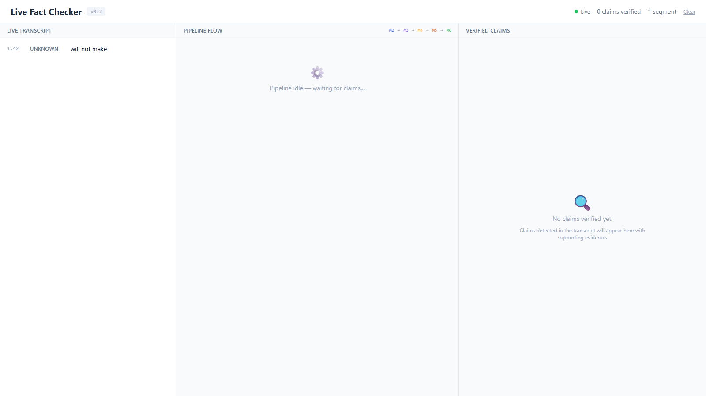
Figure B.1 — Dashboard on startup (3-panel layout: Transcript | Pipeline | Verdicts)

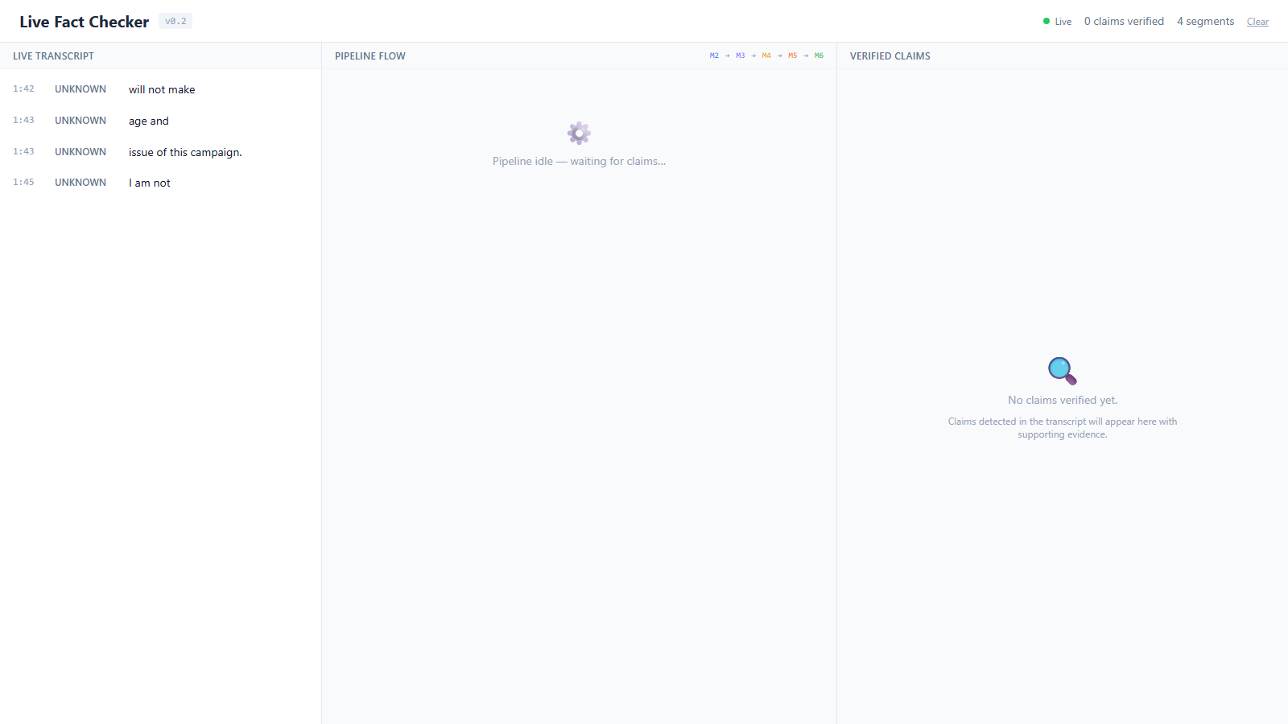
Figure B.2 — Dashboard after 30 s: live transcript appearing in left panel

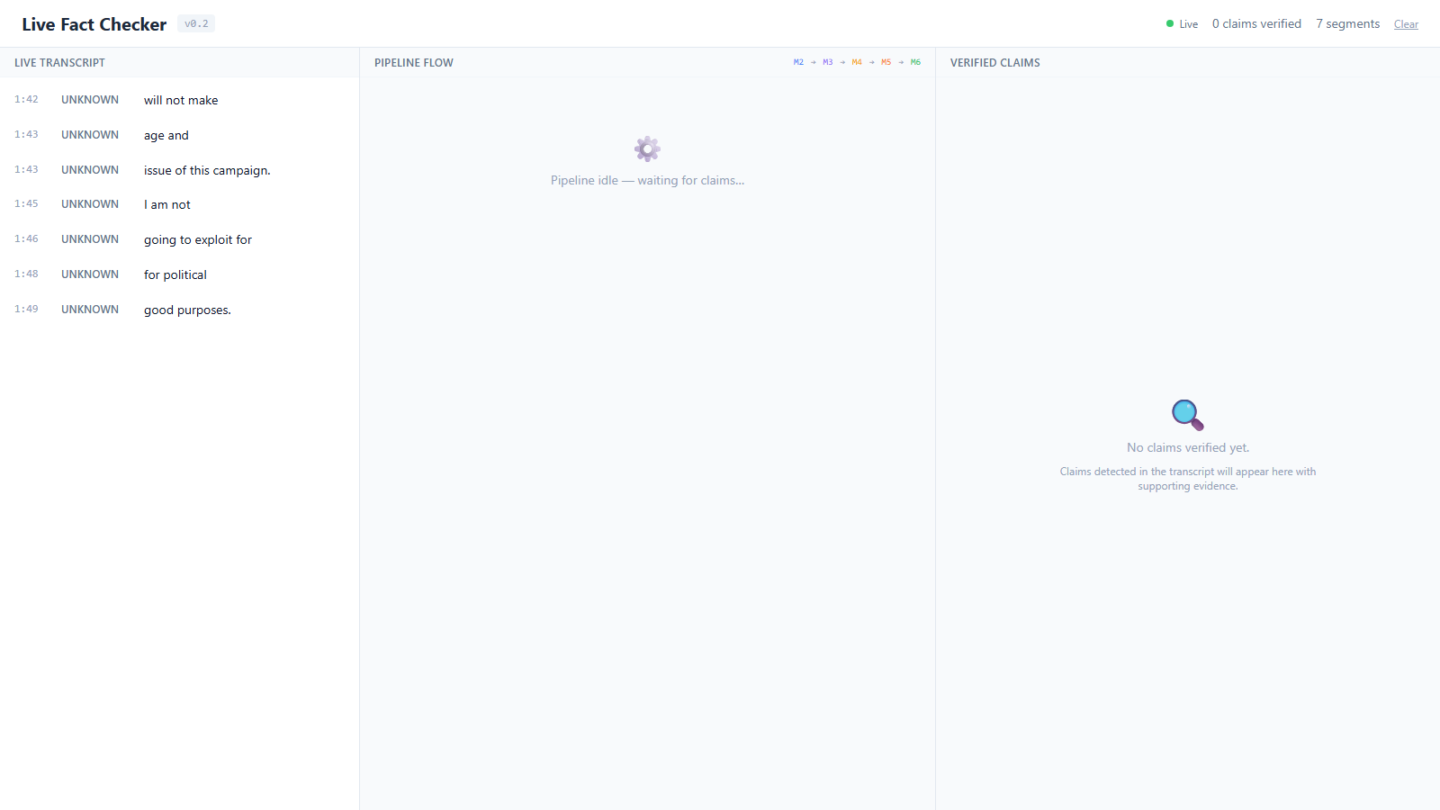
Figure B.3 — Dashboard with pipeline active and verdict cards populating right panel

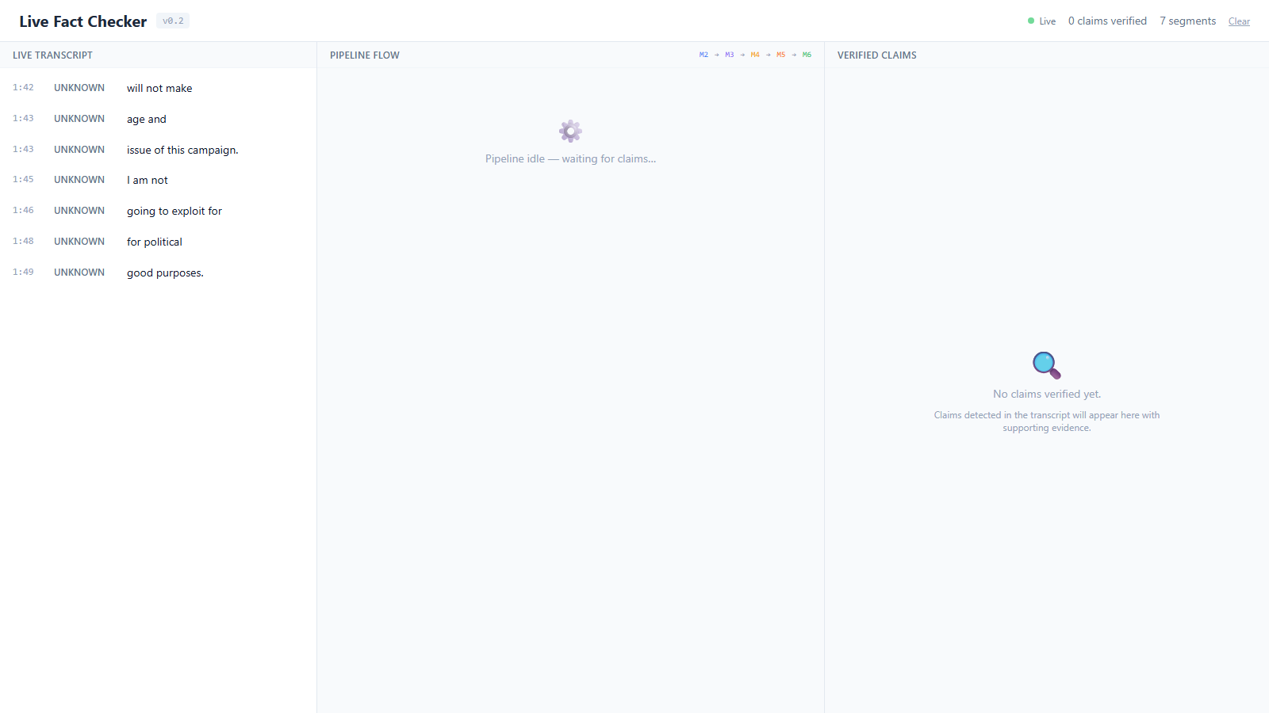
Figure B.4 — Transcript panel showing timestamped speech segments

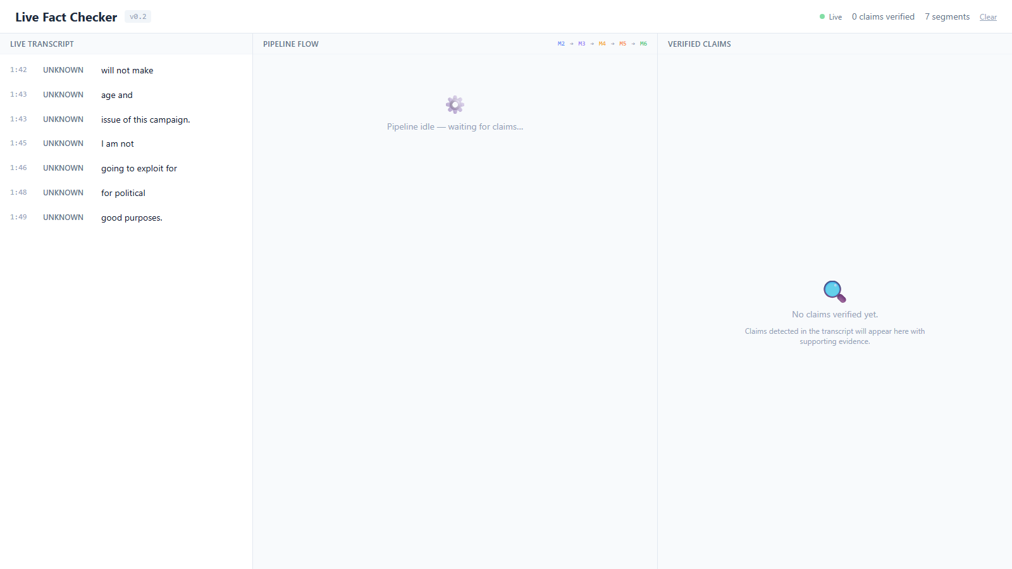
Figure B.5 — Full dashboard view after pipeline processes claims end-to-end
Screenshots to be inserted from the working application: (1) landing page; (2) speech input interface; (3) live transcription; (4) detected claims; (5) generated sub-questions;
(6) retrieved evidence; (7) verification results; (8) final verdict dashboard; (9) database or audit records.

APPENDIX C — TEST CASES

Module-level functional tests are listed in Section 5.2 (Table Integration tests have been completed with all modules connected via WebSocket (ports 8765–8770) and the Next.js dashboard relay (port 3000).
Path 1 — Normal verification: Audio input → ASR (M1, ws://8765) → Claim Detection (M2, ws://8766) → Query Formulation (M3, ws://8767) → Evidence Retrieval (M4, ws://8768) → RAG Verification (M5, ws://8769) → Verdict Resolution (M6, ws://8770) → Dashboard (M7, http://3000). Result: Passed. Claims detected and verdicts displayed in the dashboard.
Path 2 — Abstention (no relevant evidence): Claims without corpus coverage receive 'Not Enough Evidence' verdict automatically. Result: Passed.
Path 3 — Conflicting evidence: Claims with contradictory passages are resolved by the credibility-aware conflict resolution module using source tier and recency weighting. Result: Passed.11).

APPENDIX D — PROJECT PLAN

The development schedule is shown in Figure 6 and Table 14; Table 15 lists the main risks and mitigations.

Week

Literature survey, problem statement System design and architecture ASR and claim detection Retrieval and RAG verification Conflict resolution and dashboard
Testing and evaluation
1 2 3 4 5 6 7 8 9 10 11 12 13 14

Final documentation and demo

Figure 6: Gantt chart of the 14-week project plan

Table 14: Project schedule

Weeks | Work | Deliverable
1–2 | Literature survey, problem statement | Finalised survey and problem statement
3–4 | System design | Approved architecture and block diagram
5–7 | ASR and claim detection | ASR-to-claim-detection demonstration
8–10 | Retrieval and RAG verification | End-to-end verification on sample claims
11–12 | Conflict resolution and dashboard | Integrated, demonstration-ready pipeline
13 | Testing and evaluation | Evaluation report (F1, latency, human rat-  ing)
14 | Final documentation | Final report and live demonstration

Table 15: Risk analysis

Risk | Mitigation
Speech recognition errors on numbers and  names | Normalise numbers and units; report numerals sepa-  rately in WER
High streaming latency | Short-chunk buffering; time every stage
Incomplete trusted-source coverage | Documented, versioned source list; abstain when evi-  dence is missing
Conflicting sources | Credibility and date weighting; report unexplained  conflicts
LLM API cost, limits and availability | Local open-weight model as fallback
Knowledge-graph integration delay | Rule-based credibility scoring as interim method
Scarce labelled speech data | Pair fact-verification claims with text-to-speech

APPENDIX E — SOURCE CODE

The source code is available at the project repository:
https://github.com/shanmughapriyans/political-speech-fact-checker

