REG NO: 21MAI1003

Correlations types plot and Calculation:

Perfect positive correlation, perfect negative correlation,no correlation,non linear correlation, strong position correlation, strong negative correlation,low degree positive correlation,low degree negative correlation

- Perfect positive correlation

A person cycling at a average speed burns more calories each increasing minute and the table below depicts the data of a 130lb person cycling for 50 minutes.

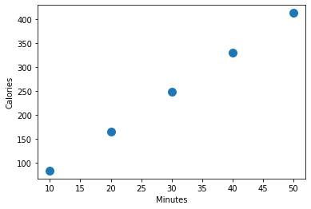
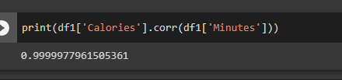
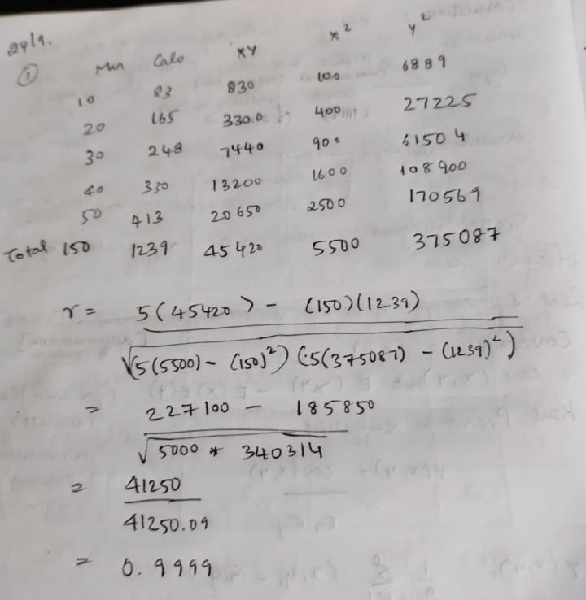

Conclusion:
This suggests a perfectly strong positive correlation

- Perfect negative correlation

A person who exercises everyday and follows a strict proper diet given by a nutritionist reduces 1kg every 7 days

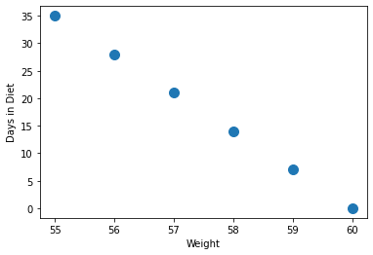
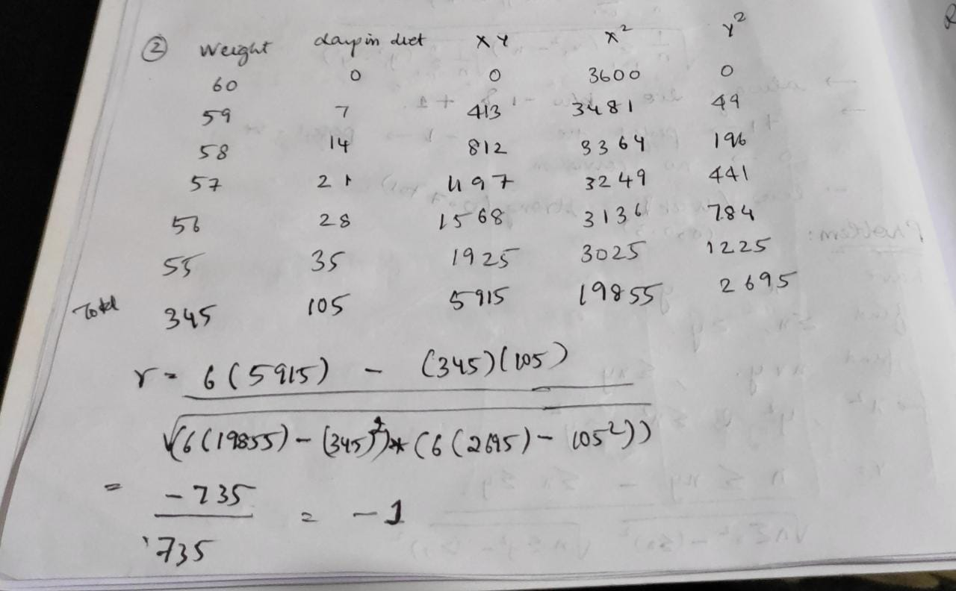

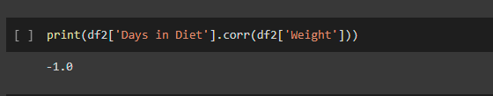

Conclusion:
This shows a perfectly strong negative correlation.

- No correlation:
A persons weight and the their score in the exam

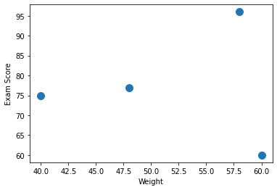
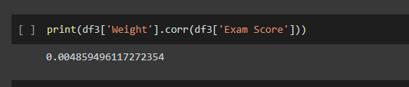

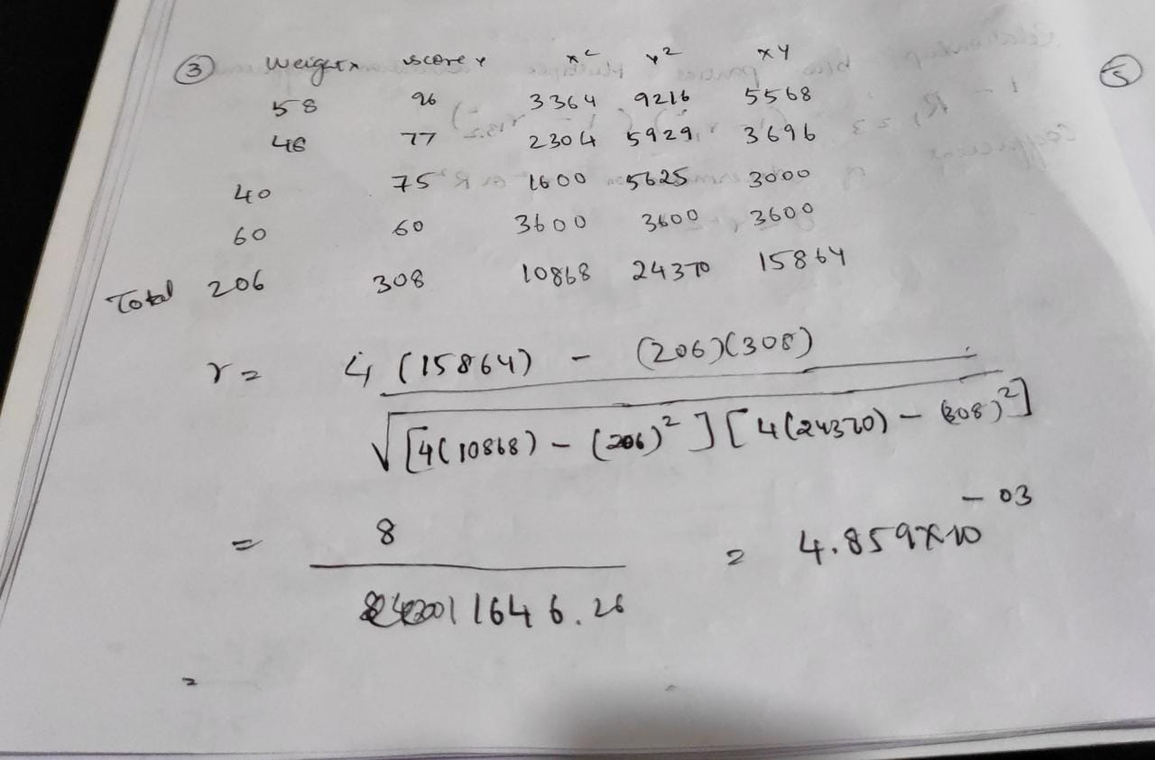

Conclusion:
There is no correlation between a person with weight and how they score in their examination

- Non linear correlation:
Price of a mobile and how many years the person keeps it

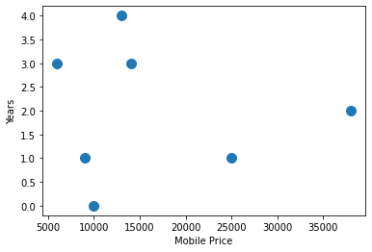
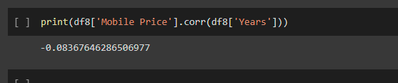

Conclusion:
The mobile price and how many years they keep it based on the value has non linear correlation to it.

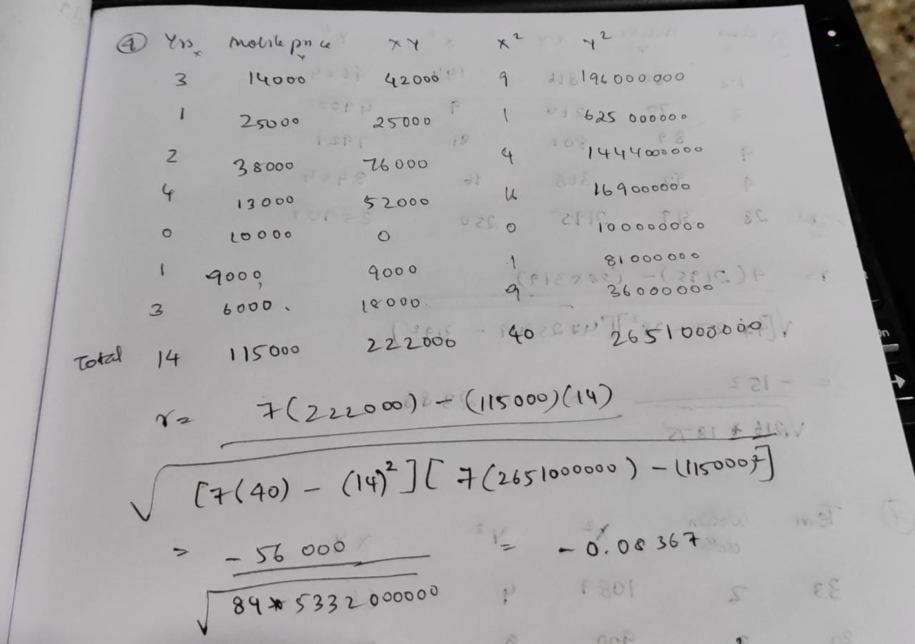

- Strong positive correlation:
As the temperature decreases, ac consumption decreases.

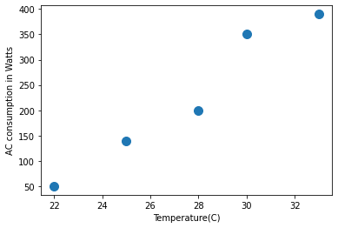
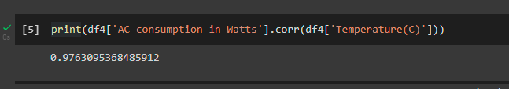

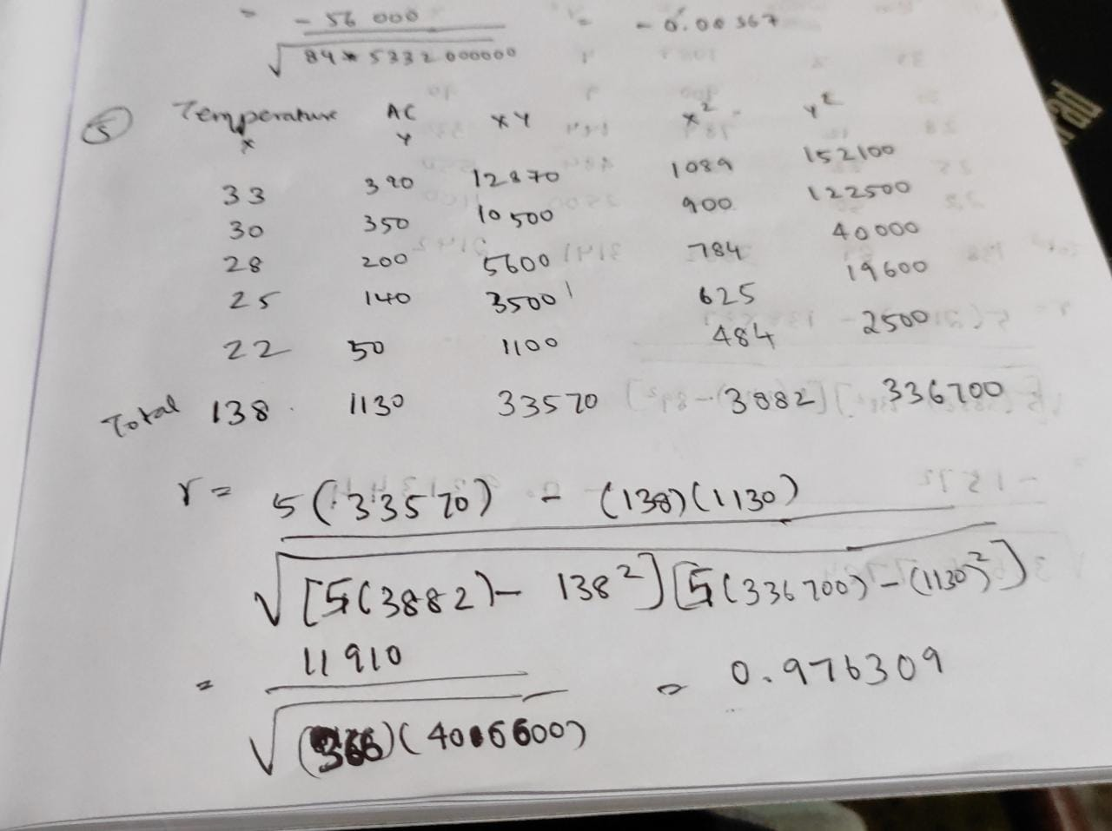
Conclusion:
Temperature price and the consumption is tend to decrease and hence has a strong positive correlation.

- Low degree negative correlation:
As the number of leaves increases, marks decrease.

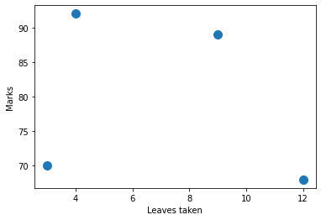
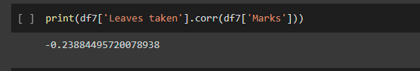

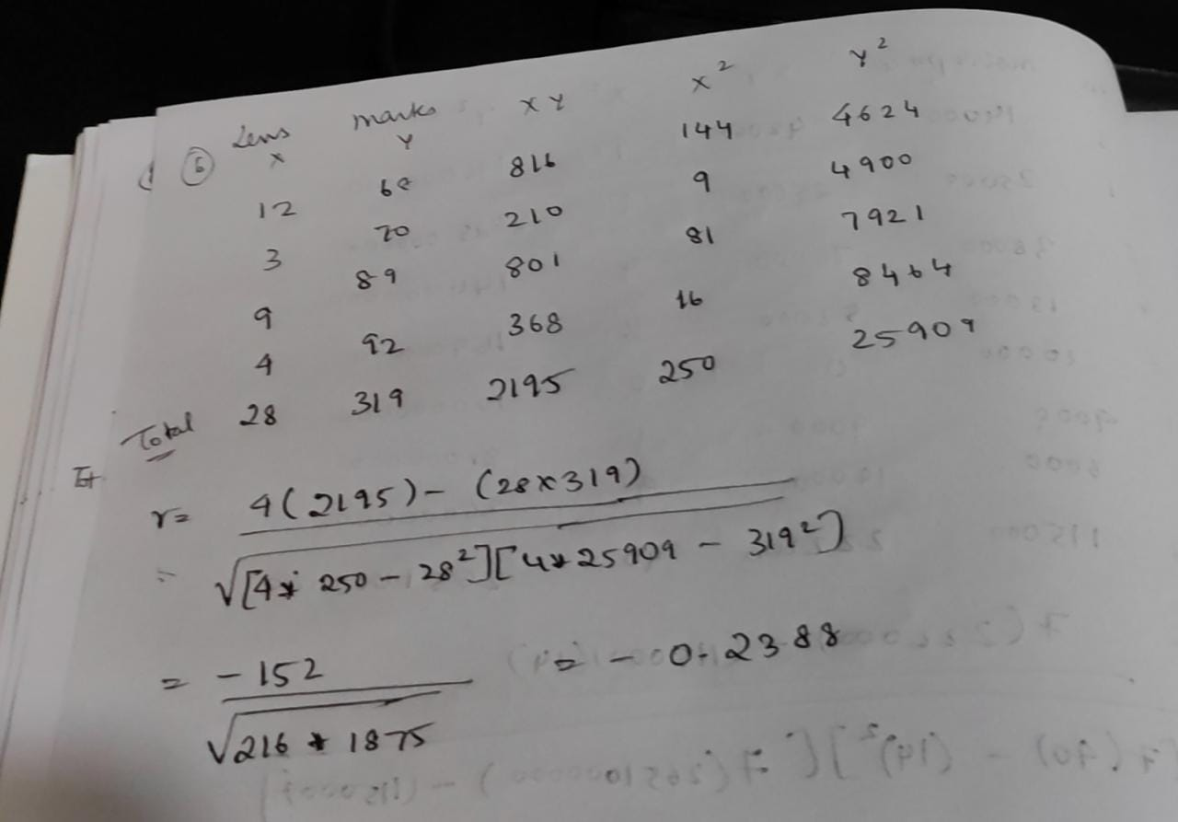

Conclusion:
The leaves taken has very little effect to the students marks and depends on the effort they put to study it. It tends have less effect and has low degree negative correlation.

- Strong negative correlation:
As the temperature increases, sale of woolen cloth decreases.

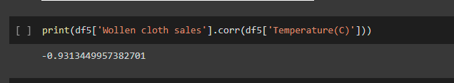
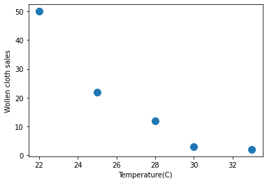

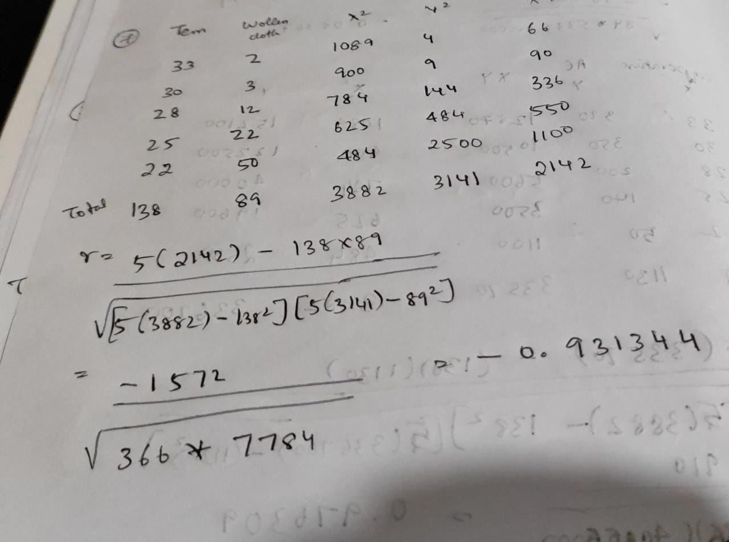

Conclusion:
As temperature decreases sale of woolen cloth increases and tends to have strong negative correlation.

- Low degree positive correlation:
As the temperature decreases, price of ac decreases

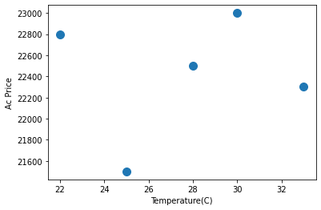
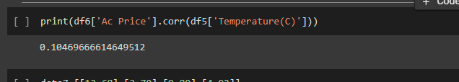

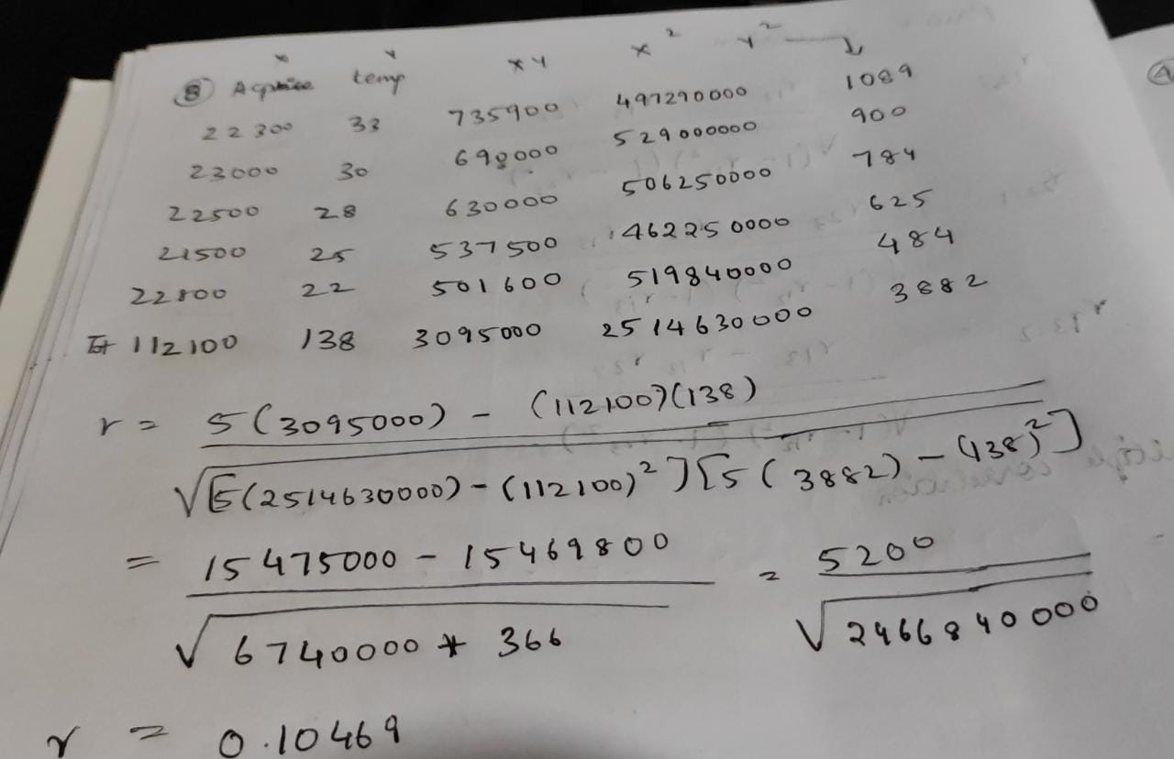

Conclusion:
The price of ac has very little effect to the temperature and hence it’s a low degree positive correlation.

NOTEBOOK LINK

https://colab.research.google.com/drive/1k185kvxUgp-KP8Zw1XUsGgF6jM00SK4k#scrollTo=X21bDNQ3Kpvf

