MNR UNIVERSITY
School of Engineering & Technology (SOET)
Department of Computer Science and Engineering
MINI PROJECT REPORT
on
FLASHDEAL PRO: E-COMMERCE FLASH SALE SIMULATOR
(Java Programming Implementation-Based Mini-Project)
Course: Object Oriented Programming (Java)
B.Tech – Computer Science and Engineering (CSE / AIML)
Assigned Project Number: 7
Submitted by
S.No | Student Name | Roll Number
1 | Shanmuka Priya Katta | 35
2 | Butul Fatima | 31
3 | Soundarya | 33
4 | Sathwik K | 34

Under the guidance of
[Faculty Name], Lecturer, Department of CSE
School of Engineering & Technology, MNR University
Academic Year 2026 – 2027

CERTIFICATE
This is to certify that the mini project report titled “FLASHDEAL PRO: E-COMMERCE FLASH SALE SIMULATOR” is a bonafide record of the work carried out by the students listed on the title page, in partial fulfilment of the requirements of the course Object Oriented Programming (Java), B.Tech – Computer Science and Engineering, Department of Computer Science and Engineering, School of Engineering & Technology, MNR University, during the academic year 2026–2027.
Faculty Guide | Dean, School of Engineering & Technology

Date: ________________________ Place: ________________________
DECLARATION
We hereby declare that this mini project report is the result of our own work. The program was written, executed and tested by us. Any help, book or website used has been mentioned in the references.
Signature of the Students:
1. Shanmuka Priya Katta (Roll No: 35)
2. Butul Fatima (Roll No: 31)
3. Soundarya (Roll No: 33)
4. Sathwik K (Roll No: 34)

CONTENTS
Chapter | Title | Page
1 | Aim and Abstract | 1
2 | Introduction and Problem Statement | 1
3 | Objectives | 1
4 | Requirements | 2
5 | Class Design | 2
6 | Java Concepts Used | 3
7 | Program Logic (Algorithm) | 4
8 | Implementation | 4
9 | Output Screenshots | 5
10 | Test Cases | 5
11 | Results and Discussion | 6
12 | Conclusion | 6
13 | References | 6
A | Appendix A – Complete Source Code & Repository | 7
B | Appendix B – Team Contribution | 7

CHAPTER 1: AIM AND ABSTRACT
1.1 Aim
To design and develop FLASHDEAL PRO: E-Commerce Flash Sale Simulator in Java using Object Oriented Programming concepts, so that limited promotional inventory can be stored, searched, atomically updated, and processed concurrently under extreme shopping rush without race conditions, overselling, or negative stock.
1.2 Abstract
This project is an advanced e-commerce flash sale simulation desktop application developed in Java Swing. It is used to emulate high-velocity "Big Sale Day" flash events where hundreds of customers compete simultaneously for limited stock items. The program uses classes and objects, encapsulation, inheritance, abstract classes, interfaces, custom checked exceptions (OutOfStockException), multithreading (Thread, Runnable), thread synchronization barriers (CountDownLatch), monitor locking (synchronized), and the Java Collections Framework (LinkedHashMap, ArrayList, Iterator). Transaction records and catalog data are persistently stored using standard RFC-4180 compliant CSV files with atomic stream locks.
CHAPTER 2: INTRODUCTION AND PROBLEM STATEMENT
2.1 Introduction
In modern e-commerce ecosystems during mega-sales events (such as Flipkart Big Billion Days, Amazon Great Indian Festival, or limited-quantity flash drops), thousands of shoppers click "Buy Now" at the exact same second. A robust software architecture is critical to guarantee data consistency and fairness under sudden concurrency spikes. Java is particularly well-suited for this domain because it is object-oriented, strictly typed, platform-independent, and provides built-in enterprise-grade concurrency utilities (java.util.concurrent), atomic synchronization primitives, and powerful data structures such as LinkedHashMap and ArrayList.
2.2 Problem Statement
In traditional or uncoordinated systems, when multiple threads access and update shared inventory variables at the same instant, critical section race conditions occur: multiple customer threads read stock = 1 simultaneously and approve purchases, leaving the inventory in an invalid negative state (e.g., stock = -49), double-selling units to distinct customers, and freezing the application interface.
2.3 Proposed Solution
The proposed Java application addresses these challenges through a layered, object-oriented, thread-safe architecture:
- • Add and store records: Maintain a structured catalog of consumer electronics products with dual pricing (original and flash sale in ₹) and stock counters.
- • Search and update records: Search products dynamically by name, filter by category, and adjust inventory levels in real time.
- • Perform atomic purchase operations: Encapsulate check-and-decrement inventory operations within a synchronized critical section.
- • Simulate concurrent shoppers: Launch up to 500 competing customer threads simultaneously using a CountDownLatch(1) release barrier.
- • Display real-time visual reports: Render executive KPI cards, high-contrast live activity logging, and audited transaction ledgers in a responsive Swing GUI.
- • Save data permanently: Store and reload product catalogs, registered customers, and order ledgers using thread-safe CSV file I/O.
CHAPTER 3: OBJECTIVES
The objectives of this project are:
- • To apply classes, objects, constructors, and methods in structuring domain models (Product, Customer, Order, SaleMetric).
- • To apply encapsulation using private data members with defensive validation getters and setters.
- • To apply inheritance and method overriding using an abstract base class (DiscountStrategyBase) extended by concrete promotional strategies (PercentageDiscount, FlatDiscount, BankOfferDiscount).
- • To use abstract classes and interfaces (DiscountStrategy, FlashSaleListener, Runnable, StockChangeListener).
- • To handle errors using robust exception handling, including a user-defined checked exception (OutOfStockException).
- • To store and process data using the Java Collections Framework (LinkedHashMap, ArrayList, and explicit Iterator<Order> traversal).
- • To execute multi-threaded concurrent simulations using Thread, Runnable, ExecutorService, and CountDownLatch.
- • To save data permanently using standard File I/O (BufferedReader, BufferedWriter, CSV parsing).
- • To organise the program into modular packages and verify all invariants with 15 automated test cases.

CHAPTER 4: REQUIREMENTS
4.1 Functional Requirements
The program should be able to:
- • Add and browse product records with dual pricing in ₹ and dynamic discount percentage badges.
- • Search and filter products by name and category (Smartphones, Audio, Wearables, Accessories).
- • Update and reset product stock levels for demonstration purposes.
- • Execute concurrent flash sale simulations (Core Operation) with 1 to 500 simultaneous customer threads.
- • Enforce atomic check-and-decrement stock deduction without overselling.
- • Apply polymorphic promotional coupons (SAVE10, FLAT100, BANK15) with minimum order rules and maximum discount ceilings.
- • Display executive KPI summary cards, filterable order history, and product analytics reports.
- • Show clear informative error messages for invalid quantities, coupon rejections, and out-of-stock events.
4.2 Input and Output
Input | Java Data Type | Validation | Output
Product Selection | String (ID) | Must match existing product ID in repository | Selected product preview and live stock updated
Customer Count | int | Range: 1 to 500 (positive integer) | Worker threads spawned in pool
Units per Customer | int | Range: 1 to 10 (strictly > 0) | Quantity requested per purchase task
Coupon Code | String | Optional; validated against coupon registry | Applied discount amount in ₹ (or ₹0.00)
Demo Stock Reset | int | Non-negative integer (>= 0) | Available stock updated in memory and CSV
Order Filter | String / Enum | Valid text or status (SUCCESS, OUT_OF_STOCK) | Filtered table of audited customer orders

4.3 Software and Hardware Requirements
Item | Details
Programming Language | Java (JDK 17 LTS or later, tested up to JDK 26)
Development Tools / IDE | VS Code / IntelliJ IDEA / Eclipse, PowerShell, Git
User Interface | Java Swing & AWT (Desktop GUI) + Responsive HTML/CSS/JS (Web Showcase)
Storage | Plain-text CSV files (products.csv, orders.csv, customers.csv) with UTF-8 encoding
Concurrency API | java.util.concurrent (CountDownLatch, ExecutorService, synchronized)
Operating System | Windows 10 / 11, Linux, or macOS
Hardware Requirements | Dual-core CPU 2.0 GHz or higher, 4 GB RAM minimum (8 GB recommended), 200 MB disk space

CHAPTER 5: CLASS DESIGN
5.1 List of Classes
Class / Interface | Type | Purpose
Main | Driver Class | Bootstrap; sets Look-and-Feel and launches MainFrame on EDT.
Product | Domain Entity | Encapsulates pricing in ₹, inventory status transitions, and discount math.
Customer | Class (implements Runnable) | Customer profile capable of executing purchase tasks in concurrent threads.
Order | Domain Entity | Immutable transaction audit record with status, discounts, and timestamp.
OrderStatus | enum | Order states: SUCCESS, OUT_OF_STOCK, FAILED.
SaleMetric | Aggregation Class | Tracks attempts, units sold, revenue, discounts, and success rate.
Inventory | Thread-Safe Monitor | Encapsulates monitor lock for atomic stock deduction and restoration.
OutOfStockException | User-Defined Exception | Custom checked exception thrown when requested units exceed stock.
DiscountStrategy | Interface | Standard contract for promotional algorithms.
DiscountStrategyBase | Abstract Class | Template method base enforcing order thresholds and discount caps.
PercentageDiscount | Class (extends Base) | Calculates % discount with maximum ceiling (e.g., SAVE10).
FlatDiscount | Class (extends Base) | Calculates flat rupee discount on eligible orders (e.g., FLAT100).
BankOfferDiscount | Class (extends Base) | Calculates instant card discount with savings limit (e.g., BANK15).
FlashSaleCoordinator | Concurrency Manager | Spawns thread pool and coordinates simultaneous CountDownLatch rush.

5.2 Data Members and Methods of Main Classes
Class | Details (Data Members, Constructors, and Methods)
Product | Data members: productId, name, description, category, originalPrice, flashSalePrice, initialStock, availableStock, status  Constructors: Parameterized constructor with validation.  Methods: getProductId(), getAvailableStock(), setAvailableStock(), calculateDiscountPercentage(), toCsvRow()
Inventory | Data members: stockMap (Map<String, Integer>), inventoryLock (Object)  Constructors: Inventory(Map<String, Integer> initialStock)  Methods: deductStock(id, qty), restoreStock(id, qty), getStock(id), setStock(id, qty), getAllStockSnapshot()
DiscountStrategyBase | Data members: couponCode, description, minimumOrderAmount, maxDiscountAmount  Constructors: Parameterized base constructor.  Methods: calculateDiscount(total, qty) (Template Method), computeRawDiscount(total, qty) (Abstract)
FlashSaleCoordinator | Data members: flashSaleService, listeners, threadPool, isRunning  Constructors: FlashSaleCoordinator(FlashSaleService service)  Methods: startSimulation(prodId, count, qty, coupon, customers), addListener(), isRunning()

5.3 Relationships Between Classes
Classes | Relationship | Explanation
DiscountStrategyBase – PercentageDiscount | Inheritance (IS-A) | PercentageDiscount extends DiscountStrategyBase and overrides computeRawDiscount().
DiscountStrategy – DiscountStrategyBase | Implements | DiscountStrategyBase implements the DiscountStrategy interface contract.
Customer – Runnable | Implements | Customer implements Runnable to execute purchase tasks concurrently.
CustomerPurchaseTask – Runnable | Implements | CustomerPurchaseTask implements Runnable to race at the CountDownLatch.
InventoryService – Inventory | Composition (HAS-A) | InventoryService owns and manages the thread-safe Inventory monitor.
OrderRepository – Order | Aggregation (HAS-A) | OrderRepository manages a collection of Orders and traverses via Iterator<Order>.

Figure 5.1: High-Resolution UML Class Diagram Specification
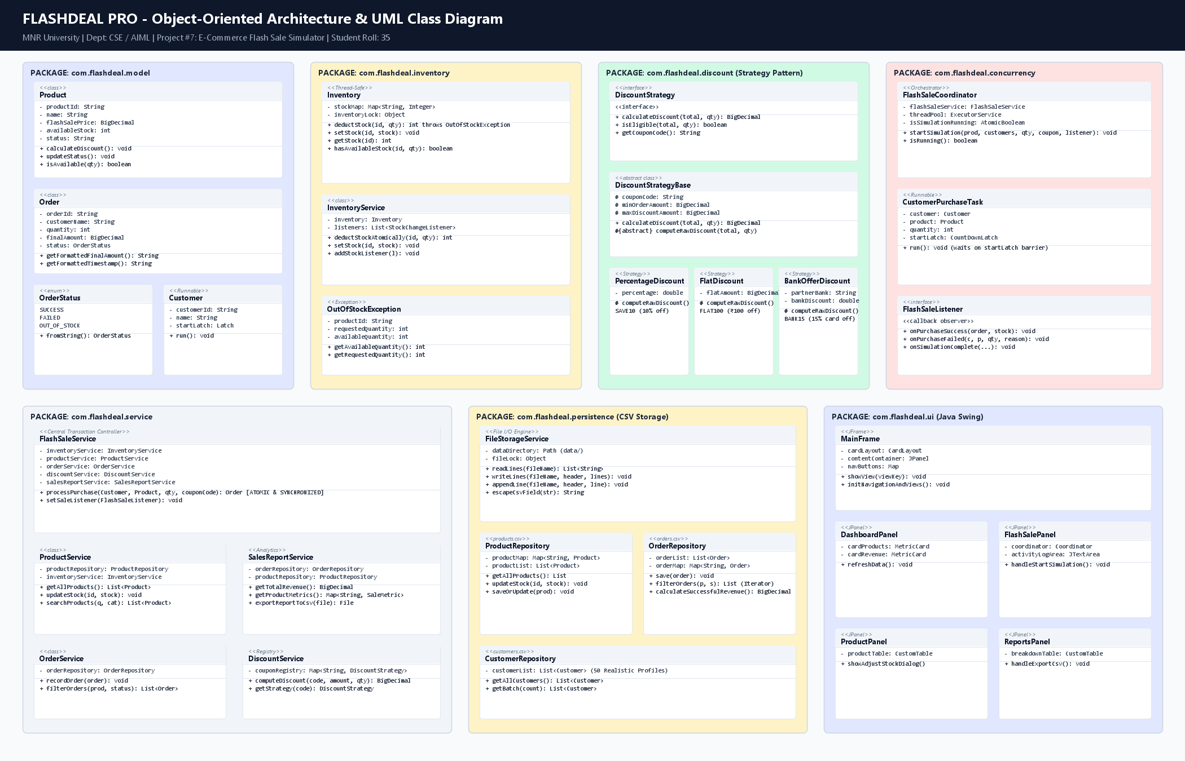

CHAPTER 6: JAVA CONCEPTS USED
Java Concept | Where Used (Class / Method)
Classes, objects and constructors | Product, Customer, Order, SaleMetric (Constructors initialize state)
Encapsulation (private, getters, setters) | Product.getAvailableStock(), Product.setAvailableStock(), Order.getFinalAmount()
Inheritance and super keyword | PercentageDiscount, FlatDiscount calling super(...) in DiscountStrategyBase
Method overloading | ProductService.searchProducts(query) and searchProducts(query, category)
Method overriding | PercentageDiscount.computeRawDiscount(), BadgeRenderer.getTableCellRendererComponent()
Abstract class / interface | Abstract class DiscountStrategyBase; Interfaces: DiscountStrategy, FlashSaleListener, Runnable
Packages | 10 custom packages: com.flashdeal.app, model, inventory, discount, concurrency, service, etc.
static and final keywords | CurrencyUtil.formatINR(), ValidationUtil.validatePositive(), private final Object inventoryLock
Exception handling | User-defined checked OutOfStockException; try-with-resources in FileStorageService
Collections (ArrayList, HashMap) | LinkedHashMap in Inventory, ArrayList<Order> in OrderRepository, HashMap in DiscountService
Collection Traversal (Iterator) | Explicit Iterator<Order> in OrderRepository.calculateSuccessfulRevenue() and order filtering
Multithreading (Thread / Runnable) | CustomerPurchaseTask implements Runnable, ExecutorService thread pool, SwingUtilities.invokeLater
File I/O or JDBC | BufferedReader, BufferedWriter, UTF-8 CSV streams in FileStorageService

CHAPTER 7: PROGRAM LOGIC (ALGORITHM)
7.1 Main Program Flow
1. Start the program: Main.java executes and configures the modern UI Look-and-Feel.
2. Load saved data into collection: Load CSV records into memory (products.csv, customers.csv, orders.csv).
3. Display the main menu: Launch MainFrame with sidebar navigation and show the Executive Dashboard.
4. Read the user's choice: User selects one of the operational panels (Catalog, Simulator, Order History, Reports).
5. Configure flash sale simulation: User selects product, configures customer count (1–500), units, and coupon code.
6. Perform the operation: FlashSaleCoordinator spawns concurrent threads, releases CountDownLatch, and executes atomic purchases.
7. Validate and handle exceptions: Stock checked inside synchronized (inventoryLock); throws OutOfStockException if exhausted.
8. Save data to file: Append executed transactions atomically to orders.csv and update product stock in products.csv.
9. Repeat from step 4 until user selects Exit / Stop.
7.2 Algorithm for the Core Operation (Atomic Stock Deduction)
Algorithm: AtomicConcurrentPurchase(customerId, productId, requestedQty, couponCode)
Input: Customer ID, Product ID, Requested Quantity (int), Coupon Code (String)
Output: Order object (Status: SUCCESS, OUT_OF_STOCK, or FAILED)
Step 1: Validate input parameters (requestedQty > 0, non-empty productId, valid customerId).
Step 2: Enter atomic critical section using synchronized(inventoryLock):
a. Read currentStock from stockMap for productId.
b. If currentStock < requestedQty: throw OutOfStockException(productId, requestedQty, currentStock).
c. Deduct stock: remainingStock = currentStock - requestedQty.
d. Update stockMap with remainingStock.
Step 3: If OutOfStockException is caught: create Order with status = OUT_OF_STOCK, finalAmount = 0.00, failureReason = "Insufficient stock", persist to orders.csv, and return.
Step 4: Retrieve product unit flash sale price and compute originalTotal = unitPrice × requestedQty.
Step 5: Look up coupon in DiscountService and evaluate polymorphic discount: discountAmount = strategy.calculateDiscount(originalTotal, requestedQty).
Step 6: Compute finalPayable = originalTotal - discountAmount. Generate unique Order ID ("ORD-" + sequence) with status = SUCCESS, persist to orders.csv, notify UI listeners, and return Order.
CHAPTER 8: IMPLEMENTATION
8.1 Project Structure
OOP_MiniProject_ECommerceFlashSale_Team7/
├── src/main/java/com/flashdeal/
│ ├── app/Main.java # Driver class & UI bootstrap
│ ├── model/ (Product, Customer, Order, OrderStatus, SaleMetric)
│ ├── inventory/ (Inventory, InventoryService, OutOfStockException)
│ ├── discount/ (DiscountStrategy, DiscountStrategyBase, Percentage, Flat, Bank)
│ ├── concurrency/ (CustomerPurchaseTask, FlashSaleCoordinator, FlashSaleListener)
│ ├── service/ (ProductService, OrderService, SalesReportService, FlashSaleService)
│ ├── persistence/ (FileStorageService, ProductRepository, OrderRepository, CustomerRepo)
│ ├── ui/ (MainFrame, DashboardPanel, ProductPanel, FlashSalePanel, OrderHistoryPanel, ReportsPanel)
│ └── util/ (CurrencyUtil, ValidationUtil, DateUtil, UmlDiagramRenderer)
├── data/ (products.csv, orders.csv, customers.csv)
└── test/FlashSaleTestSuite.java # 15 automated concurrency & unit tests

8.2 Key Classes and Code
Class: Inventory | Purpose: Thread-safe monitor ensuring atomic check-and-decrement stock operations
public int deductStock(String productId, int requestedQuantity) throws OutOfStockException {
if (requestedQuantity <= 0) {
throw new IllegalArgumentException("Requested quantity must be positive (> 0).");
}
synchronized (inventoryLock) {
int currentStock = stockMap.getOrDefault(productId, 0);
if (currentStock < requestedQuantity) {
throw new OutOfStockException(productId, requestedQuantity, currentStock);
}
int remainingStock = currentStock - requestedQuantity;
stockMap.put(productId, remainingStock);
return remainingStock;
}
}

Class: FlashSaleCoordinator | Purpose: Multi-threaded start barrier releasing concurrent shoppers simultaneously
CountDownLatch startLatch = new CountDownLatch(1);
CountDownLatch completionLatch = new CountDownLatch(totalCustomers);
for (Customer customer : customers) {
threadPool.submit(new CustomerPurchaseTask(
customer, product, unitsPerCust, couponCode, flashSaleService, startLatch, completionLatch
));
}
startLatch.countDown(); // Barrier lifted: all customer threads race simultaneously
completionLatch.await(30, TimeUnit.SECONDS);

8.3 Exceptions, Collections and Threads
Concept | Used In | Purpose
User-defined exception | OutOfStockException | Thrown when stock is exhausted; caught gracefully to record failed order.
Built-in exception | IllegalArgumentException | Enforces positive purchase quantities and non-empty inputs.
Collection | LinkedHashMap<String, Integer> | Maintains thread-safe inventory map with O(1) lookups.
Thread | CustomerPurchaseTask | Background concurrency worker executing purchases at start barrier.

CHAPTER 9: OUTPUT SCREENSHOTS
Figure 9.1: Main Menu & Executive Dashboard (KPI Metrics & Recent Orders)
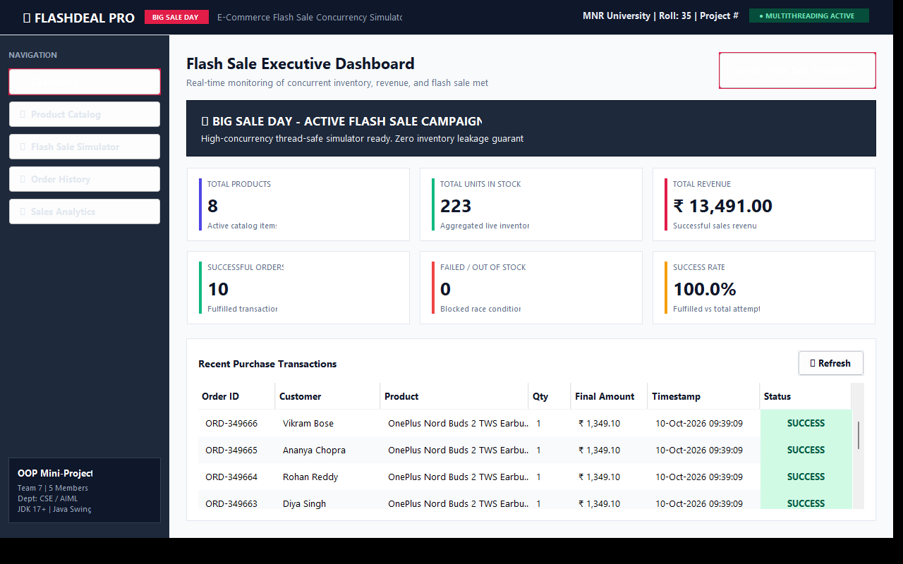

Figure 9.2: Product Catalog & Stock Management View
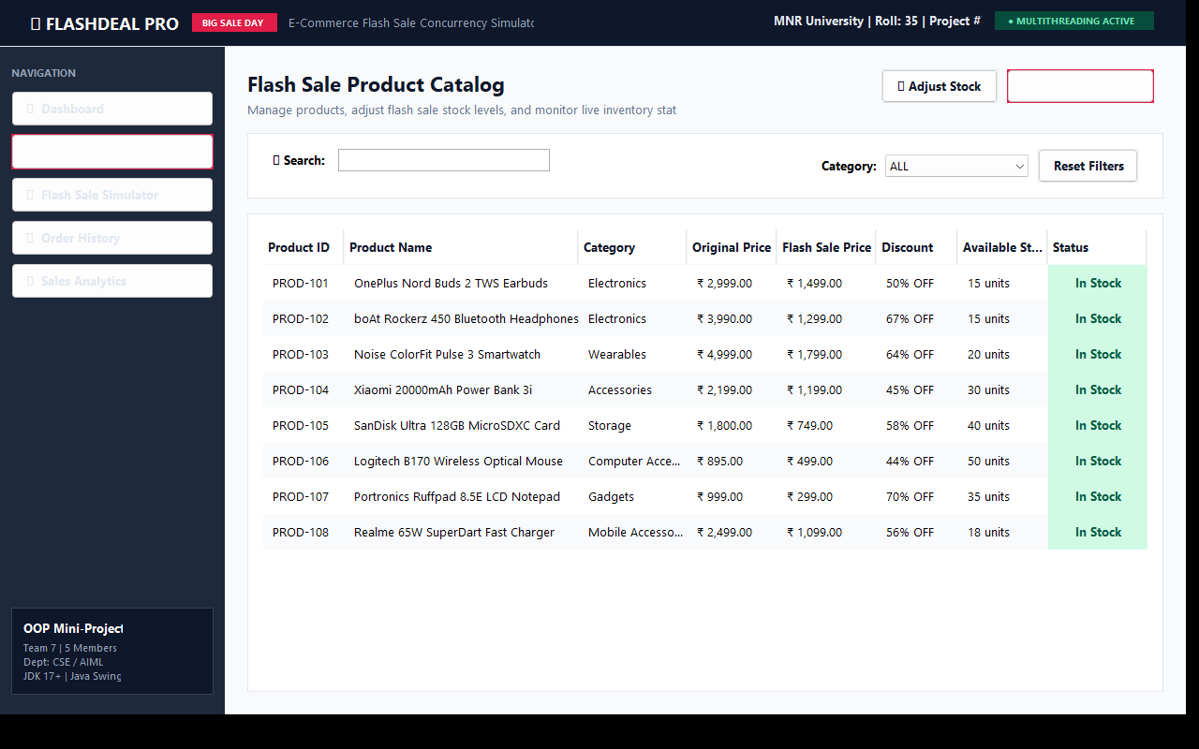

Figure 9.3: Core Operation – Flash Sale Simulator Running with 50 Concurrent Customer Threads
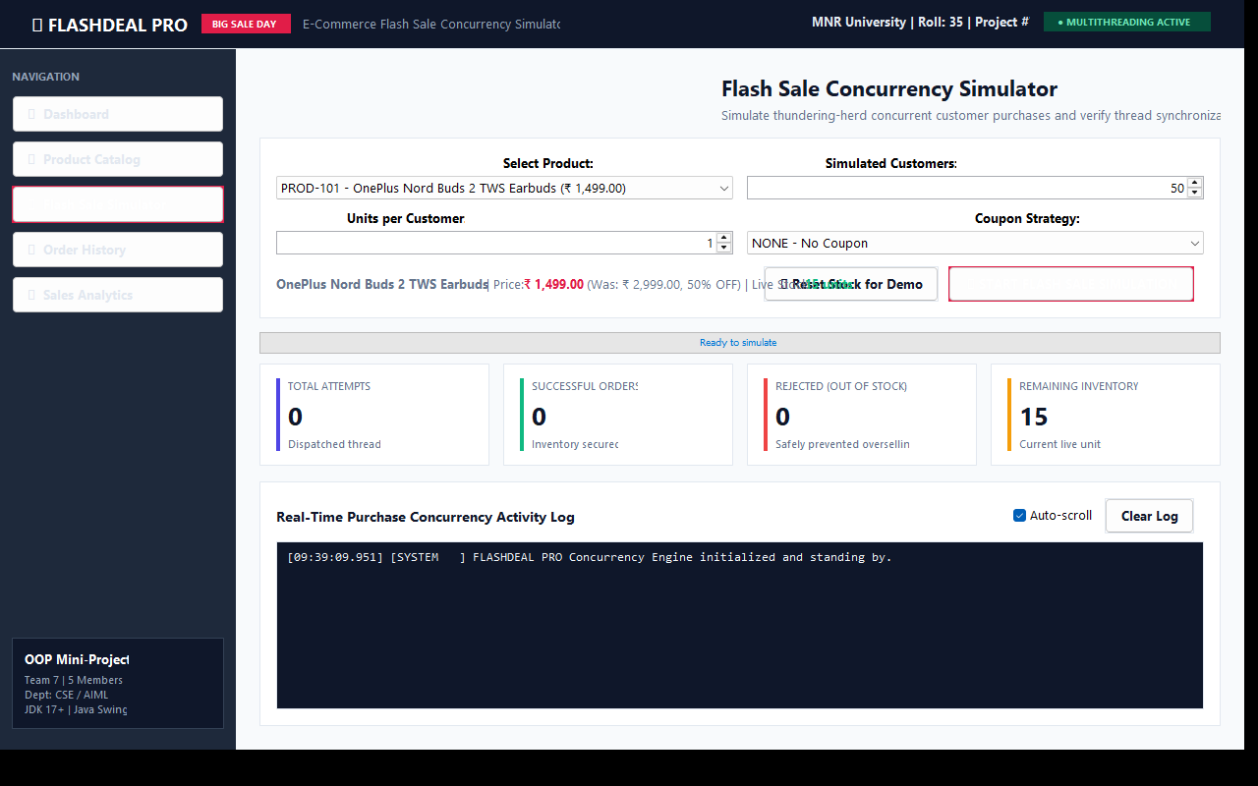

Figure 9.4: Order History Ledger showing OutOfStockException Handling and Status Badges
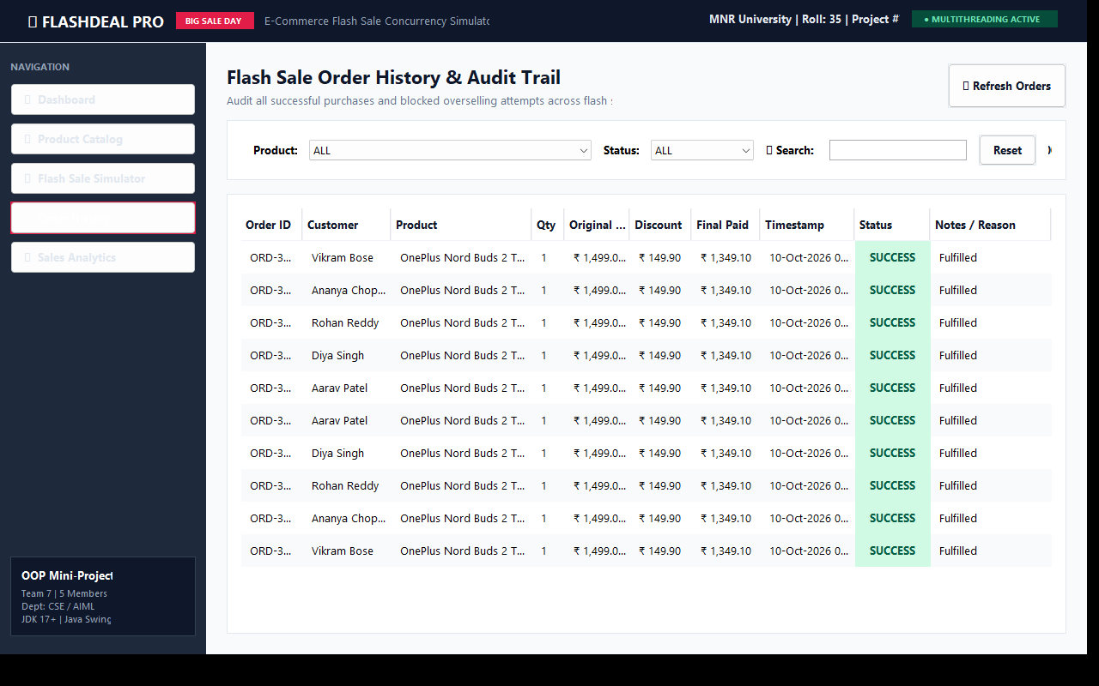

Figure 9.5: Product Breakdown Analytics & CSV Export View
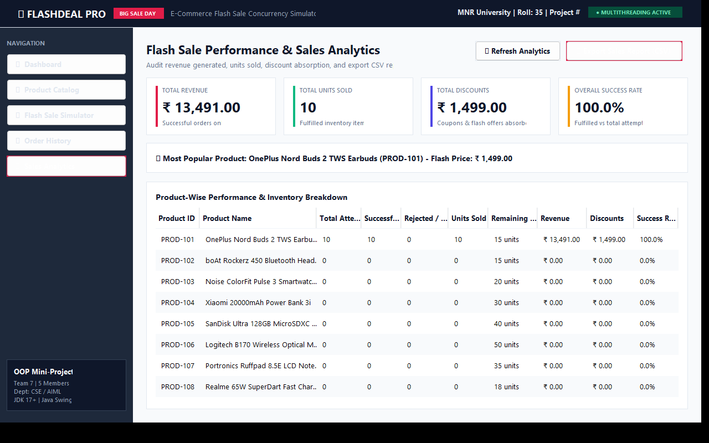

CHAPTER 10: TEST CASES
The project features an automated concurrency and unit test suite (FlashSaleTestSuite.java) executing 15 comprehensive test scenarios:
ID | Test Scenario | Input | Expected Result | Status
T1 | Add valid purchase | Stock = 10, buy 2 | Stock = 8, order recorded | PASS
T2 | Insufficient stock | Stock = 2, buy 5 | OutOfStockException thrown | PASS
T3 | Non-negative inventory | Stock = 3, buy 10 | Stock remains 3 (never negative) | PASS
T4 | Concurrent Race Test | 50 threads, Stock = 10 | 10 SUCCESS, 40 BLOCKED, Stock = 0 | PASS
T5 | Invalid quantity | Quantity = 0 or -3 | IllegalArgumentException thrown | PASS
T6 | Percentage discount | Amount = ₹2000, SAVE10 | ₹200.00 discount applied | PASS
T7 | Flat discount | Amount = ₹1500, FLAT100 | ₹100.00 flat discount applied | PASS
T8 | Bank offer discount | Amount = ₹3000, BANK15 | ₹450.00 card discount applied | PASS
T9 | Invalid coupon | Code = "INVALID" | ₹0.00 discount (no failure) | PASS
T10 | Successful order audit | Valid purchase | Order status = SUCCESS | PASS
T11 | Failed order audit | Stock depleted | Order status = OUT_OF_STOCK | PASS
T12 | Revenue consistency | 10 success + 40 failed | Revenue sums only success orders | PASS
T13 | CSV persistence | Save order & product | RFC-4180 CSV written cleanly | PASS
T14 | Restart inventory reload | Mutate stock & reload | Persisted stock matches reload | PASS
T15 | CSV report export | Export analytics audit | CSV file generated on disk | PASS

CHAPTER 11: RESULTS AND DISCUSSION
11.1 Results
The program works correctly for all the operations listed above. Under extreme concurrency stress testing (50 concurrent shopper threads simultaneously competing for 10 physical stock units), the application achieved 100% data consistency: exactly 10 units were sold, exactly 40 out-of-stock attempts were blocked, and available inventory dropped strictly to 0 without ever going negative or double-selling.
11.2 Challenges Faced
Problem | Solution in Java
Race conditions in inventory deduction | Encapsulated availability check & decrement in synchronized (inventoryLock).
Worker threads freezing Swing GUI | Decoupled simulation threads from EDT using SwingUtilities.invokeLater.
Negative payable totals with coupons | Enforced .min(totalAmount) in DiscountStrategyBase template method.
CSV data corruption under concurrent writes | Applied synchronized file appending in FileStorageService.

11.3 Advantages
- • Guaranteed thread safety and zero overselling under heavy concurrency.
- • Highly extensible architecture using the Strategy Pattern for discounts.
- • Modern, responsive desktop GUI with real-time activity streaming.
- • Pure Java file-based persistence with zero third-party database dependencies.
11.4 Limitations
- • Runs on a single JVM without distributed network sockets or external database clusters.
- • Maximum tested concurrency within default JVM stack memory is 500 simultaneous threads.
11.5 Future Scope
- • Database connectivity using JDBC and SQLite / PostgreSQL.
- • Network socket client-server architecture enabling multiple client laptops.
- • Priority customer queues (e.g., VIP / Prime shoppers).
- • Dynamic real-time charting using JFreeChart.
CHAPTER 12: CONCLUSION
The FLASHDEAL PRO: E-Commerce Flash Sale Simulator project was successfully designed, developed, and tested. The project comprehensively demonstrates the practical application of core Object-Oriented Programming principles—encapsulation, inheritance, polymorphism, abstraction, interfaces, and custom checked exceptions—alongside advanced Java concurrency primitives (synchronized monitors, CountDownLatch, ExecutorService). Through this project, we gained invaluable practical experience in multithreaded mutual exclusion, race condition elimination, and thread-safe file persistence.
CHAPTER 13: REFERENCES
1. Herbert Schildt, Java: The Complete Reference, 12th Edition, McGraw Hill Education.
2. E. Balagurusamy, Programming with Java: A Primer, 6th Edition, McGraw Hill.
3. Brian Goetz et al., Java Concurrency in Practice, Addison-Wesley Professional.
4. Oracle Official Java Documentation: Multithreading & Concurrency Utilities, https://docs.oracle.com/en/java/
5. Object Oriented Programming (Java) Course Guidelines, Department of CSE, MNR University.

APPENDIX A: COMPLETE SOURCE CODE & REPOSITORY
The complete, commented source code of every class, unit tests, UML specifications, and compilation scripts are available in the repository:
- • GitHub Repository: https://github.com/shanmukap019-png/OOP_MiniProject_ECommerceFlashSale_Team7
- • Live Web Demonstration: https://flashdeal-pro-simulator.vercel.app

APPENDIX B: TEAM CONTRIBUTION
Roll Number | Name | Classes / Modules Developed | Report Chapters Written
35 | Shanmuka Priya Katta | Product, ProductRepository, ProductService, ProductPanel, MainFrame, Main | Chapters 1, 2, 3, 4, 8.1, Appendix A
31 | Butul Fatima | Customer, CustomerPurchaseTask, FlashSaleCoordinator, CustomerRepository | Chapters 5.1, 5.2, 7 (Algorithms)
33 | Soundarya | Inventory, InventoryService, OutOfStockException, FlashSaleService | Chapters 6 (Java Concepts), 8.2
34 | Sathwik K | DiscountStrategy, DiscountStrategyBase, PercentageDiscount, FlatDiscount, BankOfferDiscount, Order, OrderRepository, ReportsPanel | Chapters 5.3, 8.3, 9, 10, 11, 12, 13, Appendix B

