MediMetrics: Hospital Operations & Patient Flow Analytics – Project Report

Abstract
This project analyses 75,000 hospital appointments (1 Jan 2022 – 31 Dec 2024) using Python, MySQL and Power BI. The workflow covered data auditing and cleaning, loading the data into a MySQL database, ten SQL business analyses, and a three-page Power BI dashboard for operational decision support.

Introduction
Hospitals lose capacity and revenue when patients miss appointments, and managers need a clear view of demand, patient flow and specialty performance. This project uses data-driven methods to measure where appointments are lost and which areas offer the best opportunity for improvement. The data covers 32,705 patients, 320 doctors, 36 hospitals, 15 cities and 14 specialties.

Objectives
• Measure overall hospital performance and appointment demand
• Identify where no-shows and cancellations occur (specialty, booking channel, lead time)
• Compare revenue, waiting time and patient satisfaction across specialties
• Build interactive dashboards for decision support

Dataset and Tools Used
Dataset: Apollo hospital appointment data – appointments (75,000 rows × 57 columns after cleaning) and doctors (320 rows × 15 columns), linked by doctor_id.
Tools Used: VS Code Jupyter Notebook, Python Pandas, MySQL, SQLAlchemy, Power BI

Headline Figures
Appointments | Patients | Completed | No-shows | No-show rate | Revenue (completed)
75,000 | 32,705 | 55,275 | 11,584 | 15.4%* | 73.9M

*Share of all appointments (dashboard definition). On completed + no-show visits only (SQL definition) the rate is 17.3%.

Data Preprocessing and Feature Engineering
The raw files were loaded into Jupyter Notebook with Pandas and audited with head(), info(), describe() and null-value checks. No duplicate appointment or doctor IDs were found. Date columns stored as text were converted to date type. Missing values were reviewed and handled as follows:
Column | Finding | Action
cancellation_reason | 92.3% missing (filled only for 5,793 cancelled visits) | Left blank by design
wait time, consultation, satisfaction, utilisation | 26.3% missing – every non-completed visit | Left null; metrics use completed visits only
insurance_provider | 68.7% missing (uninsured patients) | Filled "Not Insured"
patient_chronic_condition / membership_type | 37.4% / 77.6% missing | Filled "Unknown"

Five columns were added (52 → 57): insurance_provider_clean, patient_chronic_condition_clean, booking_lead_days_calculated, is_weekend and lead_time_category.

Database Integration
Both cleaned files were transferred from Python to the MySQL database medimetrics (tables appointments and doctors) using Pandas and SQLAlchemy. MySQL was then used for the ten analytical queries below, and Power BI reads the same two tables.

SQL Analysis and Insights

Overall Hospital Performance and Monthly Demand
75,000 appointments from 32,705 patients and 320 doctors; 55,275 (73.7%) were completed and 5,793 cancelled. Demand is seasonal – about 1.8–1.9K appointments a month in Jun–Aug and 2.3–2.4K in Jan and Oct–Dec – yet yearly totals are almost identical (24,868 in 2022, 25,054 in 2023, 25,078 in 2024), so capacity planning should follow the seasonal curve rather than assume growth.
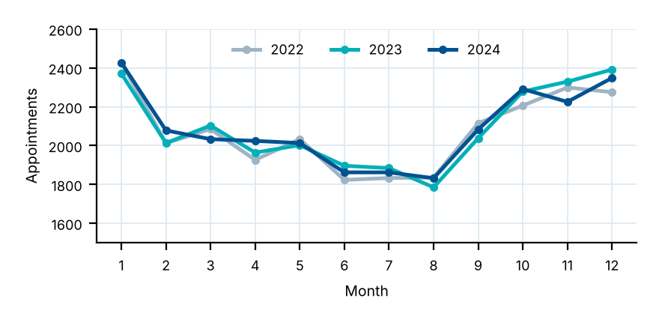
Monthly appointments for 2022, 2023 and 2024.

Appointment Status Distribution
Completed visits make up 73.70%; no-shows (15.45%) are twice as common as cancellations (7.72%). The 3.13% still "Scheduled" are all December 2024 appointments. Of 66,859 resolved appointments (completed + no-show), 17.33% were missed – about one in six.
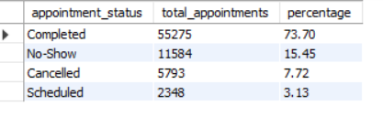
Appointment status counts and percentages (MySQL Workbench).

Busiest Doctors
The busiest doctor handles 419 appointments and four of the top seven are General Physicians. Completion among the top 15 ranges from about 67% (Dr. Karthik Patel, Dermatology) to 83% (Dr. Samuel Iyer, Urology), so workload and missed visits should be reviewed together.
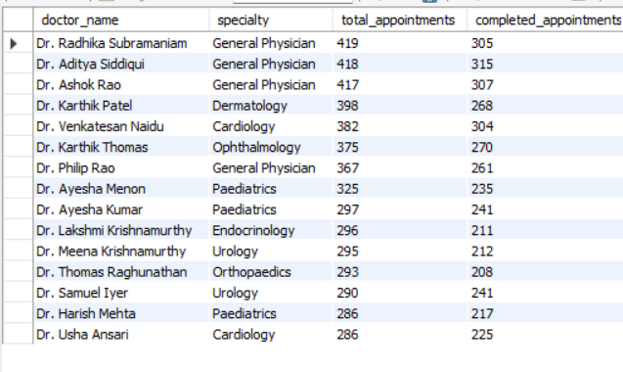
The 15 doctors with the most appointments (MySQL Workbench).

Specialty Performance: No-Shows, Waiting Time, Revenue and Satisfaction
The table combines the specialty-level SQL results, ordered by total revenue. Psychiatry (26.64%) and Dermatology (23.12%) lose the most visits and Neurology the fewest (11.67%). General Physician earns the most in total (9.48M) but the least per visit (632.79), while Psychiatry earns 2,640.45 per visit. Waiting time (11.18–12.02 min) and satisfaction (4.02–4.10 out of 5) barely differ between specialties.
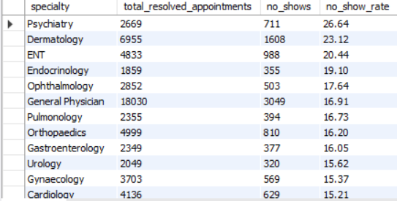
No-show rate by specialty (MySQL Workbench).
Specialty | Completed visits | No-show rate % | Avg wait (min) | Avg satisfaction | Revenue | Revenue / visit
General Physician | 14,981 | 16.91 | 11.53 | 4.07 | 9,479,887 | 632.79
Neurology | 3,899 | 11.67 | 11.64 | 4.07 | 8,096,193 | 2,076.48
Dermatology | 5,347 | 23.12 | 11.77 | 4.06 | 6,988,114 | 1,306.92
Cardiology | 3,507 | 15.21 | 11.59 | 4.06 | 6,806,264 | 1,940.77
Orthopaedics | 4,189 | 16.20 | 11.70 | 4.08 | 6,481,212 | 1,547.20
Psychiatry | 1,958 | 26.64 | 11.34 | 4.02 | 5,169,997 | 2,640.45
Gynaecology | 3,134 | 15.37 | 11.62 | 4.06 | 4,699,721 | 1,499.59
Paediatrics | 4,900 | 13.37 | 11.18 | 4.06 | 4,653,661 | 949.73
ENT | 3,845 | 20.44 | 11.30 | 4.08 | 4,631,214 | 1,204.48
Gastroenterology | 1,972 | 16.05 | 11.39 | 4.07 | 3,740,521 | 1,896.82
Pulmonology | 1,961 | 16.73 | 11.39 | 4.05 | 3,536,133 | 1,803.23
Ophthalmology | 2,349 | 17.64 | 12.02 | 4.07 | 3,446,277 | 1,467.13
Urology | 1,729 | 15.62 | 11.91 | 4.10 | 3,438,326 | 1,988.62
Endocrinology | 1,504 | 19.10 | 11.46 | 4.08 | 2,726,278 | 1,812.68

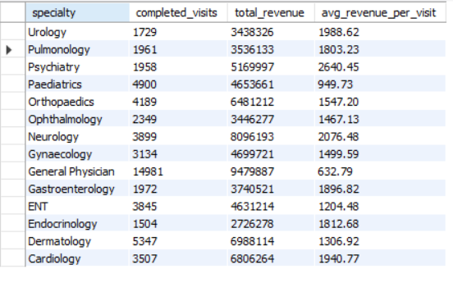
Revenue by specialty (MySQL Workbench).

No-Show Rate by Booking Channel
Walk-in bookings are missed most (22.70%) and the Apollo App least (15.36%); the app is also the largest channel (30,418 of 66,859 resolved visits). Partner App (19.75%), Website (18.77%) and Call Centre (16.52%) fall in between.
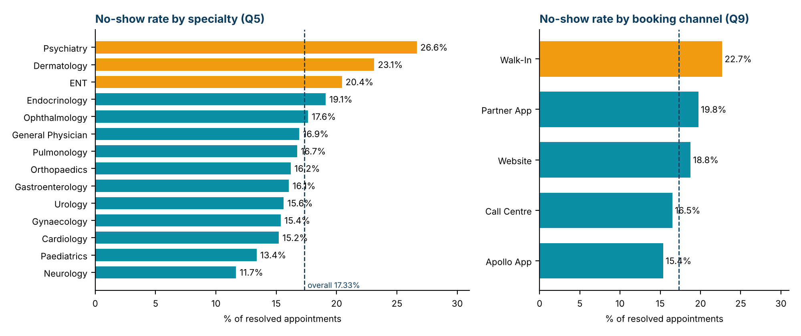
No-show rates by specialty and booking channel (orange = highest; dashed line = overall 17.33%).
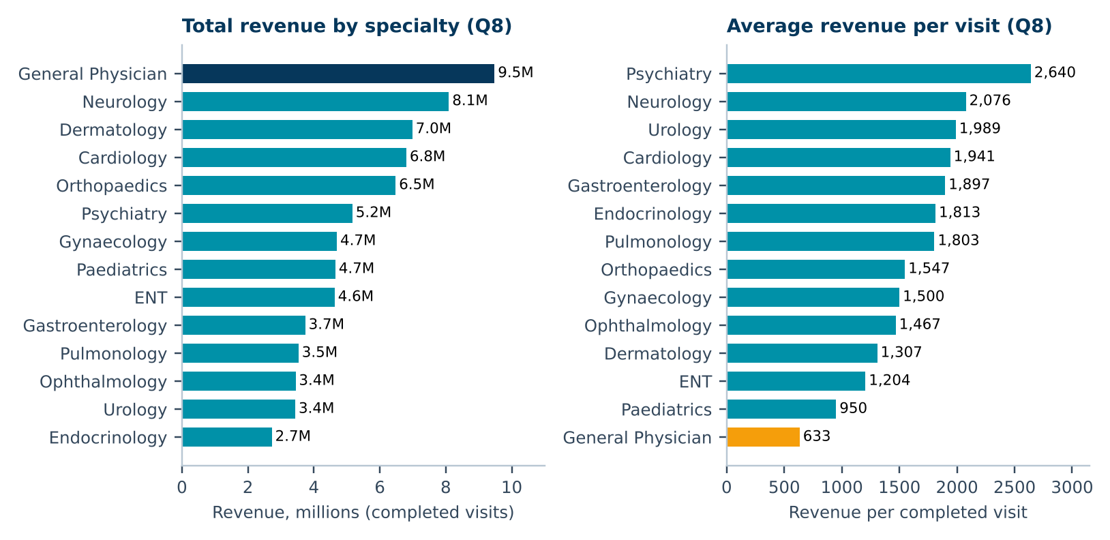
Revenue by specialty: General Physician leads on total revenue but is lowest per visit.

Power BI Dashboard
An interactive three-page dashboard (13 DAX measures) was created with five synced filters – Year, Specialty, Hospital, City and Status.

Hospital Overview
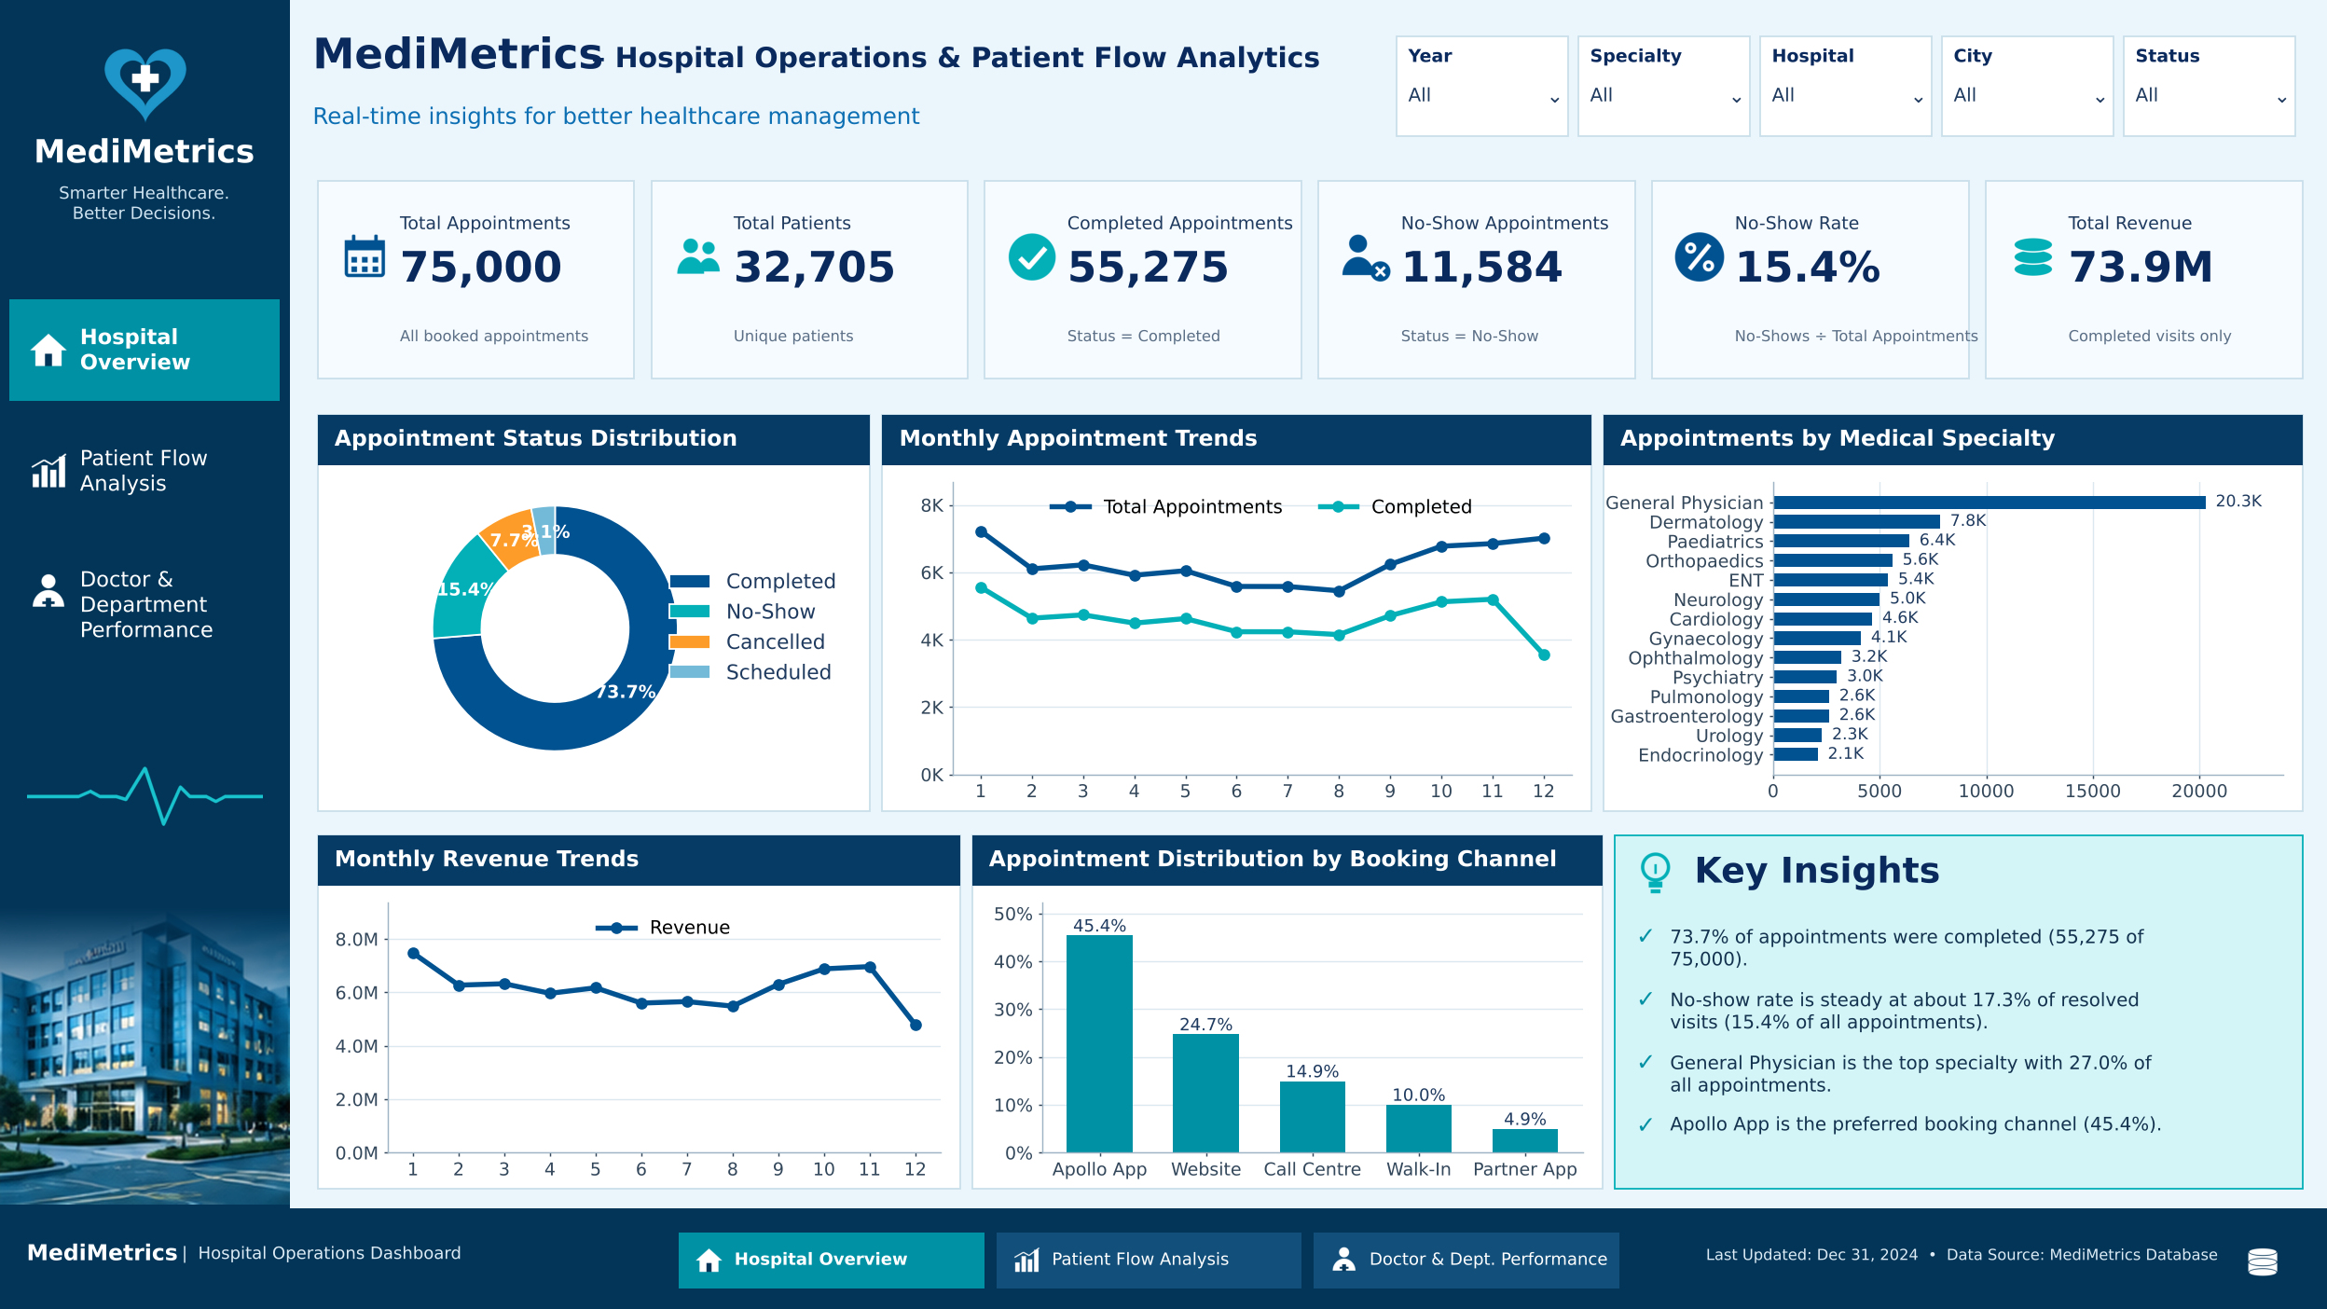
Six KPI cards (appointments, patients, completed, no-shows, no-show rate, revenue), plus status donut, monthly appointment and revenue trends, appointments by specialty and booking-channel share. The December dip reflects the 2,348 still-scheduled December 2024 appointments.

Patient Flow Analysis
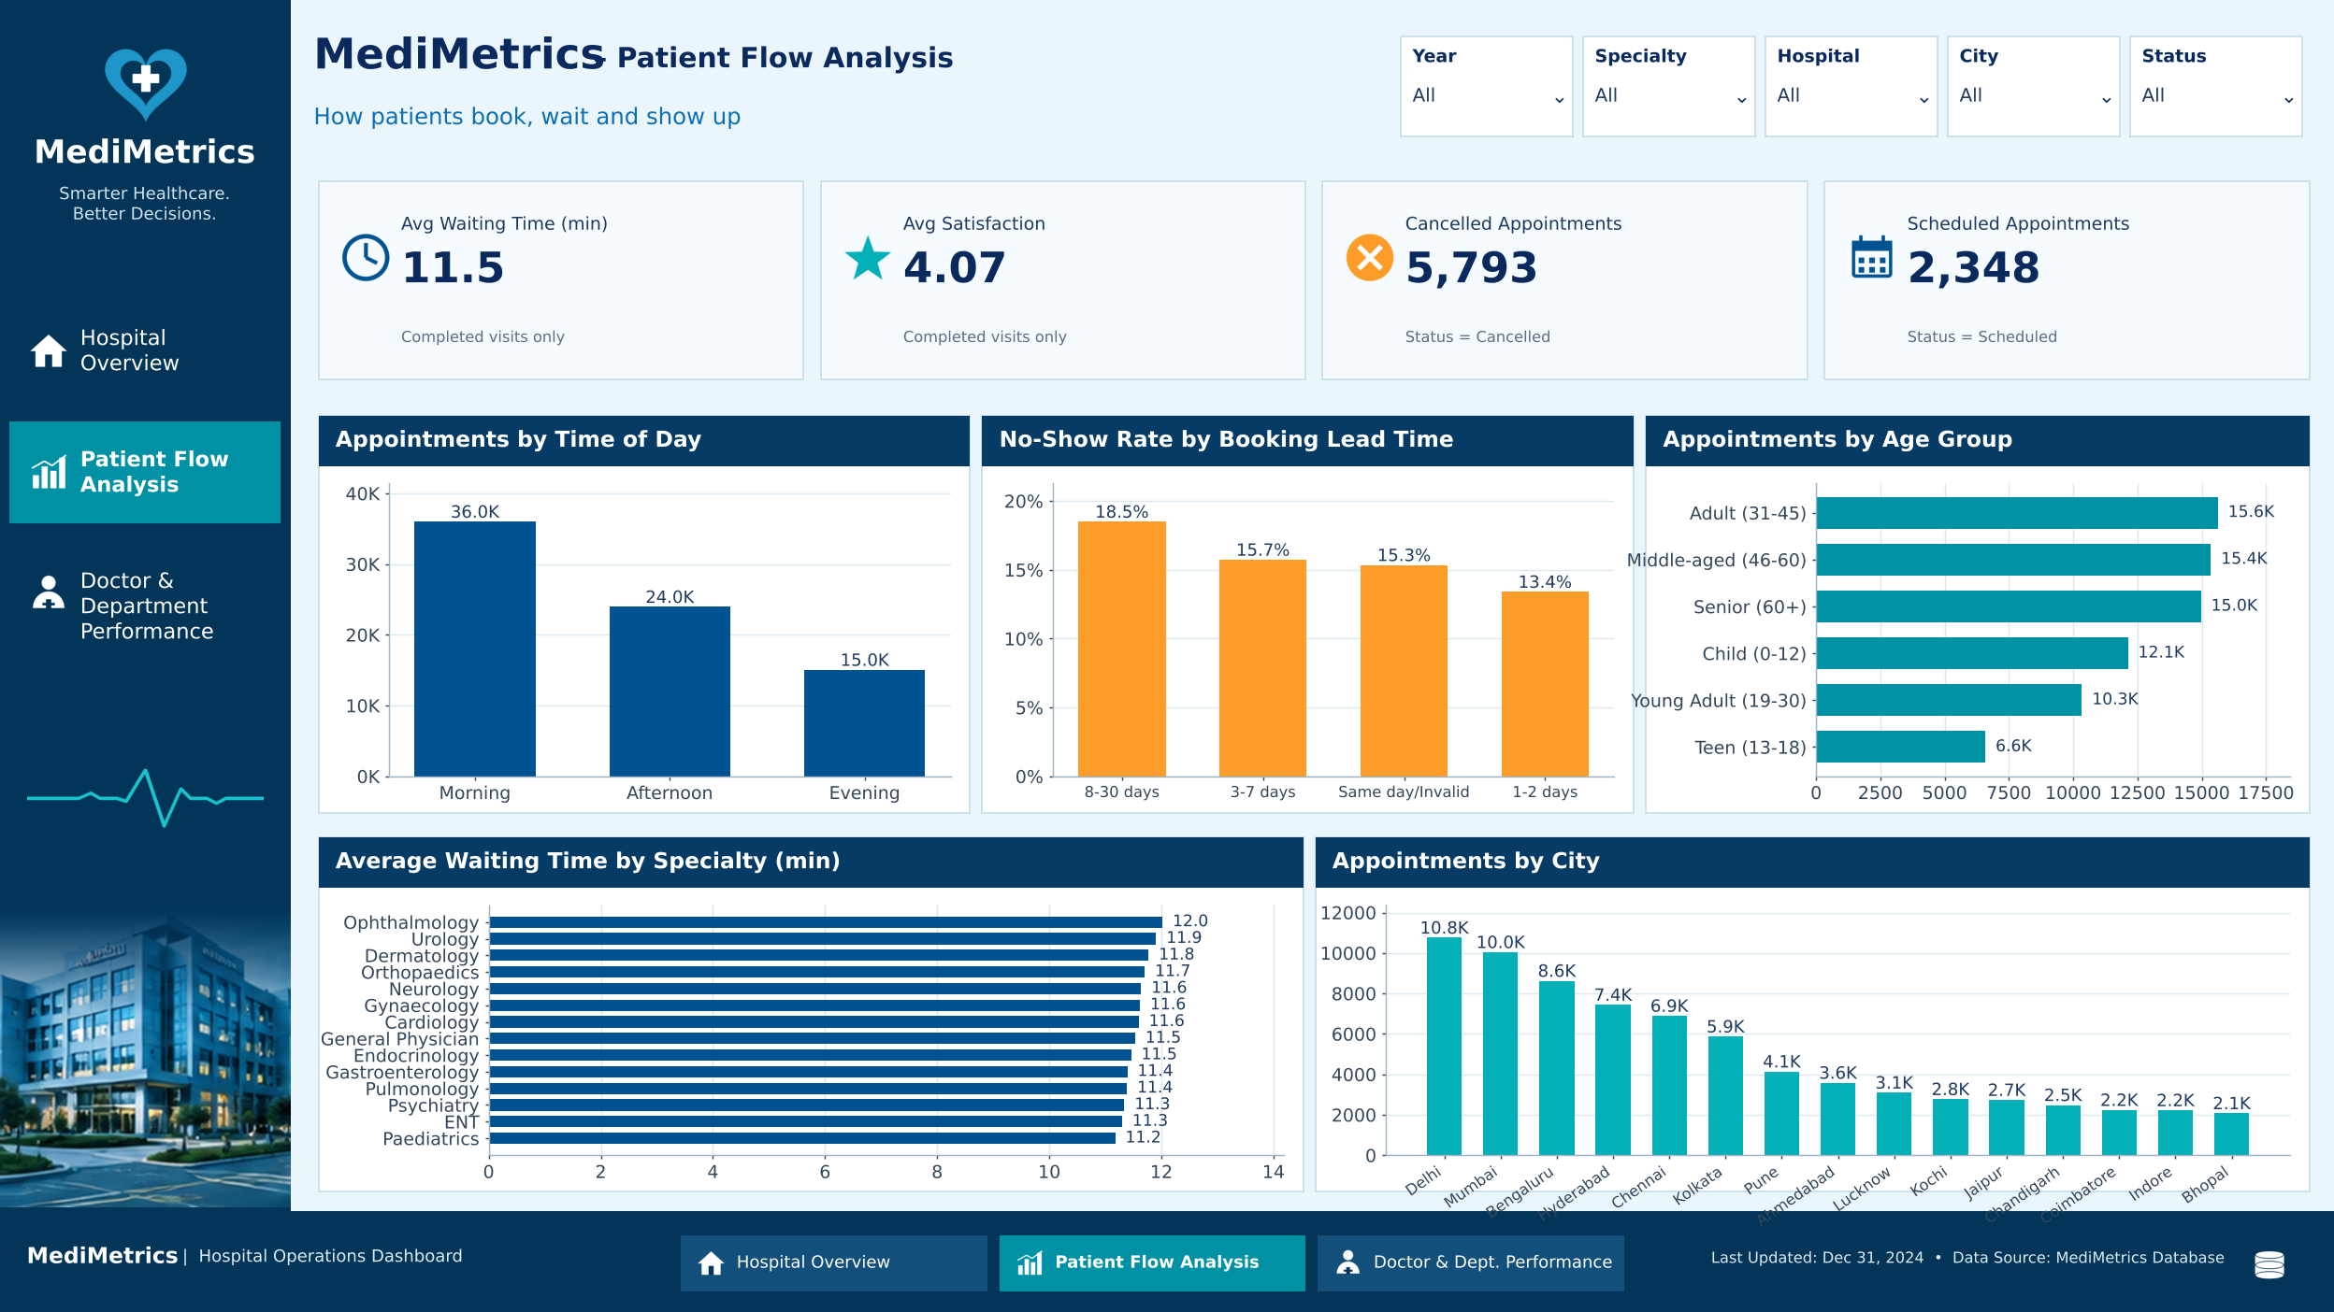
Average waiting time (11.5 min), average satisfaction (4.07), cancelled (5,793) and scheduled (2,348) appointments; appointments by time of day (morning 36.0K), no-show rate by booking lead time (highest 18.5% for 8–30 days), age group and city (Delhi 10.8K and Mumbai 10.0K lead).

Doctor & Department Performance
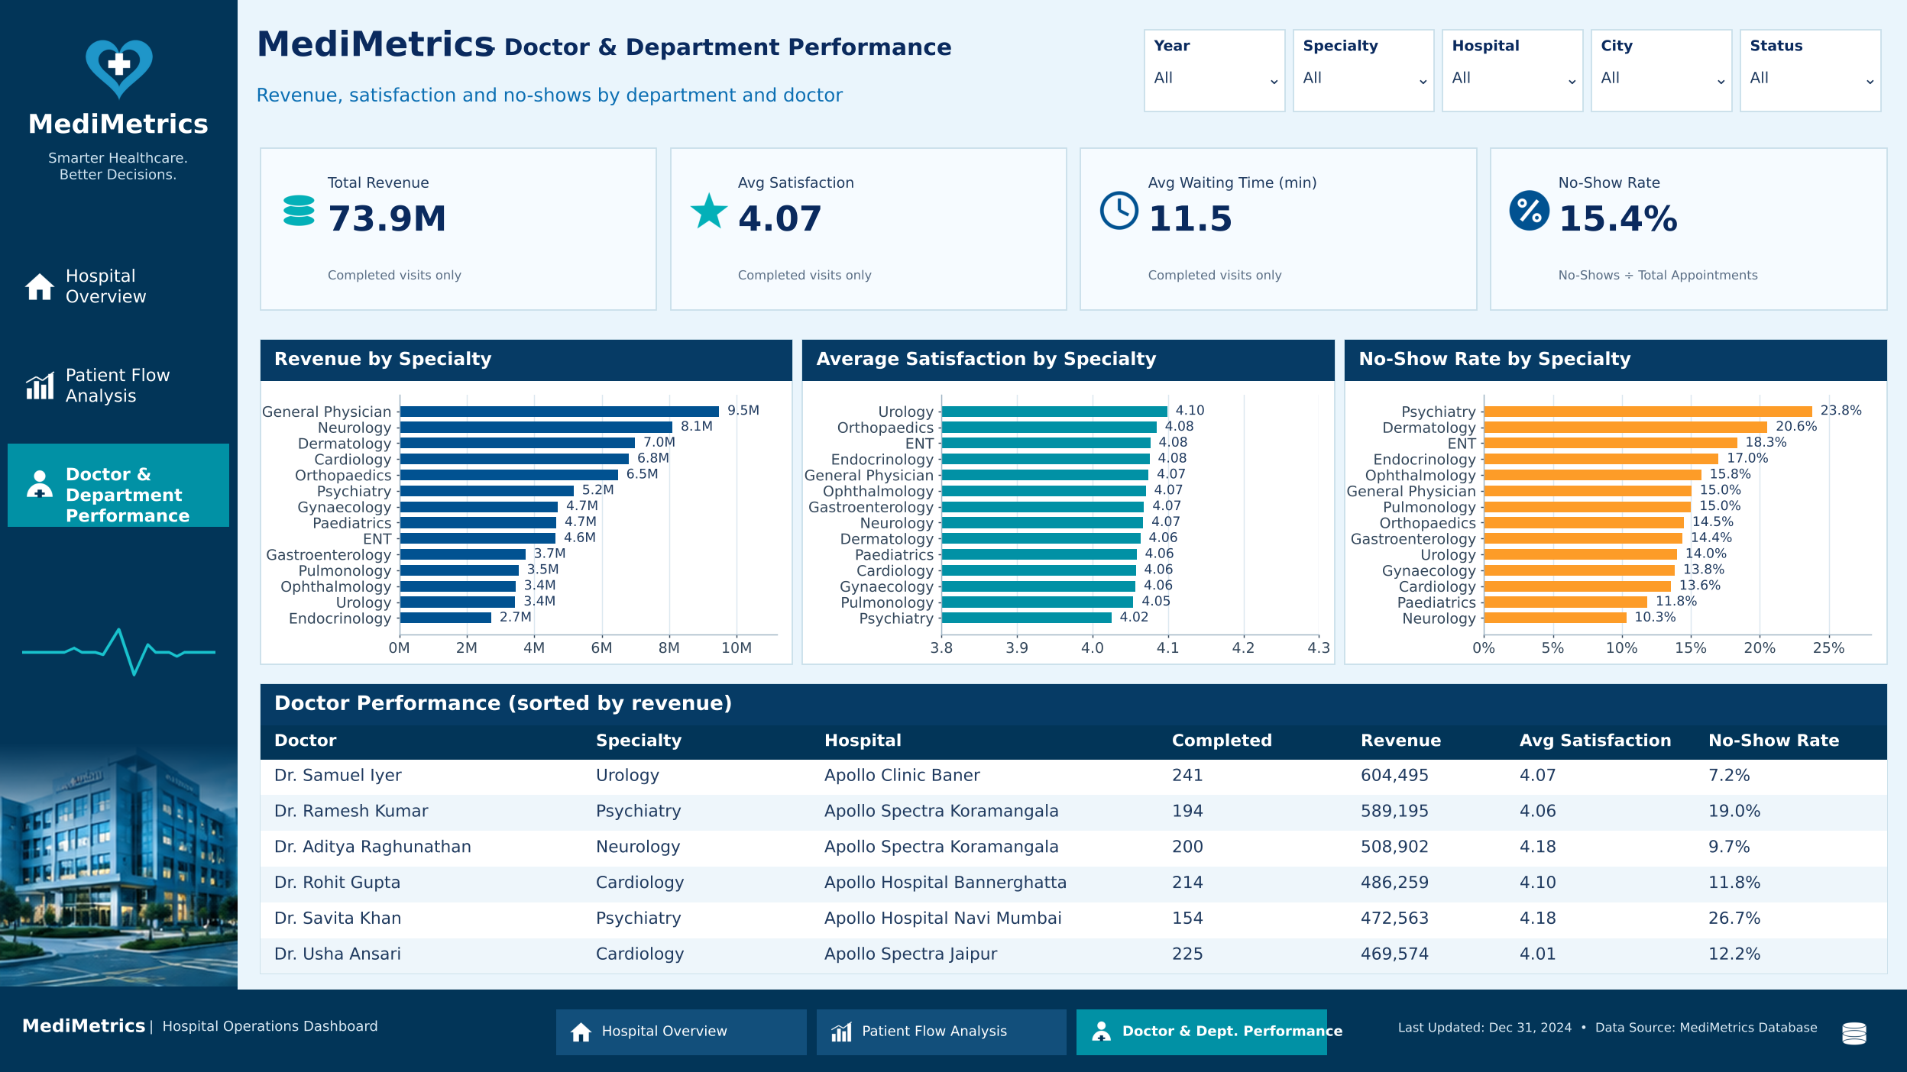
Revenue, satisfaction and no-show rate by specialty, with a ranked doctor table. On the dashboard's all-appointments basis Psychiatry shows 23.8% against 26.6% in SQL.

Key Findings and Recommendations
• Target no-shows: add reminders, deposits or confirmation calls for Psychiatry, Dermatology and ENT, for walk-in and partner-app bookings, and for appointments booked 8–30 days ahead; consider overbooking in these segments.
• Move walk-ins to the app: walk-in patients miss 22.7% of visits versus 15.4% for the Apollo App, which already carries 45% of bookings.
• Review General Physician pricing and mix: it provides 27% of volume but the lowest revenue per visit (633 versus 2,076–2,640 in Neurology and Psychiatry).
• Waiting time and satisfaction: both are uniformly good across specialties; look at hospital- or doctor-level differences instead.

Data Notes
• December 2024 is incomplete: all 2,348 appointments are still "Scheduled", which lowers 2024 revenue (23.1M vs 25.5M in 2023) – compare Jan–Nov across years.
• Two no-show definitions: SQL uses completed + no-show visits (17.33%); the dashboard divides by all appointments (15.4%). Both are valid but should be labelled.
• Security: data_importing.ipynb contains the MySQL root password in plain text; change it and use getpass or an environment variable.

Conclusion
The project successfully transformed raw hospital appointment data into meaningful business insights. Python enabled cleaning and feature engineering, MySQL supported ten analytical queries, and Power BI improved decision-making through visual analytics. The strongest business lever is reducing no-shows, and the data issues listed above are small and fixable.

