1. **Populating the eye plot and measurement Report.**
   1. In Automation Tool, click Report button -> click **Eye Plot Merge** button.

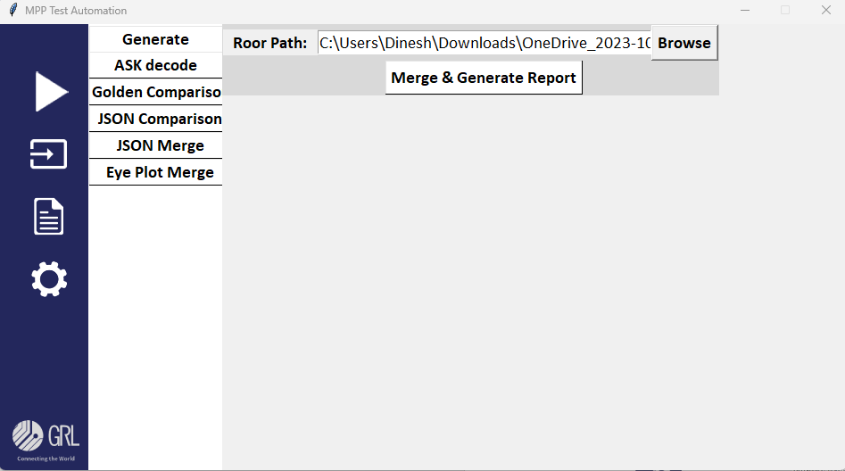

* 1. In the above window click browse button and provide the path for the projects which has to be merged, can provide multiple project which resides in sub folders. Script will identify and merge.

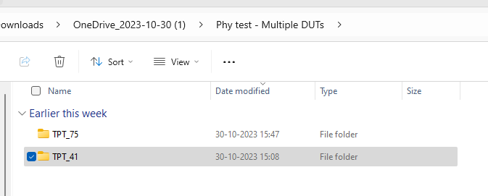

* 1. Click the **Merge & generate Report** button, to generated the report. The report will be generated in the build location/ results/ MPP Excel Reports.

**Report Structure.**

* + 1. The Report has Multiple levels of data which are grouped and merged by the board number, SW version, FW version, HW version, Project name DUT info.
    2. For each DUT separate sheets will be created, hence dut info in the json file is mandatory refer the **step 2**. For bulk update of DUT information’s.
    3. First level of group made by the bord number, SW, FW , HW versions
    4. Second level of group made by the project name , RUNs. All the testcase packets will be listed below of the level 2.
    5. For each Level 1 sets separate column of results will be generated. 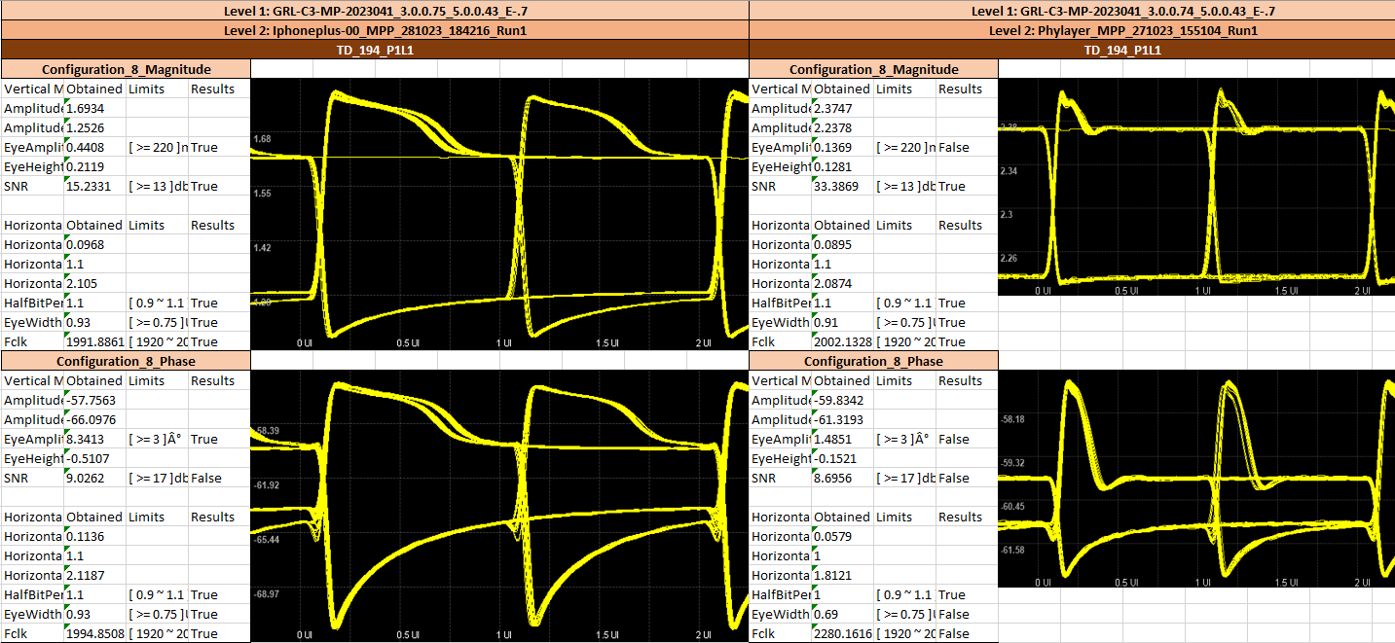

1. **Bulk Update missing DUT details.**
   1. In Automation tool, click edit button  -> Click **update DUT**.

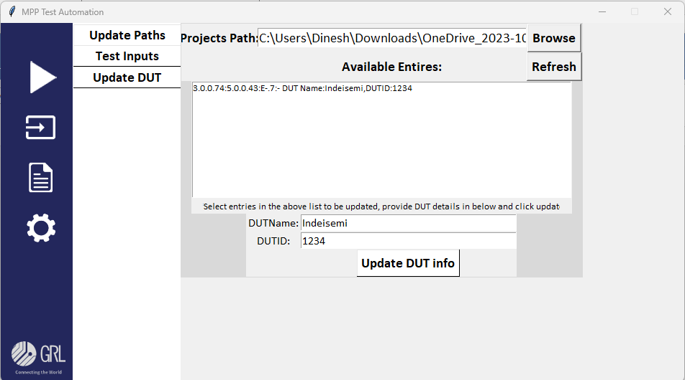

* 1. From the above window provide root folder path, which contains all the project directories by clicking the **browse** button.

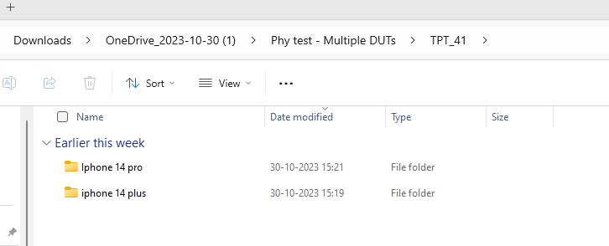

* 1. Now the below list box will show all the combination of SW version, FW version, HW version and DUT info results.

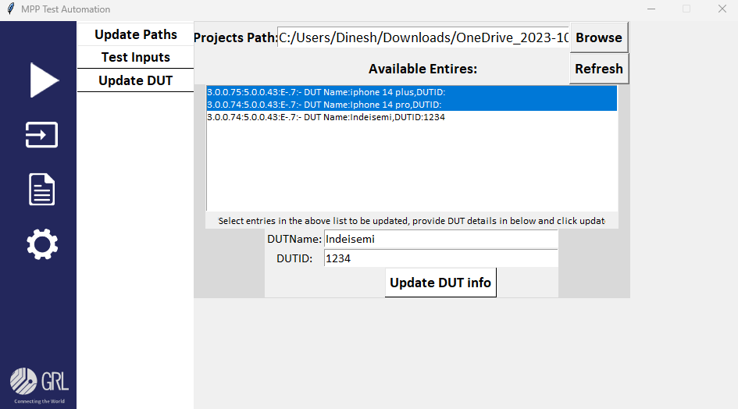

* 1. Were multiple entries can be selected and provide the DUT name and serial number in the given filed and click Update DUT info.
  2. By clicking the refresh button can see the that given DUT info updated in the applicable json files.

