**MPLA Data Analysis Tool User Guide.**

1. **Merge All Projects & Runs into csv file using tool**
   1. From the tool choose **Report** menu (3rd Option) and from **other features** section choose **BI Analysis**.

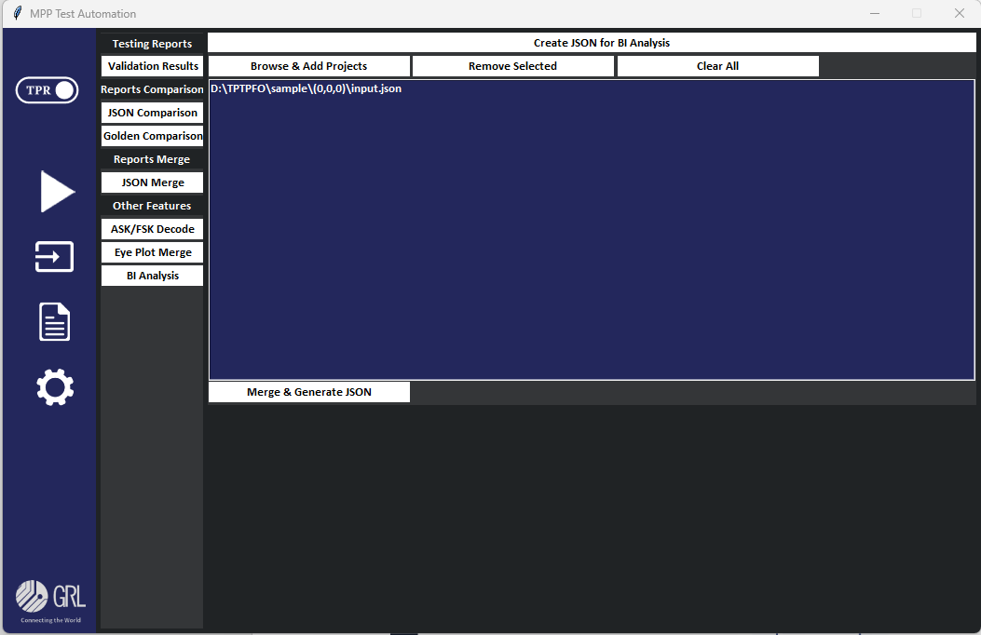

* 1. Before uploading the project file, add a Json file with necessary data inside all the projects, since the board and DUT information are not provided anywhere to capture.

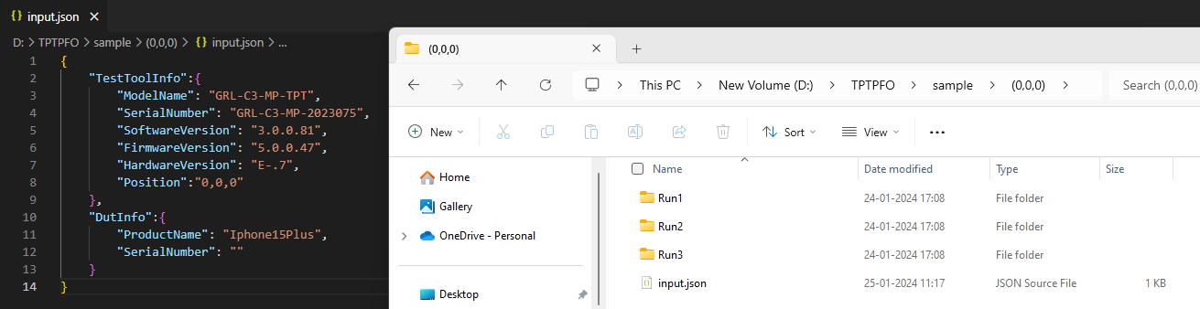

* 1. Browse and Add project as bulk by clicking the button **Browse & Add project** in the window. All the project will be loaded and listed like SS in step 1-a.
  2. Click **Merge & Generate CSV** button to get the final merged data in csv format in Build location\ Results\MPP Excel Results.

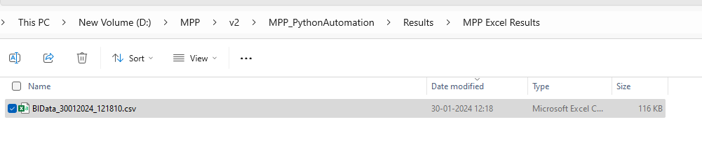

1. **Prepare Dashboards with ZOHO Analytics(One Time).**
   1. Login into Zoho Analytics : <https://analytics.zoho.com/>
   2. Create Workspace in free account.

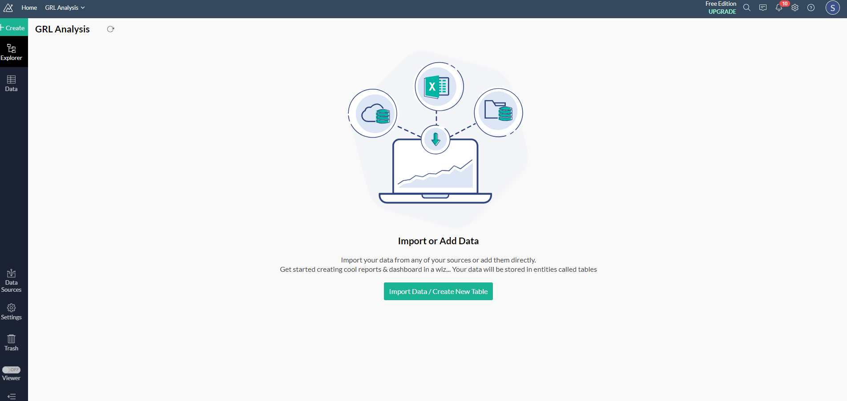

* 1. Click Create button on top right, choose import from Template.

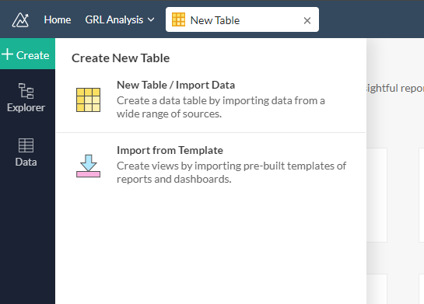

* 1. upload Template shared with build (MPPTest.atpt) file and click Next.

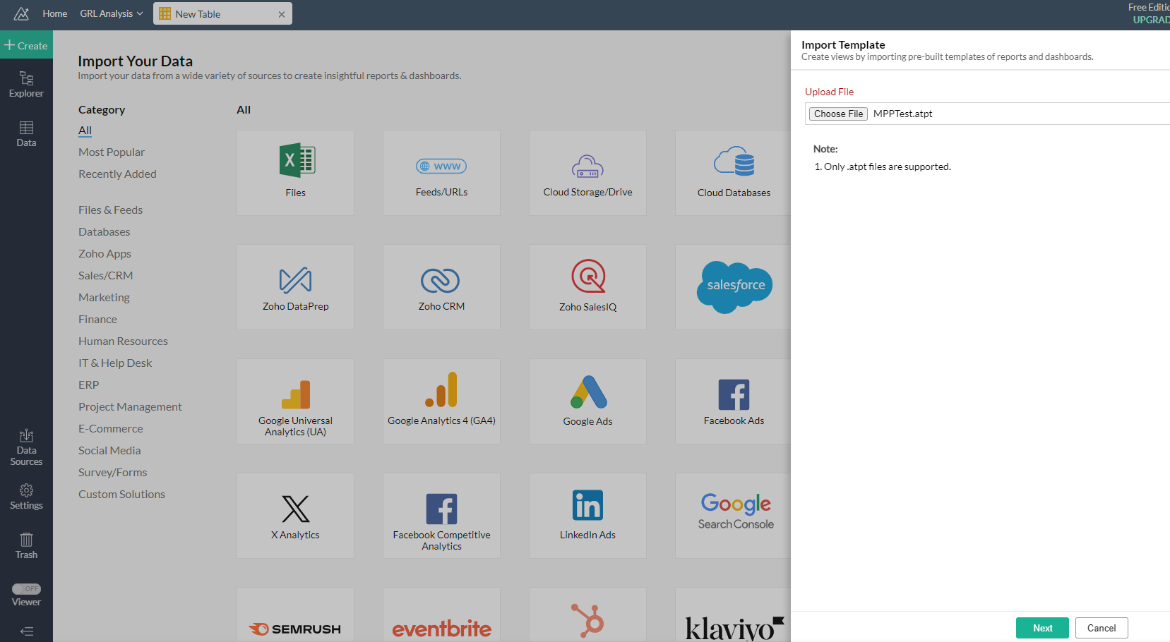

* 1. Select All Views and Click Next and Finsh.

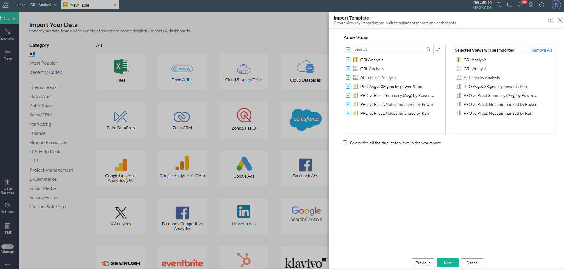

1. **Import Tool Generated CSV File into Zoho Analytics table.**
   1. Click Data in Side Menu, Choose GRLAnalysis Table.

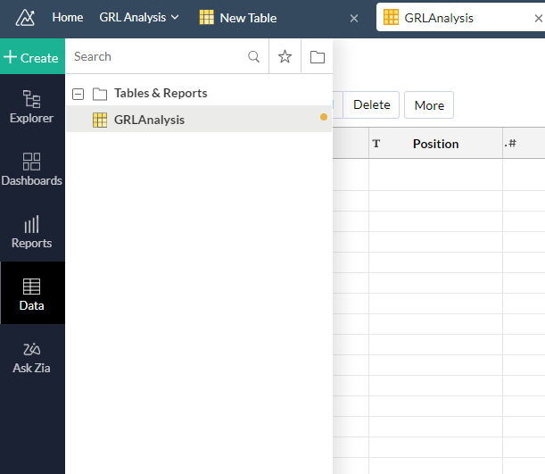

* 1. In Table view, Click Import Data ->Choose Import Data into this Table.

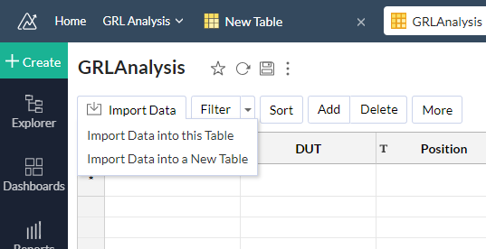

* 1. From the options, choose Local Drive

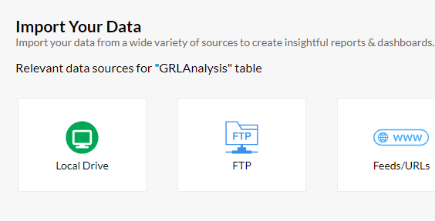

* 1. Choose the Options as per the requirements, upload the csv files generated from the tool and click Next. and import.

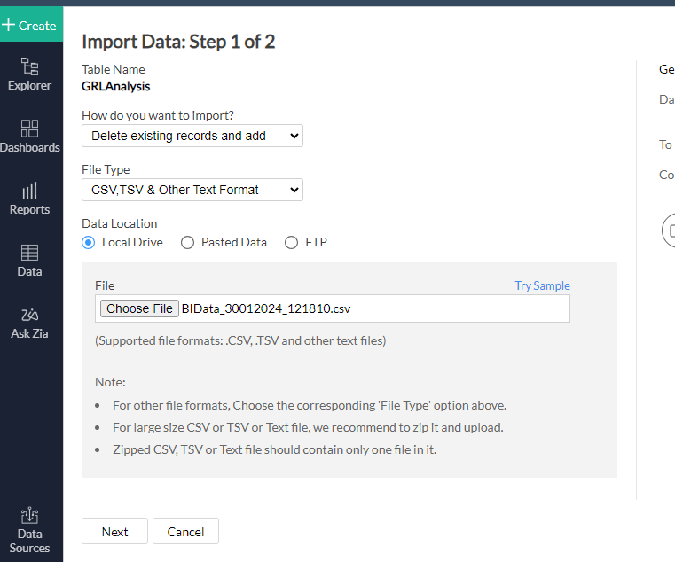

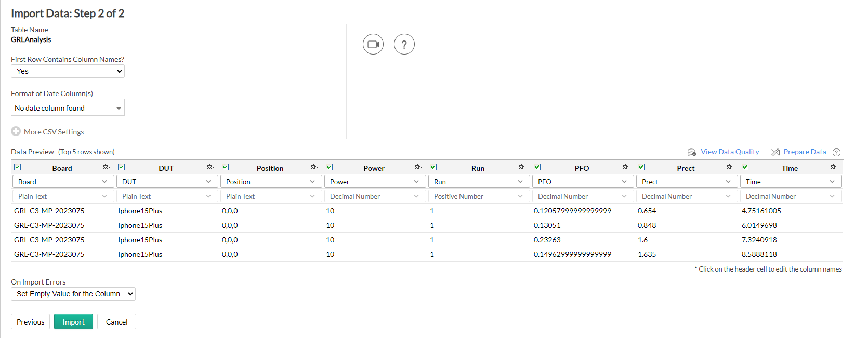

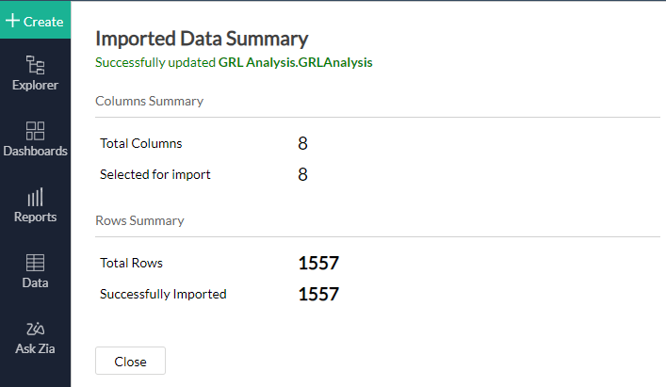

* 1. To view the Dashboard, Click Dashboards in side menu and Choose GRLAnalysis. The Dashboard with all charts will be loaded.

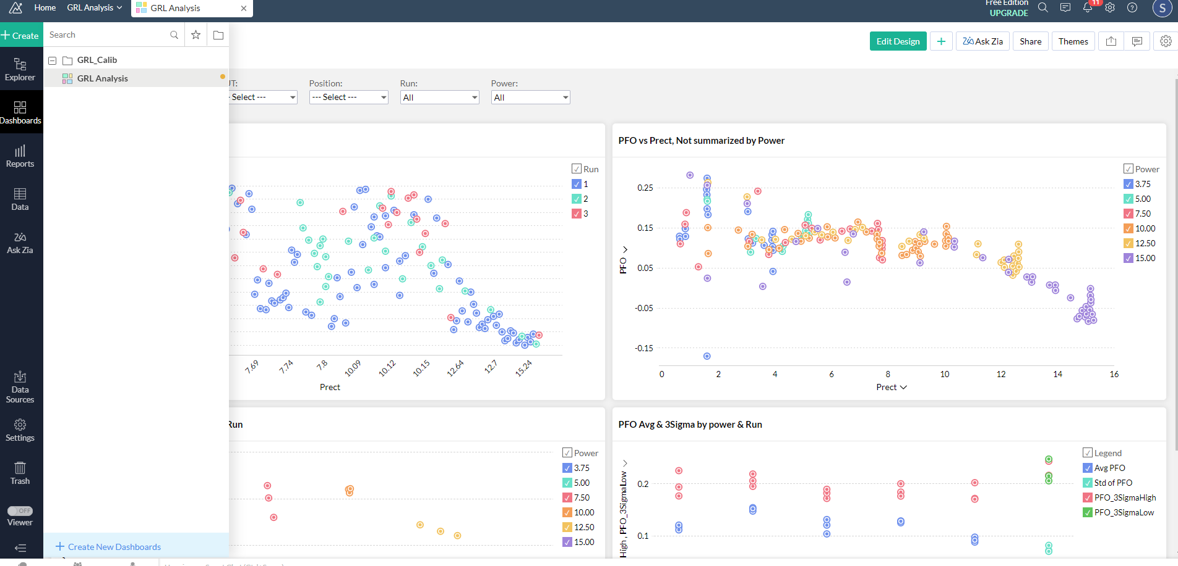

**New PFO calculation:**

1. **New Circuit Loss**

= (AC Current [A]^2)*grad)+offset

1. **New PFM:**

= ((AC Current [A]^2)* αfm* gfm) + (αfmdc*gfmdc)

1. **New PFO:**

= (((Inverter Voltage [V]* DC Current [A]) - (New FM+ Coil Loss [W] +NewCircutLoss)) – (Received Power [W]))*1000

Charts:

1. TPT XX vs Iphone 15
   1. Normal Graph – by Power
   2. Normal Graph – by Run
   3. Modified Formula Graph – by power
   4. Modified Formula Graph – by Run