MPP Test Automation and Validation – Documentation

- Environment Setup (One time)
    - Download latest version of python (3.11.x or latest) from https://www.python.org/downloads/ and install.
    - Add python entry to path variable.
      - Start menu -> search Environment variable-> Advanced tab-> Environment variable.
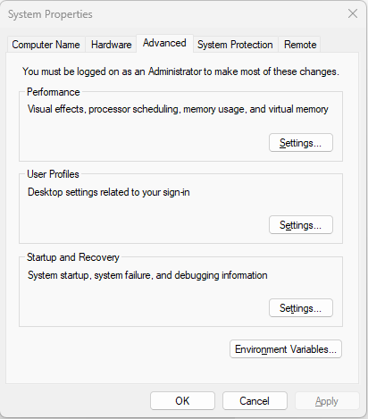
      - Add python path (i.e. C:\Users\Dinesh\AppData\Local\Programs\Python\Python311) entry to path variable in both user variables and system variables
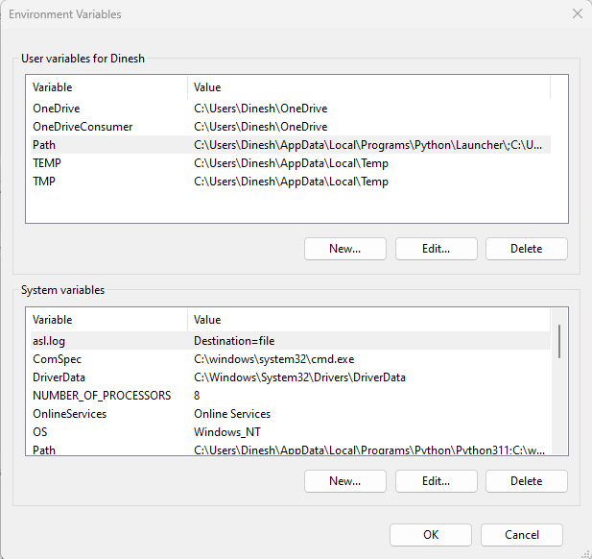
      - To verify whether python is installed properly, pass the command py --version in cmd and check that the downloaded version of python is showing as result.
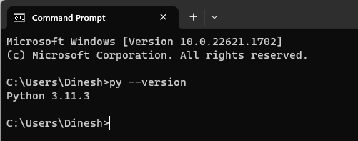

- Install Automation Tool (when new build released).
  - Double click MPPAutomation_x.x.exe to install the tool.
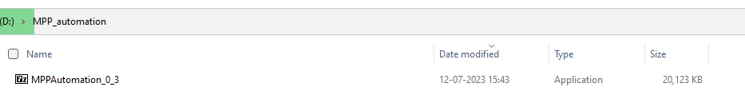
  - Provide the location to extract the files. Preferred c drive (if you are choosing the other drives, choose the same drive location upcoming build extraction.) and click extract.
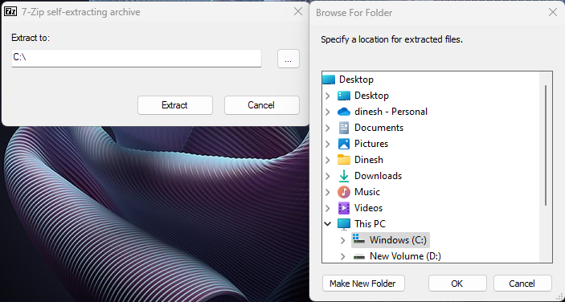
Now the tool will be installed in the C drive.
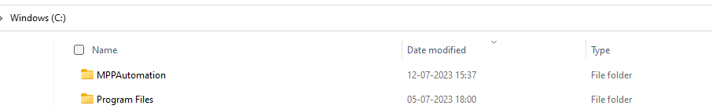
  - Update the Requirements.
      - Inside the build location find the file named as InstallRequirements.bat , double click on the file and execute.
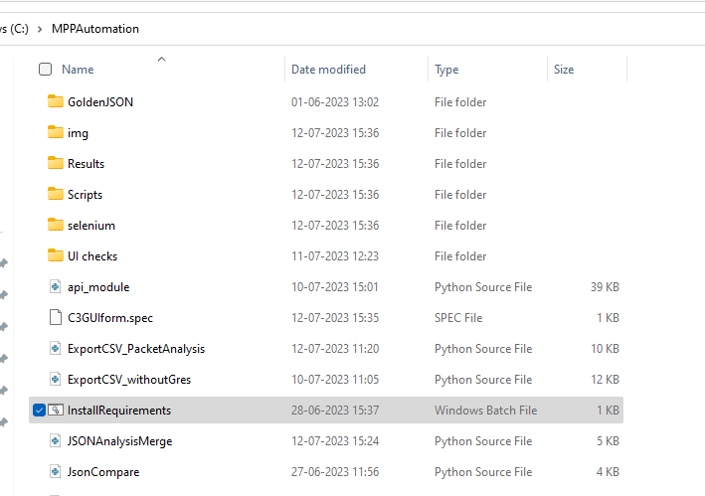
- Run and Validate Tests using Test Automation tool (Without Katalon). -MPP
  - Open GUI (designed in python)
      - Double click and run the MPPGUIform.exe file available inside build location.
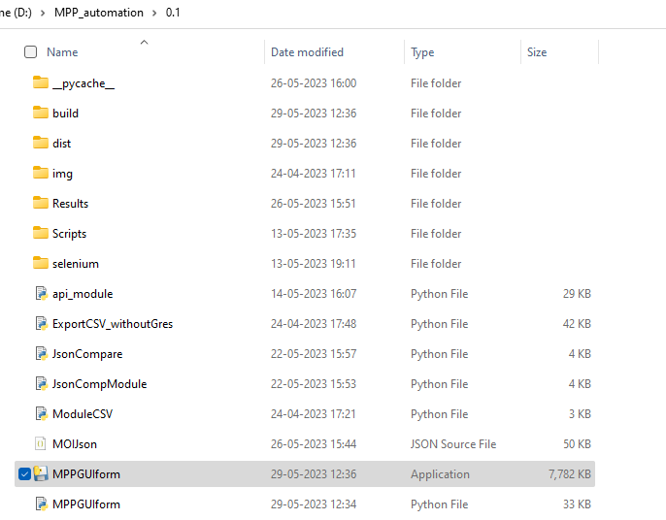
      - A simple GUI will be open.
The GUI has the options like
- Run the tests in the combination of Phases and Positions
- Automatic live validation while executing the tests
- Offline validation for already manually ran tests
- Report Generation (CTS validation, comparison of Golden and MPP)
- Advanced Packet Analysis Report (to check frequencies, all packets timings, execution count, packet flows etc)
- High level result comparison and stability check with JSON report.
- Merge JSON files from different project.
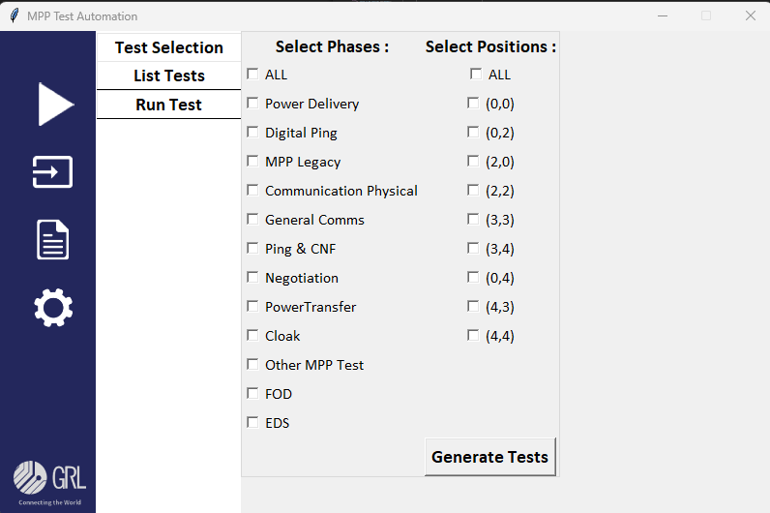

  - Feed the information related to the DUT and to fill SDF forms.
      - Click  (input) button -> Test Inputs.
A simple form will be shown where fill all the necessary information related to the testing and click update button.
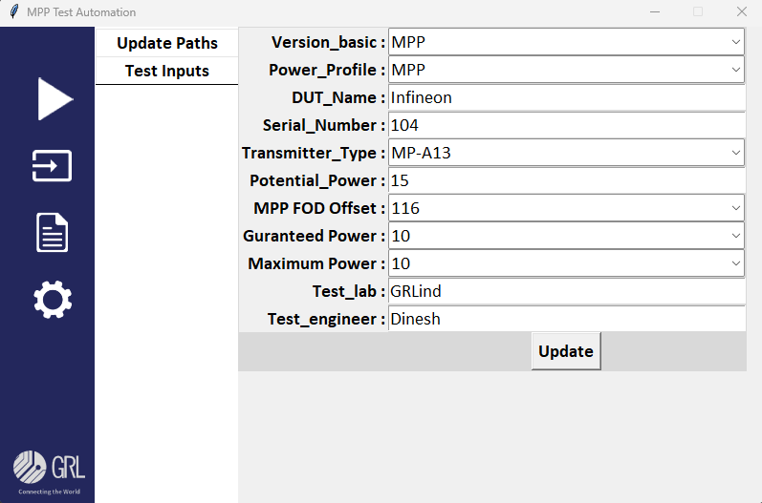

  - Select tests.
      - Click  (run) Button -> Test Selection.
Select the required phase and Positions and click the Generate Tests button to generate the list of tests to be executed. 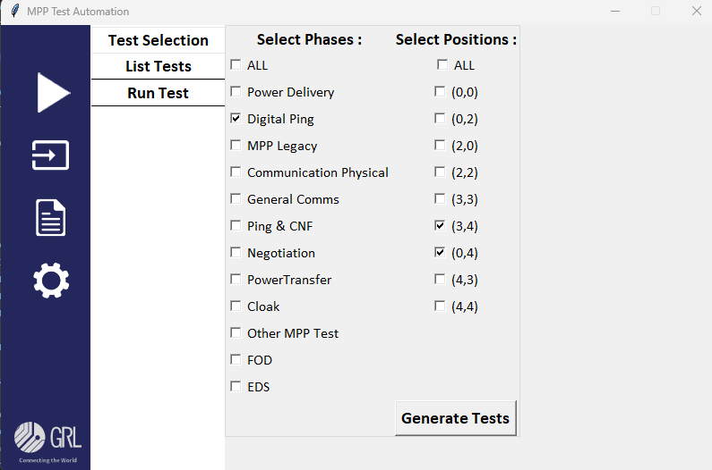
Same time an empty JSON file created to store the validation results of the above selected tests in the name of combinations of DUT, version, phase, coils and timestamp inside the result folder.
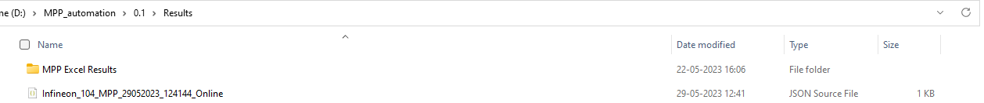

      - To view the selected tests. In the same window click the List Tests button.
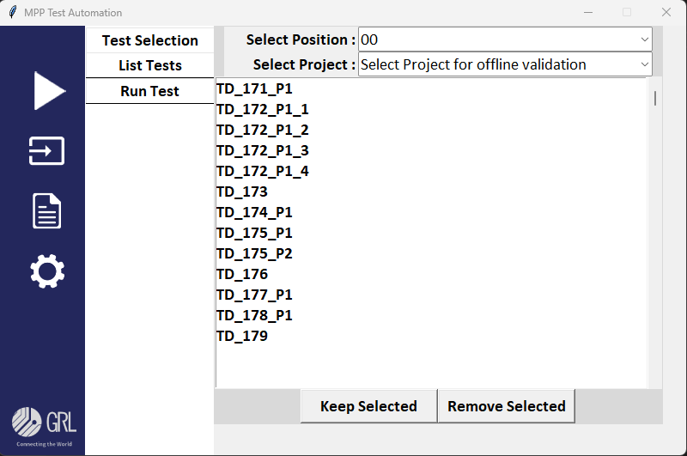
Use the dropdown (Select Position) to switch the Position and view the respective tests.
If any tests to be removed from the list can be done using the keep selected and Remove Selected buttons.

  - Run and validate the tests Coil wise.
      - Click (run) Button -> Run Tests.
Select existing project or type a new project, provide repeat count and
Select a Position from the List and Click RUN tests button to execute the selected Coil Tests
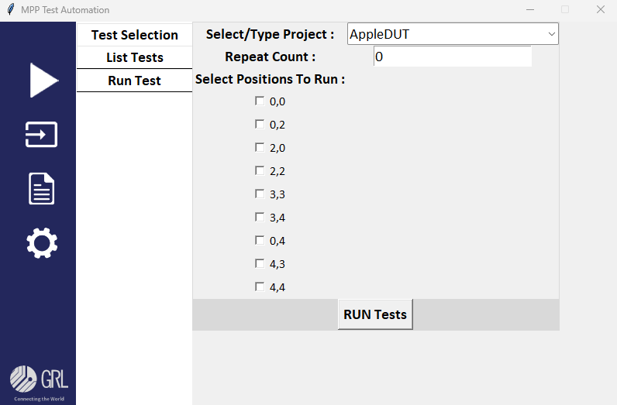
The following actions will be performed once the RUN tests button clicked.
- Browser will be open and navigated to the MPP app.
- Fill the SDF and other inputs which provided in the step b
- Select all applicable tests for the selected Position and execute.
- parallelly validate the tests as soon as one tests completes and push the results into generated JSON file.
- Once all the selected tests execution completes, MPP app will be closed and using the MPPs final JSON file to fetch each tests measures and list (MPP app validated results) for the comparison.
Same way other positions to be selected and can run the tests.

  - Generate reports in Excel.
      - Click  (report) Button -> Generate.
Click a related button to generate CTS validation report or Comparison report.
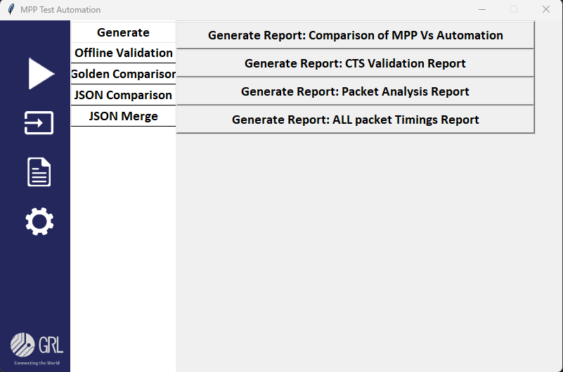
if we want to generated report for the previously generated tests then upload the particular tests JSON file in the below option and generate reports.
Click (input) Button -> Update path.
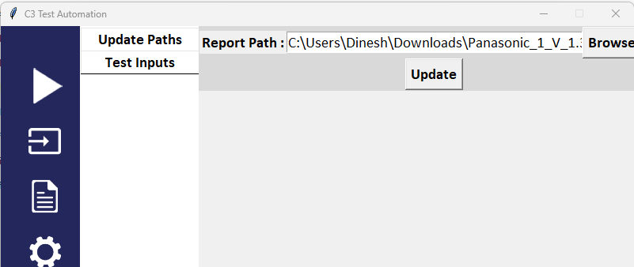
Note: This path will be automatically updated while we performing the step C. if required can upload previously generated file and get the reports in excel format.

- JSON comparison (high level)
    - Click (report) Button -> JSON comparison.
    - Make a folder contains all the individual runs project folder, Browse and update the folder path in the Project Path option.
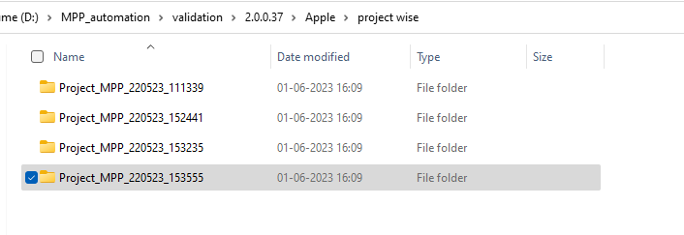
Provide Golden JSON file in the Golden path option. and click generate Report button.
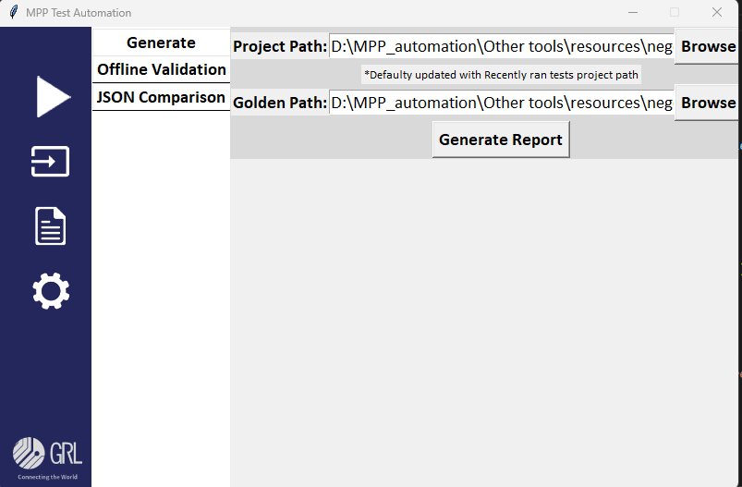
The generated reports will be available in the build path -> Results\MPP Excel Results.

- Offline Validation for previously manually ran tests.
Note: Make sure that the project folder inside the report directory of GRL-WP-TPR-C3
    - Provide the MPP final JSON file location.
      - Click (report) Button -> Offline Validation.
Browse and add the MPP Project directories by clicking the button Browse &Add Projects. Multiple project directories can be added.
Use the Remove selected / clear ALL button delete the selected project directories or remove all entries.
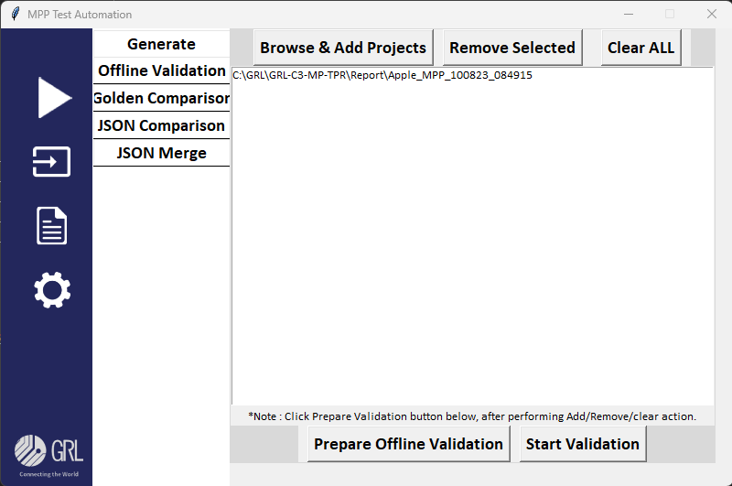
      - Click the prepare Offline Validation button. This time all the tests available in that particular project will be loaded.
  - View the available tests in the run.
      - Click (run) Button -> List Tests.
From the Select position dropdown select offline, and select any project directories from the below combo box to load the tests.
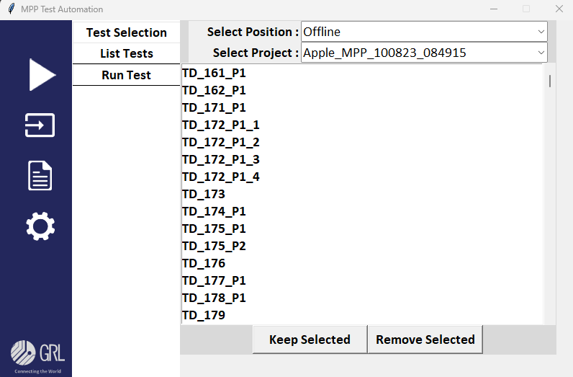
If any tests to be removed from the list can be done using the keep selected and Remove Selected buttons.

Same time an empty JSON file created to store the validation results of the above selected tests in the name of combinations of DUT, version, power profile, phase, coils and timestamp inside the result folder.
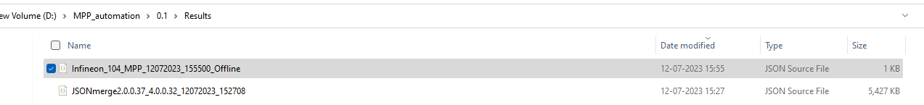
  - Start the Validation
      - Go back to the step (i) screen, and click Start Validation button.
The following actions will be performed.
- Browser will be open and navigated to the MPP app.
- Load the backup json file from the selected project folder.
- Click each Tests one by one and validated
- The Validated Tests result will be store in the report json file mentioned in the step (ii)
Note : Reports for the offline validation can be done as similar as mentioned in the Chapter 3 step (v) .

- High Level JSON comparison – for Different SW & FW populated results.
  - Provide final JSON files path for different Software versions.
      - Click (report) Button -> Json Comparison.
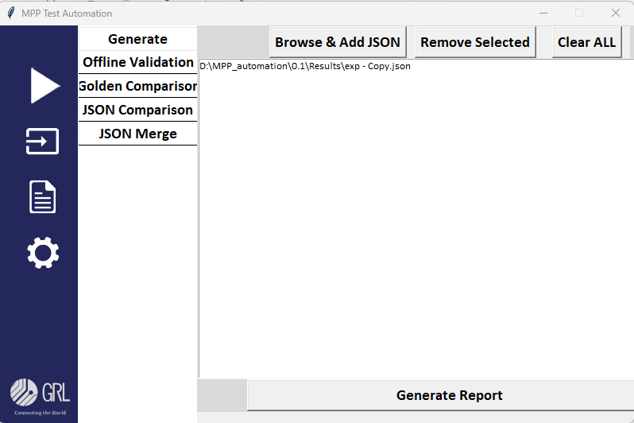
      - Click Browse &Add JSON button to add json files to compare the results. The added reports path will be shown in the below list box. (Duplicate paths will not be considered)
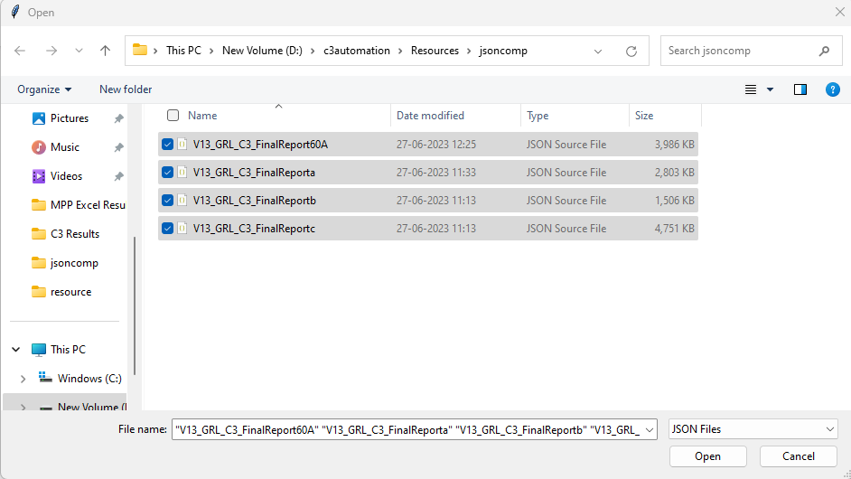
Multiple json files can also be selected one time.
      - If any json needs to remove from the list, select the json files from the list and click the button Remove Selected so the selected entries will be removed and the comparison will be happened for the rest of json files.
      - Use Clear ALL button to remove all entries.
  - Generate comparison report.
      - Click Generate Report button to create a comparison report for the selected json files and the report will be found in build location\Results\ MPP Excel Results.
Note : Use C3 Software Report analyser tool to merge individual ran json files into single json file, so that easily can segregate the SW and FW wise json files.

- MPP final JSON files merge automatically based on the results from different run.
  - Provide path of report folder which contains all the project directories (i.e. C:\GRL\GRL-C3-MP-TPR\Report or any other custom created folders)
      - Click (report) Button -> Json Merge. 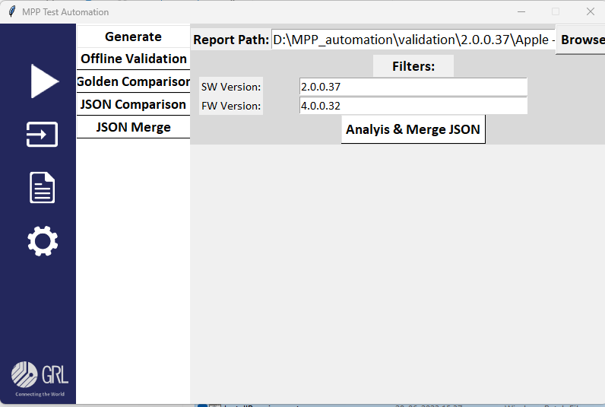
      - Provide path of report folder which contains all the project director by clicking the Browse button.
    - Add filters.
      - Provide Software and firmware version in the available filters text box in the same window. When multiple software versions project folders resides in the provided path the filter will helps to fetch the desired versions results and merge.
    - Generate Merged report.
      - Click the Analysis and Merge JSON button to generate the JSON file by comparing all the re runs result and make the merged json file for the provided Software and firmware version.
      - The report will be available in the build location\Results\.

