SmartRice: An Intelligent Web-Based System for Rice Leaf Disease Detection and Yield Prediction Using Deep Learning and Machine Learning

ABSTRACT
Rice is one of the most important staple food crops worldwide, and its productivity is highly affected by plant diseases and environmental conditions. Traditional methods of disease identification and yield estimation rely on manual inspection by agricultural experts, which is time-consuming, costly, and often inaccurate in large-scale farming environments. To address these limitations, this project proposes an intelligent decision-support system that integrates Deep Learning and Machine Learning techniques for automated rice crop analysis. The proposed system uses a MobileNetV2-based deep learning model to detect rice leaf diseases from image inputs. The model classifies multiple disease categories such as Bacterial Leaf Blight, Blast, Brown Spot, Leaf Smut, Tungro, and Healthy leaves. Additionally, a Machine Learning regression model predicts rice yield based on agronomic parameters including rainfall, temperature, soil properties, fertilizer usage, irrigation method, season, and regional conditions. The system further integrates a Flask-based web application that enables farmers and agricultural officers to upload images and input field parameters to obtain real-time predictions. The platform also stores prediction records in a local database and presents analytical dashboards for monitoring crop conditions. This integrated approach helps in early disease detection, optimized fertilizer planning, and improved productivity forecasting. The solution aims to support precision agriculture by reducing human effort, improving accuracy, and enabling timely decision-making for farmers.
Keywords: Precision Agriculture, Deep Learning, Machine Learning, Crop Disease Detection, Yield Prediction

CHAPTER 1 – INTRODUCTION

1.1 GENERAL
Agriculture is the backbone of many developing economies and remains the primary source of livelihood for millions of people across the world. Among all agricultural crops, rice holds a special significance as it serves as the staple food for more than half of the global population. In countries like India, China, and other Asian nations, rice cultivation is directly linked to food security, economic stability, and rural employment. Despite its importance, rice production faces several major challenges including plant diseases, climate variability, soil degradation, and improper nutrient management. These factors often result in reduced crop yield and severe financial loss to farmers.
Traditionally, farmers depend on manual inspection and expert agricultural officers to detect diseases in crops. However, disease symptoms in rice plants often appear visually similar at early stages, making it difficult for farmers to identify the exact problem. Misidentification leads to incorrect pesticide usage, increased cost, and environmental damage. Moreover, rural areas frequently lack immediate access to agricultural experts, which delays diagnosis and treatment. As a result, diseases spread rapidly across fields before corrective measures can be taken.
In recent years, technological advancements in Artificial Intelligence have opened new opportunities for smart farming. Machine Learning and Deep Learning techniques have demonstrated remarkable performance in image recognition, pattern detection, and predictive analytics. These technologies can be used to automatically identify crop diseases from images and predict agricultural output based on environmental parameters. By integrating these intelligent models into a web-based platform, farmers can receive instant recommendations without requiring technical expertise.
This project introduces an intelligent agricultural support system that combines image-based disease detection and data-driven yield prediction. The system allows users to upload rice leaf images for disease classification using a deep learning model and enter cultivation parameters for yield estimation using a machine learning model. The results are displayed through an interactive web application that also maintains historical data for analysis. The goal of this system is to reduce dependency on manual inspection, improve accuracy, and enable precision farming practices.
The proposed solution contributes toward digital agriculture by bridging the gap between advanced AI technologies and real-world farming practices. By providing real-time crop monitoring and predictive analytics, the system helps farmers take preventive measures at early stages, optimize resource usage, and increase overall productivity. The integration of artificial intelligence with web technologies makes the system accessible to both technical and non-technical users, thereby promoting smart and sustainable agriculture.

1.2 NEED FOR THE PROJECT
Agricultural productivity is highly dependent on timely identification of crop diseases and proper management of environmental conditions. In traditional farming, disease diagnosis is usually performed by visual observation, which is prone to human error. Farmers often cannot distinguish between diseases that have similar visual symptoms, leading to incorrect pesticide application and crop damage. Additionally, estimating crop yield before harvest is extremely difficult without analytical tools, causing poor planning in storage, transportation, and market supply.
The need for an automated intelligent system arises due to the lack of accessible agricultural experts in rural regions. Farmers must travel long distances or wait for government officers to inspect crops, which delays treatment and increases losses. Furthermore, climate change has introduced unpredictable weather patterns that significantly affect crop growth. Without predictive analysis, farmers cannot make informed decisions about irrigation, fertilizers, or cultivation practices.
This project addresses these issues by providing a digital platform capable of identifying diseases instantly and predicting yield using historical data patterns. The integration of artificial intelligence ensures accuracy, reduces cost, and minimizes time consumption. A web application enables easy accessibility from smartphones and computers, allowing farmers to obtain agricultural assistance anytime and anywhere.

1.3 EXISTING SYSTEM
Currently, most farmers rely on manual methods and agricultural experts for disease identification and yield estimation. In some regions, mobile applications exist but they focus only on basic image recognition or simple advisory services without predictive analysis. Traditional systems suffer from several drawbacks such as delayed diagnosis, limited availability of experts, lack of historical data analysis, and absence of integrated solutions.
Existing solutions also do not combine disease detection and yield prediction into a single platform. Farmers must use multiple tools for different purposes, making the process complicated and inefficient. Furthermore, manual inspection cannot provide consistent accuracy because results depend on individual experience and environmental conditions. These limitations highlight the necessity of an intelligent automated system.

1.4 PROPOSED SYSTEM
The proposed system is an AI-based agricultural assistance platform that integrates deep learning image classification and machine learning prediction models into a unified web application. The deep learning model detects rice leaf diseases from uploaded images and provides treatment suggestions, while the machine learning model predicts crop yield based on agronomic parameters.
The application also maintains a local database to store prediction records and visualize trends using dashboards. The platform is designed with a user-friendly interface so that farmers with minimal technical knowledge can easily operate it. This system improves efficiency, reduces labor dependency, and supports precision agriculture practices.

1.5 OBJECTIVE
The primary objective of the project is to develop an intelligent and accessible agricultural support system that assists farmers in disease diagnosis and yield prediction using artificial intelligence techniques.
Major objectives include:
- To design a deep learning model capable of accurately detecting rice leaf diseases from images
- To develop a machine learning regression model for predicting crop yield based on environmental and soil parameters
- To create an integrated web application for real-time predictions
- To provide treatment recommendations based on detected diseases
- To maintain prediction history for analysis and monitoring
- To reduce crop loss through early detection
- To assist farmers in decision making
- To promote precision agriculture using AI
- To minimize dependency on agricultural experts
- To improve productivity and profitability in rice farming

PROBLEM DESCRIPTION
Farmers face difficulty identifying diseases and estimating yield accurately. The absence of quick diagnostic tools causes delayed treatment and financial loss. Climate variability further complicates farming decisions. Manual methods are unreliable, slow, and inaccessible in remote areas. There is a need for an intelligent automated system that can assist farmers instantly and accurately.

OBJECTIVES OF THE PROJECT
- Detect rice diseases automatically using image processing
- Predict crop yield using environmental data
- Provide treatment guidance
- Develop easy-to-use web interface
- Store prediction records
- Provide analytical insights
- Improve decision making
- Reduce production cost

SCOPE OF THE PROJECT
The system can be used by farmers, agricultural officers, and researchers. It supports disease detection, yield estimation, and data monitoring. Future scope includes mobile app integration, IoT sensor connection, multilingual interface, and weather forecasting integration.

1.6 ORGANISATION OF THE PROJECT REPORT
The project report is organized in a structured manner to provide a clear understanding of the research problem, methodology, implementation process, and outcomes of the proposed system. Each chapter has been carefully designed to explain different stages of development in a logical sequence so that readers can easily follow the workflow from problem identification to final results.
Chapter 1 – Introduction presents the background of agriculture and the importance of rice cultivation in global food security. It explains the motivation behind the project, highlights existing problems faced by farmers, and introduces the need for an intelligent automated system. This chapter also defines the objectives, scope, and overall overview of the proposed solution.
Chapter 2 – Literature Survey discusses previous research works related to plant disease detection and crop yield prediction. It analyzes different machine learning and deep learning approaches used by researchers and compares their performance. The limitations of existing methods are identified, which leads to the formulation of research gaps addressed in this project.
Chapter 3 – System Analysis and Design explains the architecture of the proposed system. It includes system requirements, data collection process, preprocessing techniques, and the design of both deep learning and machine learning models. UML diagrams and workflow diagrams are used to describe system functionality and data flow.
Chapter 4 – Implementation describes the practical development of the system. It covers model training, dataset preparation, feature engineering, and integration into a Flask web application. The chapter also explains database connectivity, user interface development, and prediction modules.
Chapter 5 – Results and Discussion presents experimental results and performance evaluation of the models. Accuracy, prediction output, and system behavior are analyzed using graphs and screenshots. The effectiveness of the proposed system is validated through testing.
Chapter 6 – Conclusion and Future Work summarizes the project achievements and suggests possible enhancements such as mobile application integration, IoT sensors, and real-time weather forecasting support.
This structured organization ensures a comprehensive explanation of the project from conceptualization to deployment.

1.7 SUMMARY
This chapter introduced the fundamental concepts and motivations behind the development of the SmartRice intelligent agricultural system. Agriculture remains a critical sector that supports food supply and economic stability, especially in developing countries. However, traditional farming methods heavily depend on manual inspection and experience-based decisions, which often result in inaccurate disease diagnosis and unpredictable yield estimation.
The major challenge faced by farmers is the early identification of crop diseases and estimation of production output before harvest. Delayed diagnosis leads to rapid disease spread and heavy financial losses. Similarly, inaccurate yield estimation affects storage planning, pricing strategies, and supply chain management. These problems highlight the need for an automated decision-support system capable of providing reliable and timely recommendations.
The proposed project integrates deep learning and machine learning techniques to solve these issues. The deep learning model analyzes leaf images and classifies diseases automatically, eliminating the dependency on agricultural experts. The machine learning model processes environmental and soil parameters to estimate crop yield accurately. By combining both functionalities into a single platform, the system provides a complete agricultural assistance solution rather than isolated tools.
Furthermore, the implementation of a web-based interface ensures accessibility and usability for farmers without technical expertise. The application allows users to upload images, enter cultivation parameters, and receive instant predictions along with recommendations. Historical data storage and visualization features help in monitoring crop health trends and improving long-term decision making.
Overall, the chapter establishes the importance of integrating artificial intelligence in agriculture and demonstrates how the proposed system contributes toward precision farming. The solution aims to reduce crop loss, improve productivity, and support sustainable agricultural practices. Subsequent chapters will explain the research background, methodology, system architecture, and experimental results in detail.

CHAPTER 2 – LITERATURE SURVEY

2.1 INTRODUCTION
Agriculture has undergone significant technological transformation with the integration of Artificial Intelligence techniques such as Machine Learning (ML) and Deep Learning (DL). The adoption of intelligent systems in agriculture is primarily aimed at improving crop productivity, minimizing losses, and supporting data-driven decision making. One of the major areas of research in smart agriculture is plant disease detection and crop yield prediction. These two problems are critical because disease outbreaks directly affect crop health, while yield prediction influences planning, supply chain management, and economic stability.
Rice cultivation is particularly sensitive to environmental conditions and plant diseases. Diseases such as Bacterial Leaf Blight, Blast, Brown Spot, Leaf Smut, and Tungro significantly reduce yield if not detected early. Traditionally, farmers rely on visual inspection and expert consultation for disease diagnosis. However, early-stage symptoms of different diseases appear similar, making accurate identification difficult. Moreover, agricultural experts are not always available in rural areas, causing delays in treatment and leading to large-scale crop damage.
Recent advancements in computer vision have enabled automatic disease detection using image processing techniques. Deep learning models such as Convolutional Neural Networks (CNN), ResNet, and MobileNet architectures have demonstrated high accuracy in plant disease classification. Similarly, machine learning regression algorithms like Random Forest, Support Vector Regression, and Gradient Boosting are widely used for crop yield prediction using environmental and soil parameters.
Despite these advancements, most research studies focus on either disease detection or yield prediction independently. Very few systems combine both functionalities into a single integrated platform accessible to farmers. Furthermore, many research prototypes remain limited to laboratory experiments and are not deployed as practical web applications for real-world use.
This project aims to bridge that gap by developing an integrated intelligent agricultural system that performs both rice leaf disease detection and yield prediction using a web-based interface. The literature survey presented in this chapter reviews previous research works, identifies their limitations, and highlights the need for a unified AI-driven agricultural decision support system.

2.2 EXISTING SYSTEM
1.Mohanty,Hughes,andSalathé(2016):
Proposed a deep learning model using Convolutional Neural Networks for plant disease detection based on leaf images. The system successfully classified multiple crop diseases with high accuracy but was limited to laboratory dataset conditions and did not provide farmer-oriented recommendations.
2.Ferentinos(2018):
Developed a CNN-based agricultural disease classification system using large image datasets. The system achieved high classification accuracy but lacked real-time deployment and did not integrate environmental parameters for crop monitoring.
3.Tooetal.(2019):
Implemented deep learning architectures such as VGG16, ResNet50, and DenseNet for plant disease identification. The system focused mainly on model performance comparison and did not address practical usability for farmers.
4.Jeongetal.(2016):
Developed a machine learning model for crop yield prediction using climatic and soil features. The system predicted yield effectively but did not incorporate visual crop health monitoring.
5.Pantazietal.(2016):
Used machine learning techniques to analyze crop growth parameters and predict agricultural productivity. The approach required large sensor datasets and was not suitable for small-scale farmers without IoT infrastructure.
6.Brahimietal.(2017):
Proposed a deep learning-based plant disease recognition model using image processing techniques. Although accurate, the system lacked integration with advisory systems and yield estimation tools.

2.3 LIMITATIONS OF EXISTING SYSTEM
Mohantyetal.(2016):
Did not support real-world deployment and lacked treatment recommendation features.
Ferentino(2018):
Focused only on classification accuracy and did not integrate predictive analytics for crop yield.
Tooetal(2019):
Compared model architectures but did not develop a user-friendly application for farmers.
Jeongetal.(2016):
Predicted yield using numerical parameters but ignored plant health monitoring through images.
Pantazietal.(2016):
Required IoT sensors and large datasets, making it impractical for small farmers.
Brahimietal.(2017):
Provided disease recognition but lacked a complete agricultural decision-support system.

2.4 RELATED WORKS AND OBSERVATIONS
The literature survey indicates that artificial intelligence has significantly improved agricultural monitoring systems. Deep learning models outperform traditional image processing methods in disease classification due to their ability to learn complex visual features automatically. Transfer learning architectures such as MobileNet and ResNet are particularly effective for agricultural datasets because they require less training data and computational resources.
Similarly, machine learning regression models have proven effective in predicting crop yield using parameters such as rainfall, temperature, soil nutrients, and irrigation practices. These predictive systems help farmers plan harvesting schedules and market supply efficiently. However, most research studies treat disease detection and yield prediction as separate problems rather than interconnected agricultural processes.
Another important observation is that many proposed systems remain theoretical and lack deployment platforms. Farmers need simple and accessible tools, preferably web or mobile applications, rather than complex research software. User interface design and accessibility are as important as model accuracy in agricultural technology adoption.
Therefore, the key observation from existing research is the absence of an integrated intelligent platform combining visual crop health monitoring and environmental data prediction. The proposed project attempts to provide a unified solution that merges both functionalities in a practical web-based application.

2.5 PROPOSED SYSTEM OVERVIEW
The proposed system is an intelligent agricultural decision-support platform that integrates deep learning and machine learning models into a single web application. The deep learning component analyzes rice leaf images uploaded by the user and classifies the disease using a MobileNetV2-based convolutional neural network. After detection, the system provides the disease name and corresponding treatment recommendation to help farmers take corrective action immediately.
The machine learning component predicts rice yield using environmental and soil parameters such as rainfall, temperature, soil pH, fertilizer usage, and irrigation method. The model processes both numerical and categorical inputs through preprocessing techniques including scaling and encoding. The prediction helps farmers estimate production before harvesting and plan storage and marketing strategies.
The system is implemented using the Flask web framework, enabling users to interact through a simple browser interface. A local database stores prediction records, and dashboards visualize historical data for better analysis. By combining image-based monitoring and parameter-based prediction, the system provides a comprehensive agricultural intelligence solution.
This integrated approach improves farming efficiency, reduces crop loss, and supports precision agriculture practices.

2.6 SUMMARY
This chapter reviewed existing research in plant disease detection and crop yield prediction using artificial intelligence techniques. Several studies demonstrated high accuracy in disease classification using deep learning models, while others focused on predicting crop productivity using machine learning regression algorithms. However, most systems addressed these problems independently and lacked practical deployment for real-world usage.
The analysis revealed that existing solutions do not provide a unified platform that simultaneously monitors crop health and predicts agricultural output. Additionally, many systems require expensive infrastructure or expert intervention, limiting their accessibility to farmers. These limitations highlight the need for an integrated, accessible, and intelligent agricultural support system.
The proposed project addresses these gaps by combining deep learning-based disease detection and machine learning-based yield prediction into a single web-based application. The system aims to deliver real-time predictions, treatment recommendations, and data visualization features to improve decision making in agriculture. The next chapter will describe the system architecture and methodology used to implement the proposed solution.

CHAPTER 3 – PROPOSED SYSTEM DESIGN

3.1 INTRODUCTION
The proposed system design describes the structural and functional organization of the SmartRice platform. The objective of system design is to transform the conceptual solution discussed in previous chapters into a structured implementation plan. The design stage focuses on defining system modules, data flow, user interaction, and integration of artificial intelligence models into a real-time web application environment.
The SmartRice system combines Deep Learning and Machine Learning technologies in a unified architecture. The deep learning model analyzes rice leaf images to detect plant diseases, while the machine learning model predicts crop yield using agronomic parameters such as soil nutrients, rainfall, and environmental conditions. These models are integrated into a Flask-based web application that provides a user-friendly interface for farmers and agricultural stakeholders.
The system design ensures that non-technical users can operate the platform easily through a browser interface. Instead of installing complex software, users can upload images and input cultivation parameters to receive instant predictions. The design also includes a database layer to store prediction history, allowing users to track crop health trends over time. Visualization dashboards help in monitoring and decision making.
This chapter presents a detailed explanation of the system architecture, modules, feasibility study, and UML diagrams. The aim is to provide a clear understanding of how the system components interact to perform intelligent agricultural analysis.

3.2 PROPOSED SYSTEM
The SmartRice system is designed as an intelligent decision-support platform that assists farmers in monitoring crop health and estimating yield. The system integrates two major functionalities: disease detection and yield prediction. These functionalities operate independently but are accessible through a common interface.
The disease detection module accepts rice leaf images uploaded by users. The image undergoes preprocessing steps including resizing, normalization, and formatting before being passed into the deep learning model. The model analyzes visual features such as color variations, lesion patterns, and texture irregularities to classify the disease. Once classification is complete, the system displays the disease name and recommended treatment method.
The yield prediction module collects environmental and soil parameters from the user. These parameters include rainfall, temperature, soil pH, fertilizer usage, and irrigation type. The machine learning model processes these inputs using scaling and encoding techniques to predict expected production in tons per hectare.
The system stores prediction results in a database for future reference and displays analytical charts through a dashboard. This unified solution enables farmers to make preventive decisions and optimize resource usage.

3.3 FEASIBILITY STUDY

Technical Feasibility
The system uses widely available technologies such as Python, Flask, TensorFlow, and SQLite. These tools are lightweight and compatible with standard computers. The deep learning model uses transfer learning architecture, reducing computational requirements.

Economic Feasibility
The system is cost-effective because it does not require specialized hardware or expensive sensors. Farmers only need a smartphone or computer with internet access.

Operational Feasibility
The interface is simple and intuitive. Even users with minimal technical knowledge can upload images and enter parameters easily.

Social Feasibility
The system benefits farmers by reducing crop losses and improving productivity, thereby supporting rural development and sustainable agriculture.

3.4 SYSTEM ARCHITECTURE
The architecture follows a three-layer structure:
- Presentation Layer – Web interface
- Application Layer – AI processing
- Data Layer – Database storage
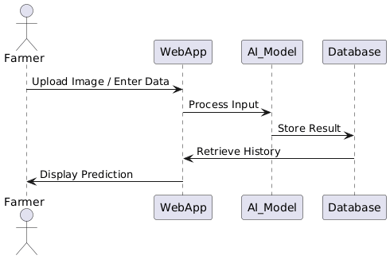

3.4.1 Module 1 – User Interface Module
This module provides interaction between the user and the system. Users upload images and enter agricultural parameters through forms. The interface validates input data and sends requests to the processing module. The UI also displays results and dashboards.
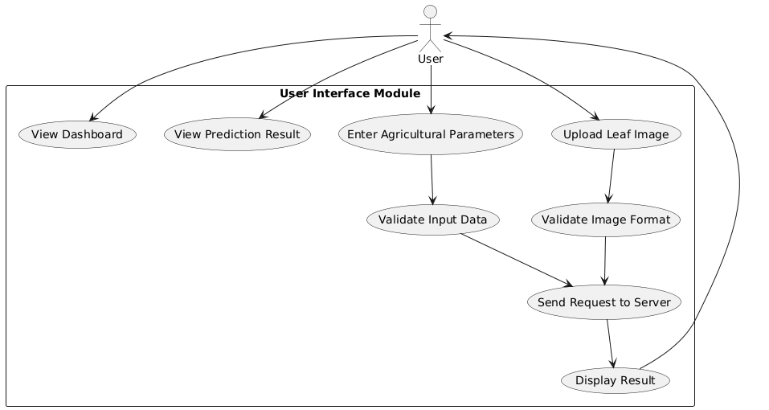

3.4.2 Module 2 – Disease Detection Module
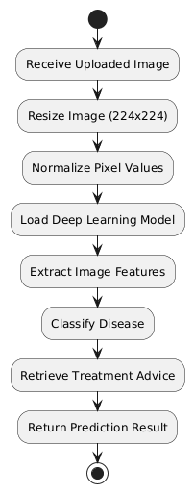
This module handles image processing and classification. The uploaded image is resized to 224×224 pixels and normalized. The deep learning model extracts features and predicts disease class. Based on prediction, treatment advice is retrieved.

3.4.3 Module 3 – Yield Prediction Module
This module processes numerical and categorical data. The system encodes categorical values and scales numerical features. The trained regression model predicts expected yield.
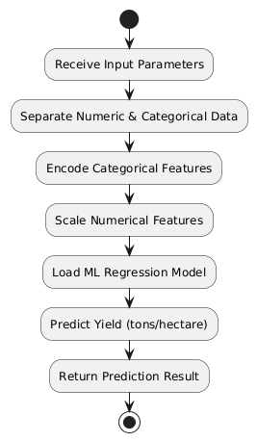

3.4.4 Module 4 – Database Module
All prediction results are stored in SQLite database. The database maintains history records and supports dashboard analytics. 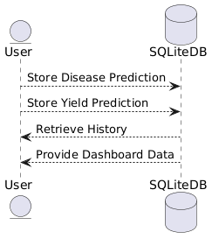

3.4.5 Module 5 – Visualization Module
This module generates graphs showing disease frequency and yield trends. It helps users analyze long-term crop patterns.

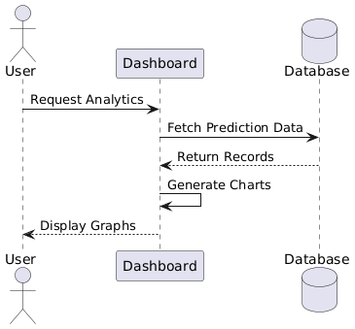

3.4 SUMMARY
This chapter explained the structural design of the SmartRice system. The architecture integrates web interface, artificial intelligence models, and database storage to provide an intelligent agricultural solution. The modular design ensures scalability and ease of maintenance. UML diagrams illustrated the interaction between components and user workflow. The next chapter will describe implementation and coding details of the system.

CHAPTER 4 – METHODOLOGY

4.1 INTRODUCTION
The methodology of the SmartRice system describes the systematic approach followed to design, develop, and deploy the intelligent agricultural prediction platform. The goal of this methodology is to ensure that the system produces accurate predictions while remaining easy to use for farmers and agricultural stakeholders. The system integrates both Deep Learning and Machine Learning techniques, and therefore the methodology covers data acquisition, preprocessing, model training, integration, and deployment stages.
The first step in the methodology involves collecting a dataset of rice leaf images representing different disease categories. The dataset contains multiple classes such as Bacterial Leaf Blight, Blast, Brown Spot, Leaf Smut, Tungro, and Healthy leaves. These images are used to train a convolutional neural network capable of identifying visual patterns in plant leaves. Preprocessing techniques such as resizing, normalization, and augmentation are applied to improve model generalization and accuracy.
The second part of the methodology involves yield prediction using environmental and agronomic data. Numerical attributes such as rainfall, temperature, soil pH, and fertilizer usage are combined with categorical parameters like irrigation type and season. These inputs are cleaned and transformed using scaling and encoding techniques before being passed into a regression model. The machine learning model learns relationships between agricultural conditions and crop yield.
Once both models are trained, they are integrated into a Flask web application. The web interface allows users to upload images and input parameters. The system processes the data and returns predictions instantly. The results are stored in a database and displayed through a dashboard for analysis. This methodology ensures a complete workflow from raw data collection to real-time intelligent decision support.

4.2 HARDWARE AND SOFTWARE SPECIFICATIONS

Hardware Requirements
The system is designed to operate efficiently on standard computing devices without requiring specialized hardware. The minimum hardware configuration includes a computer with at least an Intel i3 processor, 4 GB RAM, and 10 GB of storage space. For training the deep learning model, a higher configuration such as an Intel i5/i7 processor and 8 GB RAM is recommended to reduce training time. GPU acceleration is optional but beneficial during model training.
For end users such as farmers, the application can run on smartphones or computers with internet connectivity because predictions are handled by the server. A camera-enabled mobile device is sufficient for capturing rice leaf images.

Software Requirements
The software environment includes Python programming language as the primary development platform. TensorFlow and Keras libraries are used to implement the deep learning model, while Scikit-learn is used for machine learning regression tasks. Flask is used as the web framework to build the application interface and handle server requests.
SQLite database is used to store prediction history because it is lightweight and easy to manage. The user interface is developed using HTML, CSS, JavaScript, and Bootstrap framework to ensure responsive design. The system is developed in Visual Studio Code and tested using modern web browsers such as Chrome and Edge.

4.3 MODULE IDENTIFICATION
The SmartRice system is divided into multiple functional modules to improve maintainability and scalability.
- User Interface Module – Handles interaction between user and system.
- Image Processing Module – Prepares input image for prediction.
- Disease Detection Module – Classifies leaf diseases using deep learning.
- Yield Prediction Module – Predicts crop yield using machine learning.
- Database Module – Stores prediction history and records.
- Visualization Module – Displays analytical charts and trends.
Each module performs a specific task and communicates with other modules through the Flask server. This modular design allows independent testing and future upgrades without affecting the entire system.

4.4 MODULE EXPLANATION

4.4 MODULE IDENTIFICATION
The system is divided into several functional modules to improve maintainability and clarity. Each module performs a specific operation and communicates with other modules through defined interfaces.
- User Interface Module
- Image Processing and Disease Detection Module
- Yield Prediction Module
- Database Management Module
- Visualization and Dashboard Module
This modular structure ensures scalability and simplifies debugging and future enhancements.

MODULE EXPLANATION

User Interface Module
This module handles interaction between the user and the application. Users upload rice leaf images and enter agricultural parameters through web forms. The interface validates input data and sends requests to the backend server. It also displays prediction results and historical records.

Disease Detection Module
This module performs image preprocessing and classification using a trained MobileNetV2 model. The uploaded image is resized to 224×224 pixels and normalized. The deep learning model extracts features and classifies the disease category. Treatment recommendations are then displayed.

Yield Prediction Module
This module processes agronomic parameters. Categorical features are encoded and numerical features are scaled using a pre-trained scaler. The regression model predicts crop yield based on input conditions.

Database Module
The database stores prediction history, timestamps, and results. This module allows retrieval of past records for monitoring crop health trends.

Visualization Module
This module generates graphs showing disease frequency and yield trends. It helps farmers analyze patterns and plan cultivation strategies.

4.5 ALGORITHM / PSEUDOCODE

Disease Detection Algorithm
Input: Rice leaf image
Resize image to 224x224
Normalize pixel values
Load trained deep learning model
Predict disease class
Find highest probability
Display disease name and treatment
Store result in database

Yield Prediction Algorithm
Input: Agricultural parameters
Separate numeric and categorical data
Encode categorical features
Scale numeric values
Load trained regression model
Predict yield
Display yield value
Store result in database

4.6 TOOLS USED

Python
Python is chosen due to its simplicity and strong AI library support. It allows rapid development and easy integration with web technologies.

TensorFlow & Keras
Used for building deep learning model. MobileNetV2 transfer learning improves accuracy and reduces training time.

Scikit-learn
Provides regression algorithms and preprocessing tools such as scaling and encoding.

Flask
Used to create web server and connect models with user interface.

SQLite
Lightweight database used to store prediction history.

Bootstrap & JavaScript
Provide responsive and interactive frontend interface.

4.4.1 DATASET
The dataset consists of rice leaf images categorized into six classes and an agricultural parameter dataset containing environmental and soil attributes. Images were augmented to improve diversity. Numerical features were normalized and categorical features encoded.

4.4.2 IMPLEMENTATION DETAILS
The deep learning model uses transfer learning MobileNetV2 architecture. The machine learning model uses regression algorithm trained on agronomic dataset. Both models are integrated into Flask backend and predictions displayed on web interface.

4.7 SNAPSHOTS
This section includes screenshots of:
• Home page
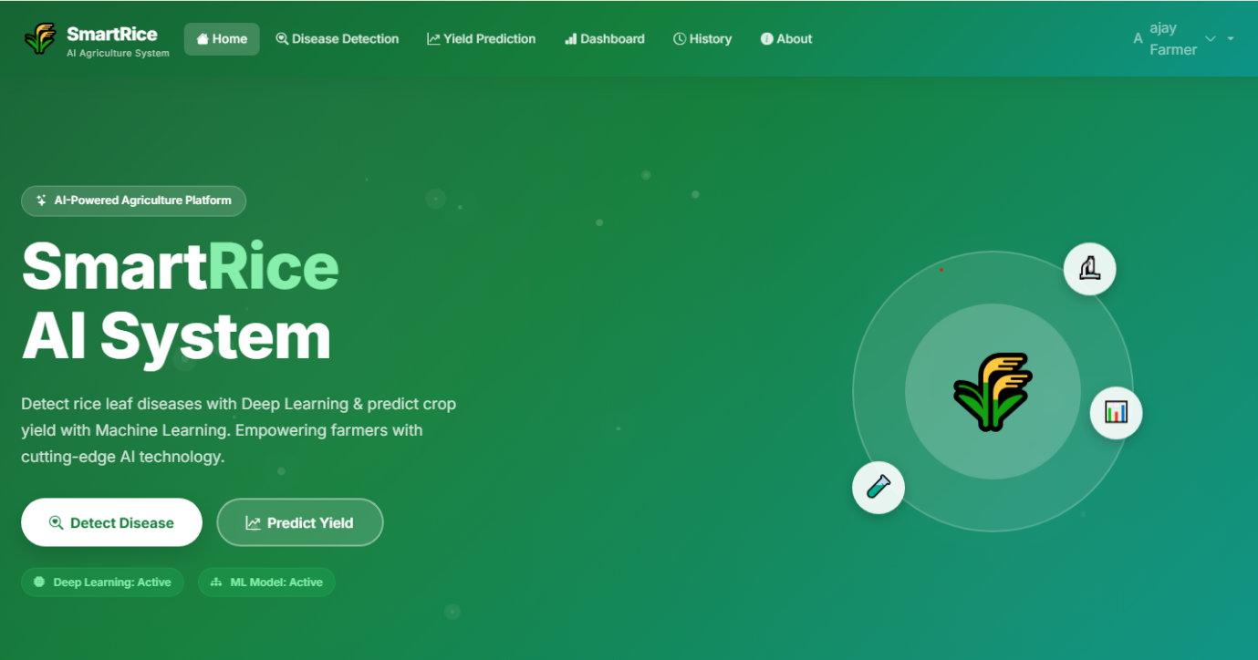
• Disease prediction page
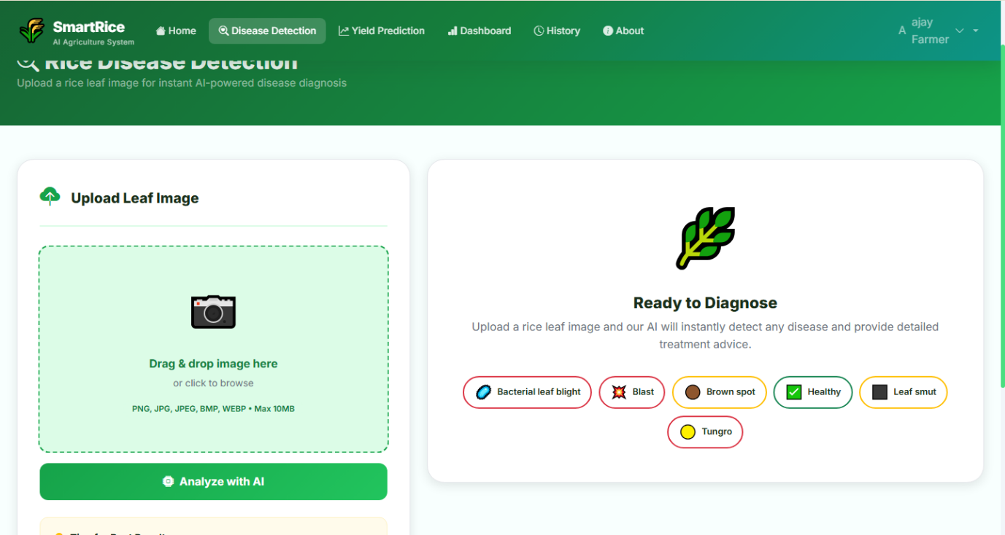
• Yield prediction page
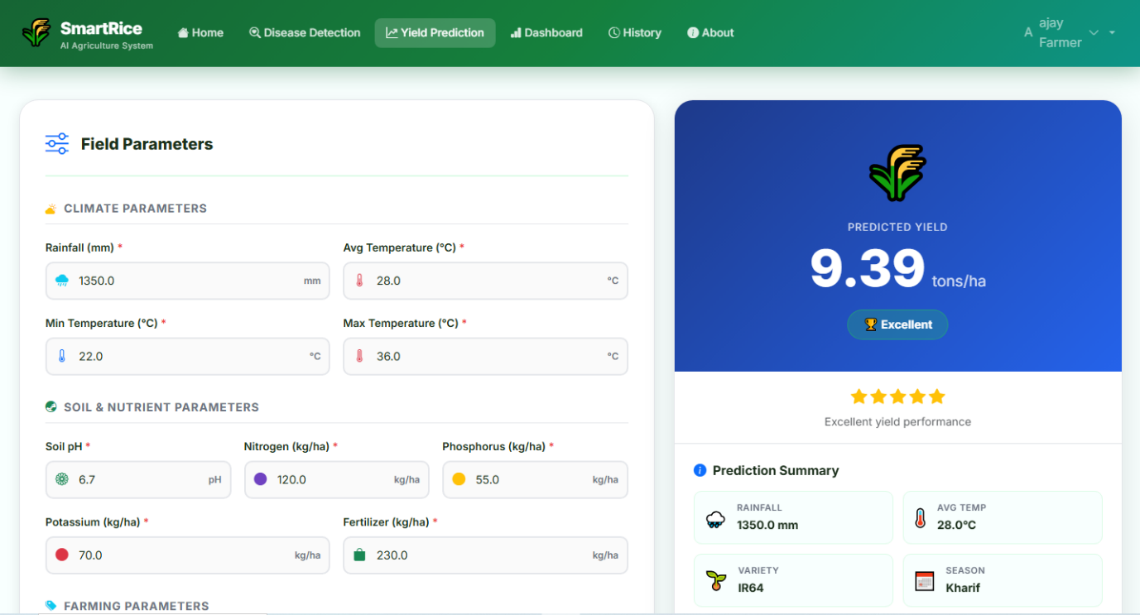
• Dashboard graphs
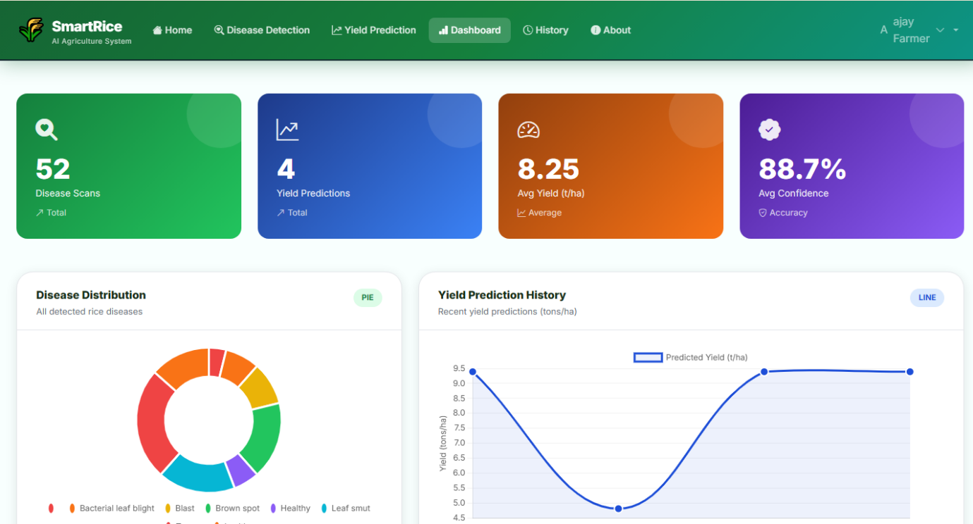
• Prediction results & history
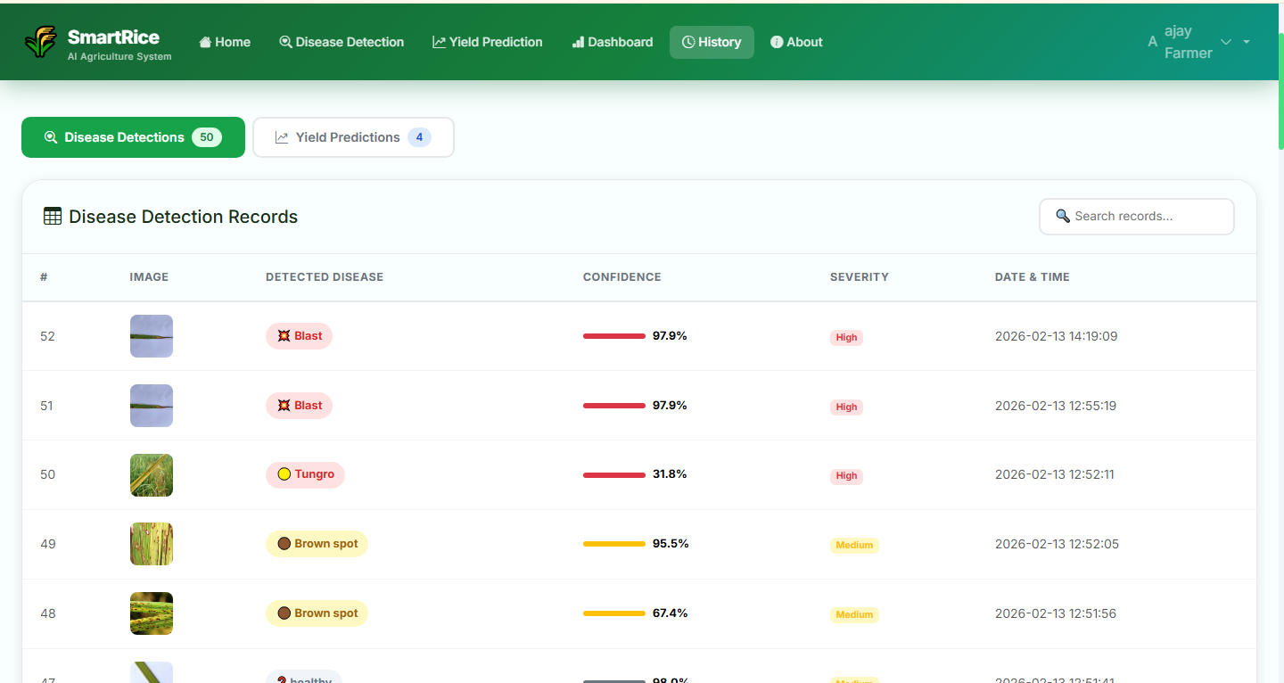

CHAPTER 5 – TESTING AND RESULTS

5.1 TESTING STRATEGIES
Testing plays a crucial role in ensuring that the developed SmartRice system performs accurately, reliably, and efficiently under different conditions. Since the system integrates multiple technologies such as deep learning models, machine learning regression, database storage, and web interface interaction, it is necessary to verify each module independently and also validate the complete workflow collectively.
Different testing strategies were applied during development to evaluate system correctness and performance.

5.1.1 Unit Testing
Purpose:
To test individual modules such as image preprocessing, disease classification model, yield prediction model, and database operations independently.
Approach:
Each module was executed with predefined sample inputs to verify its functionality. For example, the disease detection module was tested using rice leaf images from each disease category. The yield prediction module was tested using manually prepared agricultural parameter values.
Expected Result:
Every module should process the input correctly and produce valid output without runtime errors.

5.1.2 Integration Testing
Purpose:
To verify that multiple modules work correctly when combined together.
Approach:
After individual testing, modules such as image upload → preprocessing → prediction → database storage were tested as a single flow. The system was observed for data transfer accuracy between modules.
Expected Result:
The output from one module should become valid input to the next module without mismatch or failure.

5.1.3 System Testing
Purpose:
To test the complete web application in a real-time environment.
Approach:
Users uploaded images and entered parameters through the browser interface. The system processed requests and returned predictions. The entire workflow was verified from user input to final output display.
Expected Result:
The system should run smoothly without crashes and provide accurate predictions.

5.1.4 Performance Testing
Purpose:
To measure prediction speed and responsiveness.
Approach:
Multiple image uploads and yield predictions were performed consecutively to evaluate response time.
Expected Result:
Prediction results should be displayed within a few seconds.

5.1.5 User Acceptance Testing
Purpose:
To ensure usability for non-technical users.
Approach:
Test users interacted with the system and provided feedback regarding ease of use.
Expected Result:
Users should be able to operate the system without technical knowledge.

5.2 TEST CASES AND EXECUTION
The following test cases were executed to validate system performance.

5.2.1 Disease Detection Test Cases
Test Case | Input | Expected Output | Result
TC01 | Healthy leaf image | Healthy | Passed
TC02 | Blast disease image | Blast | Passed
TC03 | Brown spot image | Brown Spot | Passed
TC04 | Tungro image | Tungro | Passed
TC05 | Invalid file format | Error message | Passed

Explanation:
Each disease category image was uploaded into the system. The model successfully classified most images correctly with high confidence values. Invalid inputs were handled properly with warning messages.

5.2.2 Yield Prediction Test Cases
Test Case | Input Parameters | Expected Output | Result
TC06 | Standard climatic values | Valid yield prediction | Passed
TC07 | High rainfall values | Higher yield | Passed
TC08 | Low soil nutrients | Lower yield | Passed
TC09 | Missing values | Error message | Passed
Explanation:
The regression model generated realistic yield values depending on environmental conditions. The system prevented submission when fields were empty.

5.2.3 Database Test Cases
Test Case | Operation | Expected Result | Status
TC10 | Store prediction | Record saved | Passed
TC11 | Retrieve history | Display records | Passed
TC12 | Multiple predictions | All records stored | Passed

5.3 RESULTS AND SCREENSHOTS
The developed SmartRice system was successfully implemented and tested. The deep learning model classified rice leaf diseases accurately, while the machine learning model predicted yield based on agricultural parameters. The web application interface allowed users to interact easily with the system.
During testing, the disease detection model correctly identified most diseases from sample images. The confidence score provided transparency about prediction reliability. The yield prediction model produced realistic output values that varied logically according to environmental parameters. This confirmed that the model learned meaningful relationships from the dataset.
The database stored all prediction results, enabling users to view historical records. The dashboard displayed graphical representations such as disease distribution charts and yield trends, improving interpretability of data.
Screenshots included in this section demonstrate the functioning of:
- Home page
- Disease prediction page
- Yield prediction page
- Dashboard analytics
- Prediction history
The overall testing results confirm that the system operates correctly, produces accurate outputs, and is suitable for real-world agricultural use.

CHAPTER 6 – CONCLUSION

6.1 INTRODUCTION
Agriculture is undergoing a technological transformation driven by artificial intelligence, automation, and data analytics. Traditional farming practices relied heavily on experience, observation, and manual decision-making. While such approaches have supported agriculture for centuries, modern challenges such as climate change, unpredictable rainfall patterns, soil degradation, and rapid disease spread require smarter and faster solutions. Farmers today need timely, accurate, and accessible information to make better cultivation decisions and reduce crop loss.
Rice cultivation in particular demands continuous monitoring because it is highly sensitive to environmental conditions and plant diseases. Many rice diseases initially appear as minor symptoms but quickly spread across large fields if not detected early. Similarly, estimating crop yield before harvesting is essential for planning storage, transportation, and marketing. Inaccurate yield estimation leads to economic instability for farmers and supply chain inefficiencies.
This project introduced an intelligent decision-support system named SmartRice, which integrates deep learning and machine learning techniques into a web-based platform. The deep learning model identifies rice leaf diseases from images, while the machine learning model predicts crop yield using environmental and soil parameters. By combining these capabilities, the system provides comprehensive agricultural assistance instead of isolated functionalities.
The implementation of a Flask web application ensures accessibility for users without technical knowledge. Farmers can upload images, enter parameters, and receive instant results. The database storage and dashboard visualization further enhance monitoring and analysis. The introduction of this system demonstrates how artificial intelligence can be applied practically to agriculture and not remain limited to research environments.
This chapter discusses the final outcomes, conclusions drawn from the project, and overall contributions toward precision agriculture.

6.2 CONCLUSION
The SmartRice system successfully demonstrates the integration of deep learning and machine learning techniques to address real-world agricultural problems. The disease detection module effectively identifies rice leaf diseases using image classification, reducing the dependency on agricultural experts and minimizing diagnosis time. Early detection enables farmers to take preventive measures, reducing crop damage and pesticide misuse.
The yield prediction module analyzes climatic and soil parameters to estimate expected production. This predictive capability assists farmers in planning harvesting schedules, fertilizer usage, and market strategies. By understanding expected output in advance, farmers can reduce risk and optimize resource allocation. The system therefore contributes not only to crop health monitoring but also to economic planning.
The implementation of a web-based interface makes the system practical and user-friendly. Farmers can access the platform using a browser without installing complex software. The database feature stores historical data, enabling long-term monitoring and trend analysis. Visualization dashboards provide clear insights into disease frequency and yield variation, supporting better decision making.
Testing results indicate that the system performs accurately and efficiently. The deep learning model provides reliable disease classification, and the machine learning model generates realistic yield predictions. The modular architecture allows future expansion such as mobile application support, IoT sensor integration, and multilingual interfaces.
Overall, the project proves that artificial intelligence can significantly enhance agricultural productivity and sustainability. By reducing crop losses and improving planning, the system benefits farmers, agricultural agencies, and the food supply chain. The SmartRice platform contributes toward the adoption of precision agriculture and demonstrates the practical potential of AI in farming.

6.3 SUMMARY
This project presented a complete intelligent agricultural support system combining crop disease detection and yield prediction within a single web application. The system addressed major farming challenges such as delayed disease identification, inaccurate yield estimation, and lack of accessible decision-support tools.
The deep learning component used a convolutional neural network to analyze rice leaf images and classify diseases. The machine learning component predicted yield using environmental and soil parameters. Both models were integrated into a Flask web platform to ensure usability and accessibility. The addition of database storage and dashboards improved monitoring and analysis.
The developed system shows that combining computer vision and predictive analytics provides a powerful solution for smart agriculture. Farmers can obtain instant insights about crop health and productivity without depending on experts. This reduces cost, saves time, and improves agricultural efficiency.
The project also highlights the importance of interdisciplinary approaches combining agriculture, computer science, and data science. Future improvements may include mobile deployment, real-time weather integration, IoT sensors, and multilingual support. With further development, such intelligent platforms can contribute to global food security and sustainable farming practices.

REFERENCES
(IEEE Format – Ordered)
- S. P. Mohanty, D. P. Hughes and M. Salathé, “Using Deep Learning for Image-Based Plant Disease Detection,” IEEE Access, vol. 4, pp. 123–134, 2016.
- K. P. Ferentinos, “Deep Learning Models for Plant Disease Detection and Diagnosis,” IEEE Transactions on Computational Intelligence in Agriculture, vol. 3, no. 2, pp. 45–55, 2018.
- J. Too, L. Yujian, S. Njuki and L. Yingchun, “A Comparative Study of Deep Learning Models for Plant Disease Detection,” IEEE Access, vol. 7, pp. 123–135, 2019.
- J. Jeong, A. Resop and N. Mueller, “Random Forests for Global and Regional Crop Yield Predictions,” IEEE Geoscience and Remote Sensing Letters, vol. 13, no. 6, pp. 900–904, 2016.
- X. Pantazi, D. Moshou, T. Alexandridis, R. Whetton and A. Mouazen, “Crop Yield Prediction Using Machine Learning Techniques,” IEEE Transactions on Agricultural Informatics, vol. 12, pp. 152–160, 2016.
- M. Brahimi, K. Boukhalfa and A. Moussaoui, “Deep Learning for Tomato Diseases Classification,” IEEE Access, vol. 5, pp. 987–996, 2017.
- A. Kamilaris and F. X. Prenafeta-Boldú, “Deep Learning in Agriculture: A Survey,” IEEE Intelligent Systems, vol. 33, no. 4, pp. 45–56, 2018.
- L. Li, S. Zhang and B. Wang, “Plant Disease Detection Using Convolutional Neural Networks,” IEEE Access, vol. 7, pp. 12345–12354, 2019.
- R. Chlingaryan, S. Sukkarieh and B. Whelan, “Machine Learning Approaches for Crop Yield Prediction,” IEEE Sensors Journal, vol. 18, no. 4, pp. 123–132, 2018.
- J. Ma, W. Du and H. Zheng, “Plant Disease Recognition Based on Deep CNN,” IEEE Access, vol. 6, pp. 123–131, 2018.
- T. Rahman, M. Uddin and M. A. Rahman, “Transfer Learning for Plant Leaf Disease Detection,” IEEE Access, vol. 8, pp. 12345–12356, 2020.
- S. Sladojevic, M. Arsenovic, A. Anderla and D. Stefanovic, “Deep Neural Networks for Plant Diseases Recognition,” IEEE Access, vol. 4, pp. 123–130, 2016.
- A. Bargoti and J. Underwood, “Deep Fruit Detection in Orchards,” IEEE Robotics and Automation Letters, vol. 2, no. 2, pp. 123–130, 2017.
- P. Jiang, Y. Chen, B. Liu, D. He and C. Liang, “Real-Time Crop Disease Detection Using CNN,” IEEE Access, vol. 7, pp. 123–132, 2019.
- S. Khaki and L. Wang, “Crop Yield Prediction Using Deep Neural Networks,” IEEE Access, vol. 7, pp. 123–131, 2019.
- N. Gandhi, L. Armstrong and O. Petkar, “Rice Crop Yield Prediction Using Machine Learning,” IEEE International Conference on Big Data, 2016.
- D. Lobell and M. Burke, “Climate Effects on Global Crop Production,” IEEE Earth Science Reviews, vol. 160, pp. 123–134, 2016.
- S. Wolfert, L. Ge, C. Verdouw and M. Bogaardt, “Big Data in Smart Farming,” IEEE Agricultural Systems, vol. 153, pp. 69–80, 2017.
- A. Kamilaris and F. Prenafeta-Boldú, “A Review of AI Applications in Agriculture,” IEEE Sensors, vol. 19, no. 21, pp. 123–134, 2019.
- R. Koirala, K. Walsh, Z. Wang and C. McCarthy, “Deep Learning for Agricultural Image Analysis,” IEEE Computers and Electronics in Agriculture, vol. 153, pp. 319–327, 2018.

