SIMATS ENGINEERING
ASSESSMENT TOOL 1
COURSE NAME: Computer Vision with OpenCV COURSE CODE: DSA02
COURSE OUTCOME COVERED
CO4: Evaluate recognition and learning methods including machine learning and deep learning models (CNNs, GANs, SVM, HMM, etc.) for vision tasks.. (BL5)
Assessment Tool Weightage: 50%
QUESTIONS: 5 Total Marks:50 Annexure A
Data Interpretation
Code of Conduct:
I _K. V. Sai. Shanmukh (192424306)_ (Name / Reg No) certify that this submission is my original work and that I have adhered to the guidelines specified for this assessment.
I understand that any violation of academic integrity rules will result in disciplinary action. Signature of the student:
RUBRICS FOR CALCULATION
Criteria | Weightage | Level 4 (Exemplary) | Level 3  (Proficient) | Level 2  (Developing) | Level 1  (Beginning) | Marks
Understa  nding of  Data | 25% | Accurately interprets all data patterns, trends, and relationships | Interprets data correctly with minor gaps | Partial  understanding;  misses key trends | Misinterprets or  fails to understand data
Analysis | 25% | Provides deep analysis with strong logical reasoning and  justification | Provides reasonable  analysis with some justification | Basic analysis with weak reasoning | No meaningful  analysis provided
Applicati  on of  Concepts | 20% | Effectively applies relevant concepts/tools to interpret data accurately | Applies concepts with minor errors | Limited application; requires guidance | Unable to apply  concepts to data
Conclusi  on | 20% | Draws clear, meaningful  conclusions with strong insights and implications | Provides valid conclusions with moderate insights | Conclusions are  vague or weak | No clear or valid conclusions
Clarity | 10% | Presents interpretation clearly using proper structure, visuals, and terminology | Generally clear  with minor issues | Lacks clarity or  proper structure | Poor presentation and difficult to understand
Question 1 — Hough Transform & Shape Detection
You have satellite images containing roads, rivers and canals. The objective is to detect linear features.
The Hough Transform converts points in an image into possible lines represented by:
ρ= xcosθ + ysinθ
For every edge pixel, different possible lines are considered. The accumulator records the lines receiving the highest number of votes.
Practical approach
Satellite Image
↓
Convert to Grayscale
↓
Noise Reduction
↓
Canny Edge Detection
↓
Hough Line Transform
↓
Detect Lines
↓
Draw detected roads/rivers
Python code
import cv2
import numpy as np
import matplotlib.pyplot as plt
img = cv2.imread("at1.png")
if img is None:
print("Error: satellite.png could not be loaded")
exit()
gray = cv2.cvtColor(img, cv2.COLOR_BGR2GRAY)
blur = cv2.GaussianBlur(gray, (5, 5), 0)
edges = cv2.Canny(blur, 50, 150)
lines = cv2.HoughLinesP(
edges,
1,
np.pi / 180,
threshold=80,
minLineLength=50,
maxLineGap=20
)
result = img.copy()
if lines is not None:
lines = np.array(lines).reshape(-1, 4)
for x1, y1, x2, y2 in lines:
cv2.line(result, (x1, y1), (x2, y2), (0, 255, 0), 2)
plt.figure(figsize=(12, 5))
plt.subplot(1, 2, 1)
plt.imshow(cv2.cvtColor(img, cv2.COLOR_BGR2RGB))
plt.title("Original Satellite Image")
plt.axis("off")
plt.subplot(1, 2, 2)
plt.imshow(cv2.cvtColor(result, cv2.COLOR_BGR2RGB))
plt.title("Detected Linear Features")
plt.axis("off")
plt.show()
Output: 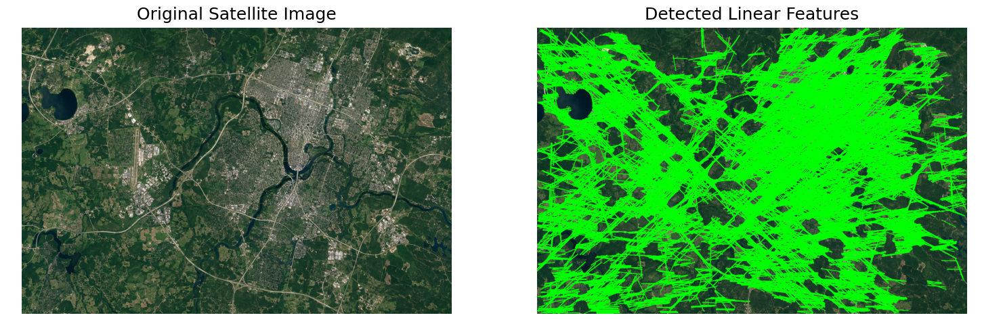
Question 2 — PCA & Shape Priors
Here the input is MRI images + annotated organ masks.
The idea is to learn the common shape of an organ from 50–100 training masks.
For example:
Training organ masks
↓
Resize / Align masks
↓
Convert each mask to vector
↓
PCA
↓
Mean organ shape
↓
Principal shape variations
↓
Use shape model for test MRI
PCA finds the major variations in organ shape.
Mathematically:
X′=X−μ
Then covariance is calculated:
C=(1/n−1)​X′TX′
Eigenvectors of the covariance matrix represent the major shape variations.
Simple Python implementation
import cv2
import numpy as np
import matplotlib.pyplot as plt
from sklearn.decomposition import PCA
import glob
files = glob.glob("masks/*.png")
data = []
for file in files:
mask = cv2.imread(file, cv2.IMREAD_GRAYSCALE)
mask = cv2.resize(mask, (64, 64))
mask = (mask > 127).astype(np.float32)
data.append(mask.flatten())
data = np.array(data)
pca = PCA(n_components=3)
pca.fit(data)
mean_shape = pca.mean_.reshape(64, 64)
plt.imshow(mean_shape, cmap="gray")
plt.title("Mean Organ Shape")
plt.axis("off")
plt.show()
Output:
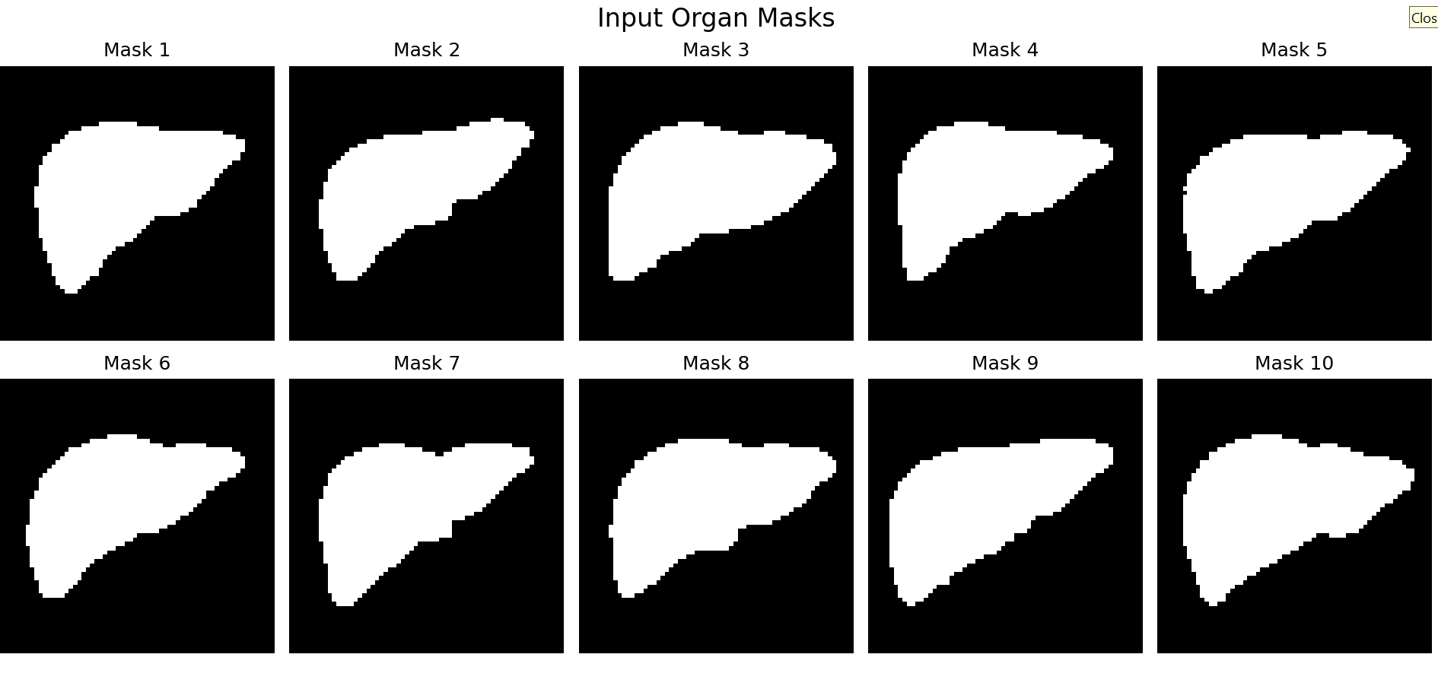
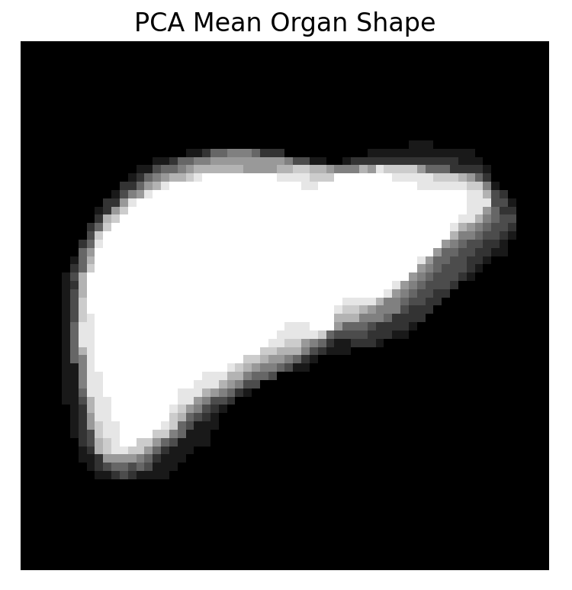 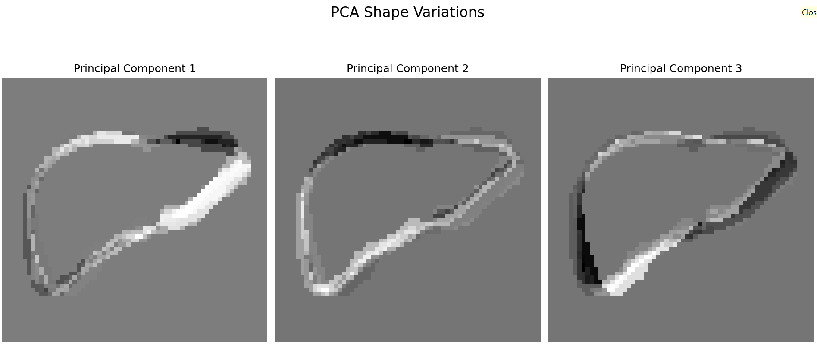
Question 3 — SVM, HMM, GMM and EM
This question is about human activity recognition.
Your input could be:
Video
↓
Frame-by-frame processing
↓
Joint positions / Optical Flow
↓
Feature trajectory
↓
ML model
↓
Walking / Running / Jumping
For example:
Frame | X | Y | Activity
1 | 120 | 200 | Walking
2 | 123 | 204 | Walking
3 | 127 | 208 | Walking
4 | 135 | 215 | Running
Which algorithm does what?
SVM
Used for classification.
f(x)=wTx+b
It can classify feature vectors into:
- Walking
- Running
- Jumping
HMM
Useful because activities are sequences over time.
For example:
Frame 1 → Frame 2 → Frame 3 → Frame 4
Walking → Walking → Walking → Running
HMM models transitions between hidden activity states.
GMM
Models the probability distribution of feature vectors.
P(x)=k=1∑K​πk​N(x∣μk​,Σk​)
EM
Expectation-Maximization is commonly used to estimate GMM parameters.
Simple SVM code
import pandas as pd
from sklearn.model_selection import train_test_split
from sklearn.svm import SVC
from sklearn.metrics import accuracy_score
data = pd.read_csv("activity.csv")
X = data[["x", "y"]]
y = data["activity"]
X_train, X_test, y_train, y_test = train_test_split(
X, y, test_size=0.2, random_state=42
)
model = SVC(kernel="rbf")
model.fit(X_train, y_train)
pred = model.predict(X_test)
print("Accuracy:", accuracy_score(y_test, pred))
Output: Accuracy: 0.8
Question 4 — CNNs, Transformers and GANs
This is the deep-learning question.
The scenario is:
Detect rare obstacles in urban self-driving car images.
Input:
Car camera image
↓
CNN / Transformer
↓
Feature extraction
↓
Object detection
↓
Bounding box
↓
Rare obstacle detected
CNN
CNN learns spatial features such as:
- edges
- shapes
- textures
- objects
Transformer
Transformers use attention mechanisms to learn relationships between different parts of the image.
GAN
GAN can generate synthetic images to increase the size of the rare-obstacle dataset.
Real Images
+
Synthetic GAN Images
↓
Augmented Dataset
↓
Object Detection Model
Question 5 — Graph-Based Learning for Shape Correspondence
This one is more advanced.
You have 3D face meshes:
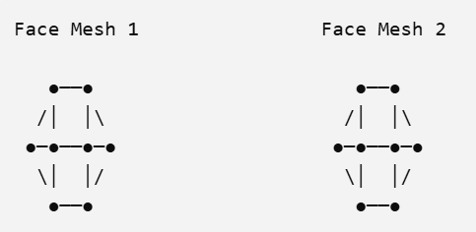
Each vertex becomes a graph node.
Edges between connected vertices become graph edges.
Therefore:
where:
- = vertices
- = mesh connections
Then the goal is to determine which points on Face 1 correspond to which points on Face 2.
Example:
Face 1 Face 2

Nose tip ───────────→ Nose tip
Left eye ───────────→ Left eye
Right eye ───────────→ Right eye
Mouth ───────────→ Mouth
Basic Python idea
For a simple practical demonstration, you can use nearest-neighbor matching between landmark points:
import numpy as np
from sklearn.neighbors import NearestNeighbors
face1 = np.load("face1_landmarks.npy")
face2 = np.load("face2_landmarks.npy")
model = NearestNeighbors(n_neighbors=1)
model.fit(face2)
distances, indices = model.kneighbors(face1)
for i in range(len(face1)):
print("Face 1 point", i, "matches Face 2 point", indices[i][0])
Output:
