SIMATS ENGINEERING
SAVEETHA INSTITUTE OF MEDICAL AND TECHNICAL SCIENCES
CHENNAI – 602105
Department of Computer Science and Engineering

ASSESSMENT TOOL 1 – INDUSTRY PROBLEM SOLVING

Course Code: | DSA0502 | Course Title: | Query Processing for Data Science
CO Assessed: | CO5 | Assessment: | Tool 2– INDUSTRY PROBLEM SOLVING
Weightage: | 35% | Total Marks:
CO5 Statement: Create meaningful visualizations using Pandas and Matplotlib, including charts, distributions, relationships, and interactive visual representations for effective communication
Student Name: | K. V. Sai. Shanmukh | Reg. No.: | 192424306
Section / Batch: | BTECH – AI & DS | Date of Submission: | 23/06/2026
Faculty In-charge: | Dr. B. Shyamala Gowri | Project Mode: | Individual Submission

Code of Conduct
I K. V. Sai. Shanmukh(192424306) (Name / Reg No) certifies that this submission is my original work and that I have adhered to all guidelines specified for this assessment. I understand that any violation of academic integrity rules will result in disciplinary action.
Signature: _K. V. Sai. Shanmukh___

- E-Commerce Sales Pattern Analysis
An e-commerce company has historical data containing date, product category, quantity sold, revenue, discount, and customer rating. Analyze the evolution of sales over time and identify relationships between discount, quantity, and revenue. Use appropriate bar charts, line charts, distribution plots, frequency plots, and scatter matrices to identify important business patterns.
Code:
import pandas as pd
import matplotlib.pyplot as plt
import seaborn as sns
# 1. Load Dataset
# Change the file name if your CSV has a different name
df = pd.read_csv("AT-2.csv")
print("First 5 records:")
print(df.head())
print("\nDataset Information:")
print(df.info())
print("\nStatistical Summary:")
print(df.describe())
# 2. Convert Date Column
df["date"] = pd.to_datetime(df["date"])
# Sort data according to date
df = df.sort_values("date")
# 3. Create Total Revenue if required
# If revenue is already present in your dataset,
# this line is not required.
# df["revenue"] = df["quantity_sold"] * df["price"]
# 4. Sales Evolution Over Time - Line Chart
daily_sales = df.groupby("date")["revenue"].sum()
plt.figure(figsize=(10, 5))
plt.plot(daily_sales.index, daily_sales.values, marker="o")
plt.title("Sales Evolution Over Time")
plt.xlabel("Date")
plt.ylabel("Revenue")
plt.xticks(rotation=45)
plt.grid(True)
plt.tight_layout()
plt.show()
# 5. Revenue by Product Category - Bar Chart
category_revenue = df.groupby("product_category")["revenue"].sum()
plt.figure(figsize=(8, 5))
category_revenue.plot(kind="bar")
plt.title("Revenue by Product Category")
plt.xlabel("Product Category")
plt.ylabel("Total Revenue")
plt.xticks(rotation=45)
plt.tight_layout()
plt.show()
# 6. Quantity Sold by Product Category - Bar Chart
category_quantity = df.groupby("product_category")["quantity_sold"].sum()
plt.figure(figsize=(8, 5))
category_quantity.plot(kind="bar")
plt.title("Quantity Sold by Product Category")
plt.xlabel("Product Category")
plt.ylabel("Quantity Sold")
plt.xticks(rotation=45)
plt.tight_layout()
plt.show()
# 7. Revenue Distribution - Distribution Plot
plt.figure(figsize=(8, 5))
sns.histplot(df["revenue"], kde=True, bins=20)
plt.title("Revenue Distribution")
plt.xlabel("Revenue")
plt.ylabel("Frequency")
plt.tight_layout()
plt.show()
# 8. Quantity Sold Frequency Plot
plt.figure(figsize=(8, 5))
sns.histplot(df["quantity_sold"], kde=True, bins=15)
plt.title("Quantity Sold Frequency")
plt.xlabel("Quantity Sold")
plt.ylabel("Frequency")
plt.tight_layout()
plt.show()
# 9. Discount Distribution
plt.figure(figsize=(8, 5))
sns.histplot(df["discount"], kde=True, bins=15)
plt.title("Discount Distribution")
plt.xlabel("Discount")
plt.ylabel("Frequency")
plt.tight_layout()
plt.show()
# 10. Discount vs Quantity Sold
plt.figure(figsize=(8, 5))
sns.scatterplot(
data=df,
x="discount",
y="quantity_sold"
)
plt.title("Discount vs Quantity Sold")
plt.xlabel("Discount")
plt.ylabel("Quantity Sold")
plt.tight_layout()
plt.show()
# 11. Discount vs Revenue
plt.figure(figsize=(8, 5))
sns.scatterplot(
data=df,
x="discount",
y="revenue"
)
plt.title("Discount vs Revenue")
plt.xlabel("Discount")
plt.ylabel("Revenue")
plt.tight_layout()
plt.show()
# 12. Customer Rating vs Revenue
plt.figure(figsize=(8, 5))
sns.scatterplot(
data=df,
x="customer_rating",
y="revenue"
)
plt.title("Customer Rating vs Revenue")
plt.xlabel("Customer Rating")
plt.ylabel("Revenue")
plt.tight_layout()
plt.show()
# 13. Quantity Sold vs Revenue
plt.figure(figsize=(8, 5))
sns.scatterplot(
data=df,
x="quantity_sold",
y="revenue"
)
plt.title("Quantity Sold vs Revenue")
plt.xlabel("Quantity Sold")
plt.ylabel("Revenue")
plt.tight_layout()
plt.show()
# 14. Scatter Matrix
numeric_columns = [
"quantity_sold",
"revenue",
"discount",
"customer_rating"
]
sns.pairplot(
df[numeric_columns],
diag_kind="hist"
)
plt.suptitle(
"Scatter Matrix of E-Commerce Variables",
y=1.02
)
plt.show()
# 15. Correlation Heatmap
correlation = df[numeric_columns].corr()
plt.figure(figsize=(8, 6))
sns.heatmap(
correlation,
annot=True,
cmap="coolwarm",
fmt=".2f"
)
plt.title("Correlation Between Sales Variables")
plt.tight_layout()
plt.show()
# 16. Average Revenue by Discount
df["discount_group"] = pd.cut(
df["discount"],
bins=[-1, 10, 20, 30, 40, 50, 100],
labels=[
"0-10%",
"11-20%",
"21-30%",
"31-40%",
"41-50%",
"50%+"
]
)
avg_revenue = df.groupby(
"discount_group",
observed=False
)["revenue"].mean()
plt.figure(figsize=(8, 5))
avg_revenue.plot(kind="bar")
plt.title("Average Revenue by Discount Range")
plt.xlabel("Discount Range")
plt.ylabel("Average Revenue")
plt.xticks(rotation=45)
plt.tight_layout()
plt.show()
# 17. Display Important Correlations
print("\nCorrelation Matrix:")
print(correlation)
print("\nAnalysis Completed Successfully!")

Output:
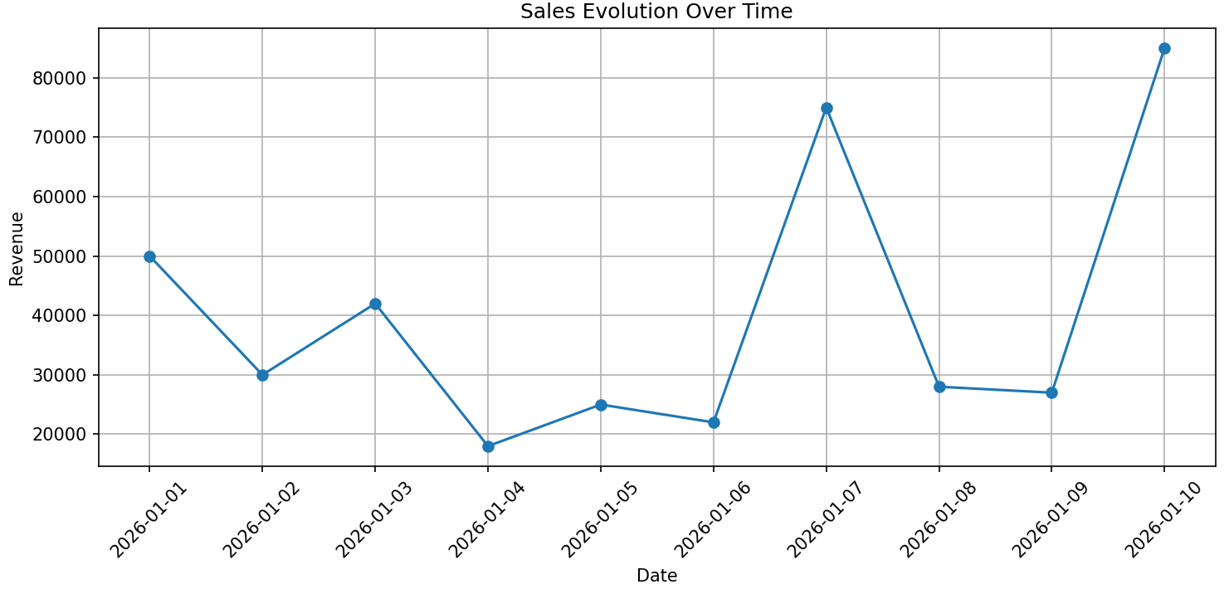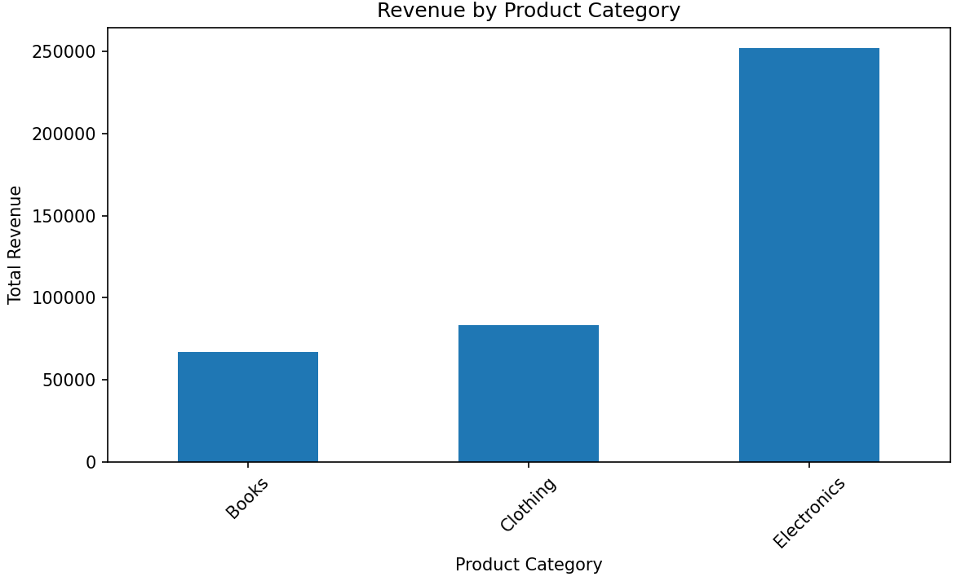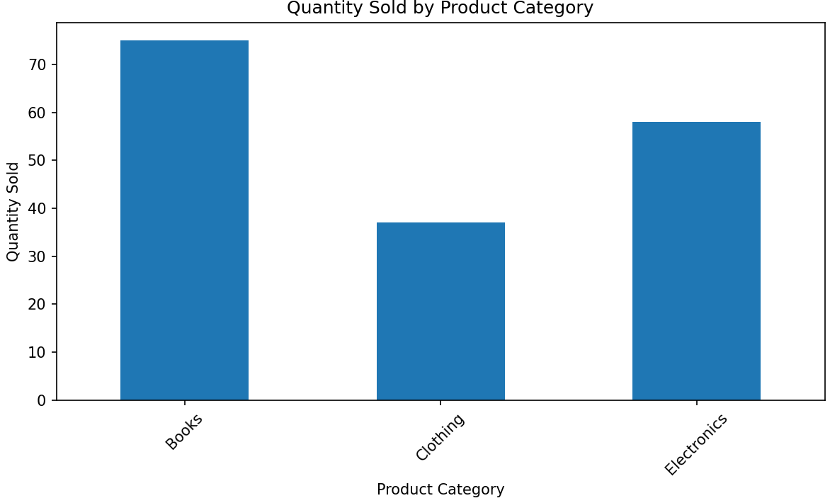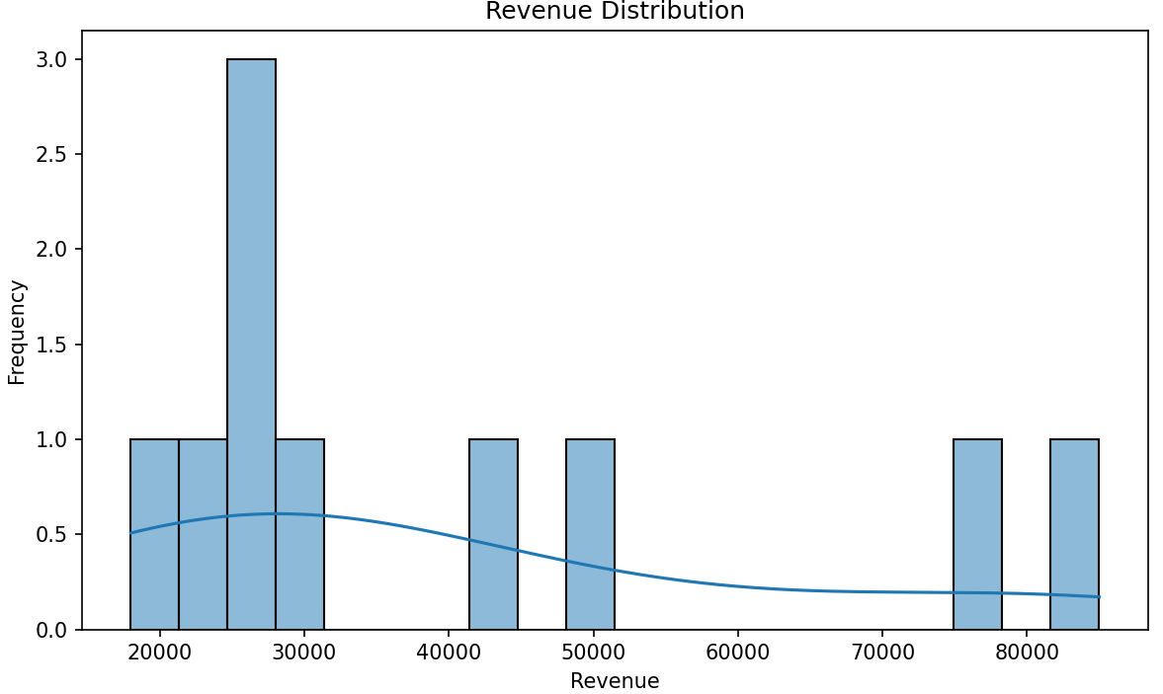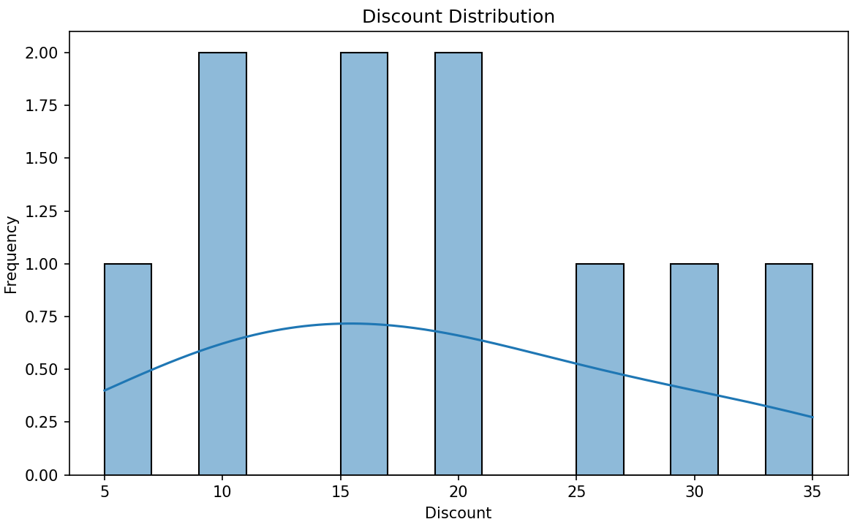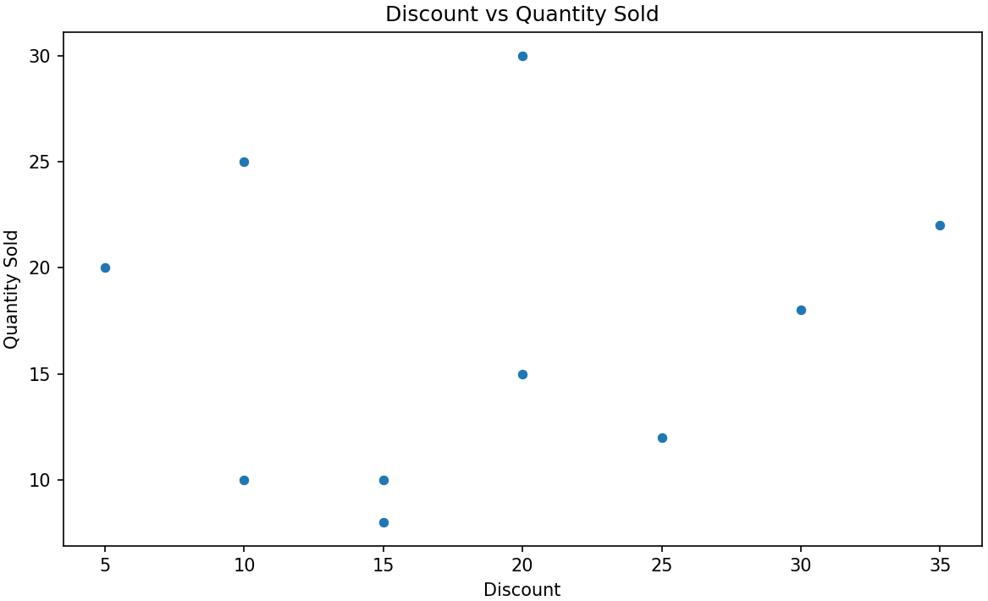

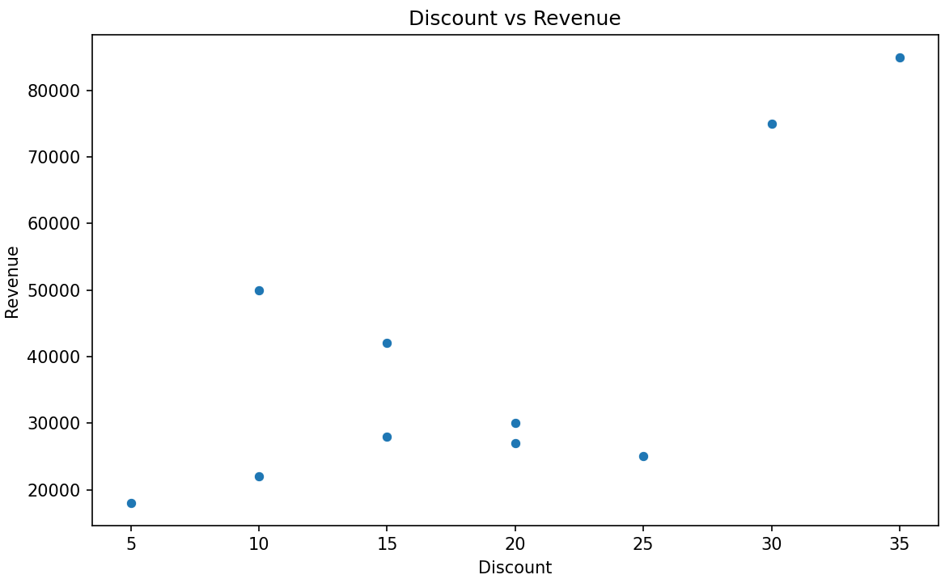
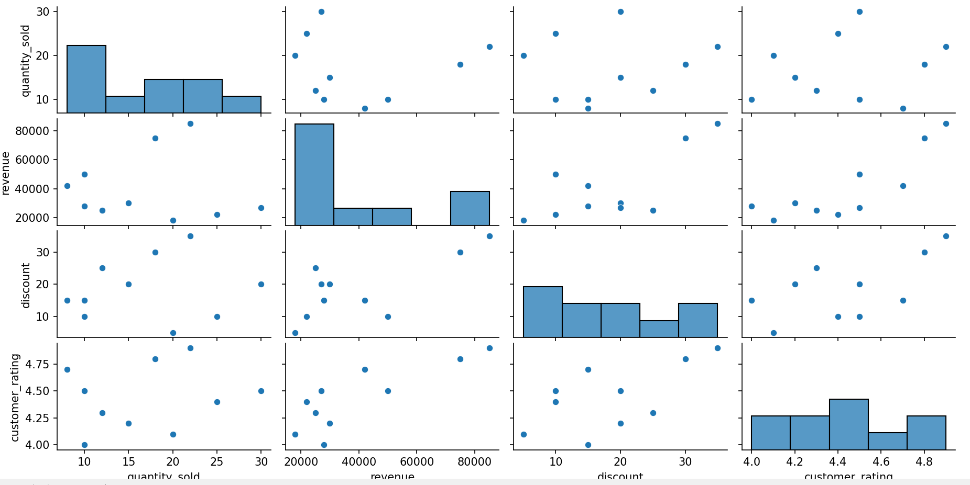
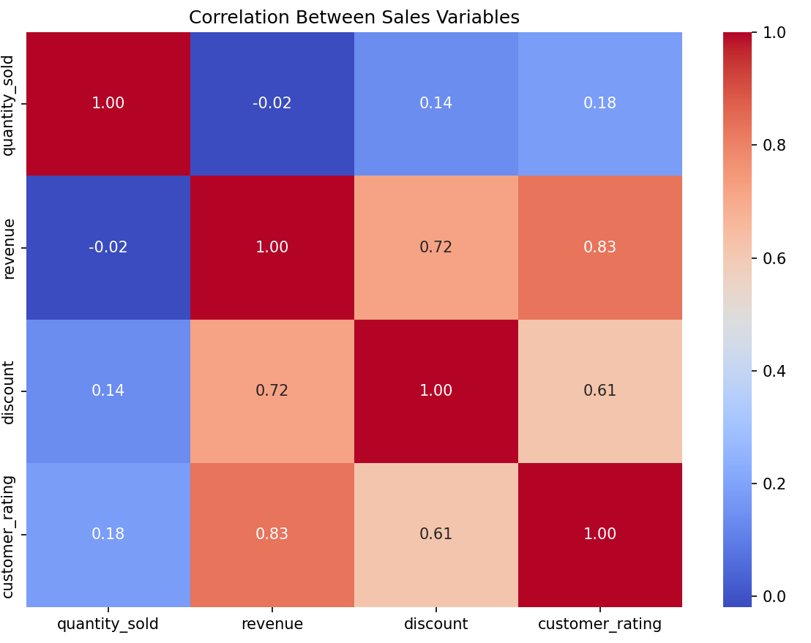

- Financial Market Analysis
A financial institution provides historical data containing date, opening price, closing price, trading volume, and daily return. Analyze the evolution of prices and relationships between trading volume and returns. Generate scatter plots, distributions, scatter matrices, lag plots, and autocorrelation plots to identify market patterns and possible dependencies. Summarize the findings for investment analysts.
Code:
import pandas as pd
import matplotlib.pyplot as plt
import seaborn as sns
from pandas.plotting import scatter_matrix, lag_plot
from statsmodels.graphics.tsaplots import plot_acf
# 1. Load Dataset
df = pd.read_csv("AT-21.csv")
print("First 5 records:")
print(df.head())
print("\nDataset Information:")
print(df.info())
print("\nStatistical Summary:")
print(df.describe())
# 2. Convert Date Column
df["date"] = pd.to_datetime(df["date"])
# Sort according to date
df = df.sort_values("date")
print("\nSorted Data:")
print(df.head())
# 3. Evolution of Opening and Closing Prices
plt.figure(figsize=(10, 5))
plt.plot(
df["date"],
df["opening_price"],
label="Opening Price"
)
plt.plot(
df["date"],
df["closing_price"],
label="Closing Price"
)
plt.title("Evolution of Stock Prices")
plt.xlabel("Date")
plt.ylabel("Price")
plt.legend()
plt.xticks(rotation=45)
plt.grid(True)
plt.tight_layout()
plt.show()
# 4. Trading Volume Over Time
plt.figure(figsize=(10, 5))
plt.plot(
df["date"],
df["trading_volume"]
)
plt.title("Trading Volume Over Time")
plt.xlabel("Date")
plt.ylabel("Trading Volume")
plt.xticks(rotation=45)
plt.grid(True)
plt.tight_layout()
plt.show()
# 5. Daily Return Over Time
plt.figure(figsize=(10, 5))
plt.plot(
df["date"],
df["daily_return"]
)
plt.axhline(
y=0,
linestyle="--"
)
plt.title("Daily Return Over Time")
plt.xlabel("Date")
plt.ylabel("Daily Return")
plt.xticks(rotation=45)
plt.grid(True)
plt.tight_layout()
plt.show()
# 6. Distribution of Daily Returns
plt.figure(figsize=(8, 5))
sns.histplot(
df["daily_return"],
kde=True,
bins=30
)
plt.title("Distribution of Daily Returns")
plt.xlabel("Daily Return")
plt.ylabel("Frequency")
plt.tight_layout()
plt.show()
# 7. Distribution of Trading Volume
plt.figure(figsize=(8, 5))
sns.histplot(
df["trading_volume"],
kde=True,
bins=30
)
plt.title("Distribution of Trading Volume")
plt.xlabel("Trading Volume")
plt.ylabel("Frequency")
plt.tight_layout()
plt.show()
# 8. Opening Price Distribution
plt.figure(figsize=(8, 5))
sns.histplot(
df["opening_price"],
kde=True,
bins=30
)
plt.title("Distribution of Opening Prices")
plt.xlabel("Opening Price")
plt.ylabel("Frequency")
plt.tight_layout()
plt.show()
# 9. Closing Price Distribution
plt.figure(figsize=(8, 5))
sns.histplot(
df["closing_price"],
kde=True,
bins=30
)
plt.title("Distribution of Closing Prices")
plt.xlabel("Closing Price")
plt.ylabel("Frequency")
plt.tight_layout()
plt.show()
# 10. Trading Volume vs Daily Return
plt.figure(figsize=(8, 5))
sns.scatterplot(
data=df,
x="trading_volume",
y="daily_return"
)
plt.title("Trading Volume vs Daily Return")
plt.xlabel("Trading Volume")
plt.ylabel("Daily Return")
plt.tight_layout()
plt.show()
# 11. Opening Price vs Closing Price
plt.figure(figsize=(8, 5))
sns.scatterplot(
data=df,
x="opening_price",
y="closing_price"
)
plt.title("Opening Price vs Closing Price")
plt.xlabel("Opening Price")
plt.ylabel("Closing Price")
plt.tight_layout()
plt.show()
# 12. Trading Volume vs Closing Price
plt.figure(figsize=(8, 5))
sns.scatterplot(
data=df,
x="trading_volume",
y="closing_price"
)
plt.title("Trading Volume vs Closing Price")
plt.xlabel("Trading Volume")
plt.ylabel("Closing Price")
plt.tight_layout()
plt.show()
# 13. Scatter Matrix
numeric_columns = [
"opening_price",
"closing_price",
"trading_volume",
"daily_return"
]
scatter_matrix(
df[numeric_columns],
figsize=(12, 10),
diagonal="hist"
)
plt.suptitle(
"Scatter Matrix of Financial Variables",
y=1.02
)
plt.show()
# 14. Lag Plot
plt.figure(figsize=(7, 7))
lag_plot(
df["daily_return"]
)
plt.title("Lag Plot of Daily Returns")
plt.tight_layout()
plt.show()
# 15. Autocorrelation Plot
plt.figure(figsize=(10, 5))
plot_acf(
df["daily_return"],
lags=30
)
plt.title("Autocorrelation of Daily Returns")
plt.tight_layout()
plt.show()
# 16. Correlation Heatmap
correlation = df[numeric_columns].corr()
plt.figure(figsize=(8, 6))
sns.heatmap(
correlation,
annot=True,
cmap="coolwarm",
fmt=".2f"
)
plt.title("Correlation Matrix")
plt.tight_layout()
plt.show()
# 17. Rolling Average of Closing Price
df["rolling_mean"] = df["closing_price"].rolling(
window=10
).mean()
plt.figure(figsize=(10, 5))
plt.plot(
df["date"],
df["closing_price"],
label="Closing Price"
)
plt.plot(
df["date"],
df["rolling_mean"],
label="10-Day Moving Average"
)
plt.title("Closing Price and 10-Day Moving Average")
plt.xlabel("Date")
plt.ylabel("Price")
plt.legend()
plt.xticks(rotation=45)
plt.grid(True)
plt.tight_layout()
plt.show()
# 18. Print Correlation Results
print("\nCorrelation Matrix:")
print(correlation)
# 19. Basic Findings
print("\n--- Financial Market Analysis Summary ---")
volume_return_corr = df["trading_volume"].corr(
df["daily_return"]
)
print(
"Correlation between Trading Volume and Daily Return:",
round(volume_return_corr, 3)
)
return_autocorr = df["daily_return"].autocorr()
print(
"Lag-1 Autocorrelation of Daily Return:",
round(return_autocorr, 3)
)
print(
"\nPositive correlation means both variables tend to move together."
)
print(
"Negative correlation means one variable tends to increase "
"when the other decreases."
)
print(
"Autocorrelation close to zero suggests weak linear dependence "
"between current and previous returns."
)
print("\nAnalysis Completed Successfully!")
Output:
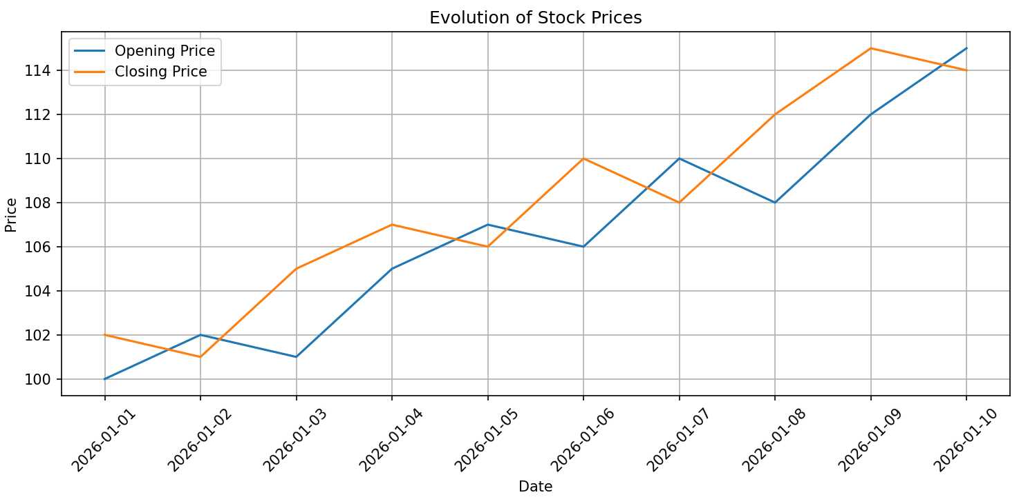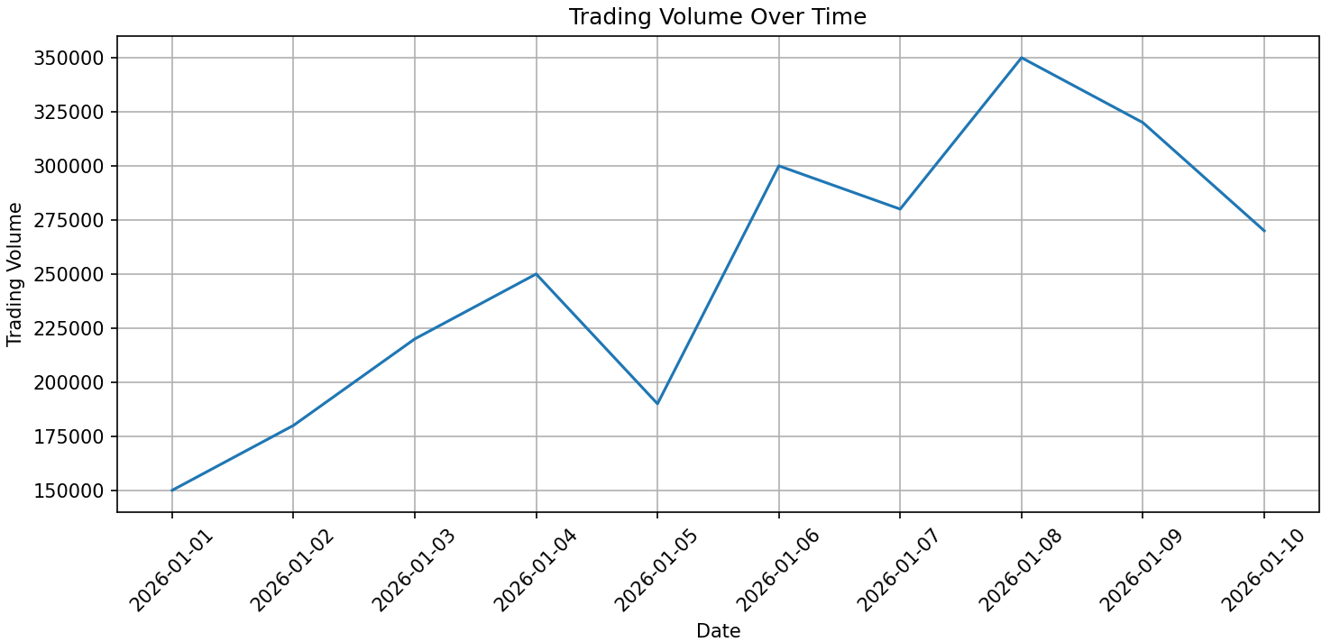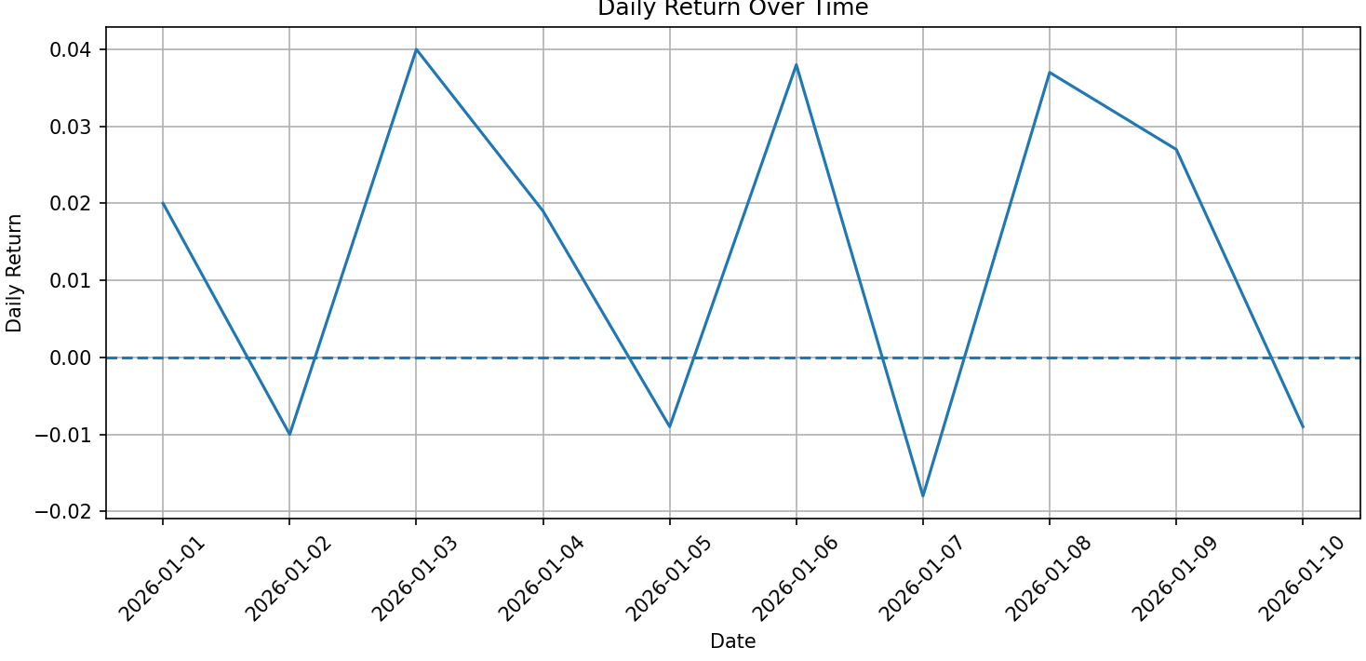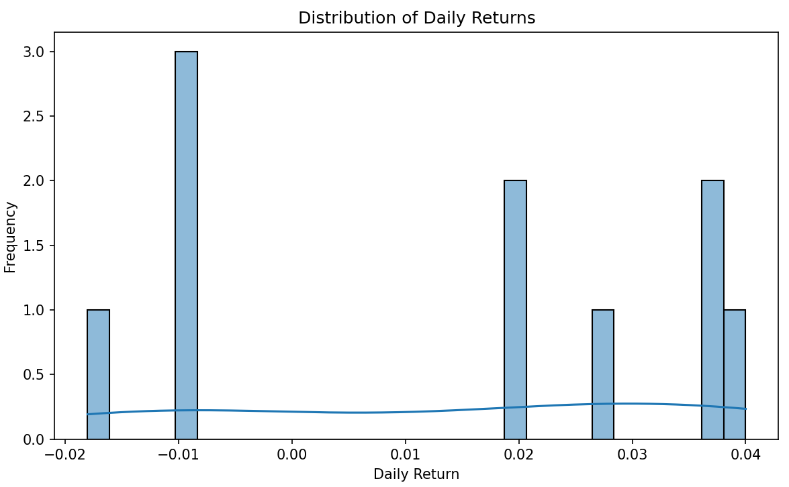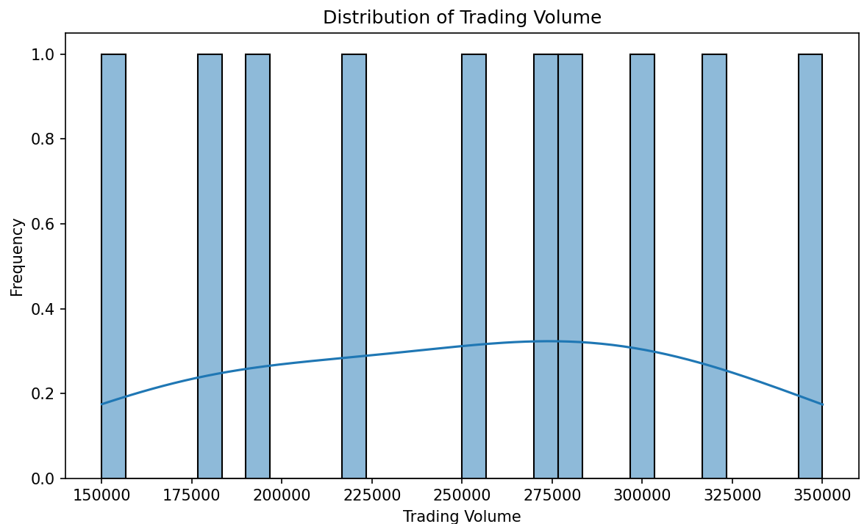
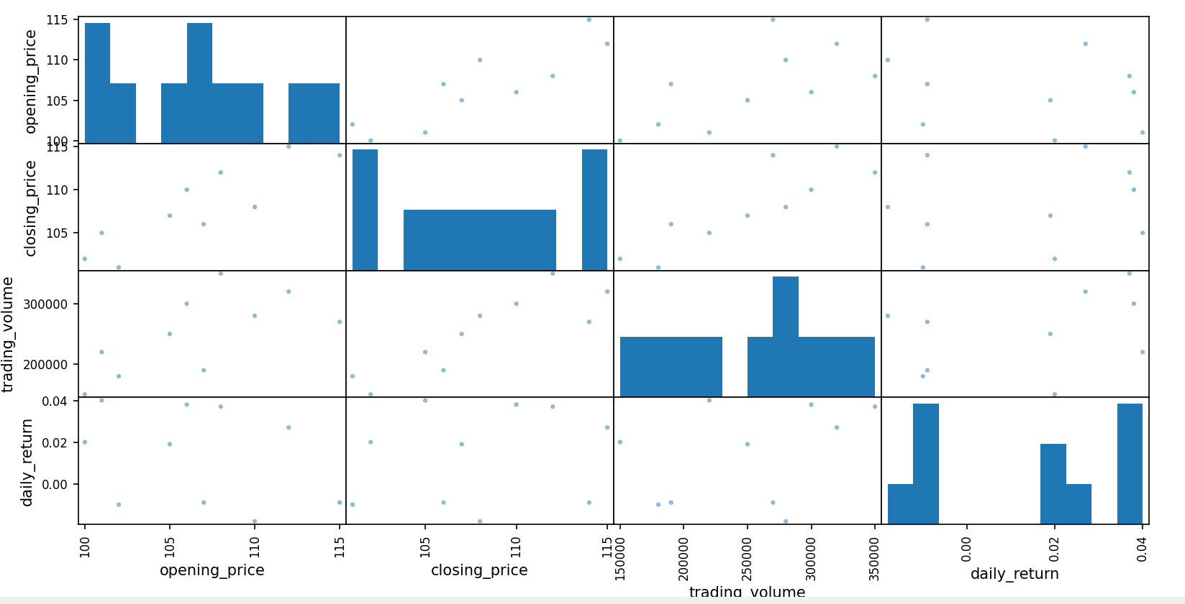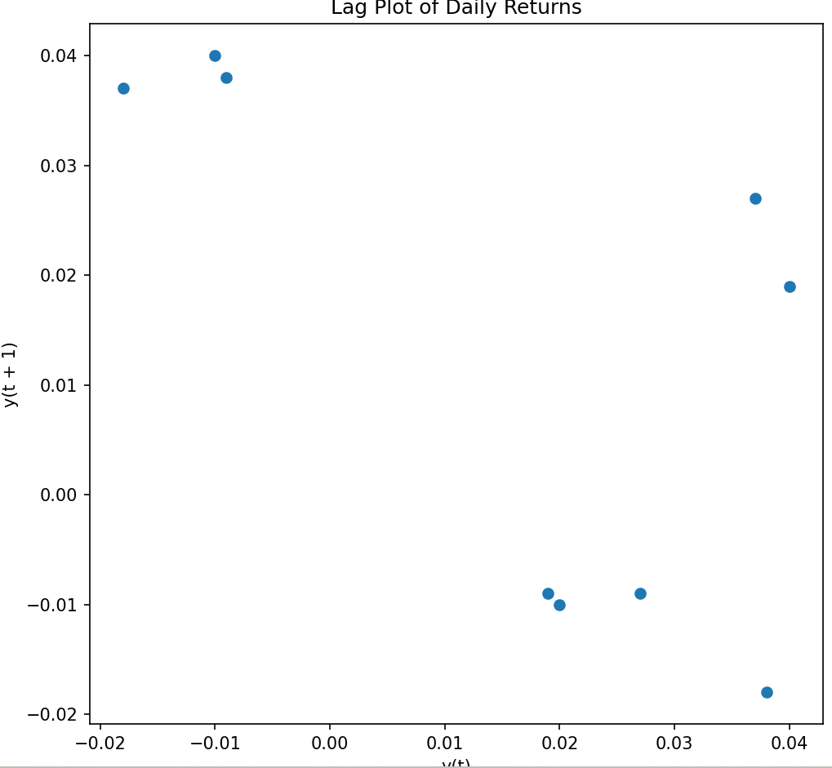
窗体底端

