SIMATS ENGINEERING
SAVEETHA INSTITUTE OF MEDICAL AND TECHNICAL SCIENCES
CHENNAI – 602105
Department of Computer Science and Engineering

ASSESSMENT TOOL 3 – Correlation and Pattern Analysis
Course Code: | DSA0502 | Course Title: | Query Processing for Data Science
CO Assessed: | CO4 | Assessment: | Tool 3– Correlation and Pattern Analysis
Weightage: | 25% | Total Marks:
CO4 Statement: Explore datasets using analytical techniques such as grouping, correlation detection, joining datasets, and extracting meaningful insights.
Student Name: | K. V. Sai. Shanmukh | Reg. No.: | 192424306
Section / Batch: | BTECH- AI & DS | Date of Submission: | 20/08/2026
Faculty In-charge: | Dr. B. Shyamala Gowri | Project Mode: | Individual Submission

Code of Conduct
I _K. V. Sai. Shanmukh (192424306)_ (Name / Reg No) certify that this submission is my original work and that I have adhered to all guidelines specified for this assessment. I understand that any violation of academic integrity rules will result in disciplinary action.
Signature: K.V. Sai. Shanmukh_

- Sales and Customer Pattern Analysis
Import sales and customer datasets and combine them using suitable table-joining techniques. Analyze the correlation between customer age, purchase frequency, discount, and purchase amount. Create meaningful customer groups, identify unusual purchasing patterns, and present the results using suitable visualizations.
Code:
import pandas as pd
import matplotlib.pyplot as plt
import seaborn as sns
# 1. CREATE CUSTOMER DATA
customers = pd.DataFrame({
"Customer_ID": ["C001", "C002", "C003", "C004", "C005",
"C006", "C007", "C008", "C009", "C010"],
"Age": [22, 35, 28, 45, 52, 31, 40, 26, 48, 37],
"Gender": ["Male", "Female", "Male", "Female", "Male",
"Female", "Male", "Female", "Male", "Female"]
})
# 2. CREATE SALES DATA
sales = pd.DataFrame({
"Customer_ID": ["C001", "C002", "C003", "C004", "C005",
"C006", "C007", "C008", "C009", "C010"],
"Purchase_Frequency": [5, 8, 3, 10, 2,
7, 6, 4, 9, 5],
"Discount": [10, 5, 20, 15, 25,
10, 8, 18, 5, 12],
"Purchase_Amount": [2500, 4200, 1800, 6500, 1200,
3800, 4500, 2200, 7200, 3100]
})
# 3. MERGE DATASETS
data = pd.merge(
customers,
sales,
on="Customer_ID",
how="inner"
)
print("Combined Dataset:")
print(data)
# 4. CORRELATION
correlation = data[
["Age",
"Purchase_Frequency",
"Discount",
"Purchase_Amount"]
].corr()
print("\nCorrelation:")
print(correlation)
# 5. CORRELATION HEATMAP
plt.figure(figsize=(8, 6))
sns.heatmap(
correlation,
annot=True,
cmap="coolwarm"
)
plt.title("Correlation Heatmap")
plt.show()
# 6. CUSTOMER GROUPING
def group_customer(amount):
if amount >= 5000:
return "High Value"
elif amount >= 2500:
return "Medium Value"
else:
return "Low Value"
data["Customer_Group"] = data["Purchase_Amount"].apply(
group_customer
)
print("\nCustomer Groups:")
print(
data[
["Customer_ID",
"Purchase_Amount",
"Customer_Group"]
]
)
# 7. CUSTOMER GROUP VISUALIZATION
plt.figure(figsize=(7, 5))
data["Customer_Group"].value_counts().plot(
kind="bar"
)
plt.title("Customer Groups")
plt.xlabel("Customer Group")
plt.ylabel("Number of Customers")
plt.xticks(rotation=0)
plt.show()
# 8. UNUSUAL PURCHASING PATTERNS
mean = data["Purchase_Amount"].mean()
std = data["Purchase_Amount"].std()
data["Unusual"] = abs(
data["Purchase_Amount"] - mean
) > 2 * std
print("\nUnusual Purchases:")
print(
data[data["Unusual"] == True]
)
# 9. AGE VS PURCHASE AMOUNT
sns.scatterplot(
data=data,
x="Age",
y="Purchase_Amount",
hue="Customer_Group"
)
plt.title("Age vs Purchase Amount")
plt.show()
# 10. PURCHASE FREQUENCY VS AMOUNT
sns.scatterplot(
data=data,
x="Purchase_Frequency",
y="Purchase_Amount",
hue="Customer_Group"
)
plt.title("Purchase Frequency vs Purchase Amount")
plt.show()
# 11. DISCOUNT VS PURCHASE AMOUNT
sns.scatterplot(
data=data,
x="Discount",
y="Purchase_Amount",
hue="Customer_Group"
)
plt.title("Discount vs Purchase Amount")
plt.show()
Output:
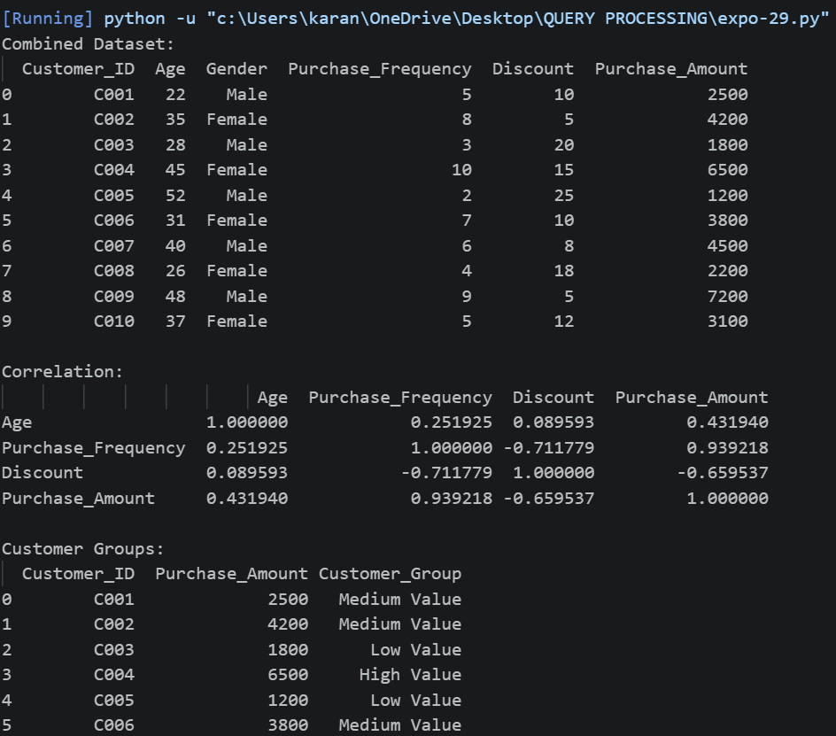
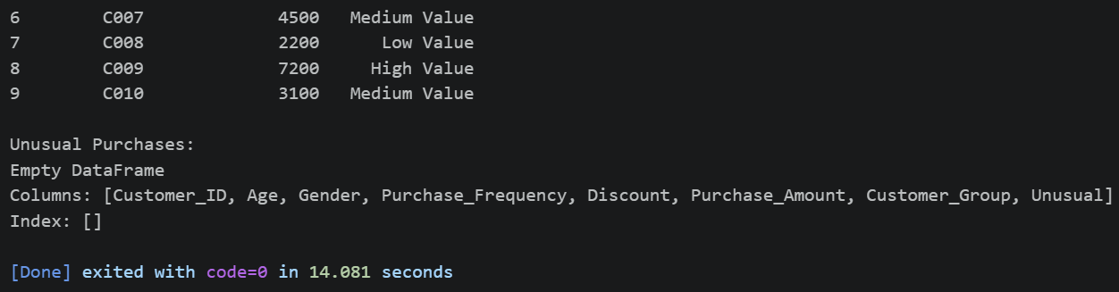
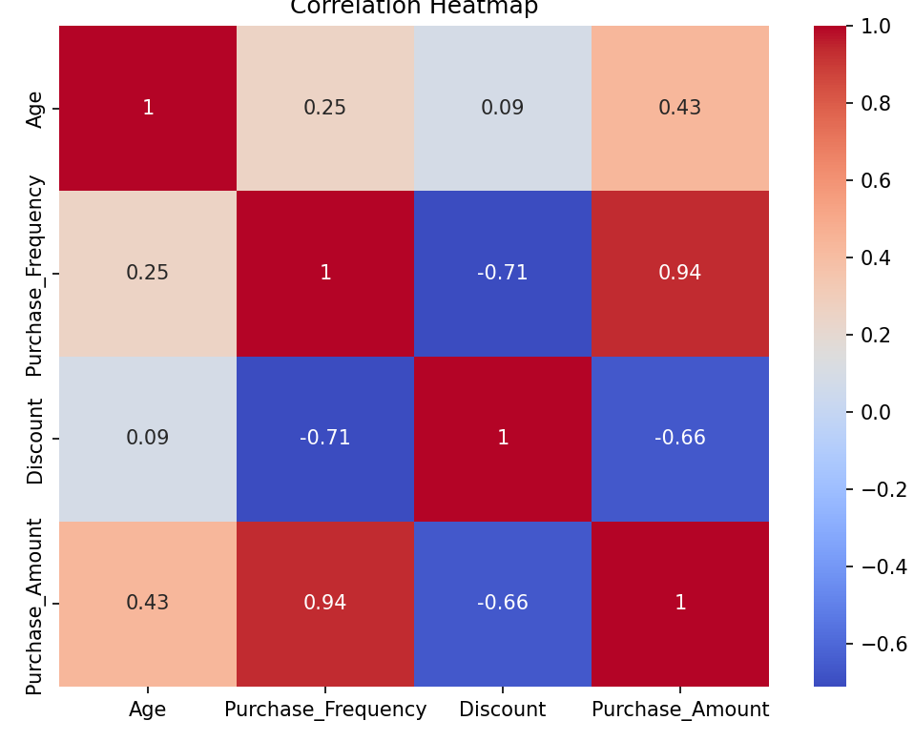
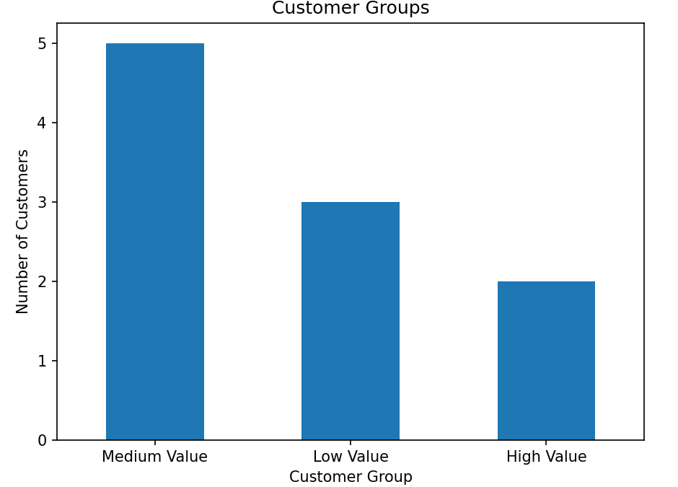

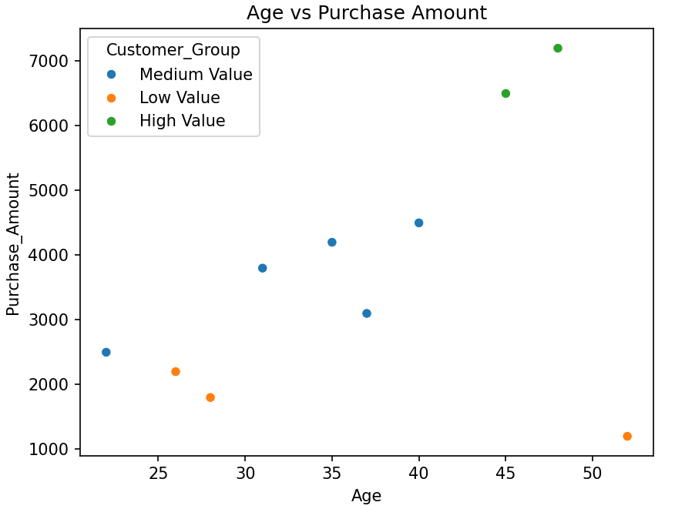
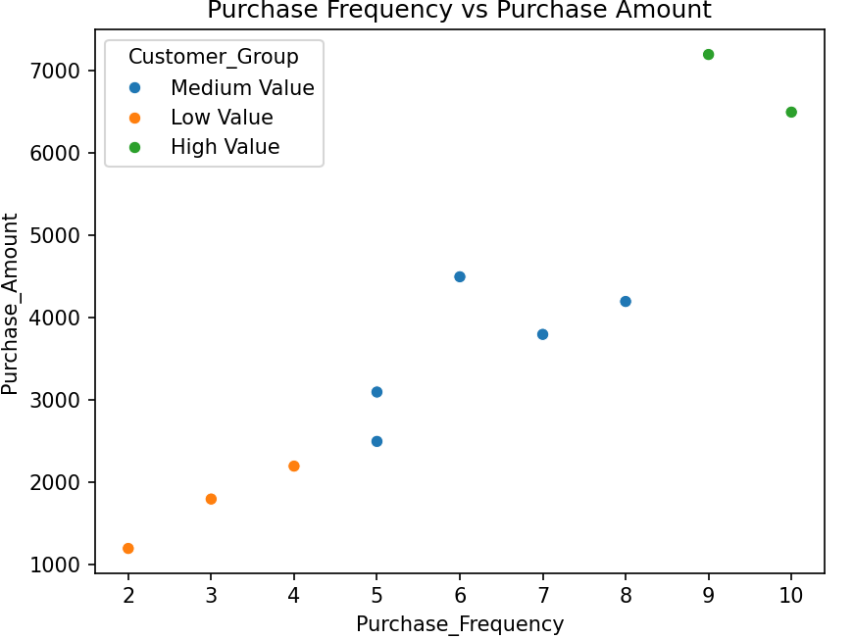
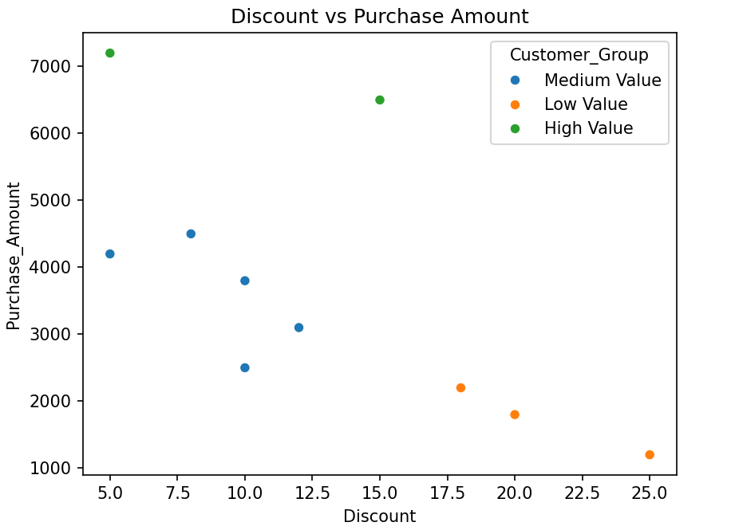

- Geographical Pattern and Correlation Analysis
Analyze a dataset containing location, population, income, sales, and customer density. Join multiple datasets, identify correlations between demographic factors and sales, group locations based on performance, detect outliers, and present geographical patterns using maps and suitable visualizations.
Code:
import pandas as pd
import matplotlib.pyplot as plt
import seaborn as sns
# 1. CREATE LOCATION DATASET
location_data = pd.DataFrame({
"Location": ["Chennai", "Bangalore", "Hyderabad", "Mumbai",
"Delhi", "Pune", "Kolkata", "Coimbatore",
"Madurai", "Kochi"],
"Population": [7000000, 8500000, 6800000, 12500000,
11000000, 5000000, 4500000, 2200000,
1500000, 2100000],
"Income": [45000, 65000, 55000, 75000, 60000,
58000, 42000, 40000, 35000, 48000],
"Customer_Density": [850, 1200, 950, 1500, 1300,
800, 650, 500, 400, 600]
})
# 2. CREATE SALES DATASET
sales_data = pd.DataFrame({
"Location": ["Chennai", "Bangalore", "Hyderabad", "Mumbai",
"Delhi", "Pune", "Kolkata", "Coimbatore",
"Madurai", "Kochi"],
"Sales": [850000, 1250000, 950000, 1800000,
1500000, 900000, 600000, 450000,
300000, 550000]
})
# 3. JOIN MULTIPLE DATASETS
data = pd.merge(
location_data,
sales_data,
on="Location",
how="inner"
)
print("Combined Dataset:")
print(data)
# 4. CHECK MISSING VALUES
print("\nMissing Values:")
print(data.isnull().sum())
# 5. CORRELATION ANALYSIS
correlation = data[
["Population",
"Income",
"Sales",
"Customer_Density"]
].corr()
print("\nCorrelation Matrix:")
print(correlation)
# 6. CORRELATION HEATMAP
plt.figure(figsize=(8, 6))
sns.heatmap(
correlation,
annot=True,
cmap="coolwarm",
fmt=".2f"
)
plt.title("Correlation Between Demographic Factors and Sales")
plt.tight_layout()
plt.show()
# 7. GROUP LOCATIONS BASED ON PERFORMANCE
def performance_group(sales):
if sales >= 1000000:
return "High Performance"
elif sales >= 600000:
return "Medium Performance"
else:
return "Low Performance"
data["Performance"] = data["Sales"].apply(
performance_group
)
print("\nLocation Performance:")
print(
data[
["Location", "Sales", "Performance"]
]
)
# 8. PERFORMANCE VISUALIZATION
plt.figure(figsize=(10, 6))
sns.barplot(
data=data,
x="Location",
y="Sales",
hue="Performance",
legend=False
)
plt.title("Sales Performance by Location")
plt.xlabel("Location")
plt.ylabel("Sales")
plt.xticks(rotation=45)
plt.tight_layout()
plt.show()
# 9. DETECT SALES OUTLIERS
Q1 = data["Sales"].quantile(0.25)
Q3 = data["Sales"].quantile(0.75)
IQR = Q3 - Q1
lower_limit = Q1 - 1.5 * IQR
upper_limit = Q3 + 1.5 * IQR
outliers = data[
(data["Sales"] < lower_limit) |
(data["Sales"] > upper_limit)
]
print("\nSales Outliers:")
print(outliers)
# 10. BOXPLOT FOR OUTLIERS
plt.figure(figsize=(7, 5))
sns.boxplot(
y=data["Sales"]
)
plt.title("Sales Outlier Detection")
plt.ylabel("Sales")
plt.tight_layout()
plt.show()
# 11. INCOME VS SALES
plt.figure(figsize=(8, 6))
sns.scatterplot(
data=data,
x="Income",
y="Sales",
size="Customer_Density",
hue="Performance",
sizes=(50, 300)
)
plt.title("Income vs Sales")
plt.xlabel("Average Income")
plt.ylabel("Sales")
plt.tight_layout()
plt.show()
# 12. POPULATION VS SALES
plt.figure(figsize=(8, 6))
sns.scatterplot(
data=data,
x="Population",
y="Sales",
hue="Performance",
s=150
)
plt.title("Population vs Sales")
plt.xlabel("Population")
plt.ylabel("Sales")
plt.tight_layout()
plt.show()
# 13. CUSTOMER DENSITY VS SALES
plt.figure(figsize=(8, 6))
sns.scatterplot(
data=data,
x="Customer_Density",
y="Sales",
hue="Performance",
s=150
)
plt.title("Customer Density vs Sales")
plt.xlabel("Customer Density")
plt.ylabel("Sales")
plt.tight_layout()
plt.show()
# 14. GEOGRAPHICAL PATTERN
# Simple geographical-style visualization
plt.figure(figsize=(10, 6))
scatter = plt.scatter(
data["Income"],
data["Customer_Density"],
s=data["Sales"] / 5000,
c=data["Sales"],
cmap="viridis",
alpha=0.7
)
for i in range(len(data)):
plt.annotate(
data["Location"][i],
(data["Income"][i],
data["Customer_Density"][i])
)
plt.colorbar(scatter, label="Sales")
plt.title("Geographical Pattern of Sales")
plt.xlabel("Income")
plt.ylabel("Customer Density")
plt.tight_layout()
plt.show()
# 15. FINAL SUMMARY
print(
"\nHighest Sales Location:"
)
print(
data.loc[
data["Sales"].idxmax(),
["Location", "Sales"]
]
)
print(
"\nHighest Income Location:"
)
print(
data.loc[
data["Income"].idxmax(),
["Location", "Income"]
]
)
print(
"\nHighest Customer Density Location:"
)
print(
data.loc[
data["Customer_Density"].idxmax(),
["Location", "Customer_Density"]
]
)
print("\nNumber of High Performance Locations:",
(data["Performance"] == "High Performance").sum())
print("Number of Medium Performance Locations:",
(data["Performance"] == "Medium Performance").sum())
print("Number of Low Performance Locations:",
(data["Performance"] == "Low Performance").sum())
print("\nNumber of Sales Outliers:",
len(outliers))

Output:
