CO-1-AT-2
Name: K. V. Sai. Shanmukh
Reg No: 192424306
Course Code: DSA-0502
Course Name: Query processing for data science

11. Movie Database (JSON)
Movie details are stored in movies. Json.
Task:
- Display all movie titles.
- Find movies released after 2020.
- Count movies in each genre.
- Save the filtered dataset.
Code:
import json
from collections import Counter
# Read JSON file
with open("movies.json", "r") as file:
movies = json.load(file)
# Display all movie titles
print("Movie Titles:")
for movie in movies:
print(movie["Title"])
# Find movies released after 2020
filtered = [movie for movie in movies if movie["Year"] > 2020]
print("\nMovies Released After 2020:")
for movie in filtered:
print(movie["Title"], "-", movie["Year"])
# Count movies in each genre
genres = [movie["Genre"] for movie in movies]
count = Counter(genres)
print("\nMovies in Each Genre:")
for genre, total in count.items():
print(genre, ":", total)
# Save filtered dataset
with open("filtered_movies.json", "w") as file:
json.dump(filtered, file, indent=4)
print("\nFiltered dataset saved as filtered_movies.json")
Output:
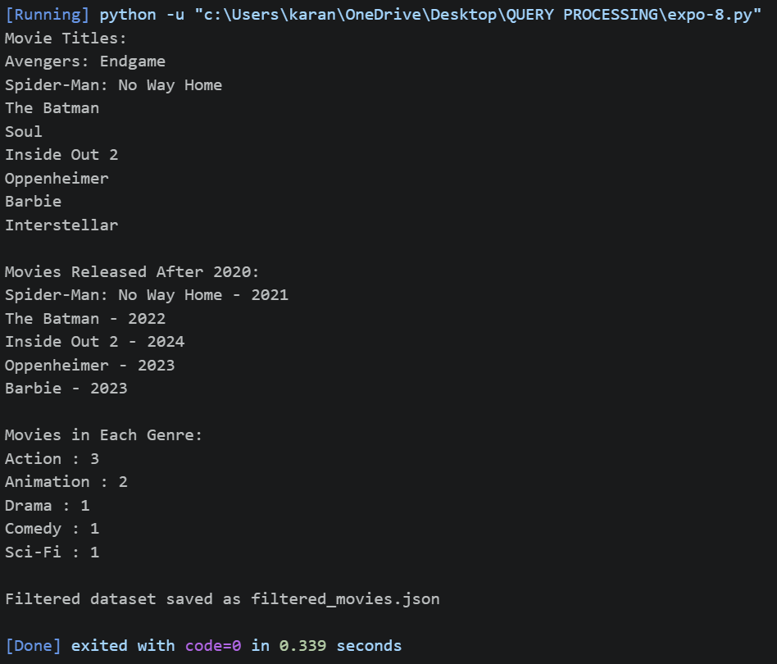
14. Online Shopping Orders
Order information is stored in orders.csv.
Task:
- Find duplicate order IDs.
- Remove duplicate orders.
- Calculate total order amount.
- Identify the customer with the highest purchase value.
Code:
import pandas as pd
# Read CSV file
df = pd.read_csv("orders.csv")
# Find duplicate Order IDs
duplicates = df[df.duplicated(subset="OrderID", keep=False)]
print("Duplicate Orders:")
print(duplicates)
# Remove duplicate orders
df_clean = df.drop_duplicates(subset="OrderID")
print("\nAfter Removing Duplicates:")
print(df_clean)
# Calculate Total Order Amount
df_clean["TotalAmount"] = df_clean["Quantity"] * df_clean["Price"]
print("\nOrders with Total Amount:")
print(df_clean)
print("\nTotal Sales =", df_clean["TotalAmount"].sum())
# Customer with highest purchase value
customer_total = df_clean.groupby("Customer")["TotalAmount"].sum()
highest_customer = customer_total.idxmax()
highest_amount = customer_total.max()
print("\nCustomer with Highest Purchase Value:")
print(highest_customer, "-", highest_amount)
# Save cleaned dataset
df_clean.to_csv("clean_orders.csv", index=False)
print("\nCleaned dataset saved as clean_orders.csv")
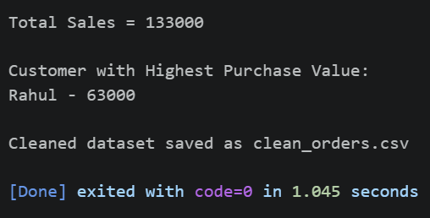
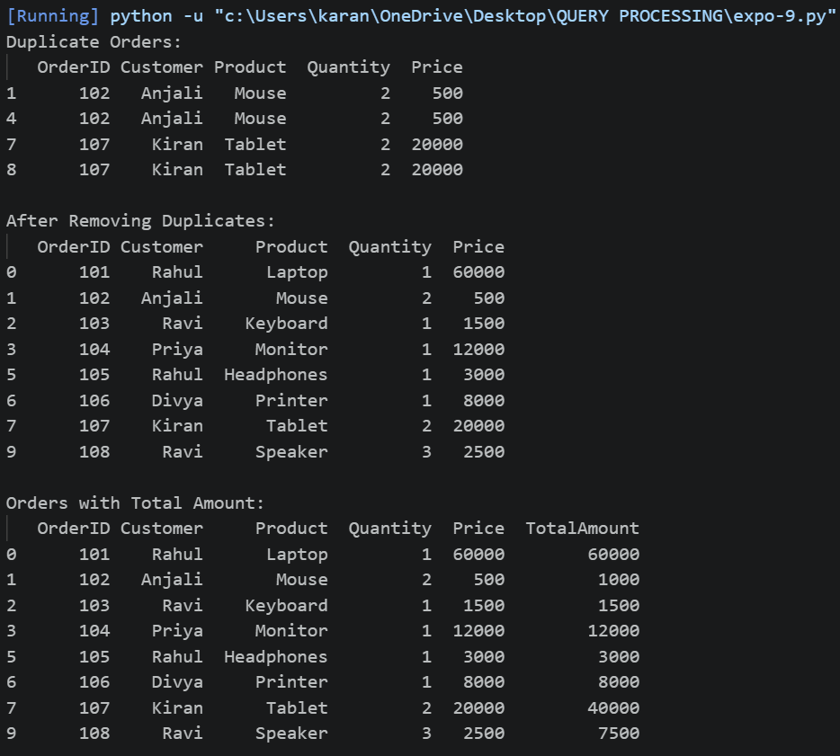
Output:

