SIMATS ENGINEERING
SAVEETHA INSTITUTE OF MEDICAL AND TECHNICAL SCIENCES
CHENNAI – 602105
Department of Computer Science and Engineering

ASSESSMENT TOOL 2 – SCHEMA ANALYSIS AND VIVA VOCE
Course Code: | DSA05 | Course Title: | Query Processing for Data Science With Real Time Applications
CO Assessed: | CO2 | Assessment: | Tool 2 – Schema Analysis and Viva Voce
Weightage: |  | Total Marks: | 35 Marks
CO2 Statement: Use Python basics and SQL libraries to connect to databases SQLite, MySQL, PostgreSQL and perform CRUD operations like Create, Read, Update, Delete. (BL6)
Student Name: | K V Sai Shanmukh | Reg. No.: | 192424306
Section / Batch: | BTECH AI & DS | Date of Submission:
Faculty In-charge: | Dr. B. Shyamala Gowri | Project Mode: | Individual Submission

Code of Conduct
I ____K .V .Sai. Shanmukh (192424306)___ (Name / Reg No) certify that this submission is my original work and that I have adhered to all guidelines specified for this assessment. I understand that any violation of academic integrity rules will result in disciplinary action.
Signature: ________K. V. Sai. Shanmukh________
Identification of Entities and Attributes (5 Marks) | Understanding of Relationships (5 Marks) | Analysis of Keys and Constraints (5 Marks) | Detection of Design Issues (10 Marks) | Viva Voce (5 Marks) | Total (35 Marks)

2. Hospital Management System
A hospital database contains:
- Patient(PatientID, Name, Age)
- Doctor(DoctorID, DoctorName, Specialization)
- Appointment(AppointmentID, PatientID, DoctorID, Date)
- Prescription(PrescriptionID, AppointmentID, Medicine)
Multiple patients can consult the same doctor.
Code:
import mysql.connector
from mysql.connector import Error
try:
# Connect to MySQL
conn = mysql.connector.connect(
host="127.0.0.1",
user="root",
password="",
database="hospitals_db",
port=3306
)
if conn.is_connected():
print("Connected to MySQL Successfully")
cursor = conn.cursor()
# Drop tables (Child tables first)
cursor.execute("DROP TABLE IF EXISTS Payment")
cursor.execute("DROP TABLE IF EXISTS Treatment")
cursor.execute("DROP TABLE IF EXISTS Appointment")
cursor.execute("DROP TABLE IF EXISTS Doctor")
cursor.execute("DROP TABLE IF EXISTS Patient")
# Create Patient Table
cursor.execute("""
CREATE TABLE Patient(
PatientID INT PRIMARY KEY,
PatientName VARCHAR(50),
Age INT,
Gender VARCHAR(10),
Disease VARCHAR(50)
)
""")
# Create Doctor Table
cursor.execute("""
CREATE TABLE Doctor(
DoctorID INT PRIMARY KEY,
DoctorName VARCHAR(50),
Specialization VARCHAR(50)
)
""")
# Create Appointment Table
cursor.execute("""
CREATE TABLE Appointment(
AppointmentID INT PRIMARY KEY,
PatientID INT,
DoctorID INT,
AppointmentDate DATE,
FOREIGN KEY (PatientID)
REFERENCES Patient(PatientID)
ON DELETE CASCADE,
FOREIGN KEY (DoctorID)
REFERENCES Doctor(DoctorID)
ON DELETE CASCADE
)
""")
# Create Treatment Table
cursor.execute("""
CREATE TABLE Treatment(
TreatmentID INT PRIMARY KEY,
PatientID INT,
Prescription VARCHAR(100),
LabTest VARCHAR(100),
FOREIGN KEY (PatientID)
REFERENCES Patient(PatientID)
ON DELETE CASCADE
)
""")
# Create Payment Table
cursor.execute("""
CREATE TABLE Payment(
PaymentID INT PRIMARY KEY,
PatientID INT,
Amount DECIMAL(10,2),
PaymentStatus VARCHAR(20),
FOREIGN KEY (PatientID)
REFERENCES Patient(PatientID)
ON DELETE CASCADE
)
""")
conn.commit()
# Insert Patient Records
cursor.execute("INSERT INTO Patient VALUES (101,'Ramesh',45,'Male','Fever')")
cursor.execute("INSERT INTO Patient VALUES (102,'Priya',30,'Female','Diabetes')")
# Insert Doctor Records
cursor.execute("INSERT INTO Doctor VALUES (201,'Dr.Kumar','General')")
cursor.execute("INSERT INTO Doctor VALUES (202,'Dr.Anita','Diabetologist')")
# Insert Appointment Records
cursor.execute("INSERT INTO Appointment VALUES (1,101,201,'2026-07-14')")
cursor.execute("INSERT INTO Appointment VALUES (2,102,202,'2026-07-15')")
# Insert Treatment Records
cursor.execute("INSERT INTO Treatment VALUES (1,101,'Paracetamol','Blood Test')")
cursor.execute("INSERT INTO Treatment VALUES (2,102,'Insulin','Sugar Test')")
# Insert Payment Records
cursor.execute("INSERT INTO Payment VALUES (1,101,500.00,'Paid')")
cursor.execute("INSERT INTO Payment VALUES (2,102,1200.00,'Pending')")
conn.commit()
print("\nPatient Records")
cursor.execute("SELECT * FROM Patient")
for row in cursor.fetchall():
print(row)
# Update Record
cursor.execute("""
UPDATE Patient
SET Disease='Viral Fever'
WHERE PatientID=101
""")
conn.commit()
print("\nAfter Update")
cursor.execute("SELECT * FROM Patient")
for row in cursor.fetchall():
print(row)
# Search Record
print("\nSearch Result")
cursor.execute("""
SELECT * FROM Patient
WHERE Disease='Viral Fever'
""")
for row in cursor.fetchall():
print(row)
# Delete Record
cursor.execute("DELETE FROM Patient WHERE PatientID=102")
conn.commit()
print("\nAfter Delete")
cursor.execute("SELECT * FROM Patient")
for row in cursor.fetchall():
print(row)
except Error as e:
print("Error:", e)
finally:
if 'conn' in locals() and conn.is_connected():
cursor.close()
conn.close()
print("\nMySQL Connection Closed")
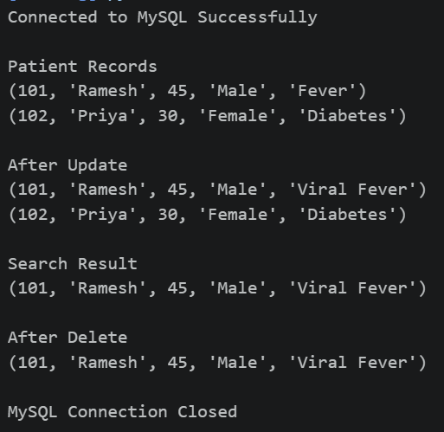
Output:
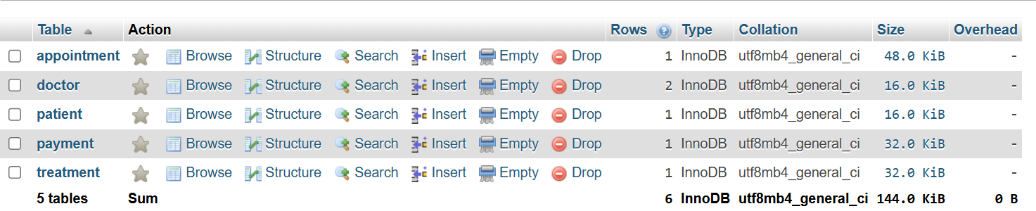
Viva Questions
Q1. What problems might occur if prescription details are stored directly in the Appointment table?
A. Storing prescription details in the Appointment table causes data redundancy and update, insertion, and deletion anomalies. It also makes it difficult to store multiple medicines for a single appointment.
Q2. How would the schema change if a prescription contains multiple medicines?
A. Create a separate table, such as Prescription Medicine (Prescription ID, Medicine), linked to the Prescription table. This allows one prescription to store multiple medicines and keeps the database normalized.

9. Learning Management System (LMS)
Tables:
- Student(StudentID, Name)
- Course(CourseID, CourseName)
- Enrollment(StudentID, CourseID)
- Assignment(AssignmentID, CourseID)
Students can enroll in many courses.
Code:
import sqlite3
# Connect to SQLite Database
conn = sqlite3.connect("lms.db")
cursor = conn.cursor()
print("Connected to SQLite Successfully")
# Drop Tables
cursor.execute("DROP TABLE IF EXISTS Assignment")
cursor.execute("DROP TABLE IF EXISTS Enrollment")
cursor.execute("DROP TABLE IF EXISTS Course")
cursor.execute("DROP TABLE IF EXISTS Student")
# Student Table
cursor.execute("""
CREATE TABLE Student(
StudentID INTEGER PRIMARY KEY,
Name TEXT
)
""")
# Course Table
cursor.execute("""
CREATE TABLE Course(
CourseID INTEGER PRIMARY KEY,
CourseName TEXT
)
""")
# Enrollment Table
cursor.execute("""
CREATE TABLE Enrollment(
StudentID INTEGER,
CourseID INTEGER,
PRIMARY KEY(StudentID, CourseID),
FOREIGN KEY(StudentID) REFERENCES Student(StudentID),
FOREIGN KEY(CourseID) REFERENCES Course(CourseID)
)
""")
# Assignment Table
cursor.execute("""
CREATE TABLE Assignment(
AssignmentID INTEGER PRIMARY KEY,
CourseID INTEGER,
FOREIGN KEY(CourseID) REFERENCES Course(CourseID)
)
""")
# Insert Student
cursor.execute("""
INSERT INTO Student
VALUES(101,'Rahul')
""")
cursor.execute("""
INSERT INTO Student
VALUES(102,'Priya')
""")
# Insert Course
cursor.execute("""
INSERT INTO Course
VALUES(201,'Python')
""")
cursor.execute("""
INSERT INTO Course
VALUES(202,'Database Management')
""")
# Insert Enrollment
cursor.execute("""
INSERT INTO Enrollment
VALUES(101,201)
""")
cursor.execute("""
INSERT INTO Enrollment
VALUES(102,202)
""")
# Insert Assignment
cursor.execute("""
INSERT INTO Assignment
VALUES(301,201)
""")
cursor.execute("""
INSERT INTO Assignment
VALUES(302,202)
""")
conn.commit()
# Display Student Records
print("\nStudent Records")
cursor.execute("SELECT * FROM Student")
for row in cursor.fetchall():
print(row)
# Update
cursor.execute("""
UPDATE Course
SET CourseName='Advanced Python'
WHERE CourseID=201
""")
conn.commit()
print("\nAfter Course Update")
cursor.execute("SELECT * FROM Course")
for row in cursor.fetchall():
print(row)
# Search
print("\nEnrollment Details")
cursor.execute("""
SELECT * FROM Enrollment
WHERE StudentID=101
""")
for row in cursor.fetchall():
print(row)
# Delete
cursor.execute("""
DELETE FROM Student
WHERE StudentID=102
""")
conn.commit()
print("\nAfter Delete")
cursor.execute("SELECT * FROM Student")
for row in cursor.fetchall():
print(row)
# Close Connection
cursor.close()
conn.close()
print("\nSQLite Connection Closed")
Output:
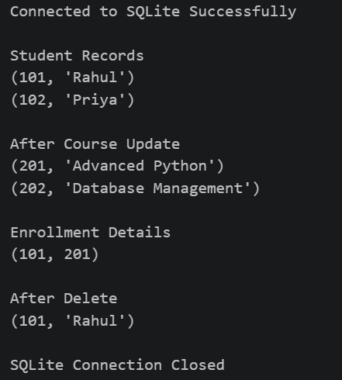
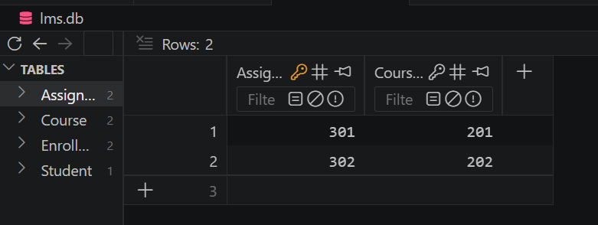

Viva Questions
Q1. Why is Enrollment considered a bridge table?
A. The Enrollment table is called a bridge table because it connects the Student and Course tables. It handles the many-to-many relationship, allowing one student to enroll in multiple courses and one course to have many students.
Q2. How would you modify the schema to record assignment grades?
A. Create a new table, Assignment Grade (Student ID, Assignment ID, Grade), to store the grade of each student for each assignment. This avoids redundancy and allows every student's assignment marks to be recorded separately.

