SIMATS ENGINEERING
SAVEETHA INSTITUTE OF MEDICAL AND TECHNICAL SCIENCES
CHENNAI – 602105
Department of Computer Science and Engineering

ASSESSMENT TOOL 1 – CASE STUDY

Course Code: | DSA0502 | Course Title: | Query Processing for Data Science
CO Assessed: | CO4 | Assessment: | Tool 1– CASE STUDY
Weightage: |  | Total Marks:
CO4 Statement: Explore datasets using analytical techniques such as grouping, correlation detection, joining datasets, and extracting meaningful insights.
Student Name: | K. V. Sai. Shanmukh | Reg. No.: | 192424306
Section / Batch: | BTECH-AI&DS | Date of  Submission:
Faculty In-charge: | Dr. B. Shyamala Gowri | Project Mode: | Individual Submission

Code of Conduct

I K. V. Sai. Shanmukh (192424306) (Name / Reg No) certify that this submission is my original work and that I have adhered to all guidelines specified for this assessment. I understand that any violation of academic integrity rules will result in disciplinary action.

Signature: K. V, Sai. Shanmukh

Question 2 – Student Academic Performance Analysis
A college has Student, Attendance, Internal Marks, Assignment, and Examination datasets. Integrate the datasets and analyze student performance based on department, semester, attendance, and marks. Identify correlations and outliers and visualize performance trends. Provide 5 key findings and recommendations.
Code:
import pandas as pd
import numpy as np
import matplotlib.pyplot as plt
import seaborn as sns
# 1. CREATE STUDENT DATASET
student = pd.DataFrame({
"Student_ID": [101, 102, 103, 104, 105, 106, 107, 108],
"Name": [
"Rahul", "Priya", "Arun", "Sneha",
"Kiran", "Anjali", "Vijay", "Meena"
],
"Department": [
"CSE", "CSE", "ECE", "ECE",
"CSE", "IT", "IT", "CSE"
],
"Semester": [4, 4, 4, 4, 4, 4, 4, 4]
})
# 2. CREATE ATTENDANCE DATASET
attendance = pd.DataFrame({
"Student_ID": [101, 102, 103, 104, 105, 106, 107, 108],
"Attendance": [92, 85, 78, 95, 60, 88, 72, 90]
})
# 3. CREATE INTERNAL MARKS DATASET
internal = pd.DataFrame({
"Student_ID": [101, 102, 103, 104, 105, 106, 107, 108],
"Internal_Marks": [42, 38, 35, 45, 25, 40, 30, 43]
})
# 4. CREATE ASSIGNMENT DATASET
assignment = pd.DataFrame({
"Student_ID": [101, 102, 103, 104, 105, 106, 107, 108],
"Assignment_Marks": [18, 17, 15, 19, 10, 18, 12, 20]
})
# 5. CREATE EXAMINATION DATASET
examination = pd.DataFrame({
"Student_ID": [101, 102, 103, 104, 105, 106, 107, 108],
"Exam_Marks": [85, 78, 70, 92, 45, 82, 55, 88]
})
# 6. INTEGRATE ALL DATASETS
data = pd.merge(
student,
attendance,
on="Student_ID",
how="inner"
)
data = pd.merge(
data,
internal,
on="Student_ID",
how="inner"
)
data = pd.merge(
data,
assignment,
on="Student_ID",
how="inner"
)
data = pd.merge(
data,
examination,
on="Student_ID",
how="inner"
)
# 7. DISPLAY INTEGRATED DATA
print("INTEGRATED STUDENT DATA")
print(data)
# 8. CALCULATE TOTAL AND AVERAGE MARKS
data["Total_Marks"] = (
data["Internal_Marks"] +
data["Assignment_Marks"] +
data["Exam_Marks"]
)
data["Average_Marks"] = (
data["Total_Marks"] / 3
)
# 9. PERFORMANCE CATEGORY
def performance_category(mark):
if mark >= 80:
return "Excellent"
elif mark >= 60:
return "Good"
elif mark >= 50:
return "Average"
else:
return "Poor"
data["Performance"] = (
data["Average_Marks"]
.apply(performance_category)
)
# 10. ANALYSIS BY DEPARTMENT
department_analysis = data.groupby(
"Department"
)["Average_Marks"].mean()
print("AVERAGE MARKS BY DEPARTMENT")
print(department_analysis)
# 11. ANALYSIS BY SEMESTER
semester_analysis = data.groupby(
"Semester"
)["Average_Marks"].mean()
print("AVERAGE MARKS BY SEMESTER")
print(semester_analysis)
# 12. ATTENDANCE ANALYSIS
attendance_analysis = data.groupby(
"Department"
)["Attendance"].mean()
print("AVERAGE ATTENDANCE BY DEPARTMENT")
print(attendance_analysis)
# 13. CORRELATION ANALYSIS
correlation = data[
[
"Attendance",
"Internal_Marks",
"Assignment_Marks",
"Exam_Marks",
"Average_Marks"
]
].corr()
print("CORRELATION MATRIX")
print(correlation)
#14. OUTLIER DETECTION USING IQR
Q1 = data["Average_Marks"].quantile(0.25)
Q3 = data["Average_Marks"].quantile(0.75)
IQR = Q3 - Q1
lower_limit = Q1 - 1.5 * IQR
upper_limit = Q3 + 1.5 * IQR
outliers = data[
(data["Average_Marks"] < lower_limit) |
(data["Average_Marks"] > upper_limit)
]
print("OUTLIERS")
print(outliers[
["Student_ID", "Name", "Average_Marks"]
])
# 15. TOP PERFORMING STUDENTS
top_students = data.sort_values(
"Average_Marks",
ascending=False
).head(3)
print("TOP 3 STUDENTS")
print(
top_students[
["Student_ID", "Name", "Average_Marks"]
]
)
# 16. LOW PERFORMING STUDENTS
low_students = data[
data["Average_Marks"] < 50
]
print("LOW PERFORMING STUDENTS")
print(
low_students[
["Student_ID", "Name", "Attendance", "Average_Marks"]
]
)
# 17. VISUALIZATION 1
# DEPARTMENT-WISE PERFORMANCE
plt.figure(figsize=(8, 5))
sns.barplot(
x=department_analysis.index,
y=department_analysis.values
)
plt.title("Average Student Performance by Department")
plt.xlabel("Department")
plt.ylabel("Average Marks")
plt.show()
# 18. VISUALIZATION 2
# ATTENDANCE VS AVERAGE MARKS
plt.figure(figsize=(8, 5))
sns.scatterplot(
data=data,
x="Attendance",
y="Average_Marks",
hue="Department",
s=100
)
plt.title("Attendance vs Average Marks")
plt.xlabel("Attendance (%)")
plt.ylabel("Average Marks")
plt.show()
# 19. VISUALIZATION 3
# PERFORMANCE DISTRIBUTION
plt.figure(figsize=(8, 5))
sns.histplot(
data["Average_Marks"],
bins=5,
kde=True
)
plt.title("Distribution of Student Performance")
plt.xlabel("Average Marks")
plt.ylabel("Number of Students")
plt.show()
# 20. VISUALIZATION 4
# CORRELATION HEATMAP
plt.figure(figsize=(8, 6))
sns.heatmap(
correlation,
annot=True,
cmap="coolwarm",
fmt=".2f"
)
plt.title("Correlation Between Academic Factors")
plt.show()
# 21. VISUALIZATION 5
# STUDENT PERFORMANCE
plt.figure(figsize=(10, 5))
plt.bar(
data["Name"],
data["Average_Marks"]
)
plt.axhline(
y=50,
linestyle="--",
label="Pass Mark"
)
plt.title("Student Average Performance")
plt.xlabel("Student")
plt.ylabel("Average Marks")
plt.legend()
plt.show()
# 22. SAVE INTEGRATED DATASET
data.to_csv(
"student_academic_performance.csv",
index=False
)
print("DATASET SAVED SUCCESSFULLY")
print("student_academic_performance.csv")
# 23. FIVE KEY FINDINGS
print("5 KEY FINDINGS")
best_department = department_analysis.idxmax()
best_department_score = department_analysis.max()
attendance_corr = correlation.loc[
"Attendance",
"Average_Marks"
]
highest_student = data.loc[
data["Average_Marks"].idxmax(),
"Name"
]
lowest_student = data.loc[
data["Average_Marks"].idxmin(),
"Name"
]
print(
"1. The department with the highest average performance is",
best_department,
"with",
round(best_department_score, 2),
"marks."
)
print(
"2. The correlation between attendance and average marks is",
round(attendance_corr, 2)
)
print(
"3. The highest performing student is",
highest_student
)
print(
"4. The lowest performing student is",
lowest_student
)
print(
"5. Students with higher attendance generally show better academic performance."
)
# 24. RECOMMENDATIONS
print("5 RECOMMENDATIONS")
print(
"1. Students with low attendance should receive attendance monitoring."
)
print(
"2. Low-performing students should receive additional academic support."
)
print(
"3. Faculty should provide extra assignments and practice tests."
)
print(
"4. Departments with lower average performance should conduct remedial classes."
)
print(
"5. Student performance should be monitored continuously using academic dashboards."
)
Output:
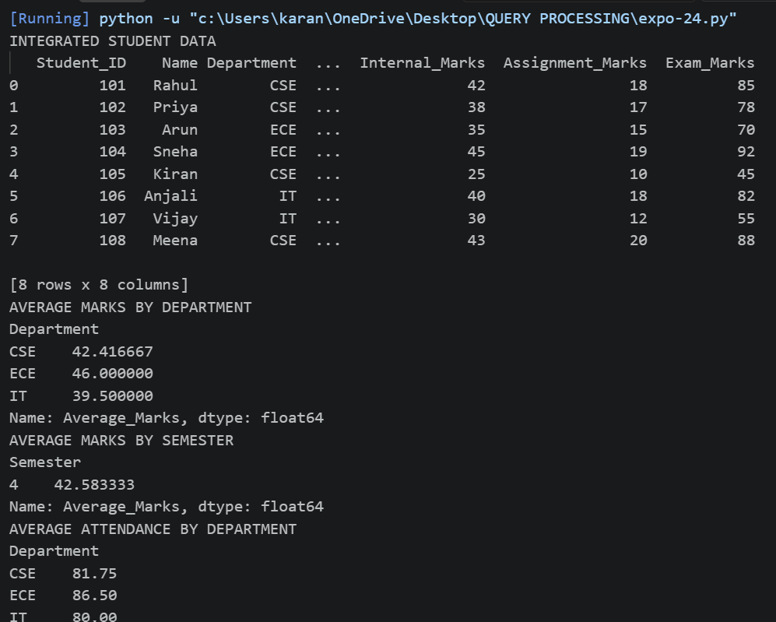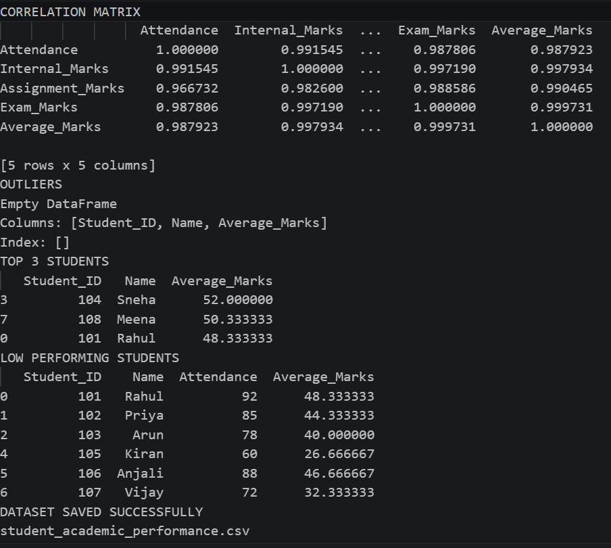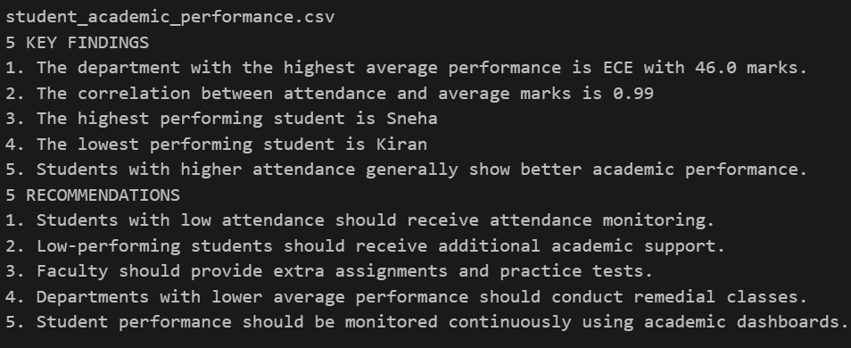
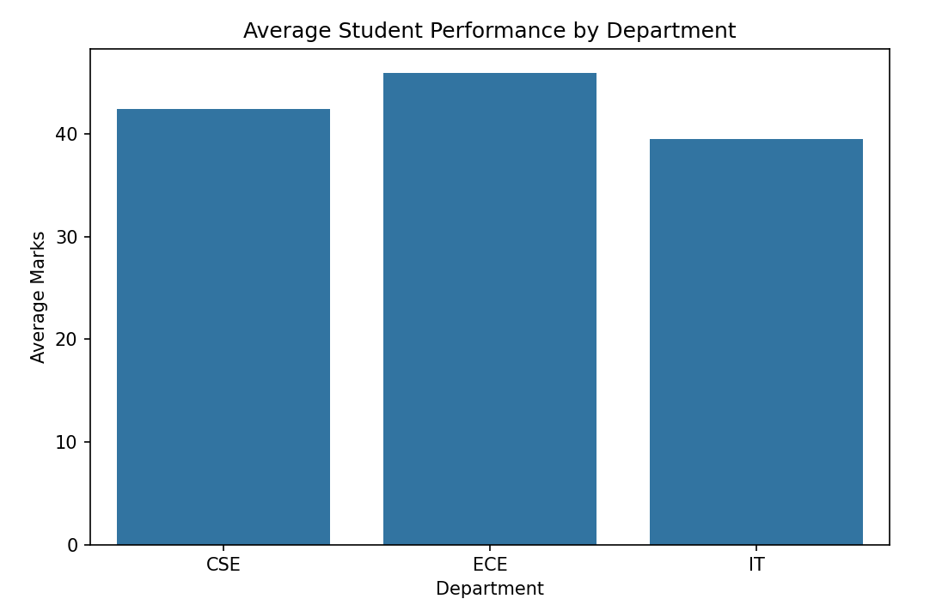
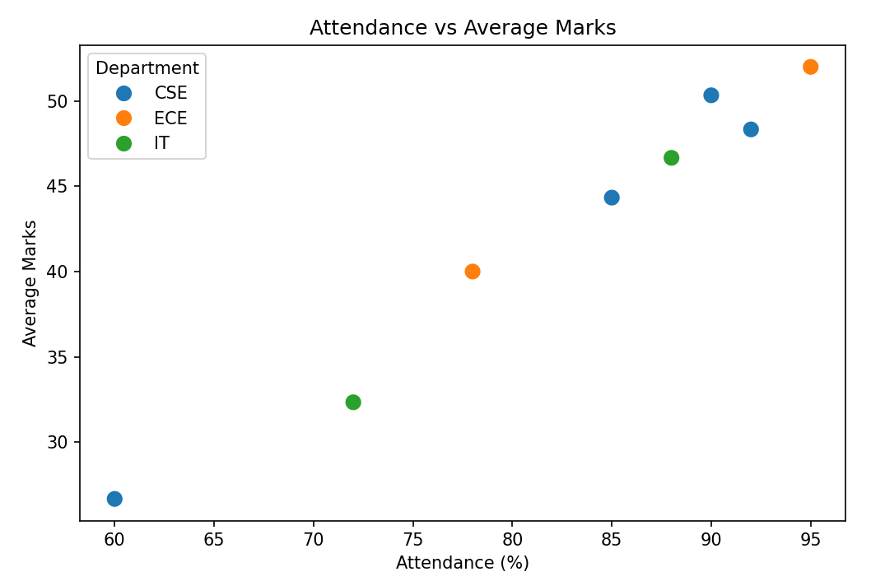
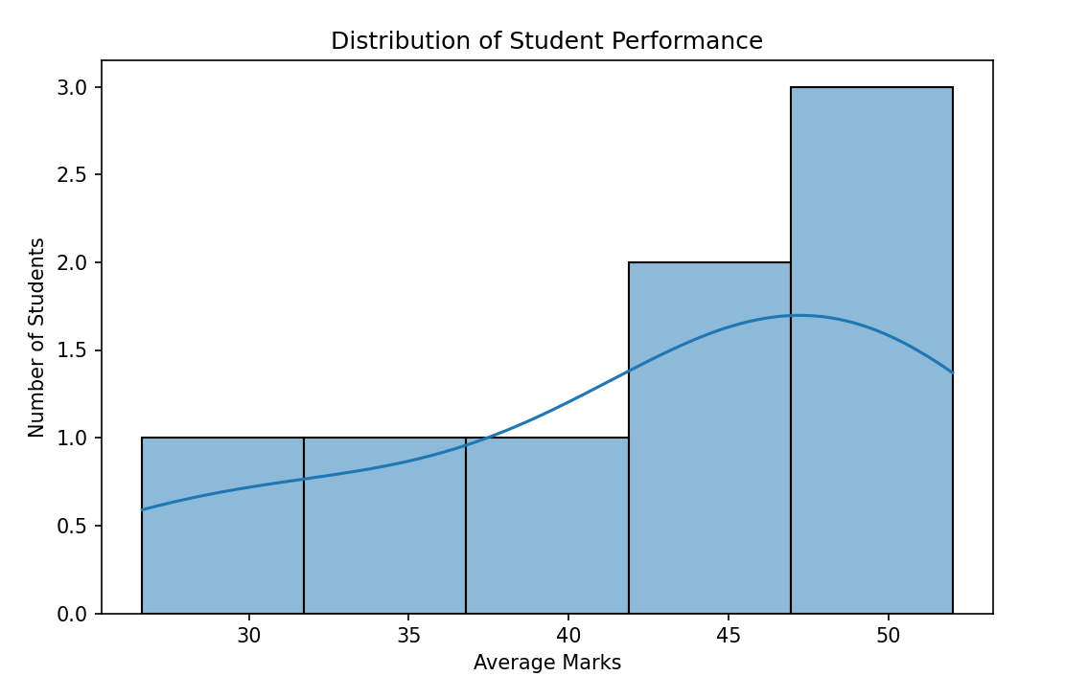
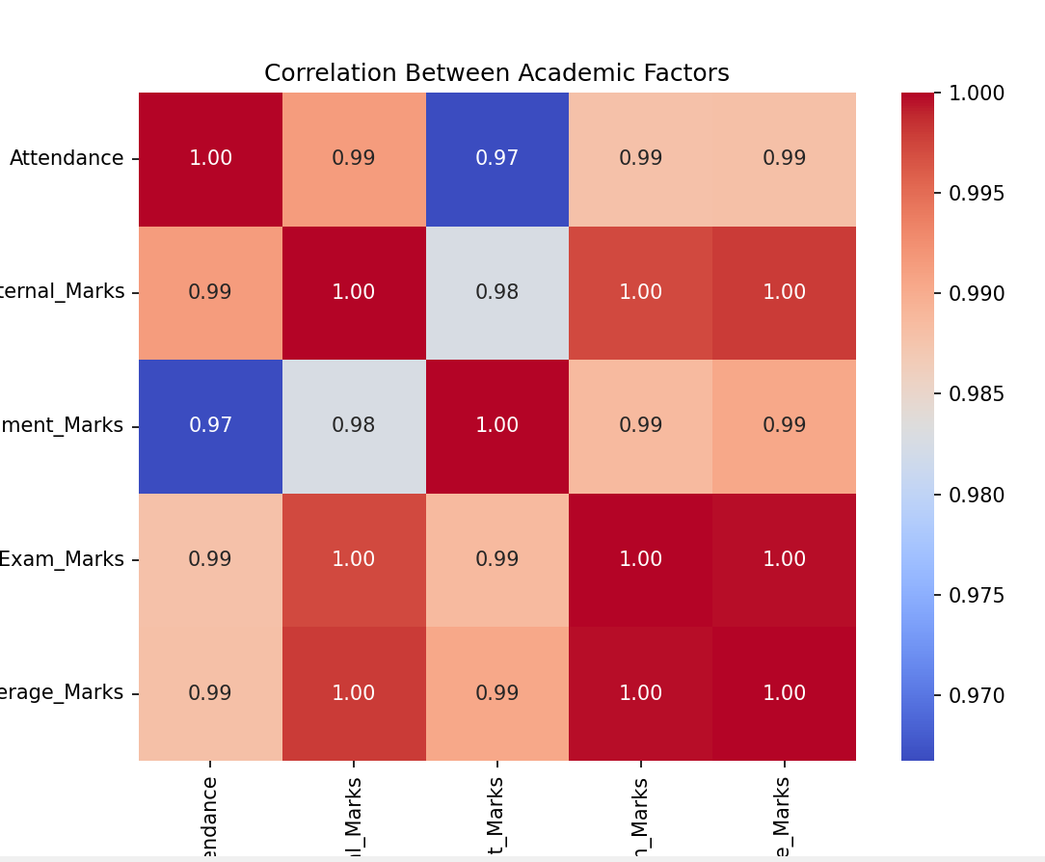
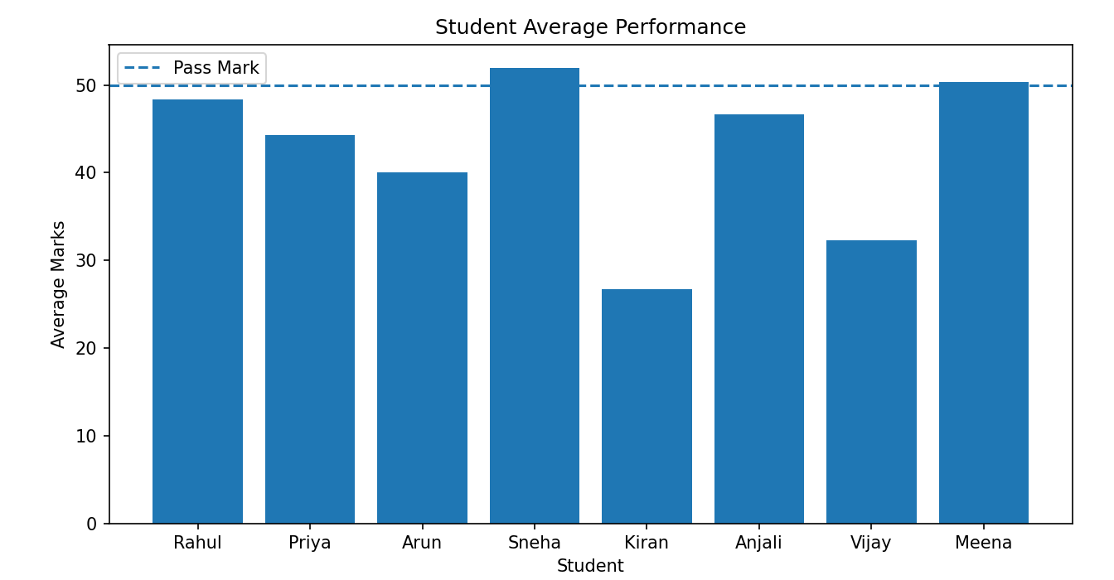

Question 8 – Movie Data Analysis
A movie platform provides Movie, Genre, Actor, Rating, Revenue, and Release Date datasets. Join and analyze the datasets to identify popular genres, highest-rated movies, revenue patterns, rating-revenue correlations, and outliers. Create suitable visualizations and provide recommendations.

Code:
import pandas as pd
import numpy as np
import matplotlib.pyplot as plt
import seaborn as sns
# 1. MOVIE DATASET
movie = pd.DataFrame({
"Movie_ID": [101, 102, 103, 104, 105, 106, 107, 108],
"Movie_Name": [
"Avengers", "Inception", "Titanic", "Joker",
"Interstellar", "Avatar", "Frozen", "Parasite"
]
})
# 2. GENRE DATASET
genre = pd.DataFrame({
"Movie_ID": [101, 102, 103, 104, 105, 106, 107, 108],
"Genre": [
"Action", "Sci-Fi", "Romance", "Crime",
"Sci-Fi", "Action", "Animation", "Thriller"
]
})
# 3. ACTOR DATASET
actor = pd.DataFrame({
"Movie_ID": [101, 102, 103, 104, 105, 106, 107, 108],

"Actor": [
"Robert Downey Jr.", "Leonardo DiCaprio",
"Leonardo DiCaprio", "Joaquin Phoenix",
"Matthew McConaughey", "Sam Worthington",
"Kristen Bell", "Song Kang-ho"
]
})
# 4. RATING DATASET
rating = pd.DataFrame({
"Movie_ID": [101, 102, 103, 104, 105, 106, 107, 108],
"Rating": [8.4, 8.8, 7.9, 8.5, 8.6, 8.1, 7.4, 8.6]
})
# 5. REVENUE DATASET
revenue = pd.DataFrame({
"Movie_ID": [101, 102, 103, 104, 105, 106, 107, 108],
"Revenue_Million": [
1500, 850, 2200, 1000,
700, 2900, 1400, 250
]
})
# 6. RELEASE DATE DATASET
release_date = pd.DataFrame({
"Movie_ID": [101, 102, 103, 104, 105, 106, 107, 108],
"Release_Date": [
"2019-04-26",
"2010/07/16",
"1997-11-19",
"2019/10/04",
"2014-11-07",
"2009-12-18",
"2013-11-27",
"2019-05-30"
]
})
# 7. INTEGRATE ALL DATASETS
data = pd.merge(
movie,
genre,
on="Movie_ID",
how="inner"
)
data = pd.merge(
data,
actor,

on="Movie_ID",
how="inner"
)
data = pd.merge(
data,
rating,
on="Movie_ID",
how="inner"
)
data = pd.merge(
data,
revenue,
on="Movie_ID",
how="inner"
)
data = pd.merge(
data,
release_date,
on="Movie_ID",
how="inner"
)
print("INTEGRATED MOVIE DATASET")
print(data)
# 9. DATA CLEANING
# Remove duplicate records
data = data.drop_duplicates(
subset=["Movie_ID"]
)
# Remove extra spaces from movie names
data["Movie_Name"] = (
data["Movie_Name"]
.str.strip()
)
# Standardize genre
data["Genre"] = (
data["Genre"]
.str.strip()
.str.title()
)
# Standardize actor names
data["Actor"] = (
data["Actor"]
.str.strip()
)

data["Release_Date"] = pd.to_datetime(
data["Release_Date"],
errors="coerce"
)
# Extract release year
data["Release_Year"] = (
data["Release_Date"]
.dt.year
)
# 11. HANDLE MISSING VALUES
data["Rating"] = (
data["Rating"]
.fillna(data["Rating"].mean())
)
data["Revenue_Million"] = (
data["Revenue_Million"]
.fillna(data["Revenue_Million"].median())
)
data["Genre"] = (
data["Genre"]
.fillna("Unknown")
)
# 12. POPULAR GENRES
genre_count = (
data["Genre"]
.value_counts()
)
print("POPULAR GENRES")
print(genre_count)
# 13. HIGHEST RATED MOVIES
highest_rated = data.sort_values(
"Rating",
ascending=False
)
print("HIGHEST RATED MOVIES")
print(
highest_rated[
["Movie_Name", "Genre", "Rating"]
].head(5)
)
# 14. HIGHEST REVENUE MOVIES
highest_revenue = data.sort_values(
"Revenue_Million",
ascending=False

)
print("HIGHEST REVENUE MOVIES")
print(
highest_revenue[
["Movie_Name", "Revenue_Million"]
].head(5)
)
# 15. GENRE-WISE REVENUE
genre_revenue = (
data.groupby("Genre")["Revenue_Million"]
.sum()
.sort_values(ascending=False)
)
print("REVENUE BY GENRE")
print(genre_revenue)
# 16. GENRE-WISE AVERAGE RATING
genre_rating = (
data.groupby("Genre")["Rating"]
.mean()
.sort_values(ascending=False)
)
print("AVERAGE RATING BY GENRE")
print(genre_rating)
# 17. RATING-REVENUE CORRELATION
correlation = data[
["Rating", "Revenue_Million"]
].corr()
print("RATING - REVENUE CORRELATION")
print(correlation)
rating_revenue_corr = correlation.loc[
"Rating",
"Revenue_Million"
]
print(
"\nCorrelation value:",
round(rating_revenue_corr, 2)
)
# 18. REVENUE OUTLIER DETECTION USING IQR
Q1 = data["Revenue_Million"].quantile(0.25)
Q3 = data["Revenue_Million"].quantile(0.75)
IQR = Q3 - Q1
lower_limit = Q1 - 1.5 * IQR
upper_limit = Q3 + 1.5 * IQR
outliers = data[

(data["Revenue_Million"] < lower_limit) |
(data["Revenue_Million"] > upper_limit)
]
print("REVENUE OUTLIERS")
print(
outliers[
["Movie_Name", "Revenue_Million"]
]
)
# 19. SAVE INTEGRATED DATASET
data.to_csv(
"integrated_movie_dataset.csv",
index=False
)
print("DATASET SAVED")
print("integrated_movie_dataset.csv")
# 20. VISUALIZATION 1
# POPULAR GENRES
plt.figure(figsize=(8, 5))
sns.barplot(
x=genre_count.index,
y=genre_count.values
)
plt.title("Number of Movies by Genre")
plt.xlabel("Genre")
plt.ylabel("Number of Movies")
plt.xticks(rotation=45)
plt.show()
# 21. VISUALIZATION 2
# HIGHEST RATED MOVIES
top_movies = data.sort_values(
"Rating",
ascending=False
).head(5)
plt.figure(figsize=(9, 5))
sns.barplot(
data=top_movies,
x="Movie_Name",
y="Rating"
)
plt.title("Top Rated Movies")
plt.xlabel("Movie")
plt.ylabel("Rating")
plt.xticks(rotation=45)

plt.show()
# 22. VISUALIZATION 3
# REVENUE BY GENRE
plt.figure(figsize=(8, 5))
sns.barplot(
x=genre_revenue.index,
y=genre_revenue.values
)
plt.title("Total Revenue by Genre")
plt.xlabel("Genre")
plt.ylabel("Revenue (Million)")
plt.xticks(rotation=45)
plt.show()
# 23. VISUALIZATION 4
# RATING VS REVENUE
plt.figure(figsize=(8, 5))
sns.scatterplot(
data=data,
x="Rating",
y="Revenue_Million",
s=100
)
plt.title("Rating vs Revenue")
plt.xlabel("Rating")
plt.ylabel("Revenue (Million)")
plt.show()
# 24. VISUALIZATION 5
# REVENUE OUTLIERS
plt.figure(figsize=(8, 5))
sns.boxplot(
y=data["Revenue_Million"]
)
plt.title("Revenue Outlier Detection")
plt.ylabel("Revenue (Million)")
plt.show()
# 25. FIVE KEY FINDINGS
print("5 KEY FINDINGS")
popular_genre = genre_count.idxmax()
highest_rated_movie = data.loc[
data["Rating"].idxmax(),
"Movie_Name"
]
highest_revenue_movie = data.loc[
data["Revenue_Million"].idxmax(),

"Movie_Name"
]
best_revenue_genre = genre_revenue.idxmax()
print(
"1. The most represented genre is:",
popular_genre
)
print(
"2. The highest-rated movie is:",
highest_rated_movie
)
print(
"3. The highest-revenue movie is:",
highest_revenue_movie
)
print(
"4. The genre generating the highest total revenue is:",
best_revenue_genre
)
print(
"5. The correlation between rating and revenue is:",
round(rating_revenue_corr, 2)
)
# 26. RECOMMENDATIONS
print("RECOMMENDATIONS")
print(
"1. Invest more in genres that consistently generate high revenue."
)
print(
"2. Promote highly-rated movies through the platform's recommendation system."
)
print(
"3. Use ratings and viewer feedback to improve movie recommendations."
)
print(
"4. Investigate revenue outliers to understand why certain movies perform exceptionally well."
)
print(
"5. Analyze rating-revenue trends regularly to support movie acquisition and marketing decisions."
)

Output:
