SIMATS ENGINEERING
SAVEETHA INSTITUTE OF MEDICAL AND TECHNICAL SCIENCES
CHENNAI – 602105
Department of Computer Science and Engineering

ASSESSMENT TOOL 2 – Open Data Analysis

Course Code: | DSA0502 | Course Title: | Query Processing for Data Science
CO Assessed: | CO4 | Assessment: | Tool 2– Open Data Analysis
Weightage: |  | Total Marks:
CO4 Statement: Explore datasets using analytical techniques such as grouping, correlation detection, joining datasets, and extracting meaningful insights.
Student Name: | K V Sai Shanmukh | Reg. No.: | 192424306
Section / Batch: | BTECH- AI & DS | Date of Submission: | 13/08/2026
Faculty In-charge: | Dr. B. Shyamala Gowri | Project Mode: | Individual Submission

Code of Conduct
I __K V Sai Shanmukh (192424306)__ (Name / Reg No) certify that this submission is my original work and that I have adhered to all guidelines specified for this assessment. I understand that any violation of academic integrity rules will result in disciplinary action.
Signature: _____K V Sai Shanmukh ______

4. Select any open transportation dataset containing traffic, public transport, vehicle, road accident, or passenger information. Analyze the data by location and time, identify patterns and outliers, create charts/maps, and develop an interactive presentation of the findings.
Code:
import pandas as pd
import numpy as np
import matplotlib.pyplot as plt
import seaborn as sns
import plotly.express as px
# 1. LOAD DATASET
data = pd.read_csv(
"hong_kong_transport_master_dataset.csv"
)
print("DATASET")
print(data.head())
# 2. CHECK DATASET INFORMATION
print("DATASET INFORMATION")
print(data.info())
print("\nMissing Values:")
print(data.isnull().sum())
# 3. DATA CLEANING
# Remove duplicate rows
data = data.drop_duplicates()
# Remove rows where important values are missing
data = data.dropna(
subset=["Year", "Category", "Metric", "Value"]
)
# Convert Year to integer
data["Year"] = data["Year"].astype(int)
# Convert date
data["Year_Date"] = pd.to_datetime(
data["Year_Date"],
errors="coerce"
)
# Remove invalid numerical values
data = data[
data["Value"].notna()
]
print("\nCleaned Dataset:")
print(data.head())
# 4. BASIC STATISTICS
print("BASIC STATISTICS")
print(
data["Value"].describe()
)
# 5. ANALYSIS BY CATEGORY
category_count = (
data.groupby("Category")
.size()
)
print("RECORDS BY CATEGORY")
print(category_count)
# 6. PUBLIC TRANSPORT ANALYSIS
public_transport = data[
data["Category"] == "Public Transport"
]
print("PUBLIC TRANSPORT")
print(
public_transport[
["Year", "Metric", "Value", "Unit"]
]
)
# 7. VEHICLE ANALYSIS
vehicle = data[
data["Category"] == "Vehicle"
]
print("VEHICLE INFORMATION")
print(
vehicle[
["Year", "Metric", "Value", "Unit"]
]
)
# 8. ROAD ACCIDENT ANALYSIS
accident = data[
data["Category"] == "Road Accident"
]
print("ROAD ACCIDENT INFORMATION")
print(
accident[
["Year", "Metric", "Value", "Unit"]
]
)
# 9. TRAFFIC / ROAD ANALYSIS
traffic = data[
data["Category"] == "Traffic/Road"
]
print("TRAFFIC / ROAD INFORMATION")
print(
traffic[
["Year", "Metric", "Value", "Unit"]
]
)
# 10. TIME ANALYSIS
print("TIME ANALYSIS")
year_count = (
data.groupby("Year")
.size()
)
print(year_count)
# 11. YEAR-TO-YEAR CHANGE
data = data.sort_values(
["Metric", "Year"]
)
data["Yearly_Change"] = (
data.groupby("Metric")["Value"]
.diff()
)
data["Yearly_Change_Percent"] = (
data.groupby("Metric")["Value"]
.pct_change() * 100
)
print("YEARLY CHANGES")
print(
data[
[
"Year",
"Metric",
"Value",
"Yearly_Change",
"Yearly_Change_Percent"
]
].head(20)
)
# 12. OUTLIER DETECTION USING IQR
def detect_outliers(group):
Q1 = group["Value"].quantile(0.25)
Q3 = group["Value"].quantile(0.75)
IQR = Q3 - Q1
lower = Q1 - 1.5 * IQR
upper = Q3 + 1.5 * IQR
group["Outlier"] = (
(group["Value"] < lower) |
(group["Value"] > upper)
)
return group
data = (
data
.groupby("Metric", group_keys=False)
.apply(detect_outliers)
)
print("OUTLIERS")
outliers = data[
data["Outlier"] == True
]
print(
outliers[
[
"Year",
"Category",
"Metric",
"Value",
"Unit"
]
]
)
# 13. CORRELATION ANALYSIS
# Convert metrics into columns
correlation_data = data.pivot_table(
index="Year",
columns="Metric",
values="Value"
)
correlation = correlation_data.corr()
print("CORRELATION MATRIX")
print(
correlation.round(2)
)
# 14. VISUALIZATION 1
# PUBLIC TRANSPORT PASSENGERS
passenger_data = data[
data["Metric"] ==
"Average daily public transport patronage"
]
plt.figure(figsize=(10, 5))
sns.lineplot(
data=passenger_data,
x="Year",
y="Value",
marker="o"
)
plt.title(
"Public Transport Passenger Trend"
)
plt.xlabel("Year")
plt.ylabel(
"Passenger Journeys per Day"
)
plt.grid(True)
plt.show()
# 15. VISUALIZATION 2
# VEHICLE TREND
vehicle_data = data[
data["Metric"] ==
"Motor vehicles per population"
]
plt.figure(figsize=(10, 5))
sns.lineplot(
data=vehicle_data,
x="Year",
y="Value",
marker="o"
)
plt.title(
"Motor Vehicles per Population"
)
plt.xlabel("Year")
plt.ylabel(
"Vehicles per 1000 Population"
)
plt.grid(True)
plt.show()
# 16. VISUALIZATION 3
# ROAD ACCIDENT TREND
accident_data = data[
data["Metric"] ==
"Road traffic injuries per population"
]
plt.figure(figsize=(10, 5))
sns.lineplot(
data=accident_data,
x="Year",
y="Value",
marker="o"
)
plt.title(
"Road Traffic Injury Trend"
)
plt.xlabel("Year")
plt.ylabel(
"Injuries per 100000 Population"
)
plt.grid(True)
plt.show()
# 17. VISUALIZATION 4
# ROAD LENGTH
road_data = data[
data["Metric"] ==
"Total public road length"
]
plt.figure(figsize=(10, 5))
sns.barplot(
data=road_data,
x="Year",
y="Value"
)
plt.title(
"Total Public Road Length"
)
plt.xlabel("Year")
plt.ylabel("Road Length (km)")
plt.xticks(rotation=45)
plt.show()
# 18. VISUALIZATION 5
# CORRELATION HEATMAP
plt.figure(figsize=(12, 8))
sns.heatmap(
correlation,
annot=True,
cmap="coolwarm",
fmt=".2f"
)
plt.title(
"Transportation Indicators Correlation"
)
plt.show()
# 19. INTERACTIVE PUBLIC TRANSPORT CHART
fig = px.line(
passenger_data,
x="Year",
y="Value",
markers=True,
title="Interactive Public Transport Passenger Trend",
hover_data=[
"Metric",
"Unit"
]
)
fig.update_layout(
xaxis_title="Year",
yaxis_title="Passenger Journeys per Day"
)
fig.show()
# 20. INTERACTIVE VEHICLE CHART
fig = px.line(
vehicle_data,
x="Year",
y="Value",
markers=True,
title="Interactive Vehicle Trend",
hover_data=[
"Metric",
"Unit"
]
)
fig.update_layout(
xaxis_title="Year",
yaxis_title="Vehicles per 1000 Population"
)
fig.show()
# 21. INTERACTIVE ACCIDENT CHART
fig = px.line(
accident_data,
x="Year",
y="Value",
markers=True,
title="Interactive Road Accident Trend",
hover_data=[
"Metric",
"Unit"
]
)
fig.update_layout(
xaxis_title="Year",
yaxis_title="Injuries per 100000 Population"
)
fig.show()
# 22. CREATE INTERACTIVE DASHBOARD
fig = px.scatter(
data,
x="Year",
y="Value",
color="Category",
hover_data=[
"Metric",
"Unit",
"Location"
],
title="Interactive Hong Kong Transportation Analysis"
)
fig.update_layout(
xaxis_title="Year",
yaxis_title="Indicator Value"
)
fig.show()
# 23. KEY FINDINGS
print("5 KEY FINDINGS")
# Finding 1
latest_year = data["Year"].max()
print(
"1. The latest year available in the dataset is:",
latest_year
)
# Finding 2
max_passenger = (
passenger_data.loc[
passenger_data["Value"].idxmax()
]
)
print(
"2. Highest public transport patronage:",
round(max_passenger["Value"], 2),
"passenger journeys per day in",
int(max_passenger["Year"])
)
# Finding 3
max_vehicle = (
vehicle_data.loc[
vehicle_data["Value"].idxmax()
]
)
print(
"3. Highest motor vehicle level:",
round(max_vehicle["Value"], 2),
"vehicles per 1000 population in",
int(max_vehicle["Year"])
)
# Finding 4
max_accident = (
accident_data.loc[
accident_data["Value"].idxmax()
]
)
print(
"4. Highest road traffic injury rate:",
round(max_accident["Value"], 2),
"in",
int(max_accident["Year"])
)
# Finding 5
print(
"5. Transportation indicators show different "
"patterns across time, indicating changes in "
"passenger demand, vehicle ownership and road safety."
)
# 24. RECOMMENDATIONS
print("5 RECOMMENDATIONS")
print(
"1. Increase public transport capacity during "
"periods of high passenger demand."
)
print(
"2. Monitor vehicle growth to reduce congestion "
"and transportation pressure."
)
print(
"3. Improve road safety measures in periods "
"with higher accident or injury rates."
)
print(
"4. Use historical transportation trends for "
"future infrastructure planning."
)
print(
"5. Develop an interactive dashboard for "
"continuous monitoring of transportation indicators."
)
# 25. SAVE ANALYZED DATASET
data.to_csv(
"analyzed_hong_kong_transport_dataset.csv",
index=False
)
print("ANALYSIS COMPLETE")
print(
"Saved as: analyzed_hong_kong_transport_dataset.csv"
)
Output:
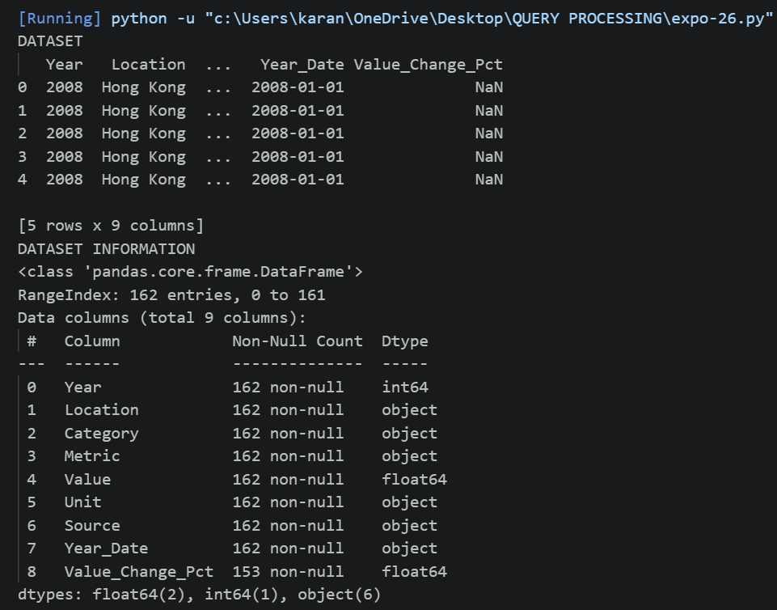
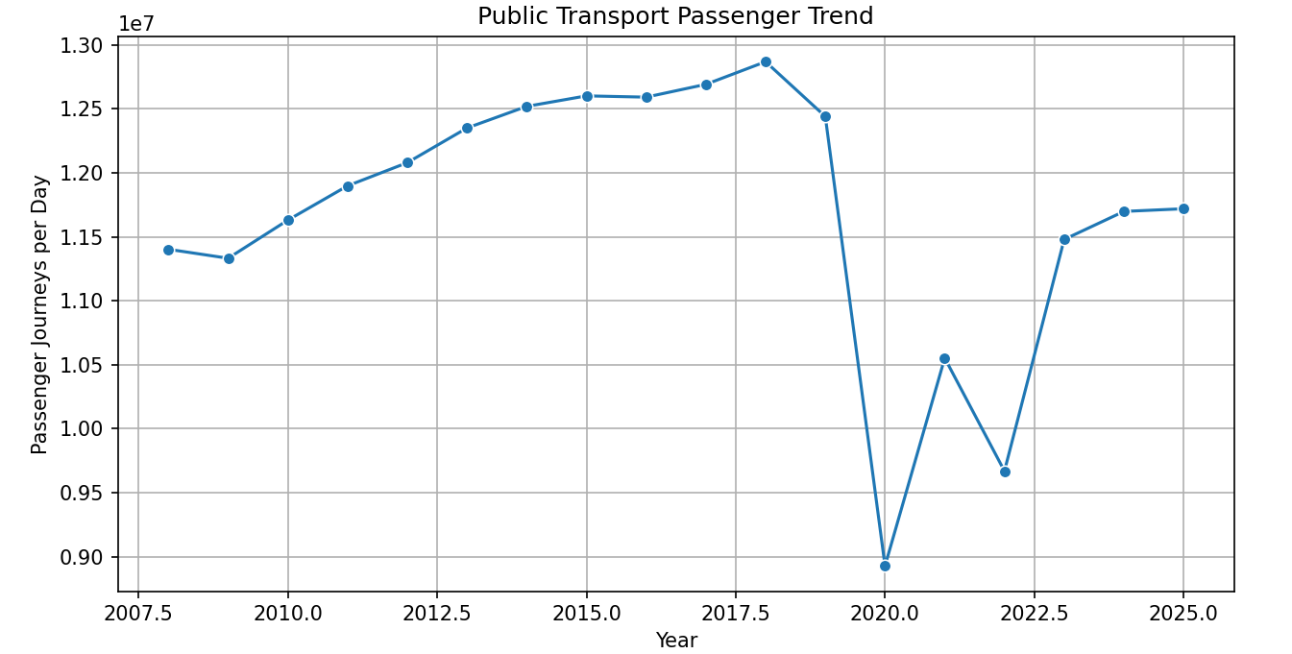
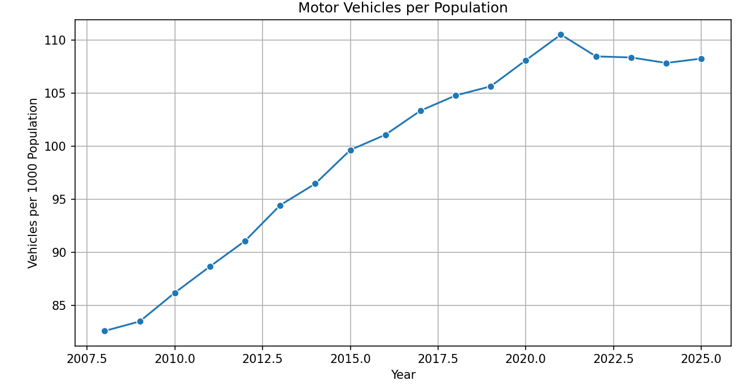
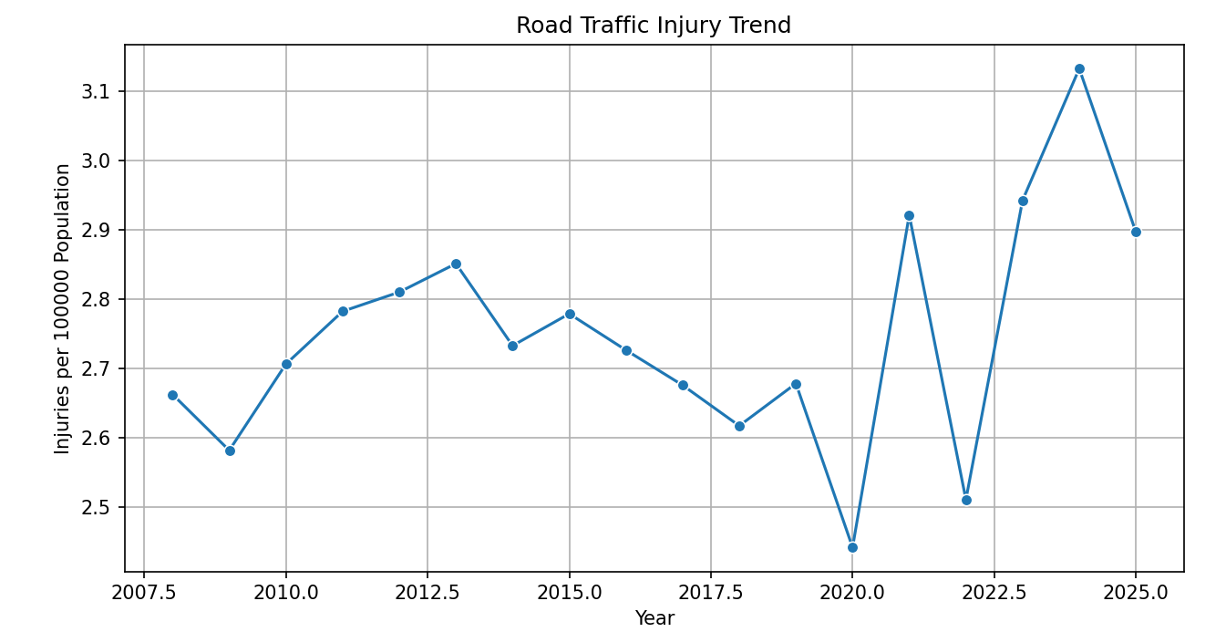
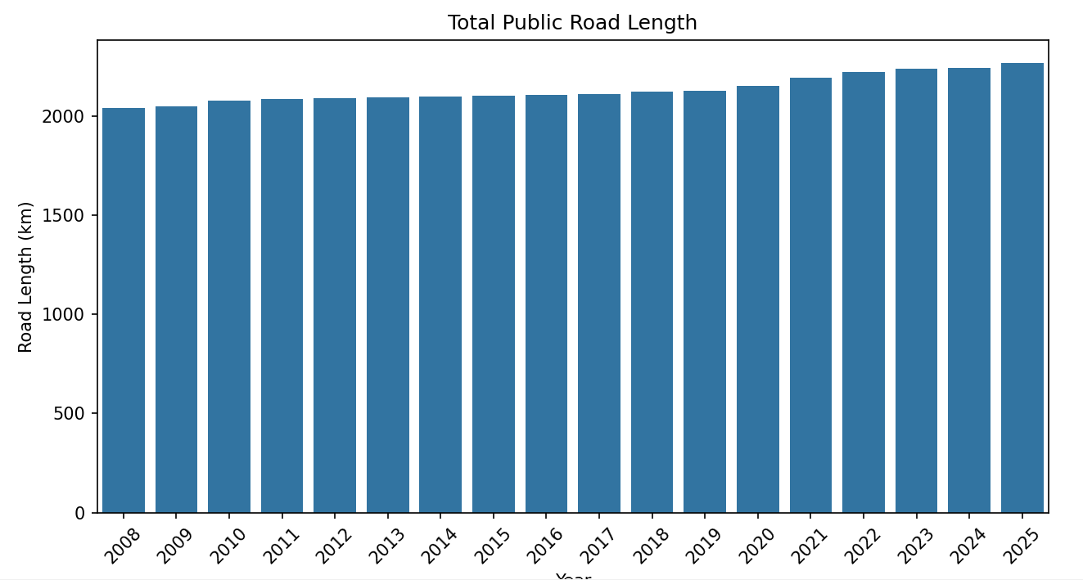
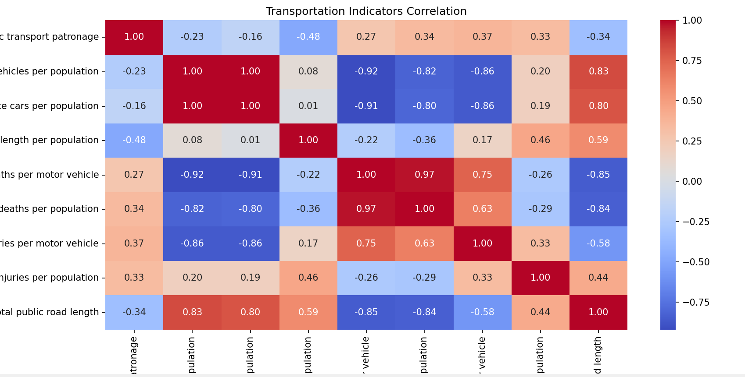
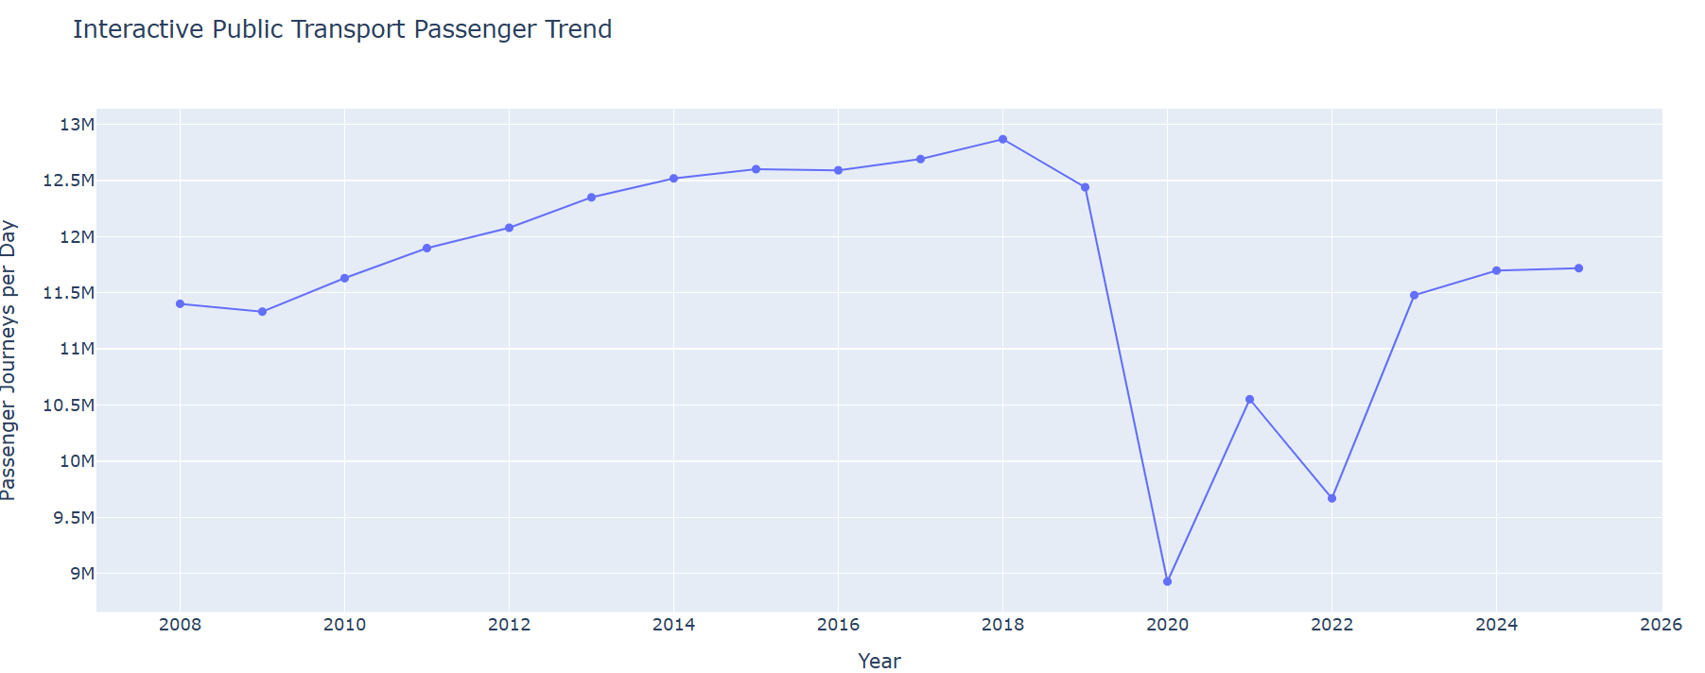
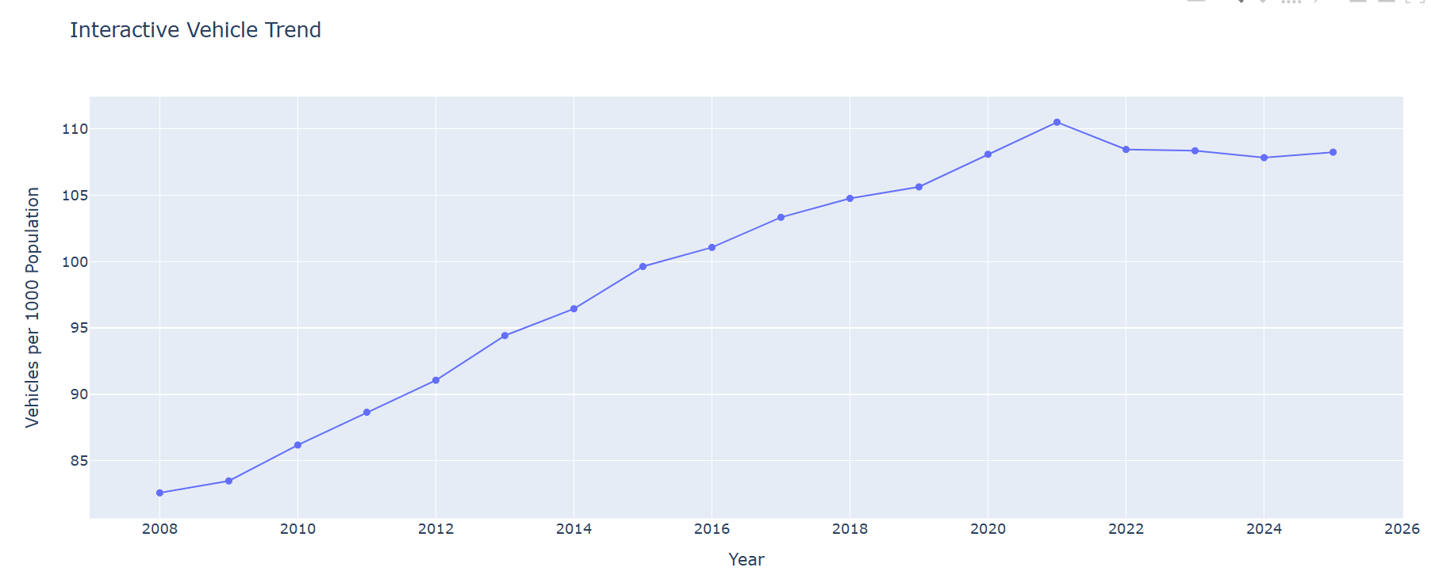
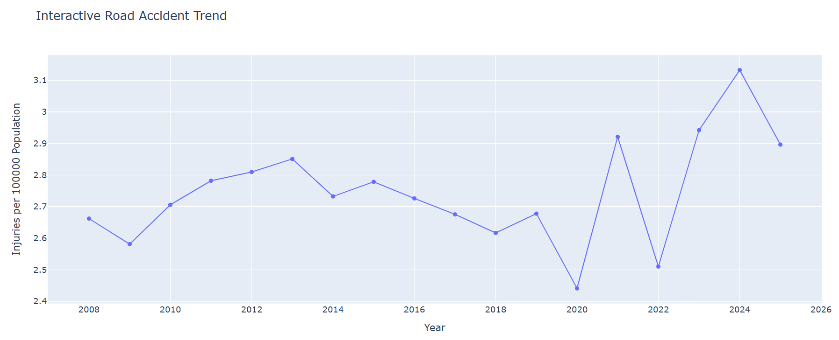
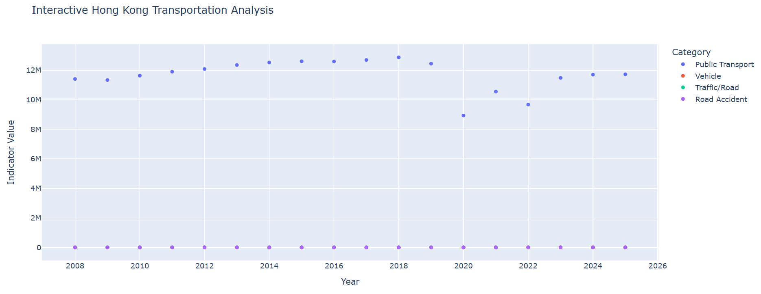
8. Select any open tourism dataset containing tourist arrivals, destinations, hotel occupancy, travel expenditure, or visitor information. Explore and analyze the data using grouping, filtering, correlation, outlier detection, and time-series techniques. Present the findings through charts, maps, and interactive visualizations.
Code:
import pandas as pd
import numpy as np
import matplotlib.pyplot as plt
import seaborn as sns
import plotly.express as px
data = pd.read_csv("india_tourism_dataset.csv")
print("\nTOURISM DATASET")
print(data.head())
data.columns = data.columns.str.strip()
data = data.dropna(subset=["States/UTs *"])
data = data.rename(columns={
"States/UTs *": "State",
"Domestic -2019": "Domestic_2019",
"Foreign - 2019": "Foreign_2019",
"Domestic -2020": "Domestic_2020",
"Foreign - 2020": "Foreign_2020",
"Growth rate - DTV 2020/19": "Domestic_Growth",
"Growth rate - FTV 2020/19": "Foreign_Growth"
})
data["State"] = data["State"].astype(str).str.strip()
numeric_columns = [
"Domestic_2019",
"Foreign_2019",
"Domestic_2020",
"Foreign_2020",
"Domestic_Growth",
"Foreign_Growth"
]
for column in numeric_columns:
data[column] = data[column].astype(str).str.replace(",", "", regex=False).str.replace("%", "", regex=False)
data[column] = pd.to_numeric(data[column], errors="coerce")
data[column] = data[column].fillna(data[column].median())
data = data.drop_duplicates(subset=["State"])
data["Total_2019"] = data["Domestic_2019"] + data["Foreign_2019"]
data["Total_2020"] = data["Domestic_2020"] + data["Foreign_2020"]
data["Total_Change"] = data["Total_2020"] - data["Total_2019"]
data["Total_Growth_Percent"] = (
data["Total_Change"] / data["Total_2019"]
) * 100
print("\nCLEANED TOURISM DATA")
print(data.head())
top_2019 = data.sort_values(
"Total_2019",
ascending=False
).head(10)
print("\nTOP 10 TOURIST DESTINATIONS - 2019")
print(top_2019[["State", "Total_2019"]])
top_2020 = data.sort_values(
"Total_2020",
ascending=False
).head(10)
print("\nTOP 10 TOURIST DESTINATIONS - 2020")
print(top_2020[["State", "Total_2020"]])
average_2019 = data["Total_2019"].mean()
high_tourism = data[
data["Total_2019"] > average_2019
]
print("\nSTATES ABOVE AVERAGE TOURISM - 2019")
print(high_tourism[["State", "Total_2019"]])
domestic_comparison = data[
["State", "Domestic_2019", "Domestic_2020"]
].sort_values(
"Domestic_2019",
ascending=False
)
print("\nDOMESTIC TOURISM COMPARISON")
print(domestic_comparison.head(10))
foreign_comparison = data[
["State", "Foreign_2019", "Foreign_2020"]
].sort_values(
"Foreign_2019",
ascending=False
)
print("\nFOREIGN TOURISM COMPARISON")
print(foreign_comparison.head(10))
correlation_columns = [
"Domestic_2019",
"Foreign_2019",
"Domestic_2020",
"Foreign_2020",
"Total_2019",
"Total_2020",
"Total_Growth_Percent"
]
correlation = data[
correlation_columns
].corr()
print("\nCORRELATION MATRIX")
print(correlation.round(2))
Q1 = data["Total_2019"].quantile(0.25)
Q3 = data["Total_2019"].quantile(0.75)
IQR = Q3 - Q1
lower_limit = Q1 - 1.5 * IQR
upper_limit = Q3 + 1.5 * IQR
outliers = data[
(data["Total_2019"] < lower_limit) |
(data["Total_2019"] > upper_limit)
]
print("\nTOURISM OUTLIERS")
print(outliers[["State", "Total_2019"]])
print("\nNumber of outliers:", len(outliers))
plt.figure(figsize=(10, 6))
sns.barplot(
data=top_2019,
x="Total_2019",
y="State"
)
plt.title("Top 10 Tourist Destinations - 2019")
plt.xlabel("Total Tourist Visits")
plt.ylabel("State")
plt.show()
comparison = data.sort_values(
"Total_2019",
ascending=False
).head(10)
comparison_plot = comparison[
["State", "Total_2019", "Total_2020"]
].set_index("State")
comparison_plot.plot(
kind="bar",
figsize=(12, 6)
)
plt.title("Tourist Visits: 2019 vs 2020")
plt.xlabel("State")
plt.ylabel("Tourist Visits")
plt.xticks(rotation=45)
plt.tight_layout()
plt.show()
domestic_total = data["Domestic_2019"].sum()
foreign_total = data["Foreign_2019"].sum()
tourist_type = pd.Series({
"Domestic": domestic_total,
"Foreign": foreign_total
})
plt.figure(figsize=(7, 5))
plt.bar(
tourist_type.index,
tourist_type.values
)
plt.title("Domestic vs Foreign Tourist Visits - 2019")
plt.xlabel("Tourist Type")
plt.ylabel("Number of Visitors")
plt.show()
growth_data = data.sort_values(
"Total_Growth_Percent"
).head(10)
plt.figure(figsize=(10, 6))
sns.barplot(
data=growth_data,
x="Total_Growth_Percent",
y="State"
)
plt.title("States with Largest Tourism Decline")
plt.xlabel("Growth Rate (%)")
plt.ylabel("State")
plt.show()
plt.figure(figsize=(8, 5))
sns.boxplot(
y=data["Total_2019"]
)
plt.title("Tourist Visit Outlier Detection")
plt.ylabel("Total Tourist Visits - 2019")
plt.show()
plt.figure(figsize=(10, 8))
sns.heatmap(
correlation,
annot=True,
cmap="coolwarm",
fmt=".2f"
)
plt.title("Tourism Data Correlation")
plt.show()
interactive_data = data.sort_values(
"Total_2019",
ascending=False
).head(15)
fig = px.bar(
interactive_data,
x="State",
y="Total_2019",
color="Total_2019",
hover_data=[
"Domestic_2019",
"Foreign_2019",
"Total_2020",
"Total_Growth_Percent"
],
title="Interactive Tourist Visits by State - 2019"
)
fig.update_layout(
xaxis_title="State",
yaxis_title="Tourist Visits",
xaxis_tickangle=-45
)
fig.show()
fig = px.scatter(
data,
x="Total_2019",
y="Total_2020",
size="Domestic_2019",
color="Foreign_2019",
hover_name="State",
hover_data=[
"Domestic_2019",
"Foreign_2019",
"Total_Growth_Percent"
],
title="Tourism Visits: 2019 vs 2020"
)
fig.show()
coordinates = {
"Andhra Pradesh": [15.9129, 79.7400],
"Arunachal Pradesh": [28.2180, 94.7278],
"Assam": [26.2006, 92.9376],
"Bihar": [25.0961, 85.3131],
"Goa": [15.2993, 74.1240],
"Gujarat": [22.2587, 71.1924],
"Haryana": [29.0588, 76.0856],
"Himachal Pradesh": [31.1048, 77.1734],
"Jharkhand": [23.6102, 85.2799],
"Karnataka": [15.3173, 75.7139],
"Kerala": [10.8505, 76.2711],
"Madhya Pradesh": [22.9734, 78.6569],
"Maharashtra": [19.7515, 75.7139],
"Manipur": [24.6637, 93.9063],
"Meghalaya": [25.4670, 91.3662],
"Mizoram": [23.1645, 92.9376],
"Nagaland": [26.1584, 94.5624],
"Odisha": [20.9517, 85.0985],
"Punjab": [31.1471, 75.3412],
"Rajasthan": [27.0238, 74.2179],
"Sikkim": [27.5330, 88.5122],
"Tamil Nadu": [11.1271, 78.6569],
"Telangana": [18.1124, 79.0193],
"Tripura": [23.9408, 91.9882],
"Uttar Pradesh": [26.8467, 80.9462],
"Uttarakhand": [30.0668, 79.0193],
"West Bengal": [22.9868, 87.8550],
"Delhi": [28.7041, 77.1025],
"Jammu & Kashmir": [33.7782, 76.5762],
"Ladakh": [34.1526, 77.5771]
}
data["Latitude"] = data["State"].map(
lambda x: coordinates.get(
x,
[np.nan, np.nan]
)[0]
)
data["Longitude"] = data["State"].map(
lambda x: coordinates.get(
x,
[np.nan, np.nan]
)[1]
)
map_data = data.dropna(
subset=[
"Latitude",
"Longitude"
]
)
fig = px.scatter_map(
map_data,
lat="Latitude",
lon="Longitude",
size="Total_2019",
color="Total_2019",
hover_name="State",
hover_data=[
"Domestic_2019",
"Foreign_2019",
"Total_2020"
],
zoom=4,
title="Tourist Visits by Indian State - 2019"
)
fig.show()
best_state = data.loc[
data["Total_2019"].idxmax(),
"State"
]
best_value = data["Total_2019"].max()
lowest_state = data.loc[
data["Total_2019"].idxmin(),
"State"
]
largest_decline_state = data.loc[
data["Total_Growth_Percent"].idxmin(),
"State"
]
print("\n5 KEY FINDINGS")
print(
"1. The state with the highest tourist visits in 2019 was:",
best_state
)
print(
"2. The highest total tourist visits recorded were:",
round(best_value, 2)
)
print(
"3. The state with the lowest recorded tourist visits was:",
lowest_state
)
print(
"4. The largest tourism decline between 2019 and 2020 occurred in:",
largest_decline_state
)
print(
"5. Tourist visits declined substantially in 2020 compared with 2019."
)
print("\n5 RECOMMENDATIONS")
print(
"1. Promote destinations with high tourism potential but lower visitor numbers."
)
print(
"2. Strengthen tourism infrastructure in highly visited states."
)
print(
"3. Use historical visitor trends to plan transportation and accommodation."
)
print(
"4. Investigate tourism outliers to identify unusual events or changes."
)
print(
"5. Use interactive maps and dashboards to continuously monitor tourism trends."
)
data.to_csv(
"analyzed_india_tourism_dataset.csv",
index=False
)
print(
"\nAnalysis completed successfully."
)
print(
"Saved as: analyzed_india_tourism_dataset.csv"
)
Output:
