SIMATS ENGINEERING
SAVEETHA INSTITUTE OF MEDICAL AND TECHNICAL SCIENCES
CHENNAI – 602105
Department of Computer Science and Engineering

ASSESSMENT TOOL 1 – Dashboard Development Task

Course Code: | DSA0502 | Course Title: | Query Processing for Data Science
CO Assessed: | CO5 | Assessment: | Tool 3– Dashboard Development Task
Weightage: | 25% | Total Marks:
CO5 Statement: Create meaningful visualizations using Pandas and Matplotlib, including charts, distributions, relationships, and interactive visual representations for effective communication
Student Name: | K V Sai Shanmukh | Reg. No.: | 192424306
Section / Batch: | B.Tech-AI&DS-2024 | Date of Submission: | 24-08-26
Faculty In-charge: | Dr. B. Shyamala Gowri | Project Mode: | Individual Submission

Code of Conduct
I _K V Sai Shanmukh (192424306)_ (Name / Reg No) certify that this submission is my original work and that I have adhered to all guidelines specified for this assessment. I understand that any violation of academic integrity rules will result in disciplinary action.
Signature: _K V Sai Shanmukh___

- Student Academic Performance Dashboard
Develop an interactive dashboard using Pandas and Matplotlib to analyze student performance. Import a dataset containing attendance, internal marks, assignment marks, laboratory marks, and final scores. The dashboard should include bar charts, distribution plots, scatter plots, and frequency charts. Use a scatter matrix to study relationships between variables and identify performance patterns and outliers.
Purpose: Analyze attendance, internal marks, assignment marks, laboratory marks, and final scores using bar charts, distribution plots, scatter plots, frequency charts, and a scatter matrix.
Python Program
Python
Run
import pandas as pd
import matplotlib.pyplot as plt
from pandas.plotting import scatter_matrix
# 1. Load Dataset
df = pd.read_csv("student_performance.csv")
# Display dataset
print("Student Performance Dataset:")
print(df.head())
# 2. Basic Information
print("\nDataset Information:")
print(df.info())
print("\nStatistical Summary:")
print(df.describe())
# 3. Check Missing Values
print("\nMissing Values:")
print(df.isnull().sum())
# Remove rows containing missing values
df = df.dropna()
# 4. Bar Chart - Average Marks
average_marks = df[
["Attendance", "Internal_Marks",
"Assignment_Marks", "Laboratory_Marks", "Final_Score"]
].mean()
plt.figure(figsize=(8, 5))
average_marks.plot(kind="bar")
plt.title("Average Student Performance")
plt.xlabel("Assessment Type")
plt.ylabel("Average Marks")
plt.xticks(rotation=30)
plt.tight_layout()
plt.show()
# 5. Distribution Plot - Final Scores
plt.figure(figsize=(8, 5))
plt.hist(df["Final_Score"], bins=10, edgecolor="black")
plt.title("Distribution of Final Scores")
plt.xlabel("Final Score")
plt.ylabel("Number of Students")
plt.tight_layout()
plt.show()
# 6. Scatter Plot - Attendance vs Final Score
plt.figure(figsize=(8, 5))
plt.scatter(df["Attendance"], df["Final_Score"])
plt.title("Attendance vs Final Score")
plt.xlabel("Attendance")
plt.ylabel("Final Score")
plt.grid(True)
plt.tight_layout()
plt.show()
# 7. Scatter Plot - Internal Marks vs Final Score
plt.figure(figsize=(8, 5))
plt.scatter(df["Internal_Marks"], df["Final_Score"])
plt.title("Internal Marks vs Final Score")
plt.xlabel("Internal Marks")
plt.ylabel("Final Score")
plt.grid(True)
plt.tight_layout()
plt.show()
# 8. Frequency Chart - Final Score
plt.figure(figsize=(8, 5))
df["Final_Score"].value_counts().sort_index().plot(kind="bar")
plt.title("Frequency of Final Scores")
plt.xlabel("Final Score")
plt.ylabel("Frequency")
plt.tight_layout()
plt.show()
# 9. Scatter Matrix
columns = [
"Attendance",
"Internal_Marks",
"Assignment_Marks",
"Laboratory_Marks",
"Final_Score"
]
scatter_matrix(
df[columns],
figsize=(12, 10),
diagonal="hist"
)
plt.suptitle("Scatter Matrix - Student Performance")
plt.tight_layout()
plt.show()
# 10. Correlation Analysis
print("\nCorrelation Matrix:")
print(df[columns].corr())
# 11. Outlier Detection using IQR
Q1 = df["Final_Score"].quantile(0.25)
Q3 = df["Final_Score"].quantile(0.75)
IQR = Q3 - Q1
lower_limit = Q1 - 1.5 * IQR
upper_limit = Q3 + 1.5 * IQR
outliers = df[
(df["Final_Score"] < lower_limit) |
(df["Final_Score"] > upper_limit)
]
print("\nFinal Score Outliers:")
print(outliers)
# 12. Performance Classification
df["Performance"] = pd.cut(
df["Final_Score"],
bins=[0, 40, 60, 75, 100],
labels=["Poor", "Average", "Good", "Excellent"]
)
print("\nPerformance Groups:")
print(df["Performance"].value_counts())
# 13. Performance Frequency Chart
plt.figure(figsize=(7, 5))
df["Performance"].value_counts().sort_index().plot(kind="bar")
plt.title("Student Performance Categories")
plt.xlabel("Performance")
plt.ylabel("Number of Students")
plt.tight_layout()
plt.show()
Expected Dataset Format
Your student_performance.csv can look like this:

Student_ID | Attendance | Internal_Marks | Assignment_Marks | Laboratory_Marks | Final_Score
S001 | 92 | 85 | 88 | 90 | 89
S002 | 78 | 70 | 75 | 72 | 74
S003 | 95 | 91 | 94 | 96 | 93
S004 | 65 | 58 | 62 | 60 | 61
What the dashboard finds:
- Average performance
- Relationship between attendance and marks
- Relationship between internal/assignment/lab marks and final score
- Score distribution
- Frequency of performance levels
- Correlations between academic variables
- Possible outliers
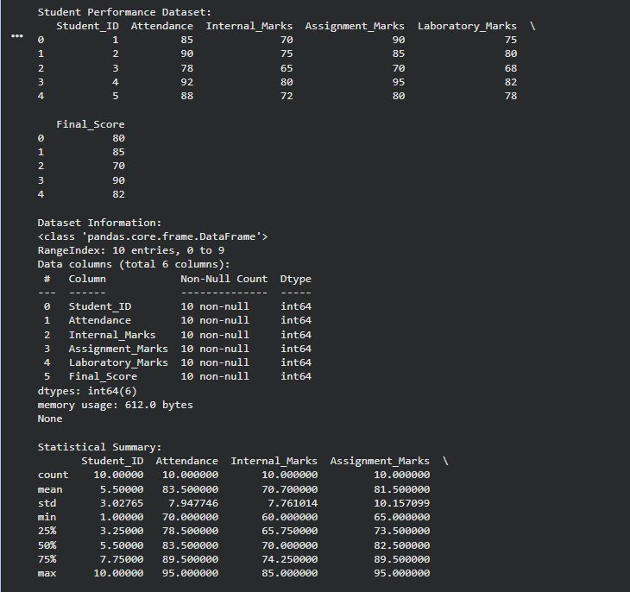
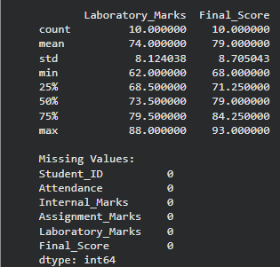
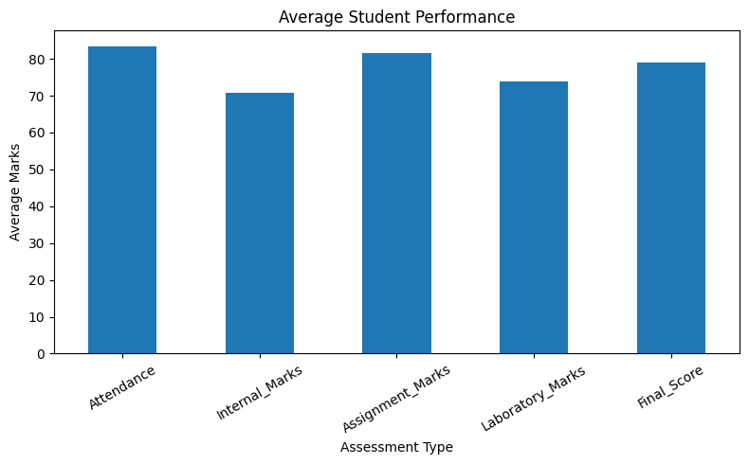
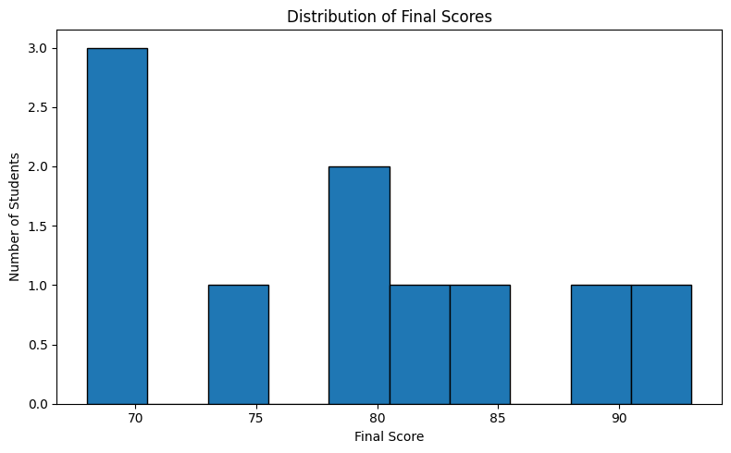
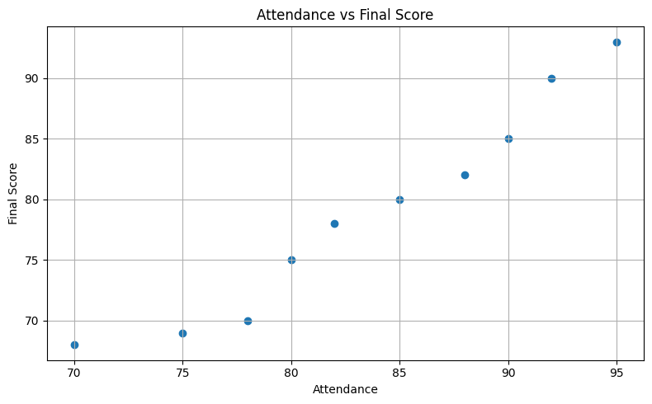
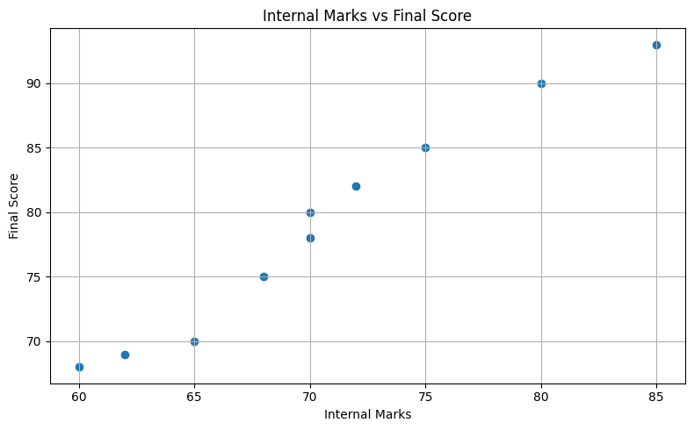
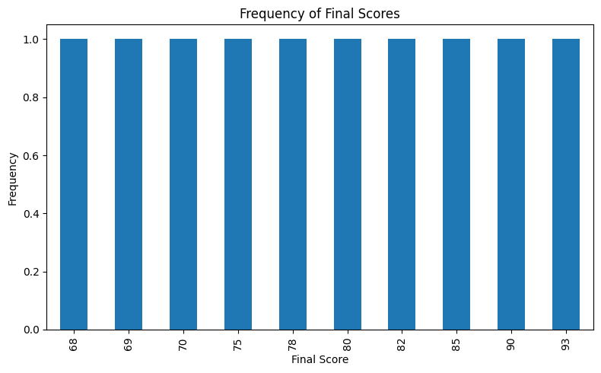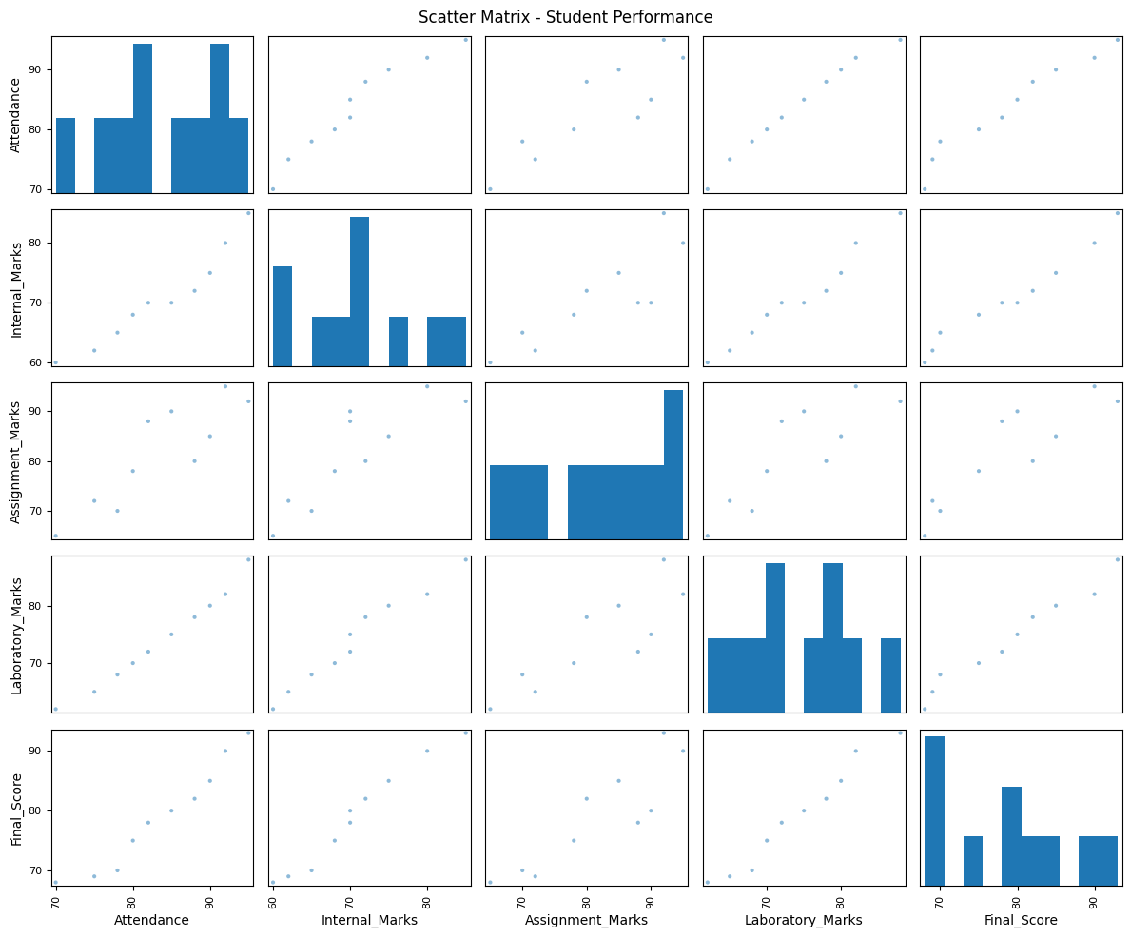
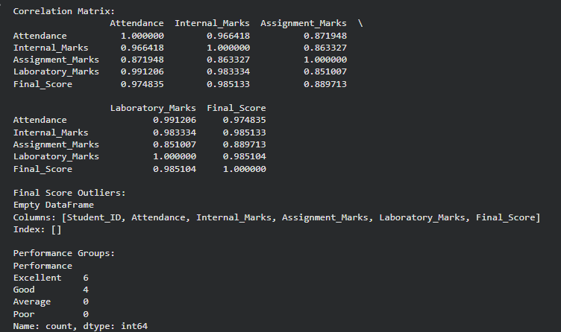
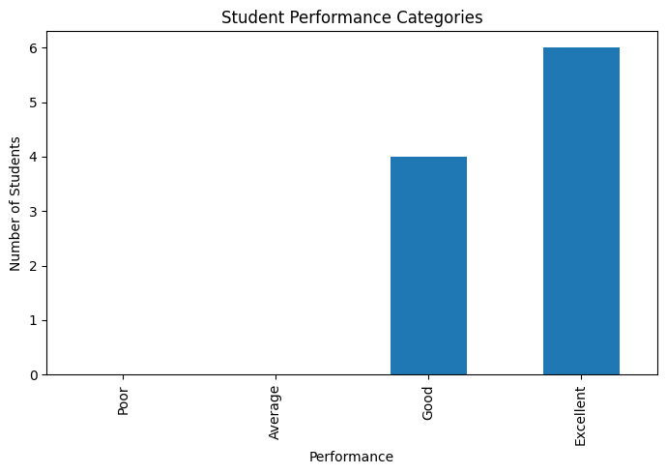
- Sales Performance and Trend Dashboard
Create a dashboard for an e-commerce company using sales data containing date, product, category, quantity, revenue, and region. Analyze the evolution of sales over time, product-wise distributions, and category frequencies. Include appropriate Matplotlib/Pandas plots and use a lag plot and autocorrelation plot to identify time-dependent sales patterns.

Purpose: Analyze e-commerce sales using date, product, category, quantity, revenue, and region. The program includes time-series analysis, product/category analysis, lag plot, and autocorrelation plot.
Python Program
Python
Run
import pandas as pd
import matplotlib.pyplot as plt
from pandas.plotting import lag_plot, autocorrelation_plot
# 1. Load Dataset
df = pd.read_csv("sales_data.csv")
# Display dataset
print("Sales Dataset:")
print(df.head())
# 2. Convert Date Column
df["Date"] = pd.to_datetime(df["Date"])
# Sort data chronologically
df = df.sort_values("Date")
# 3. Basic Information
print("\nDataset Information:")
print(df.info())
print("\nStatistical Summary:")
print(df.describe())
# 4. Check Missing Values
print("\nMissing Values:")
print(df.isnull().sum())
# Remove missing values
df = df.dropna()
# 5. Total Sales Revenue
total_revenue = df["Revenue"].sum()
print("\nTotal Revenue:", total_revenue)
# 6. Sales Evolution Over Time
daily_sales = df.groupby("Date")["Revenue"].sum()
plt.figure(figsize=(10, 5))
daily_sales.plot()
plt.title("Sales Evolution Over Time")
plt.xlabel("Date")
plt.ylabel("Revenue")
plt.grid(True)
plt.tight_layout()
plt.show()
# 7. Product-wise Sales
product_sales = df.groupby("Product")["Revenue"].sum()
product_sales = product_sales.sort_values(ascending=False)
plt.figure(figsize=(10, 5))
product_sales.plot(kind="bar")
plt.title("Product-wise Revenue")
plt.xlabel("Product")
plt.ylabel("Revenue")
plt.xticks(rotation=45)
plt.tight_layout()
plt.show()
# 8. Category Frequency
category_frequency = df["Category"].value_counts()
plt.figure(figsize=(8, 5))
category_frequency.plot(kind="bar")
plt.title("Category Frequency")
plt.xlabel("Category")
plt.ylabel("Number of Sales")
plt.xticks(rotation=30)
plt.tight_layout()
plt.show()
# 9. Category-wise Revenue
category_sales = df.groupby("Category")["Revenue"].sum()
plt.figure(figsize=(8, 5))
category_sales.plot(kind="bar")
plt.title("Category-wise Revenue")
plt.xlabel("Category")
plt.ylabel("Revenue")
plt.xticks(rotation=30)
plt.tight_layout()
plt.show()
# 10. Region-wise Revenue
region_sales = df.groupby("Region")["Revenue"].sum()
plt.figure(figsize=(8, 5))
region_sales.plot(kind="bar")
plt.title("Region-wise Revenue")
plt.xlabel("Region")
plt.ylabel("Revenue")
plt.xticks(rotation=30)
plt.tight_layout()
plt.show()
# 11. Quantity Distribution
plt.figure(figsize=(8, 5))
plt.hist(df["Quantity"], bins=10, edgecolor="black")
plt.title("Quantity Distribution")
plt.xlabel("Quantity")
plt.ylabel("Frequency")
plt.tight_layout()
plt.show()
# 12. Revenue Distribution
plt.figure(figsize=(8, 5))
plt.hist(df["Revenue"], bins=10, edgecolor="black")
plt.title("Revenue Distribution")
plt.xlabel("Revenue")
plt.ylabel("Frequency")
plt.tight_layout()
plt.show()
# 13. Lag Plot
plt.figure(figsize=(7, 7))
lag_plot(daily_sales)
plt.title("Lag Plot of Daily Sales")
plt.xlabel("Previous Day Revenue")
plt.ylabel("Current Day Revenue")
plt.grid(True)
plt.tight_layout()
plt.show()
# 14. Autocorrelation Plot
plt.figure(figsize=(10, 5))
autocorrelation_plot(daily_sales)
plt.title("Autocorrelation of Daily Sales")
plt.xlabel("Lag")
plt.ylabel("Autocorrelation")
plt.tight_layout()
plt.show()
# 15. Monthly Sales Trend
monthly_sales = df.set_index("Date")["Revenue"].resample("ME").sum()
plt.figure(figsize=(10, 5))
monthly_sales.plot(marker="o")
plt.title("Monthly Sales Trend")
plt.xlabel("Month")
plt.ylabel("Revenue")
plt.grid(True)
plt.tight_layout()
plt.show()

# 16. Correlation Analysis
print("\nCorrelation Matrix:")
numeric_columns = [
"Quantity",
"Revenue"
]
print(df[numeric_columns].corr())
# 17. Display Top Products
print("\nTop 5 Products:")
print(product_sales.head(5))
# 18. Display Best Region
print("\nBest Performing Region:")
print(region_sales.idxmax())
print("Revenue:", region_sales.max())
# 19. Display Best Category
print("\nBest Performing Category:")
print(category_sales.idxmax())
print("Revenue:", category_sales.max())
Expected Dataset Format
Your sales_data.csv can contain:
Date | Product | Category | Quantity | Revenue | Region
2026-01-01 | Laptop | Electronics | 2 | 120000 | South
2026-01-02 | Phone | Electronics | 5 | 150000 | North
2026-01-03 | Chair | Furniture | 3 | 18000 | East
2026-01-04 | Shoes | Fashion | 8 | 24000 | West
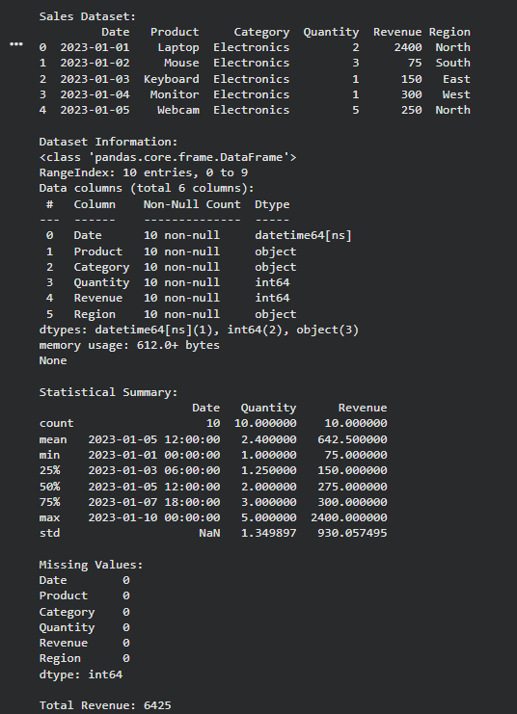
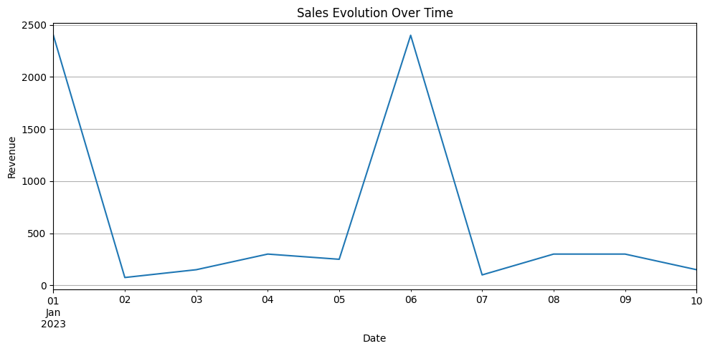
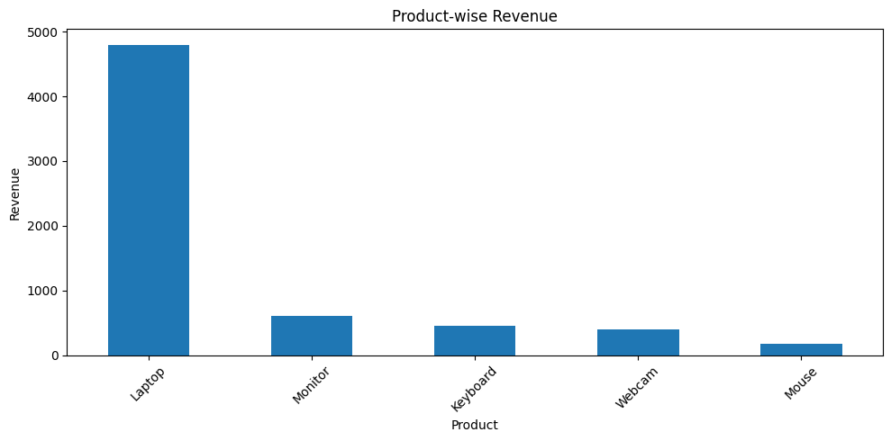
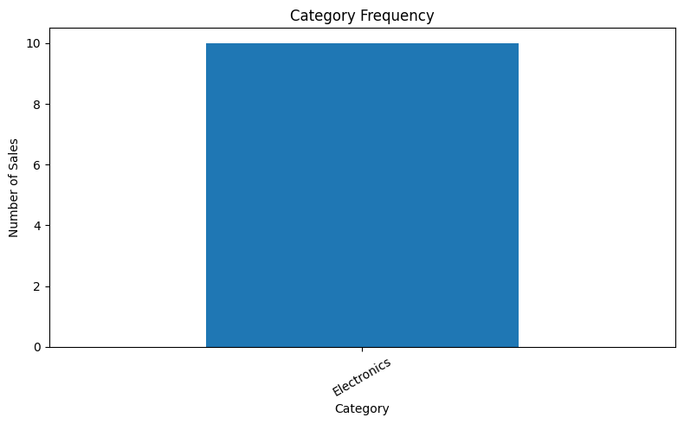
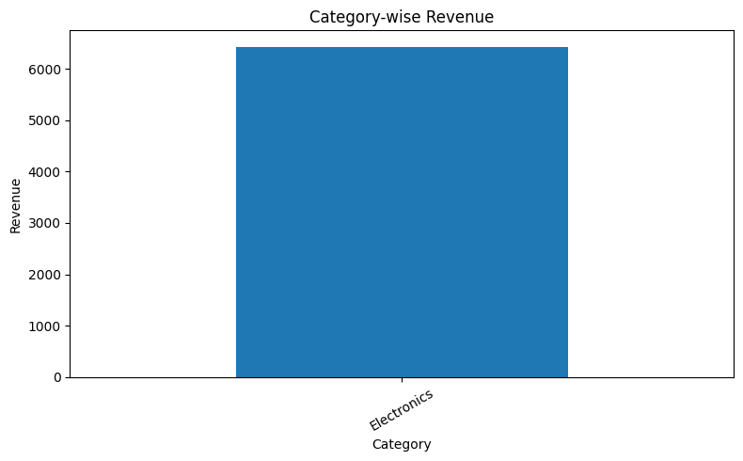
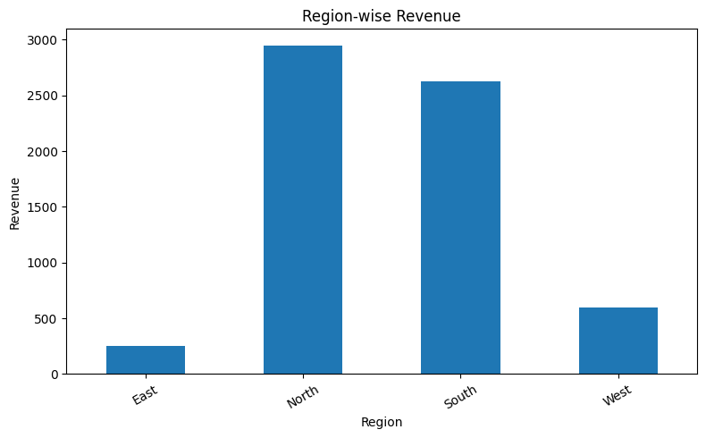
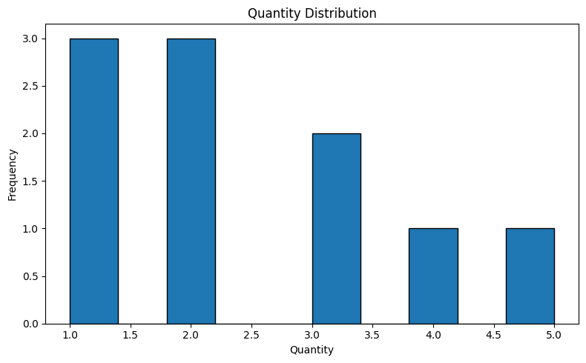
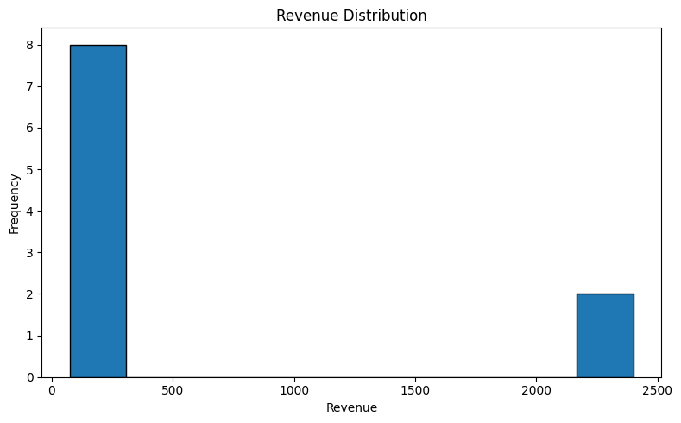
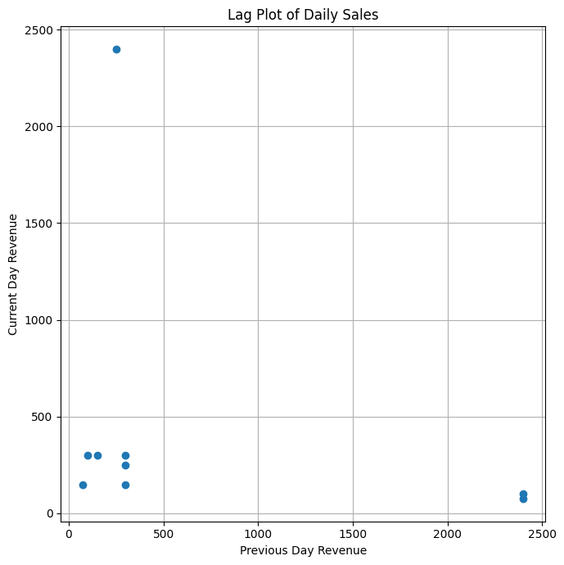
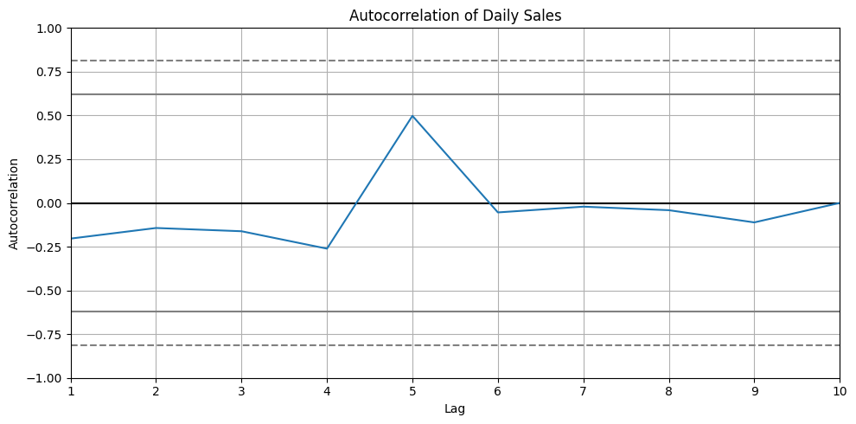
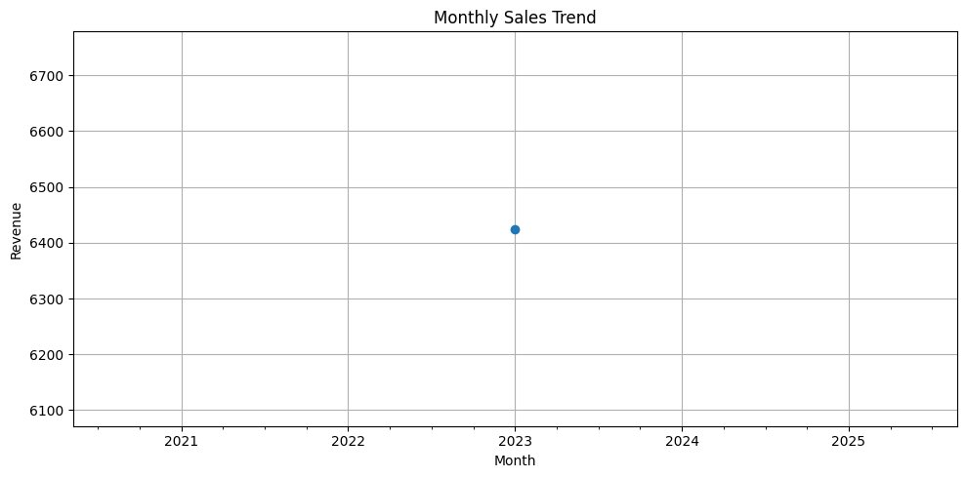
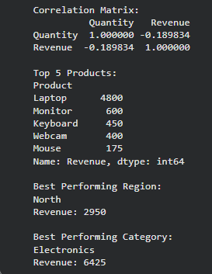

窗体底端

