1.Use Figma to create an interactive diagram illustrating the components of a basic
cellular system.
A.
Aim
To design an interactive diagram using Figma illustrating the components of a basic cellular system and their communication flow.
Algorithm
- Start.
- Open Figma and create a new design file.
- Create a desktop frame and add the title “Components of a Basic Cellular System.”
- Add the components: Mobile Station (MS), Base Transceiver Station (BTS), Base Station Controller (BSC), Mobile Switching Centre (MSC), HLR, VLR, and PSTN.
- Arrange the components in the correct sequence and connect them using arrows.
- Apply suitable colors, fonts, icons, and labels.
- Create detail frames explaining the function of each component.
- Configure prototype interactions using On Click → Navigate to.
- Add Back, Show Call Flow, and Reset Diagram buttons.
- Run the prototype in Present mode and verify all interactions.
- Save the completed design.
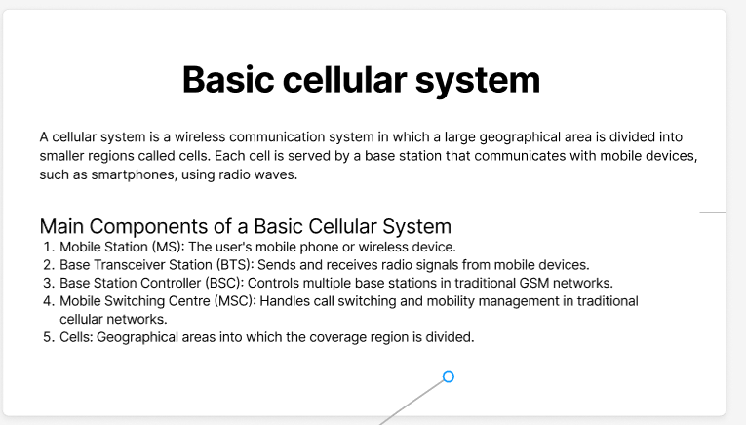
- Stop.

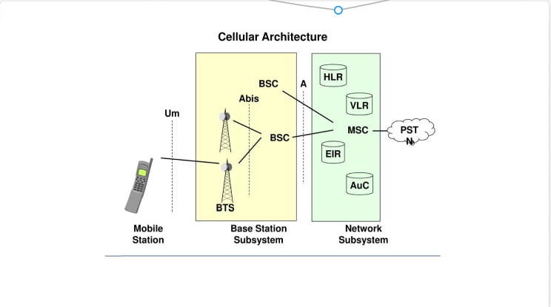
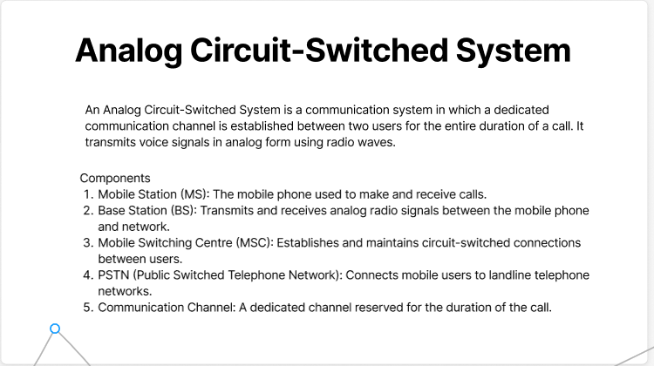
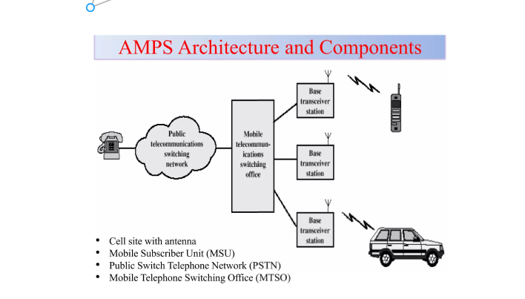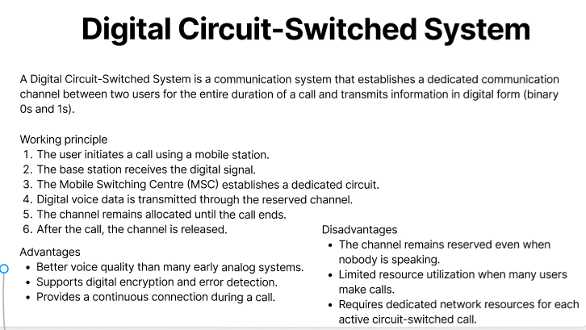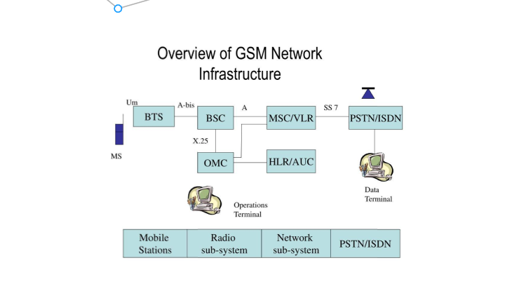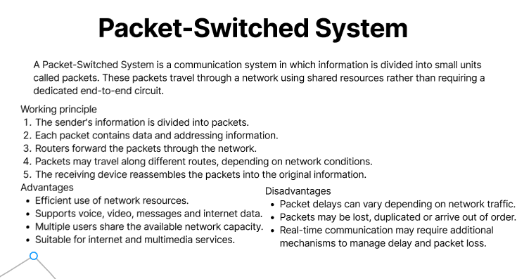

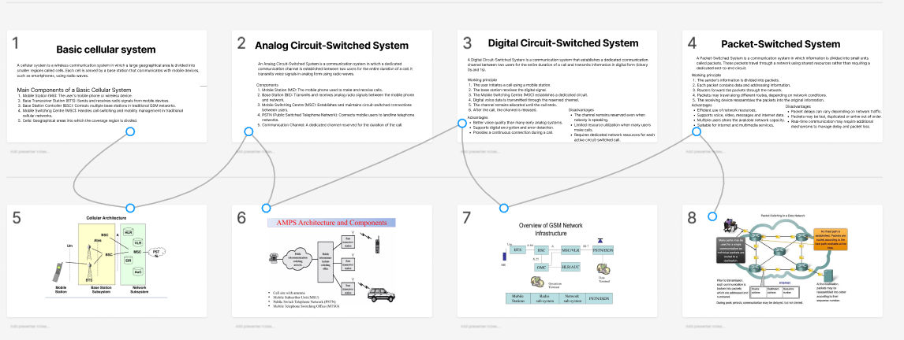
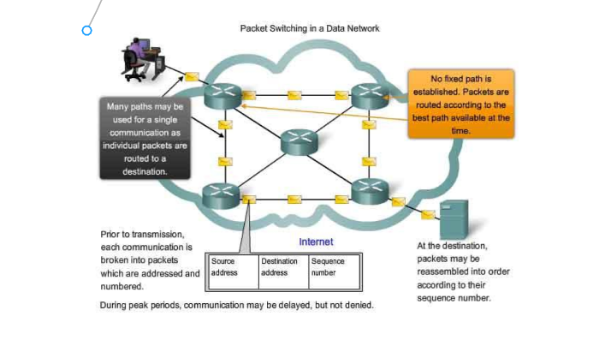

Result: Thus, an interactive diagram of a basic cellular system was designed using Figma, illustrating its components, functions, and communication flow.

