Spoorthi Infra Website Development
INTERNSHIP REPORT
Submitted in connection with the Second Year B.Tech programme in Computer Science and Engineering
Malla Reddy Deemed to be University

Student | Elasarapu Shanmukha Sai
Role | Web Developer Intern
Organization | Spoorthi Infra
Internship period | 1 September 2026 to 1 October 2026
Department | Computer Science and Engineering
Academic submission copy

Declaration
I, Elasarapu Shanmukha Sai, submit this internship report on the project “Spoorthi Infra Website Development” as a record of the frontend website work described in the accompanying project files. The report describes the website architecture, visible features, implementation approach, and limitations to the best of my knowledge.
This page is provided for the student’s review and signature. It is not a signed declaration.
Student signature: ____________________ Date: ____________________

Approval Sheet
This report is presented for academic review by the Department of Computer Science and Engineering, Malla Reddy Deemed to be University. Approval is subject to the department’s normal verification process.
Faculty guide: ____________________ Signature: ____________________
Head of Department: ____________________ Signature: ____________________
Date and institutional seal: ____________________

Acknowledgement
I thank Spoorthi Infra for the opportunity to work on a web development project during the internship period. The work provided a practical setting in which to study interface structure, reusable components, responsive layouts, navigation, and presentation of construction and interior design services.
I also thank the faculty of the Department of Computer Science and Engineering at Malla Reddy Deemed to be University for supporting practical learning. I acknowledge the value of project review, browser inspection, version control, and careful documentation in improving a frontend application.

Abstract
This report documents the frontend development of a dual-brand website experience for Spoorthi Infra and Tejes Interiors during a Web Developer internship from 1 September 2026 to 1 October 2026. The application presents a gateway for choosing a brand, then provides distinct routes and visual systems for construction and architecture on one side and interior design on the other.
The source is a React application built with Vite and React Router. It uses reusable page and layout components, CSS stylesheets, responsive layouts, local imagery, and icon components. The Spoorthi Infra side includes construction, project concepts, design visualization, an interactive spatial image explorer, and an enquiry preparation interface. Tejes Interiors has its own home, interior design, projects, visualization, spatial experience, and contact pages.
The implementation is frontend focused. The enquiry interfaces validate inputs and can prepare, copy, download, or open an email draft, but no server submission or database integration is configured. The project demonstrates how a clear route structure and consistent components can organize related brands while keeping their presentation distinct.

Contents
Chapter 1 Introduction 7
Chapter 2 Internship Overview and Objectives 8
Chapter 3 Website Design and Development 9
Chapter 4 Implementation Testing Learning Outcomes and Conclusion 12
References 15
Appendices 16
Appendix I Internship Completion Certificate 17
Appendix II Internship Offer Letter 18

Chapter 1 Introduction

1.1 Introduction to the Internship
The one-month Web Developer internship at Spoorthi Infra ran from 1 September 2026 to 1 October 2026. The offer letter identifies frontend implementation, UI improvements, testing, and content integration as internship activities. The supplied certificate confirms completion as a Web Developer Intern. This report focuses on the website project available in the workspace.

1.2 Background of the Project
Spoorthi Infra and Tejes Interiors address related but different visitor interests. The website presents construction, architecture, planning, and project visualization for Spoorthi Infra, while Tejes Interiors presents interior spaces and design services. A gateway gives visitors an immediate choice between the two experiences.

1.3 Need for the Project
A visitor may arrive with a construction requirement, an interior design enquiry, or an interest in visualizing a space. Separating the brands into clear paths helps that visitor find relevant material. The pages also make the design journey easier to understand by connecting early planning, 3D development, final presentation, and spatial exploration.

1.4 Internship Details
Student: Elasarapu Shanmukha Sai. Programme: Second Year B.Tech, Computer Science and Engineering, Malla Reddy Deemed to be University. Role: Web Developer Intern. Organization: Spoorthi Infra. Project: Spoorthi Infra Website Development. Period: 1 September 2026 to 1 October 2026.

Chapter 2 Internship Overview and Objectives

2.1 Organization Overview
The supplied materials identify Spoorthi Infra as the internship organization. The website project presents a construction and architecture practice alongside the related Tejes Interiors experience. No broader company history, size, client list, or performance claims are asserted here.

2.2 Internship Role
The role was Web Developer Intern. The offer describes assistance with responsive interfaces and website components, frontend implementation, UI improvements, testing, and content integration. The repository is consistent with this scope: it contains a React frontend, routes, pages, components, design data, and styles.

2.3 Objectives
The project objectives were to establish a professional digital presentation for both brands; make service and project information easy to find; create reusable frontend structure; support desktop and smaller screens; and let a visitor prepare an enquiry without implying that a server receives it.

2.4 Scope of Work
The source supports work on route planning, page layouts, reusable React components, CSS styling, navigation, form interface behavior, concept galleries, and browser-based spatial imagery. Git and GitHub, Visual Studio Code, Google Chrome, and AI-assisted tools are listed in the student’s supplied project brief as development tools. Individual tool usage cannot be independently established from the source files.

Chapter 3 Website Design and Development

3.1 Project Architecture
The application starts at the root route, which renders the dual-brand gateway. Nested route groups under /spoorthi and /tejes render separate layouts and pages. Shared components provide foundations such as containers, buttons, fields, section headings, and route behavior. Brand data and styling remain organized in separate files.

3.2 Loading and Gateway
A LoadingScreen component exists for a waiting state. The gateway itself displays two brand panels with hover and focus feedback. It guides the visitor to the selected brand. The source does not establish a mandatory timed loading screen before every gateway visit, so the loading state is described as an available frontend component.
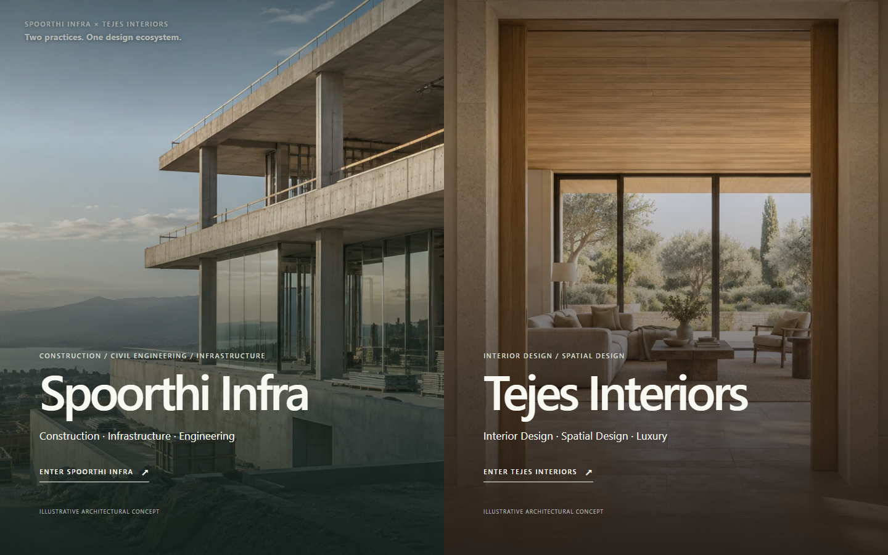
Figure 1 Dual-brand gateway in a desktop browser.

3.3 Frontend Technologies
HTML5 provides the rendered document structure, and JavaScript supplies component logic and interaction. React creates the component tree. Vite serves and builds the application. React Router maps URL paths to pages. Lucide React supplies icons. CSS3 styles the application, including responsive rules. Tailwind CSS appears in the supplied technology list but is not installed in package.json or evident in the examined styles; the current implementation is documented as CSS-based.

3.4 Component-Based Development
Reusable page containers, section wrappers, navigation elements, buttons, form fields, and media components reduce duplication. Brand-specific layouts and page modules make it possible to share interaction patterns without forcing both brands to look the same. Data files hold route paths, navigation, service information, and project concepts.

3.5 Navigation and Routing
The router defines a gateway, Spoorthi Infra pages, Tejes Interiors pages, and a not-found page. Spoorthi routes include civil construction, projects, project detail, design 3D, spatial experience, and contact. Tejes routes include interior design, projects, design 3D, spatial experience, and contact. Page transitions and route focus handling support movement between pages.

3.6 Responsive Design
The stylesheets include layout and responsive rules, while the component tree includes desktop and mobile navigation. The design intent is to preserve readable content, usable menus, and appropriate image treatment across viewport sizes. Actual device and browser certification requires a separate test record.
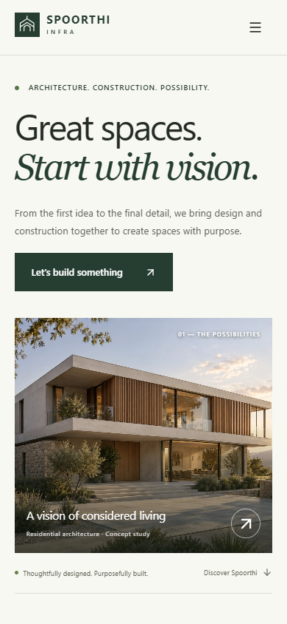
Figure 2 Spoorthi Infra home page at a narrow viewport.

3.7 Design Workflow
The content presents 2D planning as a way to establish layout and spatial relationships. 3D visualization then communicates form, materials, and atmosphere. A final output stage presents the developed direction. The spatial experience extends the visual review through browser-based image exploration. These stages explain the project story; they do not imply a production design pipeline or headset VR system.

3.8 Development Workflow
The repository’s scripts define development, lint, build, and preview commands. A practical workflow is to inspect requirements and content, implement components and routes, check visual behavior in a browser, correct layout and content issues, and build the production bundle. The source shows the implementation; it does not prove the chronology of every development activity.

Chapter 4 Implementation Testing Learning Outcomes and Conclusion

4.1 Frontend Implementation
The main result is a runnable frontend with two related brand experiences. Spoorthi Infra has an architecture and construction home page with approach, services, concept projects, process, spatial experience, questions, and contact links. Tejes Interiors has a separate home page with interior categories, materials, design development, concept studies, and contact paths.
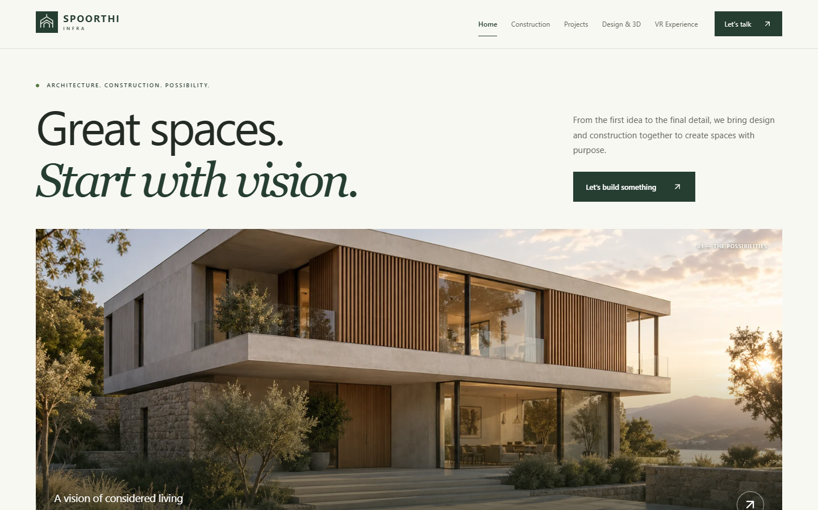
Figure 3 Spoorthi Infra home page.
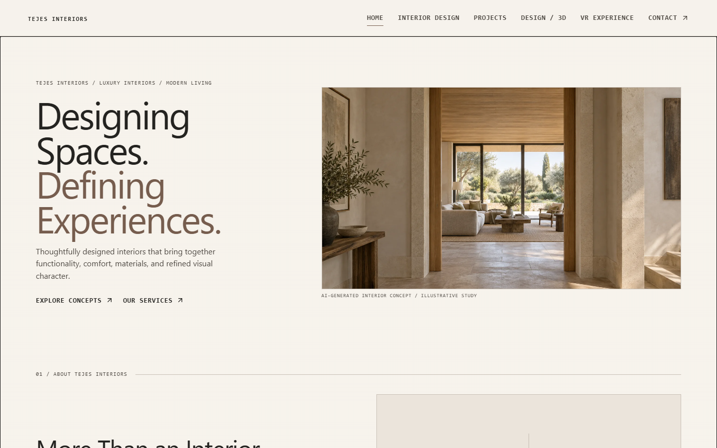
Figure 4 Tejes Interiors home page.

4.2 Feature Descriptions
The gateway directs visitors to one of two brands. The home pages establish each brand’s subject and lead to deeper pages. About and service content explain the scope of work shown by the site. Project pages present concept studies and galleries; the repository explicitly describes these as illustrative concepts rather than completed client projects. 2D, 3D, and final output sections explain progression from plan to visual presentation.

4.3 Spatial Experience and Contact
The Spoorthi Infra spatial page includes a browser image explorer with viewpoint and zoom interactions. Tejes Interiors provides a separate image exploration page with selectable studies and zoom controls. These are frontend visualization experiences; a project-specific 360-degree or headset tour would need additional assets. Contact interfaces validate entries and prepare a brief. Depending on the page, visitors can open an email draft, copy, or download it. No server-side form endpoint is configured.
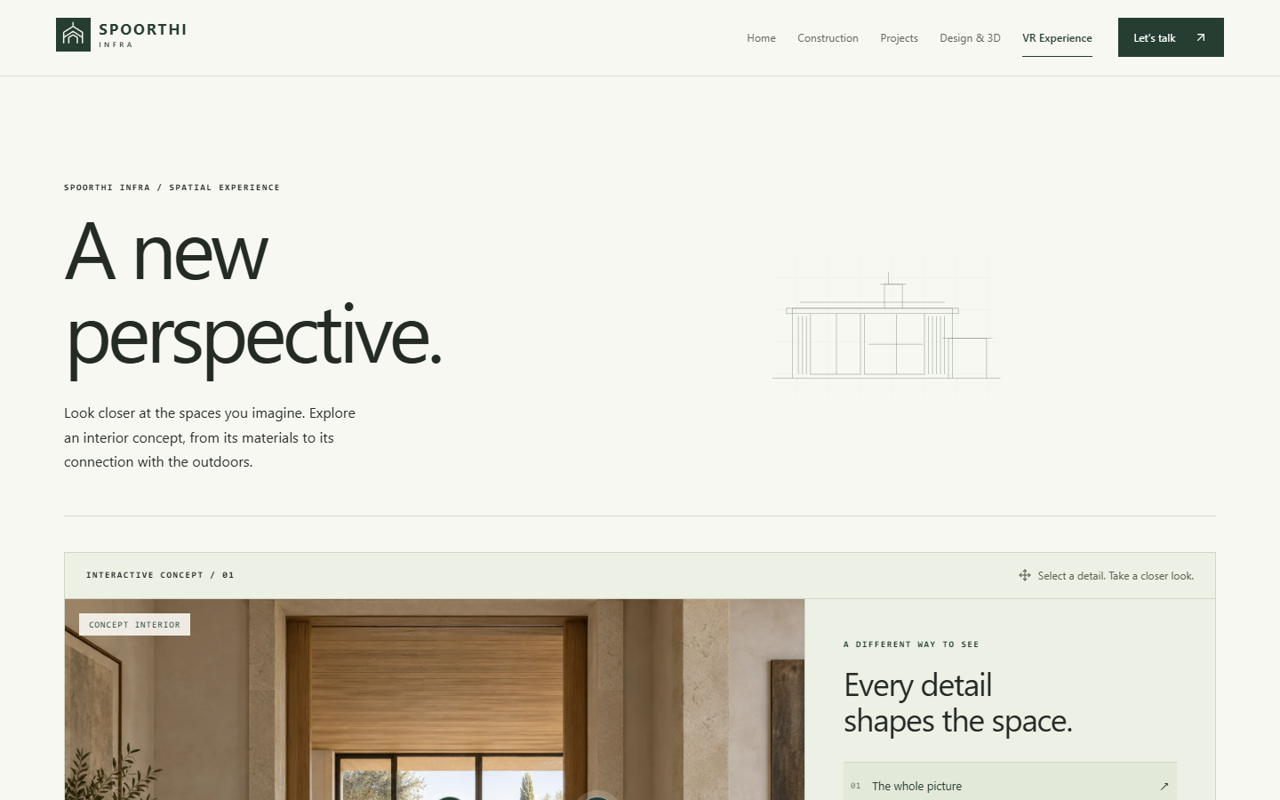
Figure 5 Browser-based spatial experience.
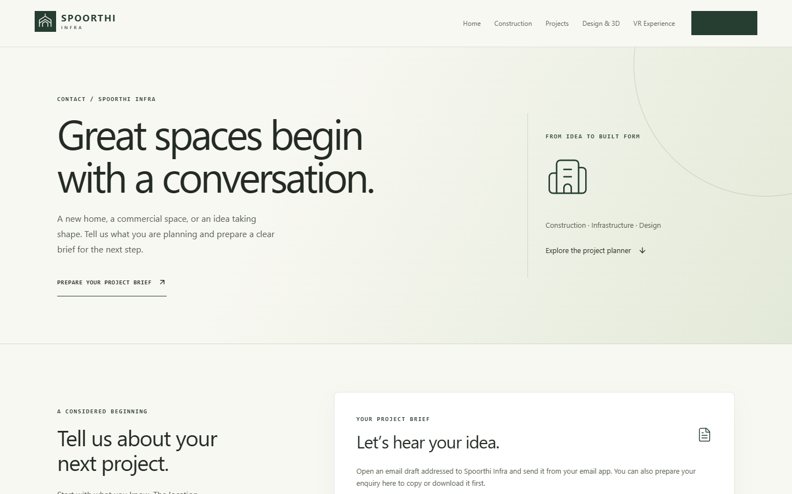
Figure 6 Spoorthi Infra contact page.

4.4 UI Testing Approach
A meaningful frontend check covers direct navigation to each route, menu and keyboard access, gateway selection, visible links and buttons, enquiry validation, project gallery controls, and layouts at wide and narrow viewports. Browser inspection should also check missing images, clipped text, and console errors. These activities are recommended verification criteria; no historical test log was supplied for the internship.

4.5 Challenges and Solutions
Two brands in one application require clear ownership of routes, content, and visual identity. Separate brand layouts and data modules address this. Reusable components reduce repeated markup while allowing brand variants. Contact interaction is handled honestly by preparing an email or downloadable brief rather than displaying a false server-submission success message.

4.6 Limitations
The repository is a frontend application. It has no configured backend service, database, authentication, payment flow, or server-side contact submission. Project imagery and descriptions include illustrative concept studies. The spatial pages are browser-based image experiences, not a verified real-time VR system. Hosting nested routes requires a single-page-application fallback.

4.7 Technical Learning
The project offers practice in building a React component tree, organizing routes, separating content from presentation, applying CSS across several page types, managing form state, and handling browser-only interactions. It also illustrates how to state the boundary between an interactive frontend and a connected service.

4.8 Professional Learning
The internship scope emphasizes requirements, UI review, responsible content integration, communication about technical issues, and attention to usability. These are transferable practices for working on a client-facing website. The repository also shows the importance of marking concept visuals accurately so users do not mistake them for completed projects.

4.9 Conclusion
The website provides a coherent frontend presentation for Spoorthi Infra and Tejes Interiors. A shared React application gives the two brands a common foundation while their routes, layouts, and content guide visitors toward different services. The project meets its presentational goal within the limits of a frontend implementation.

4.10 Future Scope
A later phase could add an approved backend and database, a genuine server-side enquiry workflow with consent and spam protection, approved project photography and verified case studies, broader accessibility review, measured performance optimization, and prepared spatial assets for richer interactive tours. Each enhancement would require separate implementation and testing.

References
[1] Spoorthi Infra, Web Developer Internship Offer Letter, reference SI/INT/WDEV/2026-10, supplied PDF.
[2] Spoorthi Infra, Certificate of Internship for Elasarapu Shanmukha Sai, supplied image.
[3] Spoorthi Infra website repository, package.json, README.md, src/routes, src/pages, src/components, and src/styles, inspected 9 October 2026.

Appendices

Appendix A Selected Route Map
/ is the gateway. /spoorthi and /tejes are the brand home routes. The remaining routes cover construction or interior services, projects, 3D design, spatial experience, and contact.

Appendix B Evidence Notes
The supplied certificate is reproduced after the title page. The offer letter confirms the internship dates and scope. The project source confirms the frontend libraries and route structure. The unavailable PowerPoint reference template could not be compared; this report follows the chapter order supplied in the written instructions.

Appendix C Suggested Screenshot Inserts
Add genuine browser captures of the gateway, both home pages, project pages, spatial experiences, contact interfaces, and a narrow viewport if a submission format requires figures. Captures should come from the running project and carry dates and descriptive captions.

Appendix I Internship Completion Certificate
The supplied certificate confirms completion of a one-month Web Developer internship at Spoorthi Infra.
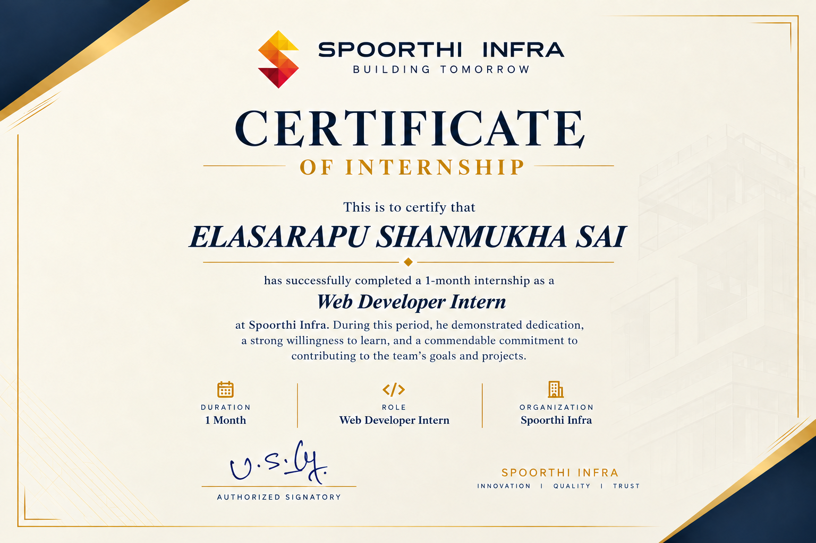
Figure 7 Supplied Spoorthi Infra internship certificate.

Appendix II Internship Offer Letter
The supplied offer letter identifies the role and internship dates.
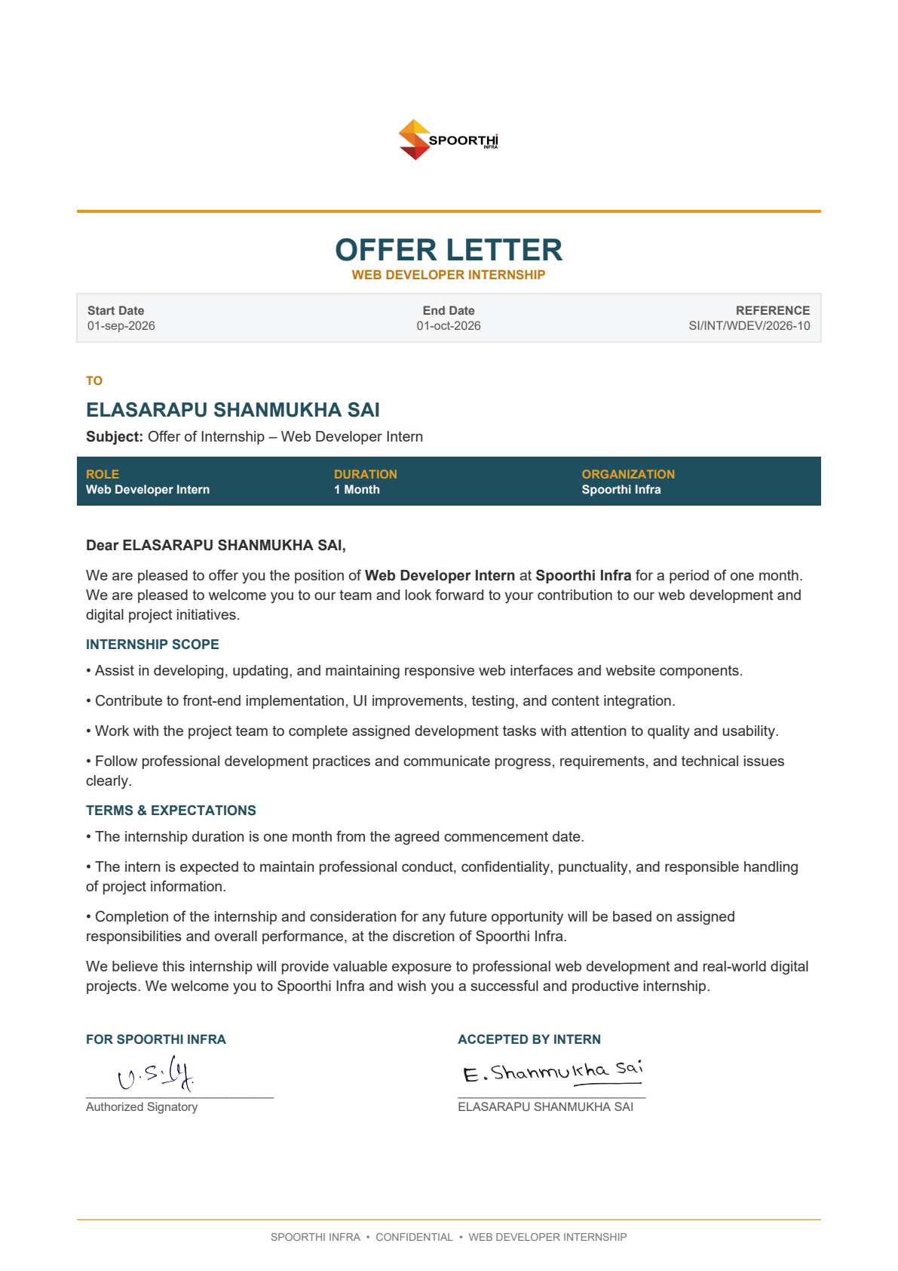
Figure 8 Supplied Spoorthi Infra offer letter.

