**Recognition of Crop Diseases Based on Deep Learning**

**700756736**

**Pasumarthi Shanmukha Laxmi**

**RESULTS**

1.USER INTERFACE

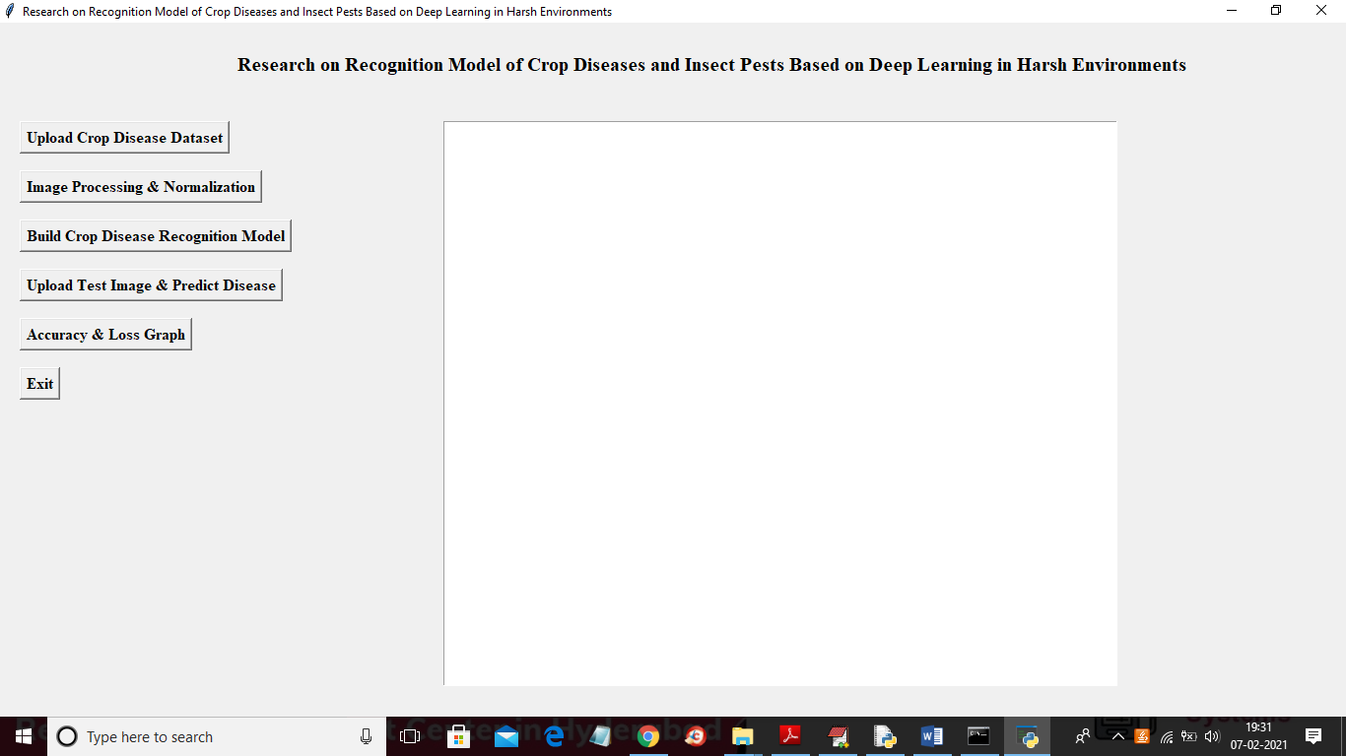

2.UPLOAD DATASET

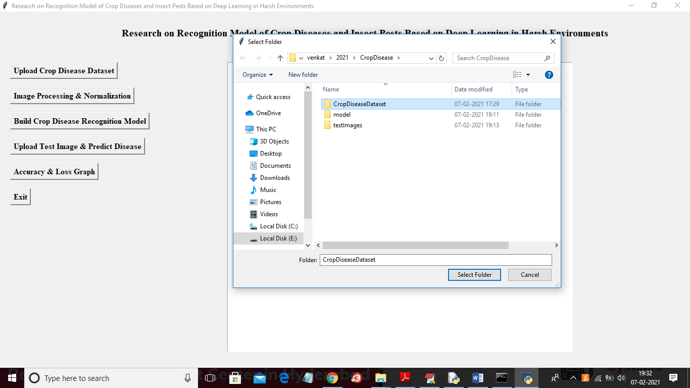

In above screen selecting and uploading ‘CropDiseaseDataset’ folder and then click on ‘SelectFolder’ button to load dataset and to get below screen.

3.CROP DISEASE DATASET

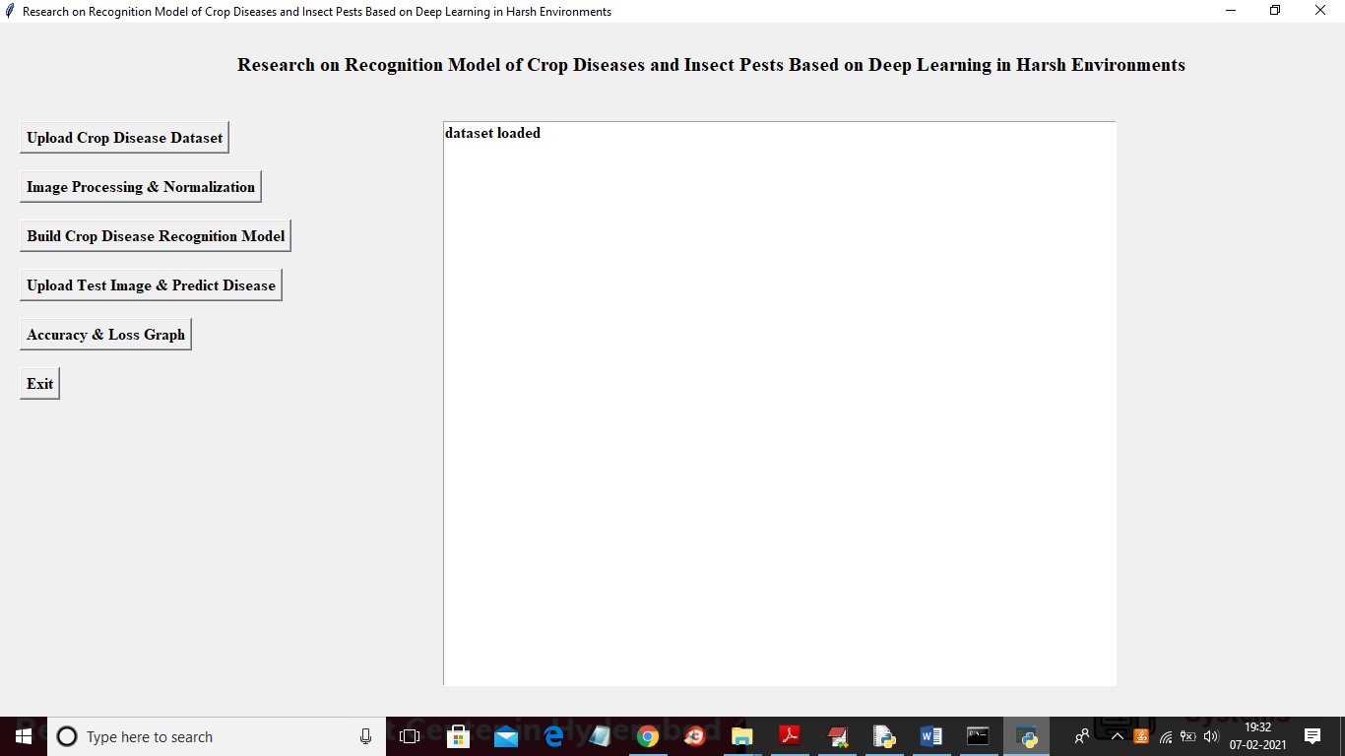

In above screen dataset loaded and now click on ‘Image Processing & Normalization’ button to read all images.

4.IMAGE PROCESSING & NORMALIZATION

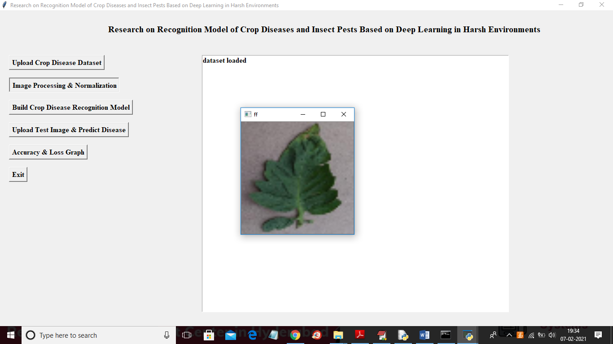

In above screen after applying normalization we are just displaying one random image from dataset to check whether images loaded and process properly or not and now you close above image to get below screen.

5.IMAGE PROCESSING

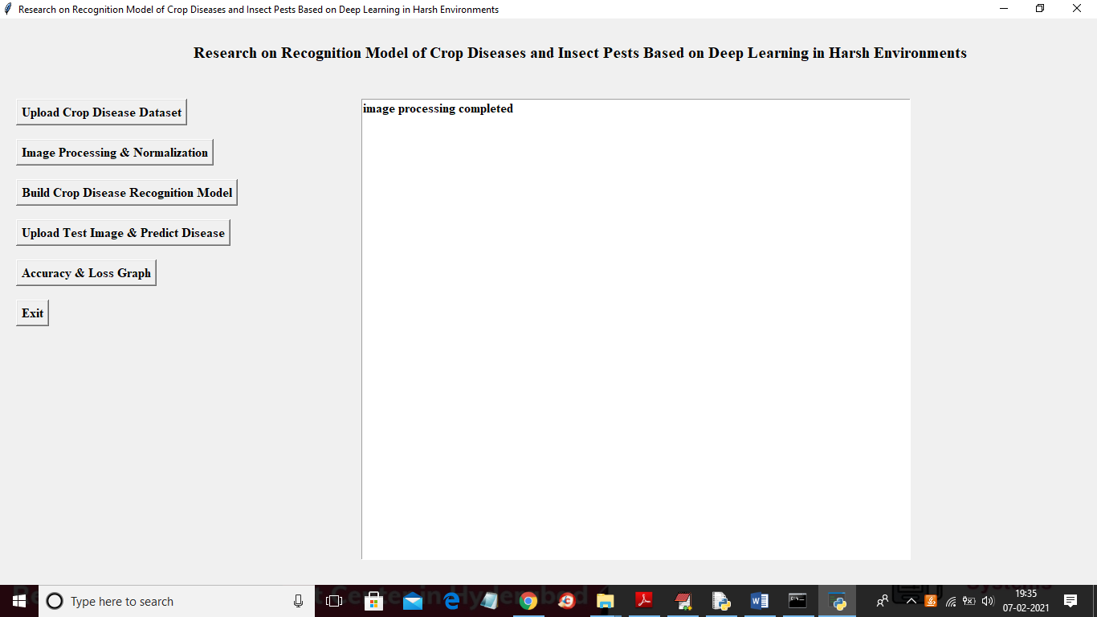

In above screen all images process successfully and now dataset images are ready and now click on ‘Build Crop Disease Recognition Model’ button to build CNN model.

6.BUILD CROP DISEASE RECOGNITION MODEL

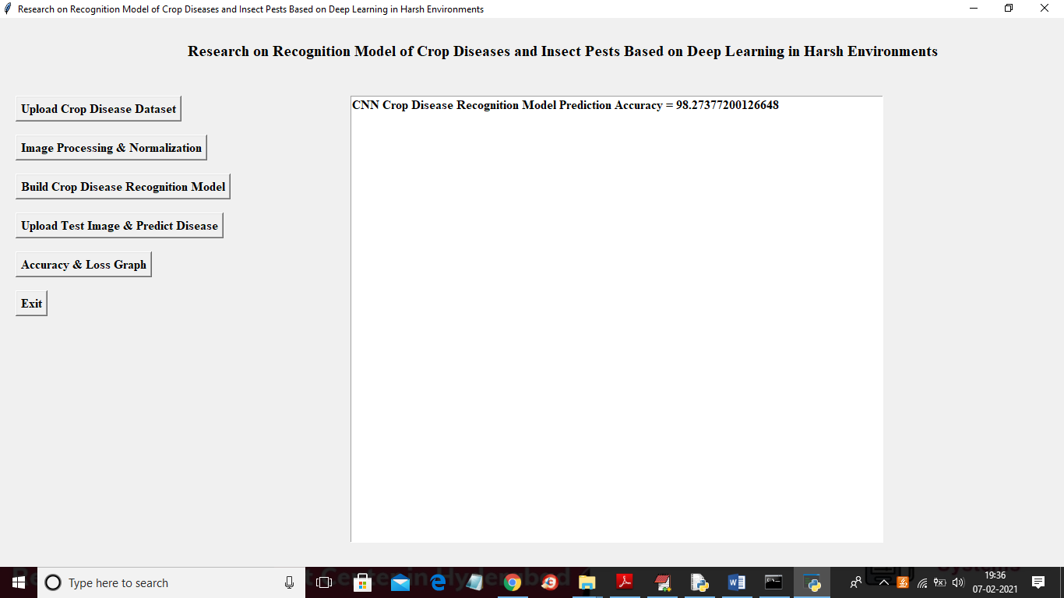

In above screen CNN model generated and its prediction accuracy is 98% and in below console screen we can see all CNN layers details.

7.CNN LAYER DETAILS

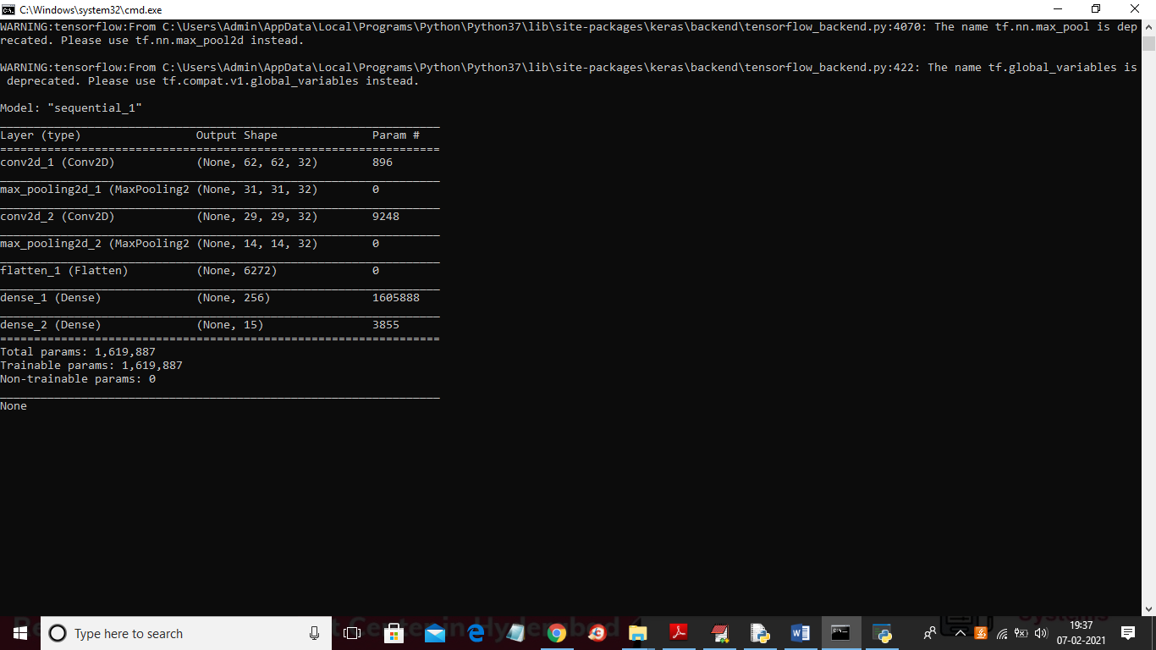

In above screen we can see we have used CONV2D, MAXPOOLING, FLATTEN and DENSE layer to build crop disease recognition model and RELU details you can see in code. Now model is ready and now click on ‘Upload Test Image & Predict Disease’ button to upload any test image and then application will predict disease or healthy from that image.

8.PREDICT DISEASE

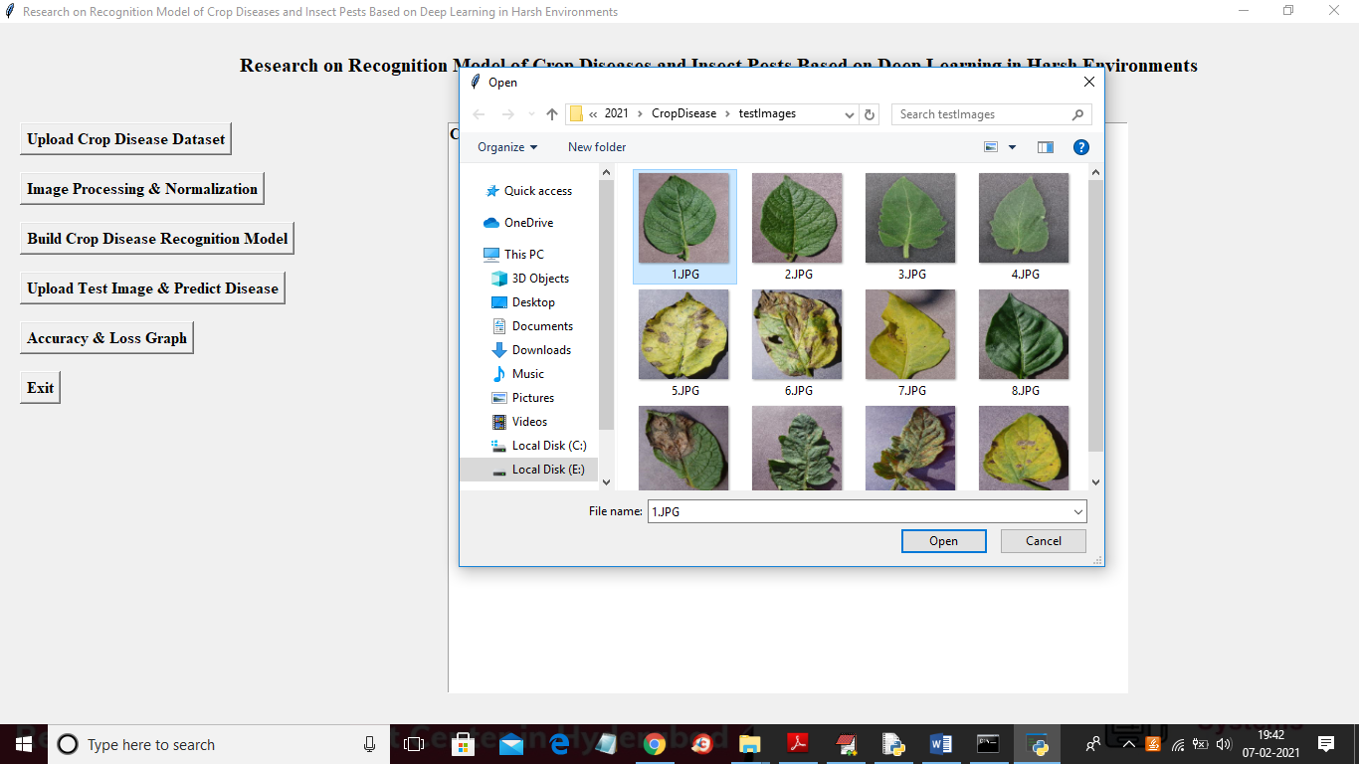

WITHOUT DISEASE:

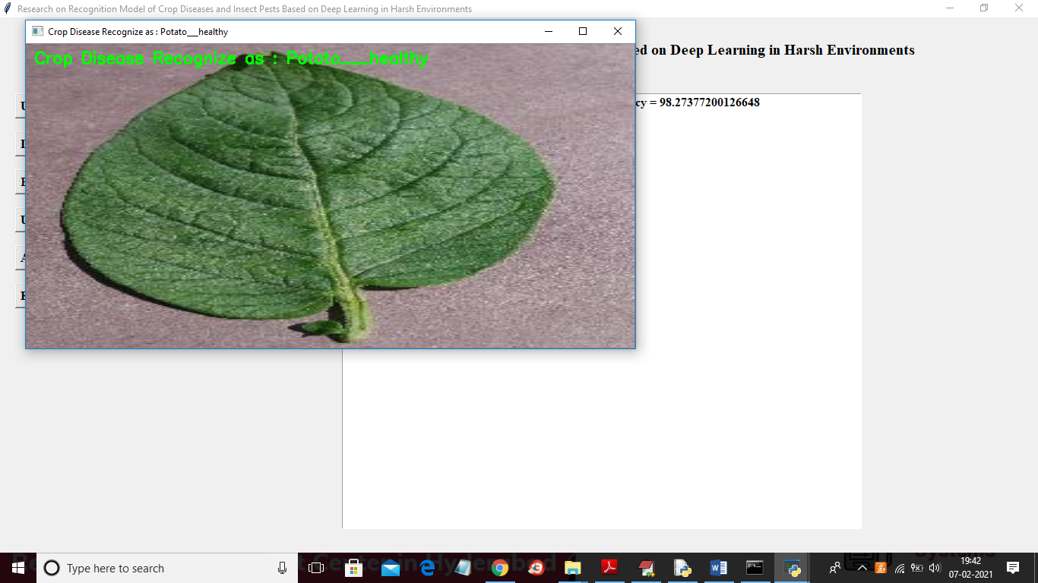

WITH DISEASE:

INPUT:

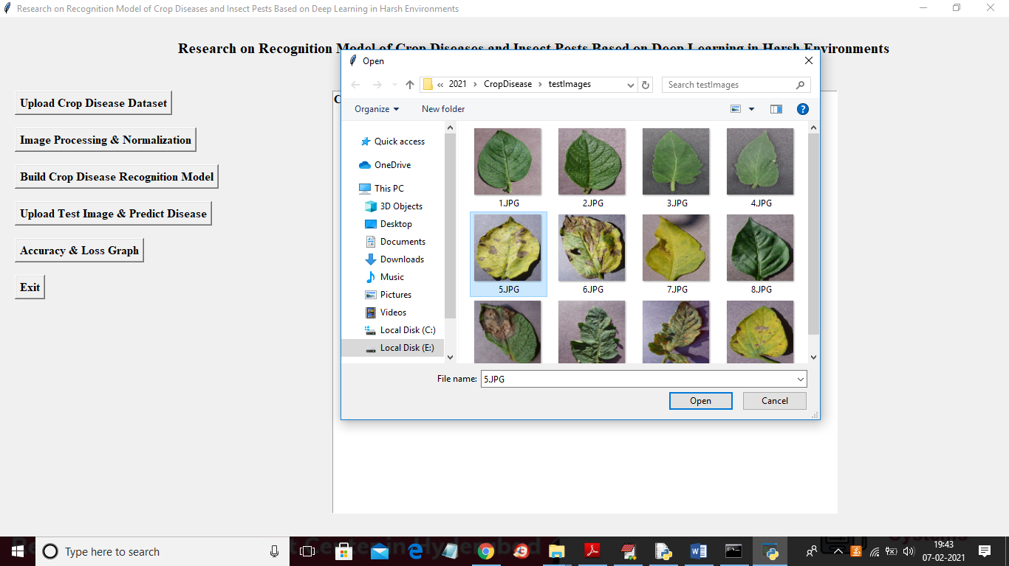

OUTPUT:

