WEB ABL LAB EXPERIMENTS

TASK 1: Movie Website
1. AIM:
To design and create a responsive movie website using HTML and CSS to display movie details, ratings, cast, and synopsis in a clean, structured layout.

2. Source code of html and css
A. HTML Code (review.html):
<!DOCTYPE html>
<html>
<head>
<title>Movie Website</title>
<link rel="stylesheet" href="review.css">
</head>
<body>
<h1>Movie World</h1>
<h2 class="oo">Welcome to our movie website</h2>
<div class="nav">
<a href="#home">Home</a>
<a href="#movies">Movies</a>
<a href="#about">About</a>
</div>
<h2 id="home">About Movies</h2>
<p>Here you can see movie details and ratings.</p>
<h2>Popular Movies</h2>
<div class="movies">
<div class="movie">
<img src="salaar.png" alt="SALAAR">
<h3>Salaar: Part 1 – Ceasefire </h3>
<p><b>Genre:</b> Indian epic action, drama, and thriller film.</p>
<p><b>Release Year:</b> 2023</p>
<p><b>Cast: </b>Prabhas, Prithviraj Sukumaran, Shruti Haasan, Jagapathi Babu</p>
<p class="rate"><b>Rating: </b>8.8/10</p>
<p><b>Synopsis: </b>In the lawless, dystopian city-state of Khansaar, Deva, an unstoppable warrior living in exile, is called back into action by his childhood friend Varadha. As the prince of Khansaar, Varadha faces a violent coup d'état orchestrated by his own family and ministers. Deva must navigate a brutal landscape of rival factions and political intrigue to help his friend reclaim the throne.</p>
</div>
<div class="movie">
<img src="bahubali.png" alt="BAHUBALI">
<h3>Baahubali: The Beginning </h3>
<p><b>Genre:</b> Epic Action, Historical Fantasy, Drama</p>
<p><b>Release Year:</b> 2015</p>
<p><b>Cast: </b>Prabhas, Rana Daggubati, Anushka Shetty, Tamannaah Bhatia, Ramya Krishna, Sathyaraj, Nassar, Subbaraju</p>
<p class="rate"><b>Rating: </b>9.8/10</p>
<p><b>Synopsis: </b>The story centers on a fierce kingdom rivalry, royal betrayal, and a son's quest to reclaim his father's throne.</p>
</div>
<div class="movie">
<img src="kalki.png" alt="kalki">
<h3> Kalki 2898 AD </h3>
<p><b>Genre: </b>Epic Mythological Science Fiction genre. </p>
<p><b>Release Year:</b> 2024</p>
<p><b>Cast: </b>Prabhas, Prabhas, Amitabh Bachchan, Kamal Haasan, Deepika Padukone, Disha Patani, Saswata Chatterjee, Anna Ben, Pasupathy, Keerthy Suresh, Vijay Deverakonda, Dulquer Salmaan, Shobana, Mrunal Thakur, Brahmanandam, S.S. Rajamouli</p>
<p class="rate"><b>Rating: </b>9.6/10</p>
<p><b>Synopsis: </b>After the Kurukshetra War in the Mahabharata, the immortal warrior Ashwatthama (Amitabh Bachchan) is cursed by Lord Krishna to wander until the arrival of Kalki, the final avatar of Vishnu.</p>
</div>
<div class="movie">
<img src="pushpa.png" alt="pushpa">
<h3> Pushpa:THE RULE</h3>
<p><b>Genre:</b>action drama ,Investigate</p>
<p><b>Release Year:</b> 17 December 2021</p>
<p><b>Cast: </b>Allu Arjun, Rashmika Mandanna, Fahadh Faasil, Jagadeesh Prathap Bandari, Sunil, Rao Ramesh, Dhananjaya, Anasuya Bharadwaj, Ajay, Ajay Ghosh, Jagapathi Babu, Divi Vadthya, Shatru, Brahmaji, Mime Gopi.</p>
<p class="rate"><b>Rating: </b>8.7/10</p>
<p><b>Synopsis: </b>follows the rise of Pushpa Raj (Allu Arjun), a fearless daily-wage labourer who climbs to the top of an illegal red sandalwood smuggling syndicate in the Seshachalam Hills of Andhra Pradesh.</p>
</div>
<div class="movie">
<img src="rrr.png" alt="RRR">
<h3>RRR </h3>
<p><b>Genre:</b> action-drama, historical fiction, and musical</p>
<p><b>Release Year:</b> 25 March 2022</p>
<p><b>Cast: </b>N. T. Rama Rao Jr., Ram Charan, Ajay Devgn, Alia Bhatt, Shriya Saran, Samuthirakani, Ray Stevenson, Alison Doody, Olivia Morris</p>
<p class="rate"><b>Rating: </b>9.4/10</p>
<p><b>Synopsis: </b>a fictional story based loosely on the lives of two real-life Indian freedom fighters, Alluri Sitarama Raju and Komaram Bheem, who never met in real life.</p>
</div>
<div class="movie">
<img src="dhu.png" alt="dhurandhar">
<h3>Dhurandhar </h3>
<p><b>Genre:</b>action, spy thriller, crime, and drama genres.</p>
<p><b>Release Year:</b> December 5, 2025.</p>
<p><b>Cast: </b>Ranveer Singh, Akshaye Khanna, Sanjay Dutt, Arjun Rampal, R. Madhavan, Sara Arjun</p>
<p class="rate"><b>Rating: </b>9.5/10</p>
<p><b>Synopsis: </b>Dhurandhar is a high-stakes spy action-thriller directed by Aditya Dhar. It follows an undercover Indian intelligence agent, Jaskirat Singh Rangi (who uses the alias Hamza Ali Mazari), playing a dangerous long-term game inside Pakistan.</p>
</div>
</div>
<h2 id="about">About Us</h2>
<p>We share movie information and reviews.</p>
<footer>
<p>Movie World - 2026</p>
</footer>
</body>
</html>

B. CSS Code (review.css):
body{
background-color: #F2F2F2;
font-family: Georgia, 'Times New Roman', Times, serif;
}
h1{
background-color: #222222;
color: white;
text-align: center;
padding: 20px;
}
.oo{
text-align: center;
color: #B22222;
}
.nav{
background-color: #222222;
padding: 15px;
text-align: center;
}
a{
padding: 15px;
color: white;
text-decoration: none;
}
h2{
color: #B22222;
}
h3{
color: #B22222;
}
.movies{
display: flex;
gap: 20px;
}
.movie{
background-color: white;
border: 1px solid #CCCCCC;
padding: 10px;
width: 200px;
margin: 10px;
}
.movie img{
width: 100%;
height: 250px;
}
.rate{
color: #ffa500;
}
footer{
background-color: #222222;
color: white;
text-align: center;
padding: 5px;
}

3. OUTPUT:
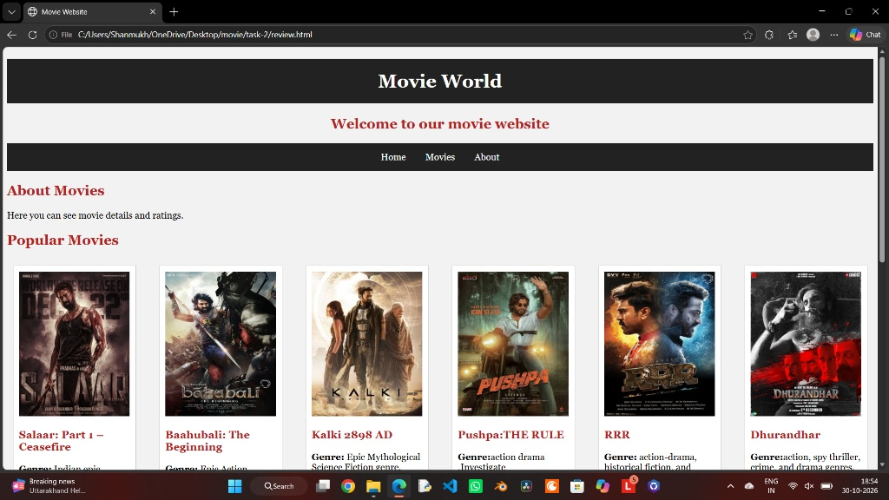

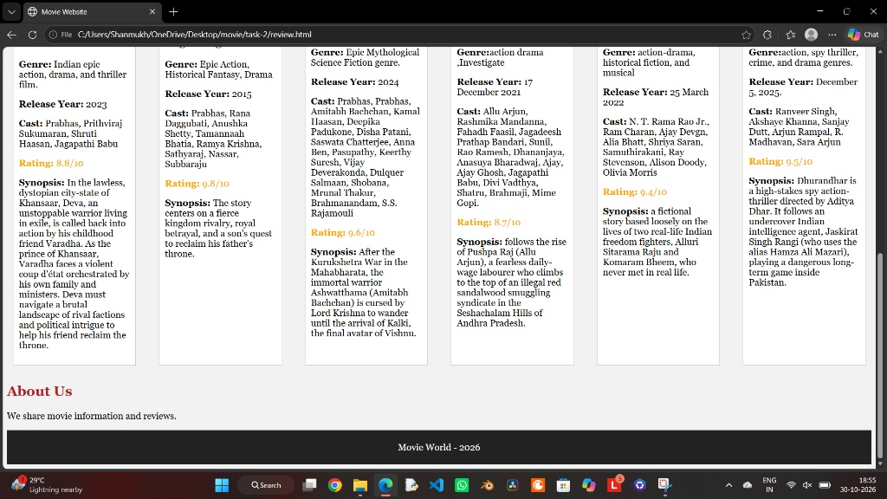

TASK 2: Student Dashboard
1. AIM:
To design and develop a responsive Student Dashboard webpage using HTML and CSS to display student details, semester results, attendance, exam schedule, and announcements in a structured layout.

2. Source code of html and css
A. HTML Code (student.html):
<!DOCTYPE html>
<html lang="en">
<head>
<meta charset="UTF-8">
<meta name="viewport" content="width=device-width, initial-scale=1.0">
<title>STUDENTS</title>
<link rel="stylesheet" href="student.css">
</head>
<body>
<h1>Student Dashboard</h1>
<div class="nav">
<a href="#details">Home</a>
<a href="#results">Results</a>
<a href="#attendance">Attendance</a>
<a href="#exams">Exams</a>
</div>
<h2 id="details">Student Details</h2>
<p>Name: Rahul</p>
<p>Course: B.Tech(CSM)</p>
<p>Semester: 2</p>
<h2 id="results">Semester Results</h2>
<table>
<tr>
<th>Subject</th>
<th>Marks</th>
</tr>
<tr>
<td>Web Development</td>
<td>95/100</td>
</tr>
<tr>
<td>Python</td>
<td>91/100</td>
</tr>
<tr>
<td>GEN-AI</td>
<td>83/100</td>
</tr>
<tr>
<td>Maths</td>
<td>87/100</td>
</tr>
<tr>
<td>English</td>
<td>80/100</td>
</tr>
</table>
<h2 id="attendance">Attendance</h2>
<p>Attendence percentage - 85%</p>
<h2 id="exams">Exam Schedule</h2>
<p>Web Development - 4th November 2026</p>
<p>Python - 6th November 2026</p>
<p>GEN-AI - 8th November 2026</p>
<p>Maths - 10th November 2026</p>
<p>English - 12th November 2026</p>
<h2>Announcements</h2>
<p class="sem">Semester examinations will begin from November 10th.<br>
Hall tickets are now available for download.<br>
The examination timetable has been released.<br>
Students are advised to prepare well for the upcoming examinations.<br>
All students must arrive at the examination hall 15 minutes early.<br>
Internal examinations will be conducted next week.<br>
Practical examinations will start from Monday.<br>
Students must bring their college ID cards to the examination hall.<br>
The last date to pay the examination fee is November 5th.
</p>
<footer>
NRI UNIVERSITY--2026..
</footer>
</body>
</html>

B. CSS Code (student.css):
body{
background-color: #eef2ff;
font-family: Arial;
text-align: center;
}
h1{
background-color: #283593;
color: white;
padding: 20px;
border-radius: 10px;
}
h2{
color: #283593;
}
p{
background-color: white;
color: #333333;
padding: 12px;
margin: 10px auto;
width: 250px;
border-radius: 8px;
}
.nav{
background-color: #3949ab;
padding: 15px;
border-radius: 8px;
}
a{
color: white;
text-decoration: none;
margin: 10px;
}
table{
background-color: white;
margin: auto;
width: 70px;
}
th{
background-color: #3949ab;
color: white;
}
td, th{
border: 1px solid #cccccc;
padding: 12px;
}
.sem{
background-color: white;
color: #333333;
padding: 12px;
margin: 10px auto;
width: 500px;
border-radius: 8px;
}

3. OUTPUT:
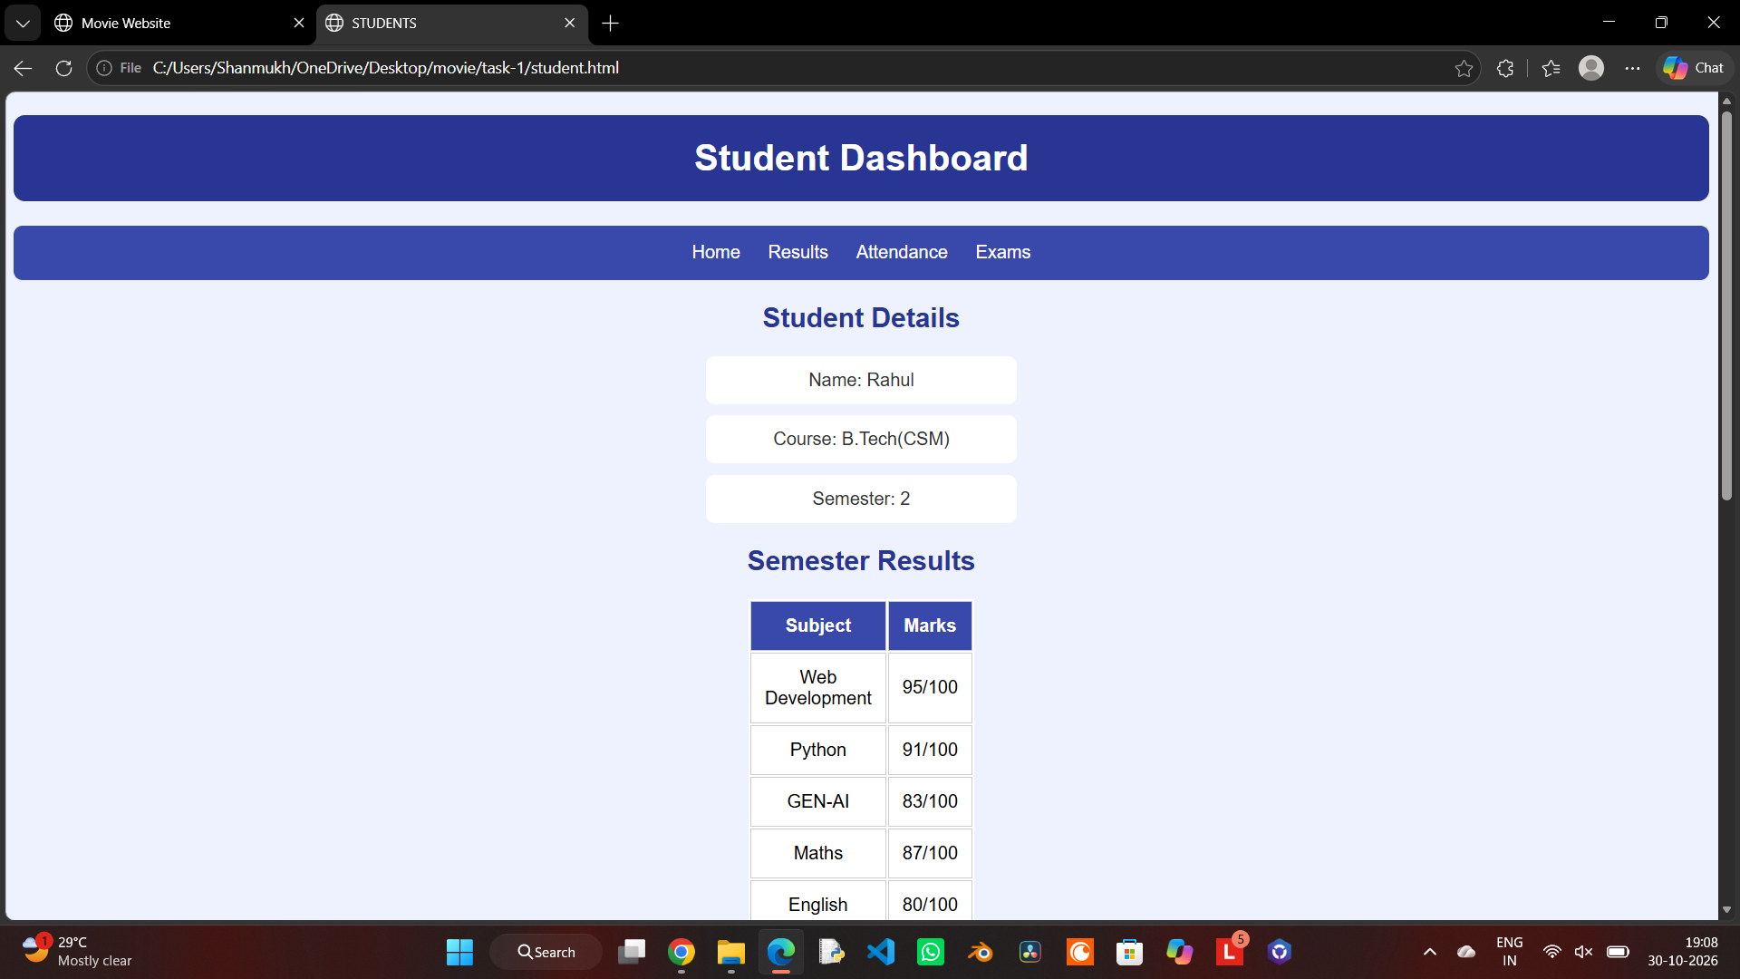

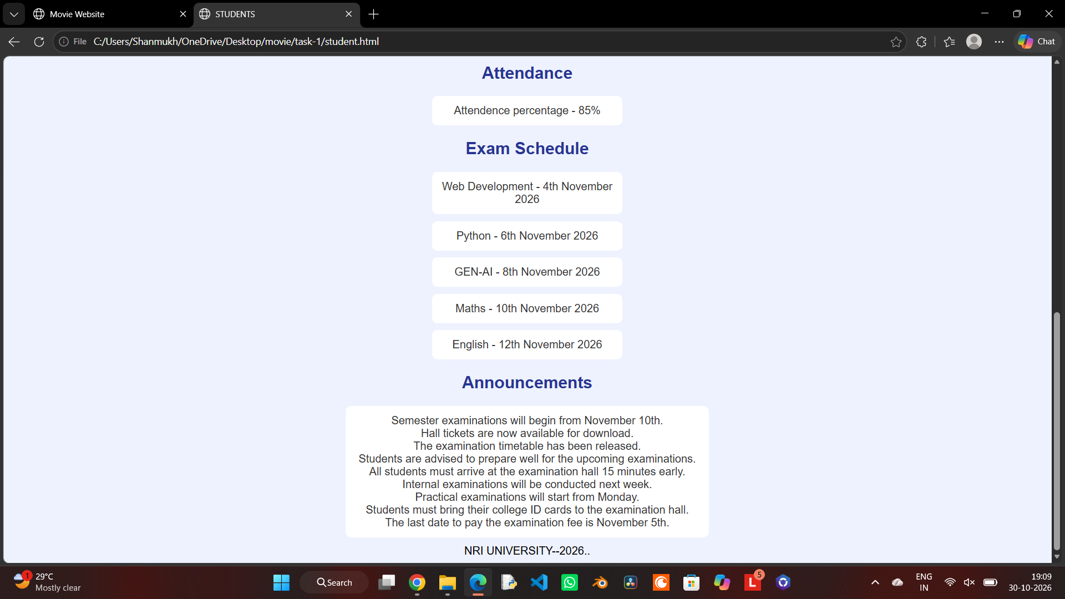

TASK 3: WELLCORE Center Website
1. AIM:
To design and create a responsive wellness website (WELLCORE Center) using HTML and CSS to showcase yoga, meditation, class schedules, and membership plans in an organized layout.

2. Source code of html and css
A. HTML Code (gym.html):
<!DOCTYPE html>
<html lang="en">
<head>
<title>WELLCORE Website</title>
<link rel="stylesheet" href="gym.css">
</head>
<body>
<h1>WELLCORE Center</h1>
<div class="nav">
<a href="#home">Home</a>
<a href="#yoga">Yoga</a>
<a href="#meditation">Meditation</a>
<a href="#classes">Classes</a>
<a href="#contact">Contact</a>
</div>
<div id="home">
<h2>Welcome to WELLCORE Center</h2>
<p>Stay healthy and peaceful with yoga and meditation.</p>
<img src="yoga.png" width="300">
</div>
<div id="yoga">
<h2>Yoga Poses</h2>
<p>Yoga helps to keep our body fit and mind calm.</p>
<img src="yoga2.png" width="200">
</div>
<div id="meditation">
<h2>Meditation</h2>
<p>Meditation helps to reduce stress and improve focus.</p>
</div>
<div id="classes">
<h2>Class Schedule</h2>
<p>Morning Yoga - 6:00 AM</p>
<p>Meditation - 8:00 AM</p>
<p>Evening Yoga - 5:00 PM</p>
</div>
<div id="contact">
<h2>Membership Plans</h2>
<p>Monthly Plan - Rs. 1000</p>
<p>Contact us to join our classes--987654321</p>
</div>
</body>
</html>

B. CSS Code (gym.css):
body {
background-color: #f1f8f2;
font-family: Arial;
text-align: center;
margin: 0;
}
h1 {
background-color: #386641;
color: white;
padding: 25px;
margin: 0;
}
.nav {
background-color: #6a994e;
padding: 15px;
}
a {
color: white;
text-decoration: none;
margin: 12px;
}
div {
padding: 15px;
margin: 15px;
}
h2 {
color: #386641;
}
p {
background-color: white;
width: 280px;
padding: 12px;
margin: 10px auto;
border-radius: 8px;
}
img {
border-radius: 12px;
border: 3px solid white;
}
button {
background-color: #6a994e;
color: white;
padding: 10px 20px;
border: none;
border-radius: 5px;
}

3. OUTPUT:
