WEB ABL TASKS – Easy English Documentation
This document explains the HTML and CSS used in the three WEB ABL tasks. The source-code sections are replaced with easy English explanations. The original output screenshots are kept below the related tasks.

TASK 1: Movie Website

1. Aim
The aim is to create a simple movie website using HTML and CSS. The website displays movie names, posters, genres, release years, cast, ratings, and short story descriptions.

2. Source Code Explanation

HTML Code Explanation
- The HTML5 declaration tells the browser that the page uses HTML5.
- The head section contains the title and connects the HTML file to the CSS file.
- The body contains the visible content of the webpage.
- The main heading displays Movie World and a welcome message is shown below it.
- The navigation bar contains Home, Movies, and About links. Anchor elements are used to move to page sections.
- The Popular Movies section contains separate movie blocks. Each block has a poster, movie name, genre, release year, cast, rating, and synopsis.
- The img element displays movie posters. The src attribute gives the image file name and alt gives alternative text.
- The h3 element is used for movie names. Paragraph elements are used for movie information.
- The About Us section gives a short description and the footer displays the website name and year.

CSS Code Explanation
- The body selector sets the page background and font.
- The h1 selector gives the main heading a dark background, white text, centered text, and padding.
- The navigation class gives the navigation bar a dark background and spacing.
- The a selector styles the navigation links and removes their underline.
- The movies class uses display:flex to place movie cards in a row and gap to create space between them.
- The movie class creates a card using a white background, border, padding, width, and margin.
- The movie image rule controls the poster size.
- The rate class changes the appearance of movie ratings.
- The footer rule styles the bottom section with a dark background and white text.

3. Output – Original Screenshot
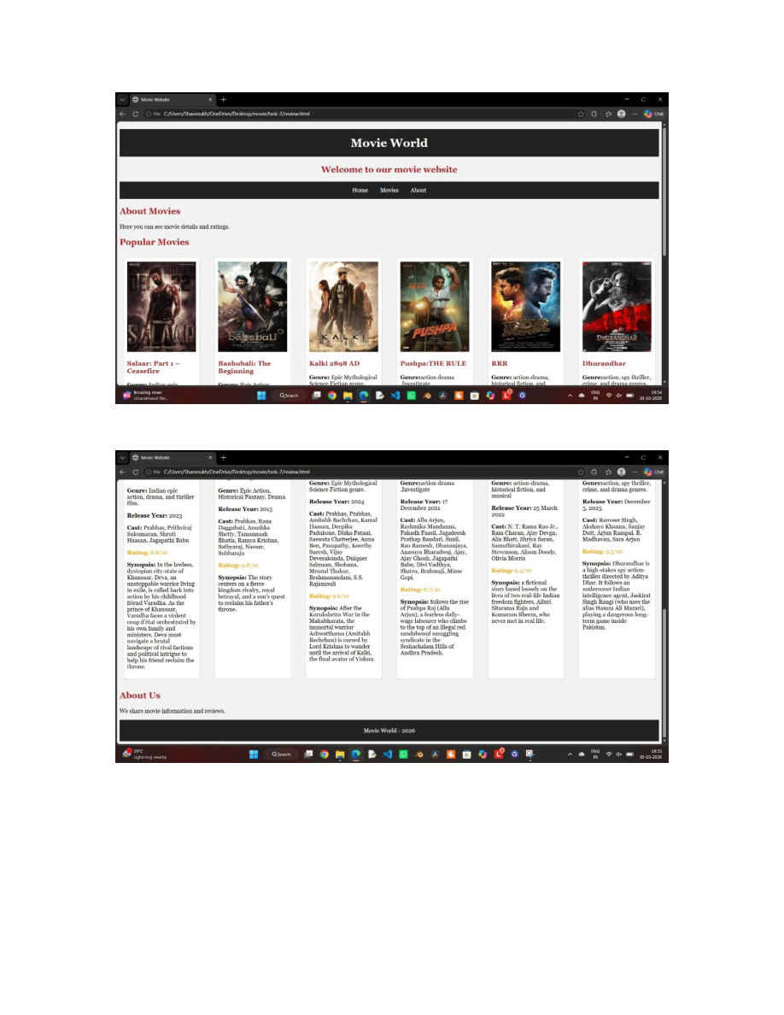

TASK 2: Student Dashboard

1. Aim
The aim is to create a Student Dashboard using HTML and CSS. The dashboard displays student details, semester results, attendance, exam schedule, and announcements.

2. Source Code Explanation

HTML Code Explanation
- The head section contains the character settings, viewport settings, page title, and CSS file connection.
- The main heading displays Student Dashboard.
- The navigation bar contains Home, Results, Attendance, and Exams links.
- The Student Details section displays the student's name, course, and semester.
- The Semester Results section uses a table to display subjects and marks.
- The table uses tr for rows, th for heading cells, and td for normal data cells.
- The Attendance section displays the attendance percentage.
- The Exam Schedule section lists the examination dates for the subjects.
- The Announcements section displays important examination and college notices.
- The footer displays the university name and year.

CSS Code Explanation
- The body rule gives the dashboard a light background, sets the font, and centers the text.
- The h1 rule styles the dashboard heading with a colored background, white text, padding, and rounded corners.
- The h2 rule changes the section-heading color.
- The paragraph rule creates white information boxes with padding, margin, width, and rounded corners.
- The navigation class styles the navigation bar.
- The link rule makes navigation links white and removes the underline.
- The table rules style the table, headings, borders, and cell spacing.
- The announcement class styles the announcement box.

3. Output – Original Screenshot
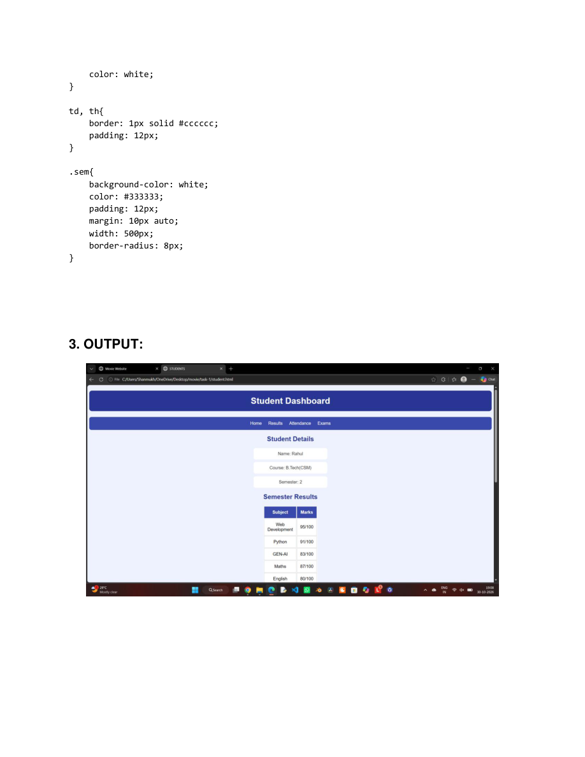
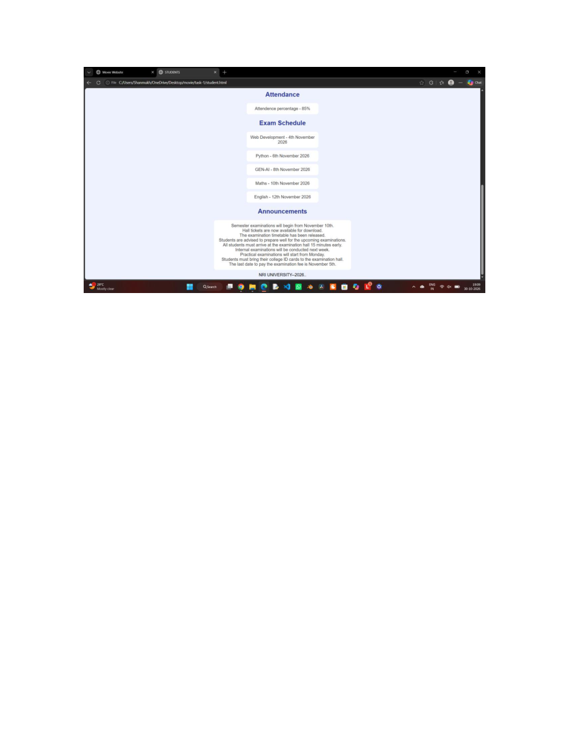

TASK 3: WELLCORE Center Website

1. Aim
The aim is to create a simple wellness website using HTML and CSS. The website provides information about yoga, meditation, class schedules, and membership plans.

2. Source Code Explanation

HTML Code Explanation
- The head section contains the title and connects the CSS file.
- The main heading displays WELLCORE Center.
- The navigation bar contains Home, Yoga, Meditation, Classes, and Contact links.
- The Home section welcomes users and displays an image.
- The Yoga section gives a short description and displays a yoga image.
- The Meditation section explains the purpose of meditation.
- The Class Schedule section lists Morning Yoga, Meditation, and Evening Yoga timings.
- The Membership Plans section displays the monthly plan and contact information.

CSS Code Explanation
- The body rule sets a light background, font, centered text, and removes the default margin.
- The h1 rule creates a green header with white text and padding.
- The navigation class gives the navigation bar a green background and padding.
- The link rule makes the navigation links white and removes their underline.
- The div rule adds spacing around webpage sections.
- The h2 rule changes the section-heading color.
- The paragraph rule creates white content boxes with width, padding, margin, and rounded corners.
- The image rule adds rounded corners and a border to images.
- The button rule styles a button with a green background, white text, padding, and rounded corners.

3. Output – Original Screenshot
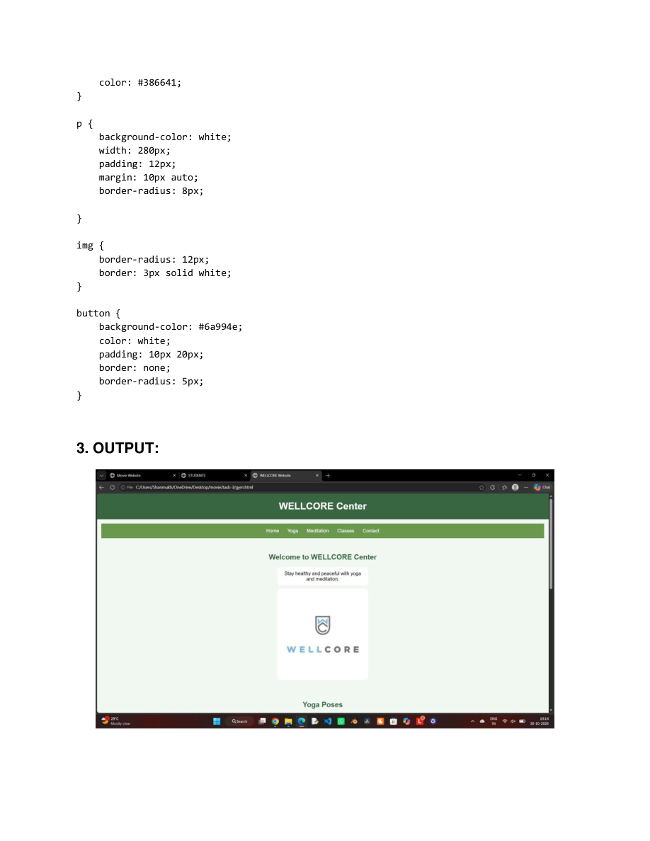
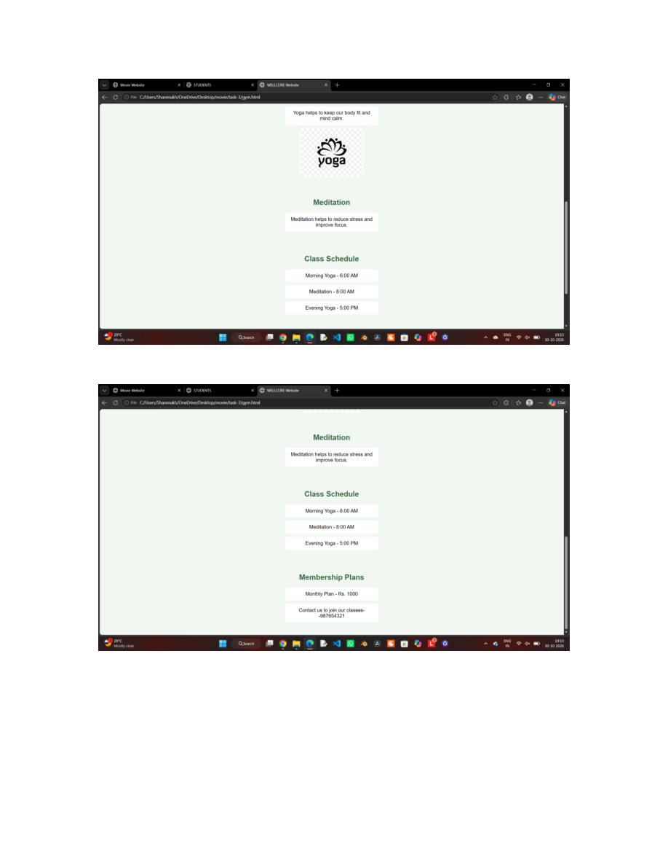

Important HTML and CSS Concepts Used
HTML/CSS Concept | Simple Meaning
h1 | Main heading
h2 | Section heading
h3 | Smaller heading
p | Paragraph
a | Link
img | Image
div | Container or section
table | Creates a table
tr | Creates a table row
th | Table heading cell
td | Table data cell
b | Makes text bold
footer | Footer section
background-color | Changes background color
color | Changes text color
font-family | Changes font style
text-align | Aligns text
padding | Space between content and border
margin | Space outside an element
width | Sets element width
height | Sets element height
border | Adds a border
border-radius | Makes corners rounded
display: flex | Creates a flexible layout
gap | Adds space between flex items
text-decoration: none | Removes link underline

Conclusion
These three tasks demonstrate the basic use of HTML and CSS. The Movie Website shows movie information in movie cards. The Student Dashboard shows student information, marks, attendance, exams, and announcements. The WELLCORE Center shows yoga, meditation, class schedules, and membership information. The original output screenshots are preserved in this document.

