Ex.No.01 - Evidence Acquisition Using AccessData FTK Imager
Experiment Name | Evidence Acquisition Using AccessData FTK Imager
Aim | To acquire volatile memory and create a forensic image of a logical storage volume using AccessData FTK Imager, followed by verification of the acquired evidence.
Tool Used | AccessData FTK Imager, Windows Operating System, Adequate storage space for the acquired evidence image

Experiment Focus: Volatile-memory acquisition, logical-drive imaging, evidence identification, image configuration, acquisition, verification, hash comparison, and review of generated image files.
Output 1 - FTK Imager Main Window
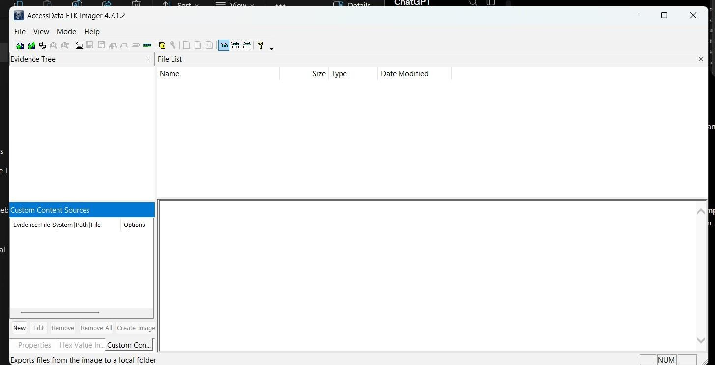
AccessData FTK Imager was launched with the required administrative privileges. The main window provides access to memory acquisition and disk-imaging functions.

Output 2 - Capture Memory Menu
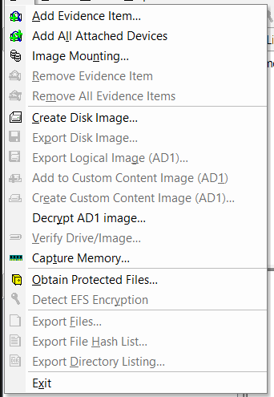
The File menu was opened and Capture Memory was selected to begin volatile-memory acquisition.

Forensic significance: The FTK Imager main window and Capture Memory menu establish the acquisition workflow for volatile memory.

Output 3 - Memory Capture Configuration
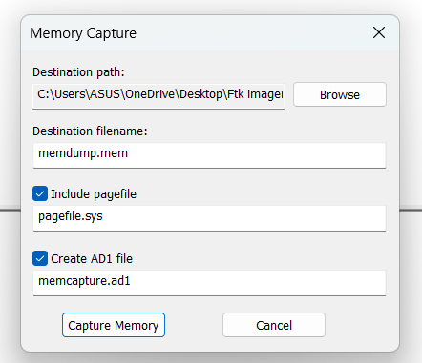
The Memory Capture window was configured with the destination folder and filename for the RAM dump. Required acquisition options were selected.

Output 4 - Memory Acquisition Progress
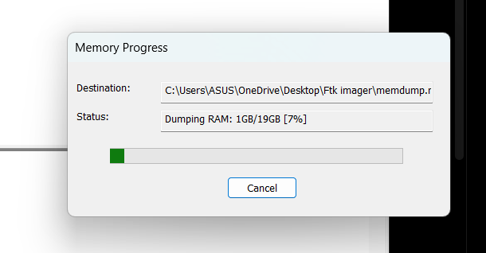
The Memory Progress window displayed the active RAM acquisition and destination information while volatile memory was being collected.

Forensic significance: Memory configuration and progress outputs document the RAM acquisition process and its destination.

Output 5 - Create Disk Image Menu
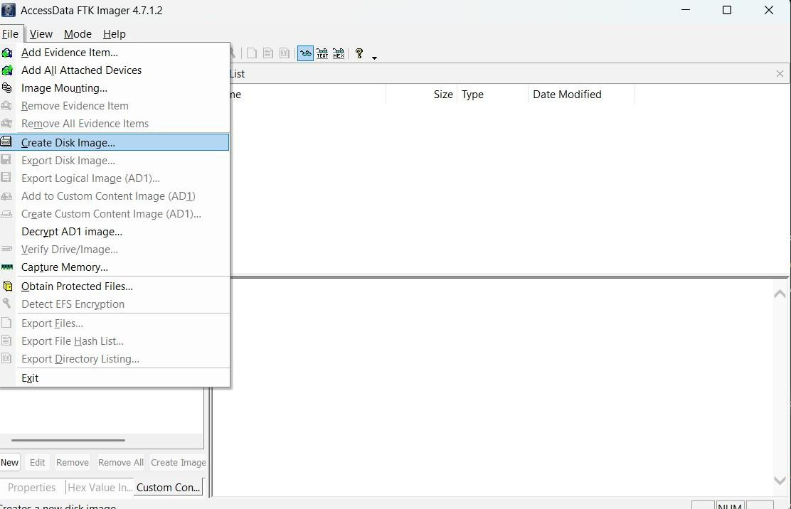
After memory acquisition, File → Create Disk Image was selected. The disk-imaging wizard opened for evidence-source selection and configuration.

Output 6 - Evidence Source Type
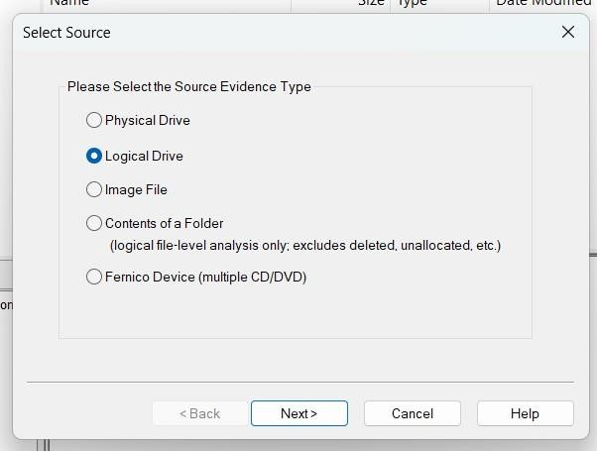
Logical Drive was selected as the evidence source type because the experiment targeted the specific D: logical volume rather than the entire physical disk.

Forensic significance: Create Disk Image and source-selection outputs establish the logical-drive imaging workflow and identify D:\ as the selected source.

Output 7 - Source Drive Selection
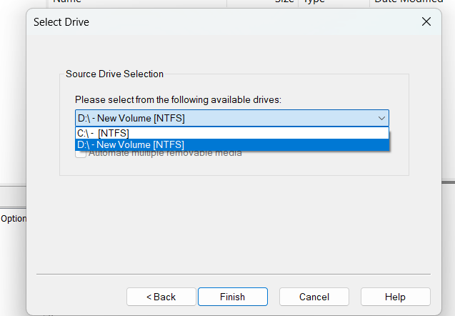
The available logical drives were displayed and D:\ (New Volume [NTFS]) was selected. Finish was used to continue.

Output 8 - Evidence Item Information
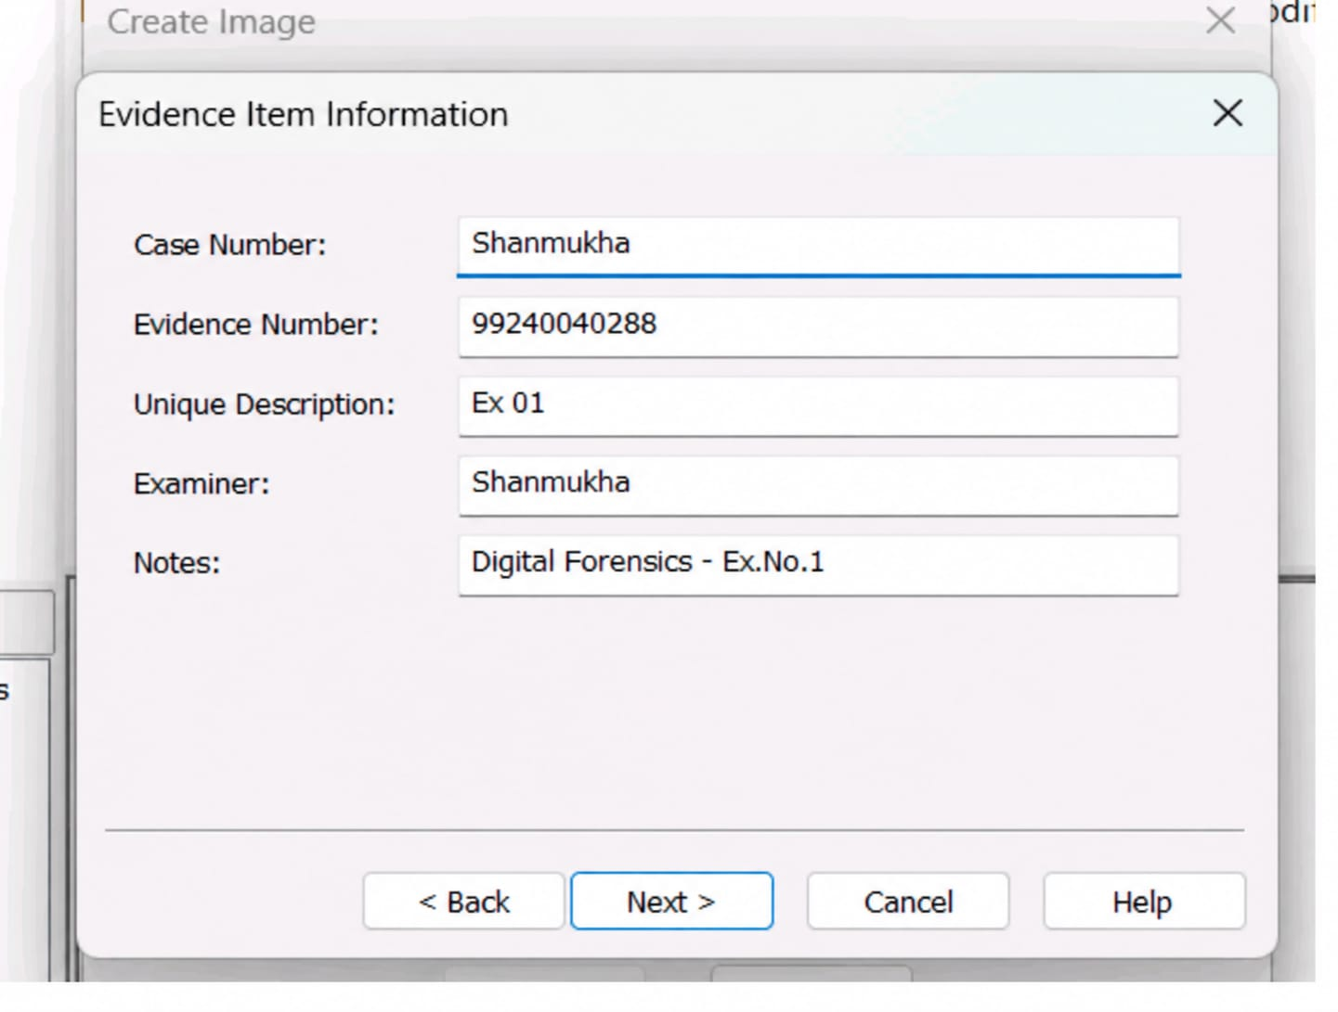
The evidence item information was entered, including case number, evidence number, unique description, examiner name, and notes.

Forensic significance: Evidence Item Information records the case and examiner metadata needed for evidence traceability.

Output 9 - Image Destination and Configuration
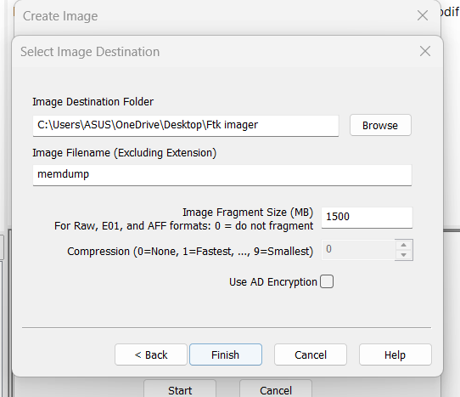
Raw (dd) was selected as the forensic image format. The image fragment size was set to 1500 MB, compression to 0 (None), and AD Encryption was not enabled.

Output 10 - Create Image Configuration and Verification
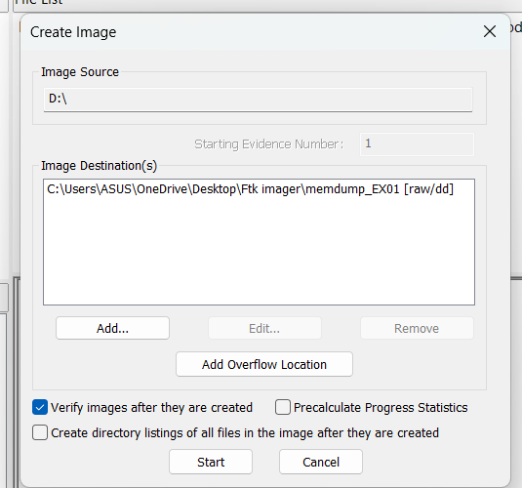
The source drive, image destination, image format, and verification settings were reviewed. Image verification was enabled before acquisition.

Forensic significance: Image configuration and verification outputs document the Raw (dd) format, 1500 MB fragments, no compression, and enabled verification.

Output 11 - Creating Image Progress
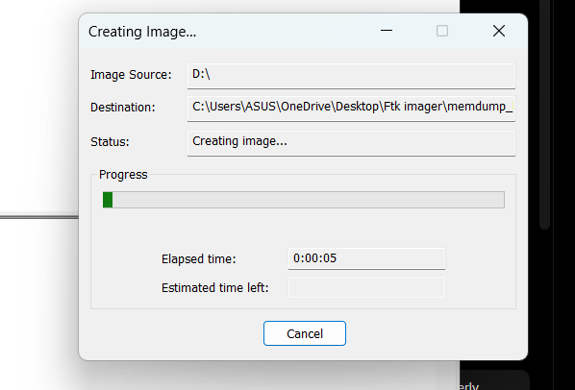
FTK Imager began creating the forensic image of the selected D: logical drive. The progress window displayed the active image-creation process.

Output 12 - Image Verification Progress
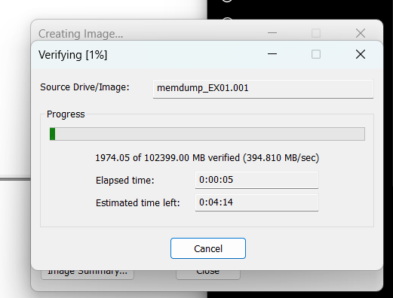
After image creation, FTK Imager initiated verification of the acquired image. The verification window displayed the integrity-check progress.

Forensic significance: The image-creation and verification outputs show the acquisition process and integrity-check stage.

Output 13 - Drive/Image Verification Results
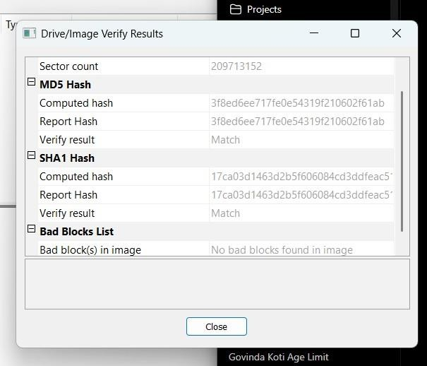
The verification results showed MD5 Verify Result: Match and SHA1 Verify Result: Match, with no bad blocks found in the image.

Output 14 - Image Summary - Case and Evidence Information
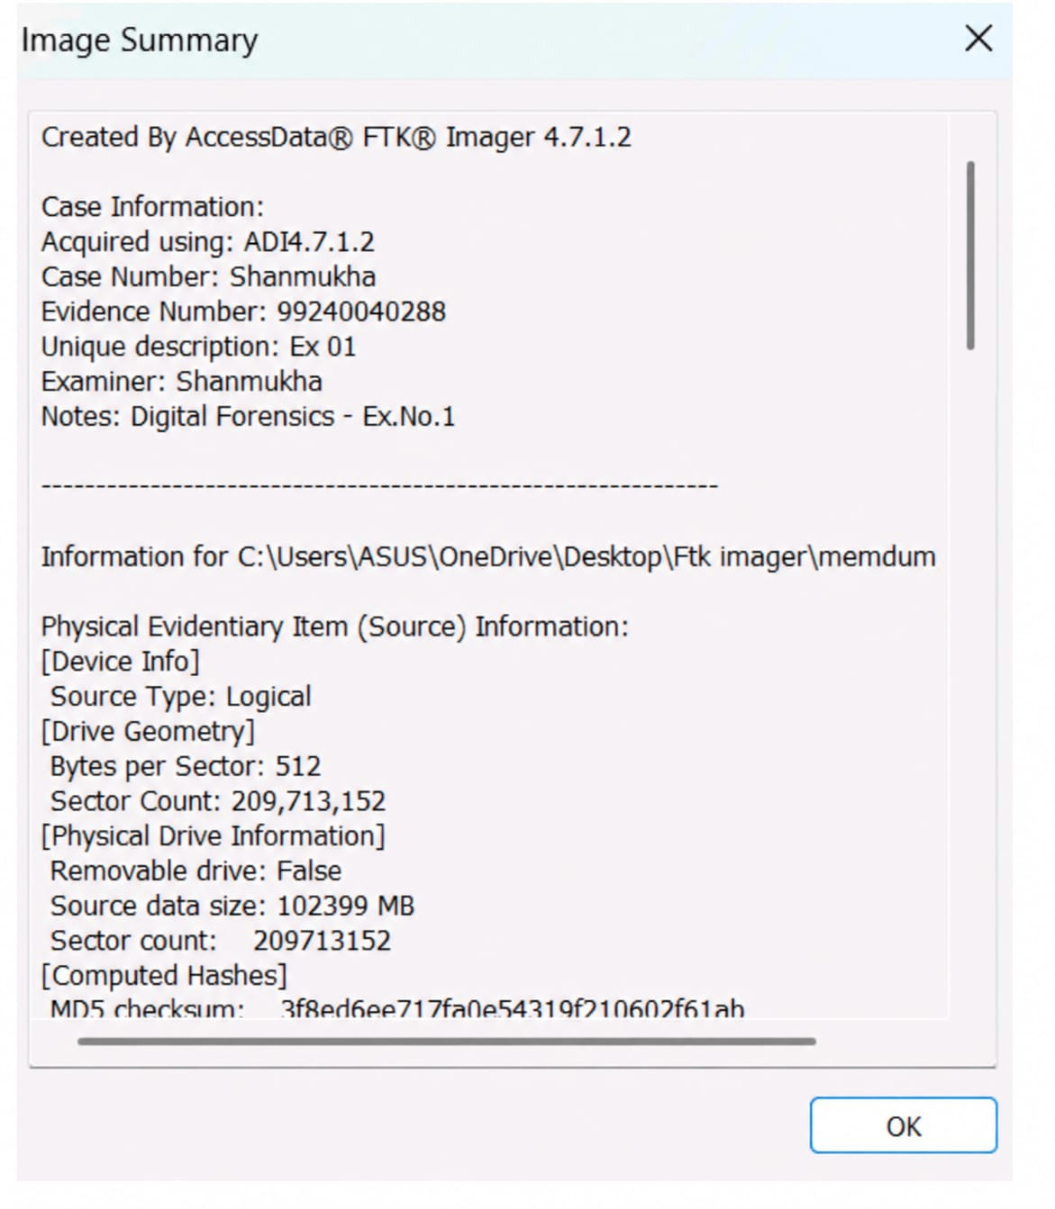
The Image Summary displayed case information, evidence identification, source information, and computed hash information for the acquired forensic image.

Forensic significance: The verification results provide the MD5/SHA1 match evidence and confirm that no bad blocks were found.

Output 15 - Image Summary - Segment List
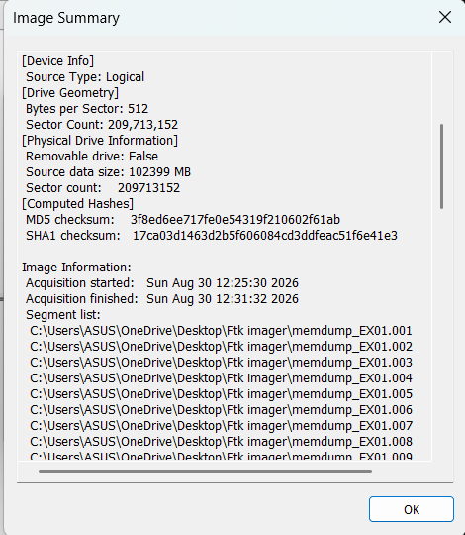
The Image Summary displayed the generated image segments. The acquired image was divided into multiple files according to the configured fragment size.

Output 16 - Image Creation Completed Successfully
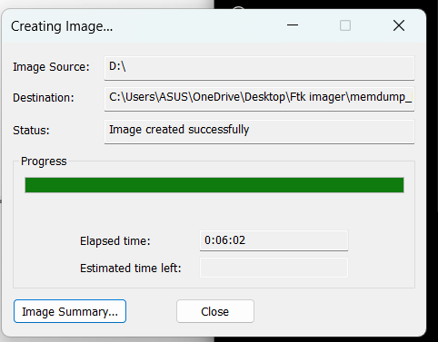
The Creating Image window reported Image created successfully, confirming completion of the forensic image acquisition.

Forensic significance: The image summaries and completion screen document the generated forensic-image segments and successful acquisition.

Output 17 - Generated Forensic Image Files
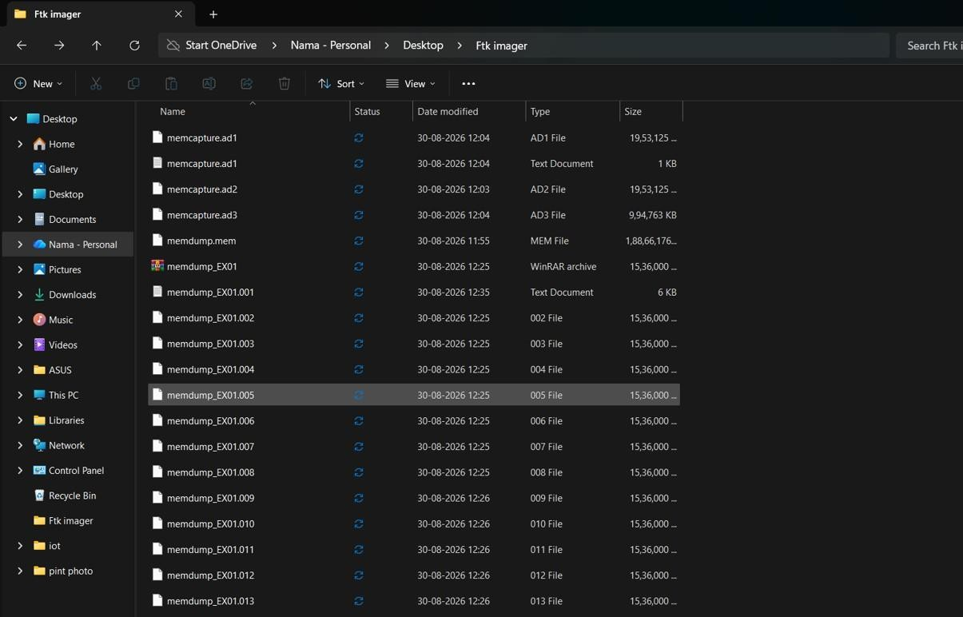
The generated forensic image segments were visible in File Explorer. These numbered segments together represent the acquired forensic image.

Observation
The experiment successfully acquired volatile memory and created a forensic image of the D: logical drive using AccessData FTK Imager. The supplied verification results show MD5 Match, SHA1 Match, and no bad blocks.
Result
The volatile memory acquisition and logical-drive forensic imaging procedures were successfully performed. A forensic image of the D: logical drive was created and verified, and the hash results matched.
Conclusion
The experiment demonstrated a structured forensic evidence-acquisition workflow using FTK Imager, including source selection, evidence identification, image creation, integrity verification, and documentation of generated image segments.
Key forensic keywords
FTK Imager | Volatile Memory | Logical Drive | Raw (dd) | Forensic Image | MD5 | SHA1 | Hash Verification | Evidence Acquisition | No Bad Blocks

