Week 4: Supervised Learning Model Implementation
YuvaIntern Virtual Data Science with Python Trainee Internship
Introduction and problem definition
This project compares binary classifiers for predicting the diagnosis label in a public teaching dataset from numeric measurements. The positive class is malignant, making malignant-class recall important alongside precision, F1, accuracy, and ROC-AUC. This is an educational exercise only, not a clinical decision system and must not be used to diagnose or guide patient care.
Dataset source and description
Source: UCI Machine Learning Repository, Breast Cancer Wisconsin (Diagnostic): https://archive.ics.uci.edu/dataset/17/breast+cancer+wisconsin+diagnostic. Loaded from scikit-learn 1.7.1's bundled copy; no network download was needed. This run used 569 observations and 30 real-valued features. Features describe cell-nucleus measurements derived from digitized fine needle aspirate images. The target is diagnosis: benign or malignant.
Exploration and data quality
Loaded shape: 569 rows by 31 columns including target. Missing feature cells: 0; exact duplicate rows: 0. The target remains separate from predictors, and the bundled matrix contains no identifier feature. Class counts:
class | count
benign | 357
malignant | 212
All 30 available numeric measurements were retained. Missingness, dtypes, example rows, and descriptive statistics are saved as CSV/JSON artifacts.
Preprocessing and feature engineering
The data were split into stratified 80% training and 20% test sets before fitting transformations. A ColumnTransformer and Pipeline put median imputation inside cross-validation folds, preventing preprocessing leakage. Logistic Regression also uses StandardScaler because the feature units differ. Random Forest uses median imputation without scaling because decision trees do not require standardization. No additional feature engineering was applied; retaining documented measures avoids unvalidated derived variables. The diagnosis is used only as the target.
Models and validation strategy
Logistic Regression is the regularized linear baseline (C=1, lbfgs solver, max_iter=3000). Random Forest is a nonlinear comparison (300 trees, unlimited depth, min_samples_leaf=1). Five-fold StratifiedKFold cross-validation compares candidates using only training data. The selection rule is highest mean training-fold malignant-class F1; the held-out test scores are not used to select the model. The test partition is evaluated once after training.
Cross-validation results (mean of five training folds)
model | cv_accuracy_mean | cv_precision_malignant_mean | cv_recall_malignant_mean | cv_f1_malignant_mean | cv_roc_auc_malignant_mean
Logistic Regression | 0.9736263736263737 | 0.9771428571428572 | 0.9529411764705882 | 0.9640480895915677 | 0.9957688338493291
Random Forest | 0.9604395604395606 | 0.9583806381790254 | 0.9352941176470588 | 0.9461476442657494 | 0.9879772961816305
Held-out test model comparison
model | test_accuracy | test_precision_malignant | test_recall_malignant | test_f1_malignant | test_roc_auc_malignant
Logistic Regression | 0.9649122807017544 | 0.975 | 0.9285714285714286 | 0.9512195121951219 | 0.996031746031746
Random Forest | 0.9736842105263158 | 1.0 | 0.9285714285714286 | 0.9629629629629629 | 0.9943783068783069
Selected by training cross-validation malignant F1: Logistic Regression. Its held-out test metrics: accuracy=0.9649, precision_malignant=0.9750, recall_malignant=0.9286, f1_malignant=0.9512, roc_auc_malignant=0.9960. These results describe one split and do not establish perfect generalization.
The highest malignant F1 on this test split belongs to Random Forest (0.9630); this test result does not override the training-only cross-validation selection, because using it to select a model would leak test information into model choice.
Classification report
precision recall f1-score support

benign 0.96 0.99 0.97 72
malignant 0.97 0.93 0.95 42

accuracy 0.96 114
macro avg 0.97 0.96 0.96 114
weighted avg 0.97 0.96 0.96 114
Confusion matrix and ROC curve
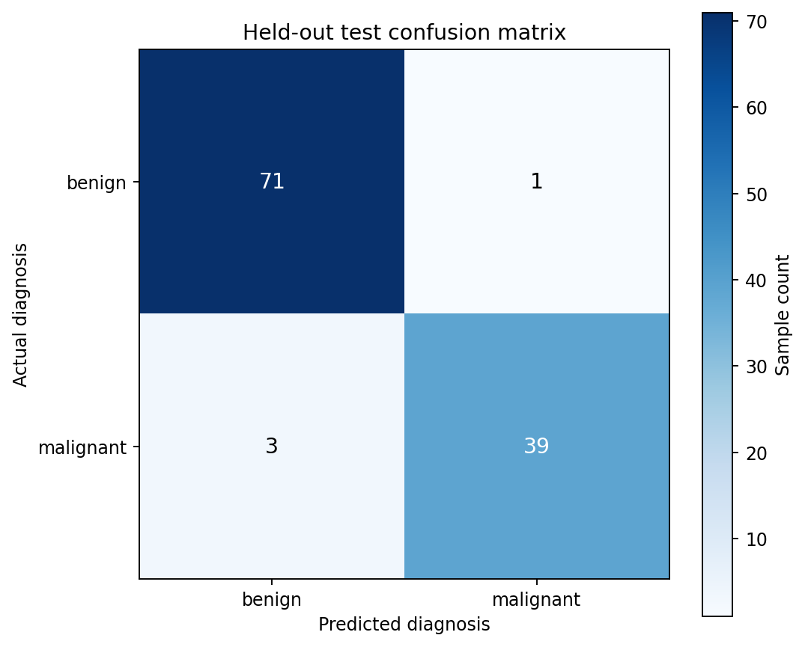
Held-out test confusion matrix: actual rows, predicted columns, benign and malignant classes.
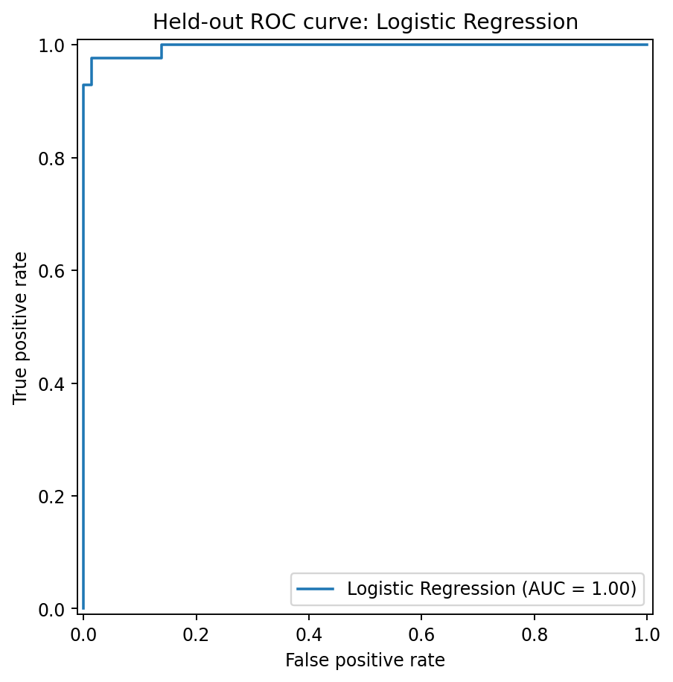
Held-out ROC curve for the selected model; threshold performance and clinical costs require separate analysis.
Feature interpretation
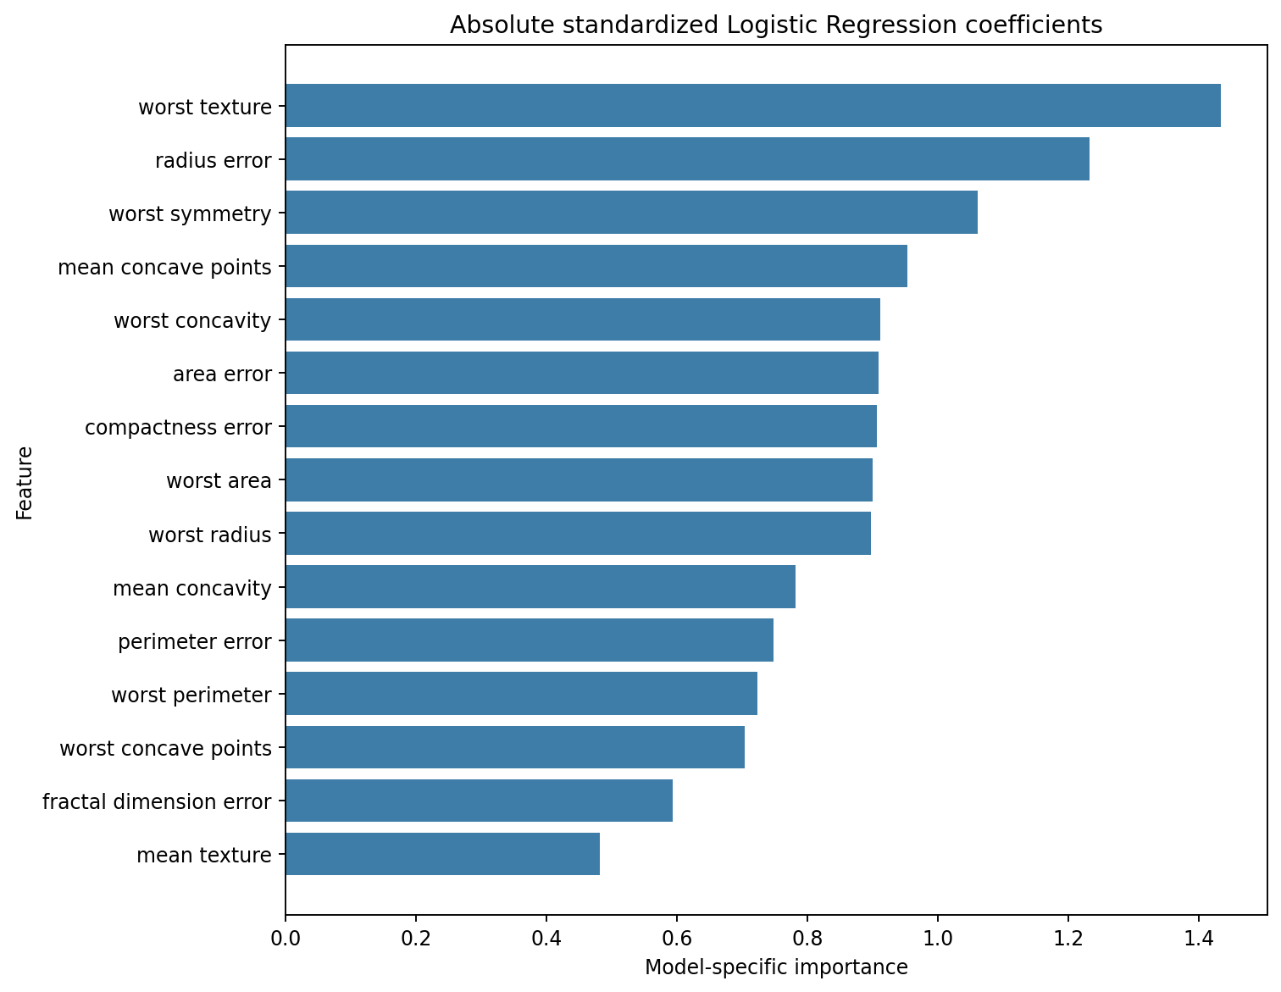
Top model-specific feature coefficients or importances; these are not causal explanations.
Coefficients or impurity-based importances can be unstable when measurements are correlated. They describe the fitted model, not medical facts or causes.
Strengths, limitations, ethics, and future improvements
Strengths include public data, train-only preprocessing pipelines, stratified validation, cross-validation, an independent test partition, and transparent model comparison. Limitations include a modest historical sample, one split, no external validation, correlated features, and no decision-cost analysis. Medical errors have serious consequences. The model is not for real-world diagnosis or treatment. Further work would require representative external validation, calibration, threshold selection with clinical experts, privacy protections, fairness assessment, regulatory review, and human oversight.
Conclusion
This project demonstrates a reproducible supervised classification workflow with a linear baseline, a nonlinear comparison, cross-validation, and held-out metrics. Results are for learning model evaluation only.
Reproducibility code excerpts
X_train, X_test, y_train, y_test = train_test_split(X, y, test_size=0.20, stratify=y, random_state=42)
pipeline = Pipeline([('preprocess', preprocessor), ('model', classifier)])
cross_validate(pipeline, X_train, y_train, cv=StratifiedKFold(5), scoring=scoring)

