Week 5: Deep Learning Application in Data Science
Fashion-MNIST clothing image classification with PyTorch.
Objective and problem statement
Classify each 28×28 grayscale clothing image into one of ten garment categories. Inputs are normalized image pixels; targets are integer labels 0–9; output is a ten-class score vector and predicted class. Convolutional layers are appropriate because they learn local spatial patterns such as edges and textures while sharing weights across an image. A simpler linear or tabular model on flattened pixels may be faster but does not use image locality as naturally; the CNN needs more computation and can still generalize poorly beyond this benchmark. This is an educational image-recognition example, not a commercial product-recognition guarantee.
Dataset source, dimensions, and licensing
Fashion-MNIST by Zalando Research, source: https://github.com/zalandoresearch/fashion-mnist. The dataset has 60,000 training and 10,000 official test images, each 28×28 grayscale, across ten classes. It is released under the MIT License; see https://github.com/zalandoresearch/fashion-mnist/blob/master/LICENSE. This run split the official training partition into 54000 training and 6000 validation images; the official test set of 10000 remained held out.
Data preparation and preprocessing
Pixel images are represented as 28×28 grayscale arrays with integer values 0–255. torchvision ToTensor converts them to float tensors in [0,1] and adds the channel dimension, giving 1×28×28 inputs. A seeded stratified split creates validation indices from the official training portion. Per-class counts are balanced; observed split counts are recorded in outputs/dataset_inspection.json. No test image was used for fitting, early stopping, or model design decisions.
Neural network architecture
Two convolutional blocks learn spatial patterns: Conv2d 1→32 (3×3, padding 1), ReLU, 2×2 max pooling; then Conv2d 32→64 (3×3, padding 1), ReLU, max pooling. The 64×7×7 map is flattened, passed through a 128-unit ReLU layer and Dropout(0.30), then a 10-logit output layer. CrossEntropyLoss combines multiclass log-softmax and negative log likelihood; Adam uses learning rate 0.001 and weight decay 0.0001. The architecture diagram is included below.
Training configuration and methodology
Device: cpu; CPU thread limit: 6. Batch size 128; maximum 5 epochs; early-stopping patience 2; best validation-loss checkpoint restored at epoch 5. Random seed 42. The model uses Dropout to reduce co-adaptation and Adam weight decay as L2-style regularization. Early stopping avoids continuing when validation loss stops improving. A CPU-friendly CNN was selected because PyTorch is installed and CUDA is unavailable.
Actual training and validation results
Training completed 5 epochs. Best validation loss was 0.2311; validation accuracy at the best-loss checkpoint was 0.9157. The plotted curves show train and validation loss/accuracy for each completed epoch. Validation loss decreased at every observed epoch and reached 0.2311 at epoch 5; training loss was 0.2699. There is no validation-loss evidence of overfitting within these 5 epochs, but the short CPU-limited run cannot rule out overfitting with longer training.
Held-out test evaluation
On the official held-out test set, accuracy was 0.9011 and macro F1 was 0.9000. The classification report below includes per-class precision, recall, F1, and support. The lowest class recall was Shirt (0.65); the most frequent off-diagonal confusions were Shirt predicted as T-shirt/top (161); Shirt predicted as Coat (81). These patterns can guide data or architecture improvements, but do not establish performance on new images or real catalog photos.
Challenges, limitations, and improvements
Images are small grayscale crops, unlike real-world product photographs with varied lighting, backgrounds, angles, and multiple objects. A compact CNN limits CPU time but may underfit more complex patterns; five epochs and early stopping constrain runtime. Fashion-MNIST is balanced and relatively clean, so test performance may overstate deployment results. Potential improvements include data augmentation, learning-rate scheduling, repeated seeds, a larger GPU-trained model, and validation on a more representative product-photo dataset.
Practical applications and ethical considerations
Image classification can support exploratory catalog tagging or educational computer-vision pipelines. This dataset does not establish accuracy on commercial inventory, accessibility impacts, or fairness across users and products. Validate on representative images before any operational use.
Conclusion
A compact convolutional network was trained with an isolated validation set and evaluated on the untouched official test partition. The artifacts preserve the real history, predictions, and class-level evaluation for review; results should be interpreted within the dataset and hardware limitations.
Code excerpts and reproducibility
# Normalize pixels and add the channel dimension
transform = transforms.ToTensor()
# Training-only optimization; validation controls checkpointing
loss = criterion(model(images), labels)
loss.backward()
optimizer.step()
Test classification report
precision recall f1-score support
T-shirt/top 0.81 0.89 0.85 1000
Trouser 0.99 0.98 0.98 1000
Pullover 0.84 0.84 0.84 1000
Dress 0.90 0.91 0.90 1000
Coat 0.81 0.87 0.84 1000
Sandal 0.97 0.98 0.98 1000
Shirt 0.78 0.65 0.71 1000
Sneaker 0.96 0.94 0.95 1000
Bag 0.98 0.98 0.98 1000
Ankle boot 0.96 0.96 0.96 1000
accuracy 0.90 10000
macro avg 0.90 0.90 0.90 10000
weighted avg 0.90 0.90 0.90 10000
Class counts in official training/test data
class | train_count | validation_count | test_count
T-shirt/top | 5400 | 600 | 1000
Trouser | 5400 | 600 | 1000
Pullover | 5400 | 600 | 1000
Dress | 5400 | 600 | 1000
Coat | 5400 | 600 | 1000
Sandal | 5400 | 600 | 1000
Shirt | 5400 | 600 | 1000
Sneaker | 5400 | 600 | 1000
Bag | 5400 | 600 | 1000
Ankle boot | 5400 | 600 | 1000
Epoch training history
epoch | train_loss | train_accuracy | val_loss | val_accuracy
1 | 0.5943 | 0.7862 | 0.3597 | 0.868
2 | 0.3671 | 0.8671 | 0.2927 | 0.8912
3 | 0.3231 | 0.8837 | 0.2575 | 0.9073
4 | 0.2925 | 0.8925 | 0.2482 | 0.9092
5 | 0.2699 | 0.9019 | 0.2311 | 0.9157
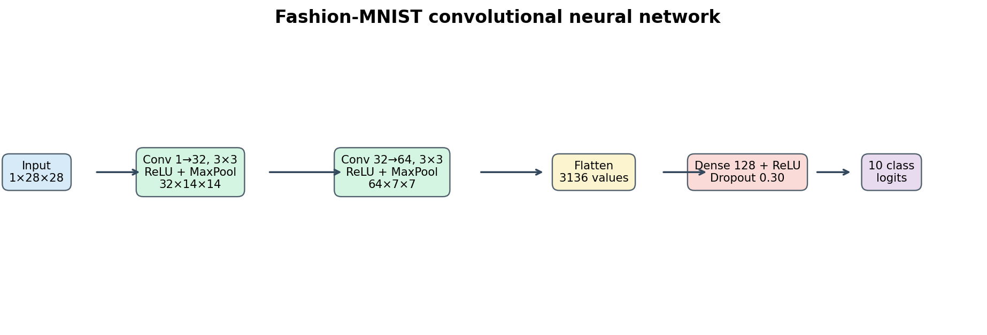
CNN layer diagram with tensor dimensions.
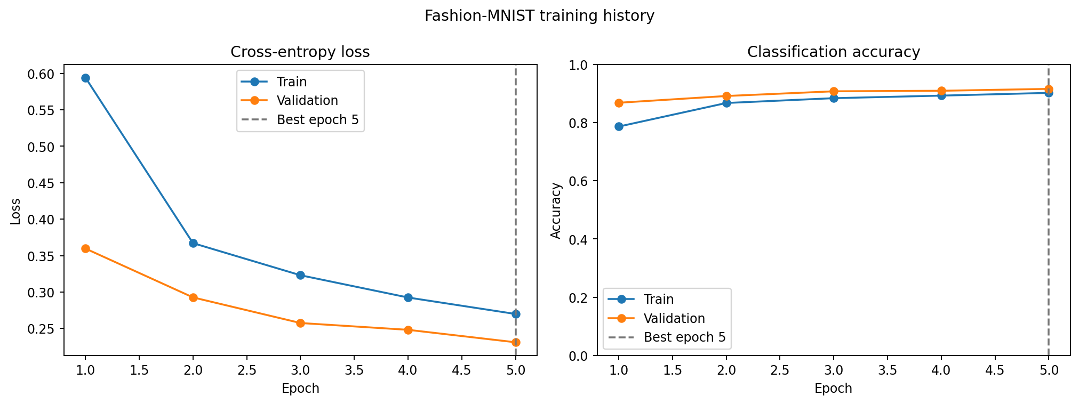
Actual training and validation loss and accuracy per epoch; the vertical line marks the best validation-loss epoch.
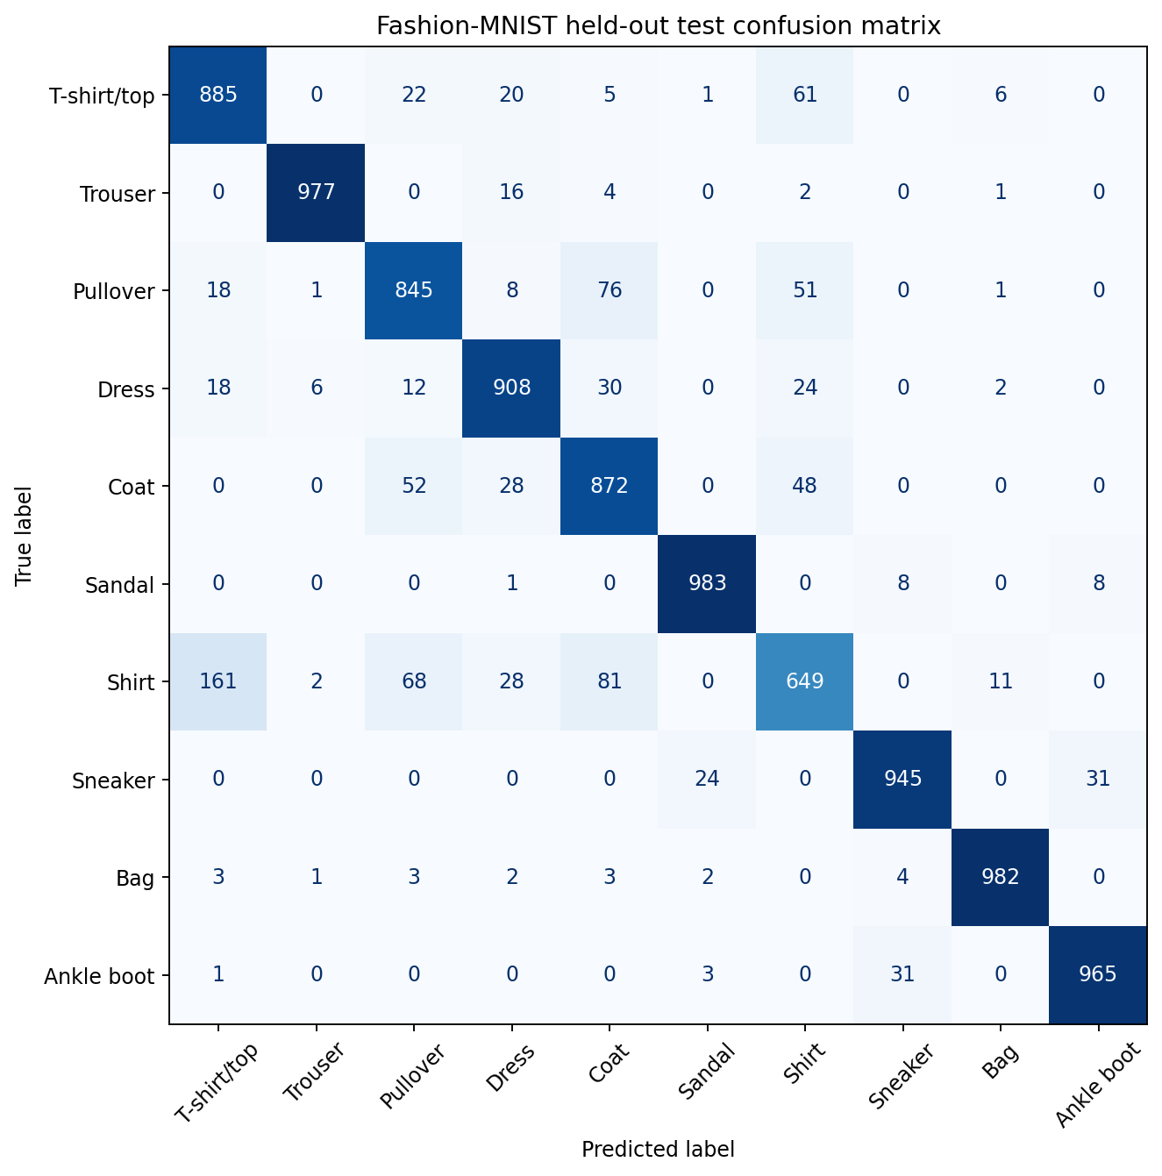
Actual test-set confusion matrix with true labels on rows and predicted labels on columns.
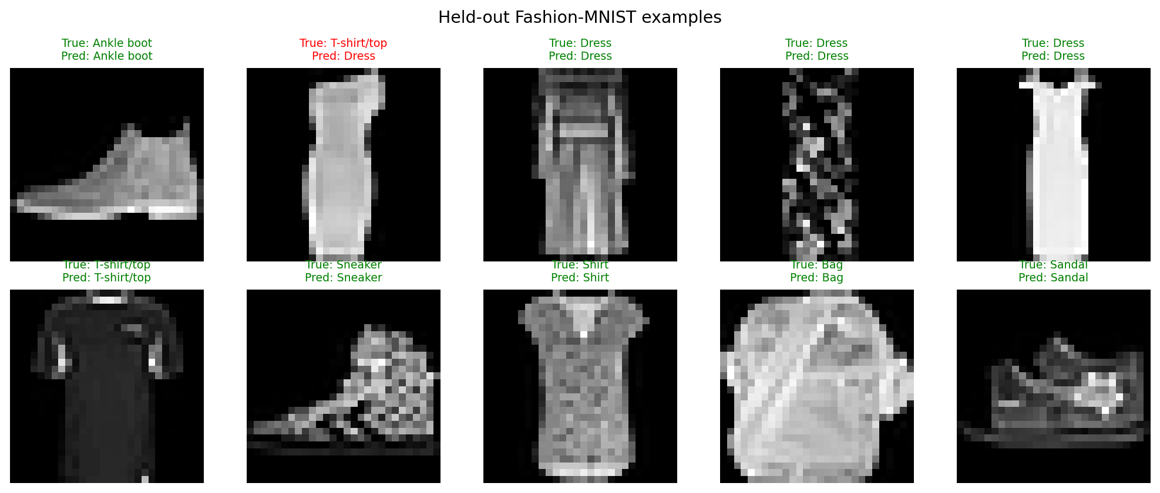
Examples from the held-out test set with true and predicted class labels.

