# Project: Calculating Family Expenses Using ServiceNow

**Objective:**

Develop a comprehensive system on ServiceNow to track, categorize, and manage family expenses efficiently, enabling informed financial decisions.The project aims to develop a

comprehensive expense calculation system using ServiceNow. This system will enable users to track and manage family expenses efficiently. It will include features such as expense categorization, budget setting, real-time tracking, and reporting capabilities. Utilizing

ServiceNow's robust platform, the project will ensure seamless integration, user-friendly

interface, and scalability to accommodate varying family sizes and financial complexities. The end goal is to empower users with the tools they need to make informed financial decisions and promote financial well-being within the family unit.

# Step 1: Setting up Your ServiceNow Instance

1. **Sign Up:**
   * Go to [ServiceNow Developer Site](https://developer.servicenow.com/) and sign up for a developer account.

# Request Personal Developer Instance (PDI):

* + After logging in, navigate to **Personal Developer Instance** section.
  + Click **Request Instance** and fill out the form.
  + Wait for the confirmation email with your instance details.

# Log In:

* + Use the credentials provided to log into your personal ServiceNow instance.

# Step 2: Create a New Update Set

1. Navigate to **All > Local Update Sets**.
2. Click **New** and create an update set with the following details:
   * **Name:** Family Expenses
3. Submit and make this update set the current active update set.

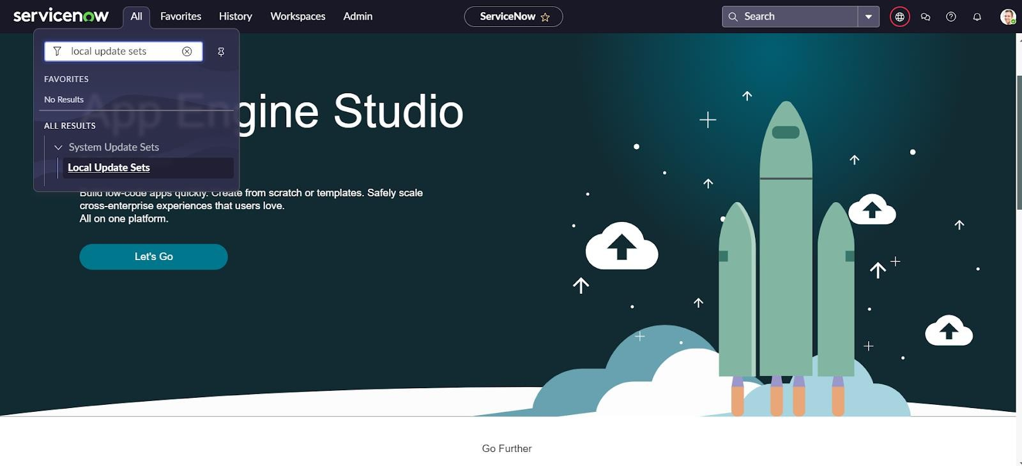

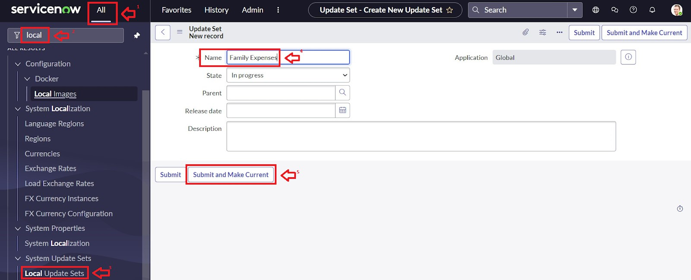

# Step 3: Create Family Expenses Table

1. Navigate to **All > Tables**, then click **New** to create a new table.
2. Fill in the details:
   * **Label:** Family Expenses
   * **Name:** Auto-populated (will default)
   * **New menu name:** Family Expenditure
3. Save the table.

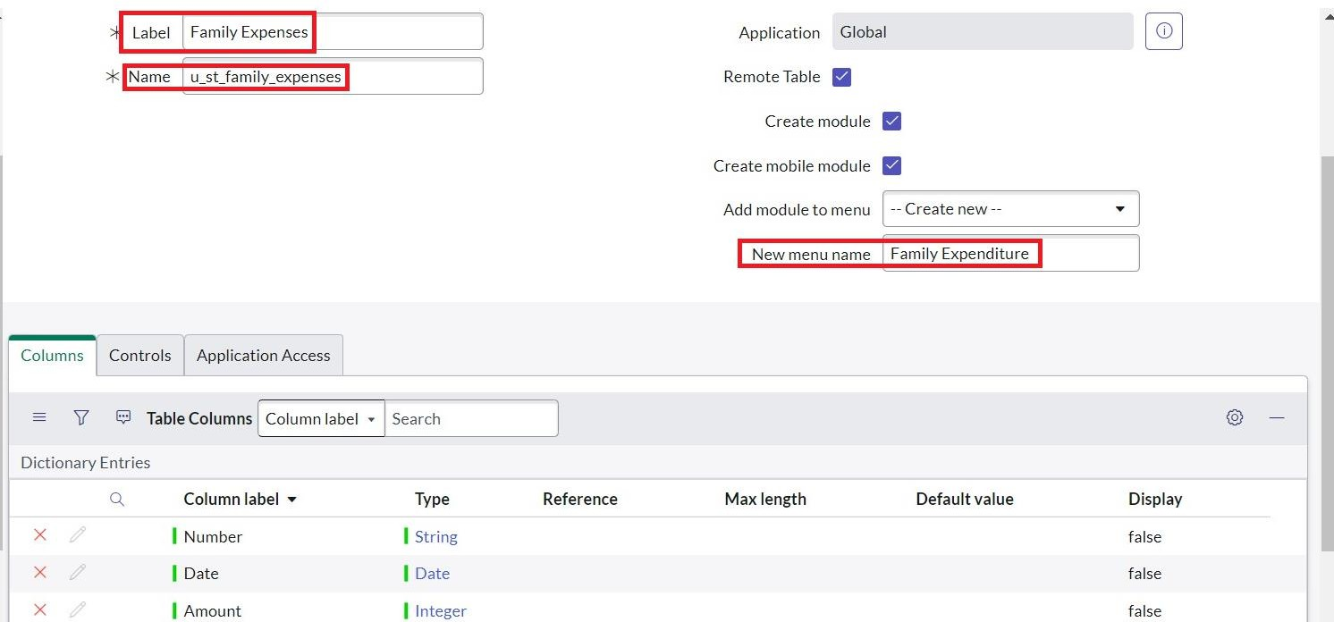

# Step 4: Add Columns (Fields) to Family Expenses Table

Add the following fields:

* **Number** (String)
* **Date** (Date)
* **Amount** (Integer)
* **Expense Details** (String, max length 800) Save your changes.

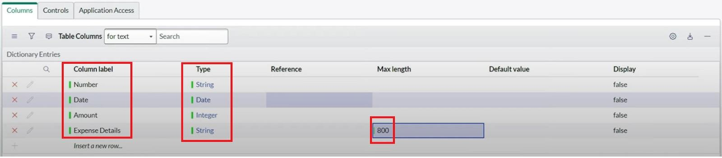

# Step 5: Make Number Field Auto-Generated

1. Open the **Number** field record.
2. Scroll to **Advanced View**.
3. Check **Use dynamic default** and set **Dynamic default value** to **Get Next Padded Number**.
4. Update the field.

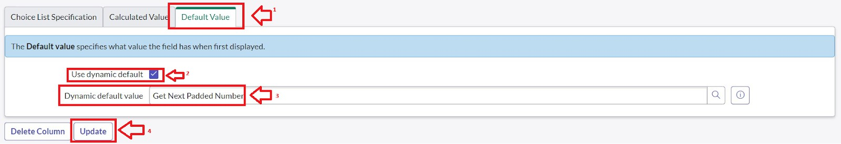

1. Navigate to **Number Maintenance**:
   * Create a new record with:
     + **Table:** Family Expenses
     + **Prefix:** MFE
   * Submit.

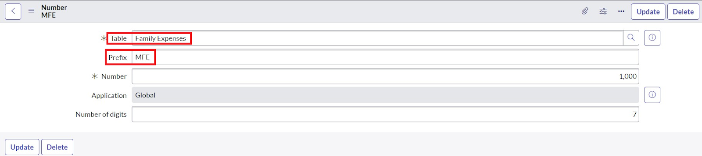

# Step 6: Configure the Family Expenses Form

1. Go to **All > Family Expenses**.
2. Click **New** to open the form.
3. Right-click on the form header, select **Configure > Form Design**.
4. Customize the form layout as needed (drag & drop fields).
5. Set:
   * **Number** field as **Read-Only**.
   * **Date** and **Amount** fields as **Mandatory**.
6. Save the form.

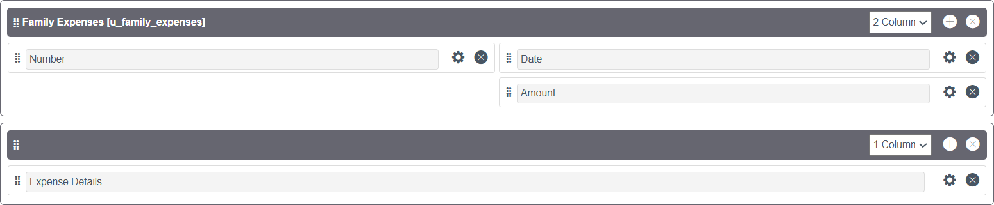

# Step 7: Create Daily Expenses Table

1. Navigate to **All > Tables** and click **New**.
2. Enter details:
   * **Label:** Daily Expenses
   * **Name:** Auto-populated
   * Add module to **Family Expenditure** menu.
3. Save.

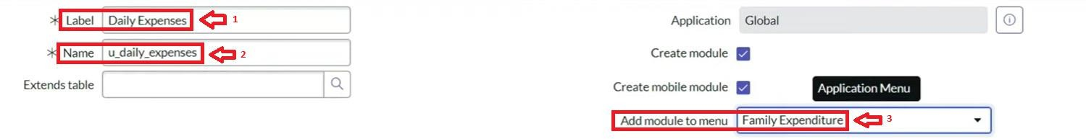

# Step 8: Add Columns to Daily Expenses Table

Add the following fields:

* **Number** (String)
* **Date** (Date)
* **Expense** (Integer)
* **Family Member Name** (Reference to Family Expenses table)
* **Comments** (String, max length 800) Save the changes.

# Step 9: Make Daily Expenses Number Field Auto-Generated

Repeat the steps from Step 5 for the **Daily Expenses** table:

* Dynamic default: **Get Next Padded Number**
* Create Number Maintenance record with prefix as **MFE** for the Daily Expenses table.



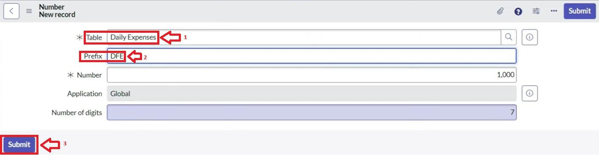

# Step 10: Configure Daily Expenses Form

1. Go to **All > Daily Expenses**, click **New**.
2. Configure the form design:
   * Set **Number** as **Read-Only**.
   * Make **Date** and **Family Member Name** mandatory.
3. Save the form.

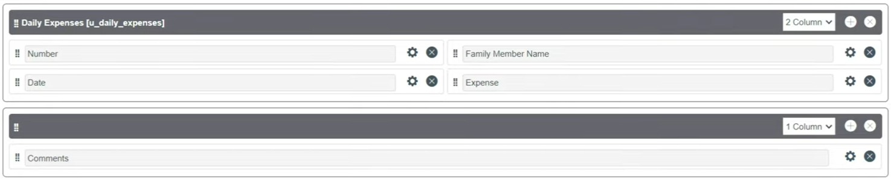

# Step 11: Create Relationship Between Tables

1. Go to **All > Relationships**, click **New**.
2. Define relationship:
   * **Name:** Daily Expenses
   * **Applies to table:** Family Expenses
   * **Related Table:** Daily Expenses
3. Save.

# Step 12: Add Related List to Family Expenses Form

1. Open the **Family Expenses** table form.
2. Right-click on the header, select **Configure > Related Lists**.
3. Add **Daily Expenses** as a related list.
4. Save.

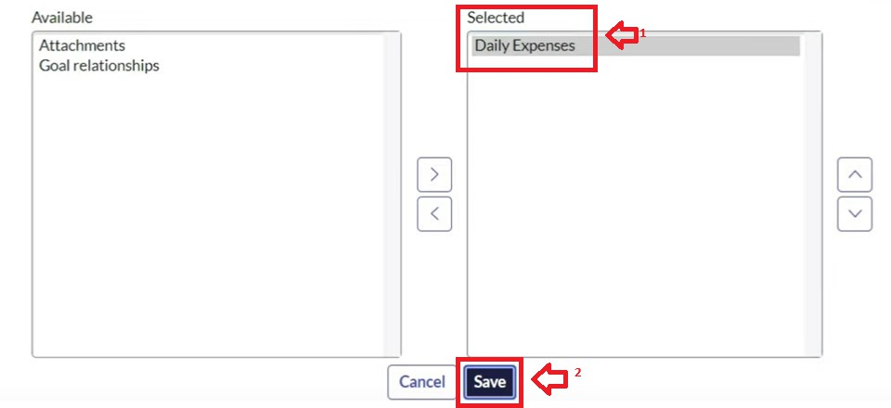

# Step 13: Create Business Rule for Expense Aggregation

1. Navigate to **Business Rules**, click **New**.
2. Enter details:
   * **Name:** Family Expenses BR
   * **Table:** Daily Expenses
   * Check **Advanced**

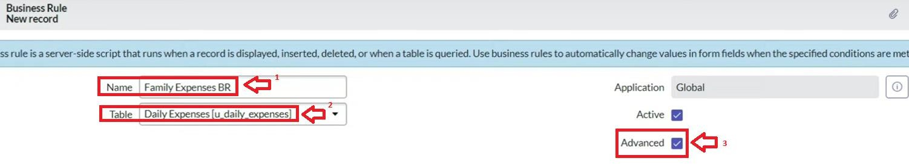

* + 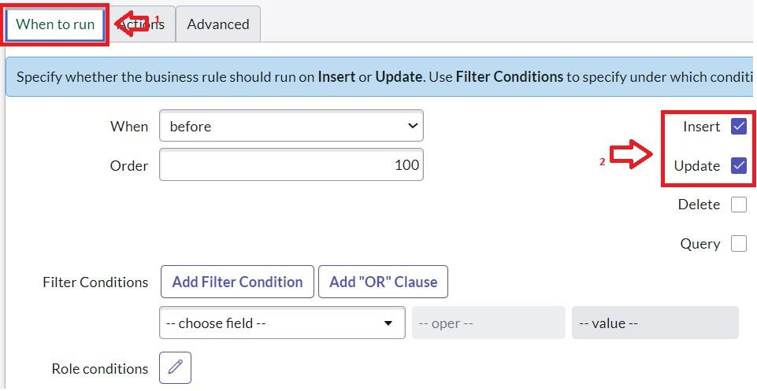When to run: **Insert** and **Update**

1. Paste this code in the **Advanced** script section:

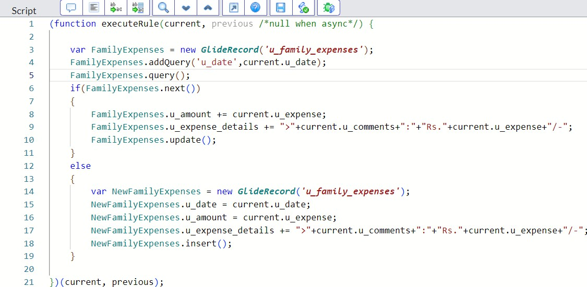

(function executeRule(current, previous /*null when async*/) { var FamilyExpenses = new GlideRecord('u_family_expenses'); FamilyExpenses.addQuery('u_date', current.u_date); FamilyExpenses.query();

if (FamilyExpenses.next()) { FamilyExpenses.u_amount += current.u_expense;

FamilyExpenses.u_expense_details += " >" + current.u_comments + ": Rs." + current.u_expense + "/-";

FamilyExpenses.update();

} else {

var NewFamilyExpenses = new GlideRecord('u_family_expenses'); NewFamilyExpenses.u_date = current.u_date; NewFamilyExpenses.u_amount = current.u_expense;

NewFamilyExpenses.u_expense_details = " >" + current.u_comments + ": Rs." + current.u_expense + "/-";

NewFamilyExpenses.insert();

}

})(current, previous);

1. Save the Business Rule.

# Step 14: Refine Relationship Query

1. Go to **Relationships**, open **Daily Expenses Relationship**.
2. Set **Applies to table:** Family Expenses.
3. In **Query with** script, add:

(function refineQuery(current, parent) {

current.addQuery('u_date', parent.u_date); current.query();

})(current, parent);

1. Update.

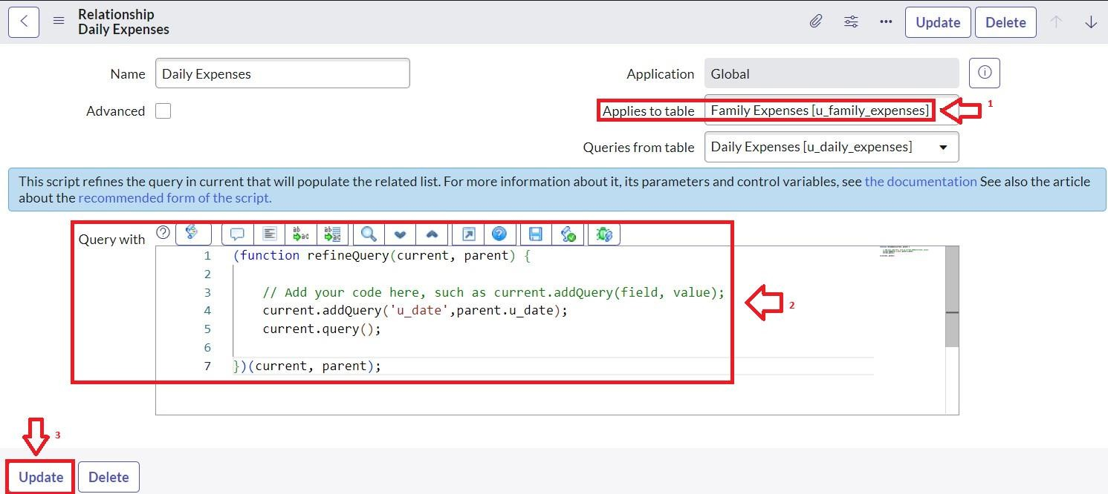

# Conclusion

By implementing this project, your family can:

* + Submit and track daily expenses.
  + Aggregate expenses on a daily basis.
  + View summarized family expense data.
  + Use a centralized and easy-to-use system.
  + Make better financial decisions with real-time data.

This system leverages ServiceNow's platform for scalability, user-friendly interface, and automation.