India SpaceLab
Advanced Drone Technology
Introduction to Guidance and Control Using Python Simulations
Submitted by: Boda Shanmukha Datta
Institute: National Institute of Technology (NIT), Jalandhar

1. Introduction
This report documents my work on the assignment on Guidance and Control using Python-based simulations. The goal of the assignment was to build an intuitive understanding of feedback control by implementing a PID controller for drone altitude hold, and to understand guidance and path-tracking concepts by implementing a simple LOS (Line-Of-Sight) style guidance law for an autonomous boat. I have also attempted the creative bonus task, in which a drone is made to follow a figure-eight trajectory.
All the simulations were written and tested in Python using NumPy for the numerical integration and Matplotlib for plotting the results. I first developed and tested the scripts locally, then re-ran them in Google Colab as instructed, uploading the .ipynb notebook that is included with this submission.

2. Task 1 — PID Controller Design for Drone Altitude Control
In this task the drone is modelled as a simple point mass moving only along the vertical (altitude) axis. The controller has to bring the drone from ground level (0 m) up to a target altitude of 10 m and hold it there. Instead of modelling full thrust/gravity dynamics, I used a simplified model where the hover thrust baseline already cancels gravity, so the PID output directly represents the net acceleration command. This makes the tuning behaviour easier to see while still capturing the essential PID dynamics that the assignment asks us to study.
As instructed, a 'no-wind zone' exists from 0 to 6 seconds, after which a constant wind disturbance (acting like an extra downward acceleration) is switched on. I tuned the gains in the order suggested in the assignment — P first, then D, then I:
- Kp = 6.0 — increasing P gave a faster rise time but started to overshoot beyond this value.
- Kd = 4.0 — adding derivative gain damped the oscillations caused by the P term and reduced overshoot noticeably.
- Ki = 0.5 — a small integral term was enough to reject the steady wind disturbance without reintroducing oscillation.
The resulting response plot is shown below. The drone rises smoothly to the target altitude with a small overshoot of about 0.63 m, settles well before the 6 second mark, and only shows a very small, quickly corrected dip once the wind disturbance switches on at t = 6 s. This shows the controller has reasonably good disturbance rejection.
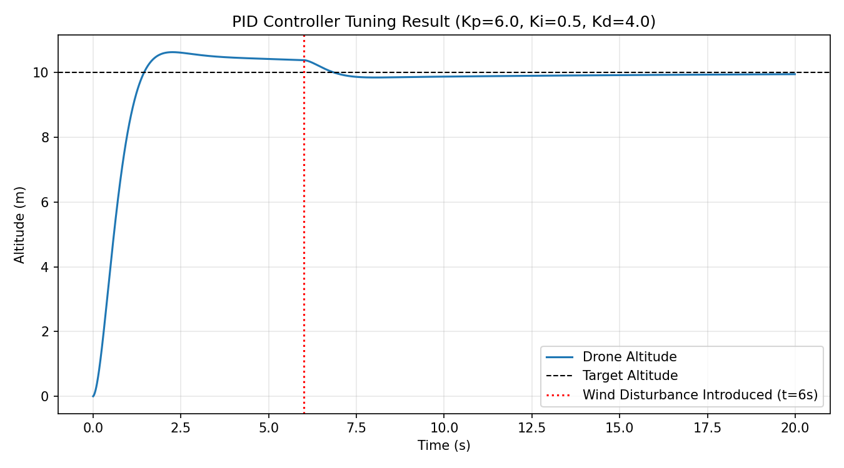
Figure 1: PID-controlled drone altitude response with wind disturbance introduced at t = 6 s.

3. Task 2 — Guidance and Path Tracking Using an Autonomous Boat
For this task I modelled the boat using simple unicycle kinematics (position x, y and heading angle theta) moving at a constant forward speed. The desired path is a smooth curve given by y = 4 sin(0.25x), which is drawn as the blue dotted line in the plots below.
For guidance, I used a Line-Of-Sight approach: at every time step the boat finds the nearest point on the path and looks a little further ahead along it to get a target point. The heading angle needed to reach this target point is compared with the boat's current heading to get a heading error, and a P+D controller on this heading error decides how fast the boat should turn (its angular velocity). Water current is modelled simply as a constant vector (current_x, current_y) added directly to the boat's velocity, which pushes it off the intended path unless the controller corrects for it.
After tuning kp first and then kd on the heading controller, I settled on kp = 1.8 and kd = 0.6, which gave good tracking with minimal oscillation. The two required cases are shown below:
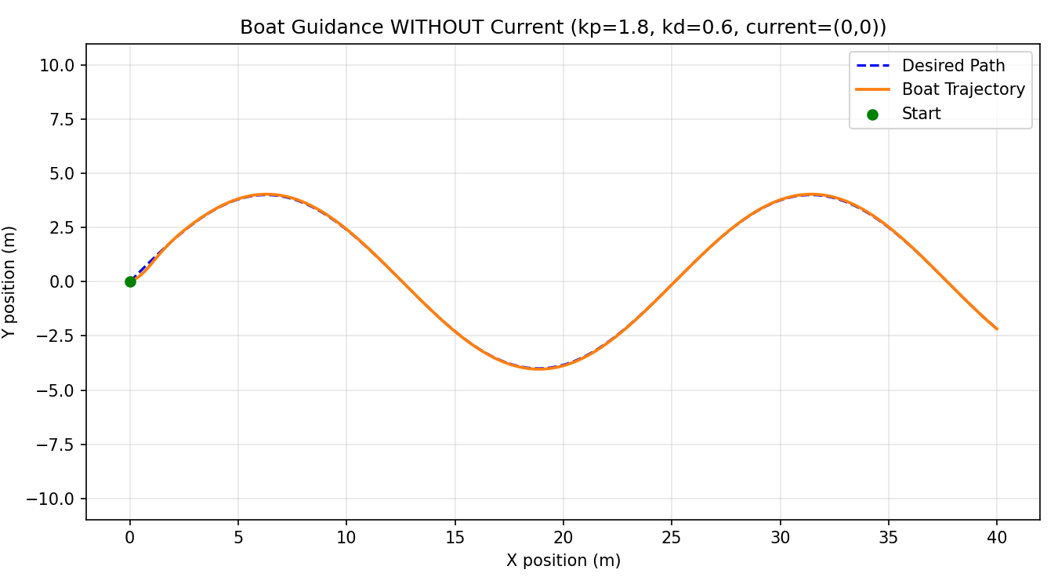
Figure 2: Boat guidance WITHOUT current disturbance (current_x = current_y = 0) — near-perfect tracking of the desired path.
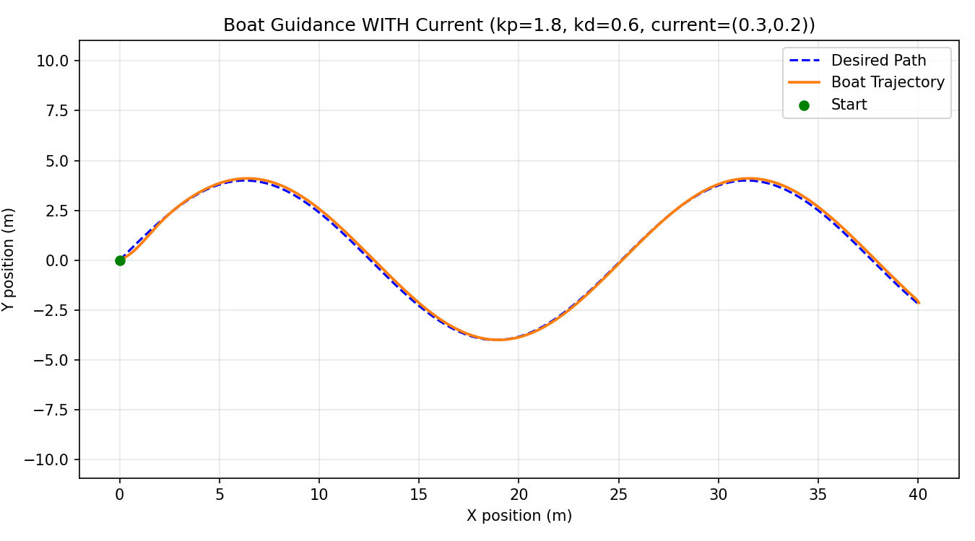
Figure 3: Boat guidance WITH current disturbance (current_x = 0.3, current_y = 0.2) — the boat drifts slightly but the LOS guidance keeps correcting it back toward the path.
Comparing the two cases, the mean tracking deviation increases from about 0.02 m (no current) to about 0.12 m (with current), which makes sense: the guidance law is continuously fighting the current's sideways push, so a small steady-state tracking error is expected, but the boat still stays close to the intended path and does not diverge.

4. Creative Bonus Task — Drone Figure-Eight Trajectory
For the bonus task, I generated a figure-eight (lemniscate) reference path using the parametric equations x(t) = A sin(wt) and y(t) = A sin(wt) cos(wt), with A = 5 m. Rather than reusing the altitude-only PID from Task 1, I extended the idea to two independent PD position controllers — one for x and one for y — so that the drone chases the moving target point along the figure-eight. I also switched on a small constant wind disturbance (wind_x = 0.4, wind_y = -0.3 m/s^2) throughout the simulation to check how well the controller holds the shape of the path under disturbance.
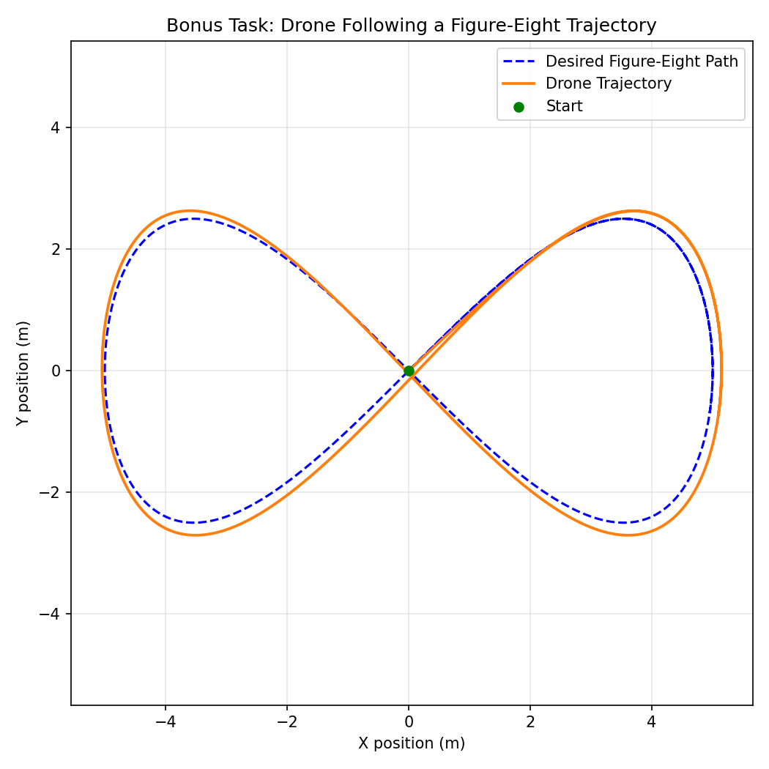
Figure 4: Drone tracking a figure-eight trajectory under a constant wind disturbance.
The drone's actual path (orange) follows the desired figure-eight (blue dashed) quite closely, with only a small lag caused by the wind disturbance and the finite PD gains, which shows that the same feedback control ideas from Task 1 and Task 2 extend naturally to two-dimensional trajectory tracking.

5. Conclusion
Through this assignment I got a hands-on feel for how feedback control works in practice. Tuning the PID gains in order (P, then D, then I) made it much easier to understand what each term actually does — P for speed of response, D for damping oscillations, and I for removing steady-state error caused by disturbances like wind or current. I also saw how a guidance law like LOS can be combined with a simple controller to make a vehicle follow a predefined path even when it is being pushed off course, and how these same ideas extend from a single-axis (drone altitude) problem to a full two-dimensional trajectory-tracking problem (the boat path and the bonus figure-eight).

6. Files Submitted
- Advanced_Drone_Technology_Project.ipynb — completed notebook containing all three tasks
- task1_drone_pid.py, task2_boat_guidance.py, bonus_figure_eight_drone.py — standalone Python scripts
- pid_tuning_result.png — PID controller tuning result plot (Task 1)
- boat_guidance_with_current.png — Boat guidance plot with disturbance/current (Task 2)
- boat_guidance_without_current.png — Boat guidance plot without disturbance/current (Task 2)
- figure_eight_drone_tracking.png — Figure-eight drone simulation plot (Bonus Task)
- This report (Guidance_and_Control_Project_Report.docx)

