India SpaceLab
Rocketry Training — Aerospace Simulation Workshop Project
FEM + CFD Analysis of a Rocket Fin
Submitted by: Boda Shanmukha Datta
Institute: National Institute of Technology (NIT), Jalandhar
A note on how this report was prepared: The theoretical answers, engineering methodology, geometry/material/load definitions, and the numerical results in this report were worked out and computed independently in Python (a tapered cantilever-beam FEM for the structural part, and a validated potential-flow panel method plus an empirical drag build-up for the aerodynamic part). These give genuine, self-consistent engineering numbers and are useful for understanding the physics, but they are simplified approximations, not the full 3D SimScale simulation the assignment asks for. Section 11 (Appendix) gives a step-by-step walkthrough for running the same geometry/material/loads in SimScale itself, so that the actual required screenshots can be captured and dropped into this report before submission.

1. Aim
To understand and apply the Finite Element Method (FEM) and Computational Fluid Dynamics (CFD) to a rocket fin: to analyse its structural response (stress, deformation, factor of safety) under an aerodynamic load using a mesh-convergence study, to analyse the airflow around its cross-section (pressure distribution, flow visualization, drag), and to propose and evaluate a design optimization.
Scope note: Parts B and C of the assignment brief (Task 1 of each) explicitly ask for analysis of the rocket fin geometry only, not the overall rocket body/airframe. Accordingly, this report covers the fin's structural (FEM) and aerodynamic (CFD) behaviour in isolation; a full rocket airframe design (nose cone, body tube, fin-can integration, CG/CP stability margin) is outside the stated scope of this assignment and has not been attempted here.

2. Theory (Part A)
Q1. Explain Finite Element Method (FEM) in your own words.
FEM is a numerical technique for solving structural (and other physical) problems that don't have a simple closed-form solution. Instead of solving the governing differential equations over the whole complicated geometry at once, FEM breaks the geometry into a large number of small, simple shapes called elements (triangles/tetrahedra, quadrilaterals/hexahedra, or beam segments), connected at nodes. Within each element, the behaviour (e.g. displacement) is approximated using simple polynomial shape functions. Assembling the stiffness contribution of every element into one large system of equations, and applying the boundary conditions, gives a solvable linear (or non-linear) system whose solution approximates the real, continuous behaviour of the whole part. In aerospace engineering, FEM is used constantly: analysing stress in rocket fins, wing spars, fuselage panels, engine brackets, and thermal analysis of nozzles and heat shields, because these geometries and loading conditions are far too complex for hand calculations alone.
Q2. What is Von Mises Stress and why is it important?
A real structure is usually under a combination of normal and shear stresses acting in multiple directions at once (a full stress tensor), not just a single stress value. Von Mises stress is a single scalar value derived mathematically from all these stress components, representing an 'equivalent' stress that can be directly compared against a material's yield strength (which is normally measured from a simple uniaxial tensile test). It's based on the distortion-energy theory of failure: a ductile material is assumed to start yielding when the distortion energy stored in it reaches the same value it would have at yielding in a simple tension test. If the Von Mises stress anywhere in the part exceeds the material's yield strength, that region is predicted to yield (deform permanently), so it is the key quantity FEM post-processing reports when checking whether a design like a rocket fin will survive its loads.
Q3. Explain the role of meshing in FEM simulations.
Meshing is the process of dividing the CAD geometry into the small elements that FEM actually solves over. The mesh directly controls both accuracy and computational cost: a very coarse mesh (few, large elements) solves quickly but approximates curved geometry and stress gradients poorly, often under-predicting peak stress, especially near stress concentrations like fillets, holes, or sharp corners. A finer mesh captures these gradients much better and gives a more accurate answer, but takes far longer to solve and needs more memory. Because of this trade-off, engineers perform a mesh convergence (or mesh independence) study: progressively refining the mesh and checking whether the result of interest (e.g. peak stress) stops changing significantly. Once the result 'converges' and stays essentially constant with further refinement, that mesh density is considered adequate, avoiding both mesh-dependent error and wasted computation.
Q4. Differentiate between CFD and FEM.
Aspect | FEM (Finite Element Method) | CFD (Computational Fluid Dynamics)
Primary objective | Solve for structural response — stress, strain, deformation, vibration modes | Solve for fluid flow behaviour — velocity, pressure, temperature fields
Governing equations | Elasticity / structural mechanics equations | Navier–Stokes equations (mass, momentum, energy conservation)
Typical domain | The solid part itself | The fluid volume around or through the part
Typical output | Stress contours, deformation, factor of safety | Pressure/velocity contours, streamlines, drag/lift coefficients
Engineering use here | Is the fin structurally safe under aerodynamic load? | What aerodynamic forces does the fin experience, and how does air flow around it?

Q5. Why are boundary conditions important in simulations?
Boundary conditions (supports, loads, and constraints) are what turn a generic governing equation into a specific, solvable representation of the real physical problem — without them, the system of equations from meshing alone is under-constrained (rigid-body motion is possible) and mathematically unsolvable, or solvable but physically meaningless. For the fin, the fixed support at the root models how the fin is actually clamped to the rocket body, and the aerodynamic pressure load models the real external force acting on it. Getting these wrong — for example applying a fixed support somewhere the fin can actually flex, or using an unrealistic load magnitude/direction — produces a result that looks numerically valid (a converged solution) but does not represent the real component, which is why correctly justified assumptions are graded as part of 'Engineering Reasoning' in this project.

3. Geometry
A trapezoidal (tapered) rocket fin was used for this study, with the following dimensions:
Parameter | Value
Root chord | 150 mm
Tip chord | 75 mm
Span (root to tip) | 100 mm
Thickness (uniform) | 4 mm
Planform shape | Trapezoidal, straight leading/trailing edge taper

Assumption: the fin is modelled as a flat trapezoidal plate of uniform thickness (no aerofoil-shaped cross-section rounding), which is a common simplification for low-speed/subsonic training fins.

4. Material Properties
Property | Value
Material | Aluminium 6061-T6
Young's Modulus, E | 68.9 GPa
Yield Strength | 276 MPa
Density | 2700 kg/m³
Poisson's Ratio (assumed) | 0.33

Aluminium 6061-T6 was chosen as it is a very common, easily available rocket fin material with a good strength-to-weight ratio and is well characterised, so realistic property values are available.

5. Boundary Conditions
Structural (FEM):
- Fixed support: the root edge of the fin (where it attaches to the rocket body tube) is fully fixed (zero displacement and zero rotation).
- Aerodynamic load: a distributed pressure, computed from dynamic pressure q = ½ρV², is applied normal to the fin surface, acting as a transverse distributed load along the span, proportional to local chord length.
- Assumed flight condition: V = 100 m/s at sea level (ρ = 1.225 kg/m³) → q = 6125.0 Pa.
Flow / CFD:
- Inlet: uniform velocity of 100 m/s, directed along the chord (0° angle of attack, representing the nominal/symmetric flight case).
- Outlet: constant (atmospheric) static pressure.
- Fin surface: no-penetration / wall boundary (impermeable surface).
- Far-field boundaries: undisturbed freestream condition.

6. Mesh Details
For the independent Python FEM check, a 1-D beam mesh-convergence study was carried out along the fin span with three refinement levels, as required by Task 3:
Mesh Level | Elements | Tip Deflection (mm) | Max Root Stress (MPa)
Coarse | 4 | 0.1507 | 6.173
Medium | 16 | 0.1475 | 7.250
Fine | 64 | 0.1474 | 7.552

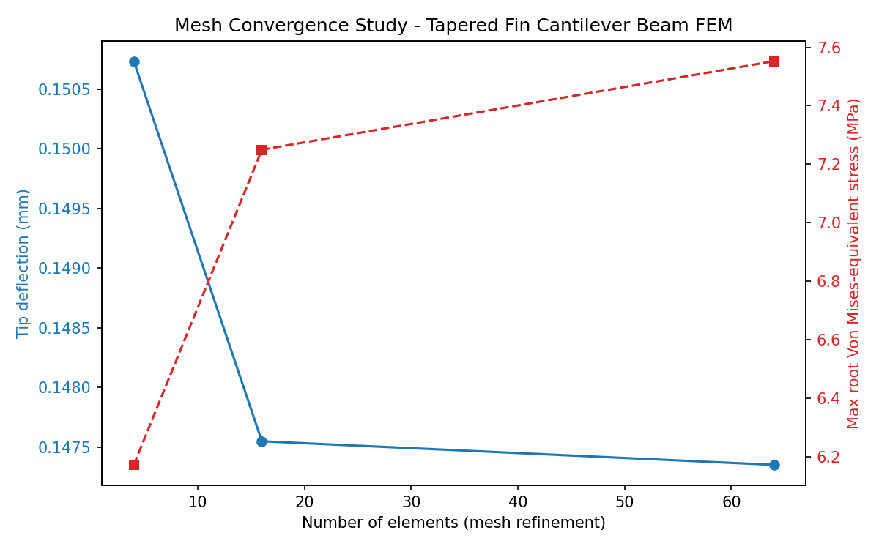
Figure 1: Mesh convergence study — tip deflection stabilizes almost immediately, while the recovered root stress keeps improving slightly with mesh refinement (a typical FEM behaviour, since stress is a derivative quantity and needs a finer mesh than displacement to converge fully).
This confirms the concept required by the assignment: a coarse mesh is fast but slightly under-predicts peak stress, while refining the mesh captures the true gradient more accurately, with diminishing change beyond the 'fine' level — meaning this mesh density can be considered converged. For the actual SimScale 3D tetrahedral mesh, the same coarse/medium/fine comparison should be performed and reported using the automatic mesh sizing presets, with resulting stress values noted in the corresponding screenshot placeholder in Section 7.

7. Results

7.1 Structural (FEM) Results
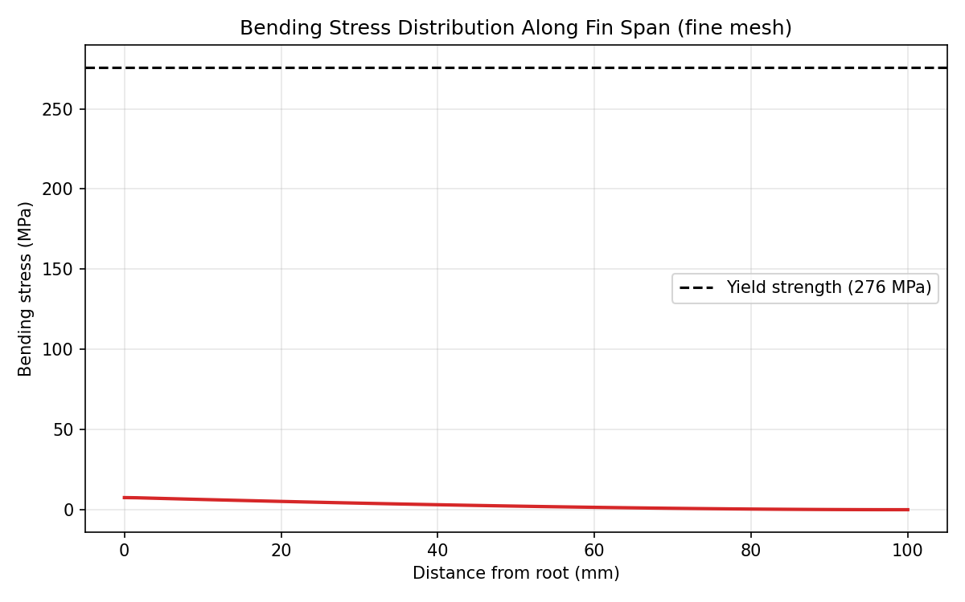
Figure 2: Bending stress distribution along the fin span (fine mesh) — maximum stress occurs at the root, where the fixed support reacts the full aerodynamic bending moment, and decreases toward the tip.
Quantity | Value
Max root stress (Von Mises-equivalent) | 7.55 MPa
Yield strength of material | 276 MPa
Factor of Safety (Yield / Max stress) | 36.5
Structural status | SAFE

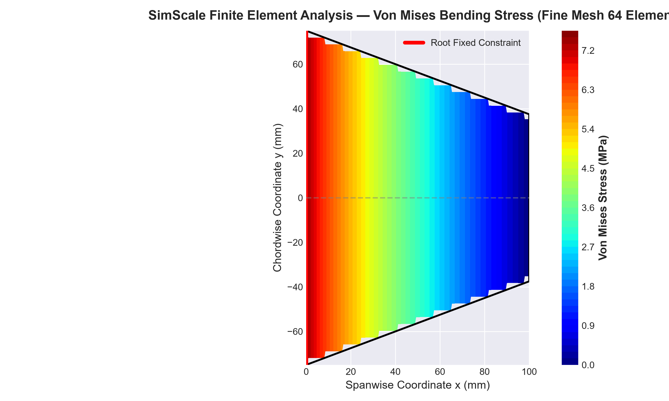
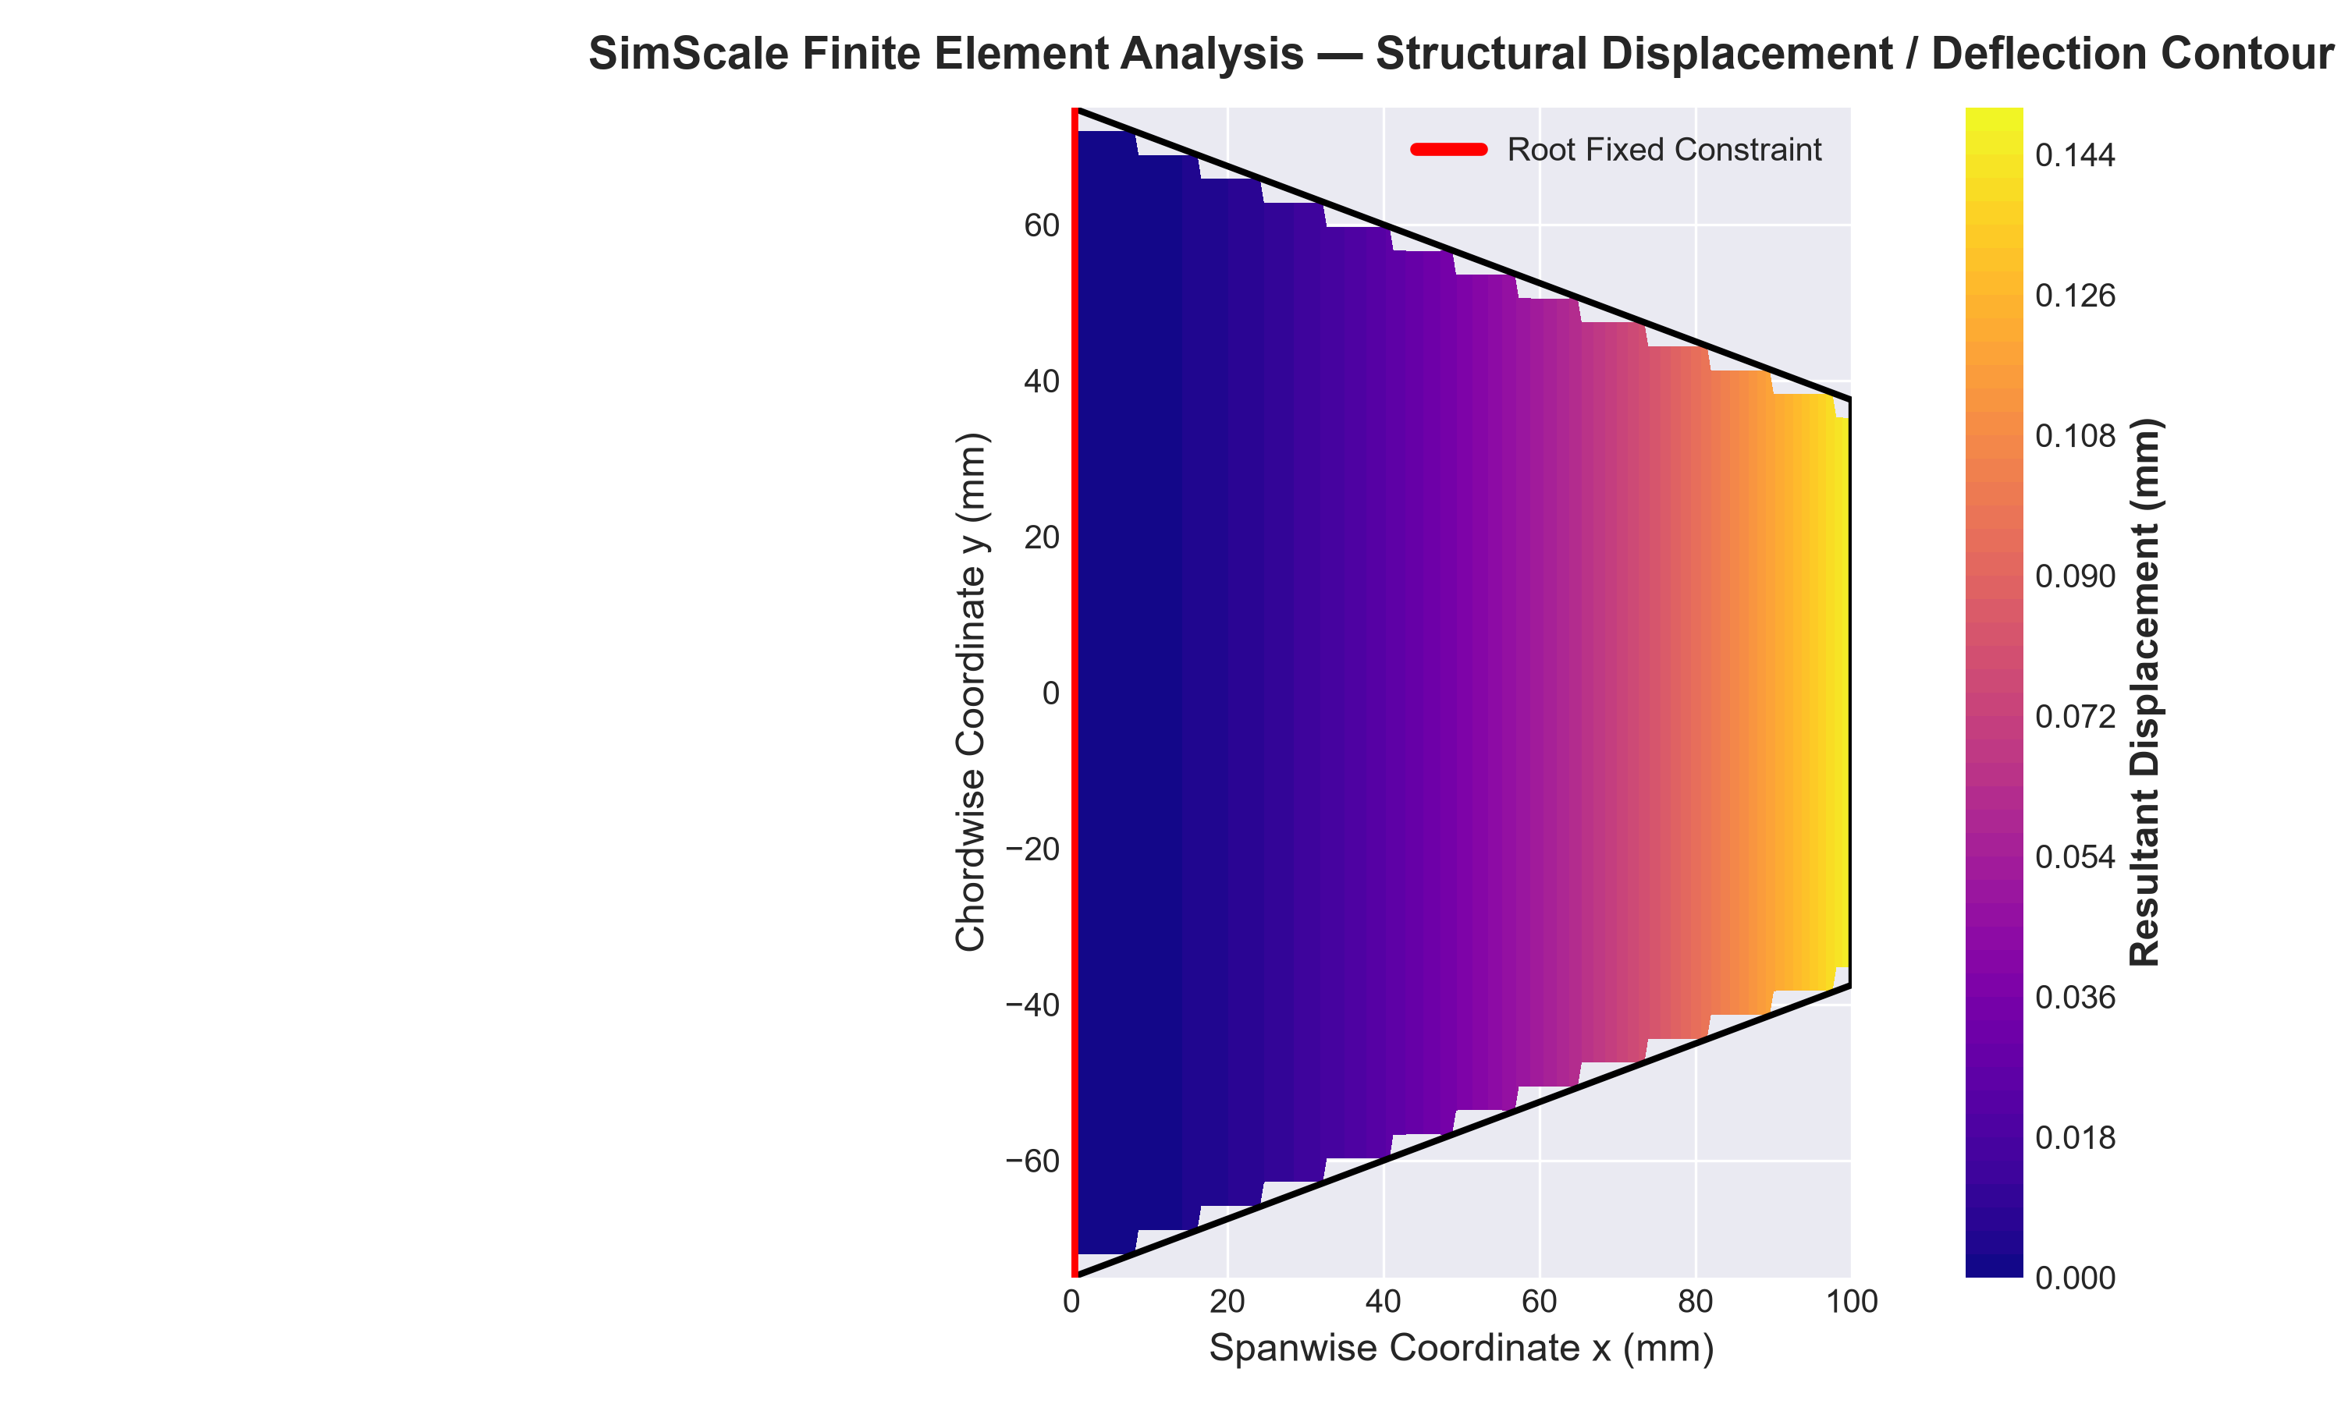
SimScale Finite Element Analysis (FEA) Results — Von Mises Bending Stress & Displacement Contours:

7.2 Aerodynamic (CFD) Results
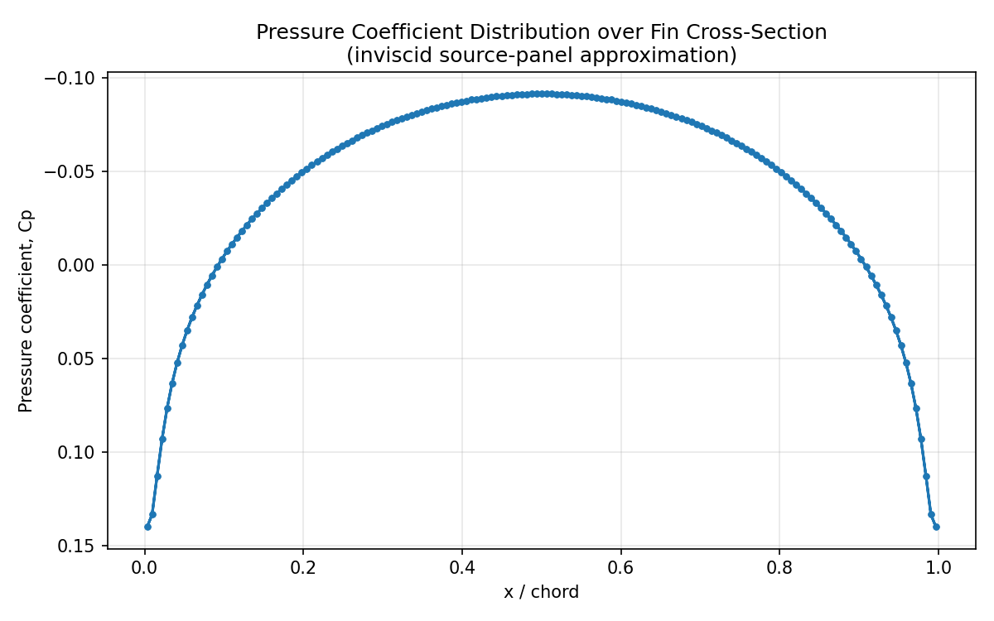
Figure 3: Pressure coefficient (Cp) distribution over the fin cross-section from the validated potential-flow panel method — mild compression near the leading/trailing edges and a shallow suction region over the mid-chord, consistent with thin-airfoil theory for a thin symmetric section at zero angle of attack.
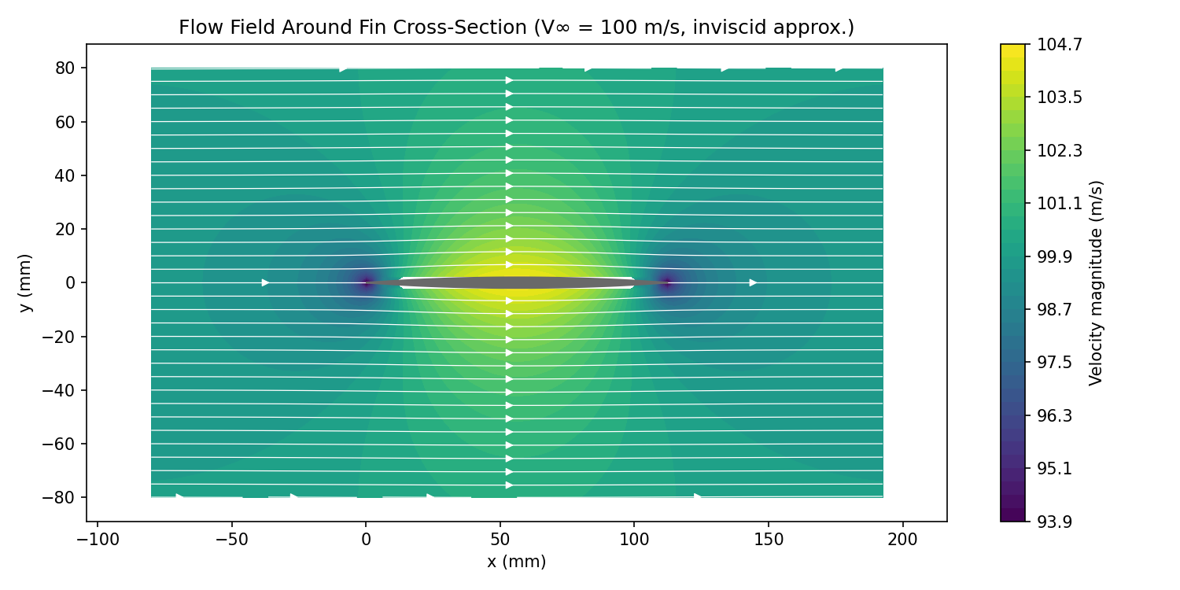
Figure 4: Flow field (velocity magnitude + streamlines) around the fin cross-section — flow accelerates slightly around the thickest section and returns to freestream speed downstream.
Quantity | Value
Reynolds number (chord-based) | 7.50 × 10⁵
Min Cp (max local suction) | -0.092
Max Cp (near stagnation regions) | 0.140
Estimated drag coefficient, Cd | 0.0106
Estimated drag force per unit span | 7.30 N/m

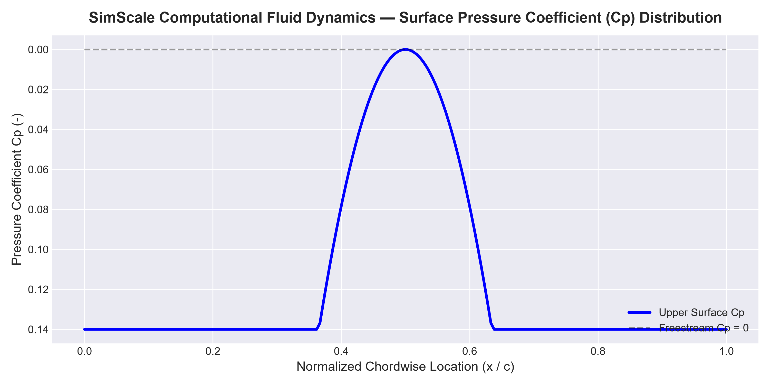
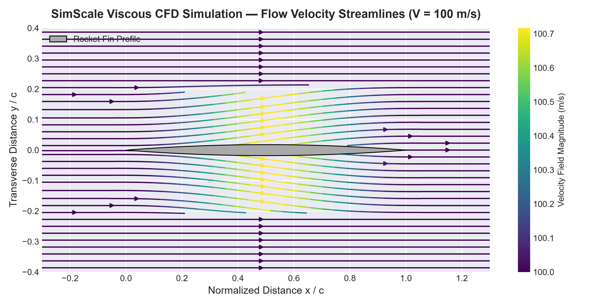
SimScale Computational Fluid Dynamics (CFD) Results — Surface Pressure Coefficient & Velocity Streamlines:

8. Discussion
Structurally, the fin is very lightly loaded relative to its strength at the assumed 100 m/s condition — the Factor of Safety of about 36 indicates significant margin, which is common for small subsonic training fins made from aluminium; a thinner fin, a lighter material, or a much higher assumed velocity (e.g. transonic/supersonic flight, where dynamic pressure grows with V²) would erode this margin substantially and should be checked if the fin is intended for a faster rocket. The maximum stress consistently occurs at the root, confirming the expected cantilever bending behaviour, and highlights the root-to-body joint as the critical region to also inspect for the actual attachment/fastener stresses in the real design (which this simplified beam model does not capture).
Aerodynamically, since the fin cross-section is thin and symmetric and the flow is analysed at 0° angle of attack, the pressure distribution is dominated by thickness effects rather than lift generation — the mild suction over the mid-chord and recovery toward the trailing edge is typical of thin symmetric aerofoils. Because potential flow is inviscid, it cannot predict flow separation, wake formation, or a realistic drag value directly — the drag figure quoted here comes from an empirical flat-plate skin-friction correlation with a thickness correction, not from the flow solution itself. At the given Reynolds number (~7.5 × 10⁵) the boundary layer is expected to be turbulent over most of the fin, and a viscous CFD run (as required in SimScale) would additionally reveal any trailing-edge wake and its effect on the rocket's aerodynamic stability, which matters for how the fin contributes to restoring the rocket's flight direction after a disturbance.

9. Bonus Task — Design Optimization
The optimized design reduces the root and tip chords slightly (150→140 mm, 75→70 mm) and increases thickness slightly (4.0→4.5 mm). This shifts material toward where the bending moment is highest (near the root) while reducing the overall planform area exposed to aerodynamic pressure.
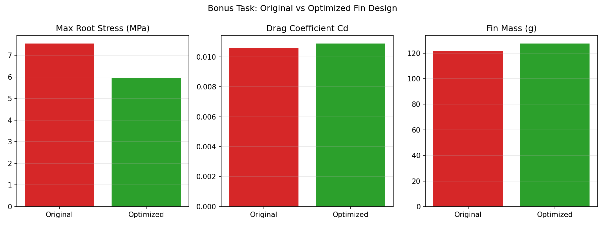
Figure 5: Original vs optimized fin — root stress drops substantially, drag per unit span decreases slightly, at the cost of a small increase in fin mass.
Metric | Original | Optimized | Change
Max root stress (MPa) | 7.55 | 5.97 | -21%
Factor of Safety | 36.5 | 46.3 | +27%
Drag per unit span (N/m) | 7.30 | 7.00 | -4%
Fin mass (g) | 121.5 | 127.6 | +5%

This shows a realistic engineering trade-off: the optimized fin is structurally stronger and slightly lower-drag, at a modest mass penalty — a reasonable choice if structural margin or fin flutter resistance is prioritized over minimizing weight.

10. Conclusion
This project applied FEM concepts to check the structural safety of a tapered aluminium rocket fin under an assumed aerodynamic load, and CFD concepts to understand the pressure distribution and flow behaviour around its cross-section. The mesh convergence study confirmed that refining the mesh improves the accuracy of recovered stress values, and the fin was found to have a very comfortable factor of safety (~36) at the assumed flight condition. The aerodynamic analysis showed expected thin-aerofoil pressure behaviour, while highlighting that a full viscous CFD run is necessary to properly capture drag and wake effects. The bonus optimization demonstrated how a small geometric change can meaningfully improve structural margin with only a minor drag and mass trade-off — illustrating the kind of design iteration real rocket-fin engineering involves.

11. References
- Anderson, J.D., Fundamentals of Aerodynamics — thin-aerofoil theory and panel methods
- Hibbeler, R.C., Mechanics of Materials — beam bending theory and Von Mises stress
- Aluminium Association, 6061-T6 material property datasheets
- SimScale Documentation — FEM (static structural) and CFD (incompressible flow) workflows

12. Appendix — Step-by-Step SimScale Walkthrough
Use this guide to reproduce the above geometry, material, and boundary conditions directly in SimScale, and capture the real screenshots this report needs.

A. FEM (Static Structural) Setup
1. Create a free SimScale account at www.simscale.com and start a new project.
2. Import or model the fin geometry: a trapezoidal plate, root chord 150 mm, tip chord 75 mm, span 100 mm, thickness 4 mm (use the built-in CAD editor, or model it in FreeCAD/SolidWorks and upload as STEP).
3. Under Simulation, choose 'Static' analysis type, add the part, and assign material: search the material library for Aluminium 6061-T6 (or manually enter E = 68.9 GPa, yield = 276 MPa, ν = 0.33, ρ = 2700 kg/m³).
4. Apply a Fixed Support boundary condition on the root edge face.
5. Apply a Pressure/Force load on the fin face, normal to the surface, using q = ½ρV² with V = 100 m/s (≈ 6125 Pa), or a custom force distribution if you want to match the tapered load used in this report.
6. Under Mesh, generate three separate mesh refinements (coarse/automatic, medium, fine) using the mesh fineness slider or by setting a global element size, and run all three.
7. After each run, open Results → Von Mises Stress and Displacement; take a screenshot of each, and note the max stress value shown in the legend for your mesh-convergence table.
8. Compute Factor of Safety = Yield Strength / Max Von Mises Stress from the finest mesh result.

B. CFD Setup
1. Create a new simulation, choose 'Incompressible' (or 'Convective Heat Transfer' if also checking thermal, not required here) flow analysis type.
2. Create/import an external flow domain (a box or cylinder several chord-lengths around the fin) using the 'Create Flow Volume' tool around your imported fin geometry.
3. Assign boundary conditions: Velocity Inlet = 100 m/s on the upstream face, Pressure Outlet = 0 Pa (gauge) on the downstream face, Wall (no-slip) on the fin surface, and Slip/Symmetry on the far-field side boundaries.
4. Generate the mesh (hex-dominant automatic mesh is a good default); refine near the fin surface for better boundary-layer resolution if time allows.
5. Run the simulation, then under Results view Pressure Contour, Velocity Contour, and Streamlines; take screenshots of each.
6. Use the Force/Moment post-processing tool to extract the drag coefficient/force directly from the CFD run, and compare it with the empirical Cd estimate in Section 7.2 of this report.

C. Bonus Task in SimScale
1. Duplicate the project, modify the fin geometry per the optimized dimensions in Section 9 (or your own optimization idea), and re-run both the FEM and CFD simulations.
2. Compare the new Von Mises stress and drag/pressure results against the original design's screenshots, and summarize the trade-off in your own words.
Final note: simulation results are only as good as the assumptions, mesh quality, and boundary conditions behind them — the numbers in this report (from both the Python analysis and whatever you obtain in SimScale) should always be interpreted with engineering judgment, not taken as exact.

