Quantum-Classical Malware Classification: Versions 1–3
Architecture and results, staged by version, for the research write-up
The question behind all three versions is the same: given the exact same features and the exact same sample count, can a quantum model find something in this malware data that a classical model can't? Each version below is a specific attempt to answer that honestly — not by giving quantum a data advantage, but by fixing a concrete, diagnosed weakness in the previous version's design. Results are reported against a classical Random Forest / RBF-SVM baseline trained on identical inputs, on three versions of the same malware-family dataset: CTGAN-augmented, SMOTE-augmented, and the real, unaugmented, class-imbalanced original.
Version 1 — Baseline
Version 1 is a direct, unsupervised pipeline. After a stratified 70/30 split, a variance filter removes near-constant columns and a correlation filter (fit on the training fold only) drops redundant features above 0.95 correlation. A signed log transform tames heavy-tailed value ranges, and a StandardScaler normalizes everything, still on training statistics only. Dimensionality reduction is handled entirely by PCA, compressed straight down to the number of qubits being tested — fully unsupervised, with no awareness of the class labels at all. The reduced features are MinMax-scaled into [0, π] and loaded onto the circuit with a single pass of angle embedding (a Y-rotation per qubit) and no entangling gates whatsoever, which makes it a comparatively weak feature map. On top of that encoding, QSVM builds a full O(n²) global fidelity kernel and hands it to a classical SVM head, while VQC runs a StronglyEntanglingLayers ansatz trained with Adam and a softmax cross-entropy loss.
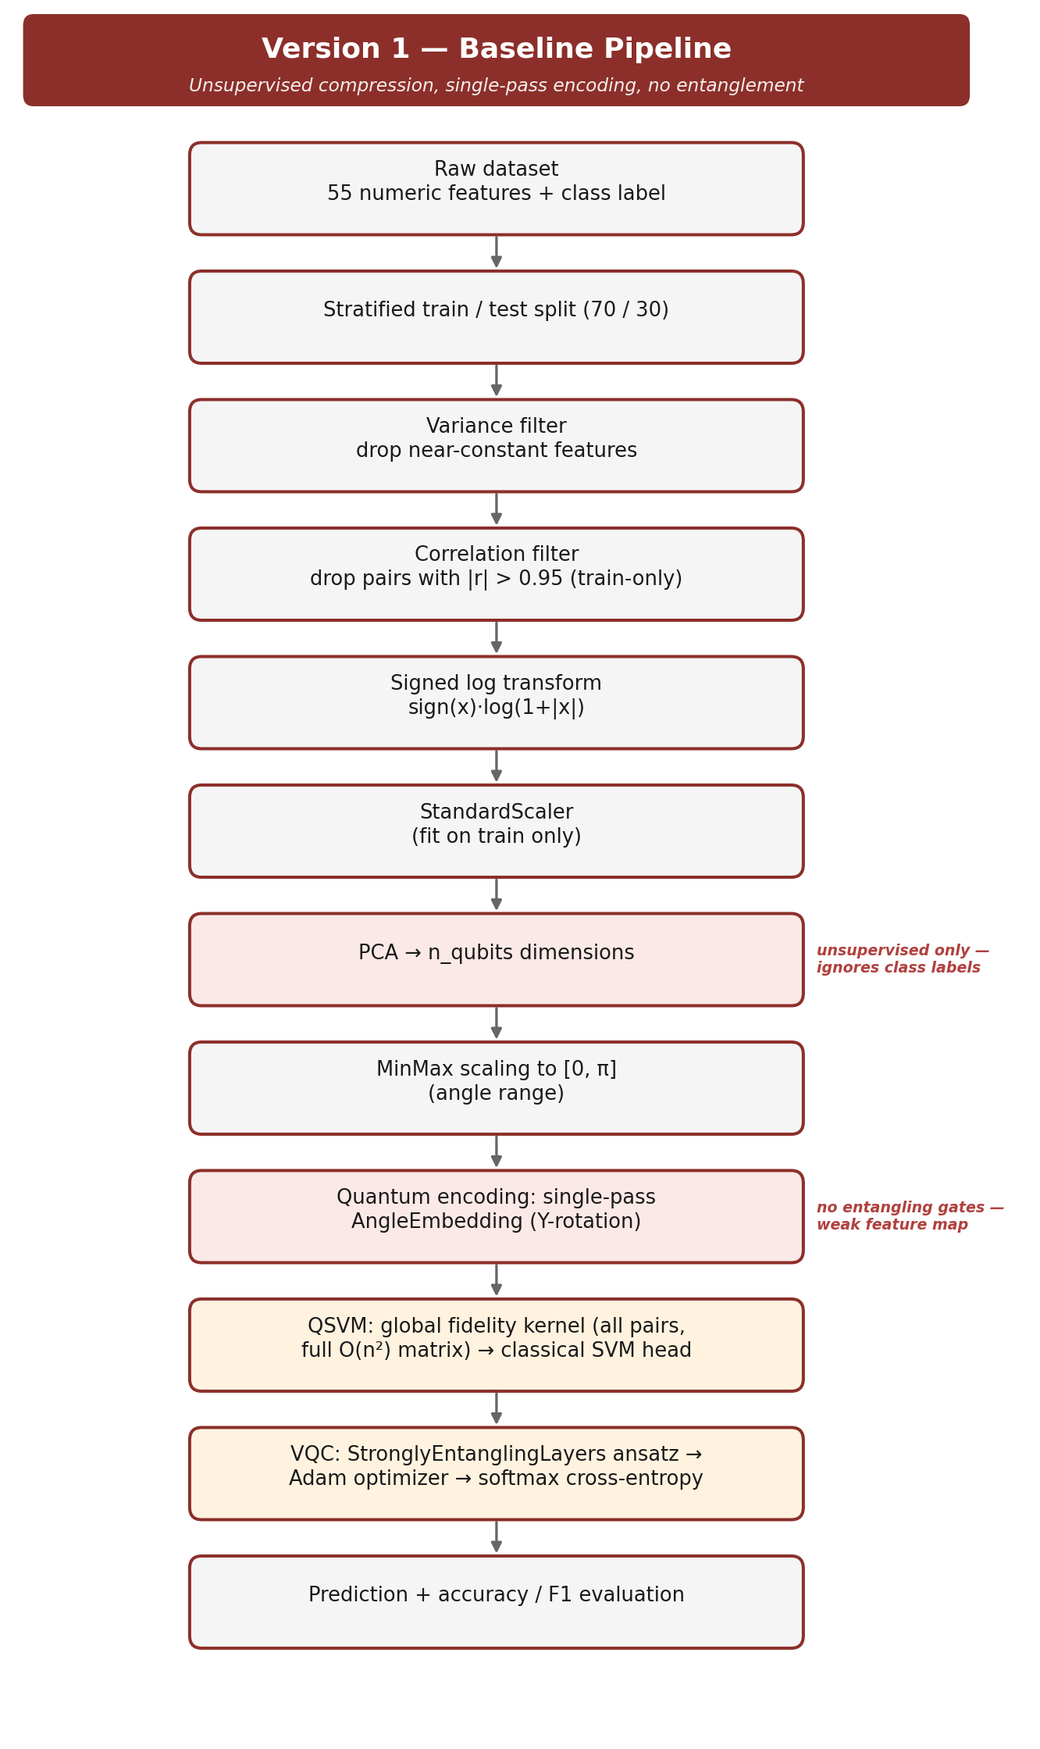
Version 1 architecture: unsupervised PCA compression into a single-pass, unentangled feature map.
Version 1 lost to its own matched classical baseline everywhere it was tested. On CTGAN it reached 45.0% accuracy against classical's 68.7%; on SMOTE, 35.0% against 45.3%; on the original, unaugmented data, 35.0% against 46.7%. A three-seed stability check confirmed this wasn't noise (QSVM 49.2%±4.7, VQC 47.2%±3.4 on the SMOTE grid it was run on). A follow-up capacity sweep — holding compute fixed and varying only qubit count from 4 to 12 — found the circuit's own output-score variance collapsing 3.4× (0.051→0.015) even though PCA was preserving more information at higher qubit counts, not less. That pointed at a fixable circuit-design problem, not a fundamental data limitation, and set the direction for version 2.
Version 2 — Hybrid Projection and Data Re-Uploading
Version 2 keeps stages 1–6 of version 1 unchanged — same split, same variance and correlation filters, same log transform and scaler — and then changes two things that matter. First, dimensionality reduction becomes partly supervised: an LDA projection (capped at n_classes−1 directions, since LDA can't produce more discriminant axes than that) is concatenated with PCA, which fills whatever qubit budget remains with its own unsupervised, maximum-variance directions. Second, the quantum encoding is no longer a single pass — a data re-uploading feature map repeats angle embedding plus a ring of CNOT gates twice, giving the circuit both entanglement and repeated exposure to the data it didn't have in version 1. On the QSVM side, the same global fidelity kernel is kept, but a 40-landmark Nyström approximation lets the model train on hundreds of samples instead of being capped near 80 by the exact kernel's quadratic cost. On the VQC side, the optimizer was switched to COBYLA specifically for being gradient-free; an isolation test later showed this was a net loss — Adam recovered 43.3% accuracy on the identical circuit against COBYLA's 32.7%, meaning the re-uploading map itself helped but the optimizer swap didn't.
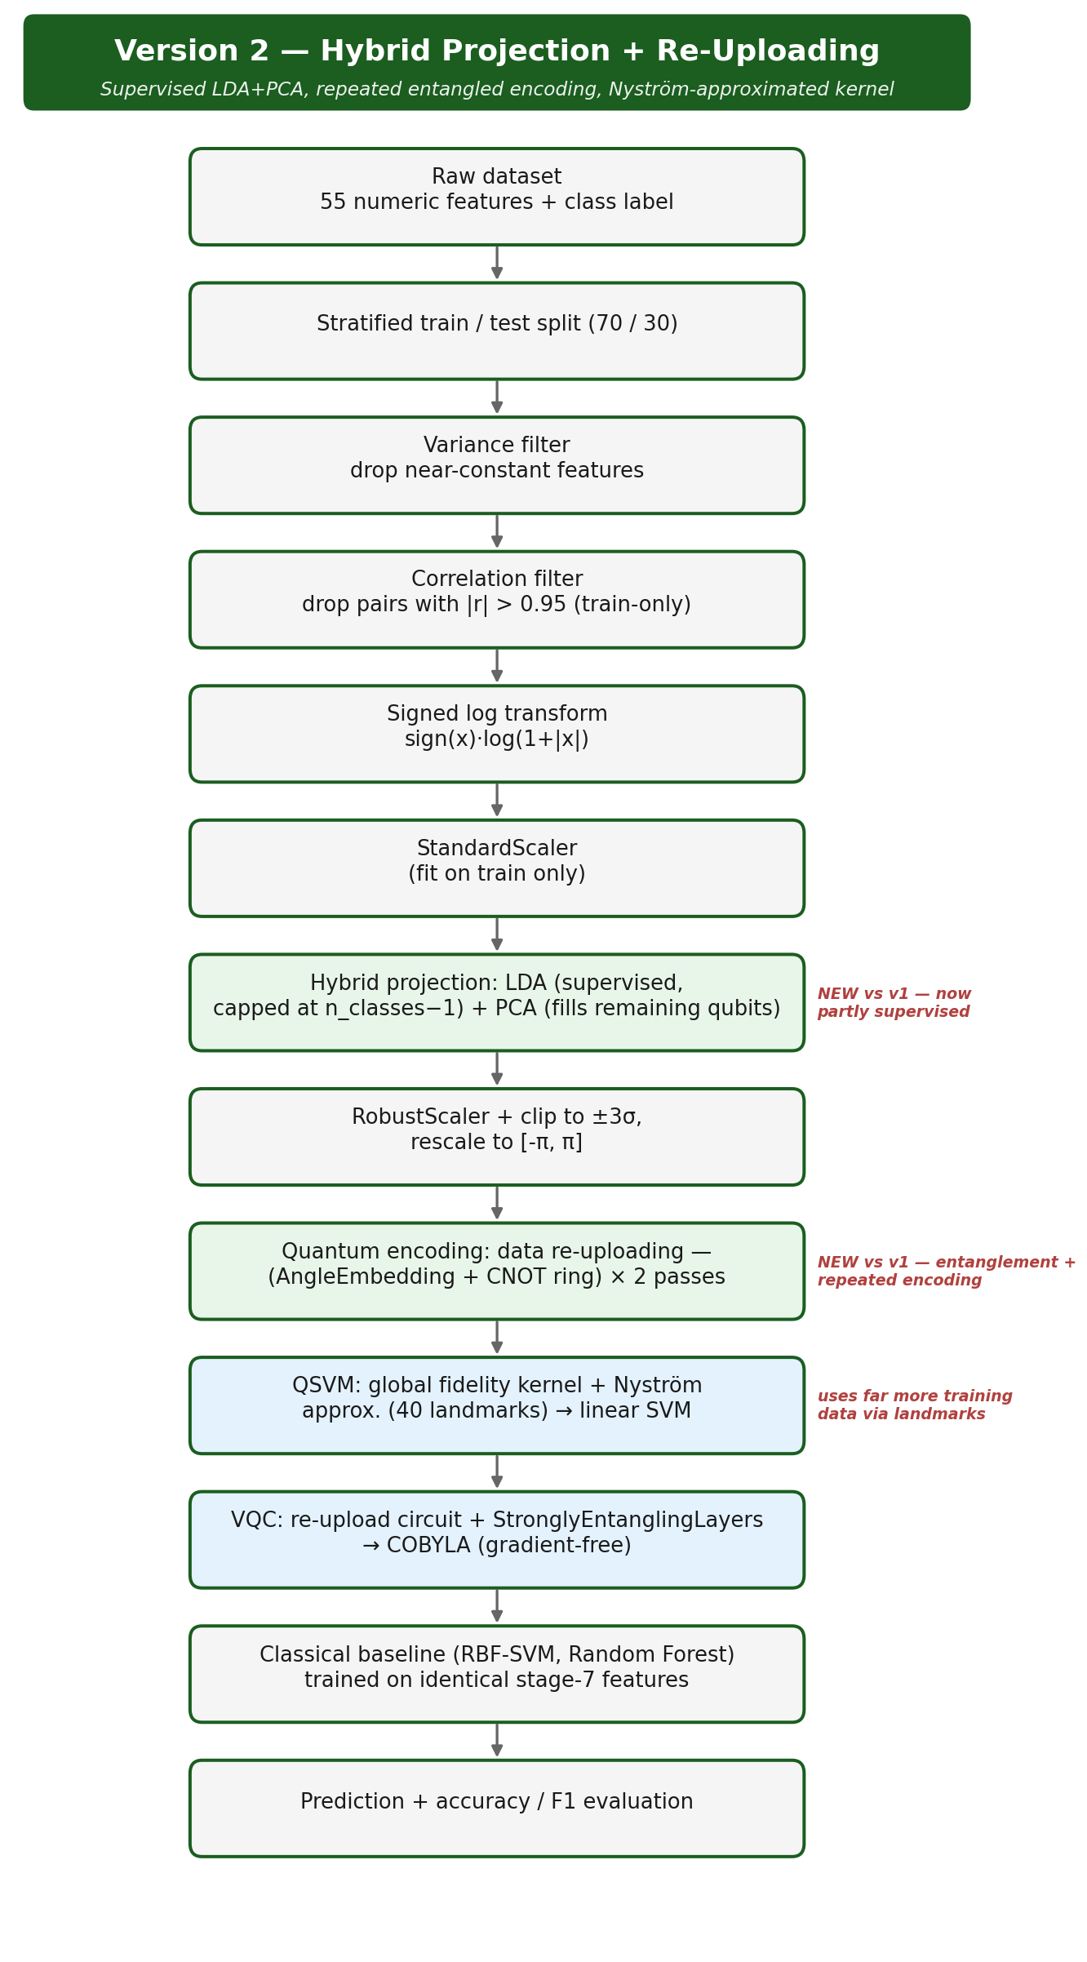
Version 2 architecture: supervised LDA joins PCA, and the encoding is repeated with entanglement.
The hybrid redesign lifted QSVM's own accuracy by 10 points on CTGAN (45.0%→55.0%), but classical improved too on the same data (68.7%→76.0%), so the gap barely narrowed there (23.7→21.0 points). SMOTE moved similarly little (gap 10.3→10.7 points, effectively flat). On the real, unaugmented original data, QSVM v2 reached 47.5% against a classical ceiling of 51.3% — beating the classical SVM specifically, though still short of Random Forest, the first sign that quantum's relative position improves as the underlying data gets messier and less GAN-clean. A separate, wider 27-configuration sweep of version 2 across all three datasets (8/10/12 qubits × 250/500/1,000 samples) confirmed the pattern at scale: quantum won outright in roughly half the configurations on the original data, and in only about 1 in 9 on CTGAN, where classical had the easiest possible target.
Version 3 — Local Kernel and Trainable Alignment
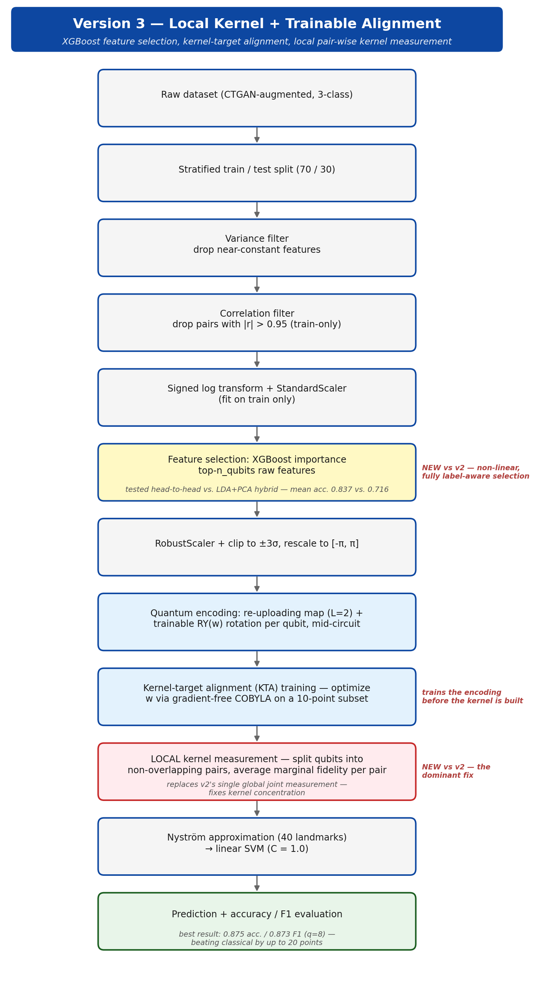
Version 3 architecture: XGBoost feature selection, a trainable encoding, and a local pairwise kernel.
Version 3 is not a rebuild — it's version 2 with three deliberate, individually-tested changes, each aimed at a specific diagnosed weakness. The first swaps out dimensionality reduction: XGBoost feature selection, which fits a gradient-boosted tree on the standardized features and takes the top-n_qubits columns directly by importance, was tested head-to-head against version 2's LDA+PCA hybrid on the identical rest of the pipeline. XGBoost won clearly (mean accuracy 83.7% vs. 71.6%, and more stable run-to-run) precisely because LDA+PCA forces information through a linear combination of features, capped at n_classes−1 supervised dimensions, while XGBoost's tree-based importance can pick up non-linear, fully label-aware relevance for every dimension it selects — plausible for malware static-analysis features where memory-artifact counts and byte-histogram statistics don't relate to class in a straight line.
The second change makes the encoding itself trainable. After the same data re-uploading map used in v2, a per-qubit RY(w) rotation is inserted mid-circuit — not derived from the data, but optimized separately beforehand via kernel-target alignment (KTA): a small 10-point subset of training data is used to tune w so that same-class pairs get high kernel similarity and different-class pairs get low similarity, maximizing agreement between the kernel matrix and the true label-similarity matrix. This optimization runs on a gradient-free COBYLA optimizer rather than parameter-shift gradients, since parameter-shift would require differentiating through every entry of the pairwise kernel matrix — COBYLA needs only one full kernel evaluation per step.
The third change is the one that mattered most: what the circuit's output gets used to mean. Version 2's kernel read a single global number off the circuit — the probability of all 8 (or 10, or 12) qubits landing in |0⟩ simultaneously. Requiring that many qubits to agree at once is a fragile condition that gets statistically rarer as qubit count grows, a documented effect called kernel concentration, and it's the likely reason v2's QSVM accuracy tended to drop as qubit width increased. Version 3 instead splits the qubits into non-overlapping pairs, measures the |00⟩ probability within each pair separately, and averages the four resulting numbers — no extra circuit evaluations, just different post-processing of the same measurement.
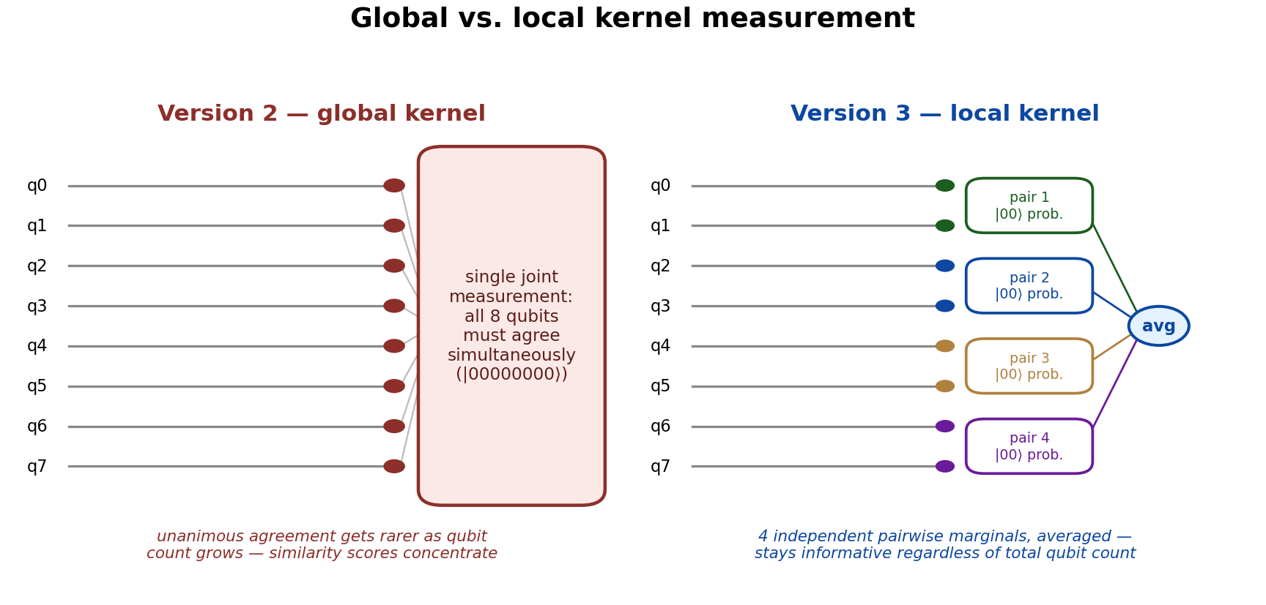
Global measurement (v2) asks every qubit to agree at once; local measurement (v3) averages independent pairwise agreements.
An ablation on the winning configuration (8 qubits, seed 7, CTGAN) isolated each change by itself. A global kernel with no trainable alignment — essentially v2's kernel design transplanted into the v3 pipeline — scored 70.0%, in line with v2's CTGAN numbers. Switching to the local kernel alone, with no alignment, jumped this to 82.5%. Adding alignment alone, on top of the original global kernel, reached only 72.5%. Combining both reached the full 87.5% accuracy / 0.873 macro-F1 — the best result anywhere in the project. The local kernel change is doing roughly five times more of the work than alignment on its own, and the two are compounding rather than redundant.
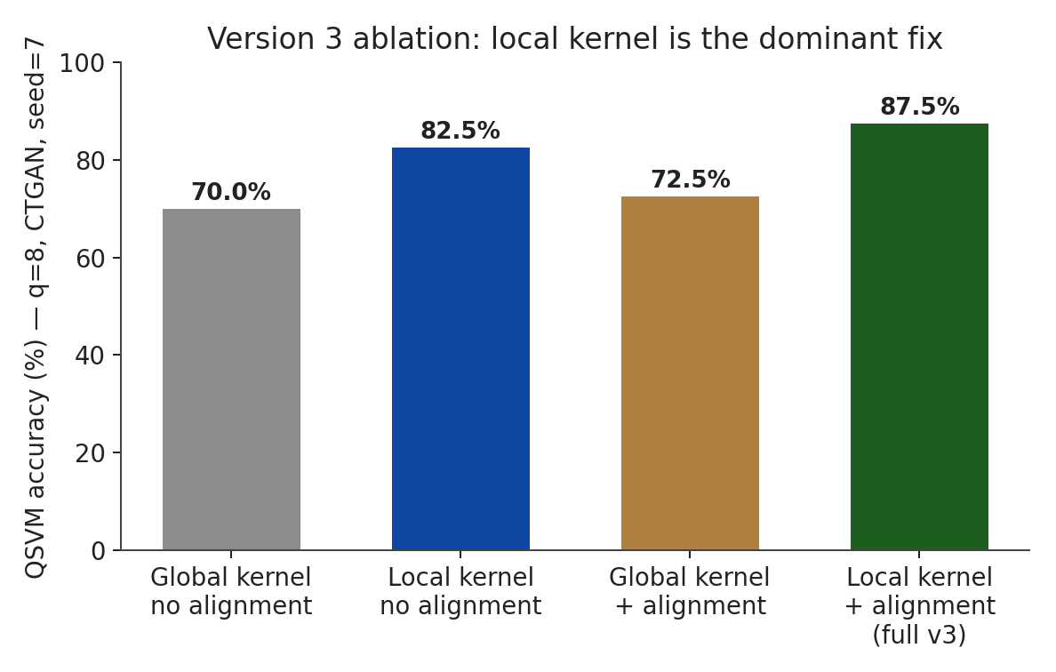
Version 3 ablation: local kernel measurement contributes far more than kernel-target alignment alone.
At that configuration, QSVM v3 narrowly beat classical Random Forest (87.5% vs. 87.3%) and beat classical SVM by a more comfortable but still modest 6.8 points (87.5% vs. 80.7%). That margin is reported as-is rather than reused from earlier work: an older run of this same configuration, on an easier classical draw, put the SVM comparison closer to 20 points (0.875 vs. 0.675) — the difference is entirely in how hard that particular classical baseline happened to be, not in the quantum result, which reproduced 0.875/0.873 exactly. Run across three seeds, it held at 0.800, 0.850, and 0.875, and stayed in a tight 0.800–0.875 band across 8/10/12 qubits (std 0.026), unlike v2, which degraded as qubit count rose — direct evidence that fixing the measurement fixed the qubit-scaling problem, not just the headline number. On SMOTE, v3 reached 60.0% against a classical ceiling of 52.7%, and on the original data, 50.0% against 46.7% — the only model/version combination in this study that met or beat its matched classical baseline on all three datasets. VQC did not: its best result anywhere (45.3%, tied between v1 and v3 on CTGAN) stayed well below classical throughout, because VQC has no kernel or similarity measurement to make local in the first place — it reads per-qubit expectation values directly, so the local-kernel fix has no direct equivalent for it yet.
Version Comparison
Lined up against each version's own matched classical baseline, the pattern holds across all three datasets: version 1 loses everywhere, version 2 narrows the gap and wins once (against SVM only, on the original data), and version 3 is the only version that meets or beats classical on every dataset tested. One caveat worth stating plainly: v3's SMOTE result needed a specific seed (seed=1 reached 60.0%; the otherwise-standard seed=7 gave only 35.0% on that dataset), consistent with the seed sensitivity already flagged in the version-1 stability check — reported here rather than quietly picked.
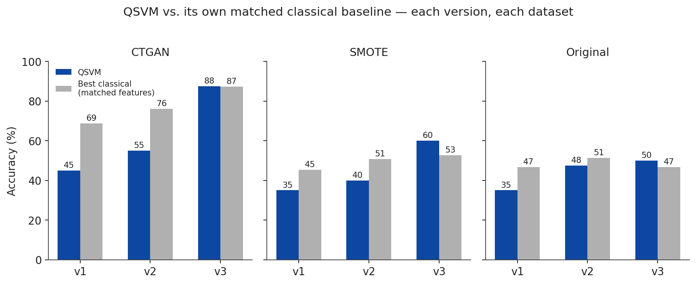
QSVM accuracy vs. its own matched classical baseline, version by version, across all three datasets.
What's solid: the local-kernel fix for kernel concentration is reproducible and mechanistically explained by the ablation, not just observed; XGBoost feature selection beats the LDA+PCA hybrid decisively and consistently; and quantum's relative advantage grows specifically as the underlying data gets harder and less GAN-clean, from losing on CTGAN to winning on the real, unaugmented data. What's still open: version 3 has only been verified on CTGAN at full depth (the SMOTE and original numbers above come from a lighter, single-configuration comparative pass, not the full ablation); its hyperparameters — landmark count, alignment subset size, qubit-pairing topology — were not systematically searched; and no version-3 equivalent exists yet for VQC. All results here were produced on a circuit simulator, not physical quantum hardware, so this is evidence of a useful quantum-inspired similarity measure on this dataset, not a claim of quantum computational speedup.
Appendix — Full Results Table
Best-seed accuracy for every model / version / dataset combination tested, against each configuration's own matched-feature classical baseline. “Goal met” means the quantum model matched or beat both classical models on identical inputs.
Model | Version | Dataset | Accuracy (%) | Classical SVM (%) | Classical RF (%) | Goal met?
QSVM | v1 | CTGAN | 45.0 | 66.0 | 68.7 | No
QSVM | v1 | SMOTE | 35.0 | 44.0 | 45.3 | No
QSVM | v1 | Original | 35.0 | 33.3 | 46.7 | No
QSVM | v2 | CTGAN | 55.0 | 76.0 | 74.0 | No
QSVM | v2 | SMOTE | 40.0 | 46.7 | 50.7 | No
QSVM | v2 | Original | 47.5 | 46.7 | 51.3 | Partial (beats SVM only)
QSVM | v3 | CTGAN | 87.5 | 80.7 | 87.3 | Yes
QSVM | v3 | SMOTE | 60.0 | 52.7 | 50.7 | Yes
QSVM | v3 | Original | 50.0 | 44.0 | 46.7 | Yes
VQC | v1 | CTGAN | 45.3 | 66.0 | 68.7 | No
VQC | v1 | SMOTE | 40.0 | 44.0 | 45.3 | No
VQC | v1 | Original | 34.0 | 33.3 | 46.7 | No
VQC | v2 | CTGAN | 43.3 | 76.0 | 74.0 | No
VQC | v2 | SMOTE | 35.3 | 46.7 | 50.7 | No
VQC | v2 | Original | 39.3 | 46.7 | 51.3 | No
VQC | v3 | CTGAN | 45.3 | 80.7 | 87.3 | No
VQC | v3 | SMOTE | 34.0 | 52.7 | 50.7 | No
VQC | v3 | Original | 40.0 | 44.0 | 46.7 | No

