Week 1 — Executive Summary
I began the week by studying data augmentation techniques for tabular class imbalance — SMOTE, Borderline-SMOTE, ADASYN, and deep generative approaches such as CTGAN, TVAE, and cGAN — and reviewing the specific challenges malware datasets pose for these techniques, including heavy benign-class skew, overlapping feature spaces between malware families, and the added complexity of high-dimensional memory-forensics features. With that grounding, I downloaded the CIC-MalMem-2022 dataset, a memory-forensics malware dataset that ships as a binary benign/malicious split, and derived four working classes — Benign, Ransomware, Spyware, and Trojan — from its fine-grained category labels. This immediately surfaced a clear class imbalance problem: Benign samples made up just over half the dataset while each malware family sat at roughly a sixth, giving an imbalance ratio of about 0.325 between the smallest and largest classes.
I then ran a full preprocessing pass on the raw data. After removing a small number of exact duplicate rows, the cleaned dataset settled at just over 58,000 samples with no missing values. I dropped constant and near-constant features, flagged a large block of highly correlated feature pairs, and used Random Forest importance and statistical tests to select the twenty most informative features out of the original set. Features were standardized, and I built a stratified 70/15/15 train, validation, and test split so that class proportions were preserved across all three partitions, with an explicit leakage check confirming no overlap between them. The chart below shows the original class distribution that this whole preprocessing pipeline was built around.
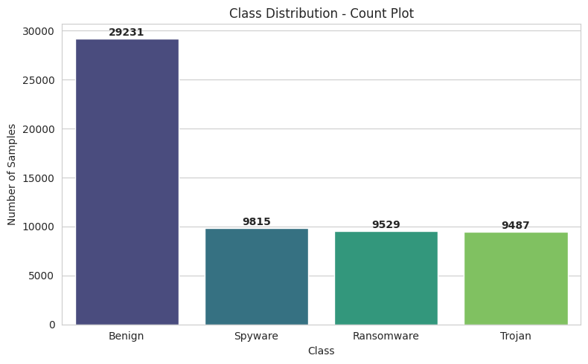
Original class distribution across Benign, Ransomware, Spyware, and Trojan.
With a clean, split dataset in hand, I implemented SMOTE, Borderline-SMOTE, and ADASYN to balance the training classes. SMOTE and Borderline-SMOTE both brought every class up to an identical count, achieving a perfect 1.0 balance ratio, while ADASYN — being density-adaptive — landed very close to balanced without being exact. All three preserved the original feature count and introduced no missing values or duplicate rows, which I verified explicitly before moving on. The comparison below shows how each technique reshaped the class counts relative to the original imbalanced dataset.
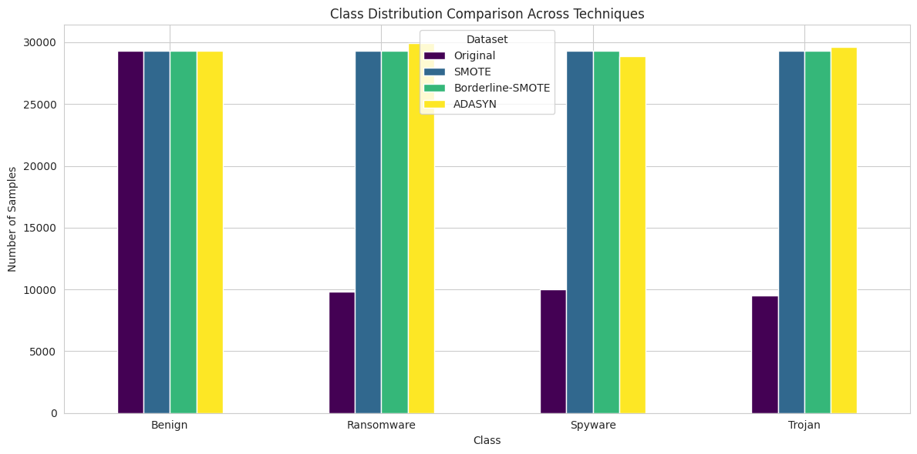
Class counts before and after SMOTE, Borderline-SMOTE, and ADASYN balancing.
In parallel, I trained deep generative models — CTGAN, TVAE, and a custom conditional GAN — on the three minority malware classes to generate synthetic samples up to the Benign count as an alternative balancing route. TVAE trained the fastest of the three and reproduced the real feature means, variances, and correlation structure most closely. CTGAN, trained at a reduced budget for this first pass, could in principle capture more complex multi-modal structure but was noticeably less stable at this budget, and the custom cGAN, since it only modeled continuous features directly, gave the least complete picture of the full feature space among the three.
To judge how trustworthy each balancing strategy actually was, I compared the original, SMOTE, and CTGAN datasets using PCA, t-SNE, and UMAP projections alongside seven statistical similarity metrics — KS statistic, Wasserstein distance, Jensen-Shannon distance, cosine similarity, Euclidean distance, Mahalanobis distance, and Maximum Mean Discrepancy. Across every single metric, SMOTE sat far closer to the real data distribution than CTGAN did — for instance, its KS statistic and MMD were roughly six to one hundred times smaller than CTGAN's, and its coverage of the real data manifold was well over ten times higher. CTGAN's synthetic points were considerably more "novel" relative to the real data, which sounds positive but here mostly reflected drift into low-fidelity regions rather than genuinely useful diversity, given the reduced training budget it was working with.
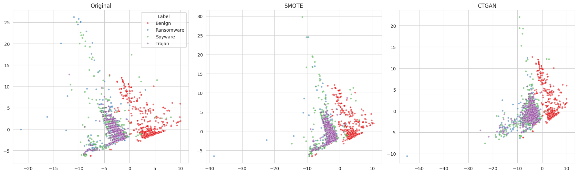
PCA projection comparing Original, SMOTE, and CTGAN sample distributions.
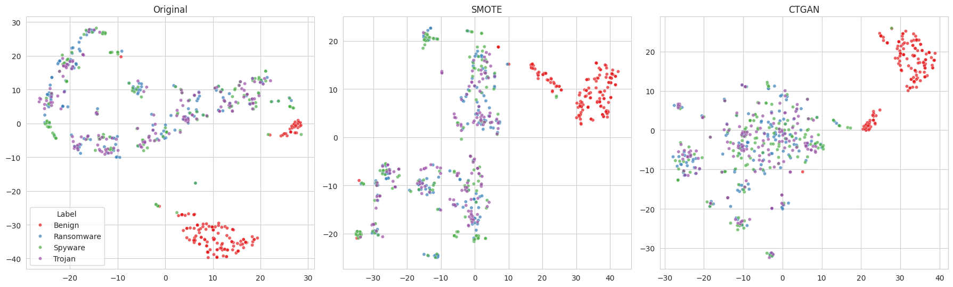
t-SNE projection comparing Original, SMOTE, and CTGAN sample distributions.
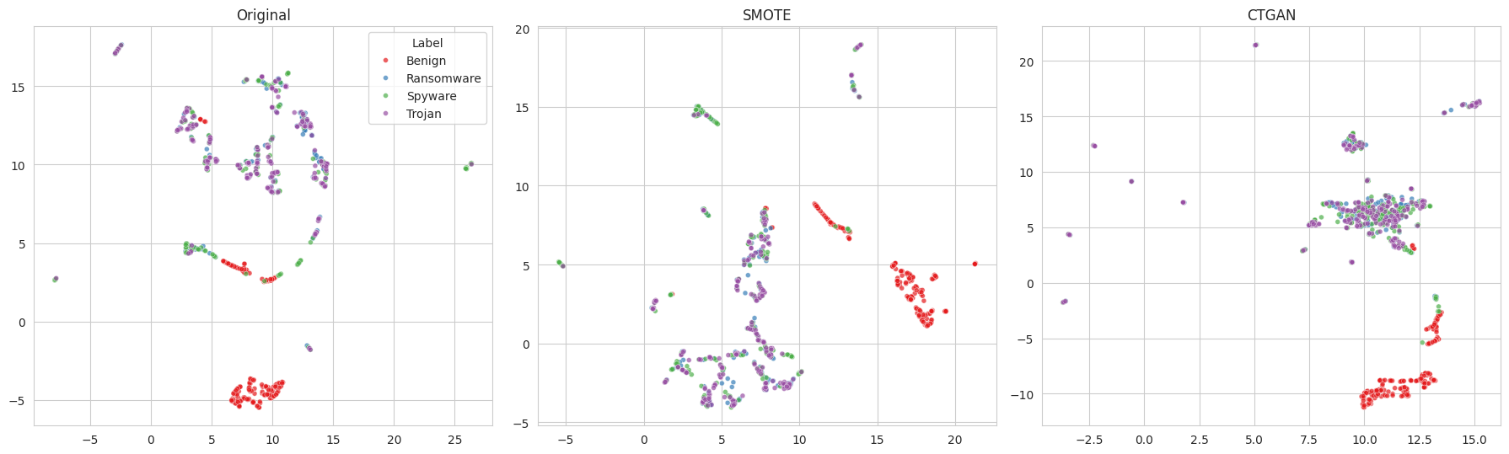
UMAP projection comparing Original, SMOTE, and CTGAN sample distributions.
Finally, I benchmarked Random Forest, XGBoost, LightGBM, and SVM across the Original, SMOTE, Borderline-SMOTE, ADASYN, CTGAN, and TVAE datasets, scoring every combination on Accuracy, Macro-F1, Weighted-F1, Matthews Correlation Coefficient, ROC-AUC, and PR-AUC against a shared held-out test set. Random Forest trained on the SMOTE-balanced dataset came out on top overall, reaching about 93.2% accuracy and Macro-F1 with a ROC-AUC near 0.99, followed closely by Random Forest on ADASYN. The generative datasets trailed behind: CTGAN's best classifier, LightGBM, reached comparable raw accuracy to Borderline-SMOTE's best result but a noticeably lower Macro-F1, reflecting weaker per-class separability from the synthetic samples, while TVAE-based models performed weakest of the augmented variants. SVM was consistently the weakest classifier regardless of which dataset it was trained on. On a direct same-test-set comparison, Random Forest accuracy moved from about 87% on the original imbalanced data to 93% with SMOTE, while the reduced-budget CTGAN dataset actually sat slightly below the original baseline — a clear signal that, at this stage, classical oversampling is the more reliable balancing strategy and that CTGAN needs a longer training run before it can be judged fairly against SMOTE.
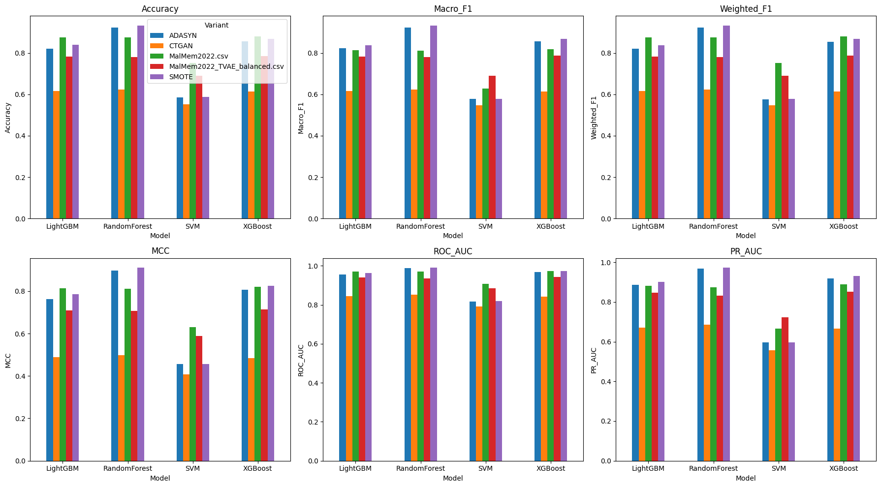
Accuracy and Macro-F1 across all model / balancing-strategy combinations.

